Learning in the Digital Era
ACCA4025
Component 1: E-portfolio

Submitted by

Student number:2519478
Date: 5 March 2026

Table of contents
Contents
E-portfolio link 3
Screenshot of e-portfolio cover page/ welcome page 3
Screenshot of task 1 4
Screenshot of mind map 5
Link to mind map 5
Screenshot of the academic poster 6
Link to the academic poster 6
Screenshot of automatic referencing tool 7
Screenshot of each page of e-portfolio 8

E-portfolio link
Anna’s E-Portfolio - Essential Skills

Screenshot and link of e-portfolio cover page/ welcome page

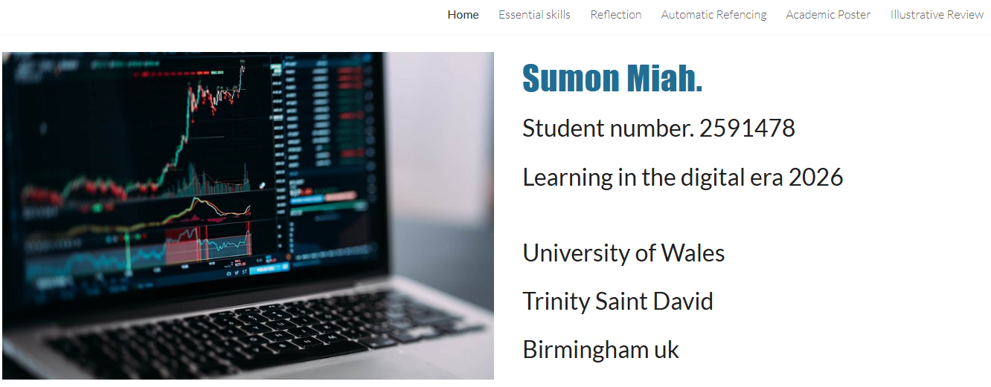
https://sites.google.com/d/1SLxUaJqZIVpveYDRA7B6Toz2w2GqPbhY/p/1ts5mOAFaKPlr1XaS6aecqVkscODjYNuk/edit

Screenshot of task 1
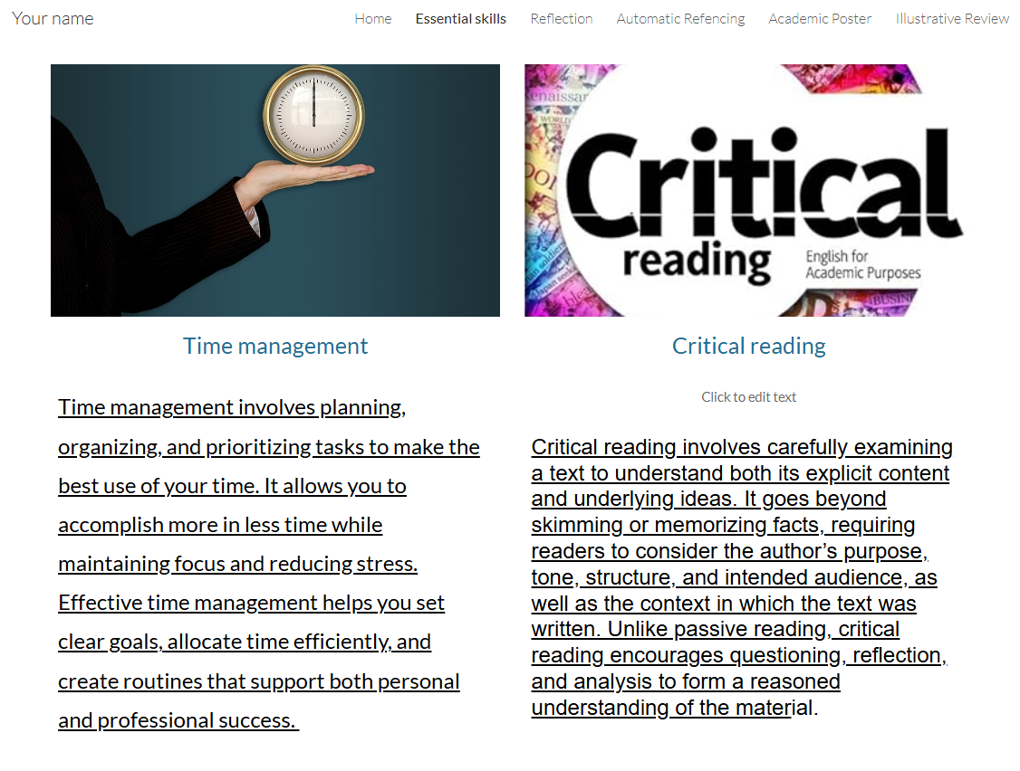

Screenshot of mind map
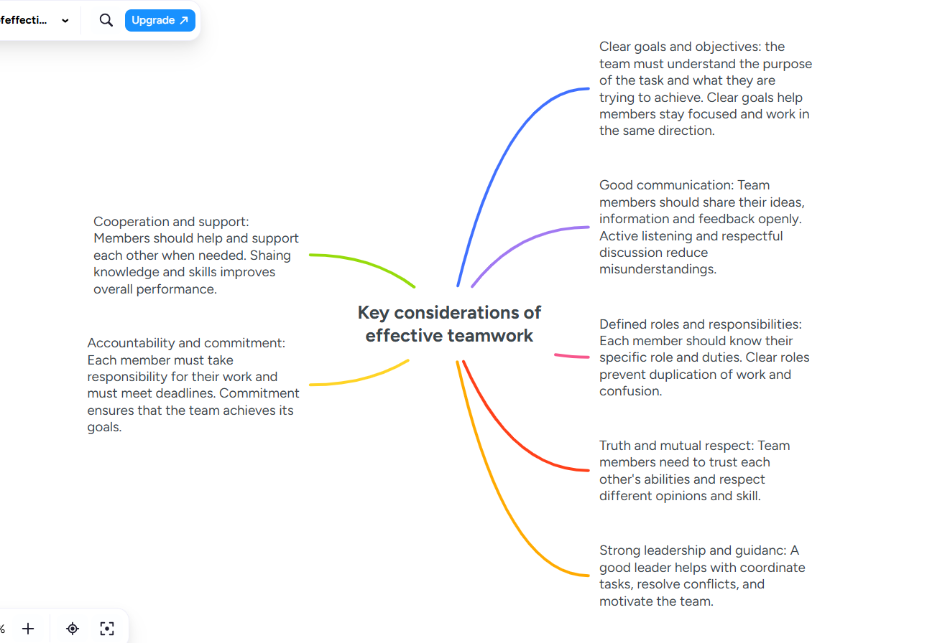

Link to mind map
https://www.mindmeister.com/app/map/3957632633

Screenshot of the academic poster
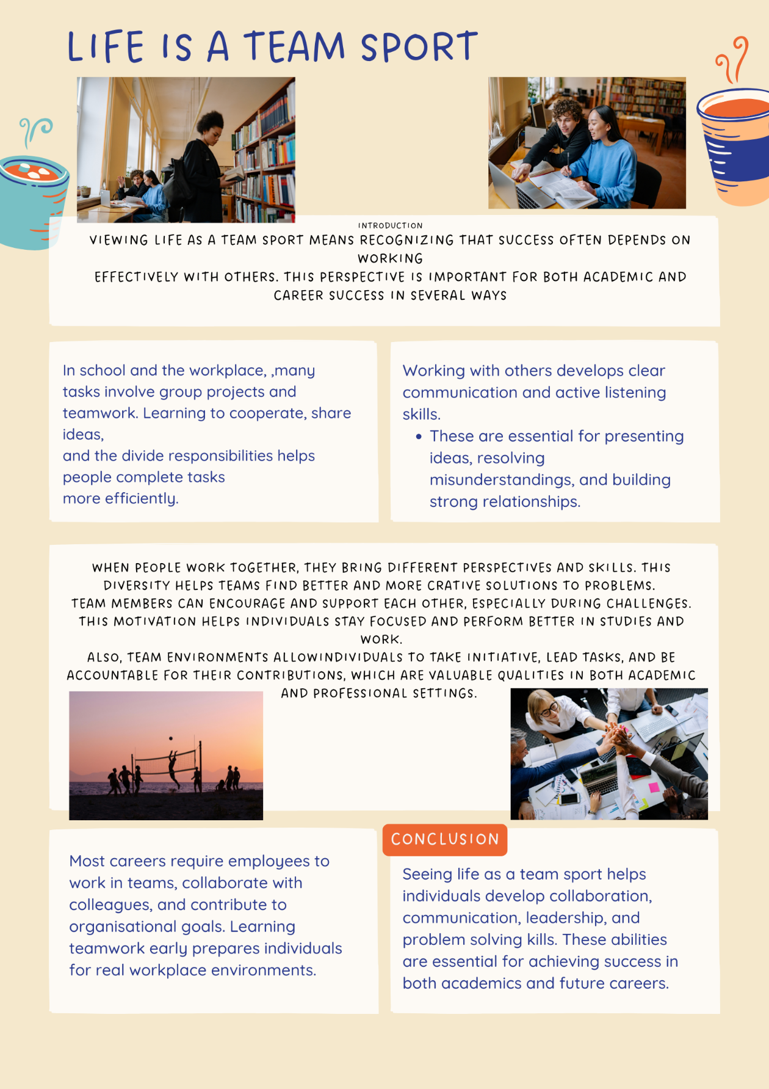

Link to the academic poster
https://www.canva.com/design/DAHDZqBUABY/UeQPN_v9aKtTr23Vwddj-g/edit?ui=eyJBIjp7fX0

Screenshot of automatic referencing tool
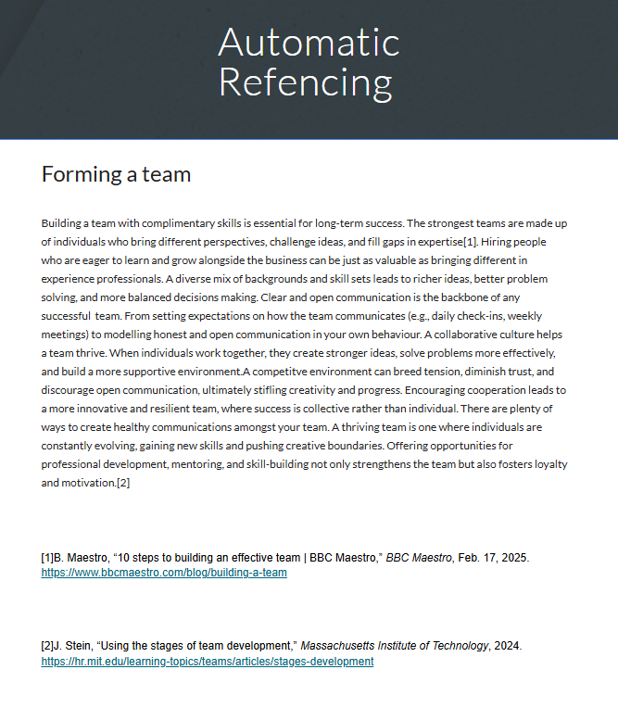

Screenshot of each page of e-portfolio



