EFFECTIVE TEAM WORKING for team success

STUDENT Name: Joan Hird
Student Number:2028356
lecturer Name: Dale Clarke
BMSW Code: 4002

CONTENTS PAGES
CASE STUDY………………………………………………………………………………………………………………………………………3
INTRODUCTION…………………………………………………………………………………………………………………………………4
Tuckman Theory……………………………………………………………………………………………………………………………… 6
Tuckman model ……………………………………………………………………………………………………………………………….7
Belbin Theory……………………………………………………………………………………………………………………………………8
Conclusion……………………………………………………………………………………………………………………………………….9
Reference………………………………………………………………………………………………………………………………………..10

INTRODUCTION
Based on Abdul's case study, we will examine many approaches to resolving his issue of successful teamwork, including the (Tuckman,1965) modules of Forming, Norming, Storming, and Performing. We will also examine Belbin's nine team roles, which are described in more detail below. The number of different sorts of behaviours that individuals participate in is limitless, but so is the number of different applications. The amount of behaviour that may make a significant impact to team performance is limited.
A certain number of related clusters are formed from these behaviours, and the team position is assigned to each of these groups. In accordance with the idea of Belbin's (Belbin, 2021), if each member of the team knows their duties within the team ecosystem, it will be simpler to identify their individual strengths, weaknesses, and abilities. Following Tuckman's philosophy, it is vital to establish a strong and productive team in five stages: growing as individuals, confronting difficulties and finding solutions, planning work, and delivering outcomes. A team that has effective communication and is working toward the same objectives. On the 16th of August. Whelan's scholarly publications on the subject of teamwork. Contrary to popular belief, despite the fact that teams constitute a fundamental organizational unit in everyday life, most of us do not work in them. Never, ever purposefully, study a great deal about how they operate or the instrument that will allow you to make them really successful.

How to develop an effective team
Working as a team is the collaborative effort of a group to accomplish a shared goal or to finish a job in the most effective and efficient manner. When cooperation occurs in the way it is intended to occur, something extraordinary occurs.
When everyone on the team is equally involved in the overarching purpose and objective, things begin to shift. You find yourself working quicker, identifying faults more readily, and inventing more effectively.
The point is reached when you are certain that everyone on your team is rooting for you, and both your work happiness and performance rise.
Good communication skills are required for the development of effective collaborative capabilities.
To identify what the team will be working towards, clear instructions and goals must be communicated to ensure that the team is successful in their efforts.
In order to guarantee that we are all striving for excellence and improved practise as a team, it is also necessary to provide honest reflective feedback.
Having the chance to work as a team provides the ability to be Reflective, which pushes each team member to enhance the team's practise and result.
To improve your team-working abilities, you must be willing to listen to and consider the many viewpoints that all contribute to the general advancement of the group.
Even though it may be challenging, it is important to draw on each other's abilities in order to achieve the overall aim. It was developed in 1965 by Bruce Wayne Tuckman and is used for group growth. It is important and inevitable for a team to grow and handle obstacles while also finding answers to problems.
Tuckman's model indicates that as a team matures and becomes more capable, connections are formed and the leader's leadership style evolves, as explained in the book This straightforward summary of the Tuckman forming, storming, norming, and performing model provides a straightforward approach to comprehend how groups grow (12 Jun 2017).
https://www.businessballs.com/team-management/team-management/tu..
• forming: Because this is the first time the team members will meet, it is critical for the team leader to organize introductions and showcase each individual's abilities.
Members of the team are also provided with project specifics and chances to arrange their tasks on a more formal basis.
Team members freely discuss ideas at this stage, taking advantage of the chance to stand out and be recognized by their peers. • Norming: at this stage, the teams have found out how to work together; there is no longer any internal conflict between them.
• When it comes to performing, there is a high degree of cohesiveness and trust among the team members. •
• Adjourning: teams conclude their project and reflect on what went well and what may be improved for the next project.

What are the types of roles that are needed to create an effective team?
A team's success is dependent on the presence of a strong leader who will serve as the group's driving force. It is necessary to have an integrative practice with persons who are ready to offer ideas and strategies in order to achieve objectives in order to form a good team.
Knowing how the team interacts while participating in the activity will help you recognize the various roles that individuals are playing in the team. It will also assist you in improving your skills by watching what has to be done better.

What type of impact can effective teamwork have on team success?
As Jones and colleagues (2007) point out, it is critical to take into account the influence of cooperation on overall performance. Teamwork is often regarded as the most important factor in boosting performance.
Working as part of a team and supporting successful cooperation among your employees may provide several benefits and competitive advantages to your organization. Motivational factors have several connections to the team's beliefs and capacity to complete tasks to a high level of excellence.
Individuals who contribute to assisting a team in producing outcomes will feel respected, supported, and devoted to one another as a consequence of increased productivity.
This may result in happier, more productive, and more motivated employees, as well as meeting deadlines, problem-solving, developing new ideas and possibilities, and creating a support network (Cannon-Bowers and Salas 20 01).
When it comes to domains such as problem-solvings, adaption, and operational management, the advantage of cooperation is a significant boost in production (Vakova, 2007).

What are the barriers to effective team working?
identify in a scenario
When communication goes down or there is a lack of understanding in the group, we begin to observe roadblocks that prevent successful cooperation from taking place.
Teamwork fails for a variety of reasons, including losing sight of their purpose or objectives, having people who refuse to accept responsibility for their tasks, resulting in resentment and blame among team members, and failing to share knowledge and communicate efficiently. When making a choice, don't search for general agreement. Management does not give them with the resources they need to do their tasks. They are not completely supported by their peers.
According to the case study, Abdul has to meet face to face with every member of the team to discuss how to rebuild the team and make it more productive.
With the help of Belbin team responsibilities, we were able to
Belbin's team role, according to Mindtools (2022), is one of nine clusters of behavioral qualities discovered by Dr. Meredith Belbin's study at Henley as being beneficial in facilitating team advancement, as determined by Dr. Meredith Belbin's research at Henley.
According to the findings of the study, the most effective teams were comprised of individuals with a varied range of behavioral characteristics.
In order to become a high-performing team, each team must be able to access each of the nine Belbin team roles behaviors.

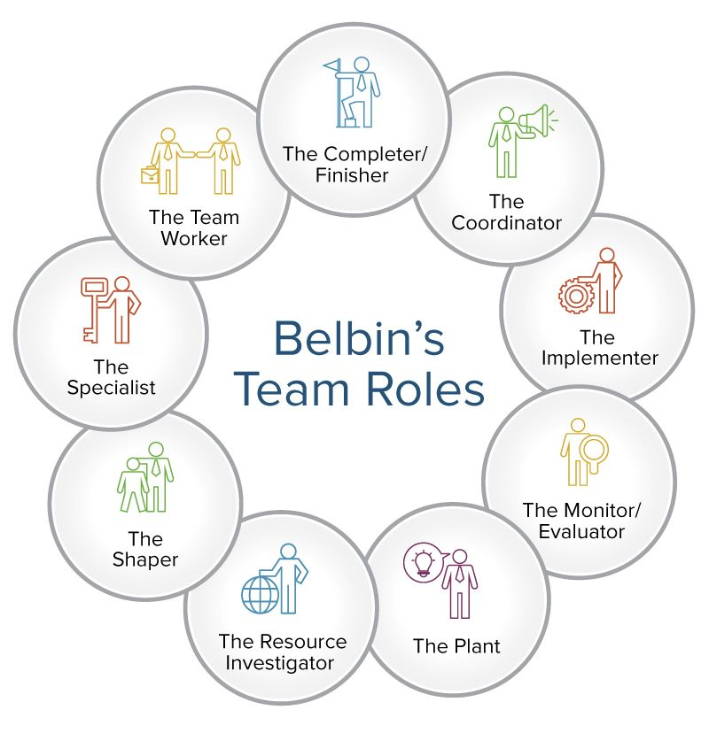
The nine-team roles are :

1: Resource Investigators are those who utilize their curious nature to uncover new ideas that they may then present to the rest of the team.
Increases outward excitement, allows for exploration of prospects, and the development of contacts
2: Teamwork. Help the team to gel by using their adaptability to identify the job that needs to be done and doing it on the team's behalf. Strength Cooperative, insightful, and diplomatic behavior is shown in order to avoid conflict.
3: Co-ordinator The Belbin idea indicates that the third team member should be the ordinator. It was necessary to keep the team's goals in mind, to pull out team members, and to assign work effectively. Strengths Capable of identifying talent, he is mature and assured. Specifies objectives
4: Plant
The team task determines two critical issues. First, it sets min problems
5: Monitor Evaluator
Makes decisions based on facts and rational thinking as opposed to emotions and instincts. they are normally .serious individuals who excel at critical thinking and strategy. planning
6: specialist
Brings in-depth knowledge of a key area to the team. the specialists are invaluable assets as they provide expert technical knowledge. strengths: single-minded, Self-starting, and dedicated. They provide specialist knowledge and skill.
7: Shaper
Provides the necessary drive to ensure that the team keeps moving and does not lose focus or momentum. Strengths: challenging, dynamic. Thrives on pressure. Has the drive and courage to overcome obstacles.
8: Implementer
Needed to plan a workable strategy and carry it out as efficiently as possible. Strengths: practical, reliable, efficient .turns ideas into actions and organizes work that needs to be done.
Completer finisher:
When a job is completed, it is most beneficial to polish and analyse the work for mistakes, submitting it to the highest standards of quality control." - by dismantling the team and putting it back together again.

Examining the strengths and shortcomings of each team member, as well as their ability to communicate effectively with one another inside the team (most people do not listen to understand they listen with the intent to reply)

When it comes to team growth, time management is quite crucial. Each member should be given a certain amount of time to arrange and accomplish duties within the time frame.
There is a good chance that the covid pandemic played a significant role in the team not meeting in person at a crucial stage of the team-building process, and that this is the reason why team members have lost focus on their purpose or goals. If the team members are too similar in terms of skills and ways of thinking, this will result in a breakdown, making it more difficult for the team members to reach their full potential of becoming a great team.

Conclusion
The team leader needs to restructure the team giving each member a. The specific task to complete in time allocated bosting team morals so the teams members feel fully supported by management. when team members take responsibility for their task there will be no resentment and blame among team members, Team members will start to share information and communicate effectively look for a consensus when making a decision. there will be more openness and trust amongst team members. When the team is provided with the resources they need the team members will get the job done

References
https://www.belbin.com/resources/blogs/belbin-and-tuckman 7th March 2022
- Cannon-Bowers, J. A., & Salas, E. (2001). Reflections on team cognition. Journal of Organizational Behavior, 22, 195–202.
- Jones, A., Richard, B., Paul, D., Sloane K., and Peter, F. (2007).”Effectiveness of teambuilding in organizations” Journal of Management.
- Griffith, Brian A., and Ethan B. Dunham. Working in Teams : Moving From High Potential to High Performance, SAGE Publications, 2014.
- Morgan, P. (2017), The Business Student’s guide to study and employability, London, SAGE.
- Martin, V. and Rogers, A. M. (2004) Leading interprofessional teams in health and social care. [electronic resource]. Routledge. Available at: http://search.ebscohost.com
- Pentland, A., (2008), Honest Signals, Cambridge, MA, MIT Press.
- Scheepers, D. and Ellemers, N., 2019. Social identity theory. In Social psychology in action (pp. 129-143). Springer, Cham.
- Tsay,M., & Brady,M., (2010), A case study of co-operative learning and communication pedagogy:Does working in teams make a difference?, The Journal of Scholarship of teaching and learning, 10(2), p.78
- van Knippenburg, D. and Schnippers, M.C. (2007) Work group diversity. Annual Review of Psychology, 58, 515-541.
- Wheelan, S.A., (2016), Creating Effective Teams, 5th Ed, London, SAGE
Vašková, R. (2007). Research on Teamwork and High Performance Work Organization, European Observatory of Working Life (www.eurofound.europa.eu)

