

LOCATION: Swansea | LLEOLIAD: abertawe
LEVEL 4 | LEFEL 4
EXAMINATION PERIOD | CYFNOD ARHOLIADAU
MAY 2024 | MAI 2024

MODULE CODE: ACDA4009
Signals and System

TIME: 2 HOURS

Equipment or materials required – Calculator
Adnoddau neu ddefnyddiau sydd eu hangen - Cyfrifiannell

QUESTION 1

- Consider the signal $x\left[n\right]$ in the below Figure1(a).
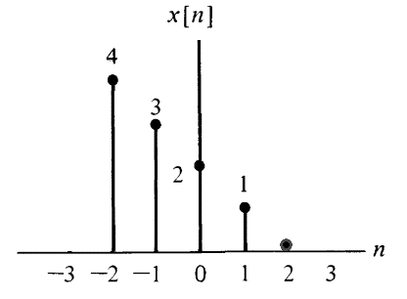
Figure: 1(a)
- Find the Even signal $x_{e}[n]$ , and the Odd Signal $x_{o}\left[n\right]$ from the above given signal $x\left[n\right].$ [11 Marks]
- Also, Prove that $x_{e}[n]$ +$x_{o}\left[n\right]$ = $x\left[n\right]$ [5 Marks]
- If $w[n]=x_{o}\left[n\right]$ then, find the value of $w[-n]$ [4 Marks]

QUESTION 2
- For functions given below.
- $δ\left[n\right]=\left\{\begin{aligned}0, n≠0 \\ 1, n=0\end{aligned}\right.$
- $u\left[t\right]=\left\{\begin{aligned}0, t<0 \\ 1, t>0\end{aligned}\right.$
Answer the Following
- Identify the Signals and provide the name of the function. [4 Marks]
- Illustrate its graphical representation. [6 Marks]
- Answer the following questions related to the rectangular pulse.
  - Generate a rectangular pulse for x(t) with unit amplitude and a duration of 2 time units. [4 Marks]
  - Illustrate the time shift and time variant representation for the function $y\left(t\right)=x(2t+3)$ . [6 Marks]

QUESTION 3

- Figure 3 below shows a data transmission system with devices connected via several signal wires.
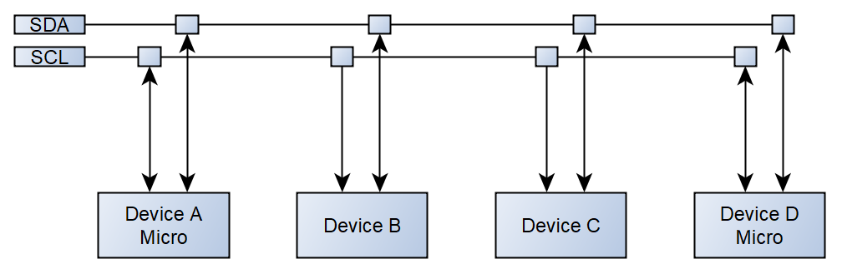
Figure 3(a) : A data transmission system
- Identify the transmission protocol shown above. [2 Marks]
- Classify this type of transmission method. [2 Marks]
- Explain briefly about the transmission method. [6 Marks]
- Give the full name of the signals present and a brief explanation of their function. [6 Marks]
- Give 2 examples of where this protocol might be used and provide a brief explanation of each of them. . [4 Marks]
QUESTION 4
- Answer the following regarding the RS232 Transmission system.
- Draw a block representation of a RS232 transmission system. [4 Marks]
- Classify this type of transmission method. [2 Marks]
- Explain briefly about the RS232 transmission method. [6 Marks]
- Give 2 examples of where this protocol might be used and provide a brief explanation of each of them. . [4 Marks]
- Draw the data byte 0xA5 (hexadecimal A5) as transmitted by this protocol and specify its parts. [4 Marks]
QUESTION 5
- Consider a UART communication scenario where the string "PRINT" is transmitted.
- Provide the binary representation of each ASCII character in the string.
[5 Marks]
- Demonstrate how the UART data frame would be constructed for each
character by providing relevant diagram. [15 Marks]

Diwedd/End

Standard ASCII character table

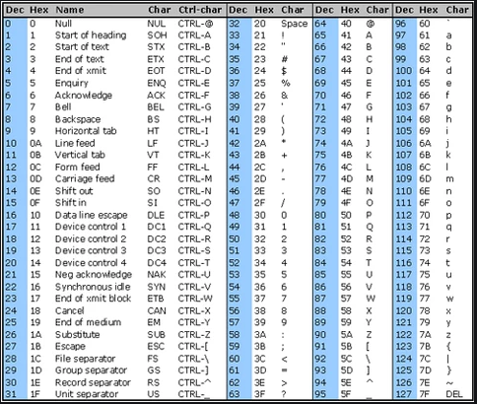

Diwedd/End

