

Title: Marketing Essentials

Module Title: M4X01916

Lecturer Name: Oluwaseun Adegbite

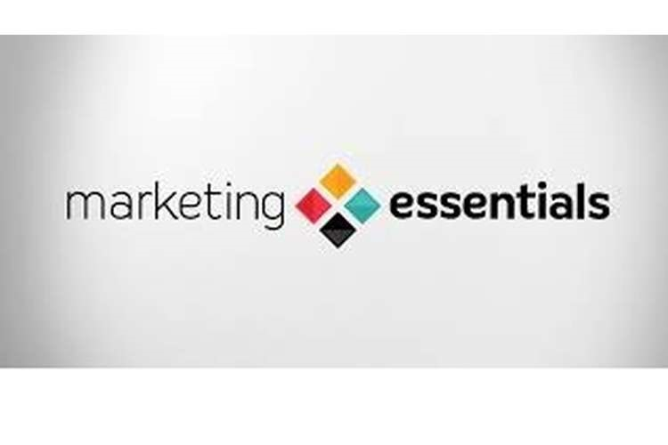

Name: Gabriel Bogdan Berchiu

Student Number: 1813615

Analyze the Importance of the Marketing Information System

1

CONTENT

Introduction……………..…………………………...P3
Quality Service……………………………………...P3
Service Promotion…………………………………..P3
Information and Communication………………….P4
Reservation System………………………………..P4
Competition………..………………………………..P4
Sales-marketing…………………………….………P5
Infrastructure………………………………………..P5
Recurrent Information……………………………...P5
Monitoring Information……………………….…….P6
Problem Related or Customized Information…....P6
Customer Relationship Management………….….P6
Competitive Marketing Intelligence………….…....P6
Solutions……………………………………….….…P7
Conclusion…………………..…………….………...P7
References…………………………………………..P8

2

Introduction

The marketing information system is defined as a set of information organized in a unitary concept, utilizing methods, procedures, material and human resources to be used for the selection, recording, processing, storage and transmission of data and information intended to serve as a basis for decision-making in specific marketing areas (Bacanu, 2006).
The approach I opted is the one of informational marketing and I will present how the hotel's strategies were formulated and implemented, taking into account both the negative and the positive answers of their clients. The permanent development aims to achieve qualitative and quantitative performances superior to those achieved in the past years, by strengthening the hotel's competitive capacity, which is based on a good economic situation, doubled by an appreciable technical and commercial potential.

Quality of Service
In order to growth customer satisfaction, to reduce the risk of loss of actual or potential customers and to have a strong competitiveness, variety, quality and diversity are the ways to ensure the competitiveness and efficiency of services by enhancing the content of the offer and increasing the quality. Hotel Majestic uses rates according to the quality of the services, where the hotel's service offers meets the 4 * category standards, which are good quality. Helps to satisfy and reward customers who perceive quality by asking for safety, comfort, quietness, cleanliness, courtesy of staff. In periods when the occupancy rate is declining, generally during the summer season, it is necessary to coordinate some free gifts and stimulants to the clients, by offering a free meal or specific gifts (Stefania, 2003)

Service Promotion
The fact that it is integrated into a well-known hotel chain helps it to create a good image, notoriety and identity. It has a successful image and this is due to the support of strong promotional campaigns, both domestically and internationally. The strategy should aim to increase the popularity of the hotel at the local level by classical and good means: an exceptional restaurant, exceptional facilities for those outside the hotel (sauna, massages, treatment, lands, and dunes).
3

Information and Communication
It's necessary to promote a marketing strategy, based on presentation, information and communication forms, to make the hotel's offer known, to collaborate with many travel agencies as possible in the country and abroad. Public Relation plays an essential role in the good workflow. The hotel contract is based on the International Hotel & Restaurant Association and International Hotel Rules, designed to provide a unitary framework for customer and hotel relations in order to protect the customer especially in countries where there is no specific legislation, establishing the rights and obligations of the contracting parties.

Reservation Systems
The reservation are confirmed electronically or by phone. - Hotel reservation through the booking or reception area. - Verbally, by presenting at the hotel or by telephone. - By letter, fax, e-mail.
Another way is the Global Distribution System, which represents the network of booking agencies that can make multiple reservation categories: rooms, public transportation tickets, car rental. This way is used to all hotels chain ranges that have a centralized booking office that interacts with hotels and with their own booking system. Here, the rates and other information from the hotels including the hotel chain are received and centralized (Majestic Hotel, 2019)

Competition
Hotel Majestic is considered the hotel of businessman. On the market where Majestic Hotel operates, they are strong competitors to face. The charging system is differentiated according to the type of room, the period of time for which the room is occupied and the occupancy of the rooms. Reservations can be made by fax, e-mail, internet, telephone. Analyzing the situation of the Majestic Hotel, based on the strengths and weaknesses of its departments, compared to the situation of the competitors, in order to get a good share in the market where it also acts as a notoriety, it is proposed to improve the services, to come up with new and performant ideas based on well-trained, skilled and specialized staff.

4

Sales-Marketing
The activities of the sector are:
- Prospecting the market - Analyzing the market segments - Knowing the individualities of all clients including new clients and setting the directions of action in accordance with them - Developing a marketing project taking into account the specific principles and objectives - Negotiating and concluding contracts - Checking the payments (running the contracts) - Organizing promotional actions

Infrastructure
Infrastructure plays a particularly important role, making it possible to exploit the attractive resources of the territory. By means of specific facilities and services (base of accommodation and public catering, recreation and cure base, auxiliary facilities, communication ways), it seeks to satisfy the tourist demand. Moreover, there is a close relationship between the size of the tourist demand and the degree of infrastructure development, each of the two parameters stimulating the affirmation of the other. The tourist infrastructure includes:
- The accommodation and public food establishments; - Ways and means of transport; - Facilities for recreation and cure; - Auxiliary (complementary)

Recurrent Information
Ramada Hotels is using a system that tracks consumer’s preferences and behaviors in time and in order to give the value proposition as best as possible to every costumer. This includes sales data, shares, call sales, inventory, customer awareness and campaigns. Recurrent information, the Ramada Hotels is using all ways to gather information about all clients and all potential clients by using their credit cards because in this case making a payment or reserve a room, during week days or busy times the hotel is gathering all information’s and use them for future booking. Accepted credit cards are: VISA, AMERICAN EXPRESS (Majestic Hotel, 2019)

5

Monitoring Information
The hotel should have accounts on all social networks that focus on visuals, such as Pinterest, which is increasingly and getting very popular, but also through the hotel's website, Facebook page, Instagram, Twitter, LinkedIn. Getting in touch with customer ideas leads to the hotel's promotion, so they can help each other by demand-offer. This was possible by allocating a space on the hotel site where customers can express their impressions, feelings as well as the attitude towards a subsequent return to the (Mihailescu, 2007).

Problem Related or Customized Information
Necessities, discontent and customer wishes are the basis for perfection. All negative reviews are actually a caution that adds more attention to managerial leadership, marketing strategies being unique. In conclusion, meeting customer needs eliminates competition and increases frequency. Providing transparency in all services, the customer gets confident and offers good reviews, recommending on his own experience.

Customer relationship management
In my opinion, to achieve perfection, hotel management should focus on the quality of all services offered, on the basis of competition, so that all lead to a good economic and financial situation. Changes in qualitative and quantitative terms are based on the field of advertising and information. The promotion will be based on infrastructure, positioning, tariff accessibility, diversified services, and diverse activities.

Competitive Marketing Intelligence
Taking into consideration the Majestic Hotel's analysis, depending on the customer's impressions of the functional departments, and comparing with the competitor's situation, in order to be well-listed and also efficiently launched, has been proposed, marketing strategies, development strategies derived from global strategies for each functional department of the hotel (Stanciulescu, 2002).

6

Solutions
Once all the operations performed during this period have been quantified, it is possible to monitor the customer's reaction so that the hotel achieves a considerable degree of occupancy. When the main goals will be achieved, when the quality of services that meet customer needs will be recognized then the goal will be achieved.

CONCLUSIONS AND APPEARANCES
The integration into a hotel chain helps to know the hotel's notoriety and promotes and sells services under a certain brand requires a marketing strategy. The method of firmly maintaining and stimulating business clientele should be adopted, and on a large scale, people's journeys for purposes related to their work, namely, official, commercial or for other reason of travel, participation in various events organized by economic enterprises or administrative bodies for their representatives. An effective image is the result of an uniqueness that the hotel has to create, this being possible by supportive and strong promotional campaigns, both domestically and internationally, and by integrating into a known hotel chain to help to create an image, a notoriety and identity to make Majestic Hotel work more efficient.
In order for the hotel to differentiate, it must meet the following requirements in order to be effective: to meet some well-appreciated customer benefits; to be presented in a special way, characteristic of the hotel; be higher than those used in the previous period; can be brought to the attention of clients; to be unique, characteristic of the hotel, in order not to allow competitors to copy; to be accessible in order to offer customers the opportunity to consume them and to be profitable and effective for the hotel's activity. From this point of view, the hotel has to adopt a positioning strategy, which will project the offer and the image of the hotel to occupy a distinctive and appreciable place in the attention for their clients. Thus, it is possible to choose strategies for positioning according to customers, competition, quality or price, which must be clearly elaborated and have efficient communication. Promoting and communicating, involves developing a service program that includes: identifying the clients which are targeted and their image of the hotel services, defining the communication and promotion objectives, setting the budget for these actions, tracking the effects of the action to see how the clients were informed and if the actions were effective.

7

References

1. Bacanu B. 2006, - Strategic management practices, Polirom Editure,
2. Kotler, P. H (2017) - Marketing Management, Teora Editure, Bucharest,
3. Mihailescu, N. (2007) - Analysis of economic and financial activity, Victor Editure,
4. Internal Documentation - Hotel Ramada Majestic Bucharest
5. Majestic.ro (2019). Majestic.ro, Available @: www.majestic.ro , (accessed on
21/02/2019),
6. Balaure, V., (2005) - (coord), - Marketing touristic, Uranus, Bucharest,
7. Majestic.com. (2019). Majestic®: Marketing Search Engine and SEO Backlink Checker. [Online] Available at: https://majestic.com/ [Accessed 19 Feb. 2019].
8. Lupu, N. (1998) , Hotelul - Economics and management, ALL Editor, Bucharest,
9. Mihail,A.C. (2002). Hotel technology Housekeeping, Editura Gemma Print, Bucharest,
10. Stefania M. (2003) , Hotel technology, clasa a XIIaeconomical high schools with profile of tourism, Niculescu Editure, Bucharest
11. Stanciulescu D.A. (2002), Hotel technology, Gemma Print, Bucharest.

8

