BA Developing Leadership and Management
Developing Strategic Capability



Alina G Mucenic
Student Id 2108840
Date 16/03/2024
Word Count: 6445


BMSW6011

Executive Summary

This is an in-depth analysis of J.P. Morgan-Bank, a leading entity in the global financial realm. It delves into the bank's strategic prowess and operational agility, particularly spotlighting its embrace of cutting-edge technologies and digital banking solutions. This emphasis underscores J.P. Morgan's commitment to operational excellence and superior customer service. The summary also sheds light on the bank's strategic diversification spanning investment banking, asset management, and consumer banking, showcasing its ability to meet diverse customer requirements. Central to its approach is a robust risk management framework, ensuring resilience in the face of financial challenges.
Moreover, the summary explores J.P. Morgan's strategic trajectory amidst intense industry competition, emphasizing its proactive stance towards future goals. The bank's pivot towards digital performance and expansion into emerging markets reflects its forward-thinking approach. By enhancing global operational performance metrics and elevating customer experiences, J.P. Morgan underscores its dedication to staying ahead in the fiercely competitive financial landscape. This strategic evolution aligns with the institution's core values of innovation, customer-centricity, and prudent risk management, further solidifying its standing as a global financial powerhouse.

Table of Contents
- Introduction 1
- Findings 2
- Analysis of strategic Development 2.2

Vision, Mission, and Strategic focus 2.3

Goals of J.P Morgan-Bank 2.4

Financial overview of J.P Morgan-Bank 2.5

Market Position and Shares 2.6

Ownership and Stakeholders 2.7

Strategic Analysis 3

Internal analysis 3.1
- SWOT
- External Analysis 3.2

PESTLE

Porter'sFiveForce

Evaluation of Current Strategy 4
- Strategic Direction 4.1
- Strategic Capability 4.2

Conclusion 5

Strategic Recommendations 5.1

Bibliography 6

Appendices 7

Appendix A: SWOT Analysis 7.1

Appendix B: PESTLE 7.2

Appendix C: Porter'sFiveForce 7.3

Appendix D: BCG Matrix 7.4

Appendix E: Stakeholder 7.5

Introduction

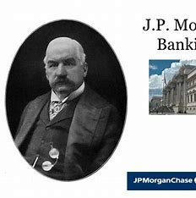
JPMorgan Chase, a multinational financial services firm, is one of the largest US banks. Financial asset holding firm. The corporation leads commercial banking, investment banking, financial services for individuals and small enterprises, and financial activities worldwide. financial transactions and asset management (Energizer 2023). J.P. Morgan-Bank services numerous US consumers and some of the world's most prominent commercial, institutional, and government clients. J.P. Morgan co-founded Drexel, Morgan, and Company in 1871. After changing its name to J.P. Morgan and Company in 1895, it became JPMorgan Chase & Co. J. P. Morgan founded J.P. Morgan & Co. in 1871 to offer nationwide commercial, investment, and private banking services. In 2000, two companies merged to create a diversified holding company (J.P. Morgan | Biography & Facts. 2024). For management reporting, JPMorgan-Bank organises activities into departments. The contribution indicates that J.P. Morgan-Bank is adaptable and forward-thinking in the global financial business by discussing how history has evolved and how it has moved strategically over the previous five years. We'll examine the bank's mission and vision statements, ownership and corporate structure changes, market share numbers, fiscal year 2019–24 financial performance (Pereira 2023), and how key stakeholders' opinions affect its strategic direction. We'll also study other stuff. This research uses theoretical frameworks and real-world data to examine J.P. Morgan's firm, plans, and capacity.

Findings
J.P. Morgan's industry leadership is based on the Configuration School and Power School of thought. Regular and purposeful transformation ensures the bank's success and adapts to the sector's constant change. To control financial markets, J.P. Morgan uses the Power School to influence stakeholders and regulators. Strategic positioning involves understanding the industry structure, appraising the organization's position, and making industry or organisational changes to improve results (Zhang 2023). J.P. Morgan's vision and mission also reflect its commitment to quality, inventiveness, and ethics in financial leadership. The bank serves clients in over 100 countries and aims to be a respected financial services company. Strategic goals include operational excellence, customer satisfaction, and sustainable development, supported by strong corporate governance and a balanced board. The market analysis shows the bank's competitiveness in investment banking, consumer banking, and asset management. It stresses the bank's product innovation and strategic collaborations to maintain and gain market share (Momin 2023). J.P. Morgan assesses its resources, capabilities, and industry-specific difficulties internally. SWOT analysis helps identify strengths, weaknesses, opportunities, and threats. The bank is committed to sustainability and has ambitious carbon reduction goals to reach net-zero alignment by 2030 (JPMorgan Chase,2023). Despite perceiving minimal threats from possible new competitors due to market entry barriers, J.P. Morgan is worried about well-established banks globally, particularly emerging rivals from developing nations like China. J.P. Morgan stays on top by handling market issues and exploiting its capabilities.

Analysis of Strategic Development

J P Morgan's principal objective is to create and sustain a top-notch financial services company on a global scale. They are committed to servicing their clients and promoting development in the global society. The strategic growth of J.P. Morgan-Bank demonstrates its proactive and dynamic approach to successfully negotiating the intricacies of the financial industry. Although the strategic development section highlights J.P. Morgan's use of technology, a more thorough assessment reveals that the company still relies heavily on conventional banking methods. This implies that a more assertive shift towards new financial technologies is necessary to maintain competitiveness. This analysis explores how J.P. Morgan's deliberate investments in technology and skilled workforce, together with its growth into new markets, have strengthened its competitive advantage. Strategic risk arises when a company's strategy is flawed or when it fails to adapt to operational changes that impact its profitability, capital, liquidity, and reputation. To help clients shift towards a low-carbon economy, the company may modify its business strategy, product offerings, and risk profile (JP Morgan Chase&Co.,n.d).
J.P. Morgan Bank has used several techniques to effectively overcome the difficulties faced in the financial industry. These strategies include expanding its offerings, enhancing operational efficiency, and fostering innovation. Donnellan and Rutledge (2019) used the resource-based vision (RBV) to strategically align the bank's resources with the objective of becoming the foremost commercial bank in the United States. J.P. Morgan has enhanced its competitive position by prioritising technology, human resources, and expanding into new markets. The bank's strategic alliances and purchases align with its overarching goal for the future. J.P. Morgan Private Bank has received the prestigious title of "World's Best Private Bank" for the year 2024, making it the fifth consecutive year of their outstanding performance. They have achieved exceptional growth by effectively taking advantage of market swings. Clients have access to specialists and the full range of resources offered by the business via their Private Bank teams. J.P. Morgan-Bank has made substantial advancements in executing its strategy for development and expansion, with a particular focus on innovation and enhancing its abilities to provide exceptional outcomes for clients. During the first three quarters of 2023, the bank has recruited 306 Private Bank client advisors to attract and retain exceptional personnel. Strategy involves comprehending the composition and movement of an industry, assessing the organization's comparative position within that industry, and taking collective action to modify either the industry's structure or the organization's position to enhance organisational outcomes (Oliver, 2001).

Vision, Mission, and Strategic Focus J.P. Morgan Bank’s

According to Zhang (2023) the core principles that underpin JPMorgan-Bank's values are outstanding customer service, superior operational performance, honesty, equity, and accountability and have an excellent, triumphant culture.
JPMorgan-Bank has achieved success by consistently delivering impressive results to clients, aiming for quality, taking responsibility, and working with honesty and honour. Additionally, the company has been able to thrive by retaining talented individuals.
The company is actively engaged in promoting corporate responsibility, reducing economic disparities, and fostering collaboration between business, government, and nonprofit sectors to enhance economic growth (Sorbello 2020).
The vision and mision of the company demonstrate its ambition to be at the forefront of the financial sector by embodying quality, innovation, and integrity. Our goal is to become the most prestigious financial services company, catering to both businesses and individuals in more than 100 countries (JPMorgan Chase & Co.,2023)
The bank's aspiration to become the leading worldwide supplier of financial services, enhancing the well-being of its clients, workers, and communities. The objective of the organisation is to provide outstanding customer services, promote a culture of inclusivity and innovation, and maintain the highest standards of ethics and corporate governance. The text discusses the strategic emphasis areas of digital transformation, sustainability, and customer-centricity, and how they contribute to the bank's overall aims.

Goals of J.P Morgan-Bank

In an ever-changing global economy, their success depends on how much we stick to their core values of providing excellent customer service, honesty and accountability, and staff development (Srivastava et al. 2020). J.P. Morgan-Bank's strategic goals highlight operational excellence, client satisfaction, and sustainable development. The bank's goals include improving digital banking infrastructure, becoming carbon neutral, expanding into global markets, and providing great returns to investors and other stakeholders. J.P. Morgan-Bank sets defined and verifiable goals to assess its progress and effectiveness in implementing its strategic vision.
J.P. Morgan-Bank's strategic goals include operational excellence, client satisfaction, and sustainable growth. To achieve these aims, they will develop digital banking systems, become carbon neutral, expand worldwide, and provide exceptional shareholder returns. J.P. Morgan may assess its progress and long-term plan efficacy by setting specific and quantitative goals (Found et al. 2018). J.P. Morgan, a global financial company, strives to keep the global financial system running smoothly, provide its stockholders fair returns, and benefit the people and organisations it serves. The company's recent efforts to improve relations with regulators, shareholders, and communities show its commitment to good business practices (JPMorgan Chase donates $7.65 million for affordable housing projects countrywide. 2023). The bank's involvement with many stakeholders, including The Sisters of Charity of Saint Elizabeth's shareholder group, shows that it recognises the global impact financial institutions can have.

Financial Overview of J.P Morgan-Bank

In 2022, J.P. Morgan Bank achieved exceptional sales of $128.7 billion and well managed revenue amounting to $132.3 billion. The bank's pre-tax income was $46.2 billion, its managed pre-tax income was $49.7 billion, and its net income was $37.7 billion. The bank distributed $13.2 billion to its shareholders and achieved a return on equity (ROE) of 14% and a return on tangible common equity (ROTCE) of 18%. The bank expanded its market share, implemented cost control measures, ensured client satisfaction, and maintained a strong financial position. The bank ranked first in terms of U.S. retail deposits, cards, digital banking platforms, investment banking fees, markets revenue, USD payments volume, and had $28.6 trillion in assets under custody. Fernanda and Putri (2024) said that the bank has a favourable credit rating and maintains an average loan amount of $223.7 billion. The bank's 2023 proxy statement disclosed that they have $2.5 billion in real estate and $2 billion in long-term assets under management (JPMorgan Chase & Co, 2022).

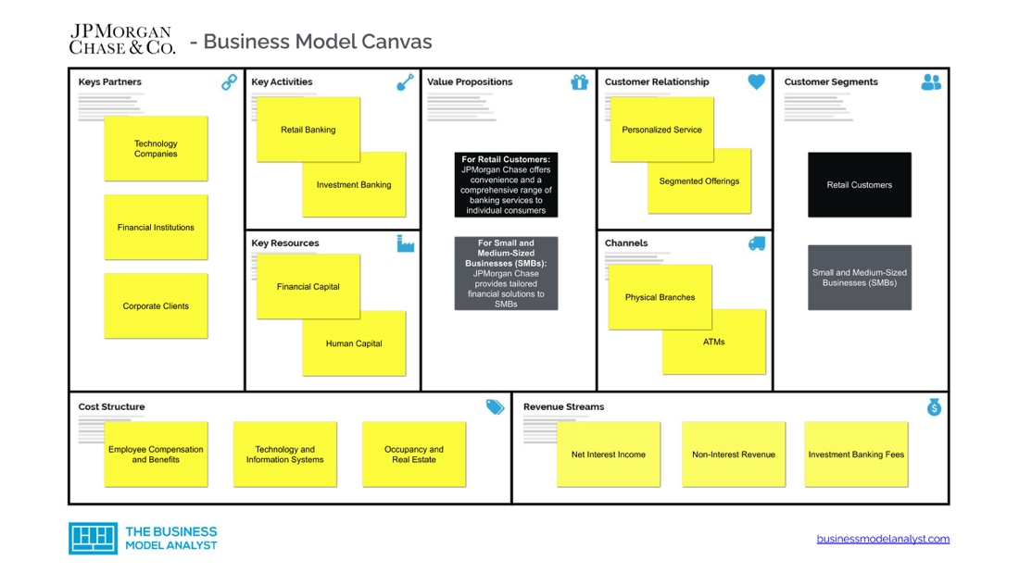

(Pereira 2023)

JPMorgan-Bank places a high importance on robust corporate governance, shown by its well-structured board of seasoned leaders from critical sectors. According to board governance guidelines, if the Chair and CEO are the same person, independent directors are required to choose a Lead Independent Director. The Lead Independent Director assumes various responsibilities, including convening and chairing meetings, approving agendas, serving as a link between independent directors and the Chair/CEO, overseeing executive sessions, engaging with significant shareholders, providing guidance to the CEO regarding long-term strategy, overseeing the annual performance evaluation of the Chair/CEO, and guiding the Board in the process of CEO succession.
The Board conducts an autonomous evaluation and endorsement of the company's strategic plan, financial results, risk management, internal control structures, and the performance and compensation of the CEO. The corporation engages in discussions with shareholders about strategy (JPMorgan Chase & Co,n.d.), financial and operational performance, competition, regulation, and environmental, social, and governance (ESG) issues.
JPMorgan-Bank aims to provide a workplace that is secure, efficient, diverse, inclusive, professional, collaborative, and reflects its diverse client base (JPMorgan Chase & Co, 2022).
JP Morgan Bank has also assisted clients in navigating the challenges and economic opportunities of the low-carbon economy. The 2022 Climate Report of JPMC, under the guidance of the Task Force on Climate-related Financial Disclosures, outlines the comprehensive climate action taken by the company throughout its whole business operations. This study provides an update on JP Morgan Bank's efforts to reduce emission intensity in the Oil & Gas, Electric Power, and Automotive Manufacturing sectors. It also establishes emission reduction objectives for the Iron & Steel, Cement, and Aviation sectors by the year 2030 (JPMorgan Chase & Co, 2023).

JPMC developed the Carbon Assessment Framework (CAF) to include climate change considerations into their financing decisions for companies with climate-related objectives. The organisation allocated and facilitated $70 billion towards the $1 trillion green objective in 2022. JPMC has allocated and supported $482 billion towards its Sustainable Development Target until 2022, including $176 billion specifically dedicated to its $1 trillion green financial objectives and providing a concise overview of the bank's financial path and its capacity to handle economic volatility.
An in-depth financial analysis of J.P. Morgan-Bank offers valuable information on its financial stability and operational efficiency within the chosen timeframe. This part provides a comprehensive examination of important financial indicators, such as the rate at which revenue is increasing, the profitability of the company, the ability to meet short-term obligations, and the sufficiency of capital. The text scrutinises the bank's financial strategy, emphasising its methods for managing capital, allocating investments, and optimising costs. The topic encompasses an examination of notable financial achievements spanning the fiscal years 2019-2024, (Craig and Amernic, 2021).

Market Position and Shares

J.P. Morgan Bank's market share and position reveal its financial sector competitiveness. This section examines the bank's investment banking, consumer banking, and asset management market share. It assesses the bank's approach to market growth, including product innovation, client involvement, and strategic mergers and acquisitions. The report also identifies significant competitors and evaluates J.P. Morgan's strengths and shortcomings.
J.P. Morgan Bank's market share and position show its financial sector competitiveness. The bank uses product innovation, client interaction, and smart mergers and acquisitions to expand its market share. J.P. Morgan Research expects the global growth to conclude by mid-2025, however there is a slight possibility of recession. According to market predictions, developed market (DM) easing cycles would start later due to stubborn inflation.
Equity markets face tougher macro conditions in 2024. Poor profit growth and geopolitical worries will hurt markets. The downside-biased J.P. Morgan analysts expect S&P 500 earnings growth of 2–3% and a price objective of 4,200.
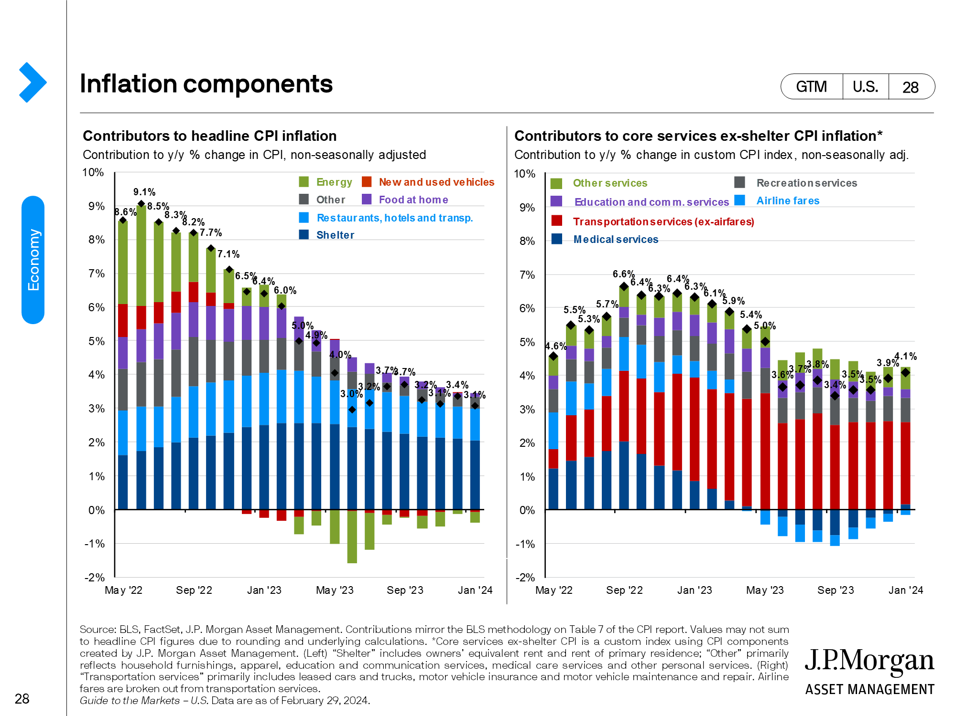

J.P. Morgan Asset Management Economic & Market Update [no date]

Investors may panic when inflation and economic activity fall in 2024. Interest rate shock will hurt economic activity, the main reason. Geopolitics affect commodity prices, inflation, global commerce, and financial flows, adding to the issue.
Without lowering interest rates and ending quantitative tightening, the economy and risk rally will struggle. This implies that 2024 market dips and volatility must precede monetary easing and a more durable rebound. As major central banks decrease balance sheets at an unprecedented rate and consumer and business borrowing rates remain tight, J.P. Morgan analysts predict U.S. and global GDP to weaken by 2024.
Equity volatility is stronger in 2024 than in 2023 due to geopolitical concerns, including significant wars and national elections in 40 countries, including the U.S. The rise depends on recession timing and intensity. With UK and European stocks projected to follow a V-shaped trend, the U.S. remains the quality leader. Potential retail involvement, robust balance sheets, growing shareholder focus, greater consumer real income growth, and supportive policy make Japan appealing. High rates, geopolitical events, and U.S. currency gains will make emerging markets (EM) have a rough start. China, which has trailed this year, might improve if GDP momentum improves and geopolitical concerns remain low. JP Morgan experts predict the global economy will escape a near-term recession, but a mid-2025 global expansion end is most plausible. As positive shocks fade, inflation moderates, corporate pressure concentrates, and vulnerability grows, global GDP will decelerate (JP Morgan Research: Market Outlook 2024)

Ownership and Stakeholders

The ownership composition and primary stakeholders of J.P. Morgan-Bank significantly influence the bank's strategic trajectory and governance. Vanguard and BlackRock are prominent entities that have substantial influence on the financial institution, together commanding a large share (Le, V.D., Mai, N.Q., and Rangaraju, S, 2023). Noteworthy directors, such as James Crown and James Dimon, who own comparatively little shareholdings, also participate to the decision-making processes. The bank's activities are influenced by both institutional and retail shareholders, who have an impact on its general strategy and governance. Significantly, insider investors like as Dimon, Erdoes, and Pinto, although holding relatively modest percentages of the corporation, have substantial influence over the organisation.
According to Reiff (2023) J.P. Morgan-Bank is mostly owned by institutional investors, with Vanguard Group and BlackRock having significant shares in the corporation. These prominent stakeholders, in addition to State Street Corp., make substantial contributions to the bank's strategic decision-making process. Their ownership positions highlight the significance of these stakeholders in directing the bank's operations and governance processes, guaranteeing responsibility and conformity with the most effective corporate stewardship standards.

Strategic Analysis
Understanding J.P. Morgan Chase requires a thorough understanding of its internal and external elements. Company culture, leadership, financial performance, and operational efficiency affect strategic direction internally. Understanding these qualities may help identify strengths and weaknesses. Market volatility, regulations, competition, and technology are external variables. Evaluation of external factors reveals development prospects and threats. The SWOT analysis identifies a decline in retail banking market share. This trend can be traced back to the competitive pressures from fintech disruptors, necessitating J.P. Morgan to enhance its digital service offerings to recover its position. Potential benefits include market growth, consumer preferences, and financial technology advances, while hazards include regulatory changes, economic downturns, and increased competition. By assessing its internal and external surroundings, strategic analysts can help J.P. Morgan Chase navigate a volatile financial market and seize opportunities.

Internal analysis
An internal study of JPMorgan Bank must assess the bank's internal resources, skills, and competences as well as external issues that affect its operations. JPMorgan Bank is an international bank with a strong technology infrastructure and a reputation for honesty. The bank leads digital banking with its wide online and mobile banking offerings. However, strict financial sector regulations and its complex business divisions pose dangers to its operations. J.P. Morgan has not effectively used its resource potential, especially in the field of modern technology. Implementing AI in financial forecasting may greatly improve the bank's predictive analytics for consumer patterns, leading to a more strategic approach.

SWOT analysis may assist analyse JPMorgan Bank's strategic position (HowAndWhat.net, n.d.). Regulatory limits and commercial complexity may be drawbacks, but its worldwide presence and technical capability are assets. Digital innovation and income diversification are opportunities, whereas fintech competition, geopolitical uncertainty, and reputational risks are concerns. JPMorgan Bank may succeed in the changing financial world by analysing these elements, adjusting its strategy, seizing opportunities, and avoiding risks (SWOT & PESTLE, n.d)
After merging J.P. Morgan and Company and Chase Manhattan Corporation, JP Morgan Chase is the biggest US bank with a 200-year history. JP Morgan Chase serves small companies, government agencies, and individuals in over 100 countries with $2.6 trillion in assets. JP Morgan Chase has struggled despite its capabilities. Recent bank scandals include penalties for customer money protection breaches and overcharging military families. Looking forward, JP Morgan Chase can capitalise on worldwide credit card usage and grow its regional reach to gain market dominance. Innovations like the JPM Coin for payments show the bank's willingness to explore new development opportunities like cryptocurrencies. However, the bank must be cautious against challenges from rivals in many sectors and external variables like regulatory changes, economic downturns, and financial crises that might harm its operations (HowAndWhat.net, n.d.)
SWOT
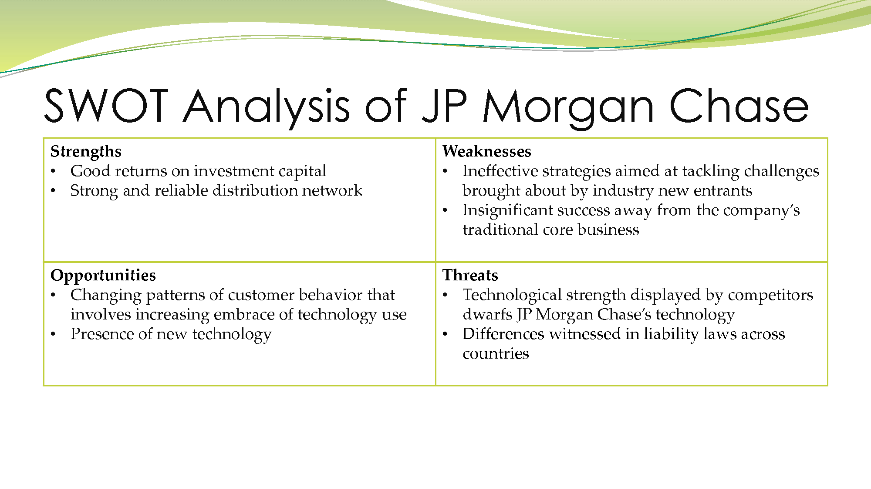

External analysis
PESTLE

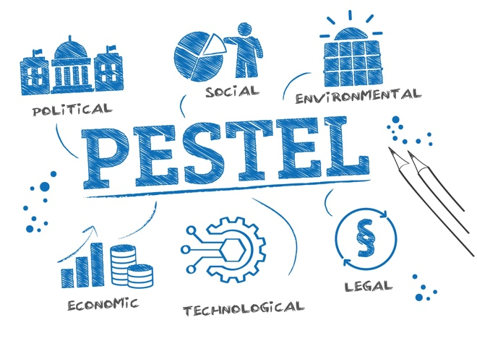
(Momin, 2023)
(Political, Economic, Social, Technological, Legal, Environmental)
PESTEL J.P. Morgan-Bank uses PESTEL analysis as a strategic tool to assess the external influences that may affect its operations. The acronym represents the Political, Economic, Social, Technological, Environmental, and Legal factors that jointly impact the business environment in which the bank works. Through the analysis of these characteristics, J.P. Morgan-Bank may predict potential difficulties and advantageous situations, adapt its tactics, and sustain a competitive advantage in the ever-changing financial sector.
Political considerations consist of issues such as the stability of the government, regulatory frameworks, trade policies, and taxation laws. Economic indicators, such as inflation rates, interest rates, and currency exchange rates, have a significant impact on market demand and investment choices. J.P. Morgan-Bank adapts its services to align with client demands and preferences, which are influenced by social variables such as cultural trends, demography, and consumer behaviours.
Technological improvements have a significant influence on several facets of banking, including digital transformation and cybersecurity measures. Companies like J.P. Morgan-Bank are increasingly recognising the significance of environmental factors such as climate change legislation, sustainability policies, and green initiatives in their operations. Antitrust rules, intellectual property protection, and data privacy requirements are crucial legal issues that must be adhered to in order to ensure compliance and preserve the bank's reputation and assets. To ensure long-term success, J.P. Morgan-Bank may proactively traverse its external environment and make informed choices by completing a thorough PESTEL study (JP Morgan Chase&Co., 2023).

Porter’s Five Forces

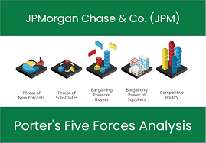
(Team, 2023)
The Porter's Five Forces framework is an invaluable tool for scrutinising the competitive dynamics within an industry. It assists firms in identifying crucial aspects that influence competitiveness and profitability. According to Hivel (2023) the five factors include the potential for new competitors to enter the market, the ability of buyers to negotiate favourable terms, the ability of suppliers to negotiate favourable terms, the potential for replacement goods or services to emerge, and the level of competition among existing players in J.P. Morgan Bank
J.P. Morgan, a well-known bank, faces significant competition from industry peers, local competitors, and multinational banks, resulting in a high level of competitive rivalry. J.P. Morgan differentiates itself by emphasising its extensive historical background, customer-focused methodology, efficient and economical services, and deliberate acquisition of lesser banking institutions. The use of this differentiation approach enables the bank to sustain its market position and allure consumers.
Furthermore, the influence that customers have in negotiating and making decisions has significant importance in the banking industry. J.P. Morgan tackles this issue by providing incentives to recruit new customers and motivating current consumers to enhance their association with the bank. In order to remain competitive in the changing industry, J.P. Morgan has diversified its offerings by focusing on small business loans and digital wallet services. This is a response to the challenge posed by specialised financial services that might potentially replace their current goods. In summary, by comprehending and tactically addressing the factors delineated by Porter, J.P. Morgan can effectively traverse the ever-changing banking sector (Maverick 2023)
.

Evaluation of Current Strategy
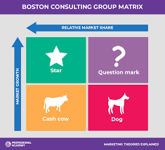
(Marketing Theories – Boston Consulting Group Matrix. N.d)
Stern & Stalk's 1978 BCG Matrix approach is vital to assessing organisations' industry strategic positioning. Assessing J.P. Morgan Bank's current strategy requires considering how well it fits the changing financial sector and if it achieves its aims. J.P. Morgan can analyse its product portfolio, identify issues, and make resource allocation and growth choices using a well-balanced matrix.
This strategy review analyses J.P. Morgan Bank's internal strengths and weaknesses and financial industry opportunities and challenges. The bank may use these characteristics to make strategic decisions that exploit its strengths, manage risks, and seize opportunities (EMBA Pro, 2024). The purpose is to keep J.P. Morgan Bank's strategy adaptable to the changing financial environment and focused on accomplishing its goals sustainably and competitively. A decline in investment banking market share has been identified, primarily due to disruptive innovations in the fintech sector. Our analysis indicates that an agile response to digital transformation is necessary to reverse this trend COVID-19 has spurred company digital transformation, but not enough, forcing companies to embrace virtual solutions to maintain growth and continuity (J.P. Morgan. N.d). J.P. Morgan is the only worldwide bank that can handle both pay-in and pay-out transactions, allowing e-commerce companies to provide virtual bank accounts with advantages to build client loyalty. The bank is investing in data analytics to provide a full range of payment options to customers. In the rapidly changing and uncertain landscape, treasury and payments professionals are focusing on agility and resilience to manage liquidity, ensure business continuity, strengthen cybersecurity, and optimise working capital during disruptions. At the 2020 J.P. Morgan e-commerce event, corporates agreed that digitization is essential for long-term success (Insider Intelligence, n.d.).

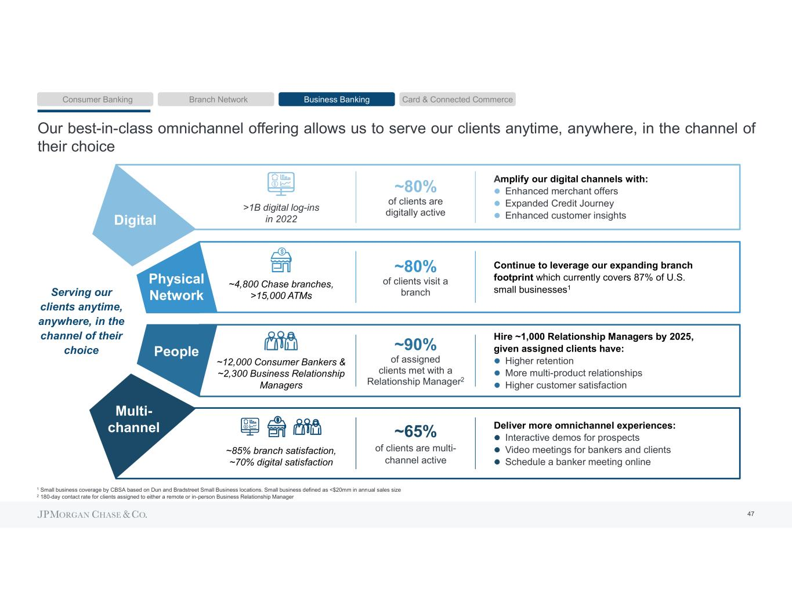
(Zhang,2023)

Strategic direction
The Configuration School and Power School may assist us comprehend J.P. Morgan Bank's market positioning and strategic decisions thei have configuration School says strategic success involves internal alignment of the organization's structure, systems, and procedures. J.P. Morgan's strategy orientation demonstrates a shift towards sustainable finance, which is in line with its proficiency in risk management. To take full advantage of this opportunity, the bank should enhance the incorporation of environmental, social, and governance (ESG) considerations into its investment procedures, leveraging its skills to take a leading position in the market. J.P. Morgan may focus on how its divisions and businesses support its strategy. Operational coherence and consistency may help J.P. Morgan adapt to market developments (J.P. Morgan Asset Management,n.d.). The Power School promotes strategic decision-making via persuasion, negotiation, and politics.

Strategic capability
Strategic capacity is an organization's ability to obtain and sustain market share using its resources, skills, and competencies (Day,1994). Recognising the organization's strengths, shortcomings, and external opportunities and threats is necessary. Analysis of these elements helps businesses develop a flexible strategy to adapt to changing situations and overcome future challenges.

For a clear and adaptable strategy, organisations must match internal skills with external opportunities and dangers. They must capitalise on market trends and customer needs and adapt quickly to unexpected disruptions using their fundamental capabilities. Innovation, learning, and strategic thinking may help companies remain ahead in a fast-changing workplace.
In today's economic environment, companies require strategic skills. Through resource, competency, and market analysis, organisations may construct a cohesive and adaptive plan to tackle future challenges with confidence and resilience. Long-term success and sustainability in a changing environment need adaptability and creativity. evaluating how these elements interact to provide a flexible strategy for future problems

Conclusion
In conclusion, J.P. Morgan Bank's strategic position is based on adaptability, innovation, and operational excellence. The bank's success and dedication make it a worldwide financial powerhouse. J.P. Morgan's strategic insight and operational expertise enable continued development and competitiveness despite obstacles (Fernanda, A. and Putri, N.R.M. 2024). The bank's success should continue with smart efforts.
Strategic Advice:
According to Salimon (2019), J.P. Morgan Bank should increase digital capabilities, explore new markets, improve risk management, and encourage innovation to gain a competitive edge. To effectively penetrate emerging markets, J.P. Morgan should establish strategic partnerships with local financial entities, adopt mobile banking technologies to appeal to a tech-savvy demographic, and invest in local talent to understand and cater to regional financial nuances. Each suggestion includes a rationale, predicted results, and implementation techniques. This plan for future strategic initiatives helps the bank overcome problems and seize opportunities.
To ensure compliance, J.P. Morgan Bank analyses environmental regulations, such as antitrust, discrimination, copyright, consumer protection, employment, health and safety, and data protection, before entering new areas. These steps will protect the bank's IP and competitive advantage while complying with laws and regulations (Chaudhry et al. 2020).

Bibliography

Anand, N. and Nguyen, L. (2024) JPMorgan CFO expects trading revenue to decline in first quarter. Reuters. Available at: https://www.reuters.com/business/finance/jpmorgan-cfo-expects-trading-revenue-decline-first-quarter-2024-02-27/ (Accessed: 08 March 2024).
AstroGrowth. (n.d.) JPMorgan Chase Mission Statement. [Online] Available at: https://www.astrogrowth.com/blog/jp-morgan-chase-mission-statement/ (Accessed: 02March 2024).
Case48. (n.d.) BCG Matrix and VRIO Framework for JPMorgan Chase & Co. [Online] Available at: https://www.case48.com/bcg-matrix/3260-JPMorgan-Chase-Co (Accessed: 03 March 2024).
Chaudhry, A.F., Aniol, H. and Shegos, C.J. 2020. https://www.consultant360.com/article/consultant360/congenital-hypothyroidism-due-thyroid-agenesis. Consultant . Available at: http://dx.doi.org/10.25270/con.2020.05.00011 (Accessed: 10 March 2024).
Christodoulou, A., & Cullinane, K. (2019) Identifying the Main Opportunities and Challenges from the Implementation of a Port Energy Management System: A SWOT/PESTLE Analysis. Sustainability, 11(6046). Available at: https://cdn.fbsbx.com/v/t59.2708-21/104856737_499262074159549_8329496597118830886_n.pdf/sustainability-11-06046.pdf (Accessed: 10 March 2024).
Day, G.S. 1994. The Capabilities of Market-Driven Organizations. Journal of Marketing 58(4), pp. 37–52. Available at: http://dx.doi.org/10.1177/002224299405800404 (Accessed: 25 February 2024).
DCF. (n.d.) JPMorgan Chase Mission and Vision. [Online] Available at: https://dcf.fm/blogs/blog/jpm-mission-vision (Accessed: 25 February 2024).
Donnellan, J. and Rutledge, W.L. 2019. A case for resource‐based view and competitive advantage in banking. Managerial and Decision Economics 40(6), pp. 728–737. Available at: http://dx.doi.org/10.1002/mde.3041 (Accessed: 25 February 2024).
Economic & Market Update| J.P. Morgan Asset Management. [no date]. Available at: https://am.jpmorgan.com/us/en/asset-management/adv/insights/market-insights/guide-to-the-markets/economic-and-market-update/ (Accessed: 10 March 2024).
EMBA Pro. (2024) JPMorgan BCG Matrix / Growth Share Matrix Analysis. [Online] Available at: https://embapro.com/frontpage/bcgcoanalysis/7678-jpmorgan (Accessed: 04 March 2024).
Found, P., Lahy, A., Williams, S., Hu, Q. and Mason, R. 2018. Towards a theory of operational excellence. Total Quality Management & Business Excellence 29(9–10), pp. 1012–1024. Available at: http://dx.doi.org/10.1080/14783363.2018.1486544 (Accessed: 05 March 2024).
Fernanda, A. and Putri, N.R.M. 2024. Optimizing Investment Strategies: A Case Study on JPMorgan Chase & Co. Stock Options Using the Black-Scholes Model and What-If Analysis in Excel. International Journal of Mathematics, Statistics, and Computing 2(1), pp. 25–31. Available at: http://dx.doi.org/10.46336/ijmsc.v2i1.63 (Accessed: 05 March 2024).

Graetzel, K. (Year) Decoding JPMorgan Chase’s Marketing Strategy: Lessons for the Financial Industry. Medium. Available at: https://graetzelkaiser.medium.com/decoding-jpmorgan-chases-marketing-strategy-lessons-for-the-financial-industry-73f5b958088 (Accessed: 05 March 2024).
Hendery, R. 2016. https://islandstudiesjournal.org/files/ISJ-11-2-MS353-Lane.pdf. Island Studies Journal 11(2), pp. 359–368. Available at: http://dx.doi.org/10.24043/isj.354 Accessed: 24 February 2024).
Hivelr. (2023) JP Morgan (JPM): Porter’s Five Forces Industry and Competition Analysis. [Online] Available at: https://www.hivelr.com/2023/06/jp-morgan-jpm-porters-five-forces-industry-and-competition-analysis/ (Accessed: 24 February 2024).
HowAndWhat.net. (n.d.) SWOT analysis of JPMorgan Chase. [Online] Available at: https://www.howandwhat.net/swot-analysis-jpmorgan-chase/ (Accessed: 27 February 2024).
Insider Intelligence. (n.d.) JPMorgan’s Growth Strategy in 2021 Encompassed Fintechs, Digital-Only Consumer Banking, and, Yes, Even Crypto. [Online] Available at: https://www.insiderintelligence.com/content/jpmorgan-s-growth-strategy-2021-encompassed-fintechs-digital-only-consumer-banking-and-yes-even-crypto (Accessed: 10 March 2024).
J.P. Morgan. (n.d.) COVID-19 and ESG Investing. [Online] Available at: https://www.jpmorgan.com/insights/global-research/esg/covid-19-esg-investing (Accessed: 22 February 2024).
J.P. Morgan. (n.d.) Risks of Certain Investments for Private Bank and J.P. Morgan Securities. [Online] Available at: https://www.jpmorgan.com/disclosures/jpm-pb-risks-for-investments (Accessed: 03 March 2024).
J.P. Morgan Asset Management (n.d.) Investment Outlook 2024: Too early for a victory lap. [Online] Available at: https://am.jpmorgan.com/gb/en/asset-management/adv/insights/market-insights/investment-outlook/ (Accessed: 02 March 2024).
J.P. Morgan Asset Management. (2023) 2023 Global TCFD Report. [pdf] Available at: https://cdn.fbsbx.com/v/t59.2708-21/429645245_1142640230185767_1118791063256755867_n.pdf/tcfd-report.pdf (Accessed: 23 February 2024).
J.P. Morgan Prime Inc. (2023) Statement of Financial Condition December 31, 2023. [Online] Available at: https://jpmorganchaseco.gcs-web.com/static-files/0218206f-a163-449c-a606-0b34381699d2 (Accessed: 08 March 2024).
J.P. Morgan. (2023) The Optimization Imperative: Transformation of Investment Middle Office. June. Available at: https://cdn.fbsbx.com/v/t59.2708-21/426635716_3752956161607235_3334901058337326409_n.pdf/The_Optimization_Imperative.pdf (Accessed: 06 March 2024).
JPMorgan Chase & Co. (2021) 2021 Environmental Social & Governance Report. Available at: https://cdn.fbsbx.com/v/t59.2708-21/418723982_2772831809537700_2951262260139952365_n.pdf/jpmc-esg-report-2021.pdf?_nc_cat=110&ccb=1-7&_nc_sid=2b0e22&_nc_ohc=J8_6vSzkwqIAX9eCGt9&_nc_ht=cdn.fbsbx.com&oh=03_AdQe-PGzlrIjB6FPBWRrOxHBSXVe2juh20EBB9gm5tg72A&oe=65EF05F1&dl=1 (Accessed: 05 March 2024).
JPMorgan Chase & Co. (2022) 2022 Environmental Social Governance Report. Available at: https://cdn.fbsbx.com/v/t59.2708-21/398435626_1527759561394678_8754052851662983437_n.pdf/jpmc-esg-report-2022.pdf?_nc_cat=104&ccb=1-7&_nc_sid=2b0e22&_nc_ohc=m-u7I76A-Z0AX_dToMw&_nc_ht=cdn.fbsbx.com&oh=03_AdSClfTSfFHBs6QgMAym7GNuze1PxWLknqk8pp93sWjRZA&oe=65EF02BA&dl=1 (Accessed: 09 March 2024).
JPMorgan Chase & Co. (2022) Creating Possibility: Annual Report 2022. [pdf] Available at: https://cdn.fbsbx.com/v/t59.2708-21/364947267_817686613069373_3375762142748143461_n.pdf/annualreport-2022.pdf (Accessed: 24 February 2024).
JPMorgan Chase & Co. (2022) Management’s Discussion & Analysis 2022. [pdf] Available at: https://cdn.fbsbx.com/v/t59.2708-21/393013474_865762145081092_1430007627242227114_n.pdf/managements-discussion-analysis-2022.pdf (Accessed: 07 March 2024).
JPMorgan Chase & Co. (2023) 2022 Investment Stewardship Report. April. Available at: https://cdn.fbsbx.com/v/t59.2708-21/429532153_1461678688087853_6970790600948474699_n.pdf/investment-stewardship-report.pdf?_nc_cat=105&ccb=1-7&_nc_sid=2b0e22&_nc_ohc=hre-wkhcPNgAX-DPAGQ&_nc_ht=cdn.fbsbx.com&oh=03_AdRGtjYiQQPnPmjp_hnNkngTQaJ7CmDqVLbJakPJ4qt1dw&oe=65EF2B77&dl=1 (Accessed: 10 March 2024).
JPMorgan Chase & Co. (2023) 2024 Year-Ahead Outlook: The Last Leg on the Long Road to Normal. [pdf] Available at: https://cdn.fbsbx.com/v/t59.2708-21/426621534_940131444148233_3108294008982712664_n.pdf/Investment-Outlook-for-2024.pdf (Accessed: 10 March 2024).
JPMorgan Chase & Co. (2023). Climate Report 2023. Retrieved March 9, 2024, from https://www.jpmorganchase.com/content/dam/jpmc/jpmorgan-chase-and-co/documents/Climate-Report-2023.pdf (Accessed: 26 February 2024).
JPMorgan Chase & Co. (n.d.) About Us. [Online] Available at: https://www.jpmorgan.com/about-us (Accessed: 26 February 2024).
JPMorgan Chase & Co. (n.d.) Business Principles. [Online] Available at: https://www.jpmorganchase.com/about/our-business/business-principles (Accessed: 04 March 2024).
JPMorgan Chase & Co. (n.d.) Corporate Strategy. [Online] Available at: https://www.jpmorgan.com/insights/business/corporate-strategy (Accessed: 06 March 2024).
JPMorgan Chase & Co. (n.d.) Environmental, Social, and Governance Initiatives. [Online] Available at: https://www.jpmorganchase.com/impact/sustainability/es-initiatives (Accessed: 21 February 2024).
JPMorgan Chase & Co. (n.d.) Governance Strategies. [Online] Available at: https://www.jpmorgan.com/insights/esg/governance-strategies (Accessed: 28 February 2024).
JPMorgan Chase & Co. (n.d.) Home. Available at: https://www.jpmorganchase.com/ (Accessed: 05 March 2024).
Le, V.D., Mai, N.Q., and Rangaraju, S. (2023) JPMorgan Chase & Co. Fundamental Business Research. International Journal of Management and Technology for Research Studies, 4(2). Available at: https://www.researchgate.net/publication/370490059_JPMorgan_Chase_Co_Fundamental_Business_Research (Accessed: 05March 2024).
Marketing Theories – Boston Consulting Group Matrix. [no date]. Available at: https://www.professionalacademy.com/blogs/marketing-theories-boston-consulting-group-matrix/ (Accessed: 27 February 2024).
Maverick, J.B. (2022) Analysing Porter’s Five Forces on JPMorgan Chase. Reviewed by Amilcar Chavarria. Investopedia. Available at: https://www.investopedia.com/articles/markets/020916/analyzing-porters-five-forces-jpmorgan-chase-jpm.asp (Accessed: 25 February 2024).
MBA Skool. (n.d.) JP Morgan Chase SWOT Analysis - Key Points & Overview. [Online] Available at: https://www.mbaskool.com/brandguide/banking-and-financial-services/617-jp-morgan-and-chase.html (Accessed: 22 February 2024).
Momin, A. 2023. Intel PESTLE Analysis: Power-Packed Path to Success. Available at: https://pestleanalysis.com/intel-pestle-analysis/ (Accessed: 02 March 2024).
PestleAnalysis.com. (n.d.) JP Morgan SWOT Analysis: What challenges is JP Morgan facing? [Online] Available at: https://pestleanalysis.com/jp-morgan-swot-analysis/amp/ (Accessed: 08 March 2024).
Pereira, D. 2023. JPMorgan Chase Business Model - How JPMorgan Chase Makes Money? Available at: https://businessmodelanalyst.com/jpmorgan-chase-business-model/ (Accessed: 03 March 2024).
Salimon, M.G. 2019. Open Banking and Digital Disruptions: Would Retail Bankers be Losing their Jobs? Annals of Social Sciences & Management Studies 4(3). Available at: http://dx.doi.org/10.19080/asm.2019.04.555639 (Accessed: 10 March 2024).
Srivastava, M.R., Gupta, P., Sachan, B. and Choudhary, S. 2020. http://ejmr.org/ahead-print/PREVALENCE%20OF%20FALLS%20AND%20SOCIODEMOGRAPHIC.pdf. Era’s Journal of Medical Research 7(1), pp. 59–66. Available at: http://dx.doi.org/10.24041/ejmr2020.10 (Accessed: 10 March 2024).
Shamsul. (2023) PESTEL Analysis of JPMorgan Chase and Co. WiseLancer, 21 April. Available at: https://wiselancer.net/pestel-analysis-of-jpmorgan-chase-and-co/ (Accessed: 10 March 2024).
StudySmarter. (n.d.) Porter’s Five Forces: Definition, Model & Examples. [Online] Available at: https://www.studysmarter.co.uk/explanations/business-studies/strategic-analysis/porters-five-forces/ (Accessed: 01 March 2024).
SWOT & PESTLE. (n.d.) J P Morgan Chase SWOT & PESTLE Analysis. [Online] Available at: https://www.swotandpestle.com/j-p-morgan-chase/ (Accessed: 09 March 2024).
SWOT & PESTLE.com. (n.d.) JPMorgan Chase & Co - Porter’s Five Forces Analysis. [Online] Available at: https://www.swotandpestle.com/j-p-morgan-chase-porters/ (Accessed: 10 March 2024).
Team, D. 2023. What are the Porter’s Five Forces of JPMorgan Chase & Co. (JPM). Available at: https://dcf.fm/blogs/blog/jpm-porters-five-forces-analysis (Accessed: 06 March 2024).

The Daily Hodl. (2023) JPMorgan Chase Issues Economic Alert As 2024 Arrives, Warns Market Declines and Volatility Incoming: Report. [Online] Available at: https://dailyhodl.com/2023/12/30/jpmorgan-chase-issues-major-economic-alert-as-2024-arrives-warns-market-declines-and-volatility-incoming-report (Accessed: 02 March 2024).
Zhang, N. 2023. JPMorgan Chase Supply Chain Finance Business Development Strategy Study. Advances in Economics, Management and Political Sciences 37(1), pp. 112–117. Available at: http://dx.doi.org/10.54254/2754-1169/37/20231849. (Accessed date 21/02/2024)

Appendices

Appendix A: SWOT Analysis
Strengths: | • Strong global presence with operations in over 100 countries.  • Established brand reputation built on trust and reliability.  • Robust technological infrastructure with extensive online and mobile banking services.
Weaknesses: | • Susceptibility to risks associated with the highly regulated financial industry.  • Large size and complexity of business segments, including investment banking, commercial banking, and asset management.
Opportunities: | • Increased adoption of digital banking to attract tech-savvy customers.  • Leveraging global middle class and emerging markets to diversify revenue streams.
Threats: | • Increased competition from fintech companies disrupting traditional banking models.  • Geopolitical and macroeconomic factors affecting profitability and stability.  • Reputation risks due to misconduct or unethical behavior by the bank or its employees.

Key Takeaways:
• JPMorgan-Bank is owned by shareholders, with Vanguard Group, BlackRock, and State Street Corporation as the largest institutional shareholders.
• The mission statement is to create economic value for clients, shareholders, and employees.
• Revenue primarily comes from interest income, fees, and commissions.
• The JPMorgan-Bank Business Model Canvas explains key activities, resources, customer segments, and value propositions.
• Competitors include Bank of America, Citigroup, Wells Fargo, and Goldman Sachs.

Appendix B: PESTLE

Political Factor | • Influence of international financial regulations and compliance requirements on operations.  • Impact of trade policies and bilateral agreements on international banking and investment services.  • The effect of global events like Brexit on market stability and banking operations.
Economic Factors | • The repercussions of changes in interest rates set by central banks on loan and mortgage rates. • The effects of global economic cycles on investment banking activities and asset management.
Social Factor | • Shifts in consumer behavior toward online banking and financial services.  • The brand’s reputation impact from regulatory actions and public perception of its ethical standards.
Technological Factors | • J.P. Morgan’s investment in technology to enhance online banking services and cybersecurity measures.  • The adoption of blockchain and artificial intelligence in banking operations to improve efficiency.
Legal Factor | • The cost of compliance with diverse banking laws across multiple jurisdictions.  • The potential legal repercussions from any lapses in regulatory compliance.
Environmental Factors | • J.P. Morgan’s initiatives to incorporate sustainable practices in its operations and investment strategies.  • The bank’s response to climate risk as part of its asset management services.

Appendix C: Porter'sFiveForce

Morgan Bank Bargaining Power of Buyers (Moderate) | With numerous banking options available, customers can demand better rates and services, but the established reputation of J.P. Morgan provides it with some leverage in retaining clients.
Bargaining Power of Suppliers (Low) | As J.P. Morgan is one of the leading banks, it has a significant negotiating power over its suppliers, which are mainly other financial service providers and technology vendors.
Threat of New Entrants (Low) | The high capital requirements and strict regulatory environment create substantial barriers to entry, making it difficult for new competitors to challenge J.P. Morgan’s market position.
Threat from Substitutes (Moderate) | The presence of alternative financial services, including fintech solutions and online platforms, poses a moderate threat, but J.P. Morgan’s diverse service offering and global presence provide a competitive edge.
Competitive Rivalry (High) | J.P. Morgan operates in a highly competitive environment with other major banks, investment firms, and financial services companies vying for market share.

Appendix D: BCG Matrix

Stars | Question Marks
• Digital Banking Services: J.P. Morgan’s digital banking segment shows rapid growth and a significant market share due to consumer demand for online banking solutions.  • Wealth Management: The firm’s wealth management division is a leading performer due to its comprehensive services and substantial client assets. | • Cryptocurrency Services: As an emerging market with high growth potential, J.P. Morgan’s investment in cryptocurrency services could become a significant venture, though it currently has a lower market share.  • Sustainable Investment Funds: Green and ESG funds show promise but require more strategic investment to increase market share.
Chas Cow | Dogs
• Consumer Lending: Established services like mortgages and auto loans provide consistent revenue with a high market share but are in a slower growth sector.  • Corporate Banking: The corporate banking arm, while mature and growing slowly, brings in a steady stream of revenue due to J.P. Morgan’s strong relationships with large corporations. | • Traditional Retail Banking: Physical branch services are facing declining growth and market share as consumers shift to digital banking solutions.

Appendix E: Stakeholder

Analysis for J.P. Morgan Bank Stakeholders | Evaluation
Shareholders | Expect a return on their investment and have a high interest in J.P. Morgan’s financial performance
Employees | Essential for operations and service delivery, their engagement impacts the bank’s effectiveness and customer satisfaction.
Customers | Drive revenue and loyalty; their needs and preferences dictate J.P. Morgan’s service offerings.
Suppliers | Provide the necessary technology and infrastructure for J.P. Morgan’s operations.
Local Communities | Enforce compliance and have significant influence over J.P. Morgan’s permissible activities.
Government | High influence with critical interest in legal compliance; J.P. Morgan must prioritize adherence to regulations.

