Community Policing: Partnerships, Policing and People

Student name: Elena Cristina Martinica
Table of Contents
Introduction 3
Objectives 3
Main body 4
The current context of policing in England and Wales and opportunities of the Barber (2022) and Casey (2016 and 2023) reviews 4
Issues and options relating to policing by consent 7
Appropriateness of neighbourhood policing 8
Identification of the implications of institutional racism among police 9
Potential solutions via community engagement and multi-agency 10
Conclusion 12
Summary 12
Reference list 13

Introduction
Community and neighbourhood policing is considered to be an efficient opportunity to establish law enforcement and collaboration with neighbouring communities. Enacting this practice is critically involved with maintaining collaborative practices with surrounding communities and individuals living in nearby areas. This report will present a profound demonstration of the core concepts and practices relating to neighbourhood and community policies in England and Wales. In the UK, neighbourhood policing has emerged as an exclusive strategic practice supporting the involvement of different aspects, including training, resolution of various problems, community engagement and police and law enforcement. Increased focus on law enforcement and community engagement is effective in bringing opportunities relating to community-based engagement. Potential challenges can emerge relating to neighbourhood and community policing, which will be demonstrated in the context of England and Wales. This report will be categorised into three main sections, while the main body will include diverse aspects that are directly engaged with the study phenomenon.

Objectives
The main objectives of this report include:
- To explore and investigate the complications and challenges associated with policing in England and Wales,
- To investigate the perceptions, issues and other options that are relevant to policing in these neighbourhoods,
- To acquire appropriate solutions to existing complications associated with policing.

Main body

The current context of policing in England and Wales and opportunities of the Barber (2022) and Casey (2016 and 2023) reviews
Neighbourhood policing has emerged as a significant policing strategy in the UK, offering critical progress towards maintaining various aspects associated with the prevention of crime and disorder. As of 2023-24, the number of crimes has been recorded to be nearly 6.66 million in England and Wales (Clark, 2024). Over the years, policing in various locations across the UK has witnessed drastic implications. For example, in early 2000, the Queens Park estate foresaw challenges relating to policing (Innes et al. 2020). The fear of insecurity and crime rate was relatively higher in these areas, while local police encountered the prevalent problems with crime and drugs. As observed, the condition in Wales was slightly different than in these locations; however, there are severe issues relating to individuals engaged with the police department in Wales. The limited enforcement power regarding PCSO has been identified to be critically challenging for increased complications associated with policing in Wales.
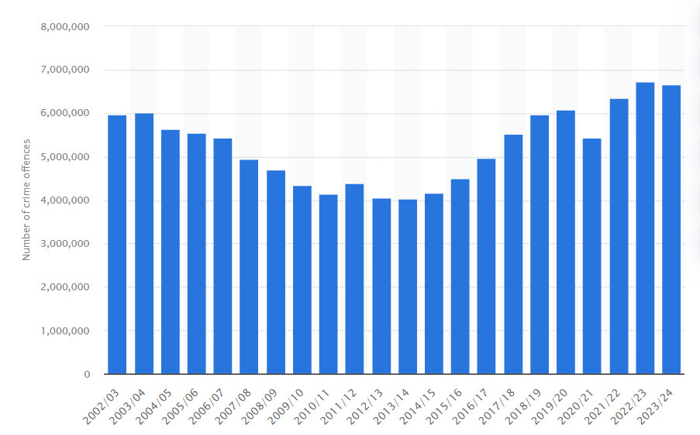
Figure 1: Number of police recorded crimes in Wales and England
(Source: Clark, 2024)
The Barber (2022) and Casey (2016 and 2023) reviews have stated analytical insights that are highly relevant for establishing a modern policing service, especially in England and Wales. This review has not only emphasised challenges relating to policing activities and initiatives in England and Wales but has also proposed promising recommendations to eliminate these implications. The formulation and implementation of a Cross-departmental Crime Prevention Strategy have been highlighted to be highly effective in preventing diverse types of crimes (Barber, 2022). Besides a Crime Prevention Strategy, a vast range of other relevant practices have also been recommended, which include the establishment of a Crime Prevention Agency, enforcement of associated duties, and creating public awareness regarding crime prevention alongside ensuring the maintenance of crime prevention duties and responsibilities in private organisations. Despite the presence of different jurisdictions in the UK, England and Wales are the major jurisdictions with the highest crime rates, accounting for 89.7 per 1000 individuals (Statista Research Department, 2024).
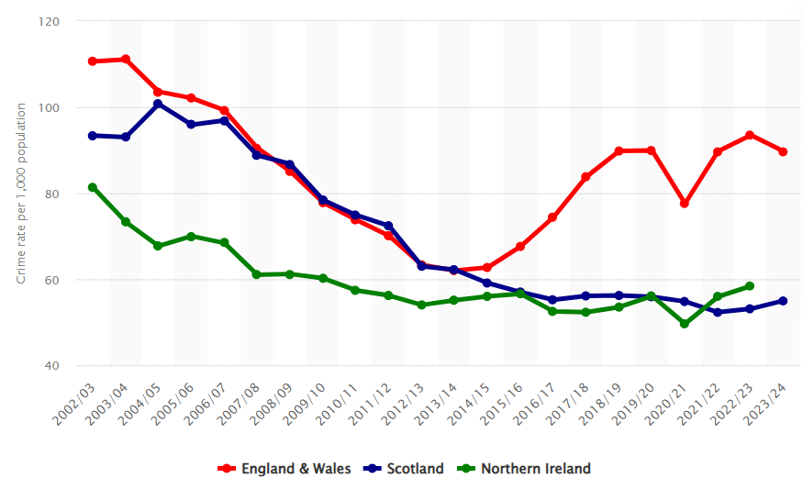
Figure 2: Differentiation of crime rates as per jurisdiction
(Source: Statista Research Department, 2024)
In England and Wales, government officials have encountered a challenging situation regarding the maintenance of policing due to the pressure of a target-driven policing approach taken by the government. Reportedly, a force has been put on by the government to decrease the crime rate by 20% (Theguardian, 2021). The prevalence of violent crimes, different offences and homicide has increased rapidly, which has created constraints for government officials, police chiefs and other individuals engaged with law engagement. In 2024, the number of hate crimes recorded by police in England and Wales accounted for 140,561, 5% less than the previous year (Gov, 2024). Furthermore, it has been decided that there is a drastic need for approximately 20,000 new officers in England and Wales. However, in 2010, the budget for policing was cut, which has impacted the new recruitment of officers for establishing law enforcement in these locations. Therefore, the current context of policing comprises severe issues relating to budget restriction, which is obviously highly challenging for policing activities in these areas.

Issues and options relating to policing by consent
Policing by consent has been optimised to be another critical aspect in this context. In the UK, a unique practice is observed, which involves gaining consensual support from individuals while informing the police for any purpose. Besides this, policing by consent also involves considering police officers as general citizens in uniform. As revealed by Stephens Griffin (2021), undercover policing is observed to bring tremendous implications on the lives of individuals surrounding the policing interventions, especially environmentalists. In another statistics, the crime rates in England and Wales is nearly 110.5 per 1000 individuals (Clark, 2024).
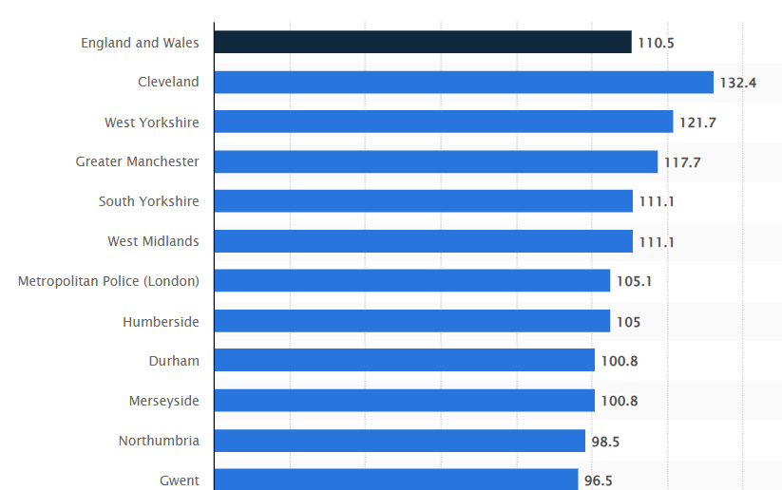
Figure 3: Crime rates in the UK by police area
(Source: Clark, 2024)
As observed, policing by consent is an innovative approach that contributes to the improvement of the internal relationships between police and the general public. The importance of police culture has been amplified through the development of knowledge despite challenging complexities (Cockcroft, 2020). Indeed, policing by consent comes with options for opting to identify the possibility of anti-social behaviour, which may include drug practices, harassment, violence, keeping firearms and various other interventions through interacting with local individuals. The presence of internal conflicts and deficiency in management has created disruptive issues.

Appropriateness of neighbourhood policing
Neighbourhood policies maintain a critical involvement in establishing community engagement while establishing law enforcement and prevention of serious crime. There are severe issues between private and public policing in the UK, which are observed to affect public police (Button, 2023). Besides this, public police are observed to maintain involvement with some of the most persistent controversial provisions of crime, which is quite low for private policing. There are various neighbourhood policing teams in England and Wales, which are also known as NPTs and are responsible for managing law enforcement in specified localities. Leveraging AI technologies has become quite common in the modern era, which has taken a significant opportunity through encouraging the police force (McDaniel and Pease, 2021). The key contribution associated with neighbourhood policing is highlighted as monitoring and preventing crime occurrences in specified localities. Indeed, maintaining a supportive connection between policing activities within private and public held a critical engagement with the regulations of private security. However, despite these complications, neighbourhood policing has emerged to be critical in England and Wales.
The importance of neighbourhood policing is dependent on various factors which are mainly involved with various aspects, such as increasing community accessibility, engaging in a partnership to resolve local problems, tackling anti-social behaviour and problems and interacting with local individuals. Partnership policing is also observed pervading the prevention of crime relating to communities. In addition to that, increased focus on community policing has created a disruptive impact on police agencies along with contributing to increased obligations (Fleming, 2006). These aspects have put police in a state of turmoil due to the increased need for interacting with people in communities and implementing common approaches to prevent anti-social behaviour. Maintaining partnerships has been prioritised as a mandatory principle for police in the UK, which provides support in the management of law enforcement in the UK.

Identification of the implications of institutional racism among police
The presence of a diverse range of challenges relating to policing is highly persistent and challenging. Also, these challenges include the presence of racism among police as police are claimed to be “institutionally racist”. Racism has emerged as a disruptive challenge in the UK, resulting in the “Black Lives Matter” movement (Joseph–Salisbury et al. 2020). collective failure relating to the handling of law enforcement regardless of the ethnicity and racial identity of individuals can contribute to the prevalence of racism among police. In the past years, a range of complaints have been raised against metropolitan police claiming their racism and misogyny against certain groups of people. The Casey report has stated that nearly 12% of women have experienced harassment or attacks in their workplace (Dodd, 2023). Despite the maintenance of various types of practices relating to establishing exclusive interaction and engagement between the public and police, the persistent presence of institutional racism has affected this collaboration.
The rising racism among police and private institutions has emerged as a critical challenge in England. Besides prioritising the persistent effects of racism, prospecting the presence of hatred and negligence toward racism has also been identified to be challenging. Different contemporary events have possessed devastating implications on policing in Great Britain, which include the pandemic outbreak (Nolan et al. 2020). However, these events have been maintained with strict interventions and policing to ensure compliance with law enforcement. However, the claims of police being institutionally racist have been proven with various recent incidents relating to metropolitan police. Increased bullying and harassment of women and men of colour have been quite common, indicating the issues with institutional racism among police, which can be a drastic hindrance to progress towards community policing.

Potential solutions via community engagement and multi-agency
Community engagement has emerged as a highly responsive practice for policing, while multi-agency working can be helpful for the management of comprehensive optimisation and prevention of crime rates in the UK. Prospecting the role of community engagement and multi-agency working will be incredibly beneficial for the evaluation of potential solutions for the challenges of policing. The UK government is accustomed to the management of establishing multi-agency work practices to provide support for preventing crime. Recently, partnered activities of Fire and Rescue Services, Care Quality Commissions and His Majesty’s Inspectorate of Probation have helped prevent youth violence (Gov, 2024). It is one of the incidents in which the UK government’s decision to utilise multi-agency working has supported the establishment of law enforcement. A huge responsibility is put upon different agencies working for social service, policing and law enforcement.
Establishing partnerships between police forces of different localities and other agencies has been proven to be highly effective in the case of providing support to law enforcement. In many locations, policing is considered to be responsive to various anti-social activities and industrialisation (Walcott, 2021). Besides this, community engagement is vital in the case of neighbourhood policing due to the responsibility of collaborative efforts. Increased participation of individuals is observed to be highly supportive of crime prevention through neighbourhood policing. The attainment of useful information based on the requirement of policing is considered to be one of the critical areas relevant to maintaining law enforcement in the UK, with a particular reference to England and Wales. Thereafter, multi-agency partnerships and community engagement are identified to be highly beneficial for solving the challenges that are commonly witnessed by police in these areas.
Therefore, in the future, community and neighbourhood policing will get access to higher responsibility regarding the management of youth violence, which can be controlled. During the pandemic outbreak, procedural justice has been prioritised for policing in the UK (Farrow, 2020). Besides this, efficient management of internal communication practices is expected to contribute to the management and importance of law enforcement in the UK.

Conclusion

Summary
Based on the overall description, neighbourhood policing has been identified as having a core importance in England and Wales. Keeping the core focus on partnership and neighbourhood policing has created an incredible opportunity for the improvement of diverse growth areas. The Barber (2022) and Casey (2016 and 2023) reviews have been acknowledged, creating a distinguished knowledge of the possible remarks for improving policing interventions and activities. Establishing different crime prevention measures through a Crime Prevention Strategy is identified to be beneficial, however, policing by consent has been identified to bring potential issues for the general public.
Other than that, neighbourhood policing holds significant support for the management of excruciating law enforcement in different localities. The main intention is to emphasise the importance of neighbourhood policing, which has created an exclusive opportunity to intervene in various types of crimes and anti-social activities. However, the claims relating to institutional racism among police have been identified to be a hindrance for the progress of community engagement as a wide range of complaints have been raised against police, especially in metropolitan areas. Lastly, multi-agency working and community engagement are identified to be some of the most rational interventions that will be extremely helpful for bringing solutions to policing challenges in the UK.

Reference list

Barber, M. (2022). A NEW MODE OF PROTECTION Available at: https://www.police-foundation.org.uk/policingreview2022/wp-content/uploads/srpew_final_report.pdf (Accessed on: 17th December, 2024).
Button, M., (2023). Working with Private Policing to Enhance Public Policing: The Case of the United Kingdom. In Handbook on Public and Private Security (pp. 223-241). Cham: Springer International Publishing. https://link.springer.com/chapter/10.1007/978-3-031-42406-9_10.
Clark, D. (2024). Crime rate per 1,000 population in England and Wales in 2023/24, by police force area Available at: https://www.statista.com/statistics/866788/crime-rate-england-and-wales-by-region/ (Accessed on: 17th December, 2024).
Clark, D. (2024). Number of police recorded crime offences in England and Wales from 2002/03 to 2023/24 Available at: https://www.statista.com/statistics/283069/crimes-in-england-and-wales/ (Accessed on: 17th December, 2024).
Cockcroft, T.,(2020). Police culture: Research and practice. Policy Press. https://books.google.com/books?hl=en&lr=&id=yyrTDwAAQBAJ&oi=fnd&pg=PR9&dq=policing+in+the+uk+book&ots=4bQtuO9LPQ&sig=V8BWHKAW2v5V7ilbkZNWt_uaI9U.
Dodd, V. (2023). Met police found to be institutionally racist, misogynistic and homophobic Available at: https://www.theguardian.com/uk-news/2023/mar/21/metropolitan-police-institutionally-racist-misogynistic-homophobic-louise-casey-report (Accessed on: 17th December, 2024).
Farrow, K., (2020). Policing the pandemic in the UK using the principles of procedural justice. Policing: a journal of policy and practice, 14(3), pp.587-592. https://www.researchgate.net/profile/Kathryn-Farrow-3/publication/345339719_Policing_the_Pandemic_in_the_UK_Using_the_Principles_of_Procedural_Justice/links/6037c4884585158939cd8c2a/Policing-the-Pandemic-in-the-UK-Using-the-Principles-of-Procedural-Justice.pdf.
Fleming, J., (2006). Working through networks: the challenge of partnership policing. Fighting crime together: The challenges of policing and security networks, pp.87-115. https://books.google.com/books?hl=en&lr=&id=nLka6I5E20EC&oi=fnd&pg=PA87&dq=working+throuigh+networks:+thecghallenge+of+partnership+policing&ots=PdE9MYKcut&sig=KF7Wy7GmVAMAgOueC18qkexWULI.
Gov. (2024). Hate crime, England and Wales, year ending March 2024 Available at: https://www.gov.uk/government/statistics/hate-crime-england-and-wales-year-ending-march-2024/hate-crime-england-and-wales-year-ending-march-2024#:~:text=crime%20recording%20practices.-,There%20were%20140%2C561%20hate%20crimes%20recorded%20by%20the%20police%20in,offences%3B%20see%20Table%202.1). (Accessed on: 17th December 2024).
Gov. (2024). Multi-agency responses to serious youth violence: working together to support and protect children Available at: https://www.gov.uk/government/publications/multi-agency-responses-to-serious-youth-violence-working-together-to-support-and-protect-children/multi-agency-responses-to-serious-youth-violence-working-together-to-support-and-protect-children#:~:text=Multi%2Dagency%20work%20was%20most,helping%20them%20to%20stay%20safe. (Accessed on: 17th December 2024).
Innes, M., Roberts, C., Lowe, T. and Innes H., (2020). Neighbourhood policing: The rise and fall of a policing model. Oxford University Press (UK). https://www.taylorfrancis.com/books/mono/10.4324/9781003108399/comparative-policing-jacques-de-maillard.
Joseph–Salisbury, R., Connelly, L. and Wangari-Jones, P., (2020). “The UK is not innocent”: Black Lives Matter, policing and abolition in the UK. Equality, Diversity and Inclusion: An International Journal, 40(1), pp.21-28. https://eprints.whiterose.ac.uk/181384/3/Joseph-Salibsury%2C%20Connelly%20and%20Wangari-Jones.pdf.
McDaniel, J.L. and Pease, K. eds., (2021). Predictive policing and artificial intelligence. Routledge, Taylor & Francis Group. https://api.taylorfrancis.com/content/books/mono/download?identifierName=doi&identifierValue=10.4324/9780429265365&type=googlepdf.
Nolan, J.J., Crispino, F. and Parsons, T. eds., (2020). Policing in an age of reform: An agenda for research and practice. Springer Nature. https://books.google.com/books?hl=en&lr=&id=sWcNEAAAQBAJ&oi=fnd&pg=PR5&dq=neighbourhood+policing+in+uk++book&ots=3WUSlRr54J&sig=XUa6svmOsL3tfwrPpHfrlgXa0y4.
Statista Research Department. (2024). Crime rate per 1,000 population in the United Kingdom from 2002/03 to 2023/24, by jurisdiction Available at: https://www.statista.com/statistics/1030625/crime-rate-uk/ (Accessed on: 17th December, 2024).
Stephens Griffin, N., (2021). ‘Everyone was questioning everything’: understanding the derailing impact of undercover policing on the lives of UK environmentalists. Social Movement Studies, 20(4), pp.459-477. https://nrl.northumbria.ac.uk/id/eprint/42751/1/Everyone_was_questioning_everything_NSG_PURE_.pdf.
Theguardian. (2021). Police in England and Wales face crime targets in return for 20,000 new officers Available at: https://www.theguardian.com/uk-news/2021/jan/11/police-in-england-and-wales-face-targets-in-return-for-20000-new-officer (Accessed on: 17th December, 2024).
Walcott, R., (2021). On property: Policing, prisons, and the call for abolition (Vol. 2). Biblioasis. https://books.google.com/books?hl=en&lr=&id=7SMAEAAAQBAJ&oi=fnd&pg=PT4&dq=neighbourhood+policing+in+uk++book&ots=ULnzimfpsj&sig=TzcX6KpUVeUYMNv_6bdkYnkDztU.

