DS 1 Template

My Screenshots/Photos
- Please add 4–6 screenshots or photos of your digital life.
- You can use your phone or laptop.
- For each screenshot, write one or two sentences explaining what it shows.

Screenshot/Photo 1
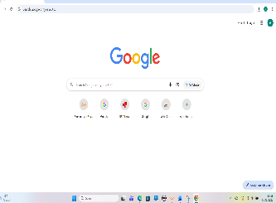
Google research – I’m using Google because it’s up-to date, accurate and the fastest tool for finding information online. It also has built-in intent understanding-not only to finds keywords but also the context of the entire sentence.

Screenshot/Photo 2
[Insert Photo/Screenshot below]
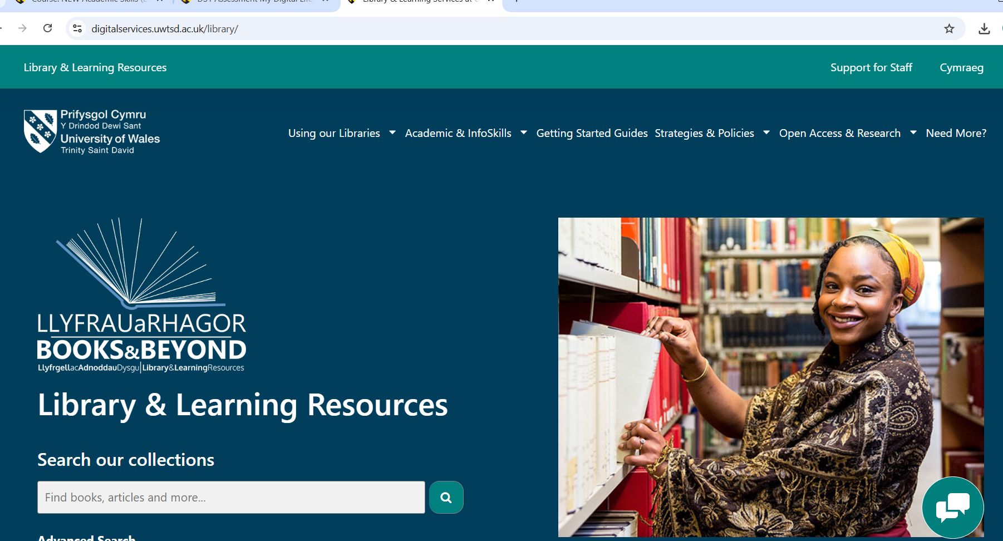
Library – e-library is a digital database space, offering available academic resources anytime. It contains lots educational materials and information like e-books, journals, audio files, videos etc.

Screenshot/Photo 3
[Insert Picture/Screenshot below]
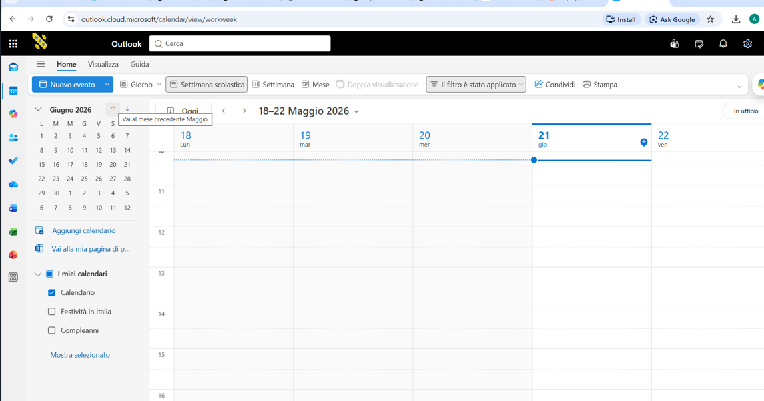
Outlook Calendar – Is helping me to keep an eye on my daily, weekly and monthly appointments, events, to schedule and organize meetings and sharing my availability with others.

Screenshot/Photo 4
[Insert Photo/Screenshot below]
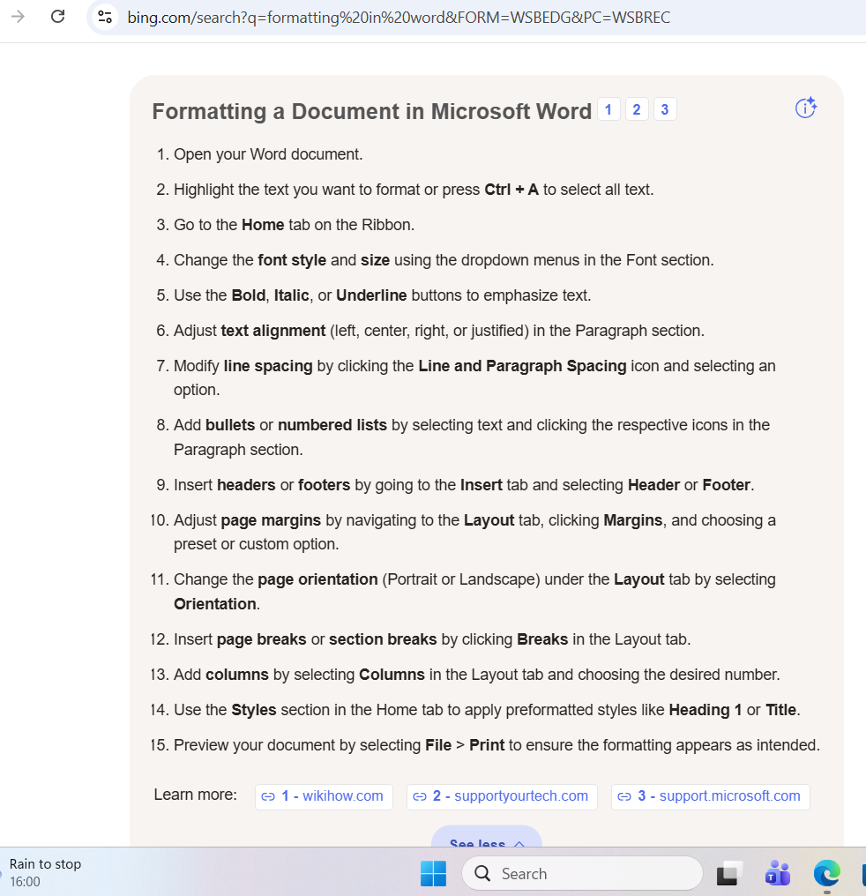
Formatting – Is letting me to change fonts, sizes, apply different types of writing, underline and emphasize selected texts. Facilitates the quick use of dashes, symbols, numbers.

Screenshot/Photo 5
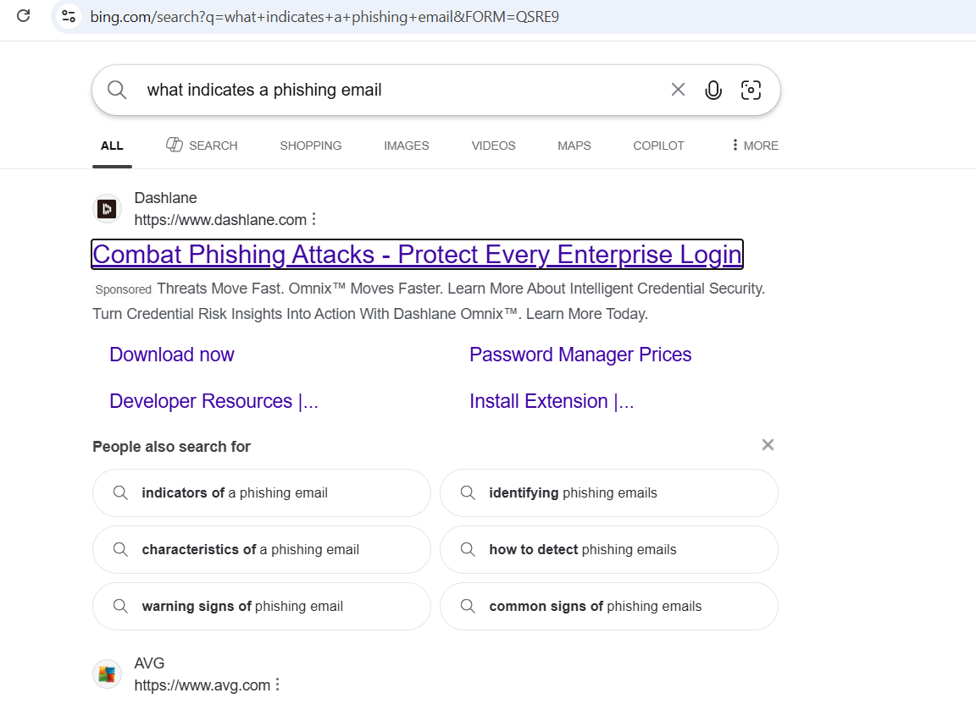
Cyber Security – phishing – fake messages – is a warning against the dangers of strange links, unknown senders and general attachments you did not expect.

Screenshot/Photo 6
[Insert Photo/Screenshot below]
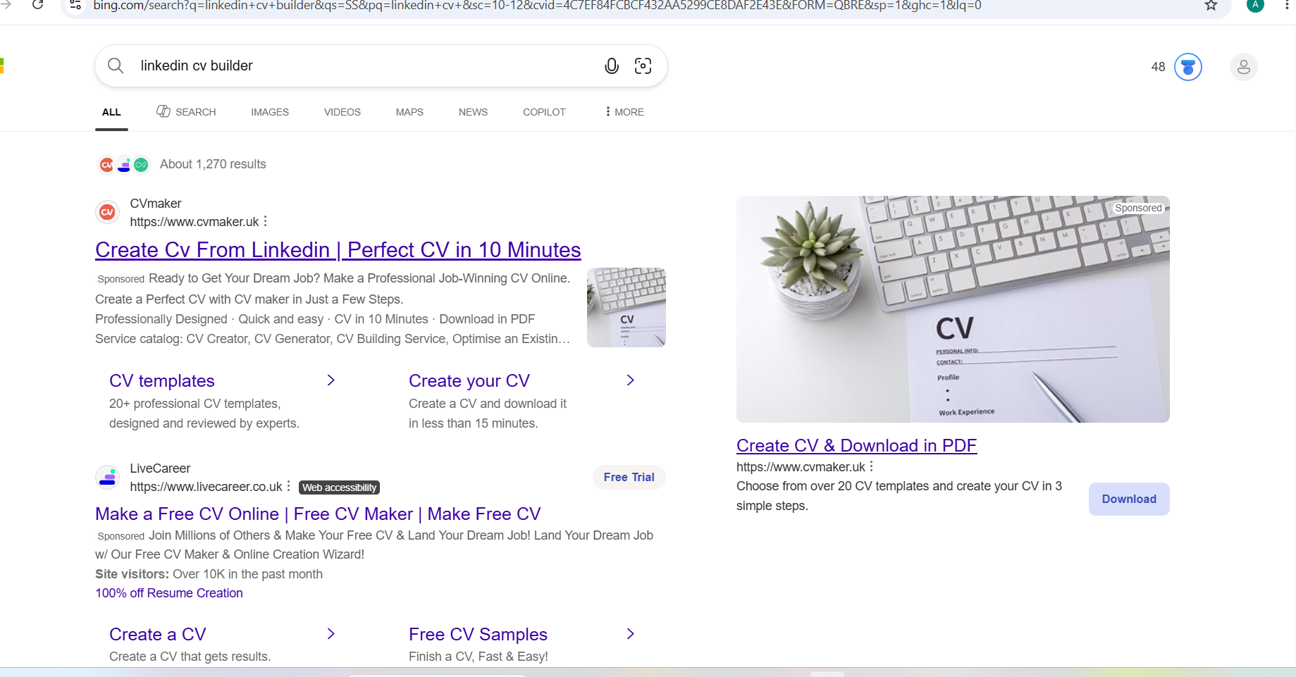
Linkedln – Linkedln profile is giving me easier way to connect with professional opportunities like grown professional experience, skills, education. Is very helpful in building a CV or lover letters. You can get and share knowledge and gain it.

My Short Reflection
- Write 5–8 simple sentences about your digital life.
- You can use the sentence starters below if helpful.
Digital skills are the ability to effectively, safety, also critically use of information and communication technologies in everyday life, work, learning. It’s not only about using a computer but about a harmonious combination of knowledge, practical skills, and appropriate attitudes towards the digital world. Digital skills allow us to operate in fundamental areas such as: information and data, communication and collaboration, creation of digital content, security and problem-solving.

Sentence starters
- I use digital tools to … communicate everyday and to improve my study and workplace skills
- I feel confident when I … helping myself with my knowledge.
- I want to improve … my knowledge in Excel
- I often use these tools: …laptop, printer
- I sometimes feel nervous about …technical issue
- I hope this module will help me …use easier and effectively my skills
- Digital skills are important for me because …are essential for studies and in the workplace.
You can write more if you want.

Submission Checklist
Before you submit, please check:
​​​ ☐ I added 4–6 screenshots
☐ I wrote short sentences for each screenshot
☐ I wrote my short reflection
☐ My work is my own
☐ My file opens correctly
​​☐ My file opens correctly

