

Accounting Fundamentals

Student ID: 2215818
Student Name: Vasile Rosca
Module Code: LCBB4001
Lecturer name: Ivana Rozic

Table of Contents
Introduction 3
“Answer for question no 1” 3
“A. Preparation of income statement and statement of finance for the business of Wales plc” 3
“B. Significance between balancing position of the statement of finance” 6
“Answer for question no 2” 6
“A. Computation of accounting ratios for the business of Sweet plc for 2021 and 2020” 6
“B. Evaluate the present basis financial performances of Sweet plc on behalf of the financial statement” 8
Conclusions 10
References 11

Introduction
An applied presence and formulation of accounting for every business is necessary which provides a positive understanding and maintenance support. With structuring the general provisions provided by IFRS a proper formulation of the financial statement of the business has been initiated that structured the accounting developments in standardised support. The concept of such accounting engagement brings positive financial development and optimised structure position also formulated to account for potential support on a standard basis (Carey et al., 2017).
General processing of accounting disclosure including a financial approach also brings value maintenance support that provides the ultimate support of accounting stability and proper financial feasibility. This report mainly provides general understanding support regarding the financial statement processing for Wales plc and also the financial performance measurement for Sweets plc for the two different periods.

“Answer for question no 1”

“A. Preparation of income statement and statement of finance for the business of Wales plc”
Identification and the engagement of proper accounting disclosure related to business in the form of a report is mainly structured with the provisions of IFRS support. Even the presence of GAAP is also noticed regarding the formulation of financial operating structure purpose that brings the ethical presence and accounting integrity development in a standardised basis. A proper formulation of accounting for every business is generally structured with the involvement of three financial statement support that managed and formulated the basic accounting growth position on a sustainable basis (Schroeder et al., 2022).
According to current accounting computation and processing support a general position regarding the accounting measurement has been evaluated. Such details have been provided.
“In the books of Wales plc”
“Income statement”
“For the year ended 31st December 2022”

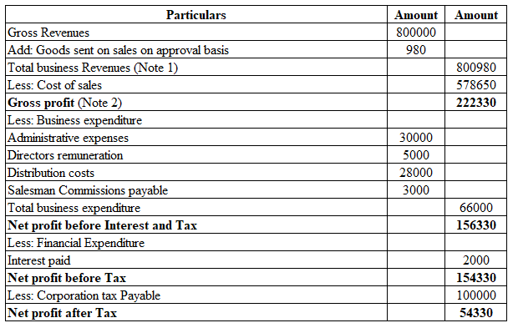
A general identification regarding the total business revenue has been determined with the involvement of goods sent on sale on an approval basis to determine the actual level of revenue for the current period.
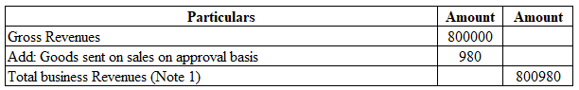
Associated with this measurement the general computed position regarding the total amount of goods on approval is adjusted for the debtor balance recognition purpose.
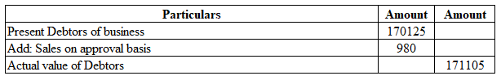

“In the books of Wales plc”
“Profit and Loss appropriation”
“For the year ended 31st December 2022”
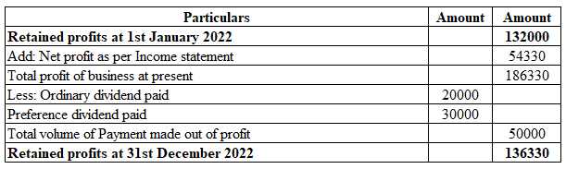
“In the books of Wales plc”
“Statement of Finance”
“For the year ended 31st December 2022”
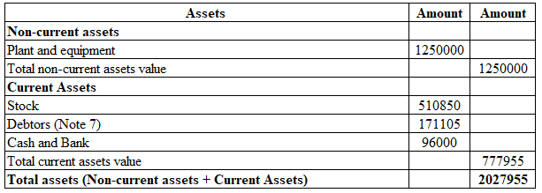
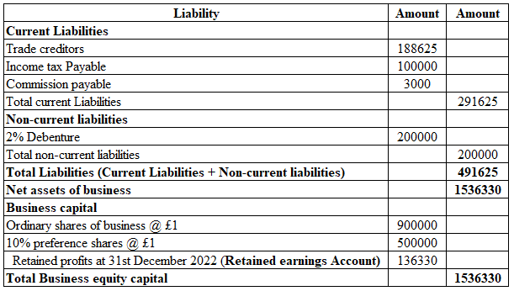

“B. Significance between balancing position of the statement of finance”
According to basic theoretical identification the presence and formulation of a “business balance sheet or statement of finance” are mainly structured based on accounting equation support. The presence of such an equation indicates the volume of business assets is generally equal to the summation of total liabilities and equity balance, or “Total assets = Total liabilities + Equity capital”. The presence of this concept mainly represents an equal financial processing approach associated with the accounting element support that maintains the optimised position of financial values in a standardised structure (Weygandt et al., 2018). With the same support, the convention of accounting and double entry principle of accounting is also structured for the financial value development support including a balancing position between the debit and credit balance position that ultimately approached the progressive financial accountability support on a simultaneous basis. A positive breakdown structure related to the individual accounting elements is also initiated for the progressive operating development support including the optimised value development approach on a comprehensive basis (Kimmel et al., 2020). The presence of this type of engagement including accounting principles processing mainly initiates the balancing approach of the business balance sheet for developing and managing transparency in valuation.

“Answer for question no 2”

“A. Computation of accounting ratios for the business of Sweet plc for 2021 and 2020”
According to the basic accounting position, a primary volume of importance to the engagement of accounting performance metrics is initiated for the financial performance evaluation support. The concept of accounting ratio analysis is considered as a type of financial analysis mechanism that is approached for the measurement and processing support of accounting analysis including the accounting compatibility progressive approach in an optimised basis (Langfield-Smith et al., 2018). As per the current financial performances related to Sweets plc, the benchmarking approach regarding the comparison of the accounting position of this business for two different periods has been evaluated.
“Return on Capital Employed”
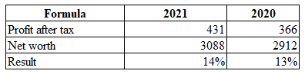

“Return on Equity”
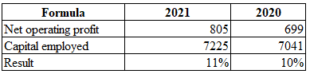
“Earnings per share”
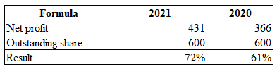
“Net profit margin”
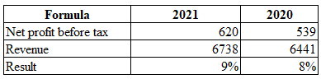
“Asset turnover”
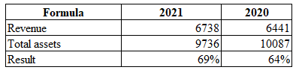
“Stock holding days”
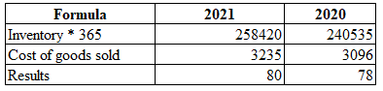
“Debtors collection period”
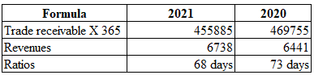
“Current ratio”
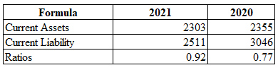
“Gearing ratio”
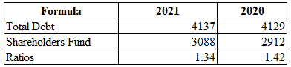
“Interest cover”
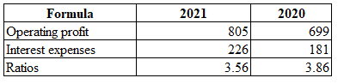

“B. Evaluate the present basis financial performances of Sweet plc on behalf of the financial statement”
The concept of benchmarking is mainly evaluated in individual businesses in the context of evaluating the comparative analysis under the involvement of “Management Accounting”. A general presence and formation of this analysis bring the basic understanding of the accounting potential of a business that is managed for the structural growth of accounting and operating development structure purposes.
According to the present provided financial structure for the business of Sweet plc has been evaluated for two different periods basis. Such details are provided.
“Return on Capital Employed”: “The identified processing of this measurement is structured to recognise the earning position associated with the net worth support. It mainly brings the accounting development position including the value initiative progress in comprehensive support (Jones et al., 2018). As per the general understanding current position indicates expansion support compared to the previous level which indicates around a 1% growth approach in the present period.”
“Return on Equity”: Appearances of this analysis mainly bring the returning position of business associated with the level of equity processing approach that managed the accounting development growth fundamentally. As per the analysis here also 1% growth position is noticed compared to the earlier status of the business that initiates a progressive development position (Dyson and Franklin, 2020). However, it indicates the management of the business should provide significance over the cost formulation for future development.
“Earnings per share”: The measurement of this processing mainly applied for the structural support including the earning compatibility processing approach that identifies the market position of the business in the context of shareholder engagement. According to the currently computed position a progressive growth of 9% in earning development has been initiated in the business indicating the progressive growth including the standardised value compatibility initiative of this business in the present order (Horngren et al., 2018).
“Net profit margin”: An identification of this measurement is mainly structured for the processing and formulation of accounting earning compatibility support that manages the operating beneficial approach in a formulated order (Khan, 2019). As per the engagement, the present earning volume of the business initiates a 1% growth position that is sustainable for the progressive strategic approach in future. Additionally, a positive cost-controlling structure is mainly required in the business for the preceding future.
“Asset turnover”: The presence and analysis of this measurement are mainly initiated to evaluate the utilisation support of business assets associated with the turnover position so that the marketing growth and other associated development can be identified. According to present computed support, a progressive development of around 5% growth is initiated in the present position in the business that balances the accounting developments on a comprehensive basis (Shim, 2022). However, a proper cost development asset formulation is required for future growth.
“Stock holding days”: General volume of importance regarding the measurement and formulation of this analysis brings the understanding support of inventory engagement level of business in a proper basis that also proceeds for the demand processing support in a business (Vogel, 2020). According to the present analysis, the volume of such time is mainly expanded which means in the present position the general level of productive demand has declined, which is not sufficient for the optimised structure of the accounting position on a sustainable basis.
“Debtors collection period”: A sustainable measurement of this analysis mainly initiated to recognise the volume of business financial collection time support that managed the financial value and cash flow processing on a sustainable basis (Finkler et al., 2022). According to the present analysis support the volume of this period mainly initiates a general reduction approach in the present period from the volume of 73 days to 68 days that identifies the progressive accounting position and optimised credit policy development approach mainly. However, progressive operating development is required for future progress.
“Current ratio”: According to accounting fundamentals the processing of this measurement brings the general understanding support of accounting liquidity development approach including the working capital formulation structure on a developing basis. As per the general understanding, the position of this analysis indicates the optimised growth structure in the present period with the declining support of accounting current liability position on an optimised basis. However, a proper marketing initiative including the financial growth and balancing structure related to business stability is mainly required for the future stability position.
Based on the above analysis, processing the overall position and formulated structure of the business indicates an optimised growth position including the operating accountability support. However, in some aspects, the financial structure including the capital balancing and liquidity position of the business needs to be restructured properly for future value development.

Conclusions
In summary, an understanding support and maintenance approach of accounting is initiated for the operating value development purpose that manages the structure of finance on a sustainable basis. The general understanding of support basic accounting maintenance and standards brings the operating value maintenance support on a sustainable basis that manages the structural growth of accounting and financial standardised approach on a progressive basis. In both cases, the overall financial position of organisations is initiate the sustainability and operating accountability that manage the structural position and other growth support on a developing basis.

References
Carey, M., Knowles, C. and Towers-Clark, J., 2017. Accounting: a smart approach. Oxford University Press.
Dyson, J. and Franklin, E. 2020. Accounting for non-accounting students (10th Ed.) Pearson Education Limited: Harlow
Finkler, S.A., Calabrese, T.D. and Smith, D.L., 2022. Financial management for public, health, and not-for-profit organizations. CQ Press.
Horngren, C.T., Stratton, W.O. and Sundem, G.L. 2018. Introduction to management accounting : [chapters 1-17]. Pearson.
Jones, C., Finkler, S.A., Kovner, C.T. and Mose, J., 2018. Financial Management for Nurse Managers and Executives-E-Book. Elsevier Health Sciences.
Khan, U., 2019. Does fair value accounting contribute to systemic risk in the banking industry?. Contemporary Accounting Research, 36(4), pp.2588-2609.
Kimmel, P.D., Weygandt, J.J. and Kieso, D.E., 2020. Financial accounting: tools for business decision-making. John Wiley & Sons.
Langfield-Smith, K., Thorne, H. and Hilton, R.W., 2018. Management accounting: Information for creating and managing value. Sydney: McGraw-Hill Education.
Schroeder, R.G., Clark, M.W. and Cathey, J.M., 2022. Financial accounting theory and analysis: text and cases. John Wiley & Sons.
Shim, J.K., 2022. Financial management. Professor of Finance and Accounting Queens College City University of New York.
Vogel, H.L., 2020. Entertainment industry economics: A guide for financial analysis. Cambridge University Press.
Weygandt, J.J., Kimmel, P.D. and Kieso, D.E., 2018. Financial Accounting with International Financial Reporting Standards. John Wiley & Sons.

