CertHE Computing Skills for Workplace
Networks and Cyber Security Essentials ACCA4024

Student: Amjad Ali 2424832

Lecturer: Muhammad Azeem Abbas

Date: 21st March 2026

Contents
Student: Amjad Ali 2424832 1
Lecturer: Muhammad Azeem Abbas 1
Date: 13th March 2026 1
HealthPlus Analytics (HPA) 4
Developing a Comprehensive Data Security and Governance Framework 4
Module: 4
1. Introduction 4
2. Identification of Threats 5
2.1 External Threats 5
2.1.1 Ransomware 5
2.1.2 Phishing and Social Engineering 6
2.1.3 Cloud Infrastructure Attacks 6
2.2 Internal Threats 6
2.2.1 Insider Threats 6
2.2.2 Bring Your Own Device (BYOD) 6
2.2.3 Inadequate Access Controls 6
3. Security Policies 7
3.1 Data Protection and Classification Policy 7
3.2 Access Control Policy 7
3.3 Acceptable Use and BYOD Policy 8
3.4 Incident Response Policy 8
3.5 Backup and Business Continuity Policy 8
4. Mitigation Measures 9
4.1 Technical Controls 9
4.1.1 Network Security 9
4.1.2 Endpoint Protection 9
4.1.3 Cloud Security 9
4.2 Administrative Controls 9
4.2.1 Governance and Oversight 9
4.2.2 Supplier Risk Management 9
5. Monitoring and Incident Response 10
5.1 Continuous Monitoring 10
5.2 Incident Response Flow Diagram 10
6. Training and Awareness Programme 10
6.1 Training Content 10
6.2 Delivery Methods 10
6.3 Measuring Effectiveness 10
7. Conclusion 11
8. References 12
9. Appendix 13
Powerpoint slide 13

HealthPlus Analytics (HPA)

Developing a Comprehensive Data Security and Governance Framework

Module: Cyber Security / Information Assurance
Role: IT Security Manager
Organisation: HealthPlus Analytics (UK)

1. Introduction
Cybersecurity is vital in healthcare due to rising threats and sensitive patient data. Recent breaches at HealthPlus Analytics (HPA), including unauthorised data access and a ransomware attack, reveal major security gaps. This report outlines a strengthened data security and governance framework to improve HPA’s resilience and compliance with UK GDPR and NHS standards.

Category | Threat | Description | Key Risks/ Consequences
External | Ransomware | Encrypts systems and demands payment. High impact on healthcare availability. | Loss of system access, data exfiltration, major service disruption.
External | Phishing & Social Engineering | Deceives users to steal credentials or deploy malware. Increased risk with remote work. | Compromised accounts, unauthorised access, lateral movement in network.
External | Cloud Infrastructure Attacks | Misconfigurations exposing data, weak APIs/identity controls. | Data breaches, UK GDPR violations, loss of trust.
Internal | Insider Threats | Intentional or accidental misuse of privileges by employees/contractors. | Data breaches, unauthorised access, operational risk.
Internal | BYOD Risks | Personal devices lacking security controls. | Data leakage, unauthorised access, device compromise
Internal | Inadequate Access Controls | Users having excessive privileges. | Larger impact of compromised accounts.

Table 1/ Identification of Threats

2. Identification of Threats
Healthcare organisations are among the most targeted sectors globally due to the high value of patient data and the critical nature of healthcare services [2]. A comparison of different forms of threats is shown in Table 2.

2.1 External Threats

2.1.1 Ransomware
Ransomware attacks involve encrypting critical systems and demanding payment in exchange for decryption. According to the UK National Cyber Security Centre (NCSC), ransomware represents a significant threat to healthcare organisations because they depend heavily on continuous system availability. Such attacks can lead to severe consequences including the loss of access to analytics platforms the potential exfiltration of sensitive patient data and major service disruptions for NHS clients [5].

2.1.2 Phishing and Social Engineering
Phishing attacks [6] exploit human behaviour to steal credentials or deliver malware and the rise of remote and hybrid working environments has significantly increased organisational exposure to these threats. When attackers successfully deceive users, the consequences can be severe including compromised cloud accounts unauthorised access to sensitive data and an increased likelihood of lateral movement within the network enabling further compromise.

2.1.3 Cloud Infrastructure Attacks
Misconfigured cloud storage, APIs or identity permissions can unintentionally expose sensitive data to the public internet creating significant security and compliance risks for organisations. Such weaknesses may result in serious consequences including data breaches violations of UK GDPR requirements and a loss of trust from healthcare partners who rely on secure handling of confidential information.

2.2 Internal Threats

2.2.1 Insider Threats
Employees or contractors may intentionally or unintentionally cause data breaches through misuse of access privileges or failure to follow security procedures.

2.2.2 Bring Your Own Device (BYOD)

The use of personal devices for professional tasks introduces several security risks particularly when those devices lack proper safeguards. Common issues include the absence of encryption outdated operating systems and the use of insecure or unvetted applications. Together these weaknesses increase the likelihood of unauthorised access data leakage and broader compromise within organisational networks [7].

2.2.3 Inadequate Access Controls
Inadequate access controls happen when users are given more access than they need. This makes things riskier because if one of those accounts gets hacked the attacker can do far more damage than they should be able to.

Table 2 / Security policies
Policy | Purpose | Key Requirements
Data Protection & Classification Policy | Ensures appropriate handling of data based on sensitivity. | Four data classes (Public Highly Confidential), encryption in transit and at rest.
Access Control Policy | Restricts access based on job roles. | RBAC, least privilege, mandatory MFA.
Acceptable Use & BYOD Policy | Secure use of organisation and personal devices. | Device encryption, MDM, corporate/personal data separation, remote wipe.
Incident Response Policy | Effective and compliant handling of incidents. | Defined incident categories, escalation processes, ICO notification within 72 hours.
Backup & Business Continuity Policy | Ensures data recovery and service resilience. | Daily encrypted backups, offline/immutable storage, disaster recovery testing.

3. Security Policies
HPA will implement a set of security policies aligned with ISO/IEC 27001, UK GDPR, and the NHS Data Security and Protection Toolkit (DSPT). As demonstrated in the above table 2.

3.1 Data Protection and Classification Policy
Classifies data into four categories Public, Internal, Confidential and Highly Confidential to ensure appropriate handling across all information types. Patient data falls under the Highly Confidential category due to its sensitivity and the strict regulatory requirements surrounding its use. To maintain the security of all classified data the policy mandates encryption both during transmission and while stored at rest [8].

3.2 Access Control Policy
Strong access management practices including Role Based Access Control (RBAC) to ensure users only receive permissions aligned with their job responsibilities. This approach is supported by the principle of least privilege which restricts access to only what is strictly necessary for performing assigned tasks. In addition, mandatory Multi-Factor Authentication (MFA) is required to provide an extra layer of security reducing the risk of unauthorised account access even if credentials are compromised [10].

3.3 Acceptable Use and BYOD Policy
Strict mobile and endpoint security controls to protect sensitive information across all devices. Mandatory device encryption ensures that data remains protected even if a device is lost or stolen while Mobile Device Management (MDM) provides centralised oversight of security configurations and compliance. To further safeguard information corporate and personal data are kept strictly separated to prevent accidental leakage or unauthorised access. Additionally remote wipe capability allows the organisation to securely erase corporate data from a device in the event of loss theft or compromise [11].

3.4 Incident Response Policy
A well-structured incident response framework that includes clearly defined incident categories and established escalation procedures to ensure timely and effective action. These processes support compliance with legal and regulatory obligations including the UK GDPR requirement to notify the Information Commissioner’s Office (ICO) of a qualifying personal data breach within 72 hours. This structured approach helps minimise impact maintain accountability and ensure consistent handling of all security incidents [12].

3.5 Backup and Business Continuity Policy
Robust data resilience strategy that includes daily encrypted backups to ensure critical information can be restored securely when needed. To further protect against ransomware and other destructive threats backup data is stored in offline and immutable repositories preventing tampering or unauthorised modification. In addition, regular disaster recovery testing is conducted to validate restoration processes confirm system readiness and ensure business continuity in the event of a major incident [13].

Table 3/ Mitigation Measures
Control Type | Measure | Description
Technical Controls | Network Security | Next‑gen firewalls, segmentation, Zero Trust architecture.
Technical Controls | Endpoint Protection | EDR, automated patching, full disk encryption.
Technical Controls | Cloud Security | Secure baselines, CASB monitoring, continuous posture management.
Administrative Controls | Governance & Oversight | CASB monitoring of cloud usage and threats.
Administrative Controls | Supplier Risk Management | Vendor assessments, DPAs, annual compliance reviews.

4. Mitigation Measures
This is demonstrated in Table 3.

4.1 Technical Controls
Technical controls include measures such as strong access controls, endpoint protection, network security tools, cloud security configurations and continuous monitoring to reduce vulnerabilities and protect systems from cyber threats.

4.1.1 Network Security
We keep our network safe by using advanced firewalls splitting the network into smaller secure sections and following a Zero Trust approach basically always double checking that every user and device is allowed to be there. This helps stop threats from spreading across systems.

4.1.2 Endpoint Protection
To protect devices by using advanced threat monitoring tools (EDR) keeping software automatically updated to close security gaps and encrypting the entire hard drive so data stays safe even if a device is lost or stolen.

4.1.3 Cloud Security
Enforcing secure configuration baselines using CASB tools such as Netskope, Microsoft Defender for Cloud Apps, Skyhigh Security or Cisco Cloudlock to monitor cloud activity and continuously checking for misconfigurations so issues can be fixed quickly.

4.2 Administrative Controls
Administrative controls are the policies and procedures an organisation uses to manage security such as training, access rules and incident reporting processes.

4.2.1 Governance and Oversight

A CASB is a tool that watches and protects your cloud apps.
It checks who is using them makes sure data is safe and blocks anything suspicious.

4.2.2 Supplier Risk Management
Third party risk through vendor security assessments the use of Data Processing Agreements (DPAs) to define how data is handled and annual supplier reviews to ensure ongoing compliance and security standards.

Table 4 / Monitoring Response
Area | Description
Continuous Monitoring | SIEM for centralised logging, real‑time alerting, rapid threat detection.
Incident Response Process | Governed by established flow diagram [Figure 1]

5. Monitoring and Incident Response
A summary of the Monitoring Response is provided in Table 4.

5.1 Continuous Monitoring
Continuous monitoring is supported by SIEM tools [Fig 1] which centralise system logs and provide real time alerts to help the organisation quickly identify and respond to potential security threats.

5.2 Incident Response Flow Diagram
[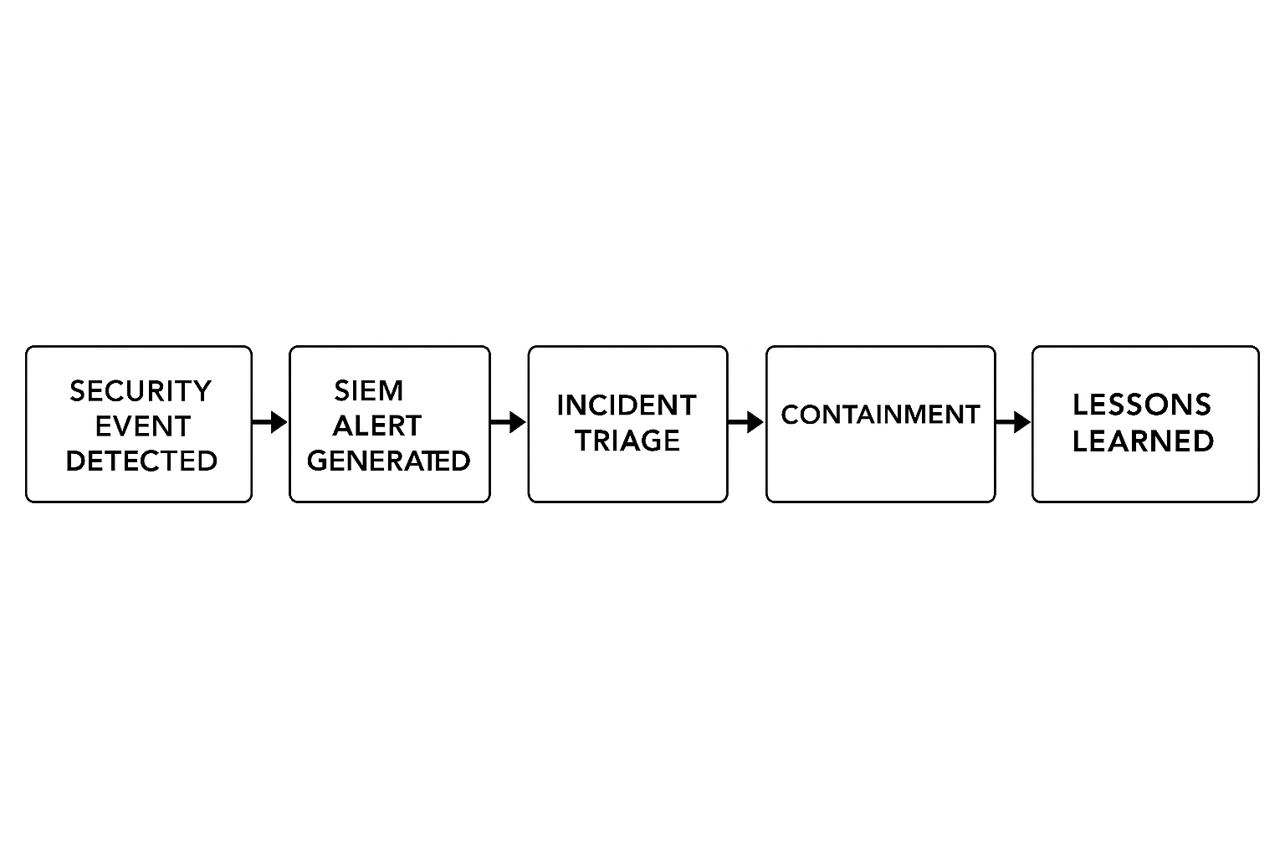
Figure 1: Incident Response Flow Diagram

6. Training and Awareness Programme
An overview of the training and awareness for cyber security is provided as Table 5.

6.1 Training Content
Staff receive regular training on key areas including UK GDPR requirements phishing and social engineering awareness secure use of cloud systems and clear incident reporting procedures. This ensures employees can identify risks, protect data and respond quickly and appropriately to security issues. [3].

6.2 Delivery Methods
Annual e-learning conducts quarterly phishing simulations and provides security training as part of the new starter induction to ensure all staff maintain strong awareness and safe working practices.

6.3 Measuring Effectiveness
Effectiveness of security training [4] is measured through phishing test failure rates, staff assessment scores and findings from internal and external audits to confirm knowledge retention, policy compliance and areas needing improvement.

Table 5 / Training & Awareness Programme
Section | Topic | Summary
Training Content | Core Training Areas | Staff receive training on UK GDPR principles, phishing awareness, secure cloud usage, and correct incident reporting procedures to help recognise and mitigate risks.
Delivery Methods | How Training is Delivered | Annual e‑learning modules, quarterly phishing simulations, and security induction sessions for all new starters to ensure consistent awareness.
Measuring Effectiveness | Performance Measurement | Training effectiveness tracked using phishing failure rates, staff assessment scores, and results from internal and external audits.

7. Conclusion
The proposed data security and governance framework provides HealthPlus Analytics with a structured and effective approach to managing cyber risk. By integrating robust technical controls, strong governance and comprehensive staff training. HPA can significantly reduce the likelihood and impact of cyber incidents while ensuring compliance with UK regulatory requirements.

8. References
[1] M. Higgins, M. Regan, and J. J. Pauli, Cybersecurity. Minneapolis, Minnesota: Essential Library, an imprint of Abdo Publishing, 2017.

[2] R. Luna, E. Rhine, M. Myhra, R. Sullivan, and C. S. Kruse, “Cyber threats to health information systems: A systematic review,” Technology and health care, vol. 24, no. 1, pp. 1–9, Jan. 2016, doi: 10.3233/THC-151102.

[3] L. Li, W. He, L. Xu, I. Ash, M. Anwar, and X. Yuan, “Investigating the impact of cybersecurity policy awareness on employees’ cybersecurity behaviour,” International journal of information management, vol. 45, pp. 13–24, Apr. 2019, doi: 10.1016/j.ijinfomgt.2018.10.017.

[4] production company Training ABC, Gahanna, OH. Cyber security for employees, (2018).

[5] M. Cousineau and K. Kispert, “Tech Lockdown,” California CPA, vol. 88, no. 1, pp. 24–25, July 2019.

[6] J. A. Young and S. Farshadkhah, “Teaching Tip: Hook, Line, and Sinker -- The Development of a Phishing Exercise to Enhance Cybersecurity Awareness,” Journal of information systems education, vol. 34, no. 4, pp. 347–359, Sept. 2023.

[7] B. Hayes and K. Kotwica, Bring your own device (BYOD) to work: trend report. Oxford: Elsevier, 2013.

[8] J. Shahid, R. Ahmad, A. K. Kiani, T. Ahmad, S. Saeed, and A. M. Almuhaideb, “Data Protection and Privacy of the Internet of Healthcare Things (IoHTs),” Applied sciences, vol. 12, no. 4, p. 1927, Feb. 2022, doi: 10.3390/app12041927.

[9] Amjad Ali 2026

[10] L. Karimi, M. Aldairi, J. Joshi, and M. Abdelhakim, “An Automatic Attribute Based Access Control Policy Extraction from Access Logs,” IEEE transactions on dependable and secure computing, vol. 19, no. 4, pp. 1–1, July 2022, doi: 10.1109/TDSC.2021.3054331.

[11] A. A. Bahaddad, K. A. Almarhabi, and A. M. Alghamdi, “Factors Affecting Information Security and the Implementation of Bring Your Own Device (BYOD) Programmes in the Kingdom of Saudi Arabia (KSA),” Applied sciences, vol. 12, no. 24, p. 12707, Dec. 2022, doi: 10.3390/app122412707.

[12] G. Tsakalidis, K. Vergidis, S. Petridou, and M. Vlachopoulou, “A cybercrime incident architecture with adaptive response policy,” Computers & security, vol. 83, pp. 22–37, June 2019, doi: 10.1016/j.cose.2019.01.011.

[13] K. Usman, H. C. Inyiama, and R. Karim, “SECURING REMOTE BACKUP FILES FROM MAN IN THE MIDDLE ATTACKS BY USING ENCRYPTION AND COMPRESSION MECHANISMS,” International Journal of Advanced Studies in Computers, Science and Engineering, vol. 8, no. 3, pp. 9–15, Jan. 2019.

9. Appendix

Powerpoint slide

