

LEVEL 5

SEMESTER 1 & 2

MODULE CODE: SHSS5084
Expedition Skills

aSSESSMENT TYPE: coursework
Assessment/Component: 3 (Option 2)
COMPONENT WEIGHTING: 15 %
WORD COUNT: 2000 words
MODULE TUTOR: DENISE LEONARD

Expedition Review:

With reference to academic literature such as but not limited to that found on the reading list, analyse and evaluate your expedition planning. In particular you should highlight strengths and weaknesses as well as identifying the potential impact on future praxis.

SUBMISSION DETAILS:

Deadline:
Date: 11th May 2018
Time: 3:00pm
Portal: Turnitin

School of Sport, Health & Outdoor Education

Assessment Feedback Sheet

Student No./Name: 1600842 Emily Wilkinson
Module: SHSS5084
Module Code: Expedition Skills

Personal Evaluation – to support your academic progress please complete the section below BEFORE submitting your work.
What do you consider to be the best aspects of this work? |  |  | Aims for my expedition
Which aspects do you consider could have been improved in this piece of work? |  |  | Organisation towards the expedition
What have you found most satisfying whilst undertaking this submission? |  |  | Analysing my work
ASSESSMENT CRITERIA | Learning  Outcomes |  | GRADE
ASSESSMENT CRITERIA |  |  | Poor  0 – 25% | Unsatisfactory  26-39% |  | Satisfactory  40 – 49% | Good  50 – 59% | Very Good  60 – 69% | Excellent  70 – 85% |  | Exceptional  86– 100% | %
Introduce your proposed expedition with emphasis on intended objectives with reference to broader Outdoor Adventure Education theory | 1,3,4,6 |  |  |  |  |  |  |  |  |  |  | 30%
Analyse your expedition plan, clearly identifying the relative strengths and weaknesses in relation to your stated objectives | 3,5, 6 |  |  |  |  |  |  |  |  |  |  | 30%
Evaluate your planning process with an emphasis on personal development and future praxis. | 3,4, 5,6 |  |  |  |  |  |  |  |  |  |  | 30%
Draw upon and correctly reference a wide range of quality academic literature | All |  |  |  |  |  |  |  |  |  |  | 10%
It is expected that students will present work that is proof read, correctly referenced and adheres to the Assessment Checklist. Therefore a range of 0 – 10 marks will be deducted for non-completion of any of the points on the checklist below.
TUTOR COMMENTS:

Submission date:  via Turnitin |  | Return date:  (at least within 4 weeks) |  |  | Tutor: DENISE LEONARD |  |  |  |  | Mark:

Assignment Checklist

- Please complete the Personal Evaluation section of the Assessment Feedback sheet, add your name and details, and paste the whole of this assignment document into the front of your assignment

- Submission is a single word file, clearly labelled with your name and module code
- Font style - Times New Roman, size -12 for text and 14 for headings
- Ink colour – black only
- Line spacing – 1.5 line spacing and 2cm- 2.5cm page margins
- Quotations more than three lines to be indented 1 line spacing
- One line space between paragraphs, paragraphs must be left aligned
- Pagination (your assignment should have page numbers)
- All tables and figures are internally referenced and have a title
- Word count checked and written at end of text (before references and any appendix)
- Assignment is within 10% of the word limit (excluding references and any appendices)
- All references in the text are included in the reference list
- Correct referencing following the Harvard style, as described in the Palgrave study skills book ‘Cite them Right’.
- Correct spelling using UK English
- Correct use of punctuation
- Grammar and syntax correct- double check anything that has a green line under it
- I have read my assignment out loud to myself and it makes sense and is easy to read
- Somebody else has read my work and it makes sense to him or her!
- I have checked and I have not plagiarised

For our expedition we planned to walk along the South West Coastal Path from St.Ives to Lands End, the expedition would last 5 days starting on the 30th March to the 3rd of April, and the first and last day of the expedition was for travelling to and from Cornwall. I had three intended objectives which I wanted to try and achieve throughout my expedition and they were:
- To explore environmental aspects of a coastal path in Britain
- To demonstrate how accessible outdoor education can be to individuals who consider themselves novices
- To develop a passion for outdoor education for future teachers.
Overall my aim and objective for my expedition was to explore environmental aspects the South West Coastal Path and to demonstrate how accessible outdoor education can be to individuals who consider themselves novices and to develop passion for outdoor education for future teachers. By encouraging future teachers to develop a passion in the outdoors it can give them a chance to bring it to schools and inspire children to play and experience the outdoors in ways such as forest schools as ‘Forest schools can offer exercise in a form that can be accessible to all children at all levels’ (Knight, 2013). John Dewey believed that children learn by doing and that in the outdoor environment children are active and interactive participants in their learning process. So I believe that it is extremely important for future teachers to be active in outdoor environments so they can encourage children to do so. I planned to reach my objective of exploring the environmental aspects by researching about the wildlife and the environment on the Cornwall coast path from St. Ives to Lands End. I made an I spy chart of the wildlife that you walk likely be able to spot during the walk from St. Ives to Lands End. I was going to give both Dan and Moly (our participants) an I spy chart each which they had to use throughout the walk to tick which animals and plants they had seen, I chose to do this because I thought it would have been a more interesting way to learn about the different wildlife on the coast path then simply telling them about it. Below is the I spy chart I was going to give to the participants:

Flora and Fauna | Most commonly found | How many?
Puffin  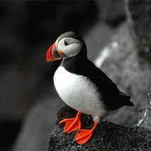 | - North Devon
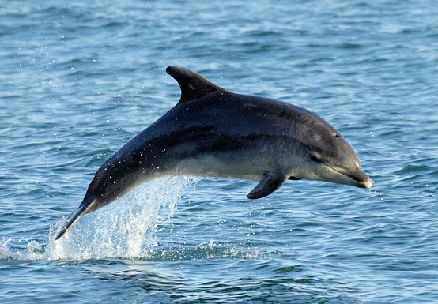  Bottlenose Dolphin | - St. Ives
Chough  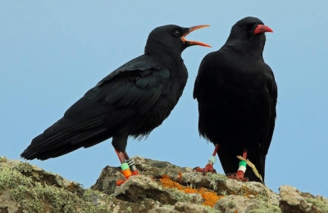 | - The Lizard Peninsula  - Coast path from Porthgwarra to Lands End
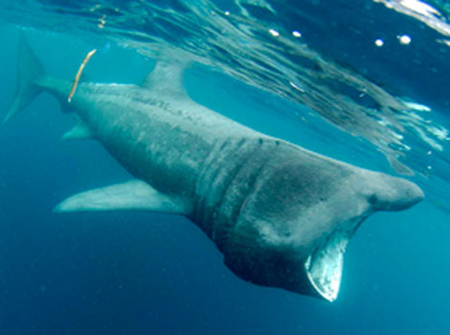  Basking shark | - Lizard Peninsula
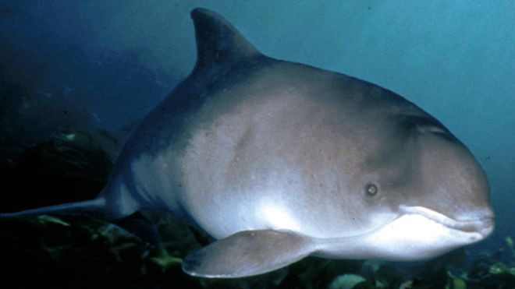  Harbour Porpoise | - Mount’s Bay, Penzance
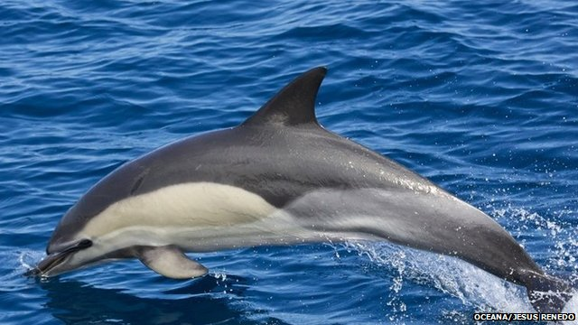  Common Dolphin | - Cornish Coast
Lotus corniculatus  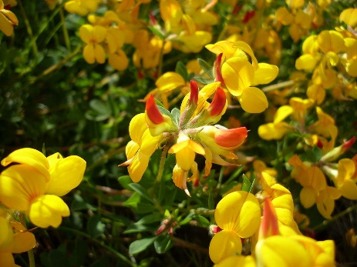 | - Cornwall coast path
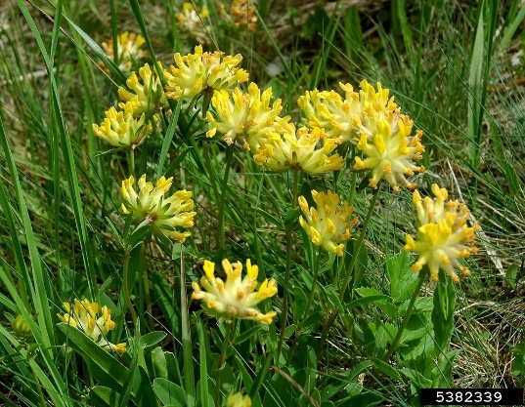  Anthyllis vulneraria (also known as Kidney Fetch) | - Cornwall coast path
Bulbous Buttercup  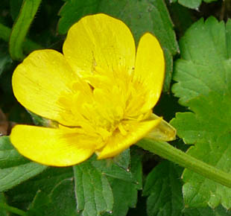 | - Cornwall coast path

The plan for our expedition was to walk along the South West Coastal Path from St.Ives to Lands End. We wanted to run the expedition over five days from Friday 30th March to Tuesday 3rd April. The first day of the expedition and the last day would have been spent traveling down and back from Cornwall. For the first day of waking we planned to walk from Rosemergy carpark (SW 422 365) in St. Ives to Botallack campsite (SW 374 337) for the first day we would have walked 6.7km, on the second day of walking on our expedition we planned to walk to St Just Campsite in Crippas Hill (SW 375 302), during this day we would have covered 7.9km. On the final day of the expedition we planned to walk 9.4km which would have been the longest distance we would have covered during the expedition. We would then finish at Sea View Holiday Park campsite in Lands End (SW 358 251) and spend the night there before we would have returned back to Carmarthen. Throughout our expedition I was going to focus on the environmental aspects of the South West Coastal path, Vanessa was going to look at the history of Cornwall, so we planned to walk to 2 mines during our expedition to experience first-hand some of the history of Cornwall.
When analysing my expedition plan and looking over it there are many strengths in the plan however there are also many weaknesses and things that I would definitely change and research more for when I plan an expedition in the future, below are the strengths and weaknesses of my expedition plan.
Strengths of my expedition plan:
- I had a clear idea of my objectives which I aimed to complete throughout the expedition
- Two of my objectives for my expedition related to encouraging individuals to participate in outdoor education and to show them how accessible the outdoors is to everyone. I believe this is an important thing to encourage as both of the participants who were going to take part in our expedition are at university training to be teachers and it is important for future teachers to develop a passion for outdoor education, this was also an aim for our expedition.
- I had everything needed to run an expedition, such as route card, kit list, behavioural forms signed by our participants, a training timeline to make sure our participants were fit and capable of our expedition, medical declaration and assumption of risk forms signed by both Molly and Dan and finally site specific and generic risk assessments.
- Another strength of my expedition plan was that we had including an ‘participants helpful bag”, the bag was going to include a bivi bag, I spy chart, camel pack and a how to pack a bag sheet. We believed that this would help our participants experience on our expedition as they would be better equipped, and this could also minimise some risk as their bags would be packed properly decreasing the chance of back injury, they would have had a bivi bag in case of emergency and a camel pack to keep hydrated.
- Additional a strength of my expedition plan was the location of our expedition. As we planned for our expedition along the coast path from St. Ives to Lands End this is a very aesthetically pleasing location and the walk is very scenic as it is on the coast path. As the participants that we were going to take on our expedition haven’t done much walking we thought that the a scenic walk with a lot to look at would be ideal for them. In the ‘journal of adventure education and outdoor learning’ (2004) Kennedy says that ‘The power and beauty of wild places may have a profound effect on young people and their sense of vulnerability, while they may take little notice of the natural environment when they are home (Kennedy, 1992)
Weaknesses of my expedition plan:
- Even though we planned the expedition we didn’t run our reconnaissance as the weather wasn’t very safe for us to drive up to Cornwall. Although we had planned where to camp on three of our nights during our expedition we still needed to talk to the National Trust about wild camping on their land on the first night of the expedition and to walk our planned route to make sure it was capable for our participants and safe.
- Another weakness in my expedition plan was that I had done the route cards based on an online map due to not doing the reconnaissance nothing was too accurate as the campsites we put down on our route cards we hadn’t checked if we were able to stay at them.
- My first objective for the expedition was “to explore environmental aspects of a coastal path in Britain”, I believe that this objective could be improved on as I haven’t put a specific place and only Britain. With my objective saying “to explore environmental aspects” I once again am not being specific towards my intentions for my expedition.
- One of the weaknesses in the planned expedition was our training days, even though we had planned them we never executed the training days which meant as leaders we wouldn’t of known the level of ability of our participants and we would only of found it out once we got to Cornwall. This is both unsafe and unfair on the participants as we could push them too hard and get injured or if one is more capable than the other the other may get discouraged, ‘In urban life this relationship between rewards and effort may be complex, and in some instance, disheartening’ (Kennedy, 1992)

After the planning of my expedition I feel that there are many improvements I could make for when I plan an expedition again in the future, such as when making timeline for trainings and the reconnaissance, I need to stick to it both to ensure that I am ready for the expedition but to guarantee that the participants we are going to take are capable and prepared for the expedition. A big development I could make when planning my next expedition would to be more prepared with checking weather conditions and traffic conditions as on Tuesday 13th February Vanessa and I left Carmarthen to do our reconnaissance, however we did not look at the weather report for Cornwall or the news on the day, so we got past Swansea and turned around due to looking at the news on the way and not feeling safe to drive down to Cornwall in the weather conditions. The same day a car crash happened on the M5 at 7am and the road was still not clear when we were on the way, this was another reason as to why we turned back and decided not to go to Cornwall. By better organisation and preparation this problem could have been solved and we could have gone to do our reconnaissance another time. On the other hand, I do feel more confident now with planning an expedition and has improved my personal development with the skills needed to do so. A I am low land leader trained I hoped to of been assessed before our planned expedition date however I didn’t organise this, this was also a personal aim for me before the planned expedition.
In conclusion my expedition plan had many strengths and weaknesses, most of the weaknesses related back to a lack of organisation which is one of the main reasons our expedition from St. Ives to Lands End never took place. However I believe my aims for the expedition were relatable to the participants we were going to take on the expedition as they relate to the University courses they are doing.

Word Count: 1749

References
Knight, S. (2013). Forest School and outdoor learning in the early years. Los Angeles: SAGE
Beames, S. (2004). Journal of adventure education and outdoor learning, (4), p.5.

