CertHE Skills for the Workplace

Problem Solving and Decision Making

BMSW4004

Andrei Amzulescu-2124638

Teacher: Akinseye Aluko

Table of Contents

Introduction 3
The issues that are found in the place of work 3
Analysing Information 4
Root Cause analysis 4
Applying situational analysis models 6
SWOT analysis of Boohoo 6
PESTEL Analysis of Boohoo 7
Range of Alternative solutions 8
Evaluation of Alternative solutions 9
Implementing the solution 9
Communication plan with stakeholders 10
Monitoring and Review techniques 14
Conclusion 14
Reference 15

Introduction

UK-based Boohoo is a household name in the world of online fashion shopping because to its hip styles and affordable costs. A number of problems have arisen for the corporation in recent years, however, such as allegations of unethical business practices in the supply chain and unfair employment policies. As a result, Boohoo has committed to implementing new ethical and environmental practices throughout the company, including a sustainability strategy and supply chain initiative. The purpose of this research is to evaluate Boohoo's sustainability strategy and provide suggestions for how the firm can better prioritize ethical and environmentally responsible business practices. The study will start with an overview of the problems found within the company's workplace and supply chain, then move on to an analysis of Boohoo's SWOT and PESTEL strengths, weaknesses, opportunities, and threats within the broader business environment. The report will then detail a plethora of choices and, using a rating system, suggest a final selection. The report will conclude with an action plan for achieving Boohoo's sustainable objectives and an explanation of how the company intends to get the word out.

The issues that are found in the place of work

Investigations indicated that factory workers were paid less than the minimum wage and were exposed to unsafe working conditions. Labor exploitation allegations have been levied against the supply chain of Boohoo, including its factories in Leicester, UK. Another accusation made against the company was that it did not take enough measures to protect its staff from the COVID-19 infection (Cirrincione, et al., 2022). The difficulties were believed to be particularly pervasive in the garment industry, where workers were paid by the piece, which resulted in long hours for inadequate compensation. It was speculated that the problems were caused by the fact that employees were paid by the piece. According to the claims, workers' health and safety were placed in jeopardy since they were apparently compelled to continue working during lockdowns, which put them in risk.
As a direct consequence of these allegations, a few major retailers have discontinued the sale of Boohoo products, and there have been several demands for a general boycott of the firm. In order to accomplish this goal, Boohoo has committed to expanding the monitoring of its supply chain and constructing more facilities in the UK. There is potential for improvement across the board in the company's supply-chain operations, as discovered by an independent audit (Jarah, et al., 2022). In any event, the event has brought to light the need for more transparency and accountability in supply chains, in addition to concerns over labor abuses in the fashion industry more broadly.

Analyzing Information

Root Cause analysis
Getting to the bottom of what's going wrong may be accomplished via a process called a root cause analysis. The employment breaches committed by Boohoo were caused by a number of circumstances, one of which was insufficient monitoring. The following is a list of six probable causes and the effects of those causes.
Cost-cutting measures:
These strategies of cost reduction at Boohoo are the direct outcome of the company's dedication to its business strategy of rapid fashion at low prices. As a consequence of this, it would seem that the company has prioritized cost reduction above the upkeep of ethical working conditions in the workplace (CIPD, 2022). A reduction in wages, an increase in the number of hours worked per week, and unsafe working conditions are all potential effects of cost-cutting tactics used throughout the supply chain.
Lack of oversight:
It's possible that Boohoo has outgrown its ability to maintain a tight check on its supply chain due to the quick pace of its business expansion. Due to a lack of management, it is probable that third-party suppliers and subcontractors took advantage of Boohoo's workers without the company's knowledge. Abuse of workers might continue without the management even seeing it when there is a lack of oversight.
Pressure to meet demand:
The capacity of the online shop Boohoo to quickly produce and supply new products in response to altering fashion trends is essential to the company's success. It puts pressure on suppliers and subcontractors to keep up with production timelines, which may lead to them adopting shortcuts in order to alleviate the tension. Workers might be vulnerable to labour abuses if they are coerced into working at a quicker pace and for longer hours in order to meet production deadlines as a direct consequence of the pressure to fulfil demand.
Lack of transparency:
The supply chain for Boohoo is rather vast, consisting of many tiers of subcontractors and suppliers; nevertheless, the firm does not reveal the nature of these business connections. It may be more difficult to identify and put a stop to labor abuses in the supply chain when there is a lack of visibility like this one (IFG. 2022). It may be more difficult to hold suppliers and subcontractors liable for labor infractions if there is a lack of transparency.
Culture of exploitation:
The fact that Boohoo places a premium on low prices and fast fashion at the expense of its employees' legal rights may contribute to the presence of an exploitative culture within the firm. The pursuit of profit may have encouraged or allowed this culture to ignore or condone abuses of employees, and it may have also been the driving force behind these behaviors (LaGuardia, and Oelke, 2021). A culture of exploitation may develop to a work environment in which the abuse of workers is accepted or even deemed necessary to accomplish the goals of the organization. This can happen if the culture is passed down from generation to generation.
Lack of worker empowerment:
As they lacked the agency to do so, workers in Boohoo's supply chain may not have been able to successfully report labor abuse or negotiate for better working conditions. Both of these actions might have been detrimental to their working circumstances. As a consequence of this, workers may be less inclined to complain about injustices in the workplace or to negotiate for improved working conditions (Wöhrmann, and Ebner, 2021). It is possible that workers may be used and abused without ever having the ability to do something about it if they do not have the empowerment to stand up for themselves.

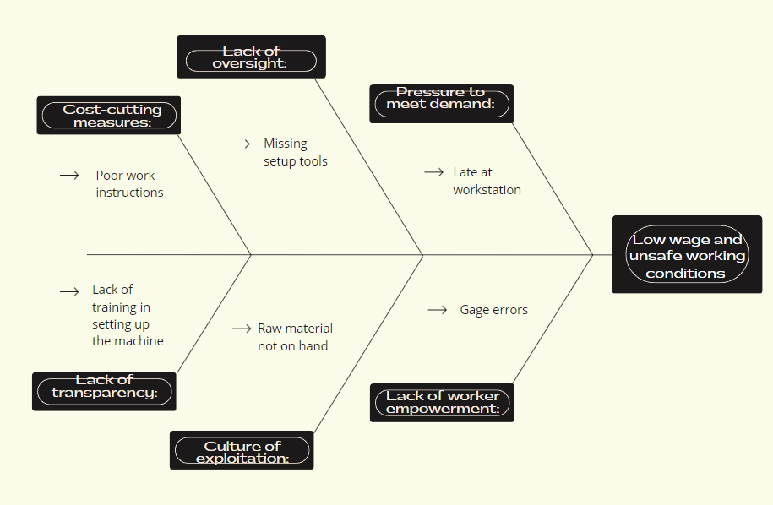
Figure 1: Fishbone Diagram
(Source: Created by learner)

Applying situational analysis models

SWOT analysis of Boohoo
The online clothes retailer Boohoo is developing quickly. A SWOT analysis may be used to create a map of the company's strengths, weaknesses, opportunities, and threats.
Strengths:
The fast fashion business model on which Boohoo was founded allows the brand to quickly adjust to the changing tastes of its clientele.
Boohoo is widely recognized as one of the best places to shop for clothes online.
Boohoo has attracted a diverse clientele because to their extensive collection of men's and women's clothing and accessories (Boohoo, 2023).
Because of its vertically integrated supply chain, Boohoo is able to rapidly produce and dispatch its products.
Weaknesses:
Claims of labor breaches in its supply chain have damaged Boohoo's reputation and led to product bans and boycotts.
Boohoo may not be able to withstand economic downturns or changes in client tastes in the United Kingdom due to its reliance on that market (Boohoo, 2023).
Boohoo's decision to operate only online might alienate customers who prefer shopping in traditional stores.
Opportunities:
Expanding Boohoo's customer base and expanding into new international markets are both attractive areas for expansion.
Boohoo may capitalize on the growing interest in ethically produced clothing by implementing sustainability initiatives to improve the company's supply chain and reduce its environmental impact.
Boohoo has a track record of acquiring other fashion companies, which might help the company broaden its offerings and appeal to a larger audience (PM, 2019).
Threats:
There are plenty of other online retailers that provide women's apparel and accessories, making Boohoo's market niche more crowded.
Customers may reduce their purchases of apparel and accessories as a result of economic uncertainty.
More pressure might be put on Boohoo by regulators to resolve labour issues and improve its supply chain practices.

PESTEL Analysis of Boohoo

The PESTEL framework is used to conduct an analysis of the many aspects of a company's macroenvironment that may have an impact on the business. The following is an example of Political: Because Boohoo operates on a worldwide scale, it is subject to the laws and regulations of a number of different countries. It is possible that political unrest or shifts in government policy, such as changes in trade agreements or tariffs, may make it more difficult for Boohoo to operate effectively in particular spheres.
Economic: Expenditure by consumers and income levels that allow for discretionary expenditure are two key economic variables that significantly influence the fashion industry. The company's sales and revenues might take a hit if the economy has a downturn or recession; on the other hand, a growth of the economy could create opportunities for the company to enter new markets (Sull, and Sull, 2022).
Social: The majority of the clients Boohoo seeks to attract fall into the category of being youthful, trend-conscious, and susceptible to the sociocultural pressures that are exerted by trends and social media. Changes in customer preferences and shifts in cultural norms may have an effect on Boohoo's sales and the demand for the company's products.
Technological: As a digital firm, Boohoo is highly dependent on the development of various technologies in order to carry out its business. E-commerce platforms, smartphone apps, and social media are some examples of recent technical innovations that the company has to stay on top of in order to remain competitive and effectively communicate with the audience it seeks to serve.
Environmental: As a retailer of quick clothes, Boohoo is subject to scrutiny about the impact it has on the environment. The expanding environmental and ethical concerns of Boohoo's consumers demand that the company make adjustments, namely the implementation of new environmentally friendly practices and a reduction in waste.
Legal: Boohoo is subject to a wide variety of laws and regulations, including those that address the rights of employees and those that address the rights of customers (Boohoo, 2023). If it does not adhere to these regulations, the company puts itself in danger of facing legal and financial repercussions.

Range of Alternative solutions

Boohoo has management and labor problems, and here are three ways to fix them.
Solution 1: Implement stronger oversight and auditing of supply chain practices:
The quality of Boohoo's supply chain practices might be enhanced by the implementation of more stringent control and auditing methods. Working with suppliers to improve their treatment of workers is one option, as is using external auditors to check in on production facilities and distributors on a regular basis. Boohoo's image might be restored and the bad headlines and boycotts it has faced in the past could be avoided if the company took proactive measures to address labor violations in its supplier chain (Parkinson, and Parkinson, 2022).
Solution 2: Expand investment in sustainable and ethical practices:
As customers become more concerned about the world around them, Boohoo may decide to set itself apart by increasing its commitment to environmentally and socially responsible business practices. Waste and carbon emissions can be lowered, more eco-friendly raw materials can be used, and global labour standards can be made more uniformly fair. Boohoo can set itself apart from rivals and appeal to a niche customer base by emphasizing ethics and the environment.
Solution 3: Improve communication and engagement with employees and stakeholders:
Greater openness and communication between Boohoo and its employees and other stakeholders might improve the company's relationships with both groups (Boohoo, 2023). One strategy is to make it easier for workers and other interested parties to provide feedback and voice concerns about the company's policies and procedures. An improvement in Boohoo's culture may result from more internal and external communication and participation.

Evaluation of Alternative solutions

Weighted decisions making matrix:
When there are several options to choose from, it might be useful to develop a weighted decision matrix to evaluate how each factor impacts the final outcome. The following is an example of a decision matrix that might be used to weigh the benefits and drawbacks of potential solutions to Boohoo's management and employee issues.

 | Weight | Motivate the staff | A place where people may talk freely and openly about their health | Flextime
Finance Management | 3 | 15 | 12 | 9
Trust Building | 5 | 20 | 25 | 20
Employee Programs | 4 | 12 | 20 | 8
Uplifting | 5 | 5 | 10 | 25

Implementing the solution
Activities | 1st to 3rd week | 3rd to 6th week | 6th to 9th week | 9th to 12th week | 12th to 15th week
Conduct a comprehensive sustainability assessment
Establish sustainability goals and targets
Partner with suppliers to improve labor practices:
Implementation of technology
Table 1: Gantt Chart

Communication plan with stakeholders

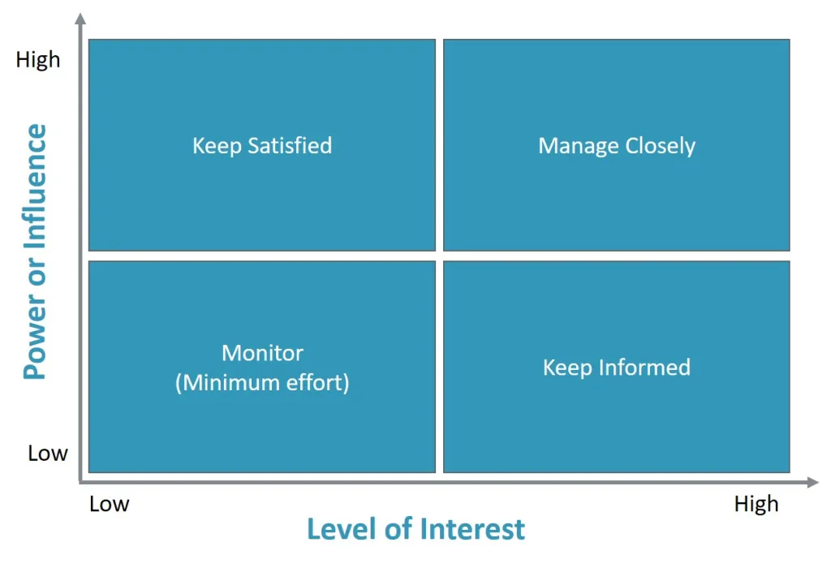
Figure 1: Stakeholder’s Power Interest Matrix
(Source: self-created)

Identify stakeholders: The first step in creating a communication plan is to identify the specific groups within Boohoo that the company hopes to reach. Stakeholders may be everything from consumers to employees to investors to suppliers to lobbying groups.
Develop key messages: Come up with interesting ways to spread the word about Boohoo's green initiatives (Brydges, et al., 2022). Boohoo has to develop engaging communications to share the company's sustainability objectives and initiatives. It's important to showcase the company's commitment to sustainability and ethics, as well as its progress towards sustainability targets.
Choose communication channels: Boohoo has to choose the best methods of reaching out to the company's constituents for communicating with them (Atherton, 2019). This includes social media like Twitter and Facebook as well as electronic newsletters, press releases, and sustainability reports. Selecting the best mediums for communicating with your target audiences can increase the effectiveness of your message.
Schedule communication activities: Boohoo must establish a regular calendar of communication activities to keep its stakeholders informed and interested. Reports on sustainability, online blogs, and electronic newsletters are all examples. By organizing regular communication initiatives, Boohoo can keep its stakeholders abreast of the company's sustainability efforts and achievements (Boohoo, 2023).
Engage with stakeholders: Through various channels, Boohoo reaches out to its community for feedback and assistance as part of their "stakeholder engagement" strategy (Boohoo, 2023). Stakeholders may be communicated with either online (through social media) or offline (by surveys and meetings).
Measure and evaluate impact: Boohoo should evaluate and study the results of its communication strategy to make sure it achieves its aims of involving and informing stakeholders. There are a variety of techniques to gauge stakeholders' familiarity with and enthusiasm for an organization's sustainability efforts, including surveys and the tracking of engagement metrics like social media likes, shares, and comments (Atherton, 2019).
Stakeholder | Power/Interest | Key interest & issues | Communication vehicle | Frequency | Comments
Employees | High | Employees want fair wages, employment stability, and a friendly workplace. | e-mails | Really frequent | Career progression and training may interest employees. Labor breaches, discrimination, and dangerous workplaces may impact workers.
Customers | High | Customers want affordable, high-quality items. | Social media | As frequent as possible | They may also care about the ethics and sustainability of their vendors. Product quality, cost, and environmental and social effect may influence buyers.
Government bodies | Medium | Governments: Governments want corporations to follow labor, environmental, and consumer rules. | Press release | Once in half a year | Environmental, labor, and regulatory infractions may hurt governments.
Suppliers | Low | Suppliers want fair business practices, fast payment, and a solid client base. | Calls, emails and direct communication | Every month at a time | Late payments, supply chain problems, and price demands might damage suppliers.
Investors | Low | Investors care about a company's finances, growth, sustainability, and ethics. | Communication in the board meetings | Once a year | Investor concerns include financial mismanagement, brand harm, and environmental or social effect.
Table 2: Communication Plan
(Source: Self-created)

Monitoring and Review techniques
The ADKAR model is a useful instrument for change management that may be used to monitor and assess the efficacy of ongoing change initiatives. The following techniques of review and monitoring may be used at various stages of the ADKAR model:

Awareness
Boohoo may measure familiarity with the program by keeping track of how many employees have received training on sustainability initiatives and how well they understand the program's goals and objectives (Cohen, et al., 2022).
Desire
In order to gauge how strongly employees feel about contributing to sustainability initiatives, Boohoo may conduct surveys or interviews to gauge employee interest.
Knowledge
Boohoo may evaluate employees' understanding of sustainability-related processes and procedures, such as those for reducing waste and conserving energy.
Ability
Boohoo is able to determine the extent to which its sustainability goals are being met by monitoring the behavior of its employees (Boohoo, 2022).
Reinforcement
Boohoo may monitor the benefits of reinforcement over time by analyzing sustainability performance measures like energy use or garbage reduction.

Conclusion
In light of the difficulties it has encountered, Boohoo has made significant strides towards more sustainable and ethical business practices. This research has identified many key avenues for future growth for Boohoo by assessing the company's problems and the broader business environment. If Boohoo adopts the suggested alterations and maintains the predetermined communication strategy, it may improve its standing as a socially responsible business and regain the support of its constituents. Long-term success is possible for Boohoo if it places a premium on sustainability and ethical business practices, which will also contribute to a more sustainable fashion sector.
Reference
Atherton, J., 2019. Social media strategy: A practical guide to social media marketing and customer engagement. Kogan Page Publishers.
Boohoo,(2022), “OUR SUSTAINABILITY PLAN”, Available at: https://www.boohoo.com/page/sustainability-guide.html
Boohoo,(2023),“About Boohoo Group”, Available at: https://www.boohooplc.com/investors/about-us
Brydges, T., Henninger, C.E. and Hanlon, M.,(2022). Selling sustainability: Investigating how Swedish fashion brands communicate sustainability to consumers. Sustainability: Science, Practice and Policy, 18(1), pp.357-370.
CIPD, (2022), “Ethical practice and the role of people professionals”, Available at:https://www.cipd.co.uk/knowledge/culture/ethics/role-hr-factsheet#gref
Cirrincione, L., Plescia, F., Ledda, C., Rapisarda, V., Martorana, D., Lacca, G., Argo, A., Zerbo, S., Vitale, E., Vinnikov, D. and Cannizzaro, E.,(2022). COVID-19 pandemic: New prevention and protection measures. Sustainability, 14(8), p.4766.
Cohen, D., Nelson, S. and Rosenman, E.,(2022). Reparative accumulation? Financial risk and investment across socio-environmental crises.
IFG,(2022),“Supply chain problems”, Available at: https://www.instituteforgovernment.org.uk/explainer/supply-chain-problems
Jarah, B., Jarrah, M. and Al-Zaqeba, M.,(2022). The role of internal audit in improving supply chain management in shipping companies. Uncertain Supply Chain Management, 10(3), pp.1023-1028.
LaGuardia, M. and Oelke, N.D.,(2021). The impacts of organizational culture and neoliberal ideology on the continued existence of incivility and bullying in healthcare institutions: A discussion paper. International journal of nursing sciences, 8(3), pp.361-366.
PM,(2019), “How Boohoo have cornered the ‘fast fashion’ online market.”, Available at: https://www.purposemedia.co.uk/insights/how-boohoo-have-cornered-the-fast-fashion-online-market/
Parkinson, S. and Parkinson, M.M.,(2022). Recognizing and Dealing with Business Distress. In Recognizing and Dealing with Business Distress. De Gruyter.
Sull, D. and Sull, C.,(2022). Preparing Your Company for the Next Recession. MIT Sloan Management Review.
Wöhrmann, A.M. and Ebner, C.,(2021). Understanding the bright side and the dark side of telework: An empirical analysis of working conditions and psychosomatic health complaints. New Technology, Work and Employment, 36(3), pp.348-370.

