BCc Heath & Social Care
Module: Changemakers: Creativity and Value Creation
Module Code: BMHP5014
Lecturer: Alice Clayton
Component 2: Written Assignment Poster & Pitch
Shanice Clarke
2328766

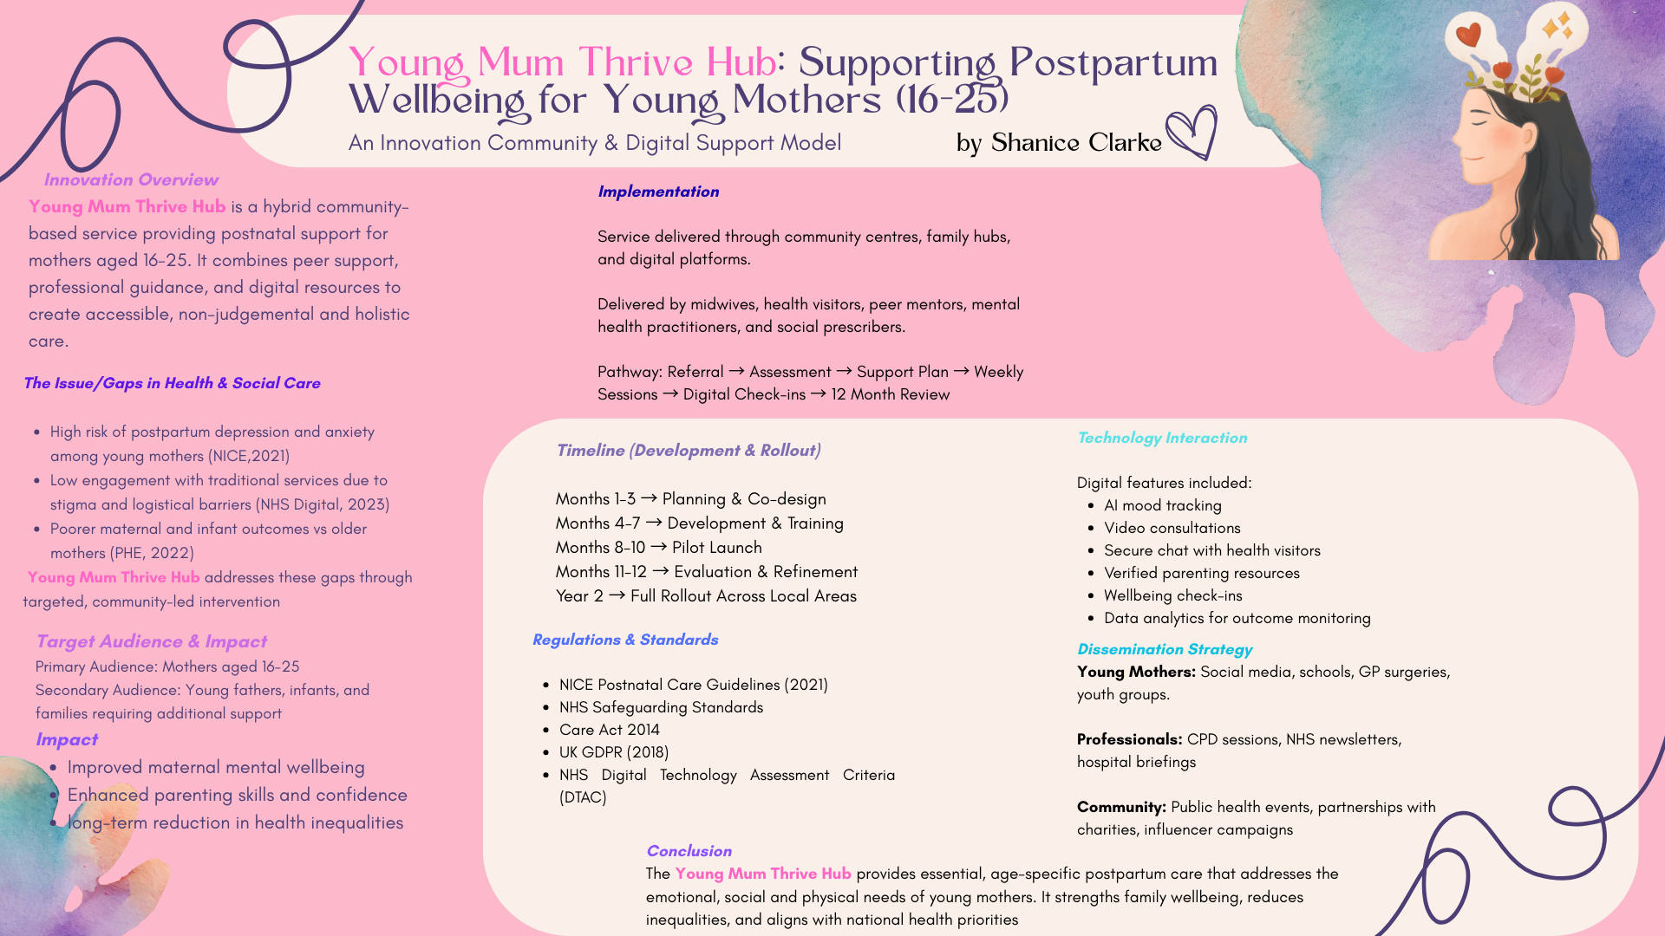

Young Mum Thrive Hub: Supporting Postpartum Wellbeing for Young Mothers (Aged 16-25)

Innovation Overview
The Young Mum Thrive Hub is an innovative hybrid support initiative designed to improve postpartum wellbeing for young mothers aged 16-25 within the local community. The Hub integrates in-person peer support, professional guidance and digital health technology to create an accessible, stigma-free and holistic support pathway for young mothers during the first 12 months after childbirth. Young mothers often experience emotional, social and practical challenges that can make the postpartum period especially overwhelming. This initiative responds by providing personalised support plans, flexible appointment options and a dedicated digital wellbeing platform that ensures continuous care, helping young mothers feel empowered, confident and connected throughout early motherhood.

The Issue/Gaps in Health & Social Care
Young mothers are among the groups most vulnerable to postpartum mental health challenges. According to NICE (2021), individuals under 25 face significantly higher rates of postpartum depression, anxiety, and social isolation compared to older mothers. NHS Digital (2023) also reports that young mothers attend fewer postnatal appointments and are less likely to seek help early. Many young mothers report feeling judged due to their age, which discourages them from accessing formal support (Public Health England, 2022). This stigma, combined with practical barriers such childcare responsibilities, financial limitations, and limited transport which means that young mothers often struggle to engage with existing services available to them. Research from the Department of Health and Social Care (2020) shows that targets, relationship-based interventions in the early years are associated with improved maternal wellbeing, strong parent-infant attachment, and long-term reductions in health inequalities.

Target Audience & Impact
The primary beneficiaries of the Young Mum Thrive Hub are young mothers aged 16-25 living in underserved communities. This demographic often includes individuals from lower-income households, care-experienced young women, those limited to family support, and young people balancing education or employment with caregiving responsibilities.

Secondary beneficiaries include:
- Infant aged 0-12 months
- Young fathers and partners
- Families requiring multi-agency support
- Local health and social care services
- The community as a whole

Adequate postpartum support has been linked to better family resilience, better bonding, less mental health problems, and healthier infant development (DHSC,2020). Thus, helping young mums promotes both individual well-being and long-term societal advantages like lower healthcare expenses, more educational achievement, and better community cohesion.

Implementation: How and Where the Hub Will Function

The Hub will operate across local community centres, NHS family hubs, youth services and partner charities, ensuring accessibility. A complementary digital platform and mobile app extend support to those unable to attend in-person sessions due to childcare, mobility issues or anxiety.
Delivery will be shared across key professionals:
- Midwives and health visitors will provide clinical guidance and safeguarding support (HM Government, 2023).
- Peer mentors, with lived experience of young motherhood will facilitate group sessions.
- Mental Health practitioners will offer emotional wellbeing support
- Social prescribers will link families to education, financial advice and housing support.
- Digital Heath team will maintain the app safety, accessibility and compliance.

Continuity and significant engagement are ensured by the phased support pathway, which includes an introduction, assessment, personalised care plan, group sessions, digital check-ins, and a structured 12-month review to monitor progress and outcomes.

Timeline (Development & Rollout)
Months 1-3: Planning and co-design. This phase involves engaging young mothers, recruiting stakeholders and developing programme content
Months 4-7: Development. Digital tools are created, peer mentor training begins, and professional resources are produced.
Months 8-10: Pilot Launch. The Hub runs into two community locations, allowing testing of both digital and in-person services.
Months 11-12: Evaluation and refinement. Data is collected to assess engagement, wellbeing outcomes and satisfaction.
Year 2: Full rollout across local area supported by a multi-channel marketing and outreach campaign.

Regulations and Standards.
The Thrive Hub is fully aligned with the UK Health and Social Care frameworks ensuring safety, quality and compliance. The initiative supports national guidelines such as:

NICE Postnatal Care Quality Standard (QS37) including maternal health and infant wellbeing (NICE,2021).
Care Act 2014, promoting wellbeing, prevention, and personalised care.
HM Government, 2023 - working together to safeguard children for protecting vulnerable parents and infants
Health and Social Care Act 2012 – safeguarding and integrated working.

The digital components fully comply with:
UK GDPR and Data Protection Act 2018, ensuring safe data storage, digital privacy and confidentiality
NHS Digital Technology Assessment Criteria (DTAC) – ensuring accessible, safe and clinically validated digital tools (NHS England, 2022).

Technology Integration
Technology is a core component of the Young Mum Thrive Hub. The secure mobile app provides daily mood tracking supported by AI prompts, wellbeing check-ins, access to evidence-based infant-care information, appointment reminders, video consultations and a secure chat system connecting young mothers with trained professionals. The platform also uses anonymised data analytics to identify trends such as engagement levels or early indicators of mental health concerns, allowing timely professional intervention and service improvements.

Dissemination Strategy
To reach young mothers effectively, the initiative will use youth-friendly communication channels such as Instagram, TikTok and Snapchat. Posters will be placed in GP surgeries, maternity units, secondary schools and colleges. Outreach workers will visit youth groups, early help teams and social care services.
To engage health and social care professionals, the Hub will host CPD Workshops, contribute to NHS newsletters and arrange presentations at midwifery and health-visitor team meetings. For wider community engagement, the programme will collaborate with local councils, public health events, children’s charities and online influencers who advocate maternal mental health. These activities will help raise awareness, reduce stigma and encourage public participation in supporting young families.

Conclusion
The Young Mum Thrive Hub offers a transformative model of postpartum support for young mothers aged 16-25. By integrating community-based care, professional expertise and digital technology, it responds directly to national health priorities and longstanding gaps in provision. Its holistic, preventative and inclusive approach supports maternal mental health, infant wellbeing and long-term social outcomes. This innovation not only uplifts young families but strengthens the wider community, embodies the principles of the common good and contributes to a fairer health and social care system.

Reference List

- Barnardo’s (2023) Supporting Young Parents.
- https://www.barnardos.org.uk

- Care Act (2014) Care Act 2014.

- Department of Health and Social Care (DHSC) (2020) Best Start for Life: Early Years Review. London: DHSC.

- HM Government (2023) Working Together to Safeguard Children.

- NHS Digital (2023) Maternity Services Monthly Statistics.
Available at: https://digital.nhs.uk

- NHS England (2022) Digital Technology Assessment Criteria (DTAC).
Available at: https://www.england.nhs.uk

- NICE (2021) Postnatal Care (NG194). National Institute for Health and Care Excellence.
Available at: https://www.nice.org.uk

- NSPCC (2022) Young Parents Support Overview.
Available at: https://learning.nspcc.org.uk

- Public Health England (2022) Health of Young Mothers in the UK – Annual Review.
Available at: https://www.gov.uk/phe
- UK GDPR (2018) General Data Protection Regulation.

