Student Name: Alina Boestean
Student Number: 2207646
Module Code: BMIH5006
Module Name: Sustainable Hospitality & Tourism Management
Lecturer’s Name: Julia Ault

Table of Contents
1 Introduction 3
2 Sustainable Accreditation Requirements 3
3 Benefits of Integrating Sustainability 6
4 Challenges of Sustainability Integration 8
5 Future Trends in the Hotel & Hospitality Industry 10
6 Recommendations 12
7 Conclusion 13
8 References 14

Introduction
The green culture paradigm shift can be attributed to the increasing consciousness of providers to contain their impact on nature and embrace principles that support the protection of the environment. Fundamental to this movement is the process of eco-certification, which is underlined by such prestigious accreditations as the Green Key certificate. These are some of the certifications to show the level of commitment towards sustainable operations that involve conservation of resources, reduction of pollution and optimization of operations. The Savoy Hotel in London is the hotel that is selected for better analysis and developing good understanding. Being one of the finest hotels in the world with quality services, the Savoy has integrated measures to curtail the effects on the environment. By reflecting on the developmental process of other similar hospitality businesses such as The Savoy, this assessment obtained some understanding of the relatively nascent contextual field of environmental sustainability and luxury hospitality.

Sustainable Accreditation Requirements
According to DA Tasci (2017), the pursuit of sustainable accreditation, which has become more noticeable in the hotel and hospitality industry, shows that there is more consciousness and concern for the environment and people. The most famous one is the Green Key certificate, signifying that the hotel will protect the environment in any possible way. According to Booking. According to the 2023 Sustainable Travel Report, there are a few advantages hotel operators can get from sustainability certification. Such benefits include attracting tourists who are fully supportive of sustainable initiatives and cost efficiencies. Most respondents to the survey said they are open to booking travel options with sustainable certification.
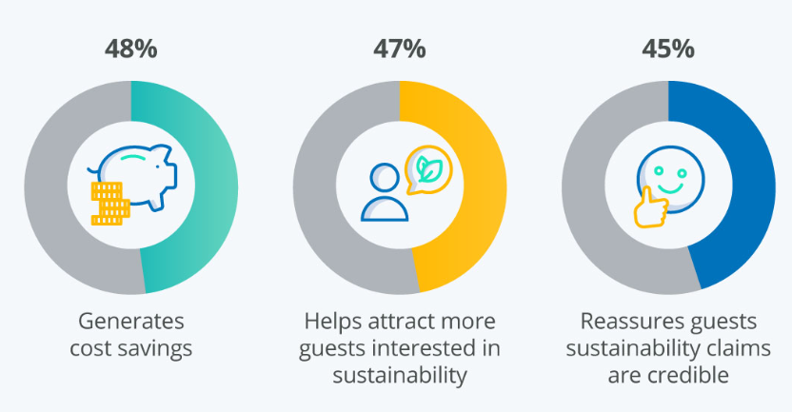
Figure 1: Being Sustainable Benefits Accommodation Providers in More Ways Than One
Source: Statista, 2023
The Savoy, London, has earned an ECOsmart Platinum accreditation, which is awarded to a limited number of companies and organizations that are committed to preserving the environment. Working with ecoSPIRITSTM (The Savoy, 2024), The Savoy has declined packaging waste and carbon emissions by adopting closed-loop systems as part of sustainable practice. The elements and framework of sustainability accreditation include various areas of operations that a hotel engages in, such as energy conservation, waste disposal, social compliance, and stakeholder involvement (Dos Santos et al., 2017). As per the 2023 Sustainable Travel Report from Booking.com, travellers are considering environmentally conscious travel options for their next vacations. Most respondents said that they are interested in travel choices with sustainable certification and that they prefer additional details regarding the certification procedure.
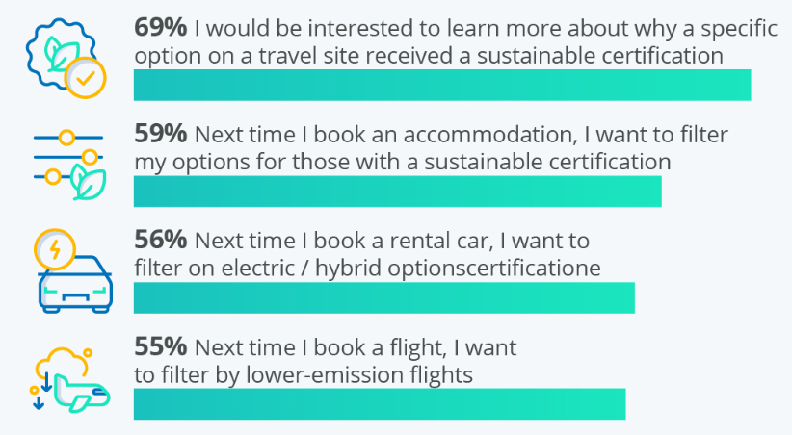
Figure 2: Most Travelers Consider Sustainability Certifications When Planning Their Next Trip
Source: 2023b
The Savoy has adopted the Sustainable process including the Green Clean program that focuses on energy and waste minimization. Also, there is a supplier and provider relationship, which ensures that sustainable materials and service providers are hired (Sehnem and Oliveira, 2017). Due to these complementarities, The Savoy aligns with the United Nations Sustainable Development Goals (UN SDGs) as a part of sustainability (The Savoy, 2023). Analyzing the above requirement of accreditation across different hotel chains enables a comparison of the approach towards sustainable development within the hotel industry. Marriott, a prominent global hotel brand, has implemented its sustainability initiatives under the umbrella of its Serve 360 (Marriott, 2024). This new direction is also referred to as the Doing Good in Every Direction platform (Marriott, 2021). At Marriott, accreditation centres on areas such as energy use, management of waste and responsible sourcing bearing in mind the corporate sustainability ideals.
Likewise, Hilton Hotels & Resorts has also made efforts towards sustainable development through the Travel with Purpose approach for social as well as environmental impacts (Hilton, 2024). Possible accreditation standards that Hilton is subjected to include the construction and design of a certain building, the use of water, and the interaction with the community. In the view of Jensen et al. (2018), different big chain hotels and umbrella bodies of accommodation have different approaches towards achieving sustainable accreditation as their brand or organizations afford those different strategies, design and functionality. For instance, boutique hotels adopt and promote sustainability through local sourcing of materials, handmade furniture, and individualized customer attention.

Benefits of Integrating Sustainability
Kuo et al. (2022) described that the incorporation of sustainability has numerous advantages that help conserve natural resources, maintain efficient operations, and create a good image of the hotels. Between July 2019 and July 2022, an online survey was conducted to find out if travellers in the UK were choosing eco-friendly lodgings to minimize their impact on the environment. The proportion of travellers considering staying at environmentally friendly hotels has grown over the past two years, reaching 37% in 2022.
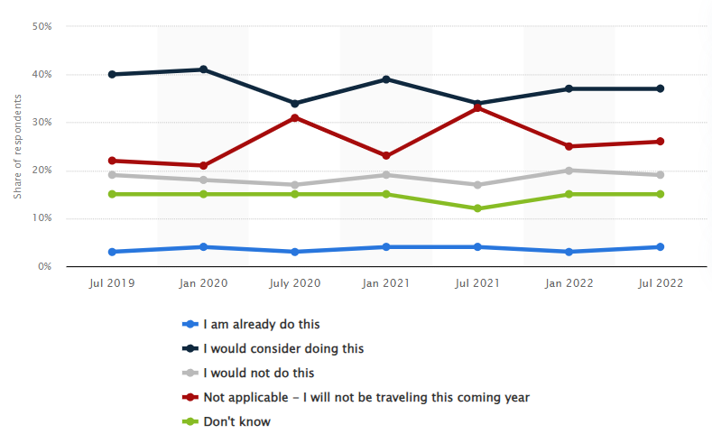
Figure 3: Travelers choosing green hotels to reduce environmental impact in the UK 2019-2022
Source: Statista, 2023a
In The Savoy, London, there are numerous sustainable practices illustrating the best way to reduce the negative effects on the environment and give the luxurious feel of the hotel. The Savoy's sustainable practices include abolishing single-use plastics, sourcing renewable energy, and implementing low-waste packaging in partnership with ecoSPIRITS™ among others (The Savoy, 2024a). Energy-efficient lighting, the use of recycled water in their amenities, and sourcing food from local farms that provide seasonal produce also manifest the hotel's commitment to sustainability. Through the calculation of the energy and water intensity, including audits, The Savoy has close control of operational variance.
Furthermore, awareness of obtaining Green Key certification proves that The Savoy is ready to protect the environment. This noble accreditation ensures that the company has complied with certain principles on energy and water usage, waste reduction, environmental purchasing, and management of environmental policies. In this way, The Savoy proves its adherence to these standards and acts as a model of successive sustainable management in the field of hospitality business and, thus, offers a competitive advantage. Reduced emission of pollution is another benefit of implementing sustainability in the hotel business (Duric and Potočnik Topler, 2021). This is why it becomes the duty of a company like the Savoy Hotel to ensure that they minimize their carbon emissions and also operate sustainably.

Challenges of Sustainability Integration
One of these challenges is the high start-up costs that are needed to finance green technology and environmentally sustainable activities. Though such investments pay off in the long run, savings on costs and the environment, the initial capital is high. For example, implementing energy-efficient systems in existing building infrastructures or installing renewable energy equipment requires substantial capital investment (Chel and Kaushik, 2018). According to 86% of respondents as of May 2023, the cost of energy is the main challenge confronting European hotel businesses during the next six months. The overall status of the economy was ranked as the second-biggest challenge confronting the European hotel industry, at 47%.
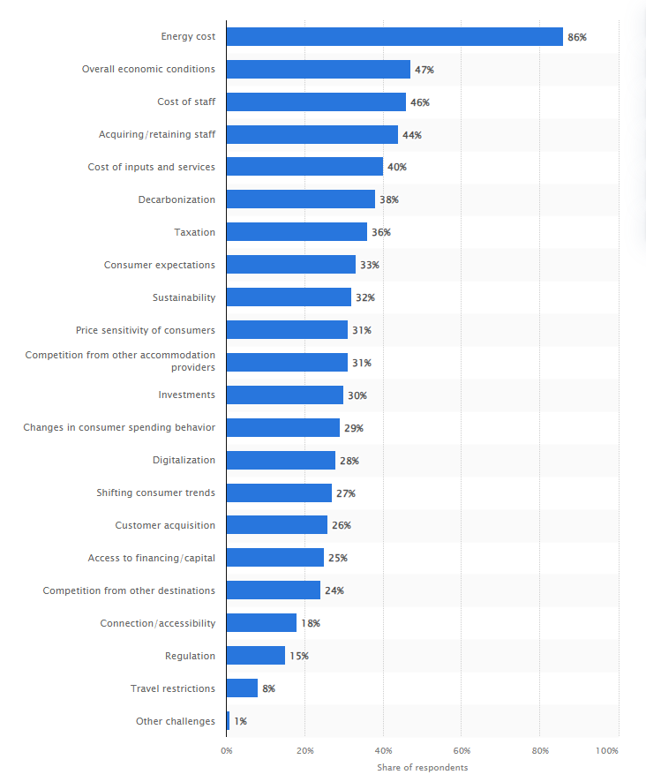
Figure 4: Top challenges expected by lodging businesses over the next six months in Europe 2023
Source: Statista, 2024
That said, accommodations, such as The Savoy, are aware that environmental responsibility is crucial and consider these costs as necessary investments for the long run. The second threat relates to the increased expectations of environmentally-conscious tourists. The more consumers come to understand the importance of sustainability in the built environment, the more they demand green services and operations (Ness and Xing, 2017). Such preferences are ever-evolving, and thus, hotels like The Savoy have to evolve as well and meet the new customer needs by providing locally grown and organic food, natural and locally produced toiletries, and energy-efficient rooms. This means that there is constant research, development, and capital investment to be ahead of consumers’ demands and be competitive in the market.
In addition, regulatory compliance has been cited as an issue facing hotels as they try to incorporate sustainability into their operations. Compliance with environmental legislations and policies is extremely challenging and time-consuming involving constant monitoring and documentation. With such responsibilities as waste disposal, energy and water conservation, a chain such as The Savoy has to contend with a myriad of local, national and international legal requirements (The Savoy, 2024c). Besides meeting legal requirements, the following of these regulations also prevents the hotel from violating environmental and ethical best practices.
Nevertheless, the future of hotels like The Savoy is not bleak, as they are taking the necessary steps and adopting new strategies to face sustainability challenges. Thus, the issue of environmental responsibility appears to be a priority for Savoy London as the company focuses on investing in sustainable solutions, meeting customer demand, and avoiding fines and other consequences of non-fulfilment of environmental standards (Savoy Signature, 2024). By evaluating potential managerial and operational actions and analyzing the risks and benefits that can result from the implementation of sustainability practices, hotels can avoid the pitfalls of embracing sustainability and gain the advantages that come with being socially and environmentally responsible.

Future Trends in the Hotel & Hospitality Industry
It is currently clear that the hotel and hospitality industry is moving toward its future path through the implementation of corporate social responsibility (CSR) and sustainability such as Caroll’s Pyramid of CSR.
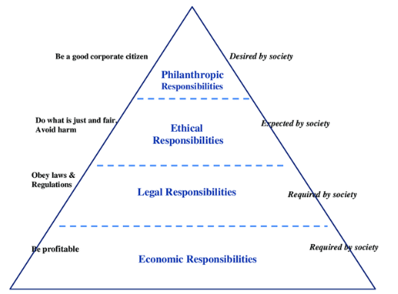
Figure 5: Carroll’s CSR Pyramid
Source: Nurunnabi et al., 2020
This is the case with hotels in the UK such as The Savoy London; companies are at the forefront of embracing social and environmental responsibilities through the incorporation of CSR perspectives in their strategic plans. For instance, the sustainable objectives and practices of The Savoy are not only limited to environmental conservation but also cover community support and charity (Weder, 2022). Apart from their sponsorship of local charities and initiatives such as Thames21, The Savoy has established its commitment towards social responsibility as well as environmental conservation.
Furthermore, there is a growing awareness of the Triple Bottom Line (TBL) a people, planet and profit approach to organisational sustainability. Many hotels are finding out that acting environmentally friendly benefits a company in the long run and the communities through which it operates.
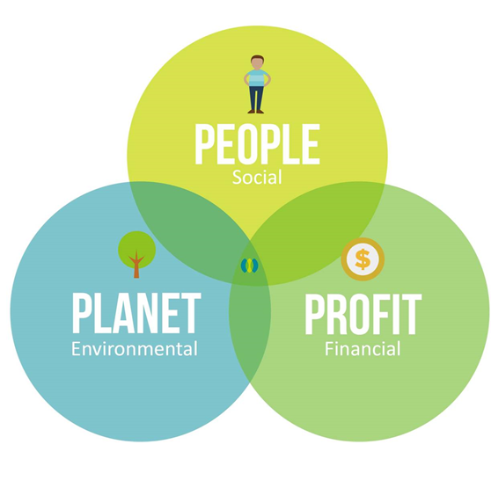
Figure 6: Triple Bottom Line (TBL)
Source: Srivastava et al., 2022
For instance, Marriott’s UK properties are making the UK hotels adopt the TBL principles by adopting energy-efficient technologies supporting the local community and promoting the same for its employees (Marriott, 2024a). It can also be rightly concluded that while addressing the TBL considerations in their operations, hotels stand a better chance of attaining the economic, environmental and social objectives as well.
In addition, the Paris Climate Agreement is critical to hotel and hospitality sustainability initiatives and objectives. This promise that seeks to ensure that the general increase in the world’s temperature remains well below 2 degrees needs to be embraced by all organizations and businesses including the hospitality industry. Lodging establishments in the UK, including the London-based properties of Hilton Worldwide, are linking their sustainability initiatives with the Paris Agreement (Hilton, 2019). Measures including carbon emission reduction, energy conservation, and encouragement of renewable energy sources are among the benchmarks that the hospitality industry is embracing to help combat climate change and attain sustainable goals.

Recommendations
- It needs to also remain committed to innovation, and promote and invest in practices and technologies that enhance its sustainability credentials further. This includes areas such as experimenting with new generations of energy sources, the application of sophisticated waste management solutions, and the use of sustainable technologies that are likely to become popular shortly.
- Sustainability needs to be communicated cross-organizationally, with guests, employees, providers, and the local community to increase awareness of sustainability problems and promote the adoption of sustainable practices at The Savoy. With the help of offering educational resources, hosting sustainability-themed activities, and encouraging environmentally friendly behaviour, the presence of the hotel can extend the scope of its sustainability efforts and encourage others to act responsibly as well (Papyrakis and Tasciotti, 2021).
- Transparency in sustainability reporting is another important aspect of the sustainability efforts of the hotel, where it needs to continuously report to its stakeholders on the sustainability milestones, successes and failures. The accurate monitoring and reporting systems methods will help in demarcating the performance indicators so that The Savoy can prove adequate corporate social responsibility as well as environmental responsibility. Moreover, the identification of clear goals and targets in compliance with international standards and frameworks will help to have accountability and to develop further sustainability considerations.

Conclusion
In a nutshell, it can be summarized that the hotel and hospitality industry in the UK, including organizations like The Savoy, is currently in the process of transitioning towards embracing sustainability and corporate social responsibility. Promoting such as eco-certification, energy-efficient technology, and outreach to the community, sustainability is progressively being incorporated into the operations of hotels. Nonetheless, with barriers for example, initial investment and compliance to regulatory requisites, frameworks such as Caroll’s Pyramid of CSR and TBL are being adopted by hotels for the realization of environmental and social value. Therefore, through innovation, stakeholder engagement, and education, hotels can advance towards greater sustainability and become models for the entire industry, their managers, and customers in the future.

References
Chel, A. and Kaushik, G., 2018. Renewable energy technologies for sustainable development of energy efficient building. Alexandria engineering journal, 57(2), pp.655-669.
DA Tasci, A., 2017. Consumer demand for sustainability benchmarks in tourism and hospitality. Tourism Review, 72(4), pp.375-391.
Dos Santos, R.A., Méxas, M.P. and Meiriño, M.J., 2017. Sustainability and hotel business: criteria for holistic, integrated and participative development. Journal of cleaner production, 142, pp.217-224.
Duric, Z. and Potočnik Topler, J., 2021. The role of performance and environmental sustainability indicators in hotel competitiveness. Sustainability, 13(12), p.6574.
Hilton 2019. 2018 Corporate Responsibility Report. [Online] Available at https://cr.hilton.com/wp-content/uploads/2019/05/Hilton-Corporate-Responsibility-2018.pdf [Accessed on 1 June 2024]
Hilton 2024. Our Approach. [Online] Available at https://esg.hilton.com/our-approach/ [Accessed on 1 June 2024]
Jensen, P.A., Maslesa, E., Berg, J.B. and Thuesen, C., 2018. 10 questions concerning sustainable building renovation. Building and Environment, 143, pp.130-137.
Kuo, F.I., Fang, W.T. and LePage, B.A., 2022. Proactive environmental strategies in the hotel industry: Eco-innovation, green competitive advantage, and green core competence. Journal of Sustainable Tourism, 30(6), pp.1240-1261.
Marriott 2021. SERVE 360 REPORT. [Online] Available at https://serve360.marriott.com/wp-content/uploads/2021/09/2021_Serve_360_Report.pdf [Accessed on 1 June 2024]
Marriott 2024. Server 360. [Online] Available at https://serve360.marriott.com/ [Accessed on 1 June 2024]
Marriott 2024a. Sustain responsible operations. [Online] Available at https://serve360.marriott.com/sustain/ [Accessed on 1 June 2024]
Ness, D.A. and Xing, K., 2017. Toward a resource‐efficient built environment: A literature review and conceptual model. Journal of Industrial Ecology, 21(3), pp.572-592.
Nurunnabi, M., Alfakhri, Y. and Alfakhri, D.H., 2020. CSR in Saudi Arabia and Carroll’s pyramid: what is ‘known’and ‘unknown’?. Journal of Marketing Communications, 26(8), pp.874-895.
Papyrakis, E. and Tasciotti, L., 2021. The economics and policies of environmental standards. Springer.
Savoy Signature 2024. Environmental Policy. [Online] Available at https://www.savoysignature.com/savoypalacehotel/en/corporate-responsibility/ [Accessed on 1 June 2024]
Sehnem, S. and Oliveira, G.P., 2017. Analysis of the supplier and agribusiness relationship. Journal of Cleaner Production, 168, pp.1335-1347.
Srivastava, A.K., Dixit, S. and Srivastava, A.A., 2022. Criticism of triple bottom line: TBL (with special reference to sustainability). Corporate reputation review, pp.1-12.
Statista 2023. Being Sustainable Benefits Accommodation Providers in More Ways Than One. [Online] Available at https://www.statista.com/chart/29876/being-sustainable-benefits-accommodation-providers/ [Accessed on 1 June 2024]
Statista 2023a. Share of travelers choosing eco-friendly hotels to reduce their environmental impact in the United Kingdom from July 2019 to July 2022. [Online] Available at https://www.statista.com/statistics/1340780/travelers-choosing-ecofriendly-hotels-uk/ [Accessed on 1 June 2024]
Statista 2023b. Most Travelers Consider Sustainability Certifications When Planning Their Next Trip. [Online] Available at https://www.statista.com/chart/29866/travelers-consider-sustainability-certifications-for-their-next-trip/ [Accessed on 1 June 2024]
Statista 2024. Main challenges expected by accommodation businesses over the next six months in Europe as of May 2023. [Online] Available at https://www.statista.com/statistics/1358403/challenges-expected-accommodation-europe/ [Accessed on 1 June 2024]
The Savoy 2023. Sustainability Report 2022-23. [Online] Available at https://savoyhotel.dk/wp-content/uploads/2024/02/Sustainability-Report-SAVOY-Hotel-2023-FINAL.pdf [Accessed on 1 June 2024]
The Savoy 2024. SUSTAINABILITY INITIATIVES. [Online] Available at https://www.thesavoylondon.com/about-us/sustainability-initiatives/ [Accessed on 1 June 2024]
The Savoy 2024a. SUSTAINABILITY. [Online] Available at https://savoyhotel.dk/sustainability/ [Accessed on 1 June 2024]
The Savoy 2024c. SUSTAINABILITY. [Online] Available at https://www.thesavoycollection.com/home/about-the-savoy-collection/sustainability-at-the-savoy/ [Accessed on 1 June 2024]
Weder, F., 2022. Strategic problematization of sustainability reframing dissent in strategic communication for transformation. Public Relations Inquiry, 11(3), pp.337-360.

