Professional Development within Health and Social Care
Name Name: Cristian Andrei Pistrescu
Student number: 2509012
The module code: LCHS4009
Assignment title: Personal Development Portfolio
Table of Contents
Task 1 4
Task 2 6
Task 3 8
Personal SWOT Analysis for the Care Assistant Role 8
b) Personal Development Plan (PDP) 9
Task 4 13
References 15
Appendix 16

List of Tables
Table 1: PDP Table 9

Task 1
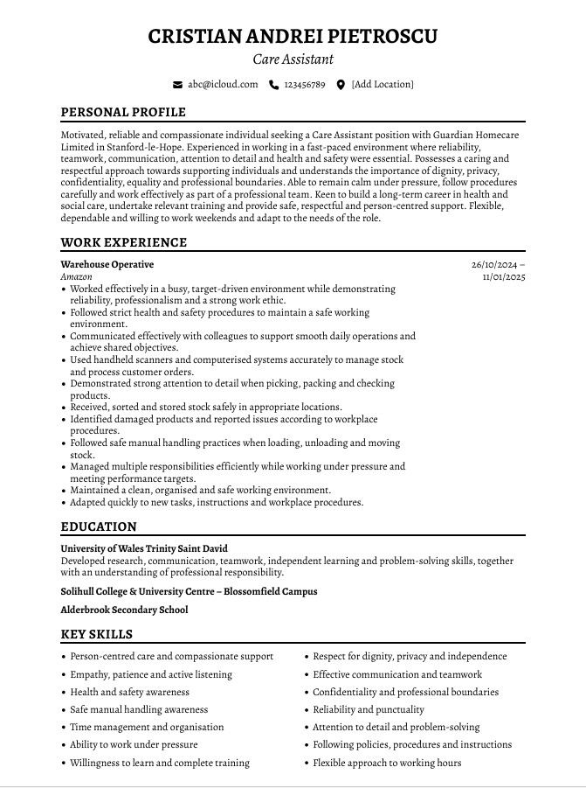
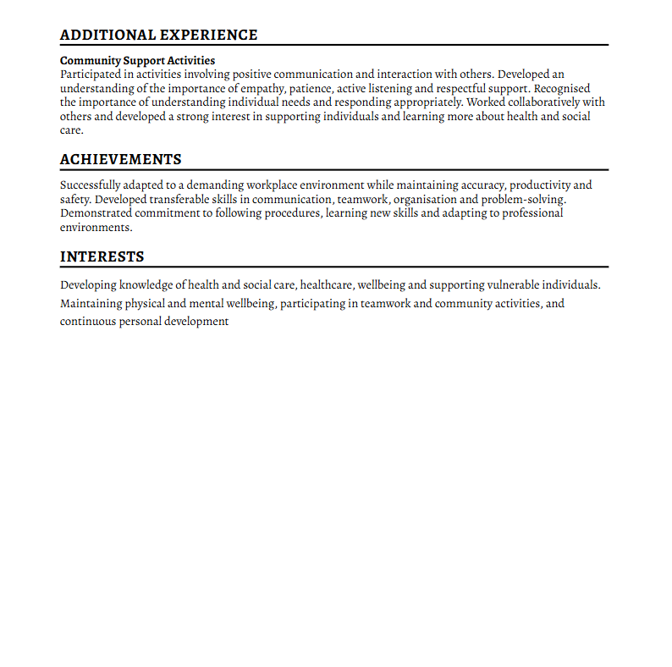

Task 2
I am seeking employment in the post of Care Assistant at Guardian Homecare Limited since I am driven to pursue a successful career in health and social care and positively transform the lives of people who need a helping hand. My long-term career goal is to grow the knowledge, practical skills, and experience required to be a good and caring care professional. My specific area of interest is in offering person-centred assistance that acknowledges the dignity, independence, privacy and personal needs of every person.
My university experience at the University of Wales Trinity Saint David has enabled me to acquire good communication, research, problem solving and independent learning abilities. I have also learned to handle tasks, work alone and serve in a team through my studies. My academic studies have enhanced my knowledge of professional responsibility and the significance of effective communication, which are extremely useful skills in a care setting (Kagonya et al, 2023). I am also eager to learn and undergo appropriate training to advance my health and social care practice.
Practices as the Warehouse Operative at Amazon have enabled me to acquire various transferable professional skills. The ability to work under pressure and be reliable, time-conscious, organised and a team worker was demanded due to working in a target-oriented and busy environment. I used health and safety procedures and workplace systems in a strict manner, and instructions were taken to the letter. These have formed my sense of detail, accountability and capability to uphold professionalism. I also learnt how to safely handle manual activities and the need to ensure a clean and safe workplace.
My general personal assets would include compassion, patience, dependability and desire to learn. I feel that good treatment needs to be empathetic, needs to be listening and respectful of each person. I can communicate positively with other people, I can be calm in difficult situations and cooperate with other people. I know the significance of confidentiality, professionalism, equality and I respect people with dignity (Hanna et al, 2022).
I feel that these qualities and skills would enable me to be a valuable contribution to Guardian Homecare Limited. I am a diligent and versatile person ready to go through training, acquire new skills and work not during regular hours, but when it is necessary to work on weekends. I would ensure that I deliver respectful, safe and supportive care, and at the same time, I would ensure that I grow professionally in the field of health and social care.

Task 3

Personal SWOT Analysis for the Care Assistant Role
Strengths
My main strength is my compassionate and respectful attitude towards supporting individuals. I also know the value of treating people with dignity, patience and kindness which are critical attributes of a Care Assistant. I have also good communication skills and listening skills which have enabled me to relate in a positive way with other people, families and co-workers. It helped to form my reliability, punctuality, teamwork, and my ability to work in a busy environment, as my past experience as a Warehouse Operative at Amazon made me organised and able to contribute to the teamwork. I have been used to observing procedures and health and safety guidelines and instructions in the workplace. My helpful behaviours, such as being a detailed person and an organiser, are helpful in accomplishing tasks correctly and in a safe working environment. I am flexible as well, capable of learning and can stay calm in stressful situations. My research, problem-solving, independent learning and professional communication skills have been enhanced by my educational experience (Cooper, 2025).
Weaknesses
My greatest weakness is that I lack formal direct experience in a formal health and social care environment. Thus, I have to acquire more practical skills of personal care, protection, care planning, infection prevention and support of individuals with various needs. I might also need someone to guide and direct me as I get used to care procedures and standards of professionalism. I also require enhancement in my self-confidence in handling difficult or emotionally tricky circumstances. Furthermore, I should acquire the necessary training and credentials which would enhance my appropriateness to the job.
Opportunities
The Care Assistant position offers a great chance to gain practical experience and qualify to an extended career in health and social care. I can acquire skills in safeguarding, first aid, moving and handling, infection control and person-centred care through workplace training, supervision and professional development. A team with seasoned professionals in the area of care would enable me to acquire their experience and expertise and enhance my practical skills. In the long run, I can also develop further qualifications and higher care positions (Bhardwaj et al, 2025).
Threats
Possible threats are the rivalry among job seekers with more direct care experience or an already existing care qualification. Care work is also emotionally and physically demanding, potentially causing difficulties, especially in cases of those with complicated needs. There is the possibility of work-life balance being compromised due to working flex hours, such as weekends. Constant learning can also be needed when there are changes in care regulations and expectations of the employers. These threats can be addressed by me with the help of training, supervision, self-reflection, overall professional standards, as well as continuing to develop my knowledge and resilience.

b) Personal Development Plan (PDP)
Table 1: PDP Table
SMART Goal | Specific Development Actions | Measurement / Success Criteria | Resources and Support | Timescale | Monitoring and Evaluation
1. Develop essential health and social care knowledge | Full employer induction and appropriate training in safeguarding, infection prevention and control, first aid, confidentiality, equality and diversity and moving and handling. Put the knowledge to the right application in day to day work. | Get at least 5 training courses that are relevant and meet the assessment or competency criteria that are required (Prisniakova et al, 2023). | Induction by the employer, training programmes, experienced colleagues and supervisor training or guidance. | Months 1–12 | Conduct the review of training certificates within three months, and communicate the progress during the supervision and performance reviews.
2. Improve practical care skills and confidence | Gain competence and experience in the giving of safe, respectful, and person-centred care through observation of effective caregivers, adherence to care plans and committing practices through practical supervision. | Diplomatic/Teamwork: Demonstrate achievement of agreed care tasks and have positive supervisor feedback on at least three formal reviews. | Placing supervision, qualified Care Assistants, care policies and role play training at work. | Months 3–18 | Keep a reflective learning journal and revisit feedback by supervisors after every three months. Discover areas in need of more practice.
3. Strengthen communication and interpersonal skills | Enhance effective listening, interpersonal and professional communication in the case of supporting service users, families, and colleagues. Train to adjust communications to personal needs. | Always get positive feedback and show increased confidence in professional dealings when the workplace is reviewed (Ocampo et al, 2025). | Supervisor feedback, reflection, practitioner training and experience observation. | Months 1–18 | Reflect fully on work each month and assess their progress by the feedback of supervision.
4. Establish long-term career progression | Consider progressing into senior care or specialist support roles and engage in regular experience as a Care Assistant, finding an appropriate healthcare qualification and becoming familiar with the responsibilities of a Care Assistant. | Satisfy at least one other relevant qualification and develop a clear progression plan in my career. | Employer assistance, training courses, career counselling and development. | Months 12–24 | Carry out semi-annual career evaluations and contrast accomplishments with the scheduled goals.

Task 4
1. Description
To conduct my assessment presentation in LCHS4009 Component 1, I prepared a presentation on the topic The Power of Reflection: A Key Skill in the Professional Practice of Health and Social Care. I learned the definition and significance of reflective practice and how it can help in safe and ethical practice, professional development, accountability, person-centred care and lifelong learning. I covered the Reflective Cycle of Gibbs (1988), the concept of reflection-in-action as expressed by Schon and the weaknesses of structured reflective models. I have also applied the concept of reflection to a case of residential care, wherein I interacted with a troubled resident, and how the facilitation of dignity and wellbeing can be accomplished through the conditioning of professional practice.
2. Feelings
I was nervous before presenting since I was afraid to speak clearly, recall critical points and be confident. My other fear was that I could talk too fast or not be able to present academic theories properly (Ahmadpour, Shariati and Moghadam, 2025). Nevertheless, I was fairly prepared, as I had researched the topic and split the presentation into distinct parts. I would also observe my overall level of confidence developing as I went through the slides during the presentation. I also felt most at ease discussing the significance of reflection and the model as developed by Gibbs, as I had already formed a good idea regarding these spheres. Having been provided with verbal feedback by my lecturer, I was happy to be convinced that I had presented related know-how and understanding. However, I realised that I had to work on my performance and sharp implementation of ideas.
3. Evaluation
One such strength of my presentation was its coherent structure. I was able to describe the way in which reflection aids patient safety, professional growth, person-centred care, and emotional resilience. The case of residential care assisted in linking theory and practice and proved how reflection could shape future professional practice. Critical awareness was also practised in discussing limitations of reflective models. But there were places that were more descriptive than analytical. I expounded theories in a way that was easily understood, but I lacked delving deeper into the implications of a theory.
4. Analysis
This experience demonstrated that effective presentation goes beyond knowledge of the subject. It also involves confidence, communication, critical thinking and the capability to relate theory to real-life situations. The model by Gibbs assisted me in analysing my performance in a systematic manner. The verbal feedback given by the lecturer demonstrated the need to focus on the further development of critical thinking and more constructive implementation. Even though I was effective in explaining the Gibbs model to them, I could have established a better link between theory and my own growth as a prospective health and social care worker (Rusov, 2023).
5. Conclusion
Generally, it was a good learning experience during the presentation. I showed excellent knowledge of reflective practice; I structured my content logically and used theory in a pertinent care event. Nevertheless, there is more to my presentations that I need to work on, including confidence, delivery and critical depth. I also need to improve my skills to relate academic theory to personal experiences and professional development. The analysis revealed that good talks should be built upon quality knowledge and sound thinking, personal use and articulation.
6. Action Plan
To enhance future presentations, I will train on using short cue cards as opposed to underlining extensively. The following practice presentations will help me assess my pace, clarity, eye contact, and body language over the initial six months, engaging in no fewer than three practice presentations and recording them. I will use the input of lecturers and peers prior to future evaluations and keep a history of suggestions. To further enhance critical thinking, I will read broader academic materials and practise how to compare theories by determining their shortcomings and how they apply to health and social care scenarios. I will also incorporate the Reflective Cycle created by Gibbs to review past academic and work experiences to finish at least four entries over the next year.

References
Ahmadpour, N., Shariati, A. and Moghadam, M.P. (2025) Effect of narrative writing based on Gibbs’ reflective model on the empathy and communication skills of nursing students. BMC Medical Education, 25(1), p.10. https://doi.org/10.1186/s12909-024-06593-7
Bhardwaj, V., Zhang, S., Tan, Y.Q. and Pandey, V. (2025) February. Redefining learning: student-centered strategies for academic and personal growth. In Frontiers in Education (Vol. 10, p. 1518602). Frontiers Media SA. https://doi.org/10.3389/feduc.2025.1518602
Cooper, N. (2025) The mismatch between physician assistants and doctors in confidence and competence. bmj, 390. https://doi.org/10.1136/bmj.r1958
Hanna, K., Giebel, C., Cannon, J., Shenton, J., Mason, S., Tetlow, H., Marlow, P., Rajagopal, M. and Gabbay, M. (2022) Working in a care home during the COVID-19 pandemic: How has the pandemic changed working practices? A qualitative study. BMC geriatrics, 22(1), p.129. https://doi.org/10.1186/s12877-022-02822-0
Kagonya, V.A., Onyango, O.O., Maina, M., Gathara, D., English, M. and Imam, A. (2023) Characterising support and care assistants in formal hospital settings: a scoping review. Human resources for health, 21(1), p.90. https://doi.org/10.1186/s12960-023-00877-7
Ocampo, F.A., McIntyre, B.G., Massey, D. and Saunders, R. (2025) Nursing student reflections on a research internship: A reflective discussion following the Gibbs' reflective cycle. Nurse education today, 145, p.106481. https://doi.org/10.1016/j.nedt.2024.106481
Prisniakova, L., Aharkov, O., Samoilov, O., Nesprava, M. and Varakuta, M. (2023) Psychology of self-development: strategies and factors of effective personal growth. http://dx.doi.org/10.14571/brajets.v16.nse2.2023
Rusov, V. (2023) Reflective dialogue-a condition for the implementation of student-centred learning. Buletinul ştiinţific al Universităţii de Stat” Bogdan Petriceicu Hasdeu” din Cahul, Seria” Stiinte Umanistice”, 17(1), pp.69-81. https://ibn.idsi.md/sites/default/files/imag_file/69-81_3.pdf

Appendix


