Managing Health, Safety and Welfare in Construction
ACBA4003
Managing Health and Safety in a Project

Contents Page
- Introduction……………………………………………………………………………………………..3
- Construction Phase Plan……………………………………………………………………...………3
  - Plan……………………………………………………………………………………………...3
  - Organise…………………………………………………………………………………….4 & 5

- Method Statements …………………………………………………………………………………...5
  - Method Statement for the Construction of the Foundation…………………………...5 & 6
  - Method Statement for the Construction of the Upper Floors and Roof……………...6 & 7
  - Method Statement for Plumbing, Heating and Electrical Work…………………………..7
- Health and Safety Regulations …………………………………………………………………7 & 8
References …………………………………………………………………………………………………9
Sources …………………………………………………………………………………………………….9
Appendix A – Risk Assessment – Construction of Foundation
Appendix B – Risk Assessment – Construction of Upper Floors and Roof
Appendix C – Risk Assessment – Plumbing, Heating and Electrical Work

1.0 Introduction
Planning consent has been received for a single; two storeys detached domestic building with a loft room which is to be located adjacent to the new student accommodation on the SA1 site which has access to a public highway. Within this report are a detailed Construction Phase Plan, three method statements and three risk assessments all including the appropriate health and safety legislation.
2.0 Construction Phase Plan
The Construction Design and Management (CDM) Regulations 2015 applies to all construction projects and is produced to ensure that health and safety issues are considered to reduce the risk of harm to those building, using and maintaining structures. The Construction Phase Plan is required from the contractor or principal contractor before the construction site is set up and the purpose of it is to outline the potential health and safety risks and their measures and details and activities of the job.
2.1 Plan
Your name/company | Anita Davis
Name and address of client | University of Wales Trinity Saint David SA1 Swansea Waterfront  Kings Rd  Swansea  SA1 8PJ
Job Description | Construction of a single, two storey detached domestic building
Start Date | 06/05/2020
Finish Date | Unknown – Estimated work time is 6 months
Is there anything the client has made you aware of? | Access directly on to a public highway
Who is responsible for ensuring the activities on site are run safely? | Site Manager
Where are your welfare facilities? | Portable installation on site of washing facilities, resting and smoking areas, toilets  They will be located in an area which ensures segregation of people, vehicles and equipment
Who else is working on the job? | Work colleagues  Other trades / contractors
Who will be the principal contractor? | Anita Davis
How will you keep everyone updated on the job? | Construction site workers – daily briefing before work starts on any relevant updates or changes  Client – through emails, phone calls and arranged meetings
List the relevant tasks that you will be undertaking on this job | General building work  Ground works / drainage / foundations  Brickwork, block work  Installation of upper floors  Installation of windows and doors  Plumbing and heating  Electrical work  Plastering / rendering / dry-lining  Roof work
Minimum Personal Protective Equipment (PPE) required | Steel toe cap boots  Overalls  Safety glasses  Hard hats  Hi-Viz vest or jacket
Site inspection arrangements | Site supervisor to carry out inspections daily
Table 1 – Construction Phase Plan
2.2 Organise
The common risks present on site have been listed in Table 2:
On Site Risk | Controls already in place
Asbestos | N/A as this will be a new build
Working at height | Scaffolding to be used with appropriate barriers and harnesses to prevent falls
Underground services | Obtain service drawings and appoint appropriate personnel to isolate services prior to start
Dust | Maintain good ventilation and dust masks to be worn
Collapse of structures | Support structure with props and ensure they are installed by a competent person
Members of the public | Access unit to be controlled by Site Supervisor and all staff on site will be signed in prior to starting work on site. Metal fencing to be put in place to prevent the public and unauthorised personnel from accessing the site.
Table 2 – On site risks
There are various major activities which will be taking place during the construction of the building, however, four major ones which have been selected are:
- Ground Works – Foundation
This will be the first major activity to be completed. The activities associated with this are; using driver operated equipment such as mini diggers, mixing of concrete and excavating foundations. The risks associated with these activities are; plant overturning, striking live services and other people, the risk of developing skin problems such as dermatitis and cement burns. The foundation depth will be of 1m and the risk of burial by the collapse of excavations is very unlikely. Various control measure which are in place are; obtain service drawings and use a CAT scanner to search the area before digging, only competent people are to use the equipment and routes will be put in place for machinery only, ensure all bare skin is covered, the correct PPE is being used and that the mixer is fully guarded.
- The Construction of the Ground Floor
This would be the second major activity to be completed. The activities associated with this are; brick work, ground floor internal and external walls, plastering rendering and dry-lining, installation of windows and doors. The risks associated with these activities are; slips, trips and falls, lung problems due to the exposure of building dusts from sanding/rubbing down plaster, back aches from lifting and handling heavy/awkward objects such as windows and door. Various control measures which are in place are; wear the correct PPE at all times, ensure dust masks are CE marked, ensure everyone is trained on how to lift properly and safely.
- Construction of the Upper Floors and Roof
This would be the third major activity to be completed. The activities associated with this are; installation of the upper floors, roof work, plastering, rendering and dry-lining, installation of windows and doors. The risks associated with these activities are; potential collapse of structures, working at height when constructing the loft and roof and exposure the building dusts. Various control measures which are in place are; support structures with props and ensure props are installed by a competent persons, ensure secure scaffolding is in place with guardrails installed, ensure the workers are working at height trained and ensure all PPE is worn.

- Plumbing, Heating and Electrical Work
This would be the fourth and final major activity to be completed. The activities associated with this are; installation of gas appliances such as boilers and cookers, confined spaces, drilling and installation of electrical appliances. The risks associated with these activities are; explosions due to a build-up of fumes, chronic knee pain from kneeling for prolonged periods on hard surfaces, electrocution, inhaling building dusts and Hand-arm Vibration Syndrome (HAVS) from drilling. The control measures which are in place are; wear correct PPE, ensure only competent people are working on specific jobs, supply knee pads or mats, ensure all electrical work complies with BS 7671.
(https://www.hse.gov.uk/pubns/cis80.pdf)
3.0 Method Statements
A risk assessment is an examination of the hazards and risks of a particular job to be able to decide what control measures to put in place to reduce the risk to an acceptable level. The purpose of producing a method statement is that it describes how the work will be carried out in a safe and controlled manner.
3.1 Method Statement for the Construction of the Foundation
This method statement is for constructing a concrete strip foundation to a depth of 1m.
The general risks of cement based products are;
- May produce allergic reactions to certain chemicals such as Chromium VI
- Contact with the cement can cause burns and dermatitis
- Potential for a hazardous alkaline solution when lime, Calcium Silicates, alkalis and water are mixed
The general risks of carrying out an excavation are;
- Electrocution, flooding etc. from striking live services
- There is potential for the excavation to collapse
- Coming into contact with people, vehicles and other plant equipment whilst operating the excavator
The appropriate control measures can be seen in Appendix A – Risk Assessment – Construction of Foundation.
The general tools and equipment used to complete the work are;
- Mechanical Excavator
- Concrete Vibrating Poker
- Dumper for the excavations
- Surveying Equipment
- Hand Tools
- Cable Detection Tools such as a CAT Scanner
- Concrete Mixer and Pump
- Standard PPE
The general order for the work to be carried out safely and efficiently is:
- Survey engineer to scan the area using a CAT scanner to determine if there are any services and to link that with the service drawing obtained.
- Engineer will then set out the excavation lines, marking all corners.
- The competent personnel operating the excavator will then dig the trench with regular breaks to check the levels. The Site Engineer will confirm when the design depth has been achieved.
- With correspondence with the construction drawings, the concrete will be discharged directly from the mixer and pump into the trench.
- Using the Vibrating Poker, the concrete will then be vibrated to remove air bubbles and levels will be checked regularly until the correct level is attained.
- After pouring the concrete, checks will be carried out ensuring all levels are within their tolerances.
3.2 Method Statement for the Construction of Upper Floors and Roof
This method statement is for constructing the upper floors and the roof of the building.
The general risks of constructing these are;
- Working from height
- Potential collapse of structures
- Injury from incorrect manual handling
- Injury from slips, trips and falls
The appropriate control measures can be seen in Appendix B – Risk Assessment – Construction of Upper Floors and Roof.
The general tools and equipment used to complete the work are:
- Hand tools
- Scaffolding
- Standard PPE
- Cavity walls
- Windows and doors
- Roof components and trusses
- Partition walls and plasterboard
- Mobile cranes
The general order for the work to be carried out safely and efficiently is:
- Continue with the outside frame of the building including the construction of the external cavity walls.
- Ensure props are in place to provide support for the structures.
- Ensure the flooring of the first floor has been constructed following all health and safety guidelines.
- Ensure partition walls have been constructed and openings for windows and doors have been framed.
- Installation of the windows and doors is to be completed with compliance with construction drawings.
- Install the walls and insulation in the loft room ensuring all correct PPE is worn.
- Ensure all safety checks have been carried out daily by Site Supervisor.
- Scaffold to be put in place around the perimeter of the building.
- Trusses to be delivered and cranes used to offload them from the lorry to the secured position within the roof.
- Ensure all elements of the roof including trusses, wall plates, and struts are constructed by competent people.
- Once the roof is constructed and all tiles are fitted, remove all waste materials and equipment and safely leave via scaffold ladders.
3.3 Method Statement for Plumbing, Heating and Electrical Work
This method statement is for installation of all electrical, plumbing and heating appliances.
The general risks which are associated with these works are;
- Electrocution if electrical lines aren’t off when work is being carried out
- Chronic knee pain from kneeling on hard surfaces
- Slips, trips and falls over cables and equipment
- Hand-arm Vibration Syndrome (HAVS) from hand tools such as drilling
The appropriate control measures can be seen in Appendix C – Risk Assessment – Plumbing, Heating and Electrical Work.
The general tools and equipment needed to undertake these tasks are;
- Appropriate PPE
- General plumber hand tools such as a pipe wrench, hole saw
- General hand tools such as power saws, wire strippers, screw drivers
- General power and lighting wiring tools
The general order for the work to be carried out safely and efficiently is:
- Once the other aspects of the building have been constructed, all appliances with plumbing, heating and electric can be put in place.
- All tests must be carried out on electrical components and plumbing components to ensure safety when installing and whilst installed.
- For electricity, ensure a competent electrician is used to install all the conduits, to drill wire holes and install all circuits safely and efficiently.
- For plumbing, ensure a competent plumber is used to install water and gas pipes for bathtubs, sinks, toilets and all other appropriate appliances.

4.0 Health and Safety Regulations
All work to be undertaken is to comply with the relevant health and safety legislation and the sites health and safety policy. The relevant regulations and legislation to the construction of this building are:
- The Health and Safety at Work Act 1974 (HASAWA) – all work undertaken is to be in accordance with this regulation. This act places a duty on employers to ensure the health, safety and welfare at work for all employees.(https://www.hse.gov.uk/legislation/hswa.htm)
- The Lifting Operations and Lifting Equipment Regulations 1988 (LOLER) – all work required to lift any heavy/awkward objects must be in accordance with this regulation. All site workers must undergo training on how to lift objects in a safe manner. (https://www.hse.gov.uk/work-equipment-machinery/loler.htm)
- The Control of Vibration at Work Regulations 2005 – all work required to use hand tools and machinery which gives off vibration to ensure workers are protecting themselves from the health risks from vibration.(https://www.hse.gov.uk/vibration/wbv/regulations.htm)
- The Control of Substances Hazardous to Health 2002 (COSHH) – work required for the mixing of cement and work which produces dust should be undertaken in accordance with this regulation to ensure maximum safety of employees.(https://www.hse.gov.uk/coshh/)
- The Work at Height Regulations 2005 – all work above 1.65m should be done in accordance with this regulation to prevent death and injury caused by falling from height.( https://www.hse.gov.uk/work-at-height/the-law.htm)
- The Construction (Design & Management) Regulations 2015 – this provides the main set of regulations to manage the health, safety and welfare of construction projects. All work permitted during this project must comply with this regulation. (https://www.hse.gov.uk/construction/cdm/2015/index.htm)
All the regulations listed above apply to all employers, employees, site supervisors and sub-contractors. Employers have the biggest role to provide the essentials to employees to undertake tasks as safely as possible.

References
https://www.hse.gov.uk/pubns/cis80.pdf
https://www.hse.gov.uk/work-equipment-machinery/loler.htm
https://www.hse.gov.uk/legislation/hswa.htm
https://www.hse.gov.uk/coshh/
https://www.hse.gov.uk/construction/cdm/2015/index.htm
https://www.hse.gov.uk/vibration/wbv/regulations.htm
https://www.hse.gov.uk/work-at-height/the-law.htm
Sources
http://buildersafety.org/method-statement-for-concrete-foundations/
https://www.designingbuildings.co.uk/wiki/Method_statement_for_construction
https://www.hse.gov.uk/risk/controlling-risks.htm

Appendix A
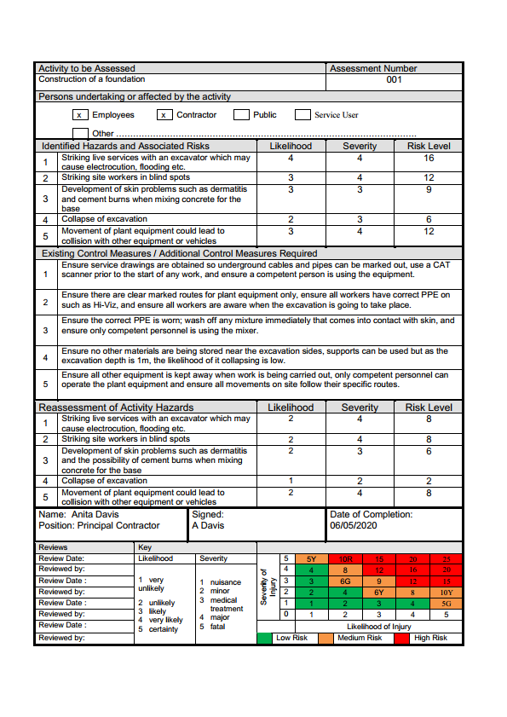
Appendix B
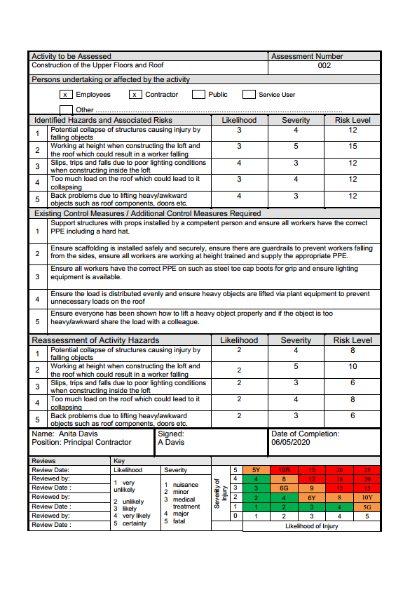

Appendix C


