Charlotte hudson 2505217
Module ECIE4010
Notes for PowerPoint presentation on wicked problem Digital exclusion.
SLIDE 13
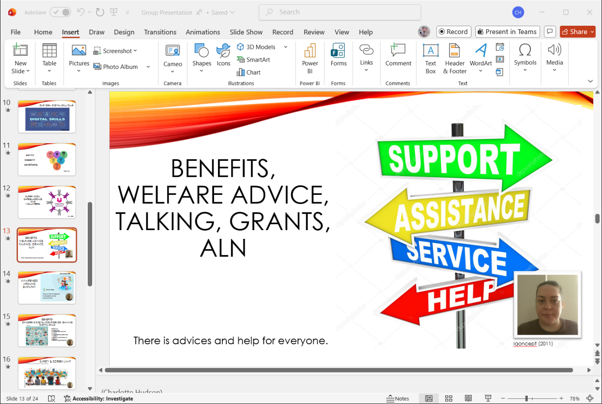
Many families are unaware of what support and help is available to help with the cost of a digital devices or internet access at home. Within our digital skills club we will offer advice, help and support where needed to assist families. ‘Over half of low-income families have said that their children will struggle to access a device or Wi-Fi at home’ (E Anderson, 22.07.2025). We will also offer ALN parents’ information to enhance their child’s learning with digital devices. ‘There are many different programs and modification that can be installed onto digital devices to support learning such as, programs for stimulation, encouraging speech, supporting numeracy, literacy, memory and cognition’. AbilitlyNet (Jan 2025)
SLIDE 14
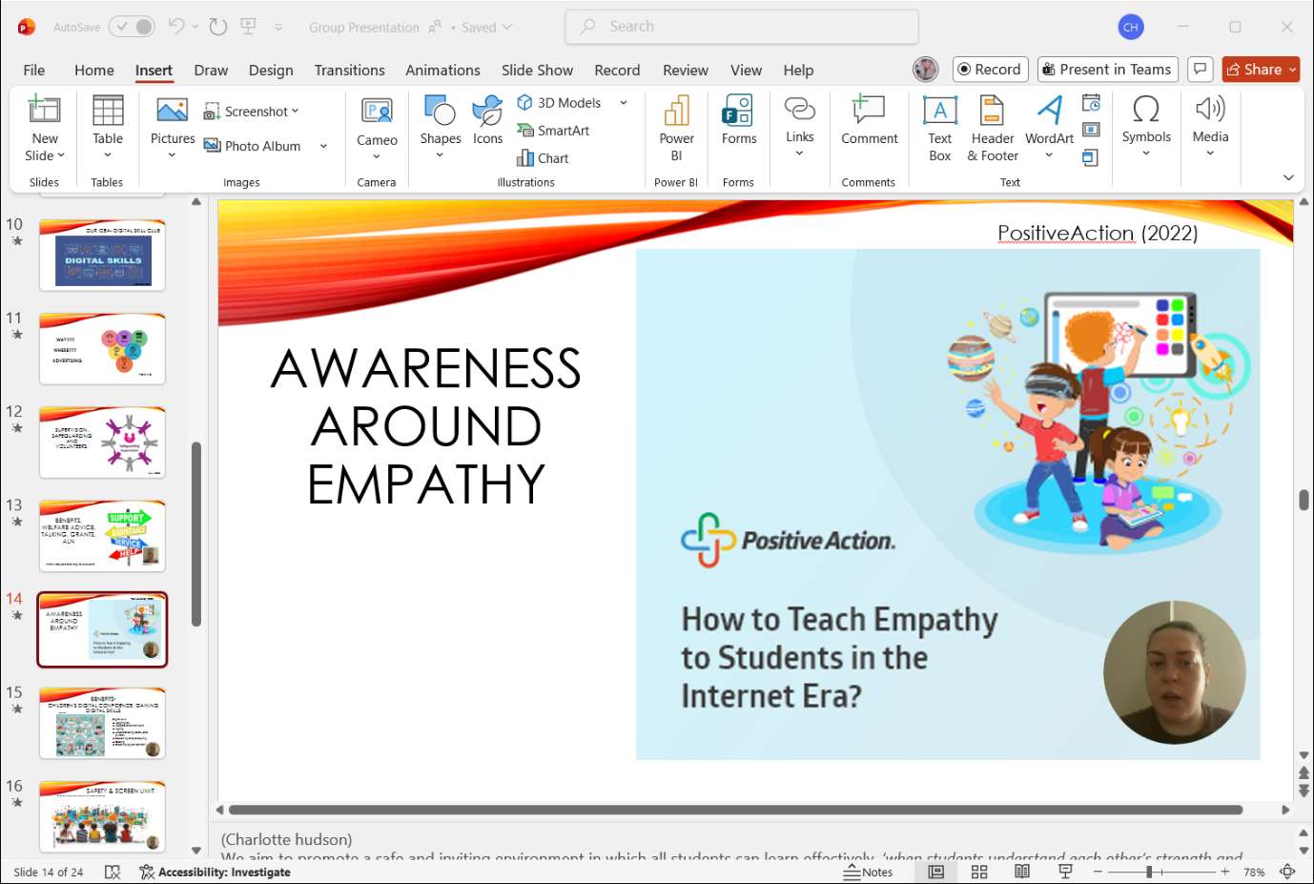
We aim to promote a safe and inviting environment in which all students can learn effectively, ‘when students understand each other’s strength and weakness, they are more likely to show kindness and develop a rapport resulting in increased positive relationships’ (positive action, 03.07.2025) We will promote digital global citizenship, the safe responsible, and ethical us of technology. (Watanabe-Crockett 01.11.2017)

SLIDE 15
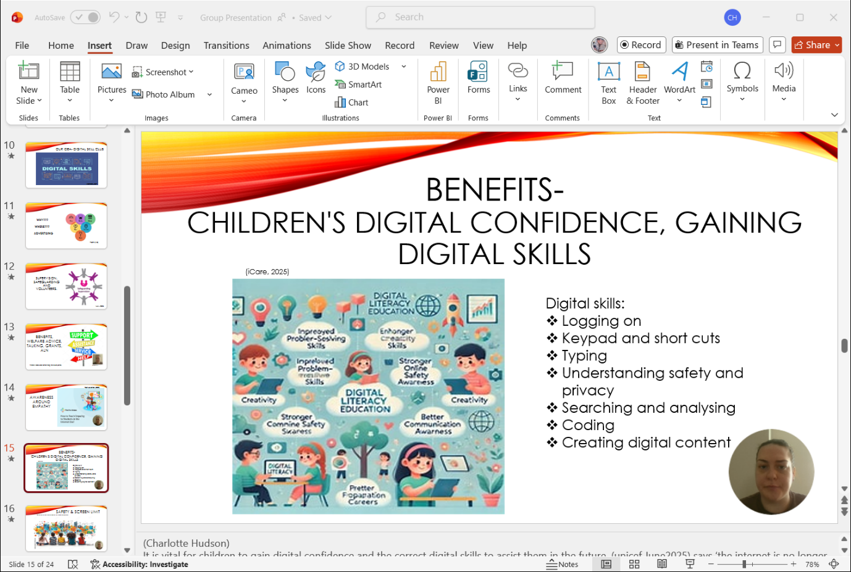
It is vital for children to gain digital confidence and the correct digital skills to assist them in the future, (unicef June2025) says ‘the internet is no longer a luxury for children, but has become a necessity for playing, learning, staying connected and building skills for the future’ having said this we believe every child should have the right to gain confidence and the adequate digital skills to be able to use digital devices. Within our digital skills club we will help to teach children the correct skills needed that allows them to confidently use digital devices, ‘digital skills are expected to feature prominently in the future of work that today’s children will enter’ (unicef, June 2025). Assisting children to confidently use digital devices will help increase their skills and aid them later in life.

SLIDE16
Many parent/ Guardians may refrain from wanting their children to have access to digital deceives as it can be such a worrying platform however, we live in a world where children are encouraged from a young age to use digital devices to complete schoolwork and homework therefor, we hope to teach children how to use these decides safely. ‘There is empirical evidence that greater digital skills are linked to better learning outcomes and empower children to better protect their safety online’ (ySkills,12-10-2020). It’s also important for children to learn from a young age to limit screen time to ensure a healthy balance.

Link for presentation
Group Presentation.pptx

Reference list

AbilitlyNet, (2025) Learning Disabilities and Computing Available at: Learning Disabilities and Computing | AbilityNet (Accessed on: 13 April 2026).
Adobe Stock file:773317208 (N.D) Concept art depicting children engaging in digital literacy and online safety programs, empowering them to navigate the digital world responsibly and safely [image] Available at: Concept art depicting children engaging in digital literacy and online safety programs, empowering them to navigate the digital world responsibly and safely. Stock Illustration | Adobe Stock (Accessed on: 10 April 2026).
Elizabeth Anderson (2025) Welsh children 'left behind' due to digital poverty. [Online]. Available at: https://www.youtube.com/watch?v=IEwERDry-rgs (Accessed: 13 April 2026).
Image iCare (2025) Building Digital Literacy in young children [image] Available at: didgital skills for children - Search Images (Accessed on:11 April 2026).
Iqoncept (2011) Service Assistance Support Help Arrow Signs Point to Solution — Photo [image] Available at: Service Assistance Support Help Arrow Signs Point to Solution — Stock Photo © iqoncept #10478720 (Accessed on:14 April 2026).
Lee Wantanabe-Crockett, (2017) What is global Digital Citizen and why does the world need them? Available at: What is a Global Digital Citizen and Why Does the World Need Them? | by Lee Watanabe-Crockett | Future-Focused Learning | Medium (Accessed on: 13 April 2026)
Positive action, (2022) 4 Benefits of empathy and inclusivity in the classroom [image] Available at: student supporting student digital empathy in schools - Search Images (Accessed on: 13 April 2026).
Positive Action, (2025) 4 Benefits of promoting empathy and inclusivity in the classroom Available at: 4 Benefits of Empathy and Inclusivity in the Classroom (Accessed on 13 April 2026).
UNICEF (2025) Childhood in a Digital World: Screen time, Skills and Mental Health. Available at: https://www.unicef.org/innocenti/media/11296/file/UNICEF-Innocenti-Childhood-in-a-Digital%20World-report-2025.pdf (Accessed: 10 April 2026).
Youth Skills (ySKILLS), (2024) EU Better internet for kids Available at: https://better-internet-for-kids.europa.eu/en/news/research-confirms-childrens-digital-skills-positively-affect-learning-outcomes (Accessed on: 11 April 2026).

