Data Collection Notes

Location:
Swansea Maritime Quarter
University of Wales Trinity Saint David – marshland
Swansea, SA1
Marshland
UWTSD – IQ Building

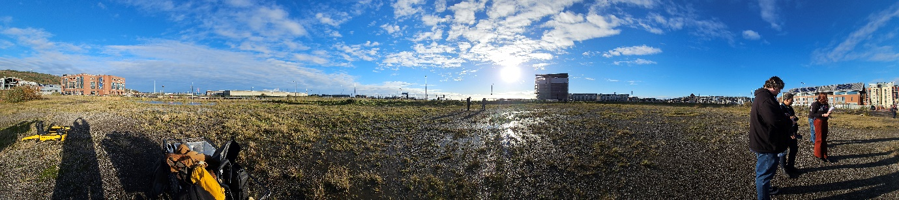
Figure 1 - Area of marshland to be surveyed
Deep water
Drone Launch Site
UWTSD – Y Fforwm

Time of day:
14:20

Weather on the day of data collection:
Bright Sunshine
Approx 15°C

Purpose:
The area has been selected as a potential site for an explosive testing site. However, it is unknown as to whether there are any threats so it is necessary to remotely assess the area to determine if there are any hazards with the area and its surroundings.

Equipment to be utilized:
DJI Mavic 2 remote drone complete with 4k RGB camera and 4k IR Camera.
Boston Dynamics Spot the Dog MkIV complete with RGB Camera located in the head and an IR camera mounted to the back.

The area to be surveyed is an area of marshland close to buildings such as the UWTSD IQ and Y Fforwm buildings as seen in Figure 1.
There is a lot of standing water some of which is of unknown depth.
The ground is very boggy and loose which could prove tricky for Spot to navigate.

Unknowns:
Currently, the condition and hazards of the area are unknown along with the field of view of the Boston Dynamics Spot the Dog. There are uncertainties over the battery life of Spot and the area able to be covered in that time before needing a recharge.
Spot has no return home function when running low on charge so may be stuck in a potentially hazardous area should it run out of charge.
Field of view of Spot is also unknown so it is unclear what area can be covered in a sweep across the marshland.
The field of view of the drone is also unknown but will be variable depending on the height that the drone passes over the land.

It was decided to start out using spot to traverse the area to be imaged in lanes. This required a Field of View to be established. This required someone to have the controller and two other people to stand either side until they were in the edge of the frame. The distance between the two were then measured and gave a FOV of 2.1m. This meant the lanes could be 2 meters wide and then overlapped to give full coverage.
Spot also has a claimed run time of 90 minutes.

Spot was started on solid ground as shown in Figure 2 and was not used to map the areas of deeper water due to a limit in capabilities so a secondary mapping capability is necessary.

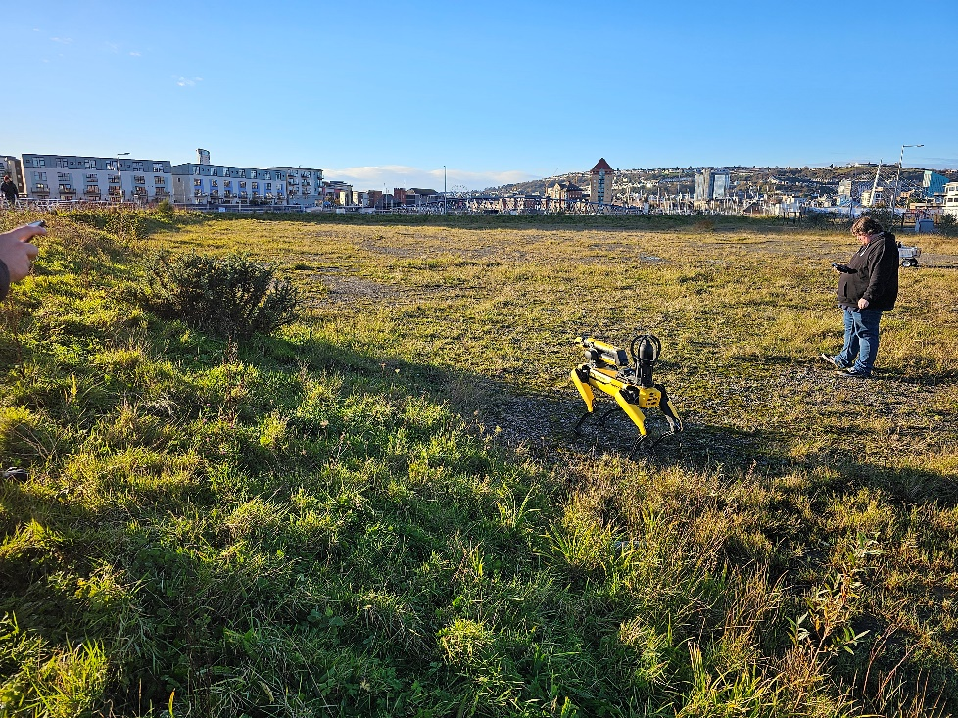
Figure 2 - Starting Position for Spot
After one pass across the terrain, when the terrain became uneven, Spot struggled and ended up “falling over” as seen in Figure 3. Also, there was a live feed from the RGB camera to the operator, however, the IR camera mounted to Spot required removing and analysing after the data had been captured.
It was deemed that this wasn’t an efficient way of mapping the location, so a drone was considered as a replacement.

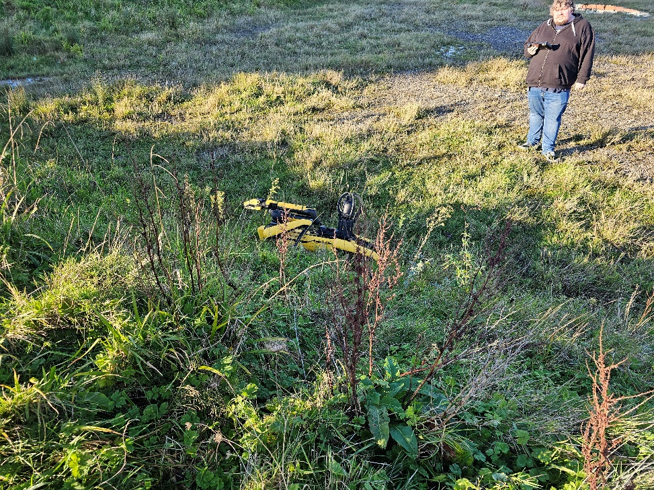
Figure 3 - Spot Re-set After Encountering Uneven Terrain

The drone to be used was a DJI Mavic 2 with a 4k RGB camera and a 4k IR camera mounted. The launch site is shown in Figure 4.

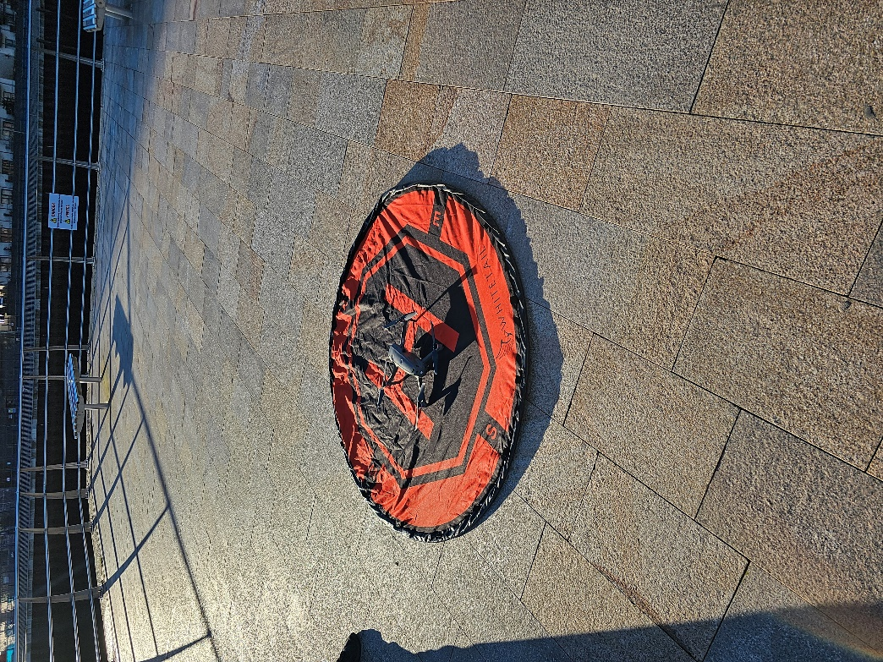
Figure 4 - Drone Launch Site

It was unclear what the field of view from the drone would be, however, there was a live feed to the drone operator. This allowed in real time to ensure that the whole area was imaged. There is also no limitation to the drone’s ability to image over areas of deep water.

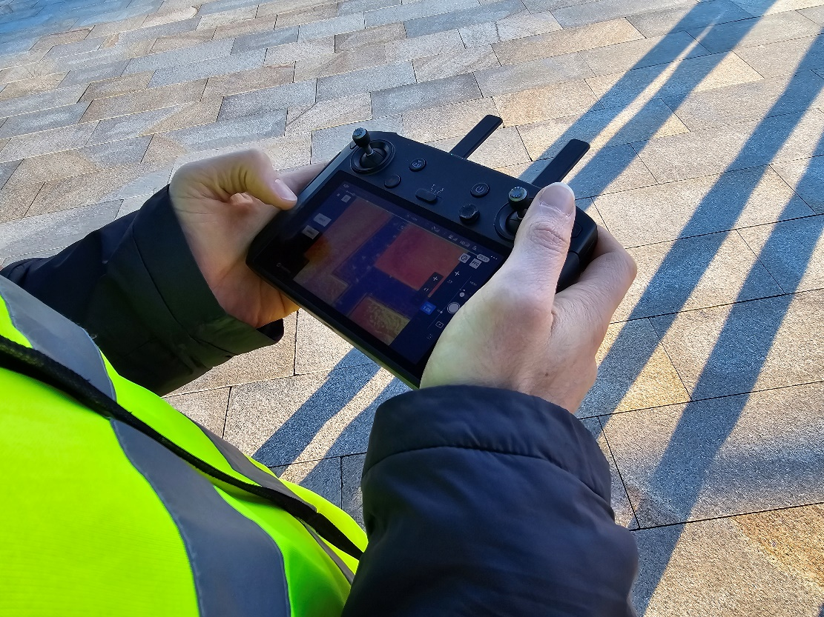
Figure 5 - Drone Camera Live Feed Showing IR Imagery

Initially, to ensure quick imagery of the whole area, a 30m drone height was initially chosen. Below in Figure 6 is the field of view from the drone’s RGB camera at an altitude of 30m.

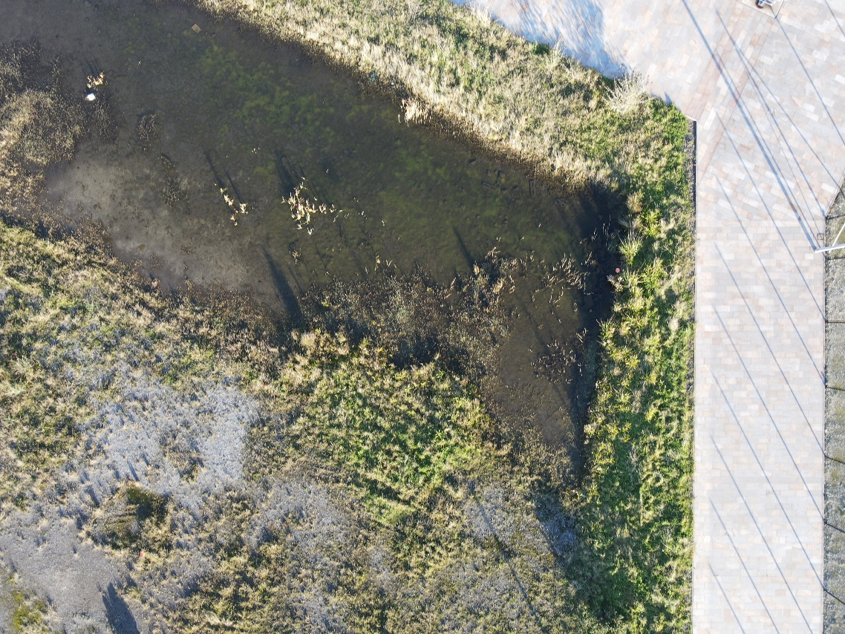
Figure 6 - Imagery from a 30m drone height
Shown in Figure 7 is the subsequent thermal image captured from the drone at an altitude of 30m.

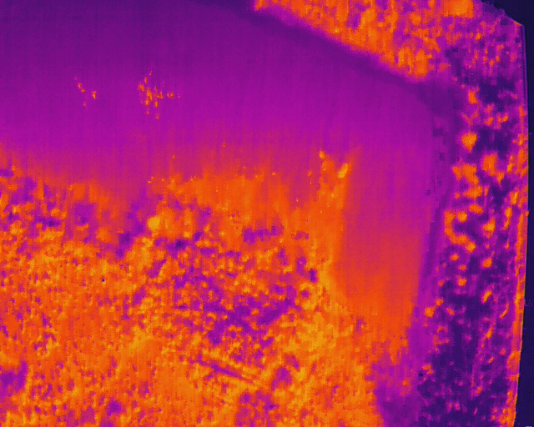
Figure 7 - Drone Captured Thermal Image 30m

The drone imagery took approximately 10 minutes to cover the whole area at 30m in which time, Spot had barely managed to cover ¼ of the area presented. This allowed us to reduce the height of the drone to capture more detailed images of areas of interest as shown in Figure 8

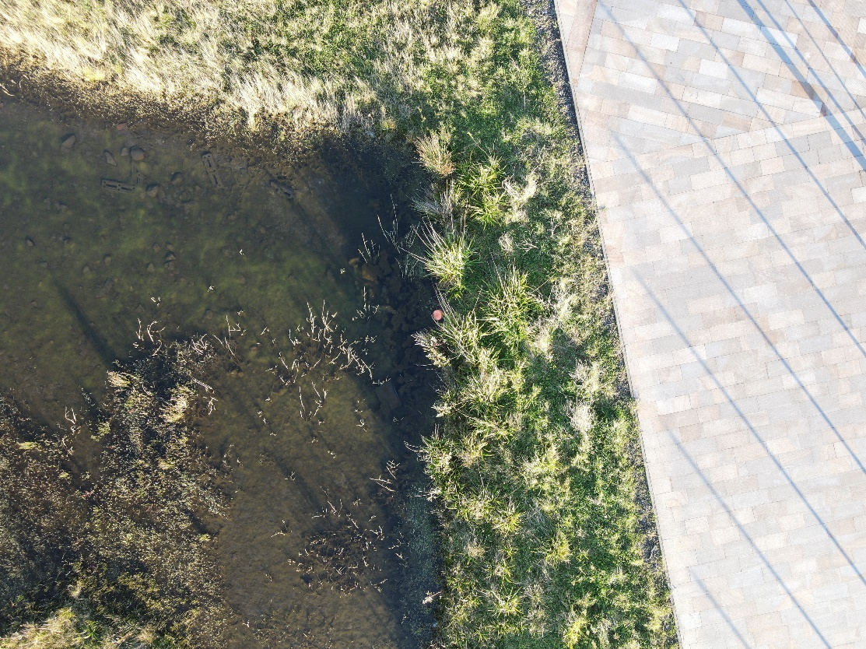
Suspect Item Identified on RGB Image
Figure 8 - Drone image of the same area from an altitude of 15m
Below in Figure 9 is the corresponding Thermal image from an altitude of 15m.
Suspect Item Identified on Thermal Image
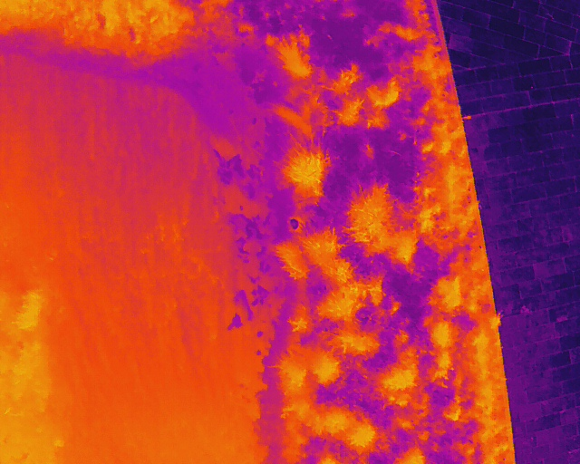
Figure 9 - Corresponding Thermal Image from an altitude of 15m
It can be seen from the images above that much greater detail can be seen from an altitude of 15m, including suspect devices. As highlighted above in both Figure 8 and Figure 9.
It is also possible to set a pre-defined flight path for the drone to follow taking pictures after a certain time interval. As the drone has a return home function, it can allow almost full autonomy.

Longitude and Latitude of imagery as well as flight height can also be given by the drone images as it has a GPS link.

Limitations to the drone is that whilst there is an instant IR feed to the operator, post-processing is still required to filter out certain frequencies of radiation. This can give a clearer idea of any potential threats on the ground below.

Due to the weather on the day of data collection (bright sunshine), the ability to see items on the ground might be reduced due to the thermal output of the ground. Also, should any objects be obscured, they might be difficult to spot.

The drone footage was particularly useful, due to the attribute data (GPS) as it could be easily mapped on to GIS software. Also, due to the aerial nature of the image capture from the drone, it reduces any image distortion or parallax issues. Below in Table 1 is the latitude and longitude of the items identified from the remotely sensed data.
Table 1 - Latitude and Longitude of items identified
Item Number | Latitude | Longitude
1 | 51.616961 | -3.927767
2 | 51.616789 | -3.927633
3 | 51.616158 | -3.927503
4 | 51.616158 | -3.927503
5 | 51.616158 | -3.927503
6 | 51.616944 | -3.927131
7 | 51.616944 | -3.927131
8 | 51.616989 | -3.927567
9 | 51.616989 | -3.927567
10 | 51.616989 | -3.927567

