Student name | Sidrah Javed
Student ID Number | 2238819
Programme | BSC Health and social care
Module code | BMHP5015
Lecturer | Reheela
Assignment Title | Component 2
Submission deadline | 2nd of December Due to 1 week extension

Contents page
1- Introduction
2-Job role Employability skills
3-Evaluate your own skills
4-Action plan and timeline
5-Building your personal brand
6-promoting your professional identity
7-Building a network for successful employment
8- Conclusion
9-Reference list

Introduction
I shall start this report by outlining the duties and significance of the work role in health and social care that I would like to pursue in the future. I will then discuss my motive for pursuing this position and why I am interested in it. I wish to become a mental health support worker professional in the future. The first responsibility of a mental health professional is to support the mental health and well-being of those who suffer from mental illness. My interest in this position stems from witnessing a close relative's long-term mental health struggles and their failure to improve. I was inspired to serve people with mental health issues after witnessing a close family member suffer in silence and thinking, "What if I were to become a mental health worker and help individuals just like my family member and support them to a recovery destination.

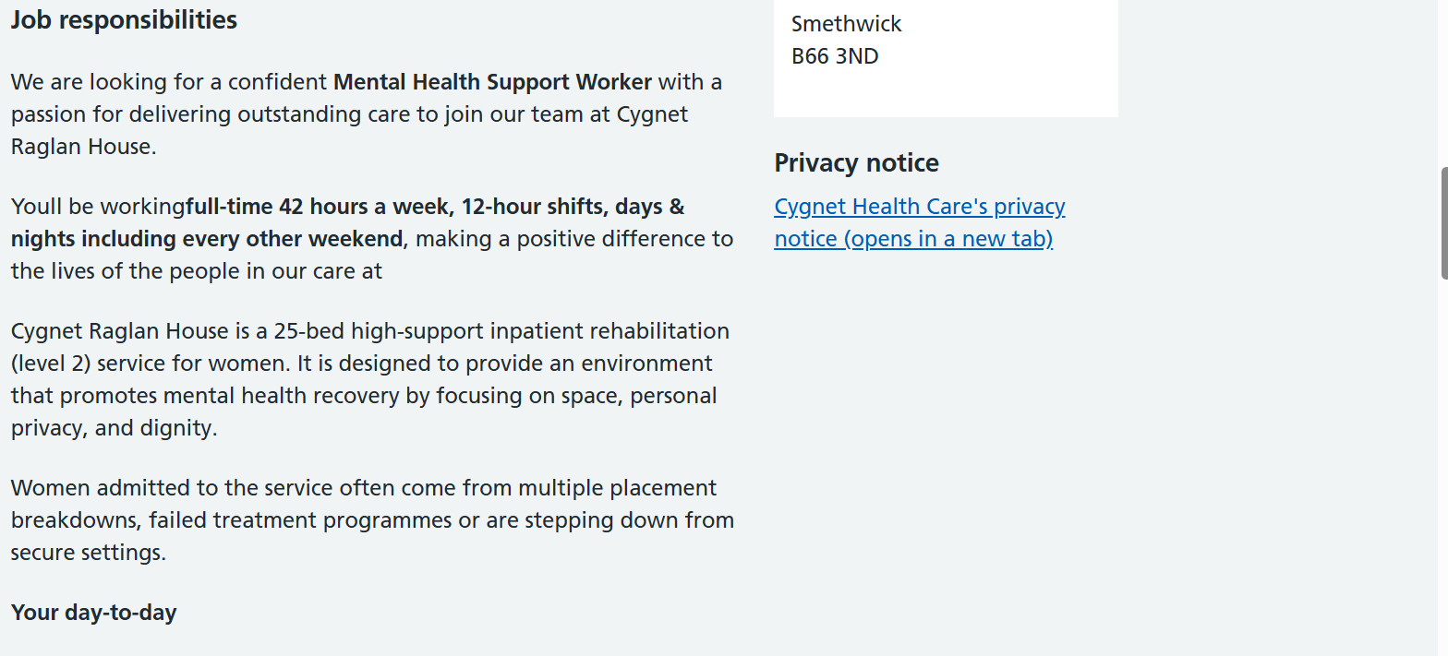
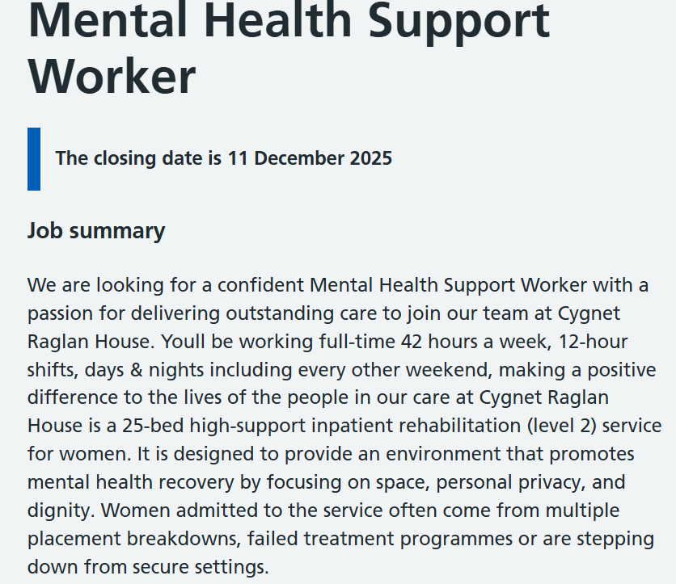
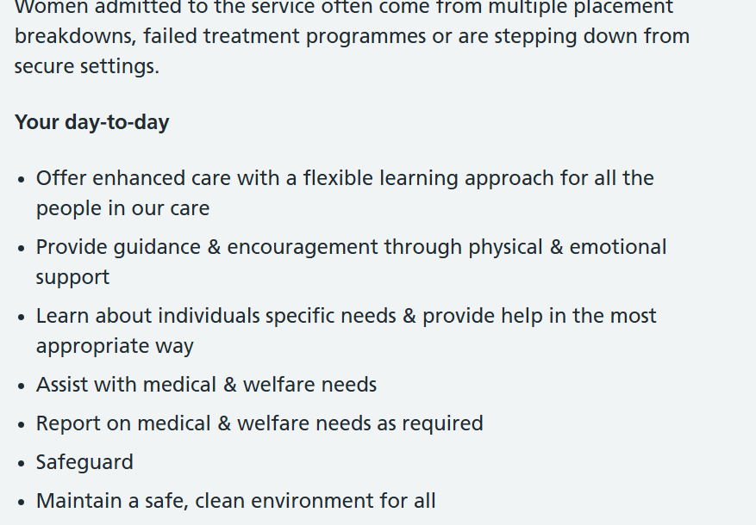
Reference for mental health support work is listed below
Jobs.NHS.uk
Cygnet Health care

Mental support worker employability skills are
- An excellent communicator and a good team player
- Passionate about empowering and supporting service user independence
- Sensitive and intuitive with the energy required to provide a trusting,stimulating and varied environment
- Genuinely driven with desire to make a real difference in people’s lives

An excellent communicator and a good team player the first text of its kind to discuss the relationship between communication techniques and high-quality patient care outcomes is Communication Skills for the Health Care Profession. According to Bartlett, J. (2009), it is a priceless tool for individuals in administrative roles as well as for aspiring and working patient carers across all specialities and services. talking with patients who have mental health issues, low literacy, health communications and quality treatment, health communications to promote behavioural change, the internet and patient-provider communications, changing care systems and the consequences for health care communications.

As a mental health support professional, you must be passionate, empowering, and supportive of service users' freedom. According to england.nhs.uk, According to the NHS long-term plan, AHPs play a key role in providing person-centred care to help the NHS meet its evolving demands. AHPs have a crucial and diverse role as first responders in diagnosis, self-management, rehabilitation, and recovery of daily living, according to the Mental Health Workforce Plan for England (2017). AHPs are used in health and care services to diagnose, treat, and assist people in becoming self-sufficient and empowering service users to become competent and self-assured. This is a crucial ability to have if you want to work as a mental health support worker.
Personalised care is one of the main ways mental health support professionals make a difference. They collaborate closely with people to comprehend their particular requirements and difficulties. Whether it's one-on-one counselling, group therapy sessions, or help with everyday tasks, this method guarantees that every individual gets the particular support they need. Mental health professionals assist individuals in developing resilience so they may manage their daily lives more effectively. Effective mental health support is built on trust. In order to establish solid, trustworthy relationships with their patients, mental health care workers frequently spend a lot of time with them.

Evaluate your skills
My present skills for the mental health support worker role include being an excellent listener. In the past, I tried to support a friend who had mental health issues by listening to her, and I was successful because she opened and I was able to provide her with the necessary support. Poor listening skills are one of the major causes of miscommunication, according to Latha, A. (2018).
In my prior position as a mental health support worker, I developed my teamwork, communication, and mental support abilities. Two months ago, I finished a mental health first aider course at UWTSD University. I obtained a three-year certificate, which I may use as proof that I am qualified for this position once I have earned my degree.
I gained a lot of new skills from this training, which further inspired me to pursue a profession in mental health I’ll use both my new and old skills to work as a mental health professional in the future. Additionally, I now hold a level 4 certification in health and social care, and I will shortly receive a level 5 certification in BSC.

My strengths are In my former role as a support worker, I would listen to the service user with empathy and compassion without passing judgement. I learnt how to handle such situations calmly and safely from my employment as a support worker. One of my talents in my work was that you will never learn the essential way, which made it difficult and distressing at times. I'm happy that encountering certain circumstances taught me how to remain composed and approach the issue professionally. My selling point for being the best applicant for this position as a mental health professional is that I'm constantly eager to pick up new abilities. Additionally, when I start a new job in the future, I'll set goals for myself and write short-, medium-, and long-term milestones that will help me reach my goals in a reasonable amount of time.
Opportunities for development
Before moving on to level 6, I want to pursue my career by finding a part-time work in the mental health field while continuing my education after earning my BSC. I will also meet one-on-one with the career counsellor to discuss any additional requirements I may have to work as a mental health professional. The restart program offers one-on-one sessions, shows you which websites you can apply to, and shows you job advertisements; in other words, email you a list of job advertisements once a month. This is the support I need to improve my skills and help me reach my goal of looking for a job in mental health.

Timeline Goals for My future

Action plan
the measures I will do to build my talents to work as a mental health support worker function position in the future. once I have completed my BSC degree in Health and social care I will look at taking a further degree The NVQ Diploma in Health and Social Care includes training in ethics and basic medical aid. This certification will increase my professional credibility and practical expertise, enabling support staff to effectively serve patients.
Additionally, by working at a community rehabilitation or therapy centre, I will obtain practical experience in mental health assistance. As a volunteer, I will shadow support staff who are already helping public health patients and completing internships in social services or healthcare. Another step I will take is look for opportunities for mental health support workers. I'll look for jobs using specialised platforms like NHS Jobs, a public health provider with lots of assistant positions, Cucumber Jobs, a top healthcare staffer recruiter who listens to the most recent opportunities for mental health support, CV Library, where I can upload my resume and apply for jobs in my free time, and LinkedIn, where I can subscribe to healthcare talent acquisition manager post alerts.

Building your personal Brand
Working in the mental health field in the future will allow me to promote my personal brand by focussing on mental health awareness. I will write about my experience with mental health, how I dealt with it, how I recovered, and why I created this brand, how it became a healing process for me, and how it serves as a reminder that even in the face of overwhelming anxiety, I still found and will find ways to carve out peace.
According to Ghaltakhchyan, S. (2025), by building a personal brand, people hope to stand out, develop a positive and reliable public reputation, and advance their careers.
Developing a strong personal brand is becoming more and more important in today's digital world in order to succeed in the competitive market. Since this is all new to me, I will definitely share my experiences and write my own story about mental health in the future.

Sharing inspirational quotations on social media, like Facebook and Tik Tok, is another method I can think about developing my own brand. Since I'm not a camera person, I wouldn't be able to speak in front of an audience or create a talking blog.

Promoting your professional Identify
I will be establishing my own professional identity by making a LinkedIn account which is a platform where I will build up my professional profile to interact with requires, search for employment and share my professional material. Additionally, Lincoln is an excellent social network which will help me to focus on my career development and unique from personal social sites it is used by persons like myself to enhance careers and uncover talent. Making a personal website to express myself, display my work, and ultimately establish a professional internet presence is another method of promoting my professional identity. and I will be in charge of the content and design. Unlike social media, this website I build will enable me to blog, network, brand, and build a professional network in the mental health industry.

Sidrah Javed
Mobile: 07474883799 Email: sidrah.deen@yahoo.co.uk

Personal Profile

I am a dynamic, highly motivated individual with a track record of achievement demonstrated in client service environments. I am equipped with excellent communication and organisational skills and an ability to maintain consistently high standards of work. I am extremely resourceful and recognised as an effective facilitator of successful initiatives. I am currently seeking a career an enhancing position within a progressive organisation where my skills can be used to their full potential.

Key Skills

- Excellent communications skills
- Excellent organisational and service skills
- Flexible and adaptable approach
- Excellent team working skills and works well independently
- Able to follow instructions and procedures carefully
- Good Information Technology skills

Employment History

Bourn view care Home March 2016-september 2016
Care Assistant

Assisting clients with personal care tasks washing,dressing,eating and toileting.
Assisting clients with medication and accompany clients to medical appointments.
Observing, monitor and recording clients physical and emotional wellbeing, and promptly reporting any changes to senior staff.

Father Hudson’s Society, Birmingham September 2015 – February 2016
Support Worker

- Supporting the wellbeing of vulnerable clients with various health conditions
- Use of excellent communication skills to understand client needs
- Supporting clients in food preparation and attending medical appointments
- Adhering to strict health and safety regulations

Proline Agency, Birmingham January 2015 – September 2015
Support Worker

- Supporting the wellbeing of elderly and vulnerable clients
- Use of excellent communication skill to be used with this role
- Helping clients who have mental problems,learning difficulties,disabilities,

Sevacare, Birmingham May 2014 – January 2015
Care Worker

- Supporting the wellbeing of elderly and vulnerable clients
- Use of excellent communication skill to be used with this role
- Providing medication in line with guidelines

Education and Training

University of Wales Birmingham Jan 2023-2024
Level 4 Health and social care

Finance Business Training May 2014
HND Finance Business Management

South & City College May 2013
Business Skills OCR Level 2 & 3 Diploma

Solihull College
Health and Social Care Level 2 June2012

South & City College May 2010
Level 1 Health & Social Care

Waverley School, Birmingham June 2009
5 GCSE’S (C-E)

Enter key training Birmingham JULY 2013
Level 1 mathematics
Level 2 functional skill English

Hobbies and Interests

I have a deep passion for working with children and enjoy being a mother to my little one I also enjoy hairdressing, beauty and retail fashion. I enjoy keeping fit, and a member of a local gym and like going swimming I also enjoy keeping my mind active and take every opportunity to learn new skills and better myself.

References Available Upon Request

Cover letter

Sidrah Javed
Email address Sidrah.deen@yahoo.co.uk
Dear sir/madam
My name is Sidrah Javed upon request after applying for the job advertisement for mental health worker online I was emailed by the recruitment team to send in a cover letter thank you for giving me this opportunity for me upon realizing that my experience will be used for your company alongside my qualifications that I have.
My professional skills
- Helped administer medications and assist with activities of daily (Adls) and facility transfers to promote security and patient wellbeing.
- Accompanied by over five or more patients per day.
- Advised patients and family on support to achieve a health lifestyle .
- Observed patient behaviours and mental status to see if patience needs a referral elsewhere for further treatment or support.
Communication skills
- Encouraged patients to discuss experiences in group and individual setting.
- Communicate with patients and families to support needing care to relieve patient anxiety and promote positive outcomes.
- I would use my effective communication skills by listening to patients,giving and receiving critical feedback and public speaking.
- I would identify patients’ objectivity’s and help them accomplish their goals my using my communication skills.
I feel confident that my ability and skills will enable me to use these skills and experience I have to use this if myself will be offered the job so I can begin making an impact on your organisation as soon as possible.
For more information regarding my qualifications and experience, see my attached cv.I would greatly appreciate an opportunity to discuss this position in more detail.
Thank you for considering my application to the next step

Sidrah Javed

Building a network
Many of the various players in the healthcare system use social networking for healthcare. According to O'brien,N (2016), each participant has a different reason for using social networking. The many social networking platforms used in the healthcare industry are defined, as are the user groups that are connected to them. When it comes to social networking for health care, there are three different emerging user groups.
According to Webber (2015), individuals with severe mental health issues, such as psychosis, have lower social capital than the general population. Social capital is defined as resources inside social networks. However, the development of social treatments that aim to improve a person's social networks is hampered by a lack of theoretically and empirically supported models. My next move after graduating from university is to sign up for a formal mentoring scheme Their job is to assist me in expanding my knowledge and abilities, share their professional experiences, and connect you with others to expand my network.
encourage you to make decisions and take action.Assist you in adopting a fresh perspective on obstacles. In order to meet individuals in the mental care industry, I will also do a search on Google Eventbrite.co.uk. Enter networking events in your area in the search field, and the list of local networking events will appear below.

Conclusion
In this report I have established myself professional goals which provide myself a clear path for what I want to achieve and assist me to stay focused on the crucial tasks.
Having clear goals can increase my desire and motivation, which makes it simpler for me to remain dedicated. goals that allow me to improve and measure my success, ensuring I stay on pace. Setting goals will also make it easier for me to prioritise activities and manage my time, which will increase my total productivity. To increase my professional network will allow me to create strong professional network by connecting with industry peers and experts. joining networking events, joining professional associations will help me to track numbers of new relationships I have created. solid professional network will offer doors to new chances and important insights for my future career in mental health. And if I stick to my long-term objectives and make use of my new abilities, I should be able to grow my professional network, which will open new doors and provide me with insightful information. I have also in this report written out my professional development Goals selecting area for professional improvement and set myself focused goals. The development plan will assist me in monitoring, advancing, and assessing my accomplishments. in the future I will first achieve my short-term goal then my mid-term goal and eventually my long-term goal and the end aim will be to work as a mental health support worker

Reference list
Ennis,G(2013) google scholar The Importance of communication for clinical leaders in Mental health.
Ratna,H(2019) google scholar The importance of effective communication in healthcare practise.
Servellen,G(2009) google scholar Communication skills for the health care professional
NHS.uk why are AHPs important in mental health practise
Ghaltakhchyan,S(2025) Personal Branding,shaping and maintaining a successful personal Brand.
O’brien,N(2016) The role of social networking in healthcare
Webber,M(2015) Enhancing social networks:A qualitative study of health and social care practise in uk mental health services
Bartlett ,J(2009) A tool for self-assessment of communication skills and professionalism in residents.
Latha,A(2018) Google scholar Importance of Listening skills over other skills
Website Cucumber-recruitment.co.uk

