Olivia Roadnight (2501022)
[Email address]
MODULE CODE: ACCA4024
VTAM Modern Security Framework Report

Table of Contents
Introduction (92) 1
Identification of Modern Threats (300p MAX) 1
Current internal threats 1
Current external threats 2
Emerging internal threats 2
Emerging external threats 3
Modern Security Policies (200) 3
Security Policies for VTAM [6] 3
Identity, Access Control and Multi-Factor Authentication Policy 4
Data Protection and Device Security Policy 4
Patch Management Policy 4
National Institute of Standards and Technology Cybersecurity Framework (NIST CSF), Cybersecurity and Infrastructure Security Agency Known Exploited Vulnerabilities (CISA KEV) and International Organisation for Standardisation Commission 27001 (ISO 27001) framework 4
Technical Mitigation Measures (220) 7
Multi-Factor (MFA) 7
Security Information and Event Management (SIEM) 8
Cloud Security Posture Management (CSPM) 8
EDR 8
Monitoring and Incident Response (150) 9
Training and Awareness (150) 9
Conclusion (60) 10

Introduction
VTMA is a medium sized financial services company, making them a high risk target for financial motivated cybercriminals. As their IT Security Manager, this report outlines cybersecurity measures required, focusing on the Zero Trust model to address vulnerabilities identified in the recent phishing and ransomware attempts faced by VTAM.

Identification of Modern Threats

Current internal threats
Insider threats are categorised malicious or unintentional, accounting for roughly 35% of all security incidents. [1]The main reason is negligence, such as accidental data leakage, phishing attacks, or mishandling sensitive data. Malicious insiders can exploit authorised access to steal data for financial gain. Additionally, stolen or sold credentials from external attacks allow attackers to become “insiders”, bypassing traditional firewalls and making it more difficult to detect attacks
Credential theft and identity-based attacks are also significant, including session hijacking where attackers steal active session cookies to bypass MFA, impersonating legitimate users without requiring password authentication. Attackers can also use social engineering to trick IT support staff into resetting credentials, allowing them to move through the network undetected.
Cloud-related threats are dangerous, as misconfigurations account for 95% of cloud breaches. [2] Which include publicly accessible storage that contains sensitive information and excessive user permissions, violating least privilege and increasing the risk of a breach.
Hybrid work further increases risks due to unsecure home or public Wi-Fi, where unencrypted networks enable man-in-the-middle attacks, since personal devices lack proper patching, protection and monitoring are required for corporate security standards.

Current external threats
VTAM’s exposure to RaaS involves unauthorised encryption attempts targeting our financial databases. To mitigate this, implementation of consistent backups and separate network VLANs will isolate the attack area. [3]
AI-powered social engineering uses AI to create convincing, personalised and scalable phishing, deepfake or voice cloning attacks to manipulate users into compromising security. Attackers use LLMs to generate realistic phishing emails and impersonate authorised personnel, making detection more difficult by removing traditional indicators such as bad grammar. [4]
Supply Chain attacks exploit trusted third-party vendors to gain access to the systems. For example, by compromising software updates or building systems to inject malicious code. The MOVEit 2023 breach demonstrates how third-party vulnerabilities can lead to large-scale data breaches, affecting thousands of businesses and individuals, causing financial loss, lawsuits, fines and reputational damage.

Emerging internal threats
Shadow IT is the use of unauthorised technologies, including hardware, software, or services without formal IT approval, often occurring when employees bypass IT controls by adopting unmonitored tools, such as generative AI, w3 which is increasingly common with “Shadow AI”, where sensitive data is inputted into public LLMs, creating risks of data leakages and security gaps due to lack of enterprise-level security and absence of central oversight.
Another emerging trend is MFA bypass, involving techniques such as MFA fatigue where users are tricked into approving repeated requests, granting privileged access without further alerts. AiTM attacks similarly bypass authentication by hijacking session tokens. Following the recent phishing incident at VTAM, attackers targeting session tokens could gain access to sensitive financial records.

Emerging external threats
AI powered technologies are increasingly used in advanced attacks such as Supply Chain compromises, where attackers manipulate training data in third party vendors AI models by inserting poisoned examples. As a result, legitimate models may contain malicious code that attackers can exploit, enabling data theft, blackmail and reputational damage for VTAM.
In 2025 the AI-enabled attacks, involving “malicious package managers” have risen by 156%, with attackers developing evasion methods to bypass detection systems. One example, is the “nullifAI” campaign targeting Hugging Face models, where corrupted file formats bypassed security scanners and created a “backdoor”, giving attackers remote access to steal credentials. [5]

Modern Security Policies

Security Policies for VTAM [6]
I propose implementing a Zero Trust (ZT) model, based on the principle of “Never trust, always verify”, which addresses the identified threats and strengthens VTAM’s security.
This model uses Strict Verification to authenticate each request based on identity, location, and device health, applies minimum privilege to restrict access to only what is required, and expects breach by designing the network to minimise the risk area. [7]
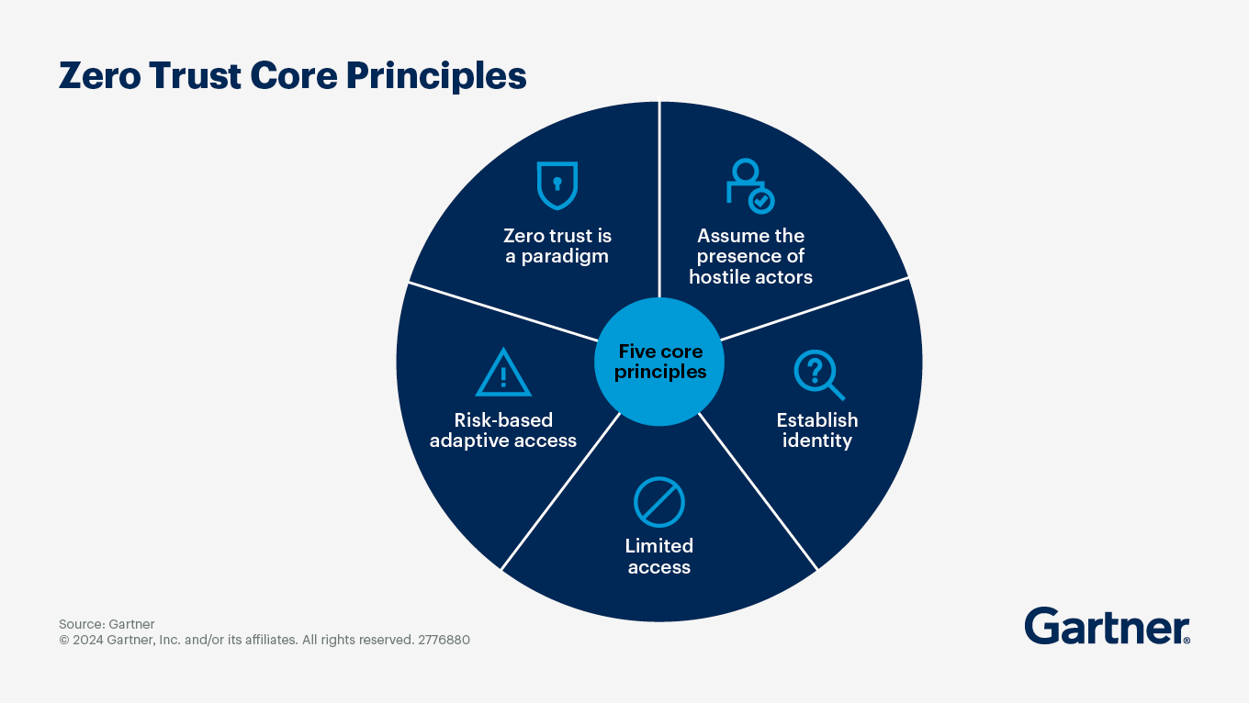
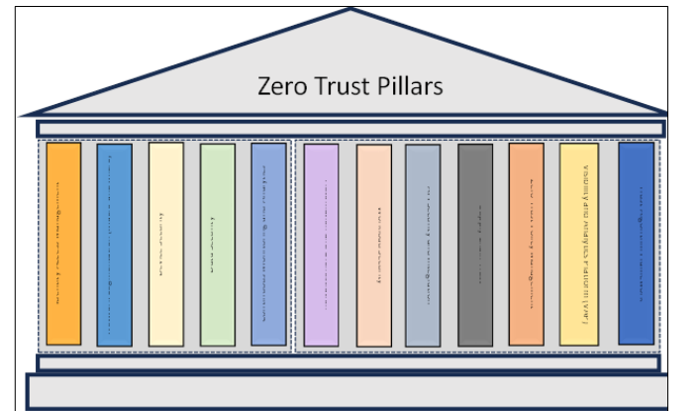
Figure 1 https://wjaets.com/sites/default/files/fulltext_pdf/WJAETS-2025-0411.pdf

Identity, Access Control and Multi-Factor Authentication Policy
This policy requires continuous authentication of users and devices to ensure only authorised access to resources. Regardless of location, this prevents attackers from using stolen credentials, as without that verification, they cannot access financial databases. Least Privilege restricts access to only required resources, ensuring a compromised account cannot encrypt all financial records.

Data Protection and Device Security Policy
Data protection involves encrypting and safeguarding information using access control and DLP tools. AES encryption ensures confidentiality by restricting access to authorised users. This aligns with GDPR requirements and protects sensitive financial data from unauthorised access. [8]

Patch Management Policy
Our patch management policy focuses on the CISA KEV Catalog, which identifies actively exploited vulnerabilities, supporting continuous patch management by prioritising real-world threats. This ensures VTAM’s client databases remain secure. [9]

National Institute of Standards and Technology Cybersecurity Framework (NIST CSF), Cybersecurity and Infrastructure Security Agency Known Exploited Vulnerabilities (CISA KEV) and International Organisation for Standardisation Commission 27001 (ISO 27001) framework
Following these frameworks support Zero Trust by enforcing continuous authentication including tools like AES encryption, strict access controls and real-time device monitoring. VTAM will map its access control logs to the NIST CSF PR.AC-1 category, ISO 27001 to maintain a continuous, audited management cycle, satisfying international compliance to security policies, and incorporating the CISA KEV Catalog, ensures every transaction on the financial ledger is authenticated using hardware backed MFA, and have legal defensive frameworks to improve business process. [10][10].
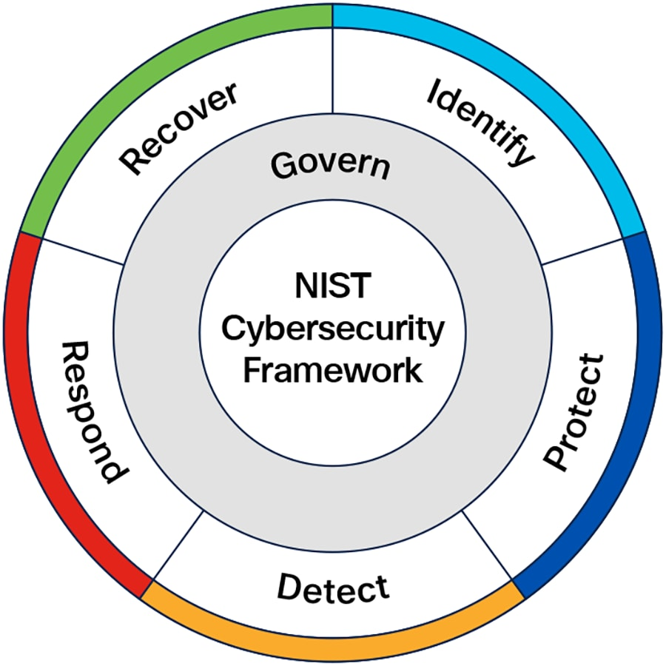
Figure 2 https://www.nist.gov/cyberframework
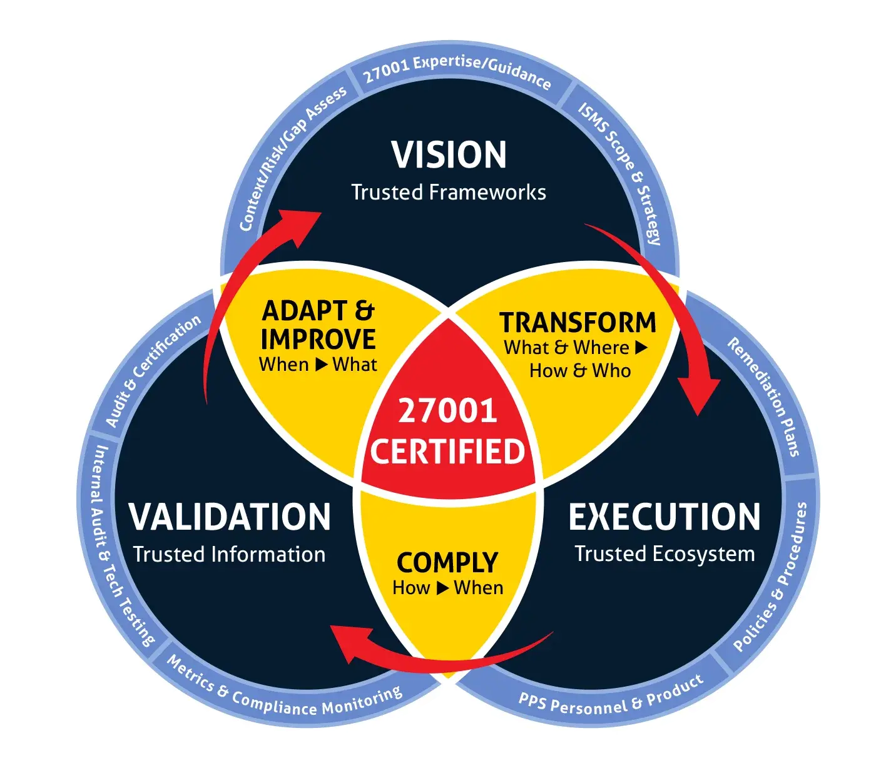
Figure 3 https://invadel.com/compliance/iso-27001/
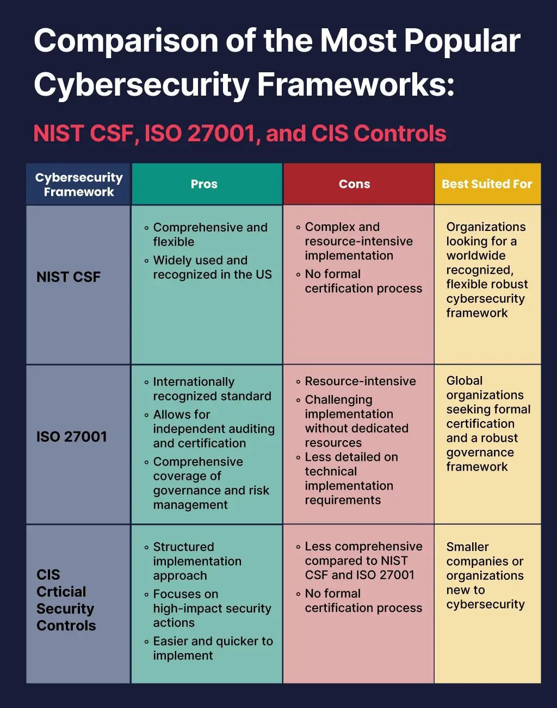
Figure 4https://www.instagram.com/p/DTITNwmDLHd/

Technical Mitigation Measures

Multi-Factor (MFA)
MFA is a multi-factor authentication mechanism requiring additional credentials from users to verify identities, e.g., passwords and biometrics. This reduces the risk of credential compromise from phishing, as stolen credentials alone cannot grant access. [11] MFA specifically will mitigate the repercussions of the recent sophisticated phishing incident. Usually, financial institutions are attacked through social engineering to gain legitimate credentials, therefore with MFA, extra authentication steps are required for access. Directly supporting GDPR where financial institutions integrate technical mitigation measures to prevent unauthorised access, protecting the company’s integrity and reputation.

Security Information and Event Management (SIEM)
SIEM uses log files to monitor network activity in real-time and detect anomalies. This enables quick identification of threats and supports incident response, protecting data integrity and compliance. [12]
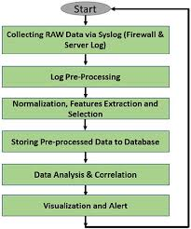
Figure 5 https://www.researchgate.net/figure/SIEM-data-processing-flowchart_fig4_365509767

Cloud Security Posture Management (CSPM)
CSPM identifies and resolves cloud misconfigurations by continuously monitoring cloud environments against security policies. This prevents data breaches and ensures compliance with security standards. [13]

EDR
EDR detects and prevents threats through continuous endpoint device monitoring and behavioural analysis. And ensures sensitive data cannot be exploited by entry point for hackers, preventing malware and ransomware in real-time attacks. [14] Beneficial for VTAM due to an attackers recent ransomware infection attempt with extra security tools to protect their records.

Monitoring and Incident Response
For VTAM, our incident response starts with SIEM alerts specifically created to protect our core asset management databases to ensure no authorised encryption occurs. By gathering disparate log entries and flagging anomalies that deviate from existing security policies, then immediate alerts trigger and an investigation analysis process occurs to determine the incident timeline and the extent of the breach. Then prevent further impact, isolating the anomalous activity is set and severs attacker access and from moving across the network. Finally, recovery will start and focus on restoring operations to their authorised, secure state through secure backups followed with an analysis for strengthening future defences post-incident. The application of this is key for ransomware mitigation, where immediate priority is to isolate the infected device and stop the encryption from spreading and protect integrity of the financial network.
With this, VTAM can respond to sophisticated threats better, as a result safeguarding their reputation and maintaining GDPR compliance through thorough accountability and quick resolution. [15] [16]

Training and Awareness
Incorporating training and awareness programs act as the ZT model’s human layer, transitioning employees to be more aware. An effective program adopts an engaging and continuous curriculum that reflects current threats, such as through phishing simulations, which are in a controlled and realistic environment using mock attacks sent to employees. This safe environment enables staff to practice identifying suspicious anomalies such as URLS or urgent unexpected requests for sensitive data. As a result, provides immediate real-world training, so if a user clicks on a simulated link, they are instantly sent to learning using feedback and exercises. Furthermore, it enforces awareness in real-world situations, and support understanding of specific and common methods used by attackers to bypass tools including AES encryption and firewalls. [17]
Another method for security is through behaviour change training. Common security risks include employee behaviour damage caused by high-pressure work environments or complacency where users skip security steps to speed up workflow, which poses a risk for VTAM’s peak finance accounting reports. Therefore, organisations should consistently expose staff to modern attack simulations to ensure that employees verify identities using MFA or report suspicious activity to create security priority habits. As a result, the transition will reduce likelihood of successful breaches, protecting company reputation. [18] [19]
Overall, these programs promote strong security protocols, build a strong security community, by ensuring data is protected and becomes a shared responsibility across all employee levels, which supports GDPR adherence to safeguarding information using organisational measures.

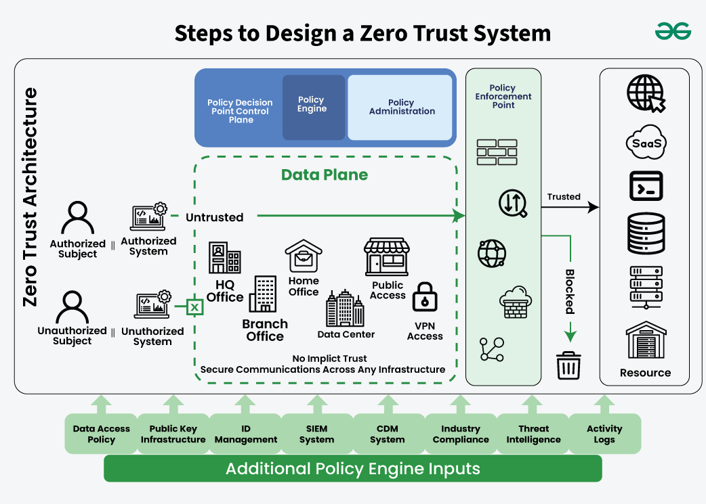
Figure 6 https://www.geeksforgeeks.org/system-design/zero-trust-architecture-system-design/

Conclusion
Overall, VTAM faces evolving threats including sophisticated phishing and ransomware that target financial databases. Therefore, adopting a ZT model will benefit them as it requires continuous authentication and least-privilege, ensures any stolen credentials alone cannot trigger an attack. Through the combination of tools like AES encryption, MFA and SIEM monitoring strategies will protect sensitive information, maintaining GDPR compliance, which will secure the company’s long-term reputation and security.

Bibliography

[1] | inavate, “Cybersecurity Trends to Watch in 2026,” [Online]. Available: https://inavate.co.uk/2026/01/05/cybersecurity-trends-to-watch-in-2026/#:~:text=Identity%2DLevel%20Risks:%20In%202026,minimise%20the%20%E2%80%9Cblast%20radius.%E2%80%9D.
[2] | SentinelOne, “50+ Cloud Security Statistics in 2026,” [Online]. Available: https://www.sentinelone.com/cybersecurity-101/cloud-security/cloud-security-statistics/.
[3] | Sophos, “What is ransomware-as-a-service (RaaS)?,” [Online]. Available: https://www.sophos.com/en-us/cybersecurity-explained/ransomware-as-a-service.
[4] | proofpoint, “What Is Social Engineering?,” [Online]. Available: https://www.proofpoint.com/uk/threat-reference/social-engineering#:~:text=Today's%20attackers%20are%20now%20using,and%20develop%20their%20strategy%20accordingly..
[5] | W. Giles, “Understanding The Rising Threat of Supply Chain Attacks in Artificial Intelligence,” [Online]. Available: https://wgilescyber.medium.com/understanding-the-rising-threat-of-supply-chain-attacks-in-artificial-intelligence-b74a653a7a5b#:~:text=AI%2Denabled%20supply%20chain%20attacks,an%20enormous%20window%20for%20exploitation..
[6] | O. B. S. M. S. C. Scott Rose, “Zero Trust Architecture,” no. August 2020.
[7] | inavate, “Cybersecurity Trends to Watch in 2026,” [Online]. Available: https://inavate.co.uk/2026/01/05/cybersecurity-trends-to-watch-in-2026/#:~:text=Identity%2DLevel%20Risks:%20In%202026,minimise%20the%20%E2%80%9Cblast%20radius.%E2%80%9D.
[8] | ICO, “Encryption and data protection,” [Online]. Available: https://ico.org.uk/for-organisations/uk-gdpr-guidance-and-resources/security/encryption/encryption-and-data-protection/.
[9] | T. Schell, “How Implementing Risk-Based Patch Management Prioritises Active Exploits,” [Online]. Available: https://www.ivanti.com/en-gb/blog/how-implementing-risk-based-patch-management-prioritizes-active-exploits.
[10] | ISO, “ISO/IEC 27001:2022,” [Online]. Available: https://www.iso.org/standard/27001.
[11] | CISA, “Multifactor Authentication,” [Online]. Available: https://www.cisa.gov/topics/cybersecurity-best-practices/multifactor-authentication.
[12] | M. S. Aljumaily, “Enhancing User and Entity Behavior Analytics in SIEM Systems Using AI-Powered Anomaly Detection: A Data- Driven Simulation Approach,” [Online]. Available: https://www.researchgate.net/publication/395674852_Enhancing_User_and_Entity_Behavior_Analytics_in_SIEM_Systems_Using_AI-Powered_Anomaly_Detection_A_Data-_Driven_Simulation_Approach.
[13] | Fortinet, “Cloud Security Posture Management (CSPM): Eliminate Cloud Risks,” [Online]. Available: https://www.fortinet.com/uk/resources/cyberglossary/cloud-security-posture-management.
[14] | Microsoft, “What is endpoint detection and response (EDR)?,” [Online]. Available: https://www.microsoft.com/en-us/security/business/security-101/what-is-edr-endpoint-detection-response.
[15] | T. L. M. V. S. S. H. C. P. B. T. J. K. A. P. F. F. H. P. R. G. P. Florian Menges, “Towards GDPR-compliant data processing in modern SIEM systems,” [Online]. Available: https://www.sciencedirect.com/science/article/abs/pii/S0167404820304387.
[16] | Kaspersky, “What is security awareness training?,” [Online]. Available: https://www.kaspersky.co.uk/resource-center/definitions/what-is-security-awareness-training.
[17] | E. Cybersecurity, “Phishing Simulations for Cybersecurity Awareness Training,” [Online]. Available: https://www.resecurity.com/blog/article/phishing-simulations-cybersecurity-awareness-training.
[18] | D. Kelleher, “The Human Factor: How employee behaviour affects cybersecurity in the workplace,” [Online]. Available: https://www.bmit.com.mt/blog/the-human-factor-how-employee-behaviour-affects-cybersecurity-in-the-workplace/.
[19] | kaspersky, “What is security awareness training?,” [Online]. Available: https://www.kaspersky.co.uk/resource-center/definitions/what-is-security-awareness-training.
[20] | R. G. R. *, “Implementing zero trust architecture in financial institutions,” no. Received on 15 March 2025; revised on 23 April 2025; accepted on 25 April 2025.
[21] | V. Božić, “Compare cybersecurity framework in NIST, ISO 27001, CIS Control and COBIT,” [Online]. Available: https://www.researchgate.net/publication/384011298_Compare_cybersecurity_framework_in_NIST_ISO_27001_CIS_Control_and_COBIT.

