Is crime a social Construct?
An examination of factors that influence crime within communities.

Ellie Bowen
Student: 2200584

Abstract

This dissertation explores the question: “Is crime a social construct?”, by examining the factors that influence crime within communities. This is achieved through exploring three objectives including the impact of socioeconomic disparities on crime, the influence of institutional practices on criminality, and the role of social and cultural narratives in defining crime within communities. Whilst crime is often perceived as an objective legal framework, this research aims to challenge this by examining the broader context in which behaviours are considered criminal and how certain groups are disproportionately affected by these perceptions.

Through utilising a mixed method approach, the study revealed that the perception of crime is not equal amongst different communities. The literature review and survey revealed that socioeconomic disparities have a fundamental role in influencing crime and its social perception. Whereas institutional practices such as law enforcements and judicial systems contribute to elements of criminality. Furthermore, the research illustrates the effect of external factors such as social and cultural narratives in defining crime. It explores the effects of media portrayals and the influence this has on the social perception of crime.

This examination aims to highlight that crime is not a legal concept, but a socially constructed narrative that is influenced by factors such as institutional practices, social disparities and cultural narratives. The purpose of this dissertation is to enhance the understanding of crime, by accounting for alternative factors that influence its perception.

Acknowledgements

I would like to dedicate this dissertation to those that have experienced social inequality within the criminal justice system. I hope this research will contribute to a better understanding of these issues and help inform future practices.

More importantly, thank you to my family for your continuous love and support – not only throughout my academic career but my entire life. To my parents, who sacrificed their early adulthood to raise me, your dedication and hard work have never gone unnoticed. You have inspired me every step of the way.

To my grandmothers, Tina, Mary and Coleen who did not have the privilege of witnessing this moment – you were with me in spirit. Your presence has guided me through this journey.

Finally, a special thank you to all those that have stood with me throughout this journey. Without your continuous support, this dream would not have become a reality.

Declarations

This work has not previously been accepted in substance for any degree and is not being concurrently submitted in candidature for any degree.
STATEMENT 1
This dissertation is being submitted in partial fulfilment of the requirements for the degree of BA/BSc.
STATEMENT 2
This dissertation is the result of my own independent work/investigation, except where otherwise stated.
Other sources are acknowledged in the Reference Section.
STATEMENT 3
I hereby give consent for my dissertation, if accepted, to be available for photocopying and for interlibrary loan, and for the title and summary to be made available to outside organisations.
STATEMENT 4
I hereby give consent for my dissertation, if accepted, to be available on the university’s IT system to those who have consent to use the system.

Student’s Name: Ellie Bowen

Signed:

Date: 23/04/ 2025

Table of Contents
Introduction 5
Objectives 8
Scope 8
Literature Review 9
The Impact of Socioeconomic Disparities on Crime 9
Influence of Institutional Practices in Shaping Criminality 11
The Role of Social and Cultural Narratives in Defining Crime within Communities 13
Methodology 17
Research Onion 17
Research Philosophy 17
Research Approach 18
Methodological Choice 18
Research Strategy 19
Time Horizon 19
Techniques for data collection, processes, and analysis 20
Sampling 20
Reliability and Validity 21
Limitations 21
Analysis 23
Findings: Description of Data Analysis and Results 23
Conclusion 40
References 43

Introduction

Davies (2024) has postulated that most traditional crimes have reduced by 90% within 30 years. This is supported by Barber (2022) who implies that all crime (excluding fraud and cyber-crime) has decreased by three quarters since 1995. However, such claims invite a closer examination of key terms and assumptions. Traditional crime can be defined as a category of offences committed for immediate or temporary benefits by individuals or groups often involving direct harm to others or property (Dey, 2020). Furthermore, Kranenbarg et al. (2018) suggest that emerging crime trends like cybercrime are surpassing traditional crimes. As new crimes continue to emerge, they have prompted the development of new definitions further shaping the legal and social perception of what constitutes criminal behaviour.

Crime is defined by legal frameworks, which have been informed by social, political, and moral norms (Fichtelberg, 2021). These frameworks evolve and are influenced by social, cultural, and economic contexts. However, institutional practices continue to regulate crime and harmful behaviours that are disruptive to communities. Domínguez and Montbolio (2021) explored how this can be achieved through improving police and community relationships. Examining these dynamics will demonstrate how crime is constructed and managed within different social structures. Additionally, it will illustrate how institutional practices adapt to emerging challenges.

Societal values, rules, and power structures significantly contribute to the perception of crime. Canter and Young (2016) support this, by suggesting that crime is influenced by cultural and social contexts. It further explores how crime is perceived within different communities and how the perception and definition of crime have evolved. This can be demonstrated by the difference between moral and legal standards. Morality and law represent different aspects of society and normative behaviours (Cane, 2012). Legal systems enforce formal sanctions, whereas moral frameworks are often personal, religious, or philosophical. This difference is essential for understanding how crime is influenced by social perceptions.

Exploring crime as a social construct is essential for understanding the role of societal narratives that contribute to the perception of crime and deviant behaviour. As opposed to viewing crime as an individual element, this approach recognises that definitions and perceptions of criminality evolve over time and within cultural contexts. It highlights how specific socioeconomic groups influence crime, further reflecting and reinforcing structures of inequality. A socioeconomic group is defined by their position within society, which is determined by occupation, education, or social class (Manstead, 2018). This research aims to support existing literature while also challenging certain aspects of it, to demonstrate how sociological insights can inform the development of more effective and relevant responses to crime.

It is important to acknowledge that disparities amongst socioeconomic groups may affect criminality. This includes factors such as material deprivation, which refers to limited access to essential resources such as housing, education, and healthcare (Torres-Tellez, 2023). Through examining different factors, this research will determine whether crime is a social construct within modern-day society and demonstrate how understanding its context is essential for the development of deterrence strategies. It is especially relevant in today’s socioeconomic climate where 22% of the British population is living in poverty (Joseph Rowntree Foundation, 2024) and is committing crimes to access the resources they require. The research of Merton implies that individuals are likely to commit an offence if they do not possess the means to achieve it legitimately (Featherstone and Deflem, 2003). Therefore, demonstrates the impact of socioeconomic disparities on criminal behaviour in communities. However, Savolainen et al. (2013) have challenged Merton’s theory by suggesting that his ideologies are outdated and not applicable to modern-day society.

Institutional practices such as law enforcement and judicial systems are an essential aspect of shaping criminality by influencing how crime is perceived and addressed within society. A modern criminal justice system has attempted to ensure that every offender is treated fairly and is rehabilitated effectively to create safer communities (Howard League for Penal Reform, 2024). This has been achieved by the implementation of new policing strategies and legislation, which can either reinforce or challenge the social perception of crime. Despite this, there have been recent discussions in the media that suggest several inequalities in the criminal and judicial system persist. This can be illustrated by the disparities in arrest rates, where black individuals were arrested over twice as much as those who are white (Home Office, 2024). In addition to this, over-policing certain crimes may influence the social perception of crime. This will further assess how policing strategies and criminal justice policies reinforce or challenge the social construction of crime within various communities.

Focusing on more specific elements such as the role of social and cultural narratives in defining crime within communities will establish whether crime is a social construct. Historically, society collectively had one concept of crime, and all criminals were prosecuted similarly. Research suggests that the perception of crime varies amongst communities, thereby resulting in different responses towards crime (Wolfgang, 1978). Cultural narratives are influenced by factors such as family, education, peers, and societal values which collectively define what is criminal or deviant. Therefore, the application of laws that regulate deviant and criminal behaviours may alternate within different cultures. For example, violent crimes were endorsed amongst subcultures like the Teddy Boys to improve their social status (Savage, 2024). Media outlets will sensationalise events, which can result in misinterpretation of certain crimes and their perpetrators. This is evident in cases regarding the Black Lives Matter (BLM) movement where the media illustrated a false narrative, focusing on violence and conflict rather than the objective of the protest (Henn and Posegga, 2023). Moreover, this research will examine how media representations and societal norms contribute to the public perception of criminality.

Objectives
The focus of this research is to answer the question, ‘Is crime a social construct?’ by examining the factors that influence criminality within communities. This will be achieved through the following objectives:
• Investigate the impact of socioeconomic disparities on criminal behaviour in communities: Analyse how factors such as poverty, education, employment opportunities, and housing inequalities contribute to the prevalence and type of crimes committed within different socioeconomic groups.
• Evaluate the influence of institutional practices, such as law enforcement and judicial systems in shaping criminality: Critically assess how policing strategies and criminal justice policies reinforce or challenge the social construction of crime within various communities.
• Explore the role of social and cultural narratives in defining crime within communities: Examine how societal norms and media representations contribute to the public perceptions of criminality.

Scope
The next chapter presents a review of existing literature, examining theoretical concepts and perspectives that inform this research. It will focus on the relevant discussions surrounding the social construction of crime, exploring the various theoretical frameworks that influence how criminal behaviour is understood in diverse societal contexts. Chapter three discusses the methodological framework, detailing the research design, data collection strategies, and analytical methods used. This chapter will also discuss ethical considerations and the limitations of this research. Furthermore, chapter four will present the study’s findings, interpreting them through the theoretical concepts previously explored. The final chapter will conclude the research, reflecting on its significance, and limitations and suggesting possible directions for future research. Additionally, this chapter will highlight any unexpected findings and consider their implications for understanding crime as a social construct.

Literature Review

The purpose of this literature review is to examine whether crime is a social construct by analysing factors that influence criminality within communities. This topic was chosen to demonstrate the importance of understanding how these factors shape the social perceptions of crime. The review will explore how social disparities contribute to the prevalence and nature of crime committed within specific socioeconomic groups. In addition, the review will assess the impact of institutional practices such as policing and judicial processes in reinforcing or challenging the perceptions of crime. By evaluating the role of social and cultural narratives in defining crime, this review aims to deconstruct the narrative that criminal behaviour originates from deprived areas and is committed by specific socioeconomic groups. It will also identify gaps in the literature proposing directions for future research and practices. The study will examine how these factors collectively contribute to the social construction of crime and its influence on criminality within communities.

An analysis of current research demonstrates an insufficient knowledge of the relationship between poverty, discrimination, and systematic bias and their combined influence on shaping criminal behaviour. This review will further assess how these factors influence or reinforce one another.

The Impact of Socioeconomic Disparities on Crime
Socioeconomic disparities can influence criminal behaviour within communities. This includes factors such as poverty, education, employment opportunities, and housing inequalities. Socioeconomic resources play a crucial role in addressing poverty and inequality. The research of De Courson and Nettle (2021) suggests that crime and reduced social cohesion are associated with increased levels of inequalities or limited accessibility to socioeconomic resources. An increase in the number of individuals experiencing poverty may further contribute to the prevalence and nature of crimes committed within specific socioeconomic groups. Newburn (2016) elaborates on this by implying that income inequality significantly influences violent and property crime, more specifically in deprived areas. This can be further supported by the research of the Trust for London (2025), which recorded forty percent more crime in low-income areas in 2023. It is thought that violent crimes occur in disadvantaged communities due to an increased level of exploitation with individuals presenting deviant behaviour to assert dominance and avoid being victimised (De Courson et al., 2023).

Materialism also plays a crucial role in influencing criminality, where the desire to possess luxurious items entices individuals to resort to crime (Shek et al., 2022). Merton’s theories of anomie and strain provide context for this, explaining that crime is committed by those who cannot achieve means legitimately (Murphy and Robinson, 2008). Theories of such propose that specific groups and individuals are more likely to engage in antisocial or criminal behaviour. Despite this, Savolainen et al. (2013) reinforce the principle that socioeconomic disparities should not account for crime in modern-day society. The article suggests that the association between criminality and socioeconomic disparities is a result of heritable and acquired characteristics and competencies. Therefore, demonstrates the importance of studying the influence of socioeconomic disparities alongside other factors such as social and cultural narratives.

Limited research into the relationship between socioeconomic factors and crime does not provide context to explain why crime occurs in thriving communities. However, the House of Commons (2014) implies that under the previous government institutional attitudes influenced how police officers approach crime resulting in some offences being overlooked. This further emphasises the research of the Police Foundation (2017) which suggests that neighbourhood policing teams are compromising a high volume of data by over-policing certain offences. In addition to this, the complexity of organised crime may affect the ability to effectively investigate these offences. The Police Foundation (2017) suggests that this is further impacting offending rates, which contributes to disparities among figures. This will then further contribute to the narrative that specific socioeconomic groups commit more offences.

Influence of Institutional Practices in Shaping Criminality
It is believed that an individual’s behaviour is influenced by their environment. This can be demonstrated by the research of Schubert et al. (2011) which discovered that young offenders’ behaviour is significantly influenced by their experience of the criminal justice system and this will impact their behaviour as adults. Ineffective rehabilitation strategies and early deterrence strategies are impacting offending rates with an estimated 29% of offenders re-offending (Taylor, 2022). In addition to this, it is estimated that young offenders typically re-offend and commit around four offences each (Youth Justice Board, 2024).
Implementing more effective strategies and developing different approaches to rehabilitate offenders may significantly contribute to reducing re-offending rates. The previous government proposed new measures to improve rehabilitation in prisons, these include addressing the requirements of different cultures, providing access to resources, and creating safer modern rehabilitation facilities (Ministry of Justice, 2022). However, Bullock and Bunce (2020) criticise both existing and proposed rehabilitation strategies for their limited effectiveness following release from prison and probation services. Their research highlights the need for additional support and early-stage preparation to guide individuals in transitioning back into the community.
Criminological research has informed the criminal justice system of preventative measures to challenge criminality within communities. An example of this includes the Rational Choice Theory (1979) which implies that a likely offender, a suitable target, and the absence of a capable guardian constitute criminality. Therefore, effective deterrence strategies have been implemented to reduce offending. An approach that has been utilised by police services to challenge criminality is problem-oriented policing, more specifically hot spot policing. This concept focuses on increasing the number of police and deterrence methods within a specific area and has been proven effective at reducing violent crime and disorder (College of Policing, 2021).
A limitation of this approach is spatial crime displacement, which occurs when a significant focus on reducing crime in a specific area results in the relocation of criminal activity (Weisburd, 2016). In addition, increasing police presence in specific areas may result in non-conformity and distrust amongst specific communities. This is especially evident in disadvantaged communities, where existing perceptions of police legitimacy are insufficient (Bolaji and Metcalfe, 2024).
Expanding on this, systematic bias can reinforce criminality within some communities. The most prominent bias that appears within institutional practices is racial bias. Institutionalised racism can be defined as the failure of an establishment to offer suitable and professional behaviour or service to individuals based on their race, culture, or ethnicity (Macpherson, 1999). This can be reflected through practices such as stop-search procedures. Recent data demonstrates the disparities in stop-search procedures as black individuals were detained four times more than those who are white (Home Office, 2024). This can be attributed to high volumes of crime within specific areas and other crime characteristics.
While historic events such as the Brixton Riots, illustrates the effect institutional racism has on reinforcing crime within communities it is important to consider more recent evidence to understand the complexity of institutional practices and their impact on social perception. Casey (2023) raised significant concern regarding institutional culture, accountability and trust particularly against marginalised groups. However, labelling the criminal justice system as institutionally racist requires an examination of other factors including social exclusion, gang involvement and anti-authoritarian attitudes (Committee on Race and Ethnic Disparities, 2021).
Elaborating on this, Casey (2023) acknowledges that black and ethnic minority individuals are disproportionately targeted by certain practices within the Metropolitan Police. The report emphasises the need for improved representation of these communities within the police and states that more must be done to increase public confidence within the police. To improve this, several suggestions were made to implement community policing modules to reduce conduct between the criminal justice system and the public. Community policing strategies aim to promote collaborative relationships between the police and the public to address the catalyst of the crime rather than focus on punitive policies (College of Policing, 2021).

The Role of Social and Cultural Narratives in Defining Crime within Communities
Social and cultural narratives are an essential aspect of defining crime within communities by influencing how societies identify crime, label individuals as criminals, and the perception and punishment of crime. These refer to a system of beliefs and values that shape the behaviour and perceptions of a community (National Academies of Sciences, Engineering, and Medicine, 2018). These narratives are influenced by social norms, media portrayals, and cultural values which contribute to the social perception of crime. Although similar, they influence the perception of criminality differently. This can be attributed to the different types of norms, values, and historical influences within different communities.

The social disorganisation theory further highlights how these narratives influence a community’s ability to regulate crime. It explains that factors such as poverty, frequent relocation, and family instability diminish a community’s ability to establish relationships and enforce social norms (Schroder et al., 2014). When social sanctions are not able to be enforced, the community’s ability to collectively cooperate and implement social norms to deter crime is compromised. Social sanctions are an essential aspect of regulating and maintaining order within a community by enforcing social norms through reactions of approval or disapproval (Claridge, 2020). Therefore, communities with disrupted social structures are more likely to present criminal or deviant behaviour.

The Cycle of Violence further provides context for the influence of cultural and social narratives on crime within communities. This theory suggests that the repetitive nature of abusive relationships can significantly impact the victim, potentially influencing them to either become violent perpetrators or remain in abusive situations as victims (Widom, 1989). It has three main elements that explain the cycle including escalation, incident, and reconciliation. This is especially relevant when examining patterns in domestic abuse relationships, child abuse, and community violence. Intimate partner violence has become an epidemic that is affecting approximately thirty percent of women globally (World Health Organization, 2024).

The research of Sangeetha et al. (2022) has explored the effect of intimate partner violence and its effect on victims. Their research defines intimate partner violence as a critical social issue that violates women’s rights and represents a global health concern, affecting the well-being of women across diverse countries and cultures. Walker (1977) expands on this, suggesting that traditional social narratives have conditioned individuals, predominantly women to remain in violent relationships. Traditional social norms reinforce gender stereotyping, preventing women from attaining equal status and portraying them as the property of men. This issue is particularly evident across cultures where violence against women is condoned (Yonfa et al., 2021). Thus, emphasising the influence of social structure and its effectiveness in enforcing control amongst a community.

Furthermore, Sangeetha et al. (2022) review of When I Hit You demonstrates how cultural narratives shape the cycle of violence. Their research summarises how social and cultural narratives like preserving reputation and traditional gender roles contribute to abuse. Despite this, a limitation of their research is that it exclusively focuses on intimate partner violence in heterosexual relationships. Rollé et al. (2018) imply that researchers have not explored the correlation between LGBTQI+ relationships and intimate partner violence due to existing fears and misconceptions. However, it is apparent that all methods of abuse are more common in homosexual or bisexual relationships (Messinger, 2011). Another limitation of their research is its narrative-based methodology, which generally can be criticised for its reliability. As this method relies on the researcher’s interpretation of the participant's experience, the personal biases involved can affect the accuracy and consistency of the findings (Bell, 2002).

Additionally, the effect of social and cultural narratives can be reflected through media portrayals. Baranauskas and Drakulich (2018) explored the construction of crime within the media and its influence on the perception of crime. Their research emphasises that crime is not reported but constructed through framing techniques that influence how audiences perceive criminal behaviour, justice, and punishment. For example, media outlets will often focus on sensationalising violent offences and high-profile cases which results in a false representation of crime. This can misinform the public of accurate crime rates and create an exaggerated fear of crime. By focusing on particular crimes, media representations can distort the public perception of crime, reinforcing cultural and social narratives that may not accurately reflect reality.

These misrepresentations are particularly noticeable in the portrayal of certain social groups. According to Leverntz (2012), media outlets often portray young male ethnic minorities from deprived areas as offenders. This research endorses the idea that media portrayals influence the public perception of crime and implies that it further contributes to the development of punitive policies. It is estimated that 71% of the British population believe that the criminal justice system is too lenient when it comes to punishment (House of Commons Justice Committee, 2023). These ideologies are reinforced through political campaigns and informal interactions between the public and law enforcement agencies (Leverntz, 2018). These campaigns also foster racial stereotypes portrayed by the media to support their narrative and implement stricter deterrence measures.

Szczepan (2024) examined the effect of sensationalising crime and its impact on public fear and perceptions of victimisation. The study proposes that consistent representation of crime through the use of accessible outlets such as documentaries and television shows contribute to the desensitisation of crime. It further predicts that this may result in indifferences towards both direct and indirect victims portrayed and their experience of victimisation. Despite this, Di Tella et al. (2019) revealed that existing victims of crime are more likely to become desensitised to crime. Thus, emphasising the effect that extended exposure to crime has on individuals, especially those who reside in areas with high crime or weak social cohesion.

Although media portrayals can significantly influence the public perception of crime, they often support policing strategies and raise awareness about crime-related issues. Walsh et al. (2022) address the concern of framing techniques used by media outlets and acknowledge the impact this has on social and cultural narratives. However, their research also emphasises its relevance in modern-day society suggesting that media sources are an essential aspect of policing. The article highlights multiple benefits of combining policing practice and the media, including improved engagement, transparency, and knowledge. Further focusing on the disparities among representations of black and ethnic minorities, Bjornstrom et al. (2010) suggest that crime characteristics and regional demographics may account for this. This includes the severity of a crime, victim demographics, and the amount of victims.

In conclusion, this literature review has explored the concept of crime as a social construct by examining factors that contribute to the perception of criminality within communities. Through analysing social disparities, institutional practices, and cultural narratives the influence of structural and societal narratives can be demonstrated. The review demonstrates how the correlation between socioeconomic inequalities, systematic bias, and media portrayals reinforces stereotypes of specific communities. Furthermore, institutional practices often reflect and sustain these narratives rather than challenge them. Despite the proposed suggestions to improve this, there is limited research that provides perspective on the collective influence of poverty, discrimination, and systematic bias on criminal behaviour. Addressing how these disparities inform each other will provide further insight. Ultimately, acknowledging the social construction of crime can further inform criminal justice policies and promotes strategies that support marginalised communities and those disproportionally affected by crime.

Methodology

The purpose of this research is to establish whether crime is a social construct and to examine the factors that contribute to criminality within communities. To achieve this, a variety of literature was reviewed. The objective of this research includes investigating the impact of socioeconomic disparities on criminal behaviour, examining the influence of institutional practices in shaping criminality, and exploring the role of social and cultural narratives in defining crime. Through reviewing existing literature, it was evident that there is limited research that examines the correlation between certain factors including poverty, discrimination, and systematic bias, and how that contributes to criminality and the perception of crime. This study aims to contribute to existing research by challenging or reinforcing previous findings. This chapter will examine the methodological approach applied in this study and provide justifications for the research methods chosen. Additionally, it will evaluate the advantages, limitations, and ethical considerations of this research.

Research Onion
This methodological framework was introduced by Saunders et al. (2019) to provide context for researchers during their study. It is a framework that divides research into subsections to support researchers in selecting appropriate methods and to help achieve reliable outcomes. This framework will be applied to this study to ensure that the chosen research methods are effective and contribute to producing substantial and comprehensive findings.

Research Philosophy
The first element of this framework is research philosophy, which refers to the assumptions and beliefs about how knowledge is formed and understood (Saunders et al., 2009). The framework focuses on three philosophical approaches. This study will adopt an interpretivism research philosophy method. Interpretivism research philosophy acknowledges the subjective nature of reality and emphasises the importance of interpreting societal dynamics through the experiences and perspectives of research participants (Ryan, 2018). It is essential to consider the responses generated through the selected research method, especially when external variables may influence the participants' feedback. As this study heavily relies on how external factors influence the perception of crime this approach is best suited. An advantage of this approach is the insight that it allows researchers to achieve, enabling them to focus on specific contexts and develop a better understanding of the research (Pham, 2018). This will ensure that conclusions are well-structured and clear.

Research Approach
After selecting the appropriate research philosophy, the framework offers two possible approaches. As this research will utilise an interpretivism perspective, it is most beneficial to apply an inductive reasoning approach. The purpose of an inductive approach is to develop a better understanding by identifying generalisations and patterns based on specific observations or data (Klauer and Phye, 2008). This will allow researchers to develop a theory or conclusion from the information collected. Furthermore, Theophilus (2018) demonstrates that inductive research includes systematically comparing and contrasting data to identify emerging patterns and generate generalised conclusions. By adopting a combined interpretive and inductive approach to compare and evaluate public perception, this study accounts for external variables which helps inform an insightful and compelling research study.

Methodological Choice
The methodological choice will establish whether the research will consist of qualitative or quantitative data. Quantitative data refers to numerical information, whereas qualitative data provides a descriptive representation (Tang, 2020). According to Leavy (2020), qualitative data is achieved through methods like interviews, observations, or recordings and is beneficial for understanding social reality by exploring the meaning individuals assign their experiences and interactions. Quantitative data is collected through methods such as surveys and aims to produce new knowledge by reducing complex variables into measurable components within structured and controlled environments (O’Dwyer and Bernauer, 2016). This research aims to utilise both qualities by implementing a mixed methods approach. A mixed method approach will enable research to be explored from multiple perspectives, combining the subjective insights of qualitative research with the consistent and widely applicable data from quantitative data (Regnault et al., 2018). As this study gathers multiple perspectives on crime and its influences, relying on one method would not provide an accurate narrative. Utilising a mixed method approach ensures that the study illustrates the complexity of these perspectives, addressing individual details of this study.

Research Strategy
The research strategy that has been selected for this study is a survey. A survey is a method used to collect data and insights from individuals. It is typically employed to obtain specific information on a topic, particularly when existing research is limited (Ceccato et al., 2024). This research strategy was chosen as it allows large amounts of data to be collected from diverse populations, making them ideal for addressing research questions where broad patterns and trends need to be identified. An advantage of using both quantitative and qualitative components in the survey is the valuable insight that it provides the researcher, along with the ability to maintain a persistent comparative approach during data analysis (Palinkas et al., 2015). The survey will be distributed online, using social media platforms such as Instagram, Facebook, and X (formerly Twitter). This ensures that the survey will generate responses from different age categories, ethnicities, and genders. The use of social media allows for quicker access to a diverse audience, especially those who are not accessible through traditional methods. In addition to this, online surveys are generally more accessible. It was recorded by McMaster et al. (2017) that online surveys typically receive a higher response rate in comparison to traditional paper surveys, indicating that contacting participants online is more effective.

Time Horizon
Furthermore, the research framework provided by Saunders et al. (2019) recommends the research be completed within a certain timeframe. Their research emphasises the importance of adhering to a specific timeframe, suggesting that the chosen time structure will determine whether the research will capture limited results within a specific time or a broader set of data collected at intervals. This survey will utilise a cross-sectional approach, that allows relevant information to be collected within a specific time (Kesmodel, 2018). An advantage of this approach is its efficiency. Due to its nature, researchers can quickly gather information, allowing them to observe variables within the population simultaneously (Capili, 2022). According to Wang and Cheng (2020), cross-sectional research is effective for determining the prevalence and analysing the correlation between various factors and outcomes. A cross-sectional approach will be beneficial for this research project, as it adheres to the time constraints of an academic deadline. This survey will be distributed via social media platforms over a week to ensure that it generates the estimated amount of responses. Following the completion of this survey, the responses will be analysed accordingly.

Techniques for data collection, processes, and analysis
To collect primary data, the survey will generate qualitative and quantitative data through the use of open and closed-ended questions. Open-ended questions encourage participants to provide detail that allows further exploration of a specific topic, in contrast to closed-ended questions which generate a consensus through set responses (Rosala, 2024). According to Baburajan et al. (2022) combining this approach results in more comprehensive and meaningful data. Their research further emphasises the importance of using consistent and accessible language that is understandable to the survey's target audience, as this encourages greater participation and improves data quality. The survey will be created through the use of Google Forms, which will ensure that the survey is accessible. Additionally, Google Forms can present quantitative data through pie charts, which helps visualise data and interpret results. Following the submission of data, it can be examined and analysed using thematic analysis. Thematic analysis evaluates, examines, and identifies reoccurring patterns that are evident in the data collection process (Sovacool et al., 2023).

Sampling
Sampling is the process of selecting individuals from a larger population to represent the researcher's target audience (Kelley et al., 2003). This research survey will utilise a convenience sampling method, where participants are easily accessible and are self-enrolled (Novosel, 2023). Convenience sampling is a popular sampling method due to its practicality, as it allows for efficient data collection with minimal resources. The survey will aim to generate 100 responses from individuals aged between 18 and 65. This sample size has been selected to ensure that this research is representative of different characteristics. The Medical Research Council (2022) emphasises the importance of diversity among research, as it is a crucial aspect of achieving credible data.

Reliability and Validity
Reliability and validity are fundamental concepts in research that ensure the quality and trustworthiness of a study’s findings. According to Andersson et al. (2024), reliability is defined as the consistency of data, regardless of the tools used or the observers conducting the evaluation. To ensure that this study is reliable, the research method and the survey questions must be clearly explained and well structured. Validity refers to the extent to which the data collected through the survey accurately reflects the characteristics of the general population (Patino and Ferreira, 2018). To enhance the validity of this study, the sample will collect a variety of responses that will represent a larger population. In addition to this, the survey questions will align with the research objectives.

Limitations
A limitation that could potentially occur during this study is sampling bias. According to Novosel (2023), convenience sampling increases the risk of sampling bias suggesting the findings may not be an accurate representation of a larger population. To address this limitation, the study will clearly define sample characteristics and acknowledge the generalisability in the analysis and conclusion. Additionally, any demographic or contextual data collected will be used to provide transparency. This will allow the readers to interpret the findings within the appropriate context.

A further limitation of this research is academic constraints, which may affect the response rate. The effect of time constraints may also be reflected in participants' responses. It is suggested that they may rely on simplified decision-making strategies or provide quicker answers without processing available information (Weening and Maarleveld, 2002). To improve this, the survey will be designed for participants to understand and navigate it easily. Clear instructions will be provided and complex vocabulary will be explained. Also, participants will be able to complete the survey within a specific time frame.

Analysis

This chapter presents the findings collected by the survey. This survey was distributed using Google Forms to ensure it was accessible to participants using social media platforms. It included twenty-one questions in total and has accumulated a hundred responses. It is important to acknowledge that 1% is equivalent to one participant, as the survey generated one hundred responses.

Its description at the beginning of the survey explained its purpose, ensuring that the participants provided informed consent before proceeding. The description stated that continuing with the survey implied that they consented for their response to be utilised within this research. However, it also emphasised their entitlement to anonymity. Receiving informed consent from the participants is essential for the ethical considerations of this research.

Furthermore, this chapter will analyse the data accumulated by the survey and will be used to determine whether crime is a social construct. The data will further provide insight into public attitudes and perspectives and will be compared with the secondary data discussed in the literature review to highlight similarities, differences, or emerging patterns.

Findings: Description of Data Analysis and Results
The first question of this survey was to determine the gender of each participant. This question was included to contribute to existing literature on this topic and to further evaluate its relevance and applicability in its current context. According to the data generated, the majority (69%) of participants were female, as opposed to 30% of male responders. Additionally, 1% of participants chose not to disclose their gender.

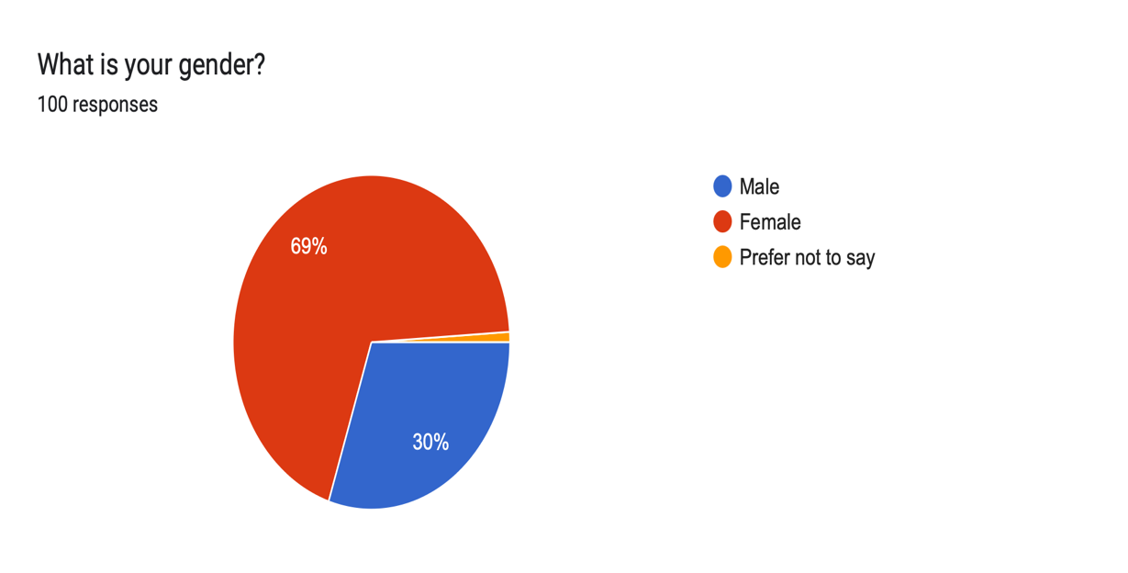

The second question asked was to determine the age of participants. This question was included to contribute to existing literature on this topic and further to evaluate its relevance and applicability in its current context. The age category provided by this research was 18-to 65-year-olds. This survey generated results from all age categories. However, 18-to 24-year-olds engaged most with this survey (37% of participants). This was closely followed by 25 to 34-year-olds (25% of participants) and 35- to 44-year-olds (24% of participants).

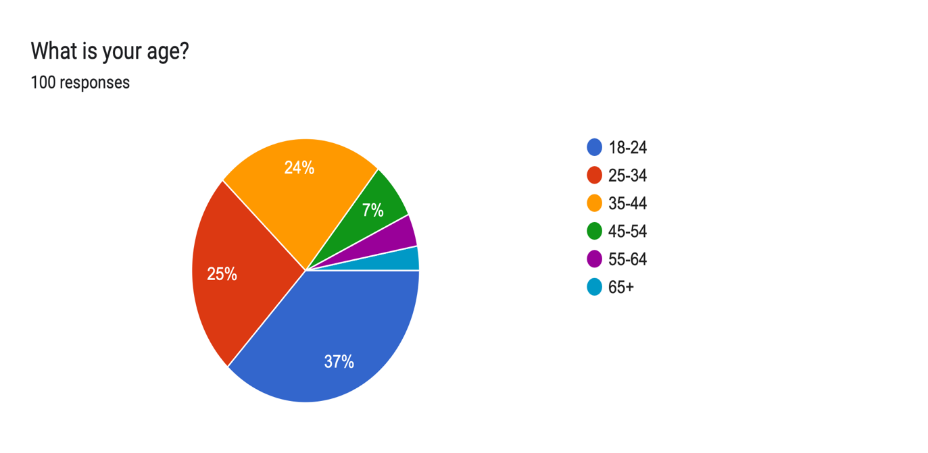

The third question asked was to determine the ethnicity of each participant. This question was included to contribute to existing literature on this topic and further to evaluate its relevance and applicability in its current context. The majority of the participants are white (96%), with the minority representing mixed (3%) and Asian (1%).

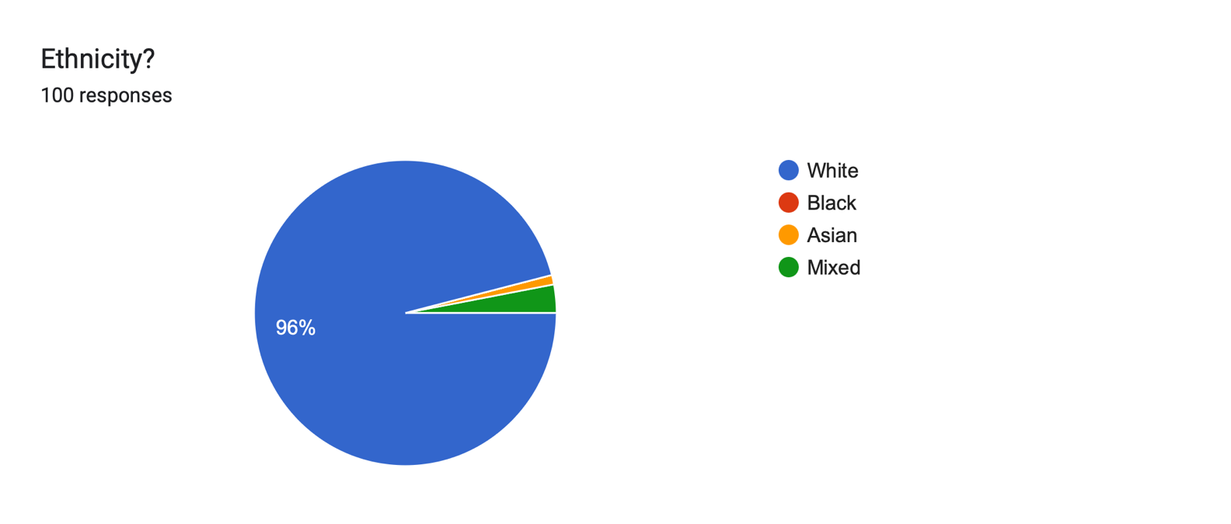

The purpose of this question was to determine the salary of each participant. This question was included to contribute to existing literature on this topic and further to evaluate its relevance and applicability in its current context. The survey is representative of a wide range of salaries. From assessing the data, the majority (31%) of participants earned between £12, 571 -£32, 571 annually. Additionally, the data demonstrates that 29% of participants earned less than £12, 770. The survey recorded that 29% of participants earned between £32, 572 and £50, 270 per year. A minority of participants (11%) earned over £50, 271.

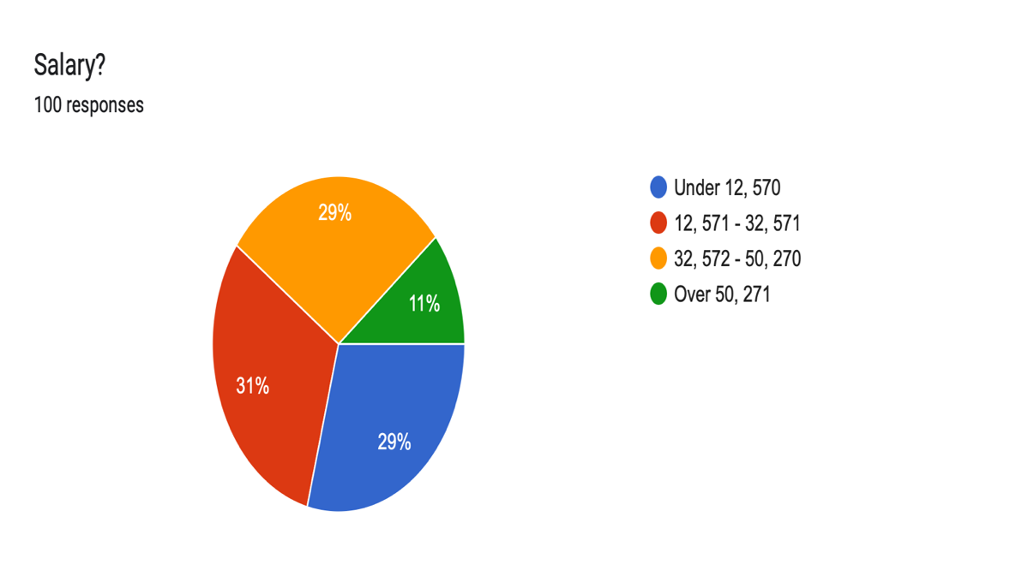

The fifth question was asked to provide an insight into the population that has witnessed crime. This question was included to contribute to existing literature on this topic and further to evaluate its relevance and applicability in its current context. The responses generated show that 73% of participants have witnessed a crime, in comparison to the 27% that have not.

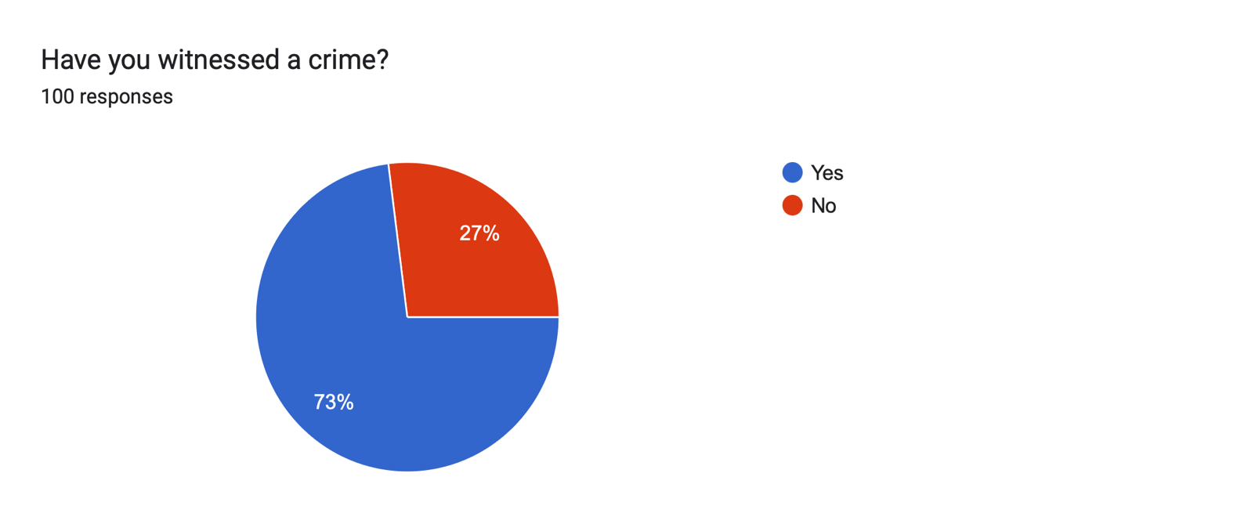

Expanding on the previous question, it was relevant to establish the frequency with which the population has been exposed to crime. This question was included to contribute to existing literature on this topic and further to evaluate its relevance and applicability in its current context. The data suggests that more than half (54%) of participants rarely witness a crime. Whereas 14% of participants are often exposed to crime.

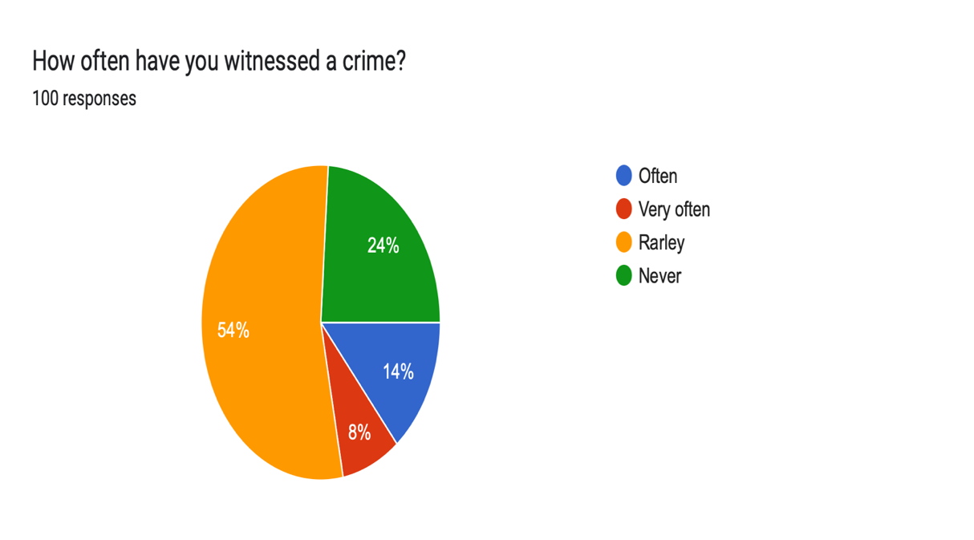

The purpose of this question was to review the effects of exposure to crime. This question was included to contribute to existing literature on this topic and further to evaluate its relevance and applicability in its current context. According to the data, 64% of participants believe that exposure to crime has not affected their perception of crime. Despite this, 17% of participants suggested that exposure to crime has desensitised them to crime. This further emphasises the research of Di Tella et al. (2019), which suggests that those who are most frequently exposed to crime are more likely to become desensitised. Whereas 19% did not know its effects.

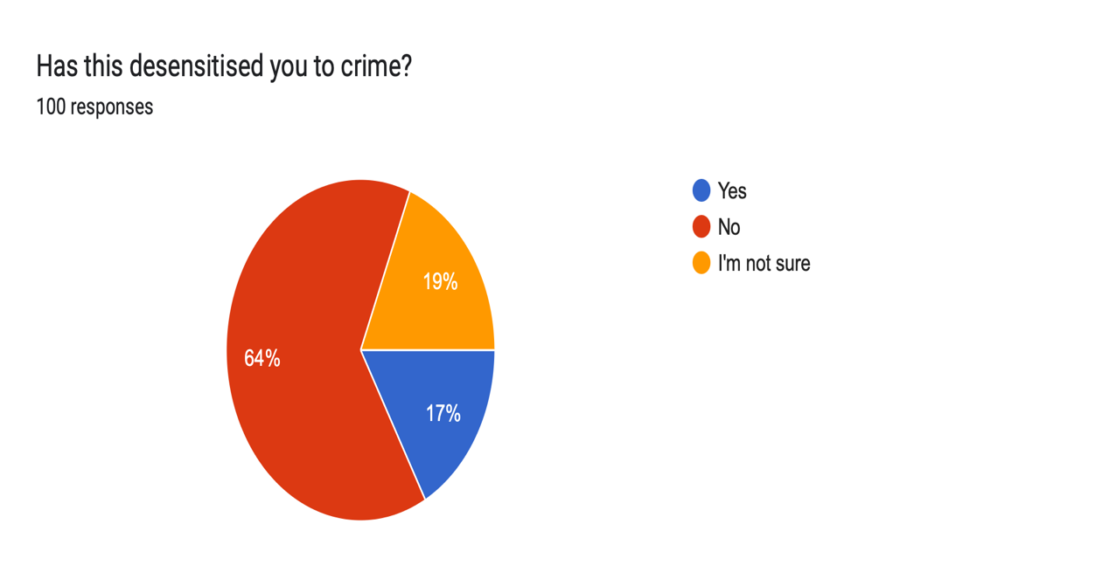

The eighth question of this survey asked: “What factors do you believe contribute to criminality?”

The purpose of this question is to familiarise the researcher and potential readers with factors that the participants believe contribute to criminality. This question generated a variety of responses with approximately 40% of participants suggesting that socioeconomic deprivation and poverty contribute to criminality. Furthermore, it is estimated that 35% of respondents believe that upbringing and family environment influence crime. This highlights the significance of Schroder et al. (2014) findings, which imply that environmental factors diminish a community’s ability to enforce social control and effectively monitor crime. The survey demonstrates that around 25% of participants suggest that peer influence and social environments contribute to criminality. Approximately 15% of respondents believe that mental health and substance abuse contribute to criminality. In addition to this, 10% of participants suggest that social and cultural narratives influence criminality. More specifically, 5% of respondents believe that traditional gender roles contribute to criminality. Walker (1977) implied this by following their observation of women affected by domestic abuse. The survey suggests that approximately 5% of participants associated criminality with institutional and legal system failures. Additionally, the survey recorded that there were some participants (3%) who did not know of any factors that potentially contribute to crime.

The purpose of this question is to explore the percentage of individuals whose perception of crime is directly influenced by external factors. This question was included to contribute to existing literature on this topic and further to evaluate its relevance and applicability in its current context. According to the majority (56%), certain factors have influenced their perception of crime. Additionally, 27% of participants believe that these factors have had no impact on their perceptions of crime.

9.

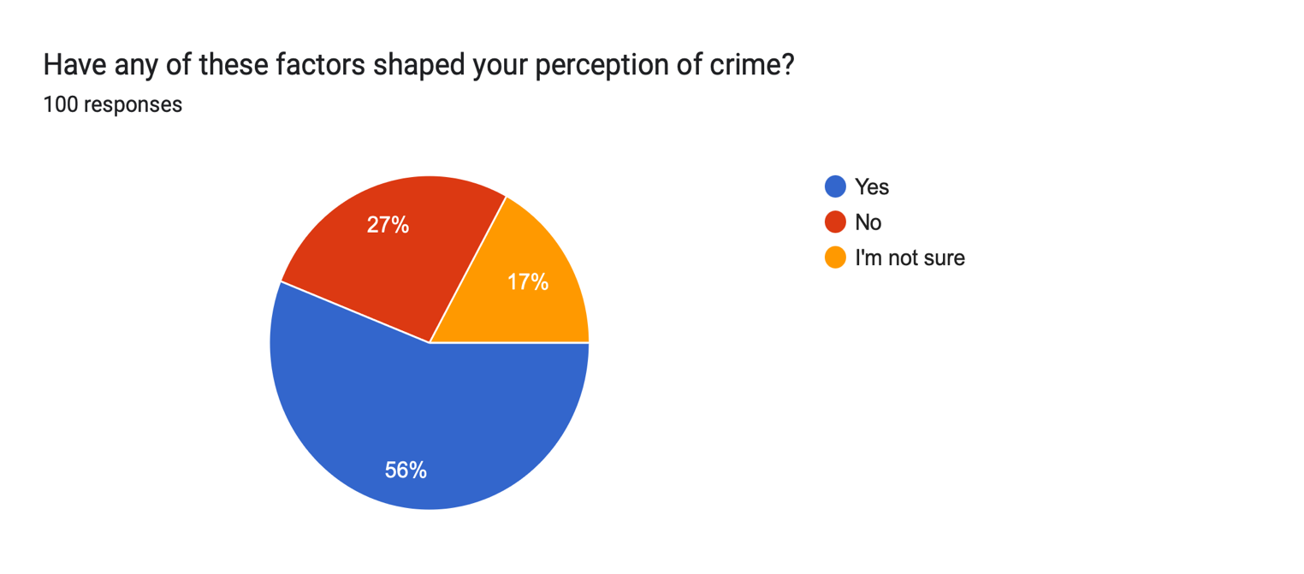

The tenth question aimed to explore the percentage of individuals who were aware of social disparities. This question was included to contribute to existing literature on this topic and further to evaluate its relevance and applicability in its current context. A majority (70%) are aware of existing social disparities. In comparison to the 30% of participants that did not.

10.
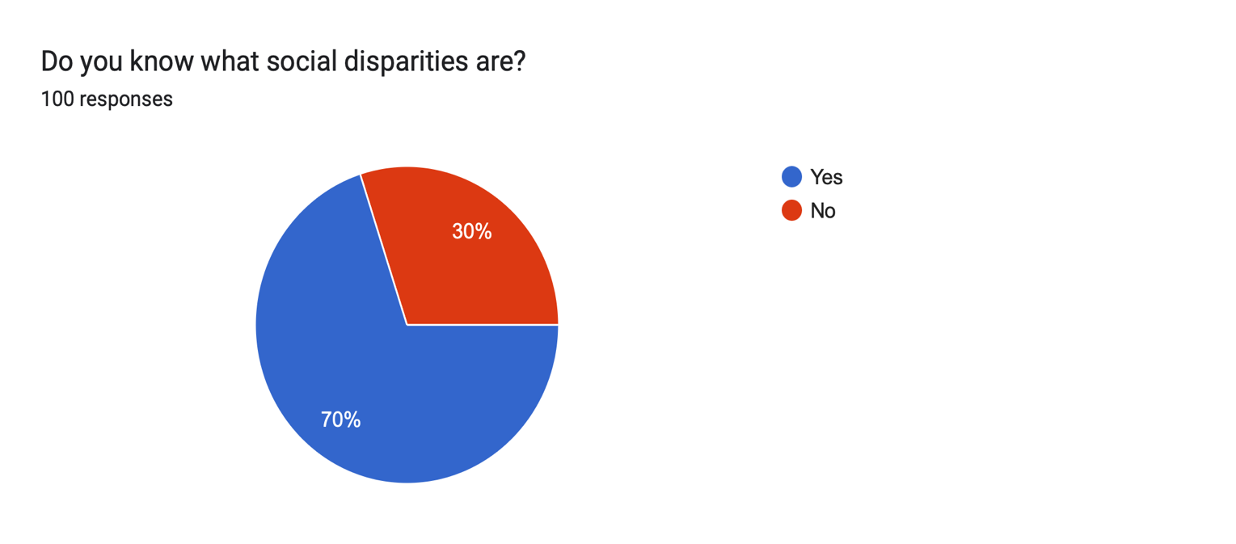

This question aimed to further explore the prevalence of certain social disparities within communities. This question was asked to provide contextual information that will support the participants' understanding and engagement with the qualitative open-ended questions later included in the survey. The survey demonstrates that 79% of participants believe that income and wealth inequality is the most common disparity within communities. This is followed by educational inequality (43%) and discrimination and marginalisation (34%). It was surprising to discover that 16% of participants did not witness any social disparities within their community.

11.
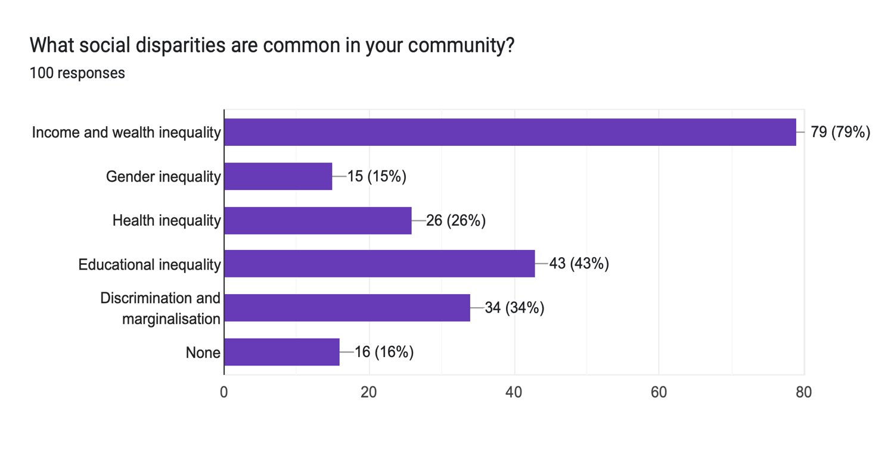

The twelfth question asked in this survey is: “How do these influence crime?”

Expanding on the previous question, the survey asked how specific social disparities influence crime within communities. The purpose of this question was to provide further context for these influences. The survey collected a variety of responses that provided valuable insights and could be analysed further. However, approximately 14% of responses were unable to be analysed effectively due to uncertainty or lack of clarity. Analysing the responses revealed that 26% of participants believe that poverty and economic inequality have influenced crime. Additionally, it is recorded that 17% of respondents believe that limited access to education, jobs, and youth service contributes to crime. A response emphasised this, stating that “poor education results in low job options, low job options result in poor income.” It is estimated that 14% of participants suggest that crime is an accessible method of receiving money and provides freedom to individuals. Furthermore, 12% of respondents implied that social norms further contribute to crime by normalising criminal behaviour. In continuation, 3% of participants have attributed crime to poor attitudes and values. These include internal factors such as greed, lack of morality, or poor work ethic. Merton’s ideologies support this, by suggesting that those who cannot achieve means legitimately will resort to crime (Murphy and Robinson, 2008). The survey also revealed that 7% of participants believe that substance misuse has influenced crime within communities. Some have also included that limited access to rehabilitative services has further contributed to crime. Taylor (2022) demonstrates the ineffectiveness of rehabilitative strategies with an estimate of 29% of offenders re-offending. It is recorded that 6% of participants believe that social inequalities such as racial discrimination, gender-based violence, and structural inequality have indirectly influenced crime.

This question was incorporated into this research to explore the influence of institutional practices on crime. This question was asked to provide contextual information that will support the participants understanding and engagement with the qualitative open-ended questions later included in the survey. The data demonstrates that 65% of participants believe that certain aspects of institutional practices influence crime. Furthermore, 28% where unsure of its influence and 7% believe it has does not affect crime.

13.

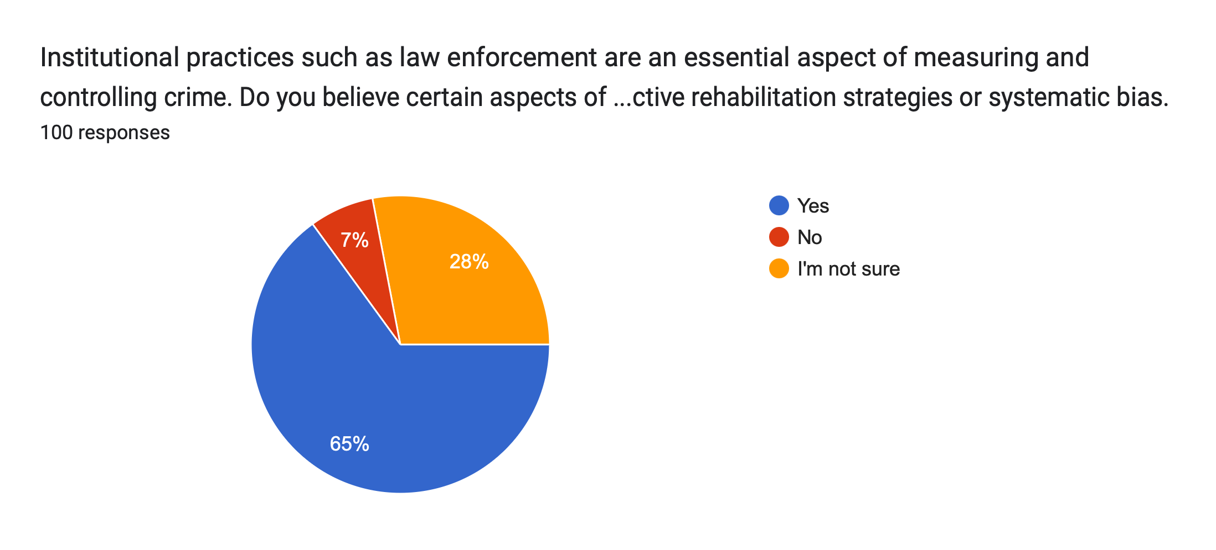

The fourteenth question asked was: “Briefly summarise your choice”

A significant number of participants (28%) expressed concern that current rehabilitation methods, particularly ones implemented in prisons are not effective. Additionally, 12% of respondents believe that criminal justice systems should focus on the primary causes of crime such as poverty, education, and mental health impairments. Bullock and Bunce (2020) suggest that offenders will benefit most from this, highlighting the requirement for additional support and early intervention strategies. Numerous responses (18% of participants) reflected concerns regarding institutional bias in law enforcement practices, particularly affecting marginalised communities. A response highlights this by stating, “too many stop searches on BAME individuals, informing the narrative that these are more criminal.” The disparities amongst arrest rates can be demonstrated through the research of the Home Office (2024) which suggests that black individuals are detained for search approximately 18.6% more than those who are white. Some respondents (15%) believe that the justice system is too lenient or inconsistent. It is recorded that 7% of participants believe that the public perception of police affects crime rates and cooperation. Finally, 10% of respondents expressed uncertainty.

The purpose of this question was to provide a better understanding of those who are aware of existing social or cultural narratives within their community. This question was included to contribute to existing literature on this topic and to further evaluate its relevance and applicability in its current context. 60% of participants are aware of social and cultural narratives. Although, 22% of participants are not.

15.
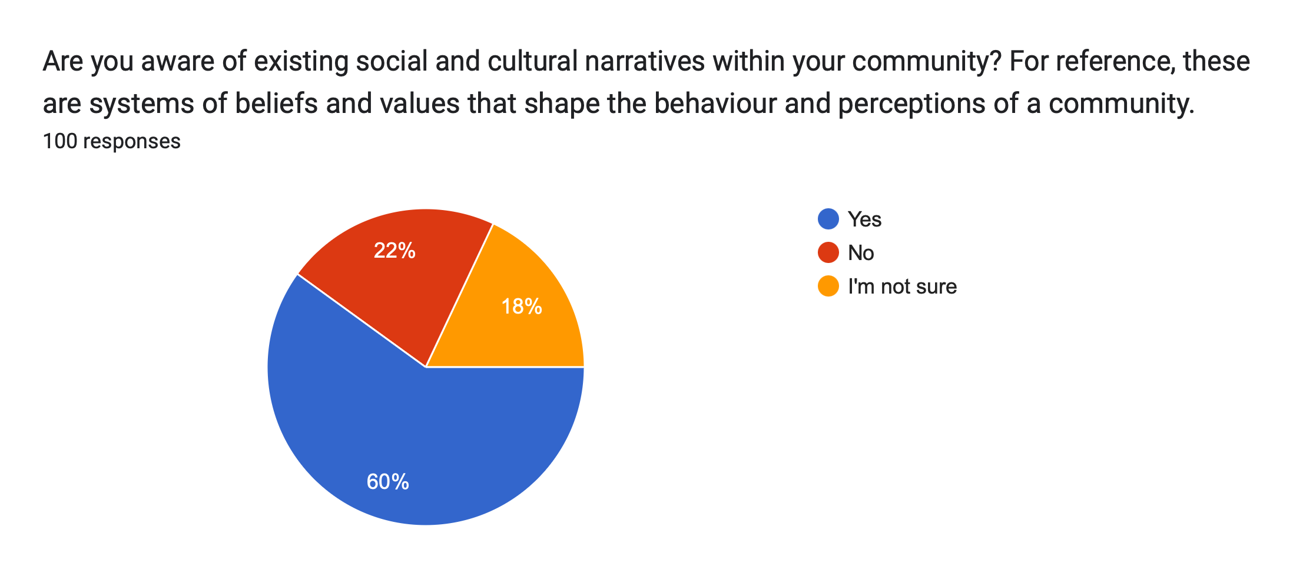

This question was implemented to explore the direct effect of social and cultural narratives on the perception of crime or deviant behaviour. This question was included to contribute to existing literature on this topic and further to evaluate its relevance and applicability in its current context. Despite the high percentage of those who are aware of existing social and cultural narratives, 40% of participants believe that this has not had an impact on their perspective of crime or deviant behaviour. In contrast to this, 29% of individuals are certain that these external factors have shaped their perception of crime or deviant behaviour. Whereas 31% of respondents are unaware of their influence.

16.

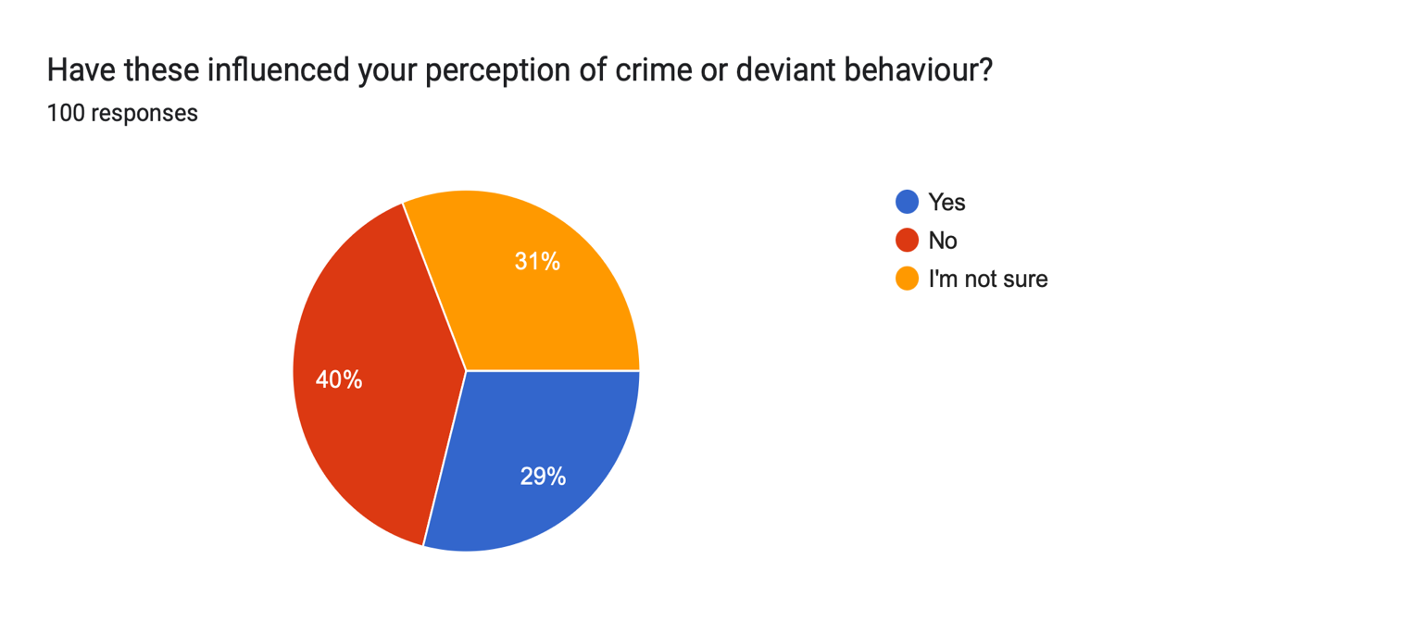

The purpose of this question was to establish how the majority of participants are informed of crime within their community. This question was included to contribute to existing literature on this topic and further to evaluate its relevance and applicability in its current context. A high percentage of individuals rely on sources such as Facebook (80%) and news (64%) to inform them of criminal activity within their community. Additionally, 6% of participants suggested that they rely on new sources such as TikTok. Whereas 1% of individuals use credible sources such as journals to contribute to their knowledge of crime.

17.
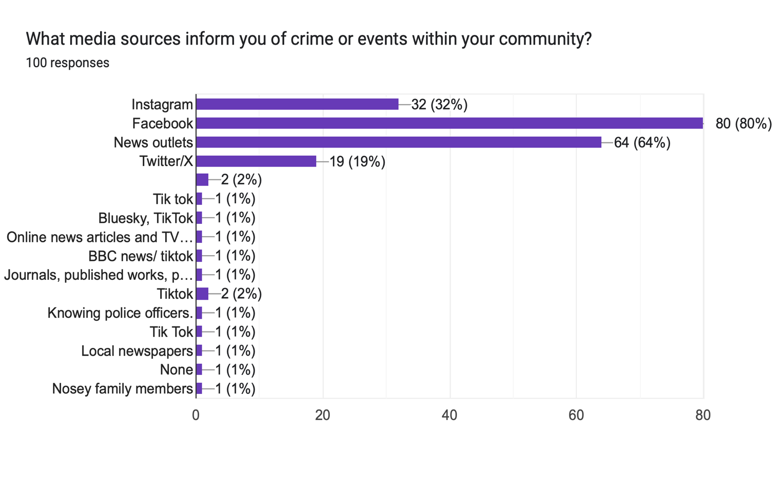

This question was asked to determine whether media portrayals of crime are influencing individuals. This question was included to contribute to existing literature on this topic and further to evaluate its relevance and applicability in its current context. The majority of participants (80%) believe that the media has not significantly impacted them. Expanding on this, 12% of participants contest that media portrayals have caused significant harm.

18.
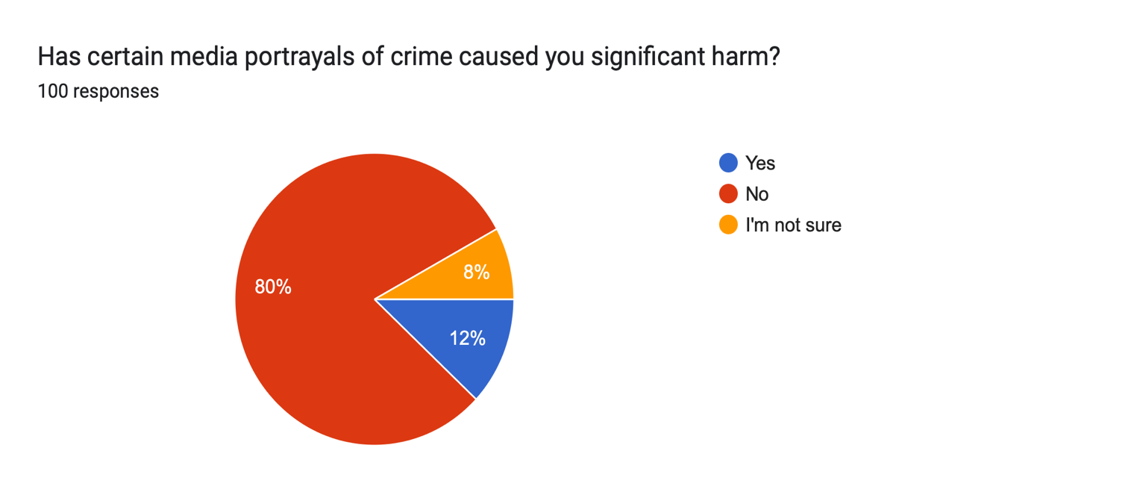

The nineteenth question asked was: “If so, how?”

The purpose of this question was to provide further insight into the influence of media portrayals on individuals. A large proportion (30%) of participants reported that media portrayals of crime have not affected them personally. Furthermore, a smaller group (13%) expressed uncertainty on the issue. The survey revealed that 22% of respondents had limited emotional or psychological impact. One participant reported that “there are reports that unsettle me in terms of their description of the individuals involved, but not enough to cause significant harm.” This implies that individuals know about media bias or sensationalism, but it does not influence their perceptions. To elaborate, 15% of participants expressed their concern for the potential impact that media bias may have on society. This further expands to its effect on specific groups, with 10% of respondents highlighting the effect certain media portrayals have on marginalised communities. However, Bjornstorm et al. (2010) emphasise that this may not be intentional, but rather focused on crime characteristics and regional demographics.

Furthermore, this question was asked to establish whether media portrayals contribute to the perception of crime. This question was included to contribute to existing literature on this topic and further to evaluate its relevance and applicability in its current context. Similarly, 62% of participants believe that media portrayals have not influenced their perception of crime. However, it is surprising to acknowledge that the same percentage of participants (19%) have been impacted or are uncertain of the influence of media portrayals on their perception of crime.

20.
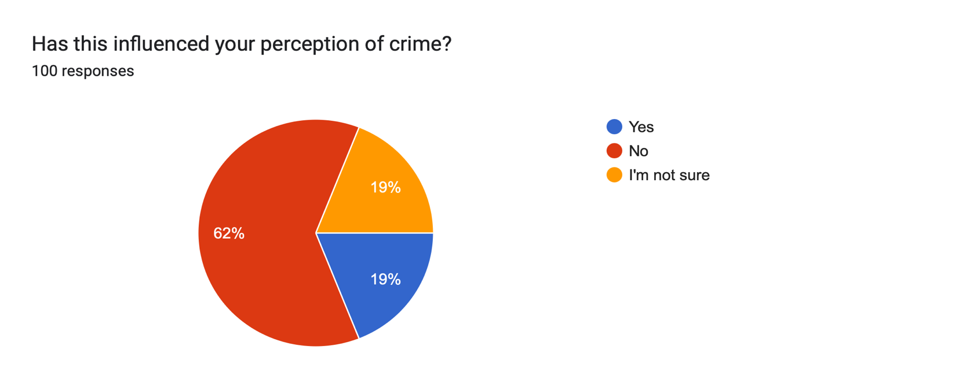

This question was asked to determine whether media outlets should have stricter reporting standards. This question was included to contribute to existing literature on this topic and further to evaluate its relevance and applicability in its current context. It is surprising to note that 79% of participants agree that stricter reporting standards should be implemented. In contrast to this, 8% of participants do not believe that this is relevant.

21.
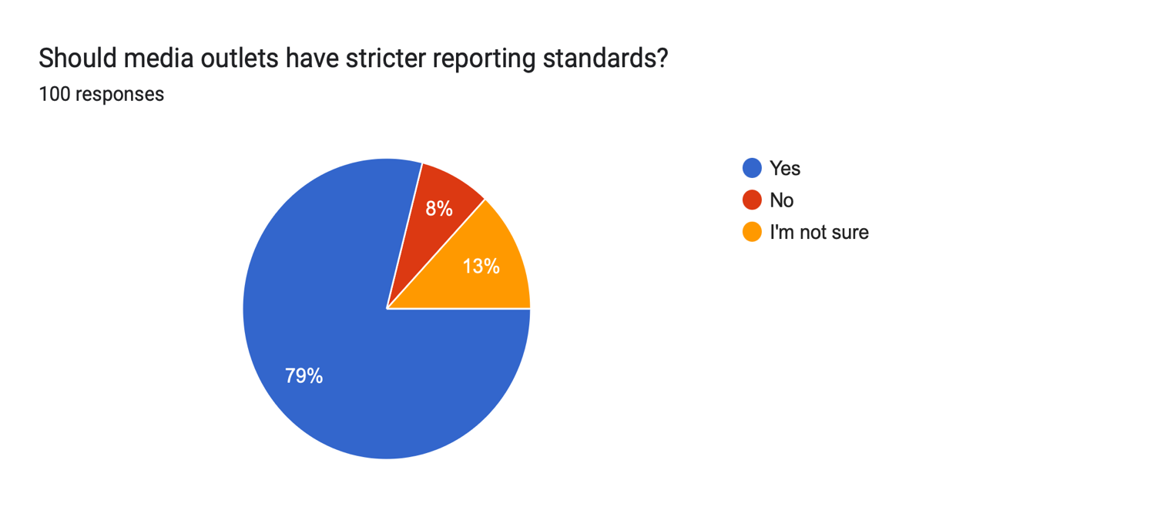

Furthermore, this analysis provides more context into crime as a social construct. Elements of this survey supported existing literature, with particular emphasis on the influence of socioeconomic factors and institutional practices. Additionally, the analysis has inadvertently introduced new factors not initially explored in the study. These unexpected insights reveal opportunities for further inquiry and illustrate the complexity of crime. It has also demonstrated how these different factors inform one other, further contributing to crime and its societal perception.

Conclusion

To conclude, this chapter will summarise some key findings from this research and how this has contributed to addressing the objectives. This research aims to explore the question: “Is crime a social construct?”, by examining the factors influencing crime within communities. A combination of primary research and a review of existing literature has allowed different perspectives on crime to be observed. This research focused on socioeconomic disparities, institutional practices, and social and cultural narratives in shaping crime and its social perception.

Additionally, this chapter will also evaluate how effectively the research has addressed the initial research gap, whilst analysing the limitations of the study and providing recommendations for future research based on these insights. This includes reflecting on elements of the study such as the methodology, considering any constraints that may have influenced the results, and identifying areas where further investigation could enhance the understanding of crime as a social construct.

To address the question “Is crime a social construct?”, all relevant factors must be considered. From a research perspective, crime is often viewed as a social construct. Evidently, from assessing primary data each participant has their own beliefs when it comes to crime and deviant behaviour. The data revealed that various factors like the media, institutional practices, and cultural elements have influenced their perception of crime. More specifically, 29% of participants declared that their perception of crime was influenced by social and cultural narratives.

The question of whether crime is a social construct was also explored through the research objectives. The importance of these was to determine how different elements contribute to the perception of crime independently while examining how these inform one other. A review of existing literature further supports this by highlighting essential theories and perspectives.

Socioeconomic disparities demonstrated a significant influence in both the literature and the survey data. The research indicated that factors such as poverty, education inequality, and limited employment opportunities are influencing crime. This was further emphasised by the data collected through the survey, with the majority (79%) of respondents suggesting that income and wealth inequality is the biggest social disparity within their communities. Thus, illustrating disadvantaged individuals as criminals. However, this was challenged by Savolainen et al. (2013) who suggest that crime is shaped by inherited traits and life experiences.

Institutional practices attempt to reinforce a fair and effective approach to dealing with crime and deviant behaviour. Elements of this have been successful and have ensured that crime is addressed through policing strategies and rehabilitative programs. However, it was highlighted through existing literature that challenges persist such as systematic bias and the overrepresentation of certain groups within the criminal justice system. This was further illustrated by the survey participants with 65% believing that aspects of institutional practices influence crime.

Furthermore, social and cultural narratives have a significant role in influencing the social perception of crime. A combination of existing literature and primary research revealed that these narratives influence the perception of crime by reinforcing stereotypes, and media portrayals and impacting policy responses toward certain groups or behaviours. For example, media portrayals often overrepresents violent crime and minority ethnic communities which reinforces biased attitudes and increases public fear. Baranauskas and Drakulich (2018) explained that media sources would utilise framing techniques to influence the interpretation of criminal behaviour, justice, and punishment. The effects of the media misinforming the public can be found in their response with 79% of respondents believing that media outlets should have stricter reporting standards.

In addressing the initial gap in research, this study has provided further insight into how crime is perceived and defined across different contexts. It has demonstrated that crime cannot be fully understood without examining the broader social, economic, and institutional environments in which it occurs. However, this study is without its limitations.

To achieve more comprehensive results, incorporating additional questions to the survey such as “Have you been a victim of crime?’ may have provided a better insight into how personal experience influences crime and its social perception. Additionally, from analysing the data accumulated by the survey some elements contribute to a crime that this research has not explored. This includes factors such as substance misuse, adverse childhood experiences, and mental health issues. Exploring these influences in future research may provide a holistic understanding of the factors that contribute to crime and shape public perception. This will further inform more effective and evidence-based policy responses.

From assessing the data, the survey demonstrated that the majority of participants (96%) are white. This affects the research as it is not representative of a wider population. A limited representation of ethnic and cultural diversity can result in an incomplete understanding of how different groups perceive and experience crime. To improve this, it may be beneficial to explore different sampling methods. This will ensure that the data accumulated is more diverse, inclusive, and reflective of social experiences. Further improving the validity and generalisability of the research.

References

Andersson, M., Boateng, K. and Abos, P. (2024) ‘Validity and reliability: The extent to which your research findings are accurate and consistent’, Research Gate. Available at: https://www.researchgate.net/publication/384402476_Validity_and_Reliability_The_extent_to_which_your_research_findings_are_accurate_and_consistent (Accessed: 24 April 2025).

Baburajan, V., de Abreu e Silva, J. and Pereira, F.C. (2022) ‘Open vs closed-ended questions in attitudinal surveys – Comparing, combining and interpreting using natural language processing’, Transportation research. Part C, Emerging Technologies, 137, pp. 103589-. Available at: https://www.sciencedirect.com/science/article/abs/pii/S0968090X22000353?via%3Dihub (Accessed: 16 April 2025).

Baranauskas, A.J and Drakulich, K.M. (2018) ‘Media constructions of crime revisited: Media types, consumer contexts, and frames of crime and justice’, Criminology, 56(4), pp. 679-714. Available at: https://onlinelibrary-wiley-com.ezproxy.uwtsd.ac.uk/doi/epdf/10.1111/1745-9125.12189 (Accessed: 10 April 2025).

Barber, M. (2022) A new mode of protection: Redesigning policing and public safety for the 21st century. Available at: https://www.police-foundation.org.uk/policingreview2022/wp-content/uploads/srpew_final_report.pdf (Accessed: 4 May 2025).

Bell, J.S. (2002) ‘Narrative inquiry: More than just telling stories’, TESOL Quarterly, 36(2), pp. 207-213. Available at: https://www-jstor-org.ezproxy.uwtsd.ac.uk/stable/3588331?seq=1 (Accessed: 8 April 2025).

Bhushan, B. (1982) ‘Lord Scarman Reports’, Economic and Political Weekly, 17(1), pp. 19. Available at: https://www-jstor-org.ezproxy.uwtsd.ac.uk/stable/4370549?searchText=&searchUri=&ab_segments=&searchKey=&refreqid=fastly-default%3A0369a2ba0c974eafa11f148e92e6a0ca&initiator=recommender&seq=1 (Accessed: 27 February 2025).

Bjornstorm, E., Kaufman, R., Peterson, R.D. and Slater, M.D. (2010) ‘Race and ethnic representations of lawbreakers and victims in crime news: A national study of television coverage’, Social Problems, 57(2), pp. 269-293. Available at: https://academic.oup.com/socpro/article-abstract/57/2/269/1655566?redirectedFrom=fulltext (Accessed: 11 April 2025).

Bolaji, Q. and Metcalfe, C. (2024) ‘Exploring the Association between Levels of Police Presence, Contact, and Perceptions of Police Legitimacy’, Crime & Delinquency, 70(12). pp. 3308-3342. Available at: https://journals.sagepub.com/doi/10.1177/00111287231226188 (Accessed: 25 February 2025).

Bullock, K. and Bunce, A. (2020) ‘The prison don’t talk to you about getting out of prison’: On why prisons in England and Wales fail to rehabilitate prisoners’, Criminology and Criminal Justice, 20(1), pp. 111-127. Available at: https://journals.sagepub.com/doi/10.1177/1748895818800743 (Accessed: 11 April 2025).

Cane, P. (2012) ‘Morality, law and conflicting reasons for action’, Cambridge Law Journal, 71(1), pp. 59-85. Available at: https://www-cambridge-org.ezproxy.uwtsd.ac.uk/core/journals/cambridge-law-journal/article/morality-law-and-conflicting-reasons-for-action/7AA1D5D2E0E53B06BE6A46057392C5CE (Accessed: 5 May 2025).

Canter, D. and Young, D. (2016) ‘Crime and Society’, Contemporary Social Science, 11(4), pp. 283-288. Available at: https://www.tandfonline.com/doi/pdf/10.1080/21582041.2016.1259495?needAccess=true (Accessed: 29 January 2025).

Capili, B. (2020) ‘Overview: Cross-sectional studies’, The American Journal of Nursing, 121(10), pp. 59-62. Available at: https://pmc.ncbi.nlm.nih.gov/articles/PMC9536510/ (Accessed: 15 April 2025).

Casey, L. (2023) Baroness Casey Review: Final report: An independent review into the standards of behaviour and internal culture of the Metropolitan Police Service. Available at: https://www.met.police.uk/SysSiteAssets/media/downloads/met/about-us/baroness-casey-review/update-march-2023/baroness-casey-review-march-2023a.pdf (Accessed: 5 May 2025).

Ceccato, V., Gliori, G., Näsman, P. and Sundling, C. (2024) ‘Comparing responses from a paper- based survey with a web-based survey in environmental criminology’, Crime Prevention and Community Safety, 26(4), pp. 216-243. Available at: https://link.springer.com/article/10.1057/s41300-024-00204-9#citeas (Accessed: 15 April 2025).

Claridge, T. (2020) ‘Social sanctions – Overview, meaning, examples, types and importance’, Institute for Social Capital, 12 February. Available at: https://www.socialcapitalresearch.com/social-sanctions/ (Accessed: 8 April 2025).

Cohen, L.E. and Felson, M. (1979) ‘Social change and crime trend rates: A routine activity approach’, American Sociological Review, 44, pp. 558-608. Available at: https://www.researchgate.net/figure/Proportion-of-Households-Unattended-by-Anyone-14-Years-Old-or-Over-by-Time-of-Day-during_tbl2_238322365 (Accessed: 24 February 2025).

College of Policing (2021) Neighbourhood policing: Impact and implementation. Available at: https://assets.college.police.uk/s3fs-public/2021-02/np_rea_summary.pdf (Accessed: 6 May 2025).

College of Policing (2021) Targeted approaches to crime and disorder reduction. Available at: https://www.college.police.uk/research/what-works-policing-reduce-crime/targeted-approaches (Accessed: 3 February 2025).

College of Policing (2021) Targeted approaches to crime and disorder reduction. Available at: https://www.college.police.uk/research/what-works-policing-reduce-crime/targeted-approaches (Accessed: 24 February 2025).

Commission on Race and Ethnic Disparities (2021) Commission on Race and Ethnic Disparities: The report. Available at: https://assets.publishing.service.gov.uk/media/6062ddb1d3bf7f5ce1060aa4/20210331_-_CRED_Report_-_FINAL_-_Web_Accessible.pdf (Accessed: 5 May 2025).

Davies, T. (2024) ‘Most crime has fallen by 90% in 30 years – so why does the public think its increased?’, Policing Insight, 23 May. Available at: https://policinginsight.com/feature/analysis/most-crime-has-fallen-by-90-in-30-years-so-why-does-the-public-think-its-increased/ (Accessed: 25 October 2024).

Day, A. (2020) ‘Comparative analysis of the traditional and emerging crimes’, Law Audience Journal, 2(4), pp. 102-112. Available at: https://www.lawaudience.com/wp-content/uploads/2021/01/Comparative-Analysis-of-The-Traditional-and-Emerging-Crimes.pdf (Accessed: 4 May 2025).

De Courson, B. and Nettle, D. (2021) ‘Why do inequality and deprivation produce high crime and low trust?’, Scientific Reports, 11. Available at: https://www.nature.com/articles/s41598-020-80897-8#citeas (Accessed: 12 February 2025).

De Courson, B., Frankenhuis, W. and Nettle, D. (2023) ‘Why is violence high and persistent in deprived communities? A formal model’, Proceedings of the Royal Society Biological Studies, 290. Available at: https://royalsocietypublishing.org/doi/10.1098/rspb.2022.2095 (Accessed: 19 February 2025).
Di Tella, R. et al. (2019) ‘Crime and violence: Desensitization in victims watching criminal events’, Journal of Economic Behaviour & Organization, 159, pp. 613-625. Available at: https://www.sciencedirect.com/science/article/pii/S0167268117302792?via%3Dihub (Accessed: 10 April 2025).

Domínguez, M. and Montbolio, D. (2021) ‘Bolstering community ties as a mean of reducing crime’, Journal of Economic Behaviour and Organization, 191, pp. 916-945. Available at: https://www.sciencedirect.com/science/article/pii/S0167268121004078 (Accessed: 4 May 2025).

Featherstone, R. and Deflem, M. (2003) ‘Anomie and Strain: Context and Consequences of Merton’s Two Theories’, Sociological Inquiry, 73(4), pp. 471-489. Available at: https://onlinelibrary-wiley-com.ezproxy.uwtsd.ac.uk/doi/epdf/10.1111/1475-682X.00067 (Accessed: 3 February 2025).

Fichtelberg, A. (2021) Criminal (In) justice: A critical introduction. 2nd ed. Delaware: SAGE Publications. Available at: https://uk.sagepub.com/sites/default/files/upm-assets/121620_book_item_121620.pdf Accessed: 4 May 2025).

Henn, T. and Posegga, O. (2023) ‘Attention-grabbing news coverage: Violent images of the Black Lives Matter movement and how they attract user attention on Reddit’, PLoS One, 18(8). Available at: https://www.proquest.com/docview/2925246760/fulltextPDF/A5336E1BEC554967PQ/1?accountid=130472&sourcetype=Magazines (Accessed: 5 February 2025).

Home Office (2024) Arrests. Available at: https://www.ethnicity-facts-figures.service.gov.uk/crime-justice-and-the-law/policing/number-of-arrests/latest/#:~:text=the%20arrest%20rate%20for%20people,arrest%20rates%20than%20white%20people (Accessed: 25 October 2024).

Home Office (2024) Stop and search. Available at: https://www.ethnicity-facts-figures.service.gov.uk/crime-justice-and-the-law/policing/stop-and-search/latest/ (Accessed: 25 February 2025).

House of Commons (2014) Caught red-handed: Why we can’t count on Police Recorded Crime Statistics. HC 760, London: The Stationary Office Limited. Available at: https://publications.parliament.uk/pa/cm201314/cmselect/cmpubadm/760/760.pdf (Accessed: 10 April 2025).
House of Commons Justice Committee (2023) Justice Committee Survey, March 2023. Available at: https://committees.parliament.uk/writtenevidence/119614/default/ (Accessed: 10 April 2025).
https://eprints.lse.ac.uk/68133/1/Newburn_Social%20Disadvantage%20and%20Crime.pdf
Joseph Rowntree Foundation (2024) UK Poverty 2024: The essential guide to understanding poverty in the UK. Available at: https://www.jrf.org.uk/uk-poverty-2024-the-essential-guide-to-understanding-poverty-in-the-uk (Accessed: 3 February 2025).

Kelley, K., Clark, B., Brown, V. and Sitza, J. (2003) ‘Good practice in the conduct and reporting of survey research’, International Journal for Quality in Health Care, 15(3), pp. 261-266. Available at: https://academic.oup.com/intqhc/article/15/3/261/1856193?login=true#no-access-message%23no-access-message (Accessed: 16 March 2025).

Kesmodel, U.S. (2018) ‘Cross-sectional studies – what are they good for?’, Acta Obstetricia et Gynecologica Scaninavica, 97(4), pp. 388-393. Available at: https://obgyn.onlinelibrary.wiley.com/doi/epdf/10.1111/aogs.13331 (Accessed: 15 April 2025).

Klauer, K.J. and Phye, G.D. (2008) ‘Inductive reasoning: A training approach’, Review of Educational Research, 78(1), pp. 85-123. Available at: https://journals-sagepub-com.ezproxy.uwtsd.ac.uk/doi/epub/10.3102/0034654307313402 (Accessed: 15 March 2025).

Kranenbarg, M.W., Ruinter, S., van Gelder, J.L. and Bernasco, W. (2018) ‘Cyber-offending and traditional offending over the life course: An empirical comparison’, Journal of Development and Life-course Criminology, 4(3), pp. 343-364. Available at: https://pmc.ncbi.nlm.nih.gov/articles/PMC6428311/ (Accessed: 4 May 2025).

Leavy, P. (2020) The Oxford handbook of qualitative research. 2nd edition. New York: Oxford University Press.

Leverentz, A. (2012) ‘Narratives of Crime and Criminals: How Places Socially Construct the Crime Problem’, Sociological Forum, 27(2), pp. 1-24. Available at: https://onlinelibrary-wiley-com.ezproxy.uwtsd.ac.uk/doi/epdf/10.1111/j.1573-7861.2012.01321.x (Accessed: 7 February 2025).

Machpherson, W. (1999) The Stephen Lawrence Inquiry (Cm 4262-I). Available at: https://assets.publishing.service.gov.uk/media/5a7c2af540f0b645ba3c7202/4262.pdf (Accessed: 25 February 2025).

Manstead, A.S.R. (2018) ‘The psychology of social class: How socioeconomic status impacts thoughts, feelings, and behaviour’, The British Journal of Social Psychology, 52(2), pp. 267-291. Available at: https://pmc.ncbi.nlm.nih.gov/articles/PMC5901394/ (Accessed: 5 May 2025).

McMaster, H.S., Leardmann, C.A., Speigle, S. and Dillman, D.A. (2017) ‘An experimental comparison of web-push vs. paper-only survey procedures for conducting in-in depth health surveys for military spouses’, BMC Medical Research Methodology, 17(4), article number 73. Available at: https://bmcmedresmethodol.biomedcentral.com/articles/10.1186/s12874-017-0337-1#citeas (Accessed: 15 April 2025).

Medical Research Council (2022) Embedding Diversity in Design: Diversity and Inclusion in the Design of Research Involving Human Participants. Swindon: UK Research and Innovation. Available at: https://www.ukri.org/wp-content/uploads/2023/03/Report_Embedding-Diversity-in-Research-Design.pdf (Accessed: 16 April 2025).

Messinger, A.M. (2011) ‘Invisible victims: Same-sex IPV in the National Violence against Women Survey’, Journal of Interpersonal Violence, 26(11), pp. 2228-2243.; Available at: https://journals.sagepub.com/doi/epdf/10.1177/0886260510383023 (Accessed: 7 April 2025).

Ministry of Justice (2022) Prisons Strategy White Paper – Response to Consultation Paper (CP 686). Available at: https://assets.publishing.service.gov.uk/media/62a71a37d3bf7f03744c7c4a/prisons-strategy-white-paper-govt-response.pdf (Accessed: 24 February 2025).

Murphy, D. and Robinson, M. (2008) ‘The Maximizer: clarifying Merton’s theories of anomie and strain’, Theoretical Criminology, 12(4). Available at: https://libres.uncg.edu/ir/asu/f/Murphy_Robinson_2008_The_Maximizer.pdf ( Accessed: 17 February 2025).
National Academies of Sciences, Engineering and Medicine (2018) Addressing the social and cultural norms that underlie the acceptance of violence: proceedings of a workshop – in brief. Washington, DC: The National Academies Press. Available at: https://nap.nationalacademies.org/download/25075 (Accessed: 11 March 2025).

Newburn, T. (2016) ‘Social disadvantage, crime, and punishment’ in H. Dean and L. Platt (ed) Social Advantage and Disadvantage. Oxford University Press: Oxford, PP. 322-340.
Novosel, L. M. (2023) ‘Understanding the evidence: Non-probability (non-random) sampling designs’, Urological Nursing, 43(5), pp. 245-247. Available at: https://openurl-ebsco-com.ezproxy.uwtsd.ac.uk/c/onvpsy/openurl?sid=ebsco:plink:entitlement&id=ebsco:aph:173128441 (Accessed: 16 April 2025).

O’Dwyer, L.M. and Bernauer, J.A. (2016) Quantitative research for the qualitative researcher. Thousand Oaks, California: SAGE.

Oakley, R. (1999) ‘Institutional Racism and the Police Service’, The Police Journal: Theory, Practice and Principles, 72(4), pp. 285-295. Available at: https://journals.sagepub.com/doi/abs/10.1177/0032258X9907200402 (Accessed: 26 February 2025).

Palinkas, L.A. et al. (2015) ‘Purposeful sampling for qualitative data collection and analysis in mixed method implementation research’, Administration and Policy in Mental Health and Mental Health Services Research, 42(5), pp. 533-544. Available at: https://link.springer.com/article/10.1007/s10488-013-0528-y (Accessed: 15 April 2025).

Patino, C.M. and Ferreira, J.C. (2018) ‘Internal and external validity: Can you apply research study results to your patients?’, Jornal Brasileiro de Pneumologia, 44(3), pp. 183. Available at: https://pmc.ncbi.nlm.nih.gov/articles/PMC6188693/ (Accessed: 24 April 2025).

Pham, L. (2018) A review of key paradigms: Positivism, interpretivism and critical inquiry. MA thesis. University of Adelaide. Available at: https://www.researchgate.net/publication/324486854_A_Review_of_key_paradigms_positivism_interpretivism_and_critical_inquiry (Accessed: 14 April 2025).

Regnault, A., Willgoss, T. and Barbic, S. (2018) ‘Towards the use of mixed method inquiry as best practice in health outcomes research’, Journal of Patient-Reported Outcomes, 2(1), pp. 1-4. Available at: https://jpro.springeropen.com/articles/10.1186/s41687-018-0043-8#citeas (Accessed: 15 April 2025).

Rollé, L., Giardina, G., Caldarera, A.M., Gerino, E. and Brusita, P. (2018) ‘When intimate partner violence meets same sex couples: A review of same sex intimate partner violence’, Front Psychol, 9, article number 1506, Available at: https://www.frontiersin.org/journals/psychology/articles/10.3389/fpsyg.2018.01506/full (Accessed: 7 April 2025).

Rosala, M. (2024) ‘Open-ended questions vs. closed questions in user research’, Nielsen Norman Group, 26 January. Available at: https://www.nngroup.com/articles/open-ended-questions/#:~:text=Open%2Dended%20questions%20allow%20participants,and%20in%20how%20much%20detail (Accessed: 16 April 2024).

Ryan, G. (2018) ‘Introduction to positivism, interpretivism and critical theory’, Nurse Researcher, 25(4), pp. 14-20. Available at: https://journals-rcni-com.ezproxy.uwtsd.ac.uk/doi/pdf/10.7748/nr.2018.e1466 (Accessed: 14 April 2025).

Sangeetha, J., Mohan, S., Hariharasudan, A. and Nawaz, N. (2022) ‘Strategic analysis of intimate partner violence (IPV) and the cycle of violence in the autobiographical text – When I Hit You’, Heylion, 8(6). Available at: https://www.cell.com/heliyon/fulltext/S2405-8440(22)01022-2?_returnURL=https%3A%2F%2Flinkinghub.elsevier.com%2Fretrieve%2Fpii%2FS2405844022010222%3Fshowall%3Dtrue (Accessed: 7 April 2025).

Saunders, M.N.K., Lewis, P. and Thornhill, A. (2009) ‘Understanding research philosophies and approaches’, Research methods for business students, 4(1), pp. 106-135. Available at: https://www.researchgate.net/publication/309102603 (Accessed: 14 March 2025).

Saunders, M.N.K., Lewis, P. and Thornhill, A. (2019) Research methods for business students. 8th edition. Harlow, England: Pearson.

Savage, J. (2024) ‘Searching for the young style rebels: How the Teddy boy emerged from postwar London’s tribal landscape of fashion, class and violence’, New Statesman (5751; February 9-15 February), pp. 44-45. Available at: https://www.proquest.com/docview/2925246760/fulltextPDF/A5336E1BEC554967PQ/1?accountid=130472&sourcetype=Magazines (Accessed: 5 February 2025).

Savolainen, J. et al (2013) ‘Material deprivation or minimal education? Social class and crime in an egalitarian welfare state’, Advances in Life Course Research, 18(3), pp. 175-184. Available at: https://www.sciencedirect.com/science/article/pii/S1040260813000130 (Accessed: 19 February 2025).
Schroeder, K.B., Pepper, G.V. and Nettle, D. (2014) ‘Local norms of cheating and the cultural evolution of crime and punishment: a study of two urban neighbourhoods’, PeerJ, 2, pp. 1-23. Available at: https://peerj.com/articles/450.pdf (Accessed: 11 March 2025).

Shek, D. T. L, Diya, D., Xiaoqin, Z and Lindan, T. (2022) ‘Materialism, Egocentrism and Delinquent Behavior in Chinese Adolescents in Mainland China: A Shor-Term Longitudinal Study’, International Journal of Environmental Research and Public Health, 19(8). Available at: https://pmc.ncbi.nlm.nih.gov/articles/PMC9026470/ (Accessed: 19 February 2025).
Shubert, C. A., Mulvey, E.P., Loughran, T.A. and Losoya, S.H. (2011) ‘Perceptions of Institutional Experience and Community Outcomes for Serious Adolescent Offenders’, Criminal Justice and Behaviour, 39(1), pp. 71-93. Available at: https://journals.sagepub.com/doi/full/10.1177/0093854811426710 (Accessed: 20 February 2025).

Sovacool, B.K., Iskandarova, M. and Hall, J. (2023) ‘Industrializing theories: A thematic analysis of conceptual frameworks and typologies for industrial sociotechnical change in low-carbon future’, Energy Research & Social Science, 97, pp. 102954 -. Available at: https://www.sciencedirect.com/science/article/pii/S2214629623000142 (Accessed: 16 April 2025).

Szczepan, B. (2024) The impact of crime media on people’s perceptions of crime, perpetrators and victims. MA thesis. Maynooth University. Available at: https://mural.maynoothuniversity.ie/id/eprint/19044/1/Barbara%20Szczepan.pdf (Accessed: 10 April 2025).

Tang, H. (2020) Engineering research: Design, methods and publications. Hoboken: Wiley.

Taylor, R. (2022) Crime and rehabilitation: An overview. Available at: https://lordslibrary.parliament.uk/crime-and-rehabilitation-an-overview/ (Accessed: 21 February 2025).

Tellez-Torres, J. (2023) ‘Empirical evidence on the relationship between material deprivation and crime: an analysis of crime in Spain’, International E-Journal of Criminal Sciences, 18(6), pp. 1-25. Available at: https://ojs.ehu.eus/index.php/inecs/article/view/25218/23124 (Accessed: 3 February 2025).

The Police Foundation (2017) The impact of organised crime in local communities. Available at: https://www.police-foundation.org.uk/wp-content/uploads/2017/10/oc_in_local_communities_final.pdf (Accessed: 20 February 2025).
The Police Foundation (2017) The impact of organised crimes in local communities. Available at: https://www.police-foundation.org.uk/wp-content/uploads/2017/10/oc_in_local_communities_final.pdf (Accessed: 11 April 2025).

Theophilus, A. (2018) ‘Qualitative research: Deductive and inductive approaches to data analysis’, Qualitative Research Journal, 18(4), pp. 383-400. Available at: https://www.proquest.com/docview/2133411195?accountid=130472&parentSessionId=PK4kkcyj%2F0FCudTZ3gZ1f396uxZTArbfW%2FcoqLq5duQ%3D&pq-origsite=primo&sourcetype=Scholarly%20Journals (Accessed: 15 April 2025).

Trust for London (2025) Crime and income deprivation. Available at: https://trustforlondon.org.uk/data/crime-and-income-deprivation/ (Accessed: 12 February 2025).

Walker, L.E. (1977) ‘Who are the battered women?’, A Journal of Women Studies, 2(1), pp. 52-57. Available at: https://www-jstor-org.ezproxy.uwtsd.ac.uk/stable/pdf/3346107 (Accessed: 18 March 2025).

Walsh, J.P., Baker, V. and Frade, B. (2022) ‘Policing and social media: The framing of technological use by Canadian newspapers (2005-2020)’, Criminology & Criminal Justice, 24(4), pp. 819-840. Available at: https://journals.sagepub.com/doi/epub/10.1177/17488958221114254 (Accessed: 11 April 2025).

Wang, X. and Cheng, Z, (2020) ‘Cross-sectional studies: Strengths, weaknesses and recommendations’, Chest, 158(1), pp. 65-71. Available at: https://journal.chestnet.org/action/showPdf?pii=S0012-3692%2820%2930462-1 (Accessed: 15 April 2025).

Weening, M.W.H. and Maareveld, M. (2003) ‘The impact of time constraint on information search strategies in complex choice tasks’, Journal of Economic Psychology, 23(6), pp. 680-702. Available at: https://www.sciencedirect.com/science/article/abs/pii/S0167487002001344 (Accessed: 16 March 2025).

Weisburd, D. (2016) ‘Does Hot Spot Policing Inevitably Lead to Unfair and Abusive Police Practices, or Can We Maximize Both Fairness and Effectiveness in the New Proactive Policing?’, University of Chicago Legal Forum, 2016, article number 16. Available at: https://chicagounbound.uchicago.edu/cgi/viewcontent.cgi?referer=&httpsredir=1&article=1578&context=uclf (Accessed: 24 February 2025).

Widom, C.S. (1989) ‘The Cycle of Violence’, Science (American Association for the Advancement of Science), 244(4901), pp. 160-166. Available at: https://www.proquest.com/docview/213547614?accountid=130472&sourcetype=Scholarly%20Journals (Accessed: 31 March 2025).

Wolfgang, M.E (1978) ‘Real and Perceived Changes of Crime and Punishment’, Daedalus, 107(1), pp. 143-157. Available at: https://www-jstor-org.ezproxy.uwtsd.ac.uk/stable/pdf/20024526.pdf?refreqid=fastly-default%3A881191ed7567ad732ef13e18bc009d66&ab_segments=&origin=&initiator=&acceptTC=1 (Accessed: 23 April 2024).

World Health Organization (2022) Violence against women. Available at: https://www.who.int/news-room/fact-sheets/detail/violence-against-women (Accessed: 7 April 2025).

Yonfa, E., Fasol, M., Cueva, C. and Zavgorodniaya, A. (2021) ‘Intimate partner violence: A literature review’, The Open Psychology Journal, 14, pp. 11-16. Available at: https://www.sciencedirect.com/org/science/article/pii/S1874350121000298 (Accessed: 7 April 2025).

Youth Justice Board (2024) Youth Justice Statistics: 2022 to 2023 (accessible version). Available at: https://www.gov.uk/government/statistics/youth-justice-statistics-2022-to-2023/youth-justice-statistics-2022-to-2023-accessible-version (Accessed: 11 April 2025).

