Name :- Ruksar israr
Student id number :- 1817838
Lecture name :-doctor Abdi Rehman
Module title:- professional and career development
Module code:- BMSW 4005

Task 3 :- reflective portfolio 3000 words
- A reflection of self awareness tool that you have used and it relevance to your further employment (1000) words
- Reflection based on your mock interview experience and feedback you received(1000) words
- Career development plan with SMART objectives strategies and detailed action. This plan should be accompanied with ancillary notes that explain each of your point mentioned in your plan. (10000)words

Table of context
Introduction 3
Self reflection 4
Swot analysis 5
What is swot analysis 5
Jo harry 6
Mock interview 8
Career development 11
Reference 14

Introduction
In this reflective portfolio I will be talking about a reflection of the self awareness tool an reflection based on the interview which had took place and how it went and how I could of got more marks then what I have got finally this reflective portfolio will also have and career development plan with smart objectives ,strategies and detailed action .
I will be also adding in my reflective portfolio and swot analysis and Johari window about myself also I will be adding my marks which I had got for my interview

Self reflection
According to Kate Herbert(2018) it states that the reason why you should self-reflect because it help you to know what u have done which is awarded what improvement you can make the next time which u may do the same thing like for example in the interview which I had on the 21st February I had an interview which was about the career and although I had tried my best the mistake which I had was the jacket I had on the hoody was up due to I was nerves and I had tried by best to make my expression as I was confident now for me my next target is to be more confident and make not to have my jacket on or my hoody up.
I think that self-reflection is an good way is because so you know what is good to be awarded and what is something is not so good that you can do some extra work or do some extra research which can help you the second time around and will be able to help you.
For example when I had the mock interview which was about the chosen job and after that I was given the feedback from the interview now I will understand that what my mistakes was and how I can do better next time.
Self reflection is
- It allows you to improve the places where u need to improve on
- It allow you to recognise what ways and strategies helped you and which did not
- Help u think and take action on which will help u do better the next time

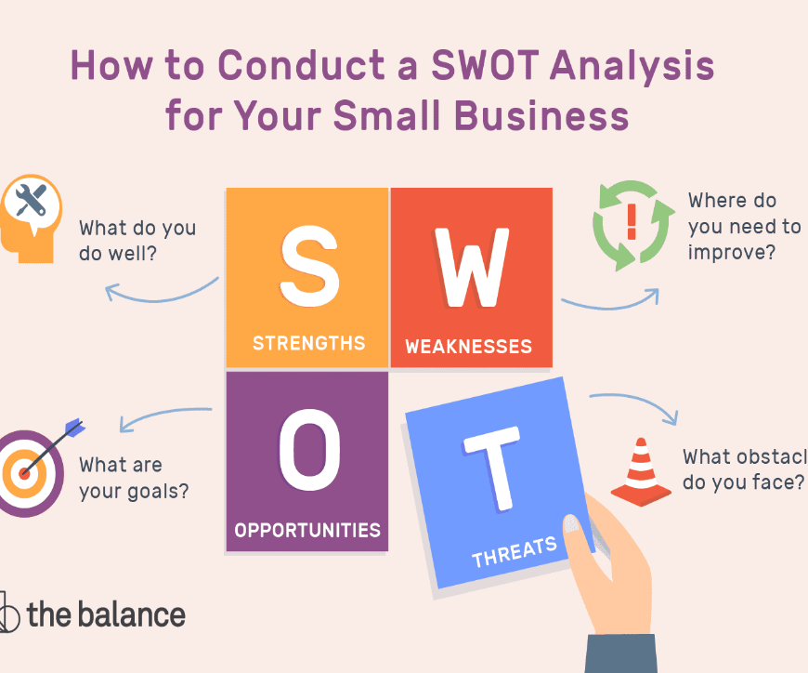
Swot analysis
strength :-  - Qualification  - Time management  - fast learner | Weakness :-  - Less experience  - Over qualified
Threats :-  - Whether  - Distance  - Competitor’s | Opportunities :-  - Training  - More learning  - More experience

What is swot analysis
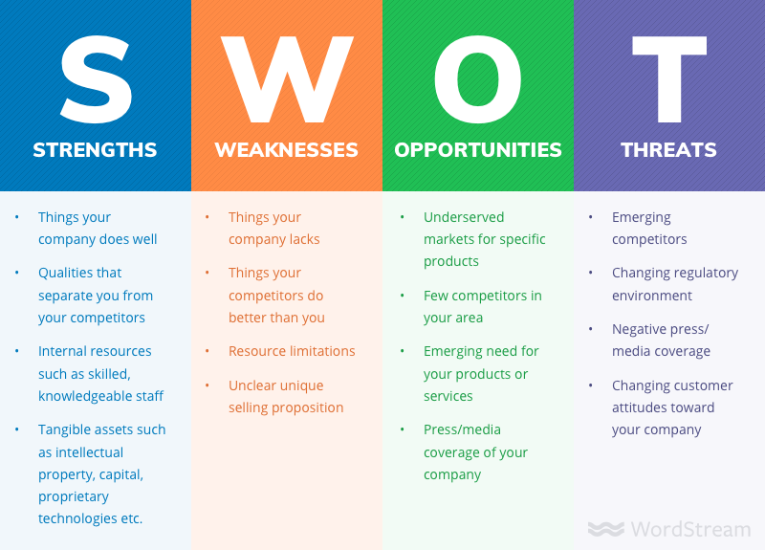
Swot analysis is an technique which organise your current position .swot stand for strength and weakness opportunities and threats.
Also you can use swot analysis to make your business it a better position so I will reduce the chances of falier of your business by an swot analysis you can understand what you are lacking in your business or what might be threats to your business. Strength is something your business does well or the way your business stand out from the other business .a weakness is something that your business might be lacing In.and threat is something that can harm your business.an opportunities is something that you might have an chance to do something positive which might change your system in your company .

Jo harry
According to selfawareness (10th November 2013) that Johari window is a psychological took which is created by a person called Joseph Luft and Harry ingham in 1955 also it states that it an tool which help you for an training and for you to understand for
- Self-awareness
- Person development
- Group dynamic
- Team development
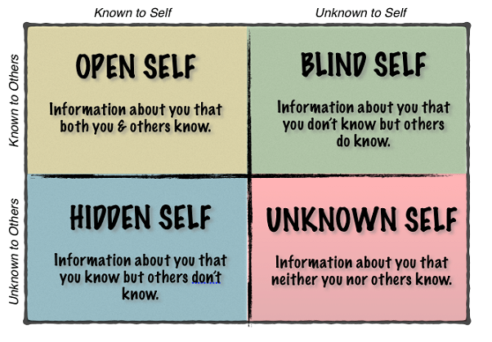
According to the education business article it states the 4 different arear of the Johari window .
- The first part is the open arear which is know by the person and know by other to they say in this arear u can add your behaviour knowledge attitude history
- The second one is the hidden arear which is part where you know yourself but the other person does not know about that part hidden part

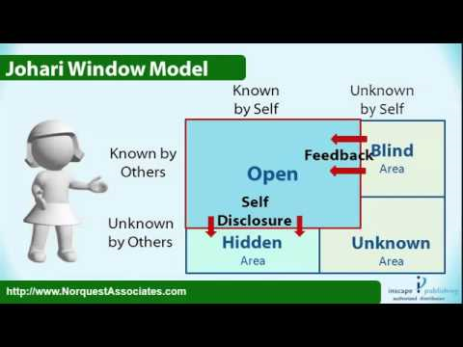
- The third one is the blind arear which is the unknow your yourself but the other people know about you but you can normally add like fear incompetence like stuff which they fear it but the other person can see it.
- Finally is the unknown arear which is the known by the person but is unknown by others

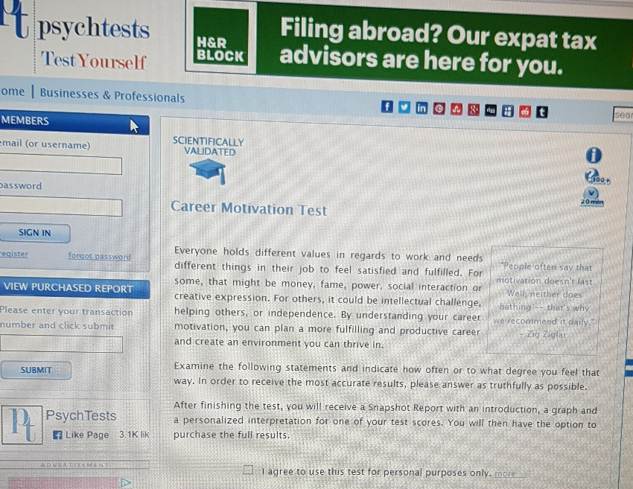
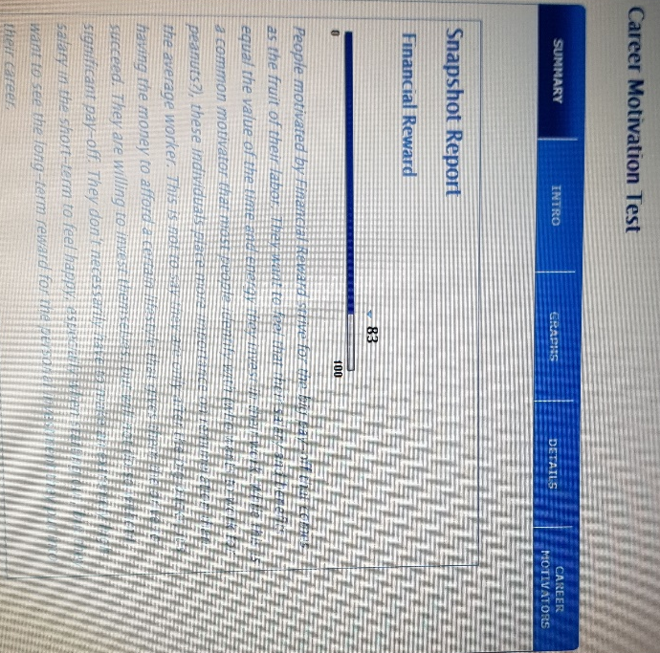
I also had took the 2 test which where online the first was a career motivation test and the second one was a career test and hear are the result which I had got:-
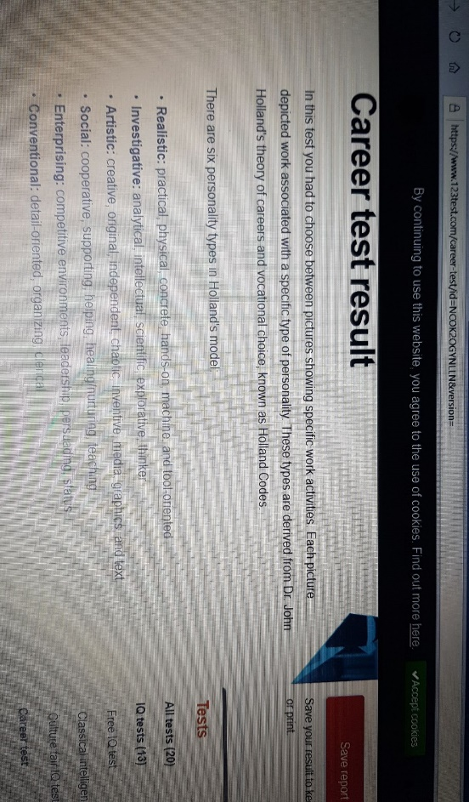

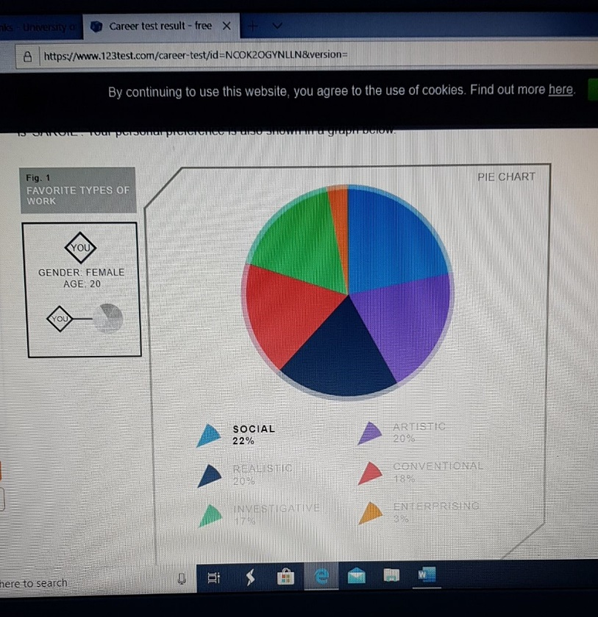
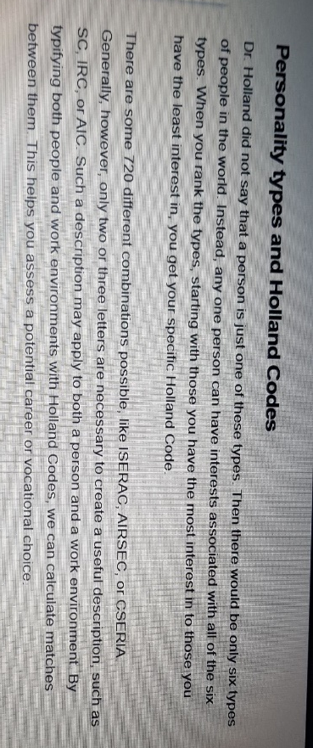
And this is the second test which I had did :-

Which I don’t agree to because I wanted to become an care assistant but imam doing my qualification so I get the right qualification s I am able to get the right qualification which I need to be able to get through the right job which I need the reason why I wanted to get my qualification so I have the right skill and knowledge which I need to ne able to do my job right and to be able to have the right knowledge to be able to do the job which is my desire to do right .

Mock interview
According to Alison Doyle 2019 that an mock interview is an practice so when you give the mock interview u will get feedback so u are able to gain more knowledge from there and be able to apply the skill and be able to perform an better performance there are one tips which are showed of how you can understand yourself for an mock interview come 10-15 min early before your mock interview time ,dress professionally and u should bring your notes in the mock interviews which you may be able to use in the mock interview .
I had an mock interview on Friday 21st of February 2020 . I had to bring in 3 pieces of paper with in in the interview which where one a cv two an cover letter and three an job description I had brought theses 3 paper in to the interview room I was really nerves giving the interview but although I had already had an interview for another job and I had gone though and got the job. I practice 3 days continually to try to show that I was not nerves and on the day I tried to give my best performance I could give but due to I was really nerves still I left my hoody my jacket up so I had to get marked low for that reason I got 71% out of 100% which was in the middle so which mean they could of hired me which still give me chance .which I still don’t feel bad for getting this mark because first at lest I tried and second at lest I can learn from the mistakes I did and I can do a better performance the next time round .
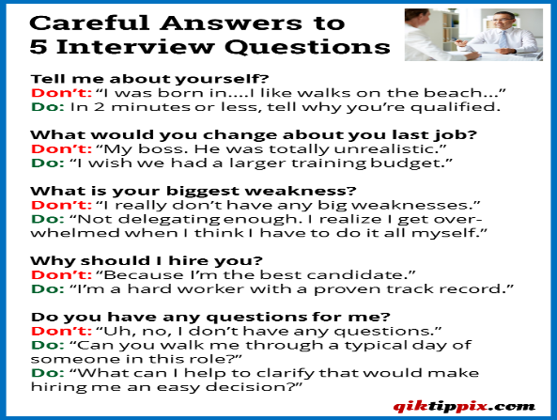
Another point is I prepared my self for the job interview by doing the background research so I had my self prepared so if the manger of the company in the interview ask me the any question of the company I had an backup an knew about the care company which I had applied for which I had applied for . also the day it was my interview few days before the interview I had found out where I was going and I knew my place around and I had gone early to the interview so I no problem coming late to the interview .i had my self-prepared by seeing the question which the company may ask me so I had some question written down and thought the answer which I thought was right .

In addition to these point I would like to add that my posture the way I was sitting Infront on the company mangers so I only had low marks only when I had the hoody of my jacket on due to I was nervous I had forgot to take my hoody off still I had made eye contact and I tried to be confident and try to show that I was not nerves but the mistake I had made was that at the end of the interview the company mangers had ask me if I had any question but I was nerves which I said I did not have any question. Plus I updates my cv and cover letter so she can see my grammar and punctuality so I had tried my best that I could get the best point but I am still happy because I tried my best and tried to get the highest points.
The way I can use my feedback from I got from my mock interview I will try to go over my interview note a bit more so I can have more confidence on the day of the interview so I don’t look nerve to the company mangers also write the question which I might need to ask the company mangers. Plus the feedback I got made me more confident and will make me not want to make the same mistake again the next time around .
According to Alison Doyle (2019)t the way you can research for your interview which are :-
- Do it yourself go over the interview
- Know the interview process
- Practice answering interview question
- Use flashcards
- Record yourself
- Dress the part
- Lastly give the set of question to a member of friend or mate which you think you will be asked and answer those question
To get better mark next time when I have an mock interview I can uses some if these tips also I can watch YouTube clips which show how to do interview also I think flashcard is the one I can use next time because I will also remember what I can say I will not have to pause and think what I need to say because another reason why I got low marks is because I was taking time to be able to think what I can answer .

I think the reason why you should get feedback is because according to Matt Hudgins (may 28 2018) it states 3 reason why you should ask for feedback and the reason are
- It’s a chance to learn more about yourself
- It show that you care about the job
- You have nothing to loose
By these point it show that you are passion you have applied for and that you know where u went wrong and will not make the same mistake again and try to perform better .
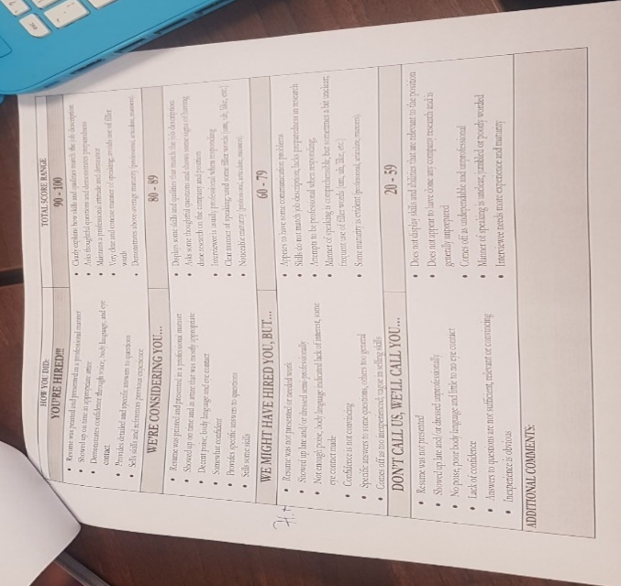

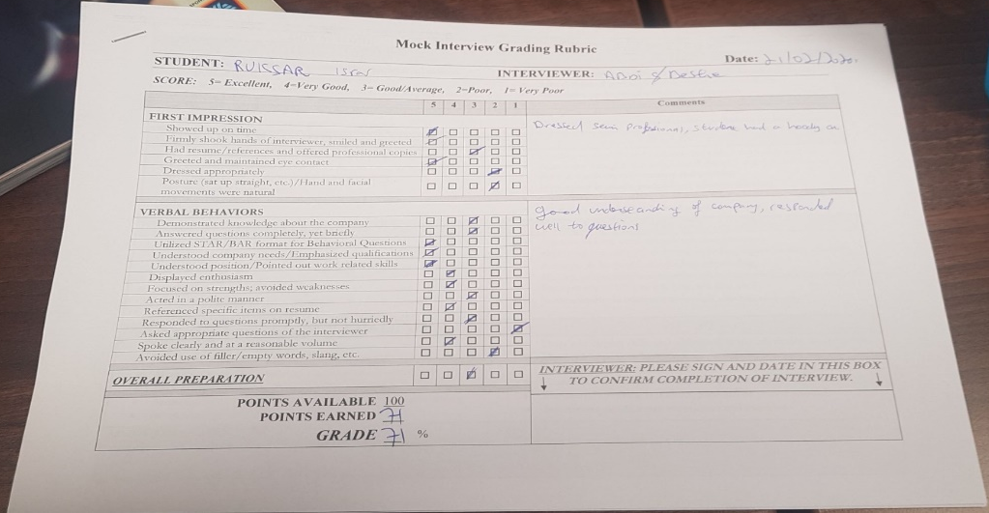

Career development
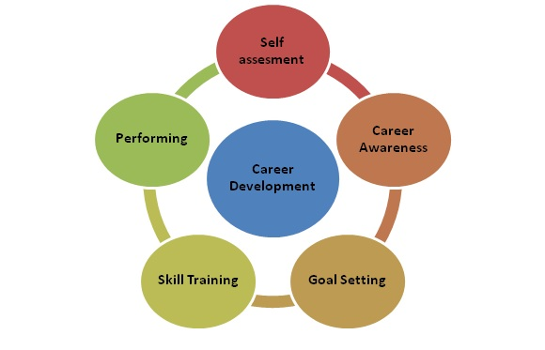
According to MBASK Career development is an series of actives of an process of an development ones career .all this includes skill more training .career development is linked to the goal and objectives you have first it starts with what your capable of then all that link to your option and choices you have .individual you need to give yourself training and then choices your career path .
According to Heathfield .Susan(2019) there are 5 tips which can improve your career development which are
- Set goals and create a plan to achieve them
- Develop an timeline including milestone
- Utilize company programs
- Own your career path
- Write it down
What is smart objectives:-
According to public health professional gateway it stats that SMART stand for
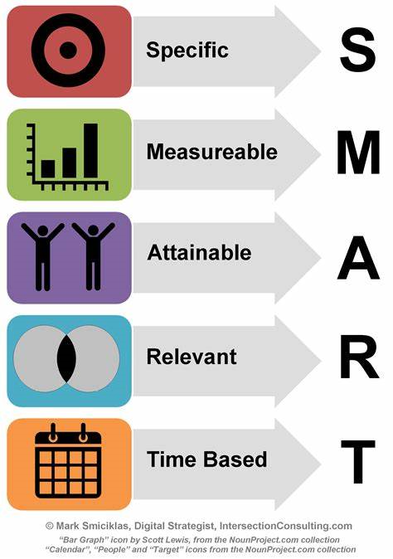
- S stand for specific meaning your information in detail what you going to expect when
- M stand for measurably number of quantities provided
- A stand for archivable easy to put in action
- R stand for consider such as resources personnel cost and time frame
- T/B stand for time bound a set time that make you help boundaries around the objectives

According to SMART goal it states that SMART goal are for your set for success by making specific,mesurbal,and achievable realistic and timely this smart method help you to push further in a sense of a direction which you need your business to go and reach your goal


My smart goal is that I want to work in a care assistant job and by over time open my own care home for the family who b working and they can leave there parents or and the elderly people who need to be cared for we will be there for there help and service

specific | measurable | attainable | realistic | Time-bound
Online education to do my math and English | To get the right online courses and get enrolled | To do extra work to be able to understand better | Use outside hours to do more work | September 2020
Go to university to do my level 3 | To go to the right university to get the right qualification | To do my work before the time | Stay back to get more work and understand it | September 2020
Work experience | When we get an email call or interview | Call or email places to ask for volunteers | Take time out to look for places and give a call to ask | November 2020

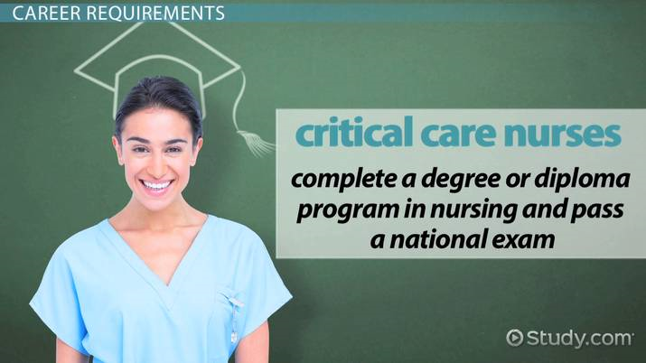
The first plan I have which is to fine the university which would do the course which I am looking for and then go and get enrolled to the course just for encases they don’t accept me or they don’t have any space or anything then my plan b is to do online courses nut on the side I will also look for an volunteer job on the side so I will get the experience I need because not everybody is perfect you always learn something new although I had already worked in a care home I wanted to have more qualification and more skill that I can delver the better service and the care that they need.
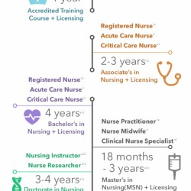
by this pic it just that how the process it takes to become an nurse but at the end of the day all theses process it take there will always be an plan B
I love to become an care assistant that has all the qualification and the skill but in some year I would love to open it so I can give them the service they need.
But due to the current viruses that id going around most of the education that I had thought about might not go to plan but there always the second plan which might go to plan
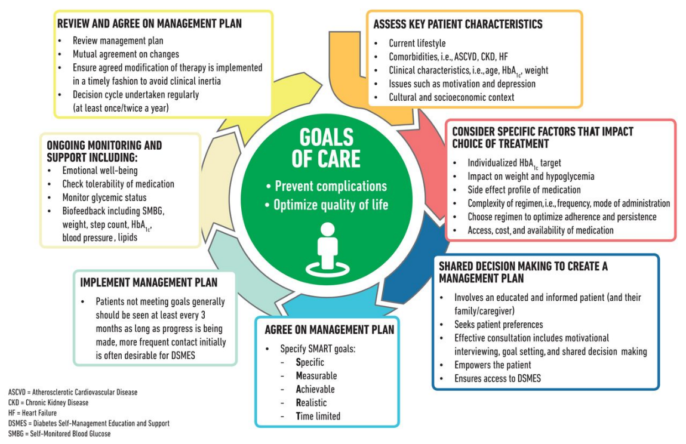
The reason why I think an smart objective is important is because that will make you more organised and will make you will make you more aware about when what thing need to be handed in and when a new project can be started but as for now due to the viruses most of people education can be delayed but some people can do it from home .

There are certain skill and qualification which I need to fix up like not to get worried about any situation which might occur and try to act confident and try to pay attention on more detail think which I can pick up new skill because there is still so much still I need to learn .

Reference
- https://www.123test.com/career-test/
- https://testyourself.psychtests.com/testid/3153
- https://www.thebalancecareers.com/improving-career-development-4058289

- https://www.thebalancecareers.com/how-to-use-mock-interviews-to-practice-interviewing-2061626

an overview of the mock interviews (Doyle.Alson October 31st 2019)acceded on 13 march 2020
- https://www.thebalancecareers.com/job-interview-practice-how-to-rehearse-for-an-interview-2062803
How to rehearse for an interview (Doyle.Alson November 17th 2019)acceded on 15 March 2020
- https://www.wayup.com/guide/community/three-reasons-its-okay-to-ask-for-feedback-after-an-interview/
3 reason why it ok to ask for feedback after an interviewer (Matt Hudgins may 28th 2018)
- https://blog.irisconnect.com/uk/community/blog/importance-of-self-reflection/
the importance of self reflection(k.herbert)2018
- https://www.mindtools.com/pages/article/newTMC_05.htm
swot analysis how to develop a strategy for the success
- https://www.selfawareness.org.uk/news/understanding-the-johari-window-model
understanding the Johari window (10th November 2013)
- https://www.educational-business-articles.com/johari-window/
The Johari window helping building trust
- https://www.mbaskool.com/business-concepts/human-resources-hr-terms/1779-career-development.html
career development definition and importance overview
- https://www.cdc.gov/phcommunities/resourcekit/evaluate/smart_objectives.html
develop smart objectives
https://corporatefinanceinstitute.com/resources/knowledge/other/smart-goal/

