Name: Mercy Tshikombwe
Student Number :2424792
Module code: BMHP5023
Module Title: Introduction to Physiology
Health and social care
Lecture Name: Dr Robert Nartowski
Assignment Title: Asthma
Date:28/ June/2026
Table of Contents
Case Study 2: Asthma 2
Introduction 2
Section 1: Anatomy and Physiology of the Respiratory System 3
Section 2: Pathophysiology of Asthma 4
Section 3: Monitoring and Data Use 6
Section 4: Evidence-Based Lifestyle Recommendations 8
Conclusion 10
Reference List 11

Case Study 2: Asthma

Introduction
Asthma is a chronic lung condition that affects the airways in the lungs. It is characterised by symptoms such as coughing, wheezing, chest tightness, and shortness of breath, which may worsen during asthma attacks. It is caused by inflammation and tightening of the muscles around the airways, making breathing difficult (WHO, 2026). According to the World Health Organization, asthma can affect both children and adults, although it is most common among children and adolescents (WHO, 2026; Liu et al., 2024).
The exact cause of asthma is not fully understood; however, evidence suggests that the condition is linked to multiple factors. These include a family history of asthma, indicating a hereditary component. Asthma is also more prevalent in individuals with allergic conditions such as hay fever (WHO, 2026). Furthermore, Lee et al. (2024) highlights that asthma is associated with environmental factors such as air pollution, particularly in urban areas. Other risk factors include exposure to tobacco smoke, vaping, dust, and mould. Living in overcrowded environments may also contribute to airway irritation and inflammation. In addition, individuals who are overweight or obese are at an increased risk of developing asthma (NHS Inform, 2026; WHO, 2026).
The purpose of this report is to provide adolescents attending the clinic with information to help them understand the causes of asthma and how the respiratory system functions. It also explains how factors such as smoking, vaping, and infections can impact lung health. In addition, the report highlights the importance of monitoring respiratory data, such as peak flow readings, to support effective self-management and reduce the risk of severe asthma exacerbations.
The report is divided into four sections: anatomy and physiology of the respiratory system; the role of respiratory irritants in causing inflammation; the importance of monitoring health data in asthma management; and evidence-based lifestyle recommendations. It concludes with a summary of the key points.

Section 1: Anatomy and Physiology of the Respiratory System
  - The Respiratory Structure
The respiratory system is the body system responsible for breathing. It allows the body to take in oxygen and remove carbon dioxide. The system is divided into the upper and lower respiratory tracts. The upper respiratory tract includes structures such as the nose, nasal cavity, and throat, where air enters the body, is filtered, warmed, and moisturised (Jung and Fraser, 2020).
The lower respiratory tract includes the trachea (windpipe), bronchi (the main airways), bronchioles (smaller airways), and the lungs. Within the lungs are tiny air sacs called alveoli, which are surrounded by small blood vessels known as capillaries. This is where gas exchange takes place (Asthma and Lung UK, 2024; Hsia et al., 2016). These structures work together to enable air to move in and out of the body (see Fig. 1 below)
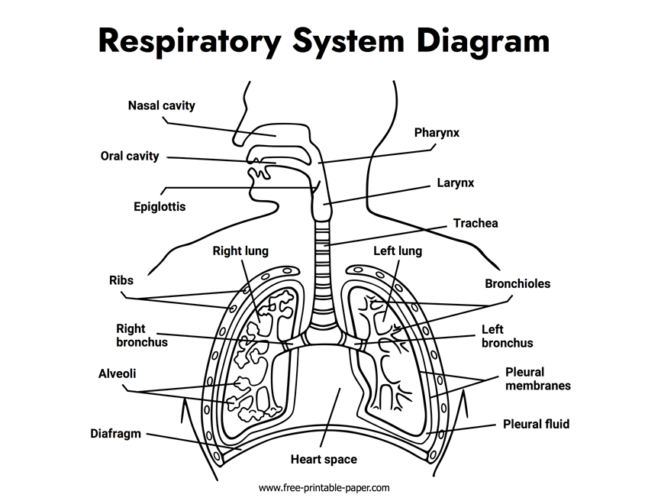
Source: https://free-printable-paper.com/respiratory-system-diagram
Fig 1. Respiratory system.

  - Respiration and Gas Exchange
Mechanical respiration is the process of breathing in and out, allowing air to move into and out of the lungs. During inhalation, the muscle beneath the lungs (the diaphragm) contracts and moves downward, while the chest cavity expands. This increases the space inside the chest,
causing air to be drawn into the lungs. During exhalation, the diaphragm relaxes and moves upward, while the ribs move downwards. This reduces the space in the chest and pushes air out of the lungs. These movements allow oxygen to enter the body and carbon dioxide to be expelled (Ingold, 2020; Hsia et al., 2016).
Gas exchange occurs during external respiration, where oxygen moves from the air in the alveoli into the bloodstream. When air is inhaled, oxygen diffuses across the thin walls of the alveoli into the surrounding capillaries. At the same time, carbon dioxide—produced as a waste gas by the body—diffuses from the blood into the alveoli and is removed during exhalation (Lister et al., 2021). This process occurs due to differences in concentration: oxygen moves from an area of higher concentration in the alveoli to an area of lower concentration in the blood, while carbon dioxide moves in the opposite direction—from the blood, where its concentration is higher, to the alveoli, where it is lower (Lister et al., 2021; Wiersinga et al., 2020).

Section 2: Pathophysiology of Asthma
Asthma is characterised by changes in the airways that occur when they are exposed to irritants such as pollen, smoke, dust, and pet hair. In individuals who are sensitive or allergic to these substances, the body identifies them as harmful. As a result, the immune system releases chemicals that cause the lining of the airways to become inflamed and swollen (Thurston et al., 2020). This inflammation affects both the lungs and the airways.
When inflammation occurs, the muscles surrounding the airways tighten (bronchoconstriction), and excess mucus is produced. This combination reduces the space available for air to move in and out of the lungs. The narrowing of the airways, along with mucus build-up, can obstruct airflow and make breathing difficult. These changes lead to common asthma symptoms such as wheezing, coughing, and shortness of breath (Hsia et al., 2016).
In the figure below (see Fig. 2), Part A shows the location of the lungs and airways within the body. Part B presents a cross-section of a healthy airway, while Part C illustrates a cross-section of an airway affected by asthma (Sinyor and Perez, 2023).

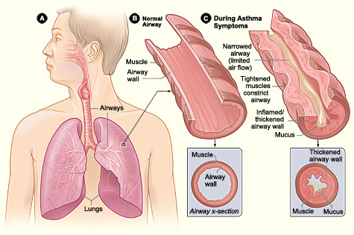

Source: Sinyor &Perez (2023).
Fig 2. Pathophysiology of Asthma
According to the National Institute for Health and Care Excellence (NICE, 2024), smoking, vaping, and respiratory infections can make breathing more difficult, particularly for people with asthma. Smoke and vape aerosols introduce toxic chemicals that irritate the lining of the airways, causing swelling and increased inflammation (Bernstein et al., 2021). This leads to airway tightening and narrowing, reducing the amount of air that can move in and out of the lungs (Chand and Hosseinzadeh, 2020). As a result, individuals with asthma are at a higher risk of experiencing asthma attacks.
Similarly, evidence from Schweitzer et al. (2017) identifies vaping as a risk factor for asthma in adolescents. The study found that adolescents who used e-cigarettes were more likely to develop asthma, even after accounting for other contributing factors. This suggests that vaping can irritate and inflame the airways, making breathing more difficult due to airway narrowing
Infections such as colds or influenza can also inflame the airways and increase mucus production, triggering symptoms such as coughing, wheezing, and shortness of breath (Thurston et al., 2020). As a result, oxygen may not enter the bloodstream as efficiently, and carbon dioxide may not be removed as effectively. This can lead to symptoms such as fatigue and breathlessness (NHS Inform, 2026).

Section 3: Monitoring and Data Use
Monitoring and recording respiratory function are an essential part of managing asthma safely and effectively. Effective self-management plays a key role in achieving good asthma control. One of the most used methods is peak flow monitoring. Peak flow measures how quickly a person can exhale air from their lungs, which reflects how open or narrowed the airways are (NICE, 2024). Studies have shown that regular peak flow monitoring helps to establish an individualised baseline for each person with asthma. This baseline is important as it allows early detection of warning signs of an asthma attack or deterioration, often before symptoms such as wheezing or shortness of breath appear (Rhee and Katchamat, 2026; NICE, 2024).
Tracking respiratory function, such as peak flow readings, provides valuable information about how well the condition is being managed. Patients who use peak flow monitoring are empowered to take an active role in managing their health and can seek help before their symptoms worsen. Asthma and Lung UK (2024) suggest that tracking peak flow readings over time can help patients identify patterns or triggers associated with their asthma, such as allergies or environmental factors like dust or weather changes. However, although peak flow monitoring is associated with positive outcomes, some studies have questioned its clinical effectiveness in improving asthma control (Gulbert et al., 2017). According to Rhee and Katchamat (2026), such inconsistent findings may be due to poor adherence, with some patients not using peak flow meters correctly or regularly.

The Royal Marsden Manual of Clinical Nursing Procedures (Lister et al., 2021) suggests that daily recording of peak flow readings, often in a diary, allows individuals with asthma and healthcare professionals to identify patterns over time. For example, a gradual decline in peak flow may indicate increasing airway inflammation or exposure to triggers such as smoke, allergens, or infection. This enables patients to seek support and allows healthcare professionals to take early action, such as adjusting inhaler use, prescribing medication, or providing further medical advice before symptoms become severe.

Monitoring also supports healthcare professionals in using objective data from peak flow readings rather than relying solely on self-reported information, which may be affected by memory or estimation. This improves communication between patients and healthcare professionals (Asthma and Lung UK, 2024). Overall, peak flow monitoring helps individuals with asthma to better manage their condition by increasing their knowledge and confidence, supporting their safety, and improving their quality of life despite living with a long-term condition.

Section 4: Evidence-Based Lifestyle Recommendations
There are several evidence-based lifestyle recommendations that can help people with asthma improve both their condition and their quality of life. Evidence suggests that lifestyle changes, such as smoking cessation and physical exercise, play a crucial role in improving asthma control and reducing the frequency and severity of symptoms (Sinyor and Perez, 2023). Evidence-based guidelines, including those from NICE, emphasise the importance of combining medical treatment with lifestyle modifications to achieve optimal outcomes (NICE, 2024).
One key recommendation is smoking cessation. Reducing exposure to tobacco smoke is important for both the prevention and management of asthma. Evidence shows that smoking is an irritant that causes airway inflammation and worsens asthma symptoms (WHO, 2026). Similarly, although vaping may appear less harmful than smoking, there is evidence to suggest that it contains substances that can irritate the lungs and cause inflammation (NHS Inform, 2026). Research has shown that stopping smoking is one of the most effective interventions for improving outcomes in people with asthma (VanFrank, 2024). Smoking cessation reduces inflammation in the lungs, which in turn lessens symptoms such as wheezing and breathlessness (NHS Inform, 2026). Despite evidence that quitting smoking improves lung function, research indicates that only a small percentage of individuals who attempt to quit are successful. Some studies suggest that failure to stop smoking is linked to nicotine addiction, social pressure, low motivation, and lack of confidence (VanFrank, 2024).
Another important lifestyle recommendation is regular exercise. A study by Kong et al. (2021) found that physical exercise helps to reduce stress among adolescents and improve asthma management. Stress has been associated with asthma, with some studies suggesting that reduced airflow can contribute to psychological stress in children and adolescents. Similarly, the World Health Organisation (WHO, 2026) states that regular physical exercise can improve lung function and strengthen respiratory muscles, which supports improved asthma control through better oxygen intake. However, Kong et al. (2021) also found that some individuals with asthma are reluctant to exercise due to fear of triggering symptoms. While exercise can sometimes induce asthma attacks, regular activities such as cycling, swimming, and walking can help individuals improve their fitness levels, making physical activity an important component of asthma management.
The World Health Organisation (WHO, 2026) recommends that individuals with asthma should avoid or minimise exposure to irritants such as dust and smoke. NICE (2024) guidelines also emphasise the importance of good hygiene practices, such as regular handwashing and avoiding contact with individuals who have respiratory infections, to reduce the risk of asthma exacerbations

Conclusion
In summary, asthma is a long-term respiratory condition that affects the airways, leading to inflammation, narrowing, and difficulty in breathing. This report has highlighted how the structure and function of the respiratory system support breathing and gas exchange, and how asthma disrupts these processes. It has also explained how exposure to irritants such as smoking, vaping, and infections can trigger inflammation, increase mucus production, and worsen airway narrowing, thereby reducing the efficiency of oxygen intake and carbon dioxide removal.
The report has emphasised the importance of monitoring respiratory function through tools such as peak flow readings. Regular tracking of data allows people with asthma to recognise early signs of deterioration and seek medical support before symptoms worsen. It has also discussed evidence-based lifestyle changes, such as stopping smoking, engaging in regular physical activity, and avoiding contact with substances that may trigger asthma attacks.
Understanding asthma and its triggers is essential for adolescents, as this knowledge supports better decision-making and encourages engagement with care plans. Improved awareness can help individuals take responsibility for managing their condition and avoiding behaviours that may worsen symptoms
Health professionals, including nurses, play an important role in patient education by providing accessible information and supporting individuals to develop self-management skills through education, monitoring, and regular reviews. Healthcare professionals have a duty of care to enable patients to manage their asthma effectively.

Reference List
Asthma + Lung UK (2024) How your lungs work. Available at: https://www.asthmaandlung.org.uk/how-your-lungs-work( Accessed on 10 June 2026).
Bernstein, J.A., Dumas, O., de Blay, F., Ederlé, C. and Malo, J.L., 2021. Irritant-induced asthma and reactive airways dysfunction syndrome. In Asthma in the workplace (pp. 251-260). CRC press.
Chand, B.R. and Hosseinzadeh, H., 2022. Association between e-cigarette use and asthma: a systematic review and meta-analysis. Journal of Asthma, 59(9), pp.1722-1731.
Ebmeier, S., Thayabaran, D., Braithwaite, I., Bénamara, C., Weatherall, M. and Beasley, R., 2017. Trends in international asthma mortality: analysis of data from the WHO Mortality Database from 46 countries (1993–2012). The Lancet, 390(10098), pp.935
Espinosa-Salas, S., Keyes, D. and Gonzalez-Arias, M., 2026. Behavior modification for lifestyle improvement. StatPearls.
Fletcher, M.J., Tsiligianni, I., Kocks, J.W., Cave, A., Chunhua, C., Sousa, J.C.D., Román-Rodríguez, M., Thomas, M., Kardos, P., Stonham, C. and Khoo, E.M., 2020. Improving primary care management of asthma: do we know what really works? NPJ primary care respiratory medicine, 30(1), p.29.
Guilbert, T.W.; Colice, G.; Grigg, J.; van Aalderen, W.; Martin, R.J.; Israel, E.; Postma, D.S.; Roche, N.; Phipatanakul,W.; Hillyer, E.V.; et al., 2017. Real-Life Outcomes for Patients with Asthma Prescribed Spacers for Use with Either Extrafine- or Fine-Particle Inhaled Corticosteroids. J. Allergy Clin. Immunol. P5, 1040–1049.e4.
Hsia, C.C., Hyde, D.M. and Weibel, E.R., 2016. Lung structure and the intrinsic challenges of gas exchange. Comprehensive physiology, 6(2), pp.827-895.
Ingold, T., 2020. On breath and breathing: A concluding comment. Body & Society, 26(2), pp.158-167.
Jung, S. and Fraser, R., 2020. Development and functional anatomy of the respiratory system. Cotes’ Lung Function, pp.33-43.
Kong, S., So, W.Y. and Jang, S., 2021. The association between vigorous physical activity and stress in adolescents with asthma. International journal of environmental research and public health, 18(7), p.3467.
Lee, S., Tian, D., He, R., Cragg, J.J., Carlsten, C., Giang, A., Gill, P.K., Johnson, K.M. and Brigham, E., 2024. Ambient air pollution exposure and adult asthma incidence: a systematic review and meta-analysis. The Lancet Planetary Health, 8(12), pp.e1065-e1078
Lister, S., Hofland, J., Grafton, H. and Wilson, C. eds., 2021. The Royal Marsden manual of clinical nursing procedures. John Wiley & Sons.
Liu, A., Zhang, Y., Yadav, C.P. and Chen, W., 2025. An updated systematic review on asthma exacerbation risk prediction models between 2017 and 2023: risk of bias and applicability. Journal of Asthma and Allergy, pp.579-589.
Love, M. and Gierer, S., 2022. Electronic cigarettes and vaping in allergic and asthmatic disease. Immunology and Allergy Clinics, 42(4), pp.787-800.
National Institute for Health and Care Excellence (NICE, 2024). Asthma, diagnosis, monitoring and chronic asthma management. Available at : https://www.nice.org.uk/guidance/ng245(Accessed on 10 June 2026).

NHS Inform (2026) Asthma. Available at : https://www.nhsinform.scot/illnesses-and-conditions/lungs-and-airways/asthma/(Accessed on 14 June 2026).
Rhee, H. and Katchamat, N., 2026. Peak Flow Meter and Spacer Use in Adolescents with Asthma: More than Just Ownership. Children, 13(2), p.302.
Santacroce, L., Charitos, I.A., Ballini, A., Inchingolo, F., Luperto, P., De Nitto, E. and Topi, S., 2020. The human respiratory system and its microbiome at a glimpse. Biology, 9(10), p.318.
Schweitzer, R.J., Wills, T.A., Tam, E., Pagano, I. and Choi, K., 2017. E-cigarette use and asthma in a multiethnic sample of adolescents. Preventive medicine, 105, pp.226-231.
Sinyor, B. and Perez, L.C., 2023. Pathophysiology of asthma. In StatPearls [Internet]. StatPearls Publishing.
Thurston, G.D., Balmes, J.R., Garcia, E., Gilliland, F.D., Rice, M.B., Schikowski, T., Van Winkle, L.S., Annesi-Maesano, I., Burchard, E.G., Carlsten, C. and Harkema, J.R., 2020.
Outdoor air pollution and new-onset airway disease. An official American Thoracic Society workshop report. Annals of the American Thoracic Society, 17(4), pp.387-398.
VanFrank, B., 2024. Adult Smoking Cessation—United States, 2022. MMWR. Morbidity and mortality weekly report, 73.
Wiersinga, W.J., Rhodes, A., Cheng, A.C., Peacock, S.J. and Prescott, H.C., 2020. Pathophysiology, transmission, diagnosis, and treatment of coronavirus disease 2019 (COVID-19) a review. Jama, 324(8), pp.782-794.
World Health Organisation (WHO, 2026) Asthma. Available at: https://www.who.int/news-room/fact-sheets/detail/asthma(Accessed on14 June 2026)

