HARLEY HARRIS 2419715
NARRATIVE AND WORLD BUILDING ASSIGNMENT
Product Name: Vital-Dyne Nitro-Cardiac Regulators (Marketed as "N-Tabs").
Wasteland Street Name: "Froglegs," "Cricket," or "Jumper."
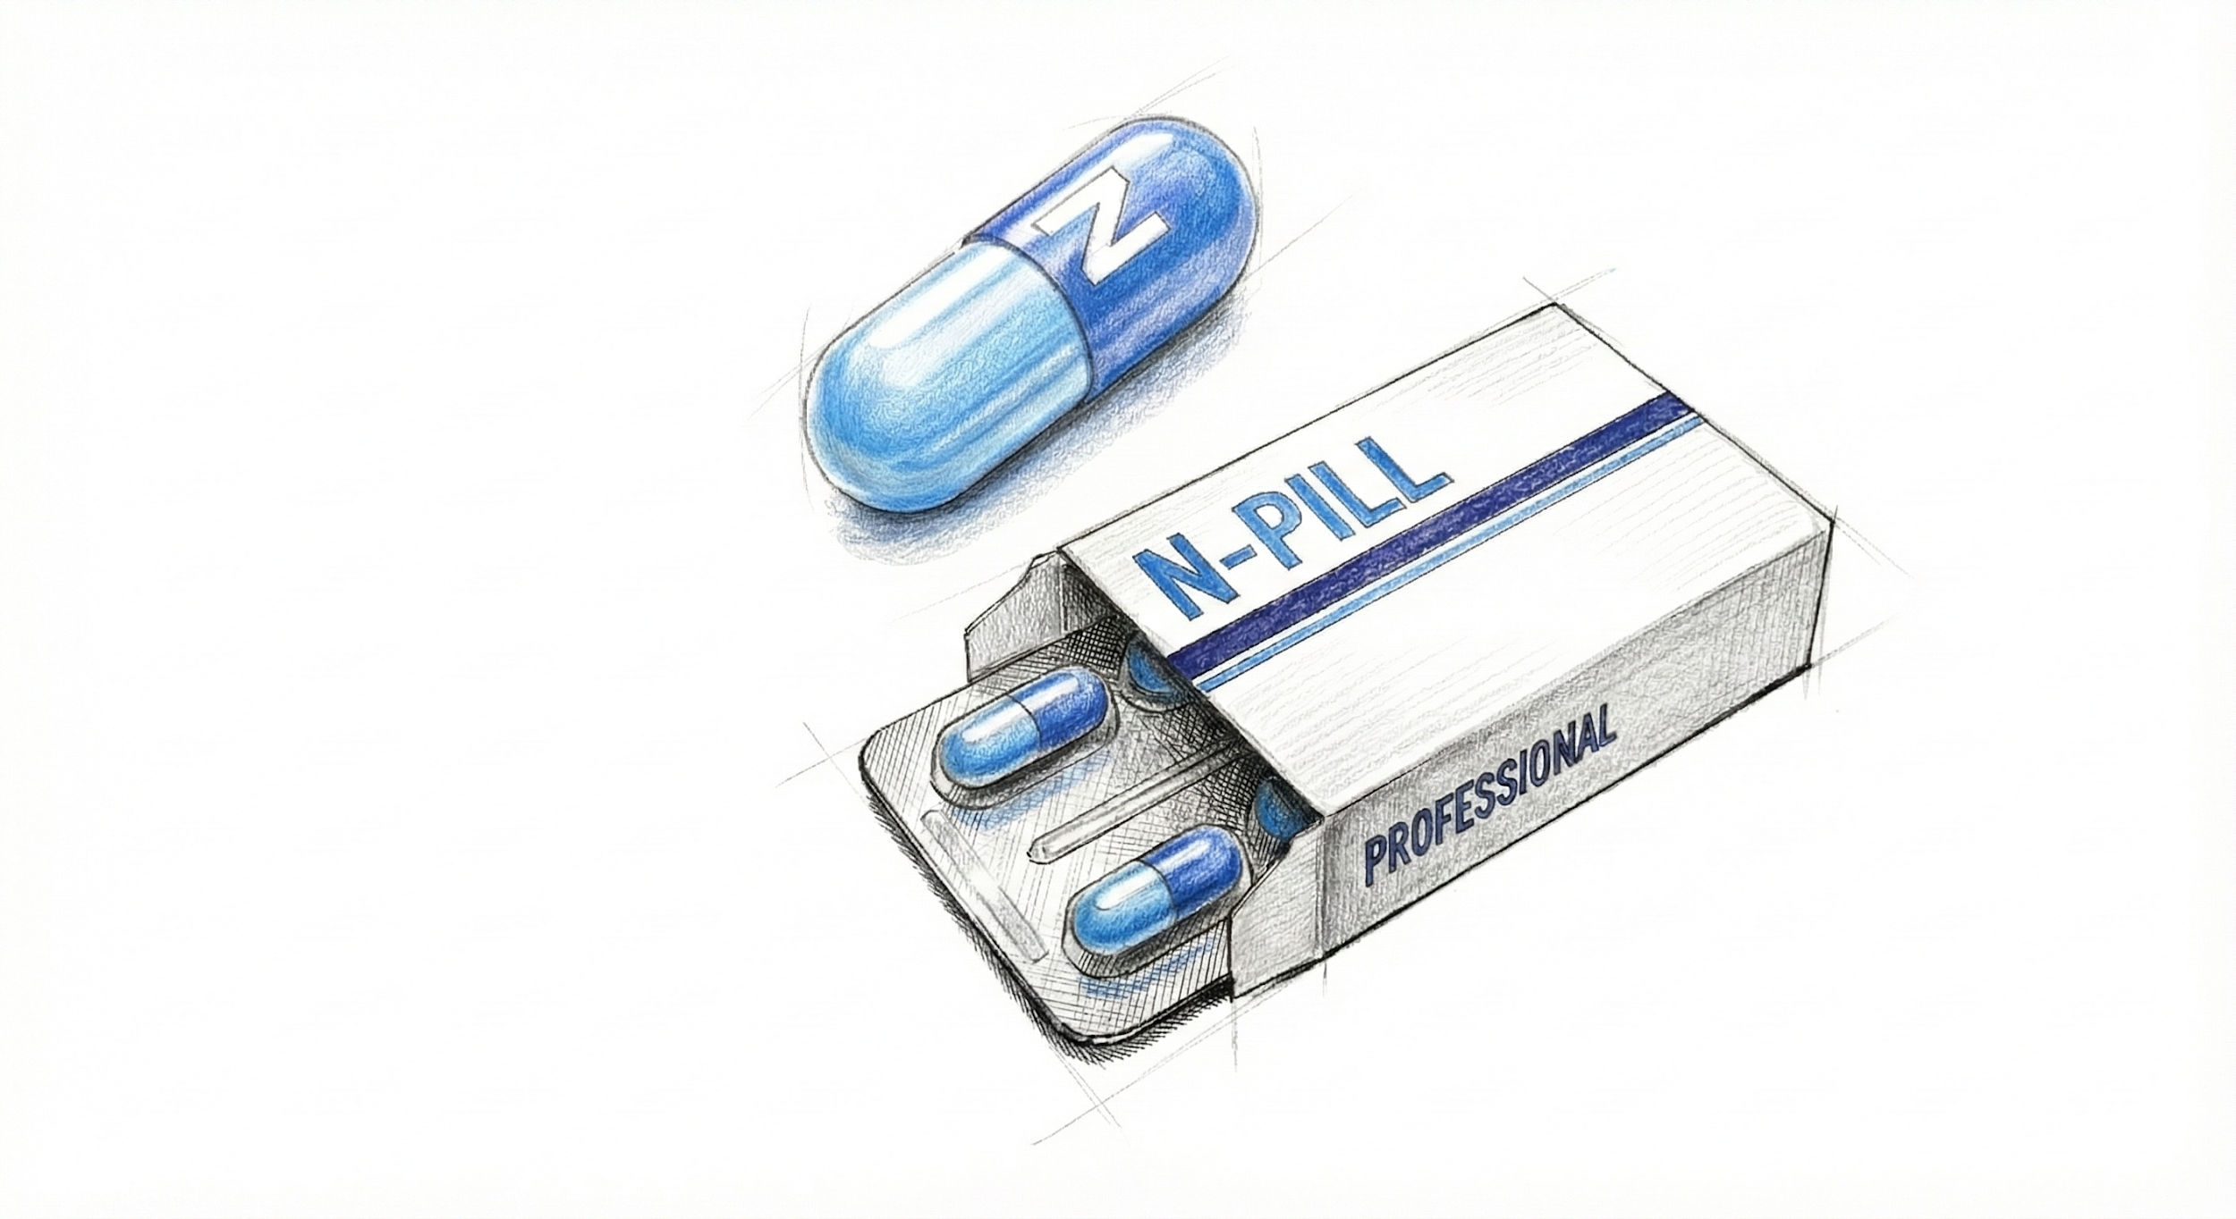
Pre-War Function: Originally, N-Tabs were a high-end pharmaceutical designed to treat "Atomic Anxiety" and stress-induced hypertension. Marketed to high-stress executives and housewives fearing nuclear war, the pill utilized a compound called Nitro-Relaxant to forcefully lower the heart rate and induce a state of chemically enforced "zen."
Post-War Mutation & Significance: Over two centuries, the background radiation of the wasteland has destabilized the chemical binding agents in the pill. The Nitro-Relaxant no longer targets the cardiovascular system to slow it down instead, it reacts violently with irradiated blood to supercharge the body’s fast-twitch muscle fibers.
In-Game Mechanics:
- Effect: Consuming an N-Tab grants the "Adrenal Spring" effect: +4 Agility and +200% Jump Height for 60 seconds.
- Side Effect: The user suffers "Cardiac Flutter," losing 2 HP per second for the duration of the effect (referencing the pill's original purpose of messing with the heart).

2. Poster Art Description
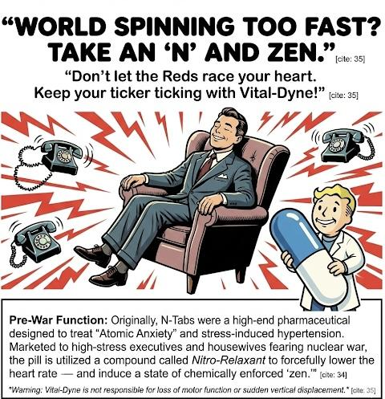

Imagery:
- Center: A smartly dressed 1950s businessman is sitting in a floating armchair, smiling peacefully with his eyes closed.
- Background: Behind him, the world is a blur of chaotic red lines and ringing telephones, implying the stress cannot touch him.
- Mascot: A Vault-Boy-style mascot in a lab coat is holding a giant N-Tab like a shield.
Copy/Text:
- Headline: (Bold, rounded font) "WORLD SPINNING TOO FAST? TAKE AN 'N' AND ZEN."
- Tagline: "Don't let the Reds race your heart. Keep your ticker ticking with Vital-Dyne!"
- Fine Print: Warning: Vital-Dyne is not responsible for loss of motor function or sudden vertical displacement.

3. CEO/Brand Backstory
Company Name: Vital-Dyne Industries. CEO: Percival "Percy" Nitt.
Corporate Culture: Vital-Dyne was a company obsessed with "Bio-Optimization." CEO Percival Nitt was a paranoid hypochondriac who believed stress was a communist plot to weaken the American workforce. The corporate culture was strictly "mandatory relaxation." Employees were fired for running in hallways or raising their voices.
The Dark Secret: Nitt rushed the N-Tab to market to beat a competitor (Med-Tek). Early clinical trials showed that if the subject had high adrenaline levels, the pill caused violent muscle spasms rather than relaxation. Nitt buried the reports, reasoning that "if the pill works, they won't have adrenaline, so the side effect is moot." This negligence is directly responsible for the horrific deaths found in the location post-war.

4. Pre-War Location
Location: The Vital-Dyne Wellness Retreat (Cambridge, Commonwealth).
Setting Description: A retro-futuristic spa and clinic featuring pristine white tiled floors (now cracked), chrome railings, and large glass observation windows. It is located near the Charles River, meaning the lower levels are flooded and highly radioactive.
Interaction with Surroundings: The location serves as a "dungeon" where verticality is the main puzzle. Because the N-Tabs allow for high jumping, the level design forces the player to find and consume the pills to leap across shattered walkways and climb up collapsed elevator shafts to reach the CEO’s office.

5. Environmental Storytelling Elements
The narrative of the location is told not through words, but through the physics of how the employees died when the bombs fell.
- The Ceiling Skeletons: Upon entering the lobby, the player encounters a strange sight: skeletons are not lying on the floor. Instead, several skeletons are embedded in the drop-ceiling tiles or wedged into high rafters, legs dangling down.
  - When the air raid sirens went off, the terrified employees took their N-Tabs to stay calm. The massive spike in adrenaline combined with the pill caused them to spasm so violently they launched themselves into the ceiling, dying instantly of impact trauma.
- The Hole in the Wall: In the therapy wing, there is a distinct, human-shaped hole punched through three consecutive layers of drywall, leading out a window. A trail of N-Tab bottles leads to the hole.
  - Inference: A patient took an overdose and literally jumped through the building.
- Terminal Entry (Dr. Aris, Head Researcher):
  - Date: Oct 2077. "Mr. Nitt, I am begging you to recall Batch 4. We exposed a test subject to mild radiation to simulate a fallout scenario. He didn't relax. He kicked a 400lb operating table across the room!!!!!!! The compound becomes volatile when exposed to isotopes! If the bombs fall, these pills won't save us they'll turn us into grasshoppers!!!."

