University of Wales Trinity Saint David
London Campus


Assignment 2
Programme: BA Business Management
Module: Project Management
Module Code: LCBB5005
Lecture: Dr. Molly Jack
Student: Basiul Vlada ( 2028043 )

Executive Summary
Project management seems to be one of the most important factors behind the success of any project. Cross Rail Project on the Elizabeth Line is the largest construction project in the UK as well as in the world. This study shows the details regarding the cross-rail project which is named as the Elizabeth Line and whether it is considered to be a success or failure. The main purpose of developing the Elizabeth Line is to provide necessary assistance to people of London to reach destinations on time. Learning from this project has been critically evaluated here along with mentioning proper justification. However, there are certain aspects that are required to be improved by the government of UK to make the Elizabeth Line more effective and thus, some recommendations are provided as well.
Table of Contents
1. Introduction 4
2. Lesson learnt from the project 4
The proper project management plan 5
Issues and loopholes in the project 7
Preliminary success factors of the project 8
3. Conclusion and Recommendations 11
Conclusion 11
Recommendations 11
Reference 13

1. Introduction
Project management seems to be an important factor that regulates the steps associated with business practices and it also helps in smooth run a business. This report considers the project planning of the Cross Rail Project on the Elizabeth Line in the UK. In this part, I have analysed my learning from the project. Along with that this project also helps in analysing the success factors of the project. I have also included a set of recommendations for a similar type of project. I have critically evaluated the good and bad sides of the project. Along with that also I have also summarized the learnt lesion from the project.
The Cross rail project is one of the big construction projects in the UK that has been executed in London. This is a more than 10 km long rail that has passed through 40 stations. “Cross rail limited, a famous construction agency has taken responsibility for the project and delivered this historic project. Proper project management is the key factor to the success of this project. Therefore, I have considered the proper project management approach as an integral part of this project. A project management plan considers a wide range of steps associated with this such as planning, implementation, execution and monitoring and reviewing the outcome. The cross-rail project of the UK is regarded as one of the greatest construction projects till below in the history of UK as well as of the whole world. However, there are certain risk factors associated with the project such as environmental, strategic, financial risks and different others. Advanced type of management technology is used for the completion of the project.
This present study has discussed several facts such as the success factors, lessons learned, stages of project management and different others.

2. Lesson learnt from the project
Cross Rail Project on the Elizabeth Line has enriched my knowledge by giving an idea regarding a proper project management plan, risk factors, proper cost analysis and different others. I have divided my overall learning from the project into three distinct categories as preliminary success factors of the project, proper idea of a project management plan and multiple loopholes in the project management steps.

The proper project management plan
Project management is regarded as one of the fundamental aspects behind the success of any project. As opined by, Stanitsas et al. (2021), proper project management is highly essential for successfully implementing any new ideas within a project. Hence, I consider that there is required to be a proper project management plan for any type of project. As stated earlier, Cross Rail Project on the Elizabeth Line is the largest construction project in the UK and all over the world. Therefore, this project has considered multiple steps of project management to properly execute this huge Endeavour. It has been reported that this particular project has been initiated in the year 1980 however some mismanagement and lack of proper maintenance led to the initial failure of the project. Therefore, in the year 2000, the UK government has given a commission to the strategic rail authority to examine the reasons for the failure of this project (Learninglegacy.crossrail.co.uk, 2022). Later, in the year 2009, Cross rail limited has taken over the responsibility to reinitiate the project. After that through different successive stages, in the year 2019, this project has c completed and finally, the tunnel has been scheduled to be opened. Hence this indicates a proper project management approach regarding keeping up the work irrespective of the difficult circumstances. Hence this can be regarded as an ideal step in proper project management approaches. A detailed overview of each step of that project over the passing of time has been given here.
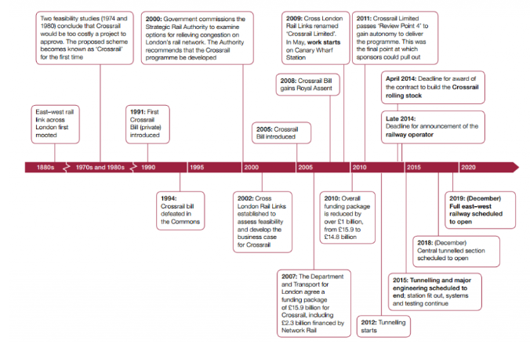
Figure 1: Development of Cross rail project
(Source: Learninglegacy.crossrail.co.uk, 2022)
The above-indicated figure has given an idea regarding successful project management. It has been reported that a step has been initiated only when the previous step is completed. In this way, this high-value and the costly project has been successfully implemented. In this way, I have learned the effective stages of project management. Proper project management consists of several steps such as planning, initiation, execution, monitoring and control and project closure. This project has considered all these steps. I have learnt that this project management plan is centred on 5 core values such as safety, inspiration, respect, collaboration, and integrity. As a part of their project management plan, the whole work has been divided into two major categories such as “On network work” and “Central section work” and both steps have considered important areas of work such as asset protection, shafts and tunnelling, system procurements, and different steps (Learninglegacy.crossrail.co.uk, 2022). A detailed overview of these works has been mentioned below:
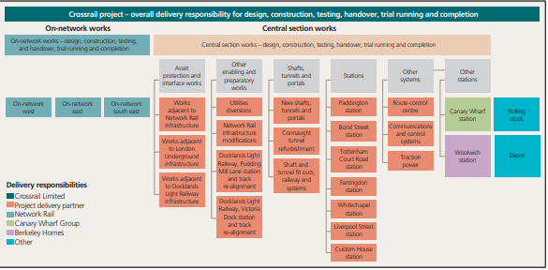
Figure 2: Delivery responsibility of the cross-rail project.
(Source: Learninglegacy.crossrail.co.uk, 2022)
From the above-indicated figure, it has been noted that this project has considered the important stages of project management and hence could deliver the project within the proper time frame. Another thing that I have learnt from the project is the cooperation of the different governing bodies, and authorities within the system and their immense contribution to making this project successful. As opined by, Anderson, (2022), a proper project management plan can also increase the success factors by effectively working on each step of the process. However, the monitoring and review steps are also necessary to find whether there are any loopholes in the project or not. Hence, I have gained a clear idea regarding the successful project management plan and its importance in delivering a successful project.

Issues and loopholes in the project
As explained earlier, Cross Rail Project on the Elizabeth Line is regarded as one of the biggest construction projects in the UK as well as in the world. There are different success factors associated with the project that has made this project a successful one. As opined by Linde-Arias, (2019), there are multiple challenges associated with any project management, hence this particular project to have some loopholes in its management plan which is the reason for the initial failure of the project. It has been observed that this project has taken a huge time to be completed. Therefore, in my opinion, this is a significant loophole in the management of the project. In this context, Thomas, (2021), has stated that time constraints used to become one of the major factors that can create multiple problems. In contradiction, Sweet, (2019), has argued that in spite of having different issues in the core management system so the initial; failure of the project has been encountered. “Poor signali8ng system” can be regarded as a major loophole in software-related work. Apart from that poor technical intervention of the project has made the project lag behind. Apart from that, I think that the poor coordination among the team members has made the poor performance of the project. Therefore, I think that the technical perspectives of this project were required to be strong enough to address the challenges in the system. The tunnelling work of this project has gone well however there were still some aspects of the authority that could have been taken care of to successfully implement the project. Another important loophole in the system was tunnelling some of the water-bearing soil. Along with that, the constant vibration of the trains has disrupted the level of the underground water. Therefore, this can be defined as another important loophole in the system. This system of the cross-rail project has hit the government minister called the “cost pressure”. However, I consider this as an important perspective as a huge amount of costs was associated with the project. In this aspect, Cooper, and Wright, (2022), have stated that there is required to be a proper budget allocation and cost analysis for any project for avoiding any kind of legal and budget-related constraints in the project. As stated earlier, I also consider the “complex signalling system as a potential loophole in the system.
Therefore, from this project, I have learnt that any kind of project irrespective of its size is required considering the budget-related issues and the other constraints of a business. Therefore, in the future, similar projects also need to consider all these perspectives for successful implementation of the project.

Preliminary success factors of the project
Successful competition of projects focused on the scope of a project, cost maintenance and time management and these have been identified as the three primary success factors of a project (Argiansyah et al. 2021). In my opinion, proper planning of a project by managing the budget effectively has been considered a key preliminary success factor of a project. I have analysed that, as the railway project has a high budget and is a risky project, therefore managing costs in each stages of the project needs to be maintained to manage the overall success rate of a project. In addition, the internal involvement of stakeholders in a project has been effective to manage the overall budget as well as ensuring the outcome of a project (Ma and Fu, 2020). I have analysed that, managing project team members, as well as adopting effective leadership approaches, has been considered impactful for a rail bridge project. Maintaining the timeline of a project along with managing project activities is also considered a preliminary success factor of a project that ensures the effectiveness of a project by properly delivering the project within time.
In my observation, effective communication between the project team members and the project manager ensures the overall quality of a project as well as helped in managing the overall performance of a project. Apart from that, synergic teamwork, and proper vision along with managing the performance of the project team members have been considered effective success factors that helped a project to be completed within time and under the budget (Gagliardi et al. 2022). I have analysed effective leadership approaches regarding project operations management that helped in managing employees and well as the success of a project. In the present situation, the incorporation of the latest technology such as project management tools and techniques has been effective to manage a project properly (Gagliardi et al. 2022). In addition, the use of automation technology and risk assessment has been considered effective methods that helped in managing the success of a project.
There were also certain success factors in the project such as proper teamwork, effective communication in the team, use of advanced technologies in the work and different others. However, it has been observed that in spite of having certain factors, this project failed as there were also certain technological failures in the project, those have been discussed in the next section. The below-indicated figure has given an idea regarding the integrated planning of this project.
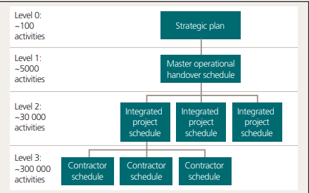
Figure 3: Integrated planning of the Cross Rail Project on the Elizabeth Line
(Source: Learninglegacy.crossrail.co.uk, 2022)
The above-indicted figure has illustrated that there was integrated master planning associated with the project that used to consider 3 levels of completion such as level o level 1 level 2 and 3. All these steps are used to consider separate activities such as project contractors and a proper strategic plan. Therefore, it can be stated that successful work has taken palace in order to deliver success in the project. Therefore, among all the critical success factors, I consider that the integrated project planning and the strategic management framework of this project have worked well. It has been observed that the plan does not consider any kind of technological intervention in the work. Hence, this project lacks on the technical side and became an ultimate failure.
From the success factors, I have realized that all parts of any project are required to be4 taken care of equally to avoid any kind of mis happenings in any project. Along with that I also learnt that in the case of big projects, the technical perspectives are needed to be taken care of crucially to avoid any kind of risks in the project.

3. Conclusion and Recommendations

Conclusion
Conclusively this study shows the importance of the cross-rail project of the Queen Elizabeth line to provide necessary assistance to the people of London regarding the transport system. The cross-rail project was approved by the parliament of UK in 2008 and the designing of the project started in 2009. However, the construction of the project started in 2011 and was completed in 2022. The project was important for the people of London to reach their destinations as London is one of the busiest cities in the UK. Further, the project brought a different dimension to the transport system of the UK in terms of covering major cities of London starting from Abey wood to Whitechapel. It is evident from the study that the Elizabeth Line is going to have a massive impact on the economy of the UK as most of the contracts were awarded to companies that are located in the UK.

Recommendations
The government of UK needs to hire more local people for Elizabeth Line:
Besides supporting passengers, it is necessary for the government of the UK to provide assistance to families in terms of providing jobs for the cross-rail projects. According to Williams and Black (2018), it is also important for the government of the UK to provide train services for 24 hours to help people reach their homes and thus, it is necessary to hire more people to provide all-day services. Further, assisting local people is a necessity for the government of the UK to support their families by providing a basic source of income. Hiring local people provides the additional facility of working according to shift timings.
The government of UK needs to reduce the ticket prices:
It is necessary for the government to make ticket prices affordable for every level of people and ensure it is accessible to most of the people of UK (Batten, 2020). Reducing the price of a ticket can attract more passengers and thus, increase the profitability of the government. The government of UK needs to provide the facility of the transport system to as many people as possible to develop more income. Thus, an increase in profitability can play a huge role in improving the GDP of the country. As per the view of Dale (2022), the price of tickets must be reduced to help the people of UK to consider rail as the main source of transport rather than personal cars.
Contactless pay needs to be implemented for passengers:
The government of the UK needs to provide the facility of a contactless payment method besides ticket booking counters. With the impact that the Covid-19 pandemic has made, it becomes much more necessary to implement contactless payment methods. The contactless payment method provides the additional facility of avoiding crowds (Anderson et al. 2018). Further, the contactless payment method provides the facility for cashless transactions to the passengers of London. The government also needs to provide the facility of a monthly pass system for passengers that are going to travel for daily purpose.

Reference
Anderson, M., 2022. Earthing Design and Installation for the Elizabeth Line. In Crossrail Project: Infrastructure Design and Construction (pp. 145-155). ICE Publishing. https://doi.org/10.1680/cpidc.66502.145
Anderson, M., Leary, N. and King, J., 2018. Earthing and Bonding Techniques and Challenges Case Study-Crossrail. DOI: https://doi.org/10.1049/cp.2018.0063
Argiansyah, Y., Susetyo, B. and Fahmi, F., 2021. Key Success Factor Analysis in Application of Manual Pert Method in Rail Road Construction.http://doi.org/10.31695/IJERAT.2021.3695
Batten, M., 2020. East London Railways: From Docklands to Crossrail. Amberley Publishing Limited.
Cooper, Z. and Wright, K., 2022. A People Centred Design: Human Factors Integration of the Crossrail Route Control Centre. In Crossrail Project: Infrastructure Design and Construction (pp. 221-233). ICE Publishing.https://doi.org/10.1680/cpidc.66502.221
Dale, S., 2022. Delivering a Safety Justification and Navigating Closure of Dependencies (from an Earthing and Bonding Perspective). In Crossrail Project: Infrastructure Design and Construction (pp. 59-69). ICE Publishing.DOI: https://doi.org/10.1680/cpidc.66502.059
Gagliardi, V., Tosti, F., Ciampoli, L.B., Battagliere, M.L., Tapete, D., D'Amico, F., Threader, S., Alani, A.M. and Benedetto, A., 2022, July. Spaceborne remote sensing for transport infrastructure monitoring: a case study of the Rochester Bridge, UK. In IGARSS 2022-2022 IEEE International Geoscience and Remote Sensing Symposium (pp. 4762-4765). IEEE. https://doi.org/10.1109/IGARSS46834.2022.9883719
Learninglegacy.crossrail.co.uk (2022). Crossrail programme organisation and management for delivering London’s Elizabeth line. Available from https://learninglegacy.crossrail.co.uk/learning-legacy-themes/project-and-programme-management/business-case/. Acessed on 07.11.2022.
Linde-Arias, E., Lemmon, M. and Ares, J., 2019. Development of a ground model, targeted ground investigation and risk mitigation for the excavation of an open face cross passage on the underground Elizabeth Line, London. Tunnelling and Underground Space Technology, 86, pp.209-223.https://doi.org/10.1016/j.tust.2019.01.004
Ma, L. and Fu, H., 2020. Exploring the influence of project complexity on the mega construction project success: a qualitative comparative analysis (QCA) method. Engineering, Construction and Architectural Management, 27(9), pp.2429-2449.https://doi.org/10.1108/ECAM-12-2019-0679
Stanitsas, M., Kirytopoulos, K. and Leopoulos, V., 2021. Integrating sustainability indicators into project management: The case of construction industry. Journal of Cleaner Production, 279, p.123774. https://doi.org/10.1016/j.jclepro.2020.123774
Sweet, R., 2019. Damned if they did: A defence of Crossrail. Construction Research and Innovation, 10(2), pp.32-38.https://doi.org/10.1080/20450249.2019.1621583
Thomas, A., 2021. The design of the Crossrail tunnels in UK. Geomechanics and Tunnelling, 14(4), pp.340-346. https://doi.org/10.1002/geot.202100014
Williams, R.V. and Black, M. eds., 2018. Crossrail Project: Infrastructure design and construction. ICE Publishing.

