Title: Why Psychology is relevant in our Health and Social Care
Name: Mariyum Munsha
Student Number: 2127038
Module name: Psychology in Health and Social Care
Module Code: LCHS4006_BIRM
Lecture Name: Joanne Davies

CONTENTS PAGE

Introduction..................................................................................page 1
Theory 1........................................................................................page 2
Theory 2........................................................................................page 3
Theory 3........................................................................................page 4
Conclusion & Recommendations................................................page 5
Reference......................................................................................page 6

INTRODUCTION
This report will discuss three different theories which will be from three different health and social care professionals. Piaget's, Erikson, and Bandura theory of cognitive development in psychology will be covered in this report. The breakdown is done on all the theories how nursery nurses and health care assistants have benefited from these theories. The knowledge that you will understand is how all three theories give you a wide range of information you will be getting. When they discuss the connection between the social environment and cognitive development, Piaget, Erikson, and Bandura. It is widely accepted that these hypotheses are quite different from one another. We consider a variety of elements that go into this conclusion. One is the simplicity of categorization provided by the present "world views" in psychology, which are fundamental conceptions of how development works that are thought to be incompatible.

THEORY 1

The first theory that has been chosen s Piaget’s life span development and behaviour in the role of a nursery nurse for children age group 0-2 it is good to know about the sensorimotor stage. There are four cognitive stages according to Piaget. a sensory-motor phase (0-2 years old) phases prior to operation (2-7 years old) operational concrete (7-11 years old) step of formally operating (11 years through to adulthood). Piaget's theory of cognitive development suggests that children move through four different stages of development. Piaget is one of the first people to study children's cognitive development and he developed the theory that children develop through different sensorimotor stages. This theory is extremely useful to know that if a child has developed any object permeance which is the understanding that things continue to exist even if a child cannot see them (Simply Psychology, 2022). Piaget believed that children build their own knowledge based on their experience, children's intelligence develops in stages that is linked to their age's. As children mature in age so does the cognitive structure in the brain and hence the intelligence Piaget’s has considered the understanding to be a major milestone in the sensorimotor to be stage. Piaget has developed a few creatives for us adults to understand what the infants are thinking. According to Piaget, children are born with an extremely basic mental structure on which all subsequent learning and knowledge are based (My Tutor, 2023)
A nursery nurse can observe a child and see if it is developing as expected and can give the child activities to do. For example, if a child is at the age of 1 years or over and has not developed object permeance this will show that they may be a development problem and further assistance can be given. Those who work with children benefit from Piaget's theories as it helps them realise that children's development is based on stages. A nursery nurse can determine whether a child's development is progressing as expected, whether the environment and resources (toys or equipment) are stimulating the child's development, and what additional support the child will require in the future to develop new interests, skills, and knowledge by watching children as they explore, play, and learn. The child is developing physically, becoming more mobile, and becoming aware of the variety of talents and abilities he or she possesses, including clothing themselves, putting on shoes, playing with toys, etc. For instance, a patient parent should have the grace to wait till their child asks for help or tries until they succeed rather than putting on the child's clothes. (NSPCC Learning, 2023)

THEORY 2

The second theory chosen is Erikson’s stages of Psychological Development. This will be based on the job role of a Health Care Assistant (HCA) in a nursing home for the elderly. Erikson’s theory has 8 stages shown in the table below.

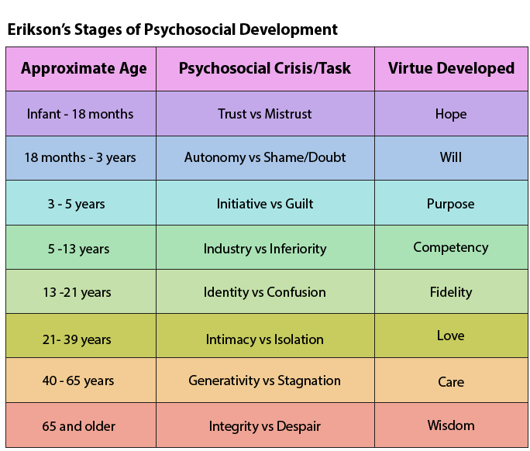
(Ferch, 2023)

According to Erikson's theory, if we pass through each stage successfully, we progress towards a healthy personality and pick up crucial qualities and skills that aid us in handling crises in the following stage. It may be more difficult to finish stages after failing to complete one, and we may also be less able to have a positive outlook on life and high self-esteem. He also thought that we may work through any or all of the stages later in life. Indeed, Eriksons theory of psychosocial development still serves as a useful resource for figuring out how kids develop. Both developmental psychology and education make use of it. It makes it possible for us to understand how a person's psychosocial and psychosexual development can be impacted by social interactions, loving relationships, ego, integrity, identity, close relationships, shame, and doubt. (Better help, 2023)
How people deal with getting older, according to Erikson, is the last step of the psychological process. This stage involves a person looking back on their life so far and thinking about if it has been successful or not and if they have done everything they could do. Older people need to accept that they are near to death if they are going to be happy (Barker, 2016). This stage includes discovering one's life's purpose, acknowledging one's successes, and accepting the things that have gone wrong in life.

The duties of a healthcare assistant include giving their patients high-quality care and treatment. Also, healthcare aides are held in high regard by the public. Upon diagnosis of the illness's condition and underlying cause, doctors recommend treatment. Yet, it is the responsibility of a nursing or healthcare assistant to take loving care of them. People take stock at this point in their lives as they look back on their experiences. People will feel content and be ready to face death with peace if they take stock of a life, they believe was well-lived. Those who look back with just regret experience terror, not the fear that their life may end without having achieved the things they feel they should have. Encouraging them to talk about things they have achieved like bringing up a family. This will make the carer’s job easier and make the older person happier. At this point, success brings sentiments of wisdom, whereas failure brings feelings of regret, resentment, and hopelessness. (Cherry, 2022)

THEORY 3

Albert Bandura was interested in psychology while studying biological sciences at the University of British Columbia. He was born in Alberta, Canada, in 1925. (Nabavi, 2012). The social learning theory (SLT) of Albert Bandura contends that humans pick up social skills by seeing and copying the actions of others. Bandura introduced a social component to his theory, contending that individuals learn through watching others, after realising that direct reinforcement did not account for all forms of learning. His theory, which takes cognition, motivation, and behaviourist learning theories into account, is seen as the link between them (Muro & Jeffrey, 2008). According to the SLT, learning can take place in response to observation, imitation, and modelling even in the absence of behaviour modification (Bandura, 1965). Bandura started studying the function of modelling in learning and aggressiveness in 1973. He set up scenarios where kids between the ages of three and five observed adults behaving violently towards a huge plastic doll known as a "Bobo" doll to test the idea that imitation had a significant role in behaviour (Sutton, 2020).

A young child is more likely to observe and imitate others they perceive to be like them, to start. As a result, it is more likely to imitate the actions of peers who have the same gender. Second, the child will mimic behaviour and earn praise or discipline from others around them. To decide whether to emulate someone else's behaviour, the child will also consider how it will affect other individuals. A person learns by observing the effects of another person's conduct (i.e., a model); for example, a younger sister who observes an older sister receiving praise for a certain behaviour is more likely to replicate that behaviour herself. This is known as vicariously reinforcing behaviour. When a young person emulates a model's behaviour, the outcomes can be Bandura's ground-breaking Bobo Doll experiment demonstrated how kids pick up new behaviours by seeing how people around them behave. It reinforces the activity for the child and raises the possibility that she will repeat it in the future when a parent praises a young child for consoling her stuffed animal. (Nolen, Jeannette L 2022)

CONCLUSION
The outcome of this report is we understand how Piaget, Erikson and finally bandura are best known for their theories. Piaget is being able to observe how young infants developed schemas that influenced their perceptions, cognitions, and assessments of the outside world. He identified four successive phases in the growth of the children. Remember that Piaget did not see children's intellectual growth as a quantitative process. Children do not just add latest information and knowledge to what they already know as they get older. Instead, Piaget argued that as infants progress through these four stages gradually, their thinking changes in a qualitative way. The same goes for Erikson we know his theory has 8 stages in place and his theory allowed professionals to understand the reasons elderly people may behave in certain ways and how they can help them successfully. We are aware Bandura contends that human behaviour is motivated by thought and reflects forward-looking planning. A component of foresight is the creation of result expectancies based on observable relationships between environmental events and human.

REFERENCES
Barker, (2016). Psychology for nursing and healthcare professionals. Thousand Oaks, CA: Sage.

Bidder (2019) Lifespan Development Harlow: Pearson.

Britannica (2022) Bobo doll experiment Available at:Stanford University | Location, Enrollment, & Notable Alumni | Britannica (Accessed 54 March)

Better help (2023) Erik Erikson: Psychology and the Stages of Psychosocial Development Available at:Erik Erikson: Psychology And The Stages Of Psychosocial Development | BetterHelp (Accessed 25 March)

Cherry, K. (2022) Erikson's Stages of Development: A Closer Look at the Eight Psychosocial Stages Available at: https://www.verywellmind.com/erik-eriksons-stages-of-psychosocial-development-2795740 (Accessed: 24 March 2023).
Course Gate (2023) Roles
and responsibilities of a healthcare assistant Available at: Roles and Responsibilities of a Healthcare Assistant | Course Gate (Accessed: 20 March 2023).

Ferch, C. (2023) Stages of Psychosocial Development: Erik Erikson Stages of Psychosocial Development Available at: https://www.orchardvalleycounselling.ca/stages-of-psychosocial-development/ (Accessed: 12 March 2023).

Healthline (2019) what is the Sensorimotor stage? Available at: https://www.healthline.com/health/baby/sensorimotor-stage#:~:text=The%20sensorimotor%20stage%20is%20the,to%20interact%20with%20their%20surroundings (Accessed: 12 March 2023).

My Tutor (2023) Describe and evaluate Piaget’s theory of cognitive development Available at: Describe and evaluate Piaget’s theory of cognitive development. | MyTutor (Accessed: 21 March 2023).
NSPCC learning (2023) Child health and development Available at:Child health and development | NSPCC Learning (Accessed 25 March 2023)

Scientific Research (2021) An academic publisher Available at: Nabavi, R.T. (2012) Bandura’s Social Learning Theory & Social Cognitive Learning Theory. Journal of Personality and Social Psychology, 1, 589. - References - Scientific Research Publishing (scirp.org) (Accessed 15 March 2023).

Simply Psychology (2023) Jean Piaget’s Theory and Stages of Cognitive Development Available at: https://simplypsychology.org/piaget.html (Accessed:14 March 2023).

Sutton (2021. What Is Bandura’s Social Learning Theory? 3 Examples.What Is Bandura's Social Learning Theory? 3 Examples (positivepsychology.com) (Accessed 19 March).

