BEng Material Science
Structure and Properties
M5X01185
Assignment 1
Lewis Millard

Abstract

This report explores if any changes in mechanical and metallurgical properties of steel will occur if the carbon composition is altered. Samples of steel will have varying carbon content from 0.2% - 1.0% carbon. The experiment consists of three tests, a tensile test, Vickers microhardness test and optical microscopy. The tensile test will compare the materials strength, toughness and ductility. The Vickers hardness test will show the materials hardness. Finally, optical microscopy will show the phase transformations of the iron-carbon phase diagram and the images will show the characteristics of the given material.

Context

Abstract 2
Context 3
Introduction 4
Method 5
Results 7
Discussion 11
Conclusion 14
Bibliography 15
References 16
Works Cited 17

Introduction

Steel is an alloy of iron, carbon and many other elements. Carbon is used to provide strength and toughness. Carbon gives steel strength by interstitial solid solution strengthening. The carbon atom takes up a position in between the gaps of the iron atoms leading to a strong bond. Steel has good mechanical properties due to the amount of energy needed to break its atomic bonds.
This experiment explores the effects of how different percentages of carbon affect the mechanical properties of steel. Depending on the required properties, steel is used a vast number of applications. Low carbon steel applications are automobile panels, sheet steel and pipes. These types of steels have less than 0.25wt% of carbon [1]. These usually are relatively soft and have low strength. However, they are very ductile, making them suitable for machining operations. Medium carbon steel applications are machinery parts, crankshafts and bolts. This type of steel has a carbon content between 0.25 – 0.60 wt%. Medium carbon steel has a higher strength than low carbon steel but this comes at the expense of its ductility and toughness [1]. High carbon steel applications are cutting tools, springs and music wire. The carbon content is between 0.6 – 1.25%. High carbon steels are the strongest and have the highest hardness but are the least ductile [1].
There are many ways or measuring mechanical properties of a specimen. A tensile test is the most common. A tensile test is where a specimen is deformed, usually to fracture, with a gradually increasing tensile load that is applied uniaxially along the long axis of the dog bone [2]. Another method is a Vickers hardness test. The Vickers hardness test is a process of which a small diamond indenter in the shape of a pyramid is forced into the surface of an object. Surface preparation is critical when preparing an object to be tested [2]. Another method is using a microscope to view the microstructure of steel which indicates what properties it will have.

Method

Prior to this experiment, samples with varying carbon contents where heated to a temperature of 950°C for an hour and were then air cooled to create a slow-moderate cooling rate. A sample of 0.4% carbon was water quenched to show what effects this would have of the mechanical and metallurgical properties. All samples have then been placed under examination with the following checks;
- Optical microscopy
- Tensile testing
- Microhardness testing

Optical microscopy specimen mounting [3]
- 0.1% carbon sample was selected to be mounted.
- The sample was placed face flat in a plastic mount.
- FT resin and hardener was poured into the mixing jug and stirred with a stirrer for 30 seconds.
- The mould was slowly poured into plastic mount and allowed to stand for two minutes.
- ID label was written and placed into the mould
- Mount was left for 1 hour.
Optical microscopy metallographic preparation [3]
- Grinding tables was used to grind the sample with the coarsest paper in one direction.
- The sample was then washed with water to remove the grinding debris.
- The grinding paper was then changed to a slightly smooth grinding pad and this process was repeated and the smoothest grinding pad was used to remove all scratches.
- Once the grinding process was completed, change the pad to a polishing pad.
- The specimen was held lightly against the pad until all scratches were removed.
- The sample was then washed with soap and water.
- The sample was then sprayed with ethanol and dried under a hair dryer.
- This process was completed for all other samples.
Optical microscopy etching [3]
- The sample was dipped into a nitol etchant for 5 seconds.
- The etchant was then washed off with water.
- The sample was checked under a microscope until the grain structure was visible.

Tensile testing [4]
- The machine was turned on.
- The computer was then turned on and the data logger was brought up.
- The specimen was placed into the grips.
- The dimensions of the sample were entered into the data logger.
- The test was then started.
- The test was stopped when the sample fractured.
- Data was then saved onto a memory stick.
- This process was repeated for the samples.
Vickers hardness testing [5]
- The power was switched on.
- 20kg load was selected.
- The sample was placed beneath the indenter.
- The indenter was lowered towards the sample by turning the reel.
- The test was started by pressing the green button.
- The indenter was then lifted after the green light came on which states that the test was complete.
- The indent was then measured via bringing the two lines on the screen to each edge of the black square.
- The value in the top right corner of the screen was recorded as this was the Vickers hardness result.
- This process was repeated for the other samples.

Results

Below are the stress vs strain curves from the tensile tests.

Figure 1 – L.Millard/ Tensile test results/2020

Below is the ultimate tensile strength (UTS) of the samples tested below.

Sample | UTS(MPa)
0.1% C | 422
0.4% C | 567
0.8% C | 864
1% C | 898
Figure 2 – L.Millard/ Tensile test results/2020

Below shows the effect of carbon on the hardness of the material.

Figure 3– L.Millard/ Hardness test results/2020

Row Labels | Average of Average hardness
0.2% C | 124.6
0.4% C | 164.7
0.8% C | 243.6
1.0% C | 264.6
Water quenched 0.4% C | 666.2

Figure 4 - L. Millard/ Hardness test results/2020

The image below is from a sample of 0.2% carbon.
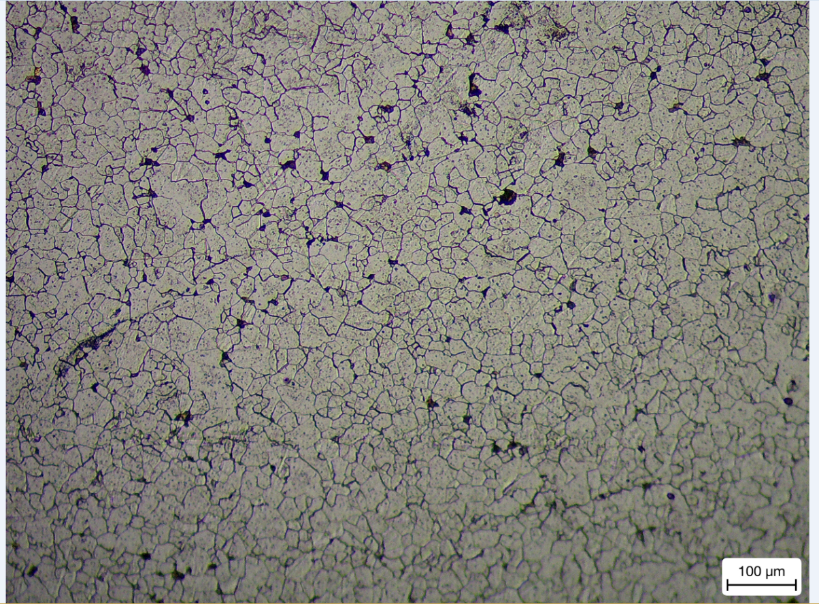
Figure 5 - L. Millard/0.2% carbon/2020
The image below is from a sample of 0.4% carbon.
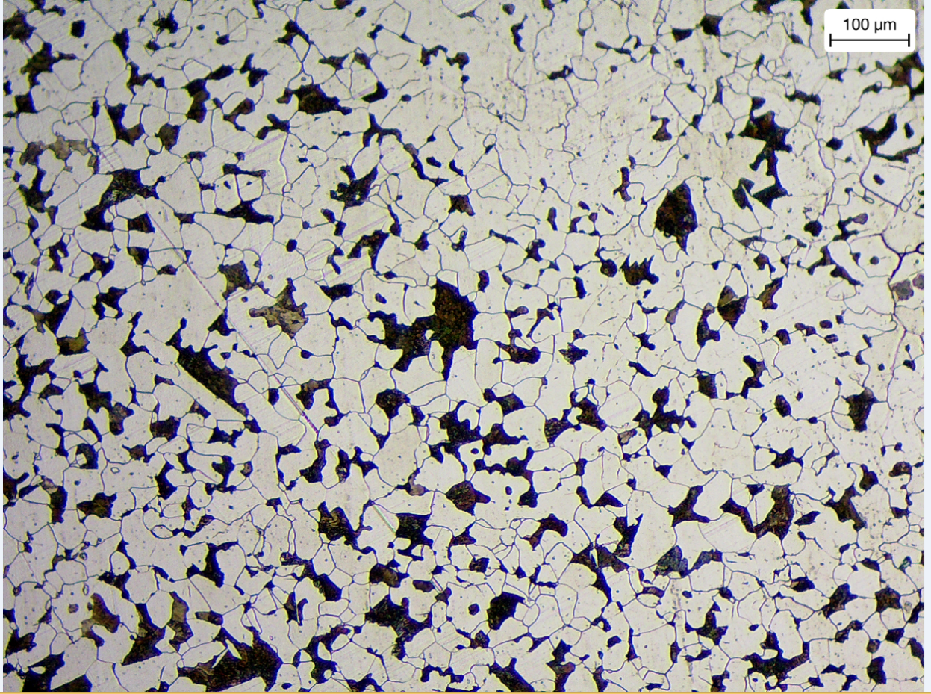
Figure 6- L. Millard/0.4% carbon/2020
The image below is from a sample of 0.8% carbon.
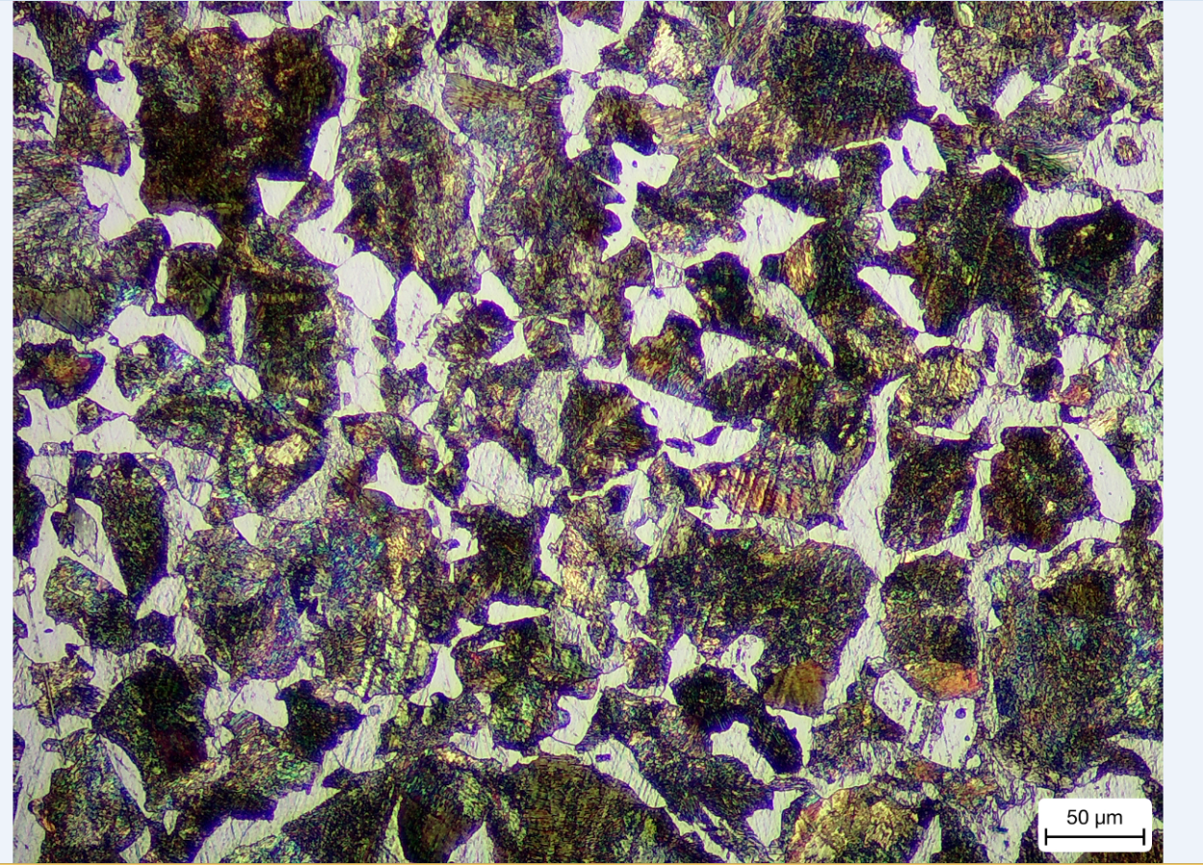
Figure 7- L. Millard/0.8% carbon/2020
The image below is from a sample of 1.0% carbon.
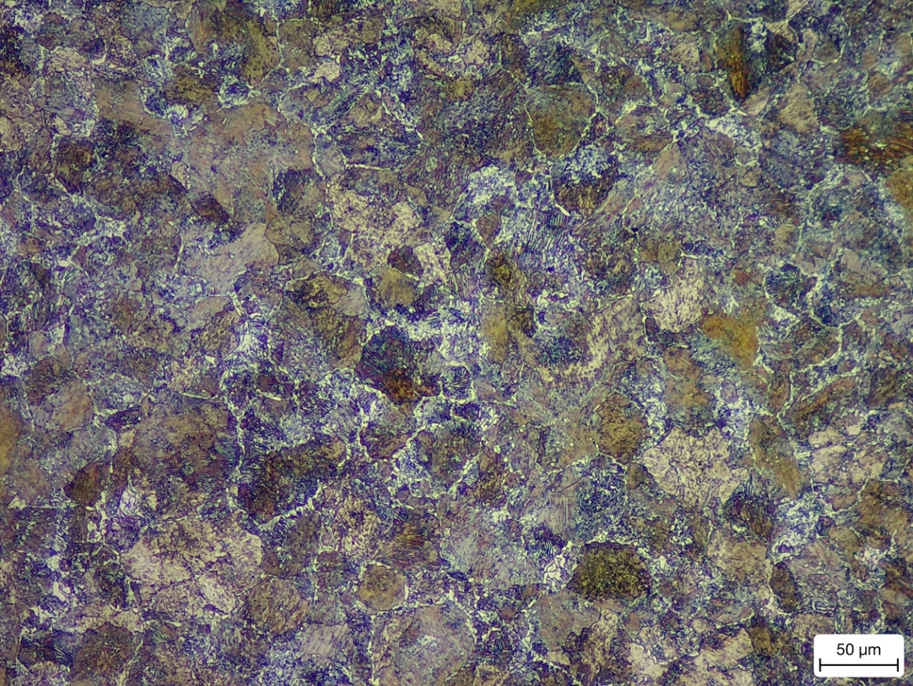
Figure 8- L. Millard/1.0% carbon/2020

Discussion
To explain the formation of the different microstructures, I will make reference to the iron carbon phase diagram to show why the microstructure changes with a change in carbon content.
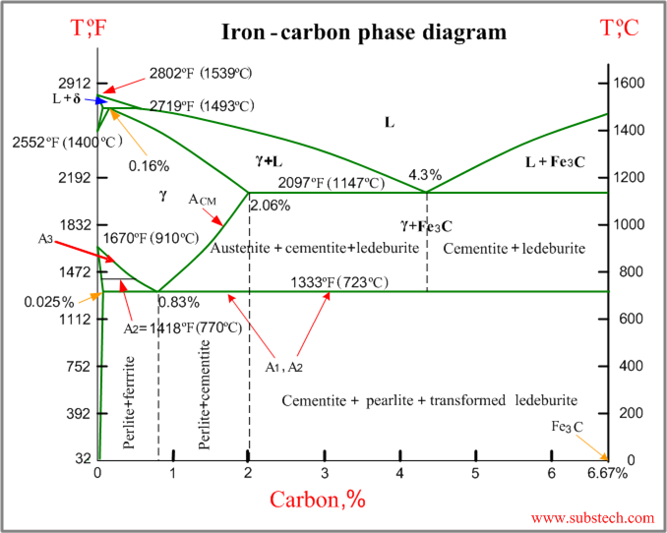
Figure 9 -(https://www.google.co.uk/search?q=iron+carbon+phase+diagram&source=lnms&tbm=isch&sa=X&ved=2ahUKEwiT3oWMmcroAhW_SRUIHfRNCnwQ_AUoAXoECA0QAw&biw=766&bih=714&dpr=1.25#imgrc=7XqykQpWn3jLxM. [Accessed 26 March 2020].)
For the mild steel with the carbon content of 0.2%, it is at 950°C in the furnace and currently has an FCC austenitic structure. The steel is very stable here as this phase can accommodate all the carbon atoms. As the steel cools, between the temperatures of 912°C and 727°C the steel has phases of both austinite and ferrite. Once the steel cools below 727°C the austinite changes to ferrite and now the all the carbon atoms can’t be accepted. 727°C is the lowest eutectoid reaction [6]. The carbon atoms that are rejected change to pearlite and a new phase is made [7]. The reason why the carbon atoms are rejected is because BCC has smaller interstices that FCC. This is called interstitial solid solution strengthening, the maximum amount of carbon that can fit into ferrite is around 0.2% as ferrite has a BCC structure [7]. This accurately correlates with the grain structure seen in figure 5 as it is mainly ferritic (white colour grains) with a small portion of pearlite which is a lamellar structure of ferrite and cementite (dark grains) [8]. The dark portions of the microstructure only appear dark as the light microscopes’ wavelength is very similar to the spacing between the lamella structure of pearlite.
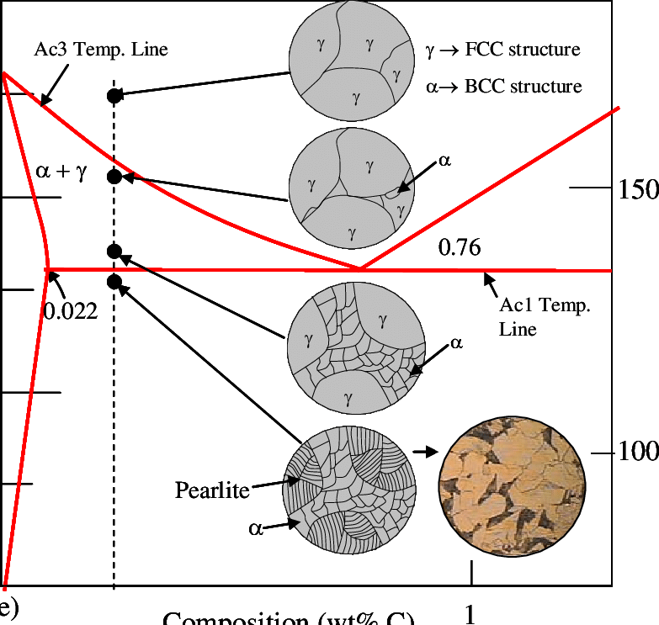
Figure 10 - K.Ryan/Materials Science and Engineering an Introduction/2019
The first of the medium carbon steel with a carbon content of 0.4%, is again heated to 950°C in the furnace and has an FCC austenitic structure. Similar to 0.2% carbon steel, 0.4% carbon steel is a hypo-eutectoid microstructure. Hypo-eutectoid steels have carbon content of less than 0.77% which is the region of phase change between complete austenite into ferrite and cementite [6]. “A eutectoid reaction is a three-phase reaction by which, on cooling, a solid transforms into two other solid phases at the same time. If the bottom of a single-phase solid field closes (and provided the adjacent two-phase fields are also solid), it does so with a eutectoid point.” [2] As the steel cools it passes through the region where austenite and ferrite exist together. This pro-eutectoid ferrite starts to grow at the austenite grain boundaries. As carbon is rejected from the ferrite, austenite becomes full of carbon. Once temperature drops below the eutectoid temperature, all of the austinite changes to pearlite and the ferrite that forms before the eutectoid temperature remains the same. This microstructure is mainly ferrite (white grains) but with a larger amount of pearlite (dark grains) when compared to 0.2% carbon [8].
The second of the medium carbon steels has a carbon content of 0.8%. Due to the eutectoid point being at 0.77% carbon [6], a 0.8% carbon steel is a hyper-eutectoid steel. The sample is heated to 950°C in the furnace and has an FCC austenitic phase. As the steel cools to a temperature between 750°C- 727°C, both austenite and cementite phases are apparent with all carbon atoms present. Pro-eutectoid cementite grows at the austenite grain boundaries [8]. When the temperature drops below the eutectoid temperature, all the remaining austenite forms into pearlite [8]. This is can be seen in figure 7 as there is vast majority of pearlite with very smalls portions of ferrite in the microstructure.
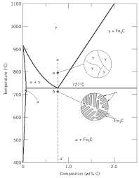
Figure 11- University of Tennessee, Dept. of Materials Science and Engineering
The last sample is a high carbon steel with a carbon content of 1.0%. This sample is a hyper-eutectoid steel. The sample is heated to 950°C in a furnace and has an FCC austenitic phase. As the steel cools, it passes through the area that austinite and cementite exists which is between 800°C – 727°C.This is a higher temperature range than 0.8% carbon steels due to the extra carbon that’s present. As the temperature drops below 727°C all remaining austenite forms pearlite. In figure 8, pro eutectoid cementite can be seen at the austenite grain boundaries. The dark grains are pearlite and can be seen more prominently than before. Finally, there is very little, if any ferrite grains visible [8].

From the tensile tests, a stress-strain curve has been generated to compare the mechanical properties of steel with difference carbon contents. The first part of the graph to analyse is the young’s modulus. Youngs modulus is a materials ability to resist elastic deformation when under a load and still return to its original shape [9]. From figure 1, it is clear that steels with 0.2% and 0.4% carbon have a lower young’s modulus than steels with 0.8% and 1.0% carbon. This implies that higher percentage carbon steel has a higher stiffness.
The second stage of the stress-strain curve to analyse is the yield point. The yield point is the limit of elastic ability and the start of plastic behaviour [10]. The yield point will increase as the percentage carbon rises as the stress-strain curve implies.
The third stage of the stress-strain curve to analyse is strain hardening. Strain hardening elongates the grain structure similar to that of cold rolling which intern, creates a stronger and harder material [11]. This region starts after the yield point and ends at the UTS. From figure 1, lower carbon steel has a flatter but longer strain hardening region which implies that the material is ductile. Higher carbon steels have a steeper but shorts region which implies the material is brittle but stronger.
The fourth stage of the stress strain curve to analyse is the ultimate tensile strength. This is the maximum stress that can be places on a material [12]. From figure 1, higher carbon steels have a greater UTS than lower carbon steels which implies that they are stronger. When comparing my UTS results against Jeom Kee Paik’s report on the mechanical properties of mild steel, his results that were completed at room temperature correlated closely with mine [12].
The final area to talk about is fracture point. The fracture point is the section of the curve the material breaks [13]. From figure 1, lower carbon steels a higher strain tolerance compared to higher carbon steels. This implies that lower carbon steels are ductile and higher carbon steel are brittle.

Figure 1 – L.Millard/ Tensile test results/2020

The hardness tests were completed on a Vickers microhardness machine. Hardness is a materials ability to resist deformation. From figure 3, it is clear that as the increase in carbon content an increase in hardness follows. This is occurring due to the phases present in the steel. The higher the carbon content, the increase in pearlite and cementite phases. Another parameter that will affect mechanical properties is cooling rate. A sample of 0.4% carbon steel was water quenched, this creates a phase called martensite which is the hardest carbon phase [14]. Changing the cooling rate from air cooled to water quenched quadrupled its hardness.

Figure 3– L.Millard/ Hardness test results/2020

Conclusion

- An increasing carbon content gives an increase in strength and stiffness.
- Cooling rate and carbon content both effect hardness. A higher carbon content and a higher cooling rates will produce harder material.
- A lower carbon content produces a ductile material.
- Lower carbon steels have a higher ferritic microstructure.
- Higher carbon steels have an increase in cementite phases in the microstructure.
- Hardness and tensile strength closely correlate.

Bibliography

[1] | A. Rogers, “About carbon steel and its uses,” METALEX, 20 August 2016. [Online]. Available: https://www.metalex.co.uk/carbon-steel-uses/. [Accessed 2 04 2020].
[2] | W. D. Callister and D. G. Rethwisch, Materials Science and Engineering, Utah: John Wiley & Sons, Inc, 2011.
[3] | N. Webb, Optical Microscopy Method, Newport: Orb Electrical Steels, 2012.
[4] | N. Webb, Tensile Testing Method, Newport: Orb Electrical Steels, 2007.
[5] | N. Webb, Hardness testing method, Newport: Orb Electric Steels, 2010.
[6] | M. Enomoto, “Proeutectoid Ferrite,” Encyclopedia of Materials: Science and Technology (Second Edition), pp. 7898-7903, 2001.
[7] | G. Meyrick and R. H. Wagoner, “Physical Metallurgy of Steel,” Ohio State University, Plymouth, 2001.
[8] | H. Bhadeshia, “Interpretation of the Microstructure of Steels,” 10 April 2020. [Online]. Available: https://www.phase-trans.msm.cam.ac.uk/2008/Steel_Microstructure/SM.html. [Accessed 10 April 2020].
[9] | J. J. Licari and D. W. Swanson, “Chapter 7 - Test and Inspection Methods,” Adhesives Technology for Electronic Applications (Second Edition), no. 2, pp. 345-377, 2011.
[10] | A. Vaidya and K. Pathak, “17 - Mechanical stability of dental materials,” Applications of Nanocomposite Materials in Dentistry, pp. 285-305, 2019.
[11] | A. P. Mouritz, “4 - Strengthening of metal alloys,” Introduction to Aerospace Materials, pp. 57-90, 2012.
[12] | J. K. Paik, K. J. Kim, J. H. Lee, B. G. Jung and S. J. Kim, “Test database of the mechanical properties of mild, hightensile and stainless steel and aluminium alloy associated with cold temperatures and strain rate,” Taylor & Francis Online, Busan, 2017.
[13] | L. W. McKeen, “1 - Introduction to Fatigue of Plastics and Elastomers,” Fatigue and Tribological Properties of Plastics and Elastomers (Third Edition), vol. 3, pp. 1-26, 2016.
[14] | A. Ramazani, H. Quade, M. Abbasi and U. Prahl, “The effect of martensite banding on the mechanical properties and formability of TRIP steels,” Materials Science and Engineering: A, vol. 651, pp. 160-164, 10 January 2016.

References

[1] | A. Rogers, “About carbon steel and its uses,” METALEX, 20 August 2016. [Online]. Available: https://www.metalex.co.uk/carbon-steel-uses/. [Accessed 2 04 2020].
[2] | W. D. Callister and D. G. Rethwisch, Materials Science and Engineering, Utah: John Wiley & Sons, Inc, 2011.
[3] | N. Webb, Optical Microscopy Method, Newport: Orb Electrical Steels, 2012.
[4] | N. Webb, Tensile Testing Method, Newport: Orb Electrical Steels, 2007.
[5] | N. Webb, Hardness testing method, Newport: Orb Electric Steels, 2010.
[6] | M. Enomoto, “Proeutectoid Ferrite,” Encyclopedia of Materials: Science and Technology (Second Edition), pp. 7898-7903, 2001.
[7] | G. Meyrick and R. H. Wagoner, “Physical Metallurgy of Steel,” Ohio State University, Plymouth, 2001.
[8] | H. Bhadeshia, “Interpretation of the Microstructure of Steels,” 10 April 2020. [Online]. Available: https://www.phase-trans.msm.cam.ac.uk/2008/Steel_Microstructure/SM.html. [Accessed 10 April 2020].
[9] | J. J. Licari and D. W. Swanson, “Chapter 7 - Test and Inspection Methods,” Adhesives Technology for Electronic Applications (Second Edition), no. 2, pp. 345-377, 2011.
[10] | A. Vaidya and K. Pathak, “17 - Mechanical stability of dental materials,” Applications of Nanocomposite Materials in Dentistry, pp. 285-305, 2019.
[11] | A. P. Mouritz, “4 - Strengthening of metal alloys,” Introduction to Aerospace Materials, pp. 57-90, 2012.
[12] | J. K. Paik, K. J. Kim, J. H. Lee, B. G. Jung and S. J. Kim, “Test database of the mechanical properties of mild, hightensile and stainless steel and aluminium alloy associated with cold temperatures and strain rate,” Taylor & Francis Online, Busan, 2017.
[13] | L. W. McKeen, “1 - Introduction to Fatigue of Plastics and Elastomers,” Fatigue and Tribological Properties of Plastics and Elastomers (Third Edition), vol. 3, pp. 1-26, 2016.
[14] | A. Ramazani, H. Quade, M. Abbasi and U. Prahl, “The effect of martensite banding on the mechanical properties and formability of TRIP steels,” Materials Science and Engineering: A, vol. 651, pp. 160-164, 10 January 2016.

Works Cited

[1] | A. Rogers, “About carbon steel and its uses,” METALEX, 20 August 2016. [Online]. Available: https://www.metalex.co.uk/carbon-steel-uses/. [Accessed 2 04 2020].
[2] | W. D. Callister and D. G. Rethwisch, Materials Science and Engineering, Utah: John Wiley & Sons, Inc, 2011.
[3] | N. Webb, Optical Microscopy Method, Newport: Orb Electrical Steels, 2012.
[4] | N. Webb, Tensile Testing Method, Newport: Orb Electrical Steels, 2007.
[5] | N. Webb, Hardness testing method, Newport: Orb Electric Steels, 2010.
[6] | M. Enomoto, “Proeutectoid Ferrite,” Encyclopedia of Materials: Science and Technology (Second Edition), pp. 7898-7903, 2001.
[7] | G. Meyrick and R. H. Wagoner, “Physical Metallurgy of Steel,” Ohio State University, Plymouth, 2001.
[8] | H. Bhadeshia, “Interpretation of the Microstructure of Steels,” 10 April 2020. [Online]. Available: https://www.phase-trans.msm.cam.ac.uk/2008/Steel_Microstructure/SM.html. [Accessed 10 April 2020].
[9] | J. J. Licari and D. W. Swanson, “Chapter 7 - Test and Inspection Methods,” Adhesives Technology for Electronic Applications (Second Edition), no. 2, pp. 345-377, 2011.
[10] | A. Vaidya and K. Pathak, “17 - Mechanical stability of dental materials,” Applications of Nanocomposite Materials in Dentistry, pp. 285-305, 2019.
[11] | A. P. Mouritz, “4 - Strengthening of metal alloys,” Introduction to Aerospace Materials, pp. 57-90, 2012.
[12] | J. K. Paik, K. J. Kim, J. H. Lee, B. G. Jung and S. J. Kim, “Test database of the mechanical properties of mild, hightensile and stainless steel and aluminium alloy associated with cold temperatures and strain rate,” Taylor & Francis Online, Busan, 2017.
[13] | L. W. McKeen, “1 - Introduction to Fatigue of Plastics and Elastomers,” Fatigue and Tribological Properties of Plastics and Elastomers (Third Edition), vol. 3, pp. 1-26, 2016.
[14] | A. Ramazani, H. Quade, M. Abbasi and U. Prahl, “The effect of martensite banding on the mechanical properties and formability of TRIP steels,” Materials Science and Engineering: A, vol. 651, pp. 160-164, 10 January 2016.

