
Diana Andrusko
Student ID: 2025664
BMIH5007
Lecturer: Dale Clark
Financial management
Grand Hotel Budget Planner

October 25, 2022
University of Wales Trinity Saint David
[Company address]

Executive Summary
This report will be about the Grand Hotel’s annual budget, along with an excel spreadsheet. We discuss expenses and income and make suggestions for better savings. The report gives an overview of why budgets are important and we can learn about different concepts and different budget types. The first budget is the incremental budget, which is recommended for long-term operation. The second is activity-based budgeting, which is more common in the manufacturing industry for budgeting purposes. The next topic is value proposition based. It is about convincing the customer that your product is the best. We can get to know the necessary steps for this. After that, we will explore the topic of zero-based budgeting, which can save you a lot of money in the long run. The last topic is about sustainability, in which we analyse what changes are needed for the hotel’s financial management, as well as how can contribute to environmental protection, taking ecological factors into account.

Table of Contents
Executive Summary 1
1. Introduction 3
2. Appendix with Excel Budget planner…………………………………………………….…………………………………….3
2.1 500 words Analysis of Grand hotel budget planner 4
3. Task 2 5
3.1 Importance of budgeting 5
3.2 understanding of incremental budgeting 7
3.3 Activity based 8
3.4 Value proposition based 8
3.5 zero based budgeting 9
3.6 How budgeting control can support sustainability 10
4. Conclusion 10
5. Reference List 12

- Introduction

This report will be about the cost planning of the Grand Hotel, as well as the reader can gain insight into the analysis of different types of costs. Debnath, (2017) describes a budget as a plan that records the resources needed to generate revenue. Budgeting is a management planning activity that covers all phases of operations for a specified period in the future. It is a formal expression of plans, goals and objectives set by management, Debnath, (2017). The purpose of the budget is to plan and manage to business. The purpose of the budget process is clearly a gradual long-term plan. It serves as a tool for the company to operate with regard to analysis and forecasting, Debnath (2017).
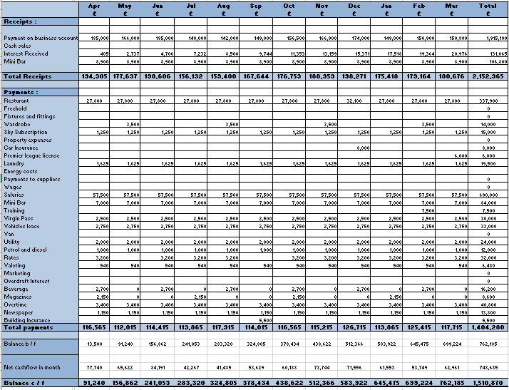
- Appendix Budget Calculations

2.1 500-words analysis of Grand hotel budget planner

The Grand Hotel is located in London. The pride of a Grand hotel room is £250/person/night. The hotel has excellent restaurant awaits its old and new guests. Based on the excel table, we can see the budget planning of the hotel between April 2022 and March 2023. Based on the table, the Grand Hotel can be classified as an incremental budgeting process, since the budget for the current year was determined on the basic of last year’s budget. Based on last year’s data and taking into account future developments, the hotel drew up a revenue plan from April 2022 to March 2023. It starts at £185,000 in April. The hotel’s April balance was £13,500, which is how the year started, and the closing balance was £1,510,870 so we can talk about a profitable business. Since the hotel is profitable, the bank pays 3% based on the balance at the end of the previous month. That is £131.65 by the end of the year. The minibar also brings good revenue per room, with the hotel paying £7,000 for it and generating £8,900 a month in revenue. We see that the expenses pay off month after month, but there are completely unnecessary monthly payments and there also alternative solutions. For example, in the case of magazines, it is not necessary to but 10 types of magazines every 3 months for £2,150, rather invest an amount in 10 different categories of books for guests to read. The newspaper has become obsolete today as everyone checks the news on their smartphones. If the hotel did not require it, it would also save £1,150. The money saved on magazines and newspaper they could invested in strong marketing. Which can mean additional income more for the hotel. Next comes the £1,000 a month petrol cost. They can change this too if they buy an electric car, thereby saving money and paying attention to the environment. Utility bill £2,000 per month. Protecting the environment is important, and sustainability can help with this. For example, use motion sensors, and LED lights to save a lot of money. Application of electric heating with solar energy. Installation of faucets with motion sensors so that water does of flow unnecessarily. It is not just the rooms that consume a lot of electricity, let is look at the restaurant and the kitchen, when buying kitchen appliances, always make sure to buy an AA++ energy-saving appliance to save electricity. The installation of the above-mentioned elements costs a lot of money, but the hotel is profitable for the next year, so that is the suggestion they slowly start investing in making the hotel more sustainable. According to (booking.com 2022), 71% of UK travellers say sustainable travel is important to them, and 42% say recent climate change news has inspired the to make more sustainable travel choices.

- Task 2

  - Importance of budgeting
Bhasin (2020) budgeting is important because it is a strategy of achieving the company’s stated goals and objectives through efficient use of resources. It is an analysis of a specific period, usually a fiscal year, that determines whether the company has sufficient financial resources to implement its plan. Budgeting is an extremely important plan that increases performance evaluation, helps in controlling income and expenses, allows you to save on unexpected and expected cost, regularly solves problems, encourages managerial responsibility, and makes revenue and capital sources profitable. Banks (2018) describes that the budget is the basic of all success. The budges help business and financial planning. A good plan not only helps the company to focus on specific steps for its success, but also helps the managers to foresee the short and long term, describe David (2019). The two main modern planning systems for companies are budgeting and financial forecasting.
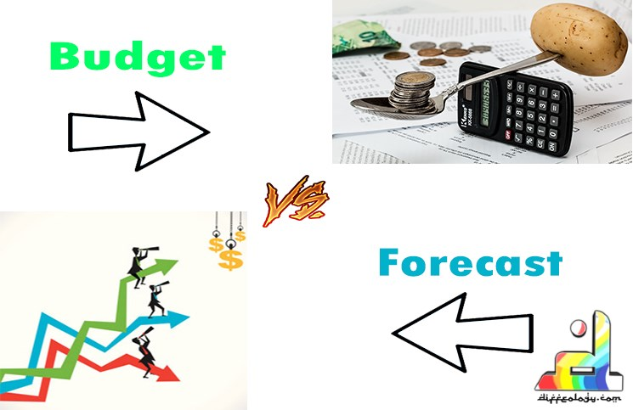
(Garcia, 2017)
The financial budget includes the company has revenues and expenses. It is a process that calculates how much revenue an organization expects to generate over a period of time, usually 1 year, and where it wants to go the company describe that Nickolas (2022)
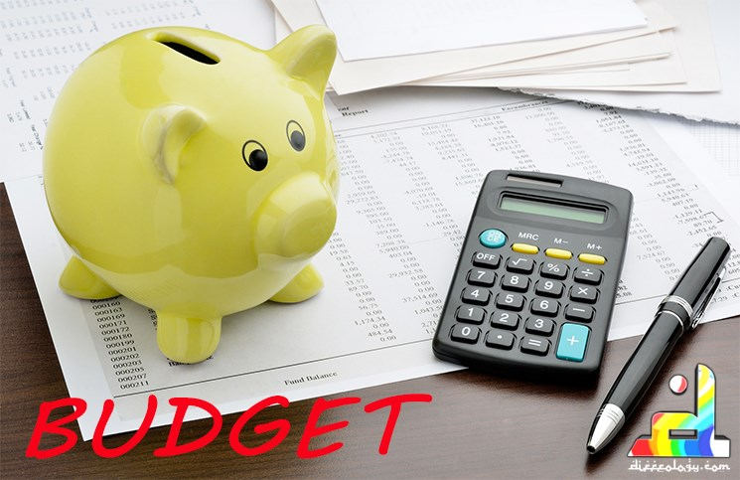
(Garcia, 2017)
Financial forecasting is the process of estimating the company has financial future based on historical data. Forecast are strategic tools that organizations use to plan their growth for several years, Nickolas (2022).
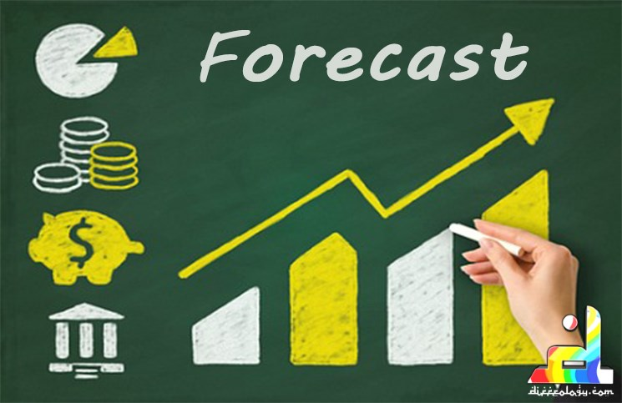
(Garcia, 2017)
Budgets are tactical used to manage operations during an accounting period. It is worth nothing that while budgeting allows you to analyse the variance of actual and expected results, forecasting is only for forecasting, it does not provide performance indicators that can be used for comparison. Garcia (2017).

  - Understanding of incremental budgeting

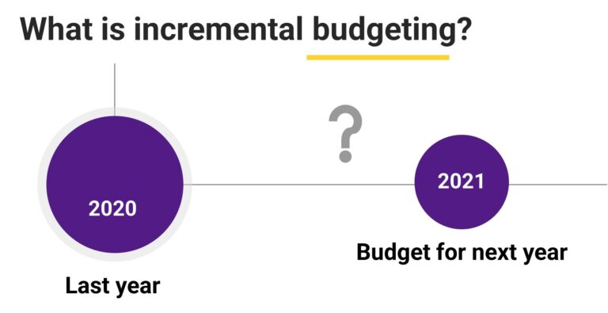
(Gandhi, 2021)

Incremental budgeting is a budgeting and control technique that allows companies to keep track of and manage their finances. Interobservers (2022). Based on information from Gandhi (2021), the incremental budget is based on the performance of the previous year's budget, and the actual amount for this year is calculated on that basis. According to CFI Team (2022), companies may be interested in incremental budgeting for several reasons. For example, incremental is the simplest budgeting approach because it uses the current period’s budget to predict the future budget, so it does not require complicated calculations. Disadvantages: Promoted unnecessary expenses. It holds back innovation. Since the new budget is based on the previous one, there is little room for the implementation of new ideas. The persistent invariance of incremental budgets does not encourage managers to check the budget in order to save expenses. Incremental budgeting should only be used if you are sure that the company’s budget will remain unchanged in the long term. In other cases, another budget technique recommended.

  - Activity Based
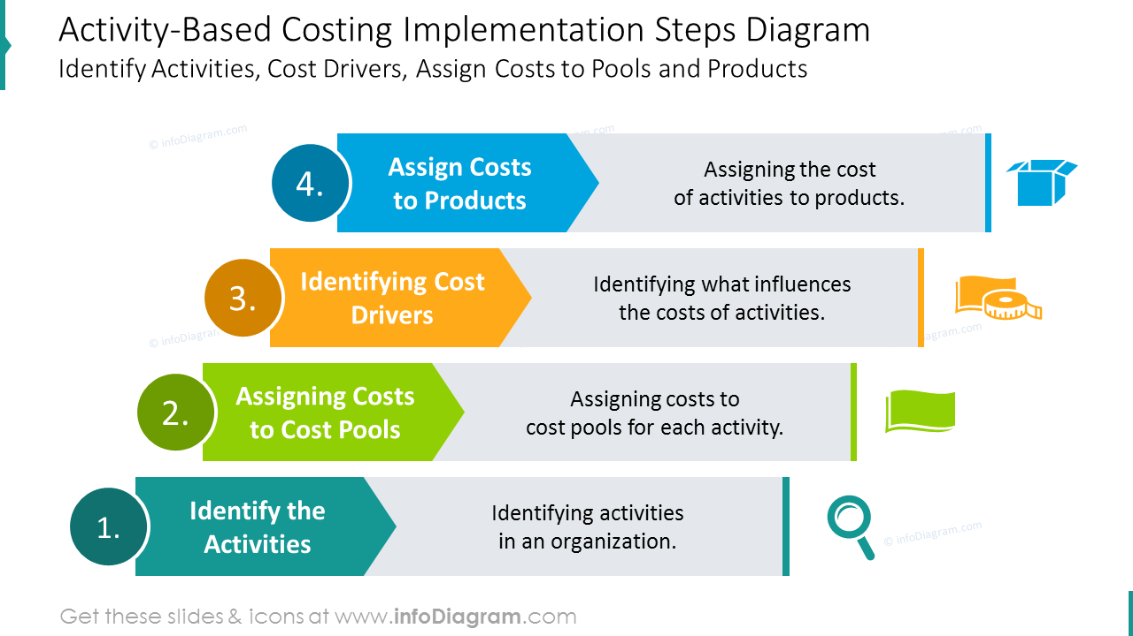
(Anastasia, 2019)
Activity-based costing (ABC) is a method for more accurately dividing overhead cost and adding them to activities. After you assign costs to activities, costs can be assigned to cost groups that use those activities. The system is suitable for the targeted reduction of general costs. ABC work best in complex environments with many machines and products. (According Tools, 2022) example, material cost, labour cost, the second is to create cost pools. Each product family has a different cost group. For example, development, advertising, and research. You can then use the data collection system to collect information about the activity controls used to assign cost from secondary cost pools to primary cost pools and to map cost from primary cost pools to cost object.
Activity based costing is widely used in the manufacturing industry because it provides more accurate data and results in values whose cost can be identified with real costs in the production phase describe the CFI Team (2022).

Value proposition based
Skrabanek (2020) the value proposition is the value promise given by the company. It explains why the customer should buy your product or service. It summarizes how the brand will fulfil its promise and how it will create value and attract customers, it explains what makes you unique and what sets you apart from other brands. The customer’s proposition is an extremely high part of the business strategy, describes the CFI Team (2022). The value proposition is an effective tool for increasing sales and building customer base. A good and compelling value proposition can absolutely improve the productivity of a company’s marketing strategy. How to create a value proposition?
- Getting to know customers
- Understanding cost and benefits
- Monitoring of competition companies. Example, strengths, weakness, what makes your product different and what makes it better
- Be clear and brief. Develop an effective value proposition the is understood by target segments.
- Spend time on design and make your offer stand out and attract attention in your marketing materials. Example, a website.
The value proposition is extremely important because if you cannot convince people that your product is the best you will lose profitability and lose business, describe Websell (2021).

Zero based budgeting
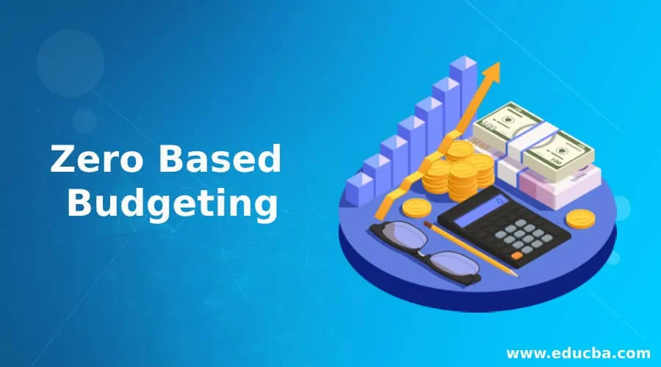
Tally Solutions (2021), with a zero-based budget, every month or every new budget created starts from zero and this budget does not depend on the previous goals set by the business. This budget saving method is one of the best if you want to save money. Planning process:
- Business goal, main goal is to increase profits or reduce costs or possibly both
- Activities to achieve the goal. You need to look at how resources are allocated to achieve your goals. Anugraha (no date)
- Determination of cost factors. To achieve the goals, you must enter the costs related to the operations, which you add as cots related to the operation and maintenance of the business if these are necessary expenses.
A zero-based budget is worth in the long run because you can save a lot of money with it. Businesses can implement zero-based budgeting for growth as it can act as a growth driver. You can achieve this by turning non-productive costs into your production direction, Tally Solution (2021).

3.6 How budgeting control can support sustainability
Schwing (2021) the central task of companies is to adapt their business structures not only to economic, but also to ecological sustainability. Sustainable finance includes all sustainable activities to financial service providers aimed at reducing environmental and climate damage, promoting social responsibility and encouraging sustainable entrepreneurship. PWC (no date), sustainable financing means that in the future the invested value, that is money, will flow towards more sustainable investments, environmental risks will be better taken into account and transparency will be encouraged. For example, reduction of greenhouse gas emissions, energy produced from renewable energy sources such as solar heating, energy reduction with wind turbines. Water conservation. Increasing energy efficiency. Example replacing traditional light bulbs wit LEDs. This will save your money like personal and if you have a business as well, PWC (no date).

Conclusion
Proper budgeting is highly important part of any company’s success. Of course, it is equally important the organization chooses a suitable budgeting method to achieve its goals. This depends on a number of factors, such as the size of the company, how old the company is, management experience, market conditions and the availability of historical data. Without an adequate budget, the company cannot build a long-term goal. This is important to creating a budget that will steer your company in the right direction and make it successful. In the case of the Grand Hotel, we can see the incremental budget based on the excel table, in which the starting amount is the closing amount of last year, so this year’s budget was determined based on last year’s income and expenses. Companies need to take financial forecasting and budgeting seriously. In this case, Grand Hotel needs both for a hotel’s financial budget, because they can get more accurate. If you invest the unnecessary cost in something else, for example in marketing, you can achieve even greater success. It is important that the Grand Hotel understands sustainability, they can save much more money with it, and the majority or guests support this way of thinking. Guest prefers to stay in sustainable hotel.

Reference List

Abhishek Debnath (2017) Budgeting in Hotels. Available at: https://www.linkedin.com/pulse/budgeting-hotels-abhishek-debnath (Accessed: 18 October 2022).

Accounting Tools (2022) Activity-based costing definition. Available at: https://www.accountingtools.com/articles/activity-based-costing (Accessed: 20 October 2022).

Anastasia (2019) Explaining Activity-Based Costing Method in PowerPoint, 18 June Available at: https://blog.infodiagram.com/2019/06/presentation-activity-based-costing-abc-method.html (Accessed: 20 October 2022).

Anugraha G (no date) Zero based budgeting. Available at: https://www.educba.com/zero-based-budgeting/ (Accessed: 23 October 2022).

Booking.com (2022) Climate, Community and Choice: Booking.com Reveals the Trends Shaping Sustainable Travel in 2022. Available at: https://news.booking.com/climate-community-and-choice-bookingcom-reveals-the-trends-shaping-sustainable-travel-in-2022/#:~:text=Climate%2C%20Community%20and%20Choice%3A%20Booking.com%20Reveals%20the%20Trends,communities%20...%205%20Tipping%20point%20for%20transportation%20 (Accessed 24 October 2022).

Britt Skrabanek (2020) How to Write a Meaningful Value Proposition (With Examples). Available at: https://www.clearvoice.com/blog/what-is-a-value-proposition/ (Accessed: 22 October 2022).
CFI Team (2022) Incremental Budgeting. Available at: https://corporatefinanceinstitute.com/resources/knowledge/finance/incremental-budgeting/ (Accessed: 19 October 2022).
CFI Team (2022) Activity-Based Costing. Available at: https://corporatefinanceinstitute.com/resources/knowledge/accounting/activity-based-costing/ (Accessed: 21 October 2022).
CFI Team (2022) Value Proposition. Available at: https://corporatefinanceinstitute.com/resources/knowledge/strategy/value-proposition/ (Accessed: 21 October 2022).
Hitesh Bhasin (2020) What is the importance budgeting? Available at: https://www.marketing91.com/importance-of-budgeting/#:~:text=What%20is%20the%20Importance%20of%20Budgeting%3F%201%201.,flexible%20...%206%206.%20Helps%20to%20save%20money (Accessed: 16 October 2022).
Jacob Schwing (2021) What is a Financial Sustainability? Available at: https://www.linkedin.com/pulse/what-financial-sustainability-jacob-schwing#:~:text=A%20quick%20Google%20search%20shows%20the%20definition%20of,on%20what%20you%20do%20both%20today%20and%20tomorrow. (Accessed: 23 October 2022).
Jennifer Garcia (2017) Different between budget and forecast. Available at: https://diffeology.com/budget-forecast-easiest-method-differentiate/ (Accessed: 17 October 2022).
John Websell (2021) What is a value proposition and why it is important? Available at: https://www.blendb2b.com/blog/what-is-value-proposition-b2b (Accessed: 19 October 2022).
Interobservers (2022) What is Incremental Budgeting? – Overview, Advantages, Disadvantages. Available at: https://interobservers.com/what-is-incremental-budgeting/ (Accessed: 18 October 2022).
Karen Banks (2018) The importance of budgeting in business. Available at: https://wlf.com.au/importance-budgeting-business/ (Accessed: 16 October 2022).
Lisa David (2019) Understanding The Difference Between Financial Forecasting and Budgeting. Available at: https://ecapitaladvisors.com/blog/difference-financial-forecasting-budgeting/ (Accessed: 16 October 2022).
PWC (no date) Sustainable finance. Available at: https://www.pwc.de/en/sustainability/sustainable-finance.html (Accessed 22 October 2022).
Ruchi Gandhi (2021) What is incremental budgeting? It is good for your business? Available at: https://finlawportal.com/what-is-incremental-budgeting-is-it-good-for-your-business/ (Accessed: 19 October 2022).

Steven Nickolas (2022) Budgeting vs. Financial Forecasting: What's the Difference? Available at: https://www.investopedia.com/ask/answers/042215/whats-difference-between-budgeting-and-financial-forecasting.asp (Accessed: 17 October 2022).
Tally (2021) What is zero-based budgeting? Available at: https://tallysolutions.com/accounting/what-is-zero-based-budgeting/#:~:text=Zero-based%20budgeting%20or%20ZBB%20is%20budgeting%20with%20a,cost%20savings%20methods%20when%20planned%20and%20implemented%20correctly. (Accessed: 23 October 2022).

