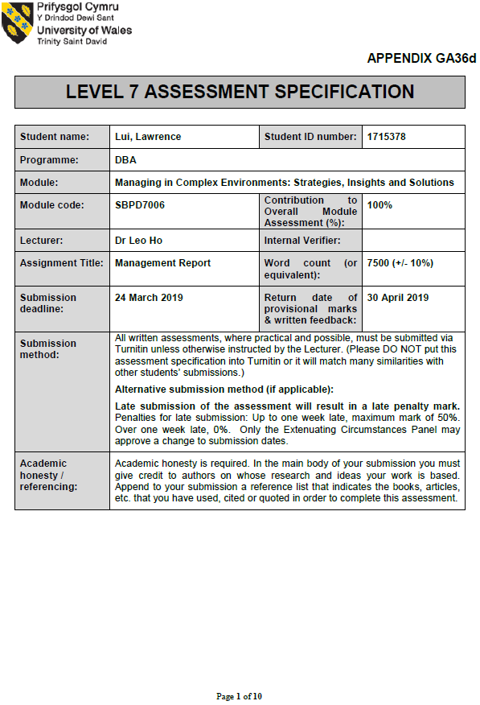

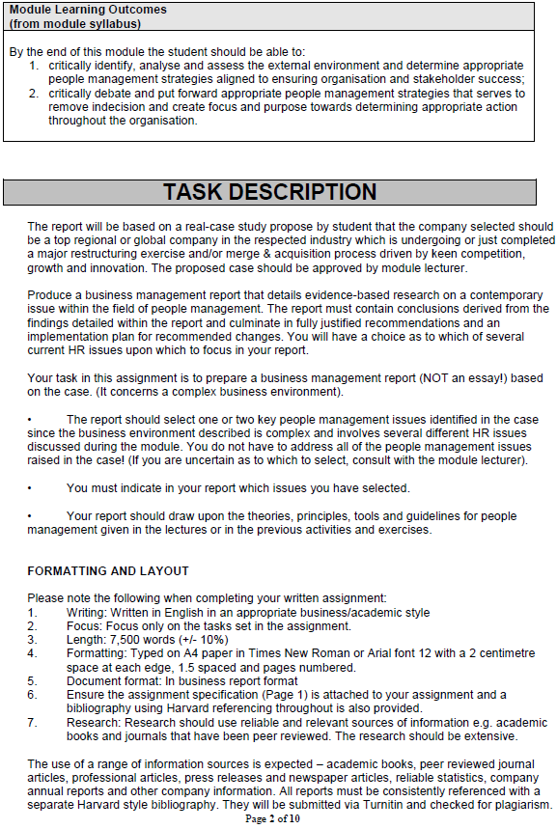

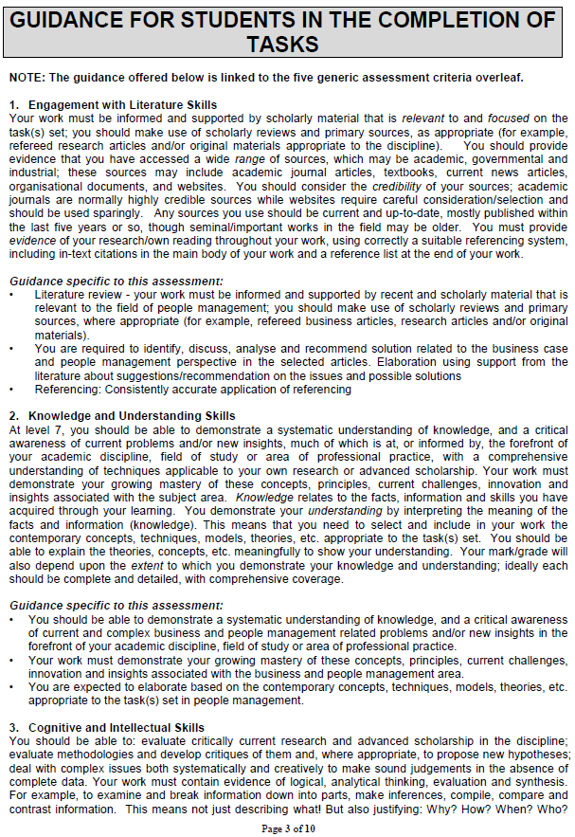

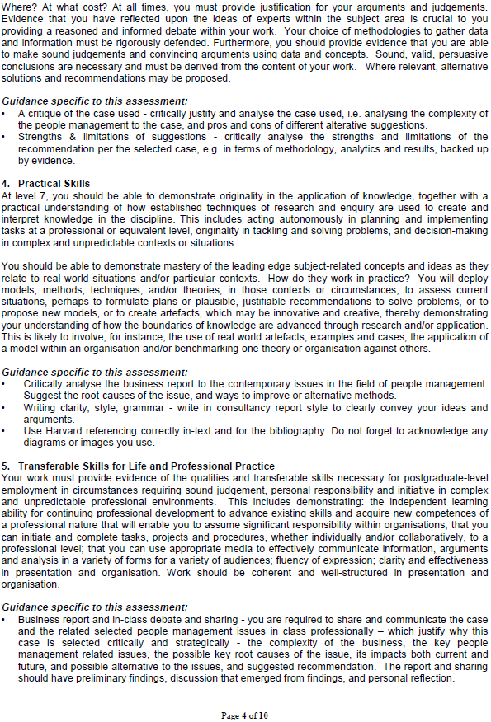

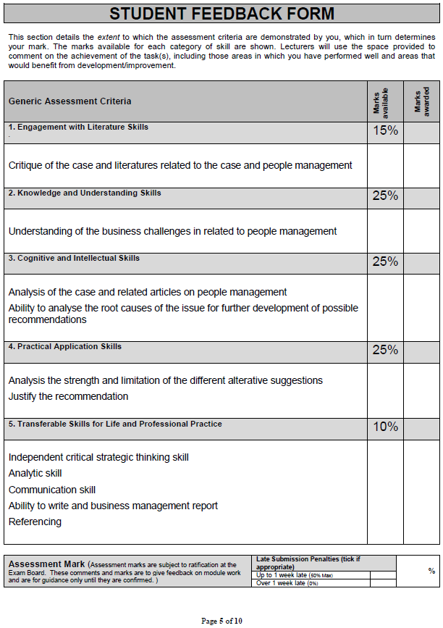

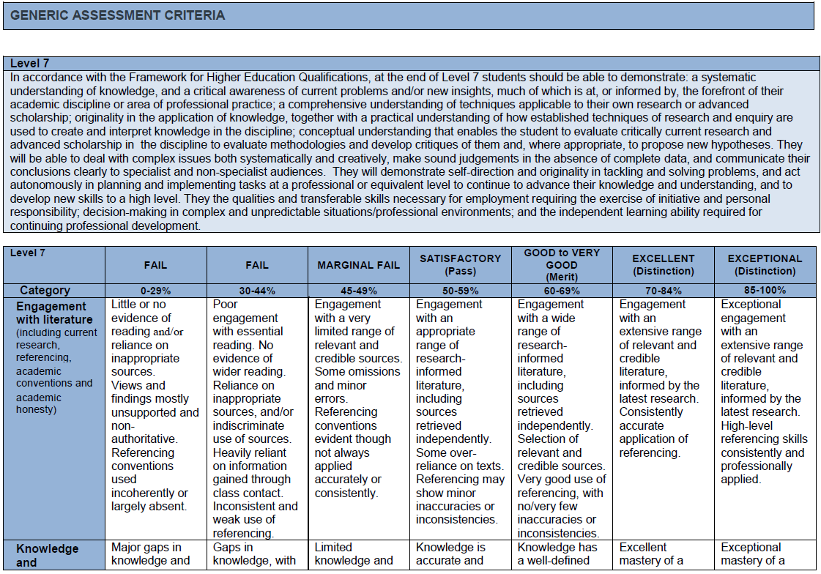

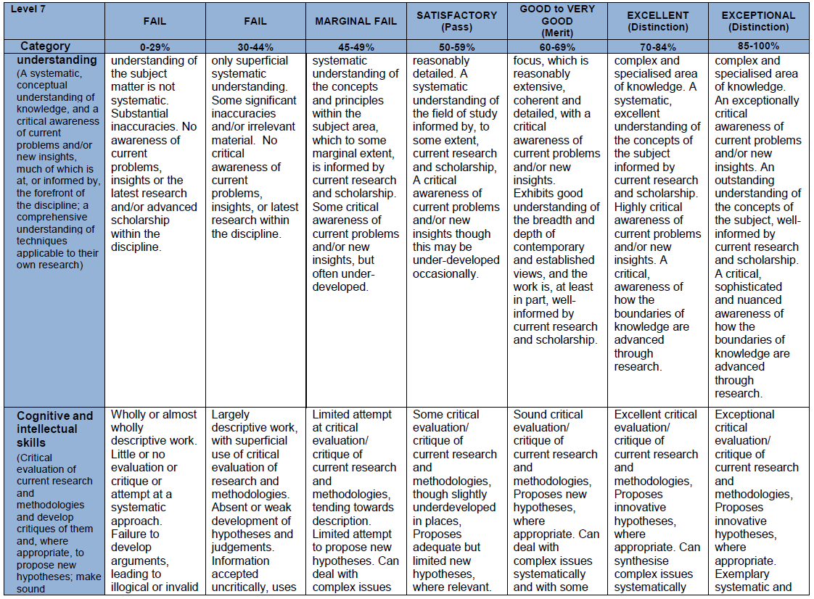

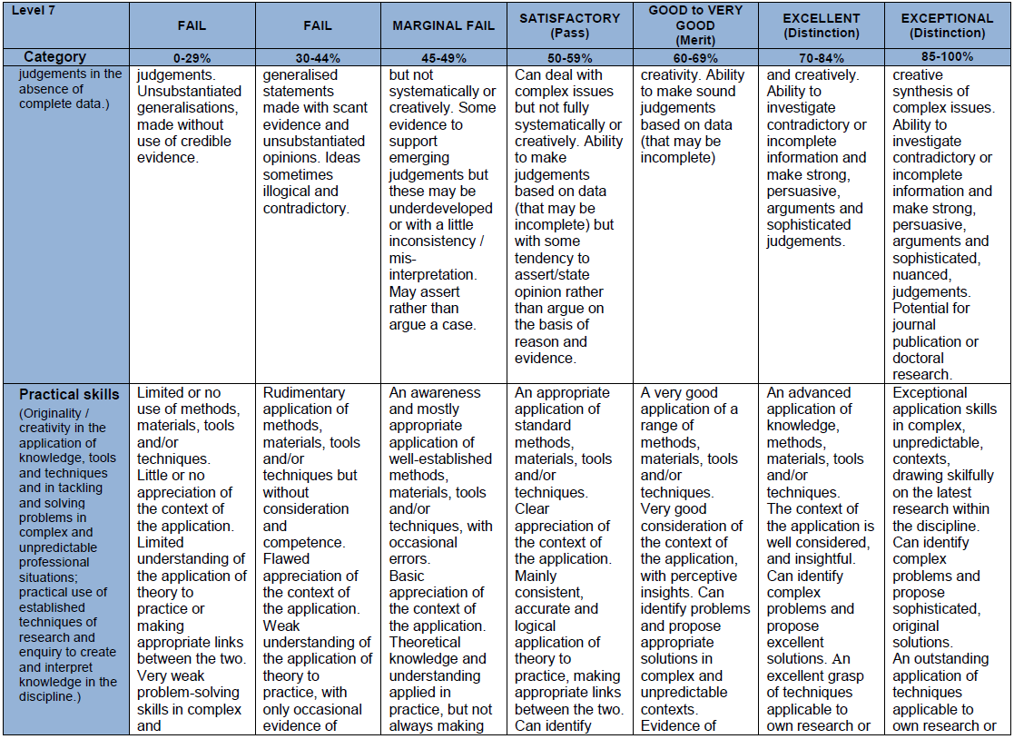

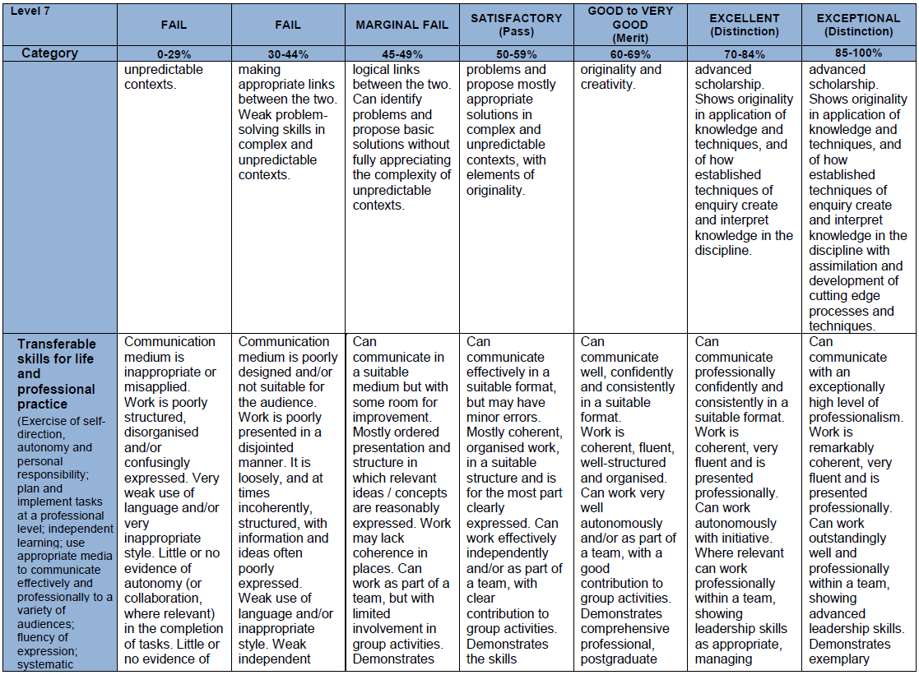

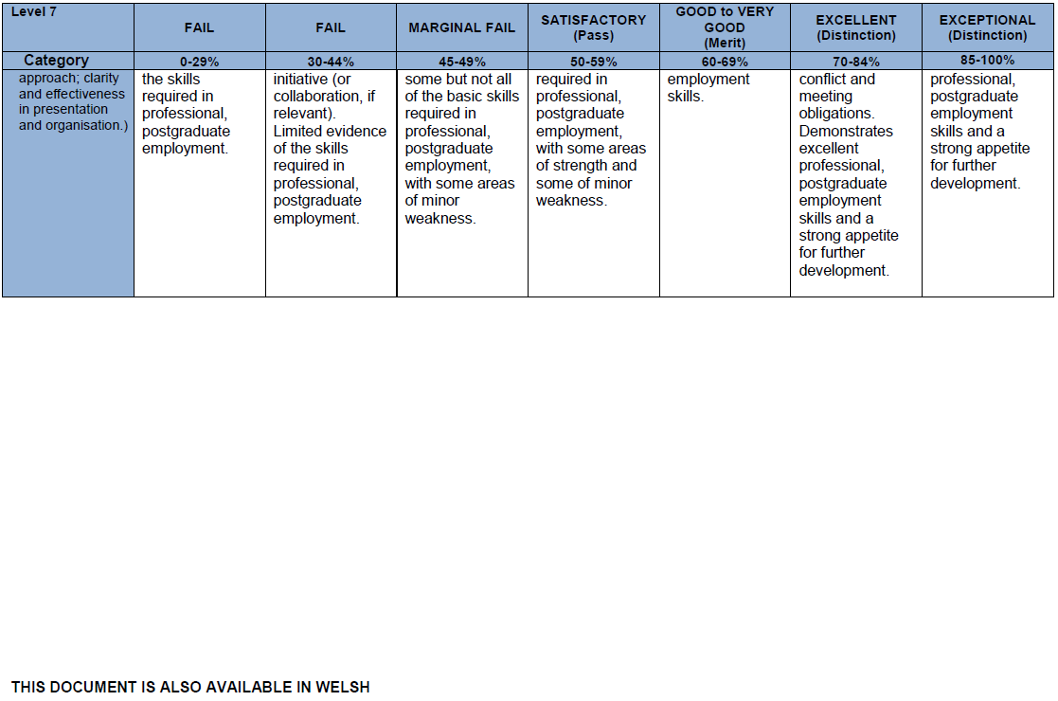

Business Management Report
for



By Lawrence Lui
24 March 2019

Student Number: 1715378
DBA, University of Wales Trinity Saint David
Course: SBPD 7006

Table of Contents

- EXECUTIVE SUMMARY 1
- COMPANY SNAPSHOT OF WARNER MEDIA, LLC 2
- Warner Media, LLC 2
- WarnerMedia’s Geographic Operations 2
- COMPANY ANALYSIS OF WARNERMEDIA 3
- WarnerMedia’s Major Business Segments 3
- WarnerMedia’s Group Management 4
- SWOT ANALYSIS FOR WARNERMEDIA 5
- LITERATURES RELATED TO THE MERGERS AND THE GROUP 12
- BUSINESS CHALLENGES ABOUT PEOPLE MANAGEMENT 16
- PEOPLE MANAGEMENT ANALYSIS FOR WARNERMEDIA 20
- ANALYSIS OF THE STRENGTHS AND LIMITATIONS OF OUR RECOMMENDATIONS 28
- CONCLUSION 30
- REFERENCES 31

EXECUTIVE SUMMARY

The objective of this business management report is to provide recommendations to the Group management of WarnerMedia with respect to its staff retention issues and. This report aims to deliver people management recommendations based on the findings that we noted.

In the report, we have focused on identifying the root causes of executives’ retention problem and change management issues that are challenges to WarnerMedia, as seen in the previous mergers & acquisition deals in the past -- a trend we should really pay attention to. We have also identified the business challenges about people management in WarnerMedia. Further, we have put a SWOT analysis in this consultancy report to help identify and analyze the overall situation of the Group in the market.

About the problem of WarnerMedia’s executives’ retention, the major findings include that the Company offered the wrong benefits to the management while the staff are fearful of layoffs. Further, the unreasonable growth targets caused staff’s resentment, and ineffective talent mobility is also a problem noted. We recommend WarnerMedia to understand the needs of executives of both sides in a M & A project. In addition, CEO, division heads and HR should all balance the mode, and map out capabilities instead of by headcounts. Learning and development is a very important tool in talent management. WarnerMedia may need comprehensive consideration in training development and delivery, interactive learning, mobile learning and agile-based training methods.

With respect to WarnerMedia’s change management issues, the staff are fearful of cultural overhauls. Staff cooperation problem is noted between the two groups prior to the mergers. There are also public relations issues which caused market speculation and impaired the Group’s image. We recommend WarnerMedia to do networking with other line managers and organize trust-building trainings and activities. We also suggest the Group to strengthen the quality of public relations officer or investor relations for more transparent information that is delivered to the consumers, as it is essential to maintain the corporate image in the world.

COMPANY SNAPSHOT OF WARNER MEDIA, LLC

Warner Media, LLC
Owned by AT&T, Warner Media, LLC (“WarnerMedia” or “the Group”) currently ranks within the top 100 US corporations in 2018 by annual revenue. The company was previously known as Time Warner Inc. which was first established in 1990 with the merger of Time Inc. and Warner Communications. The Group is now doing business as WarnerMedia, an American media and entertainment giant owned by AT & T. The Group’s businesses include television programming, films, games as well as other video content and publishing operations. Its assets include HBO, Warner Bros, Cinemax, CNN, 50% of The CW, Audience, Cartoon Network, DC Comics, TNT, New Line Cinema, and a 10% share in Hulu.

In October 2016, Time Warner was offered by AT & T an acquisition for US$108.7 billion. The merger was once in a stalemate because of the antitrust lawsuit filed by U.S Justice Department against AT & T in 2017. Eventually, the merger was confirmed successful on 12 June 2018.

WarnerMedia spin off Time Inc. in 2014 and later Time Inc. was acquired by Meredith Corporation in 2018. The Group retained the Time Warner name until AT & T’s acquisition in 2018.

The Group was earlier known as AOL Time Warner Inc. from 2001 to 2003 and its name was changed to TimeWarner from 2003 to 2018. In 2001, American Online (“AOL”) had acquired Time Warner Inc. for $164 billion and later in 2003, the name “AOL” was dropped.

WarnerMedia’s Geographic Operations
The Group currently has over 30,400 employees and continues to extend their blueprint through a number of acquisitions. Headquartered in New York, U.S.A., WarnerMedia has operations in the U.S., Canada, Germany, China, Italy, Japan, Mexico, France, Netherlands, the United Kingdom, South Korea and India.

WARNERMEDIA – COMPANY SNAPSHOT

COMPANY ANALYSIS OF WARNERMEDIA

WarnerMedia’s Major Business Segments
A variety of the Group’s businesses has made WarnerMedia and the formerly Time Warner to achieve rapid growth in the past numerous years. Mentioned in a previous section of this report, WarnerMedia’s businesses cover a wide range of businesses and the major business segments include Warner Bros, Home Box Office and Turner.

WARNER BROS
Having the most extensive collection of global brands, Warner Bros Entertainment currently leads the entertainment industry, with its footprint covering such verticals as feature film, television and home entertainment production and worldwide distribution to DVD, Blu-ray, digital distribution, to name but a few. In 2018, Warner Bros. Pictures Group had a record high of revenue of over $5.57 billion, being $1.95 billion in the U.S. and $3.62 billion in other countries (WarnerBros.com, 2019).

HOME BOX OFFICE (HBO)
HBO is the leader in the provision of premium television viewing, with services covering subscription video on demand and premium streaming service. Its branded television networks as well as subscription video-on-demand services allowed the channel to secure extensive coverage internationally, currently covering over 60 countries in the world. Indeed, HBO and Cinemax programming is now transacted over 150 markets in the world (Homeboxoffice.com, 2019).

WARNERMEDIA – COMPANY SNAPSHOT

TURNER
Apart from operating a leading 24-hour news cable channel—CNN, Turner also produces drama and kids programs. Turner is successful in upholding a suite of world renowned brands, including but not limited to CNN, Boomerang, TBC, Turner Classic Movies and Bleacher Report (Turner, 2019).

WarnerMedia’s Group Management

Name | Title
Tommy Emmerich | Chairman, Warner Bros. Pictures Group
Kevin Tsujihara | Chairman, Warner Bros.
Richard Piepier | Chairman, Home Box Office
Paul T. Cappuccio | Executive VP, Industry Policy and Government Affairs
John Stankey | CEO

SWOT ANALYSIS FOR WARNERMEDIA

WarnerMedia specializes in entertainment and media business. The group's success in a wide range of media and film studio products symbolizes diversified end markets, which likely exempts it from risks associated with a particular market segment. SO (Strengths + Opportunities) Strategies can be used because WarnerMedia’s internal strengths will take advantage of external opportunities. However, factors such as the highly competitive environment, complex economic changes, high volatility of the financial markets, low economic growth in large countries, viewers’ preference pose different threats to the Group.

SWOT ANALYSIS
STRENGTHS | WEAKNESSES
# Market position  # Digital Network | # Staff Retention Management  # Change Management Issues  #Lawsuits
# Home Box Office has a high growth rate

OPPORTUNITIES | THREATS
# Positive Outlook of Media and Entertainment Industry in the U.S. | # Intense Competition
# Acquisition of Plexchat | # Regional and Economic Influences
# Reinforce and extend capabilities under unification with AT & T | # Geopolitical uncertainties and disruption in the financial markets
# Future strategic business acquisitions based on its cash level | # Viewer Preference

SWOT ANALYSIS FOR WARNERMEDIA

STRENGTHS – Market Position: Expanding Establishments in Media Markets
Acquisitions all the years as illustrated below have enabled WarnerMedia to become a giant global media group. The blueprint of WarnerMedia is like an empire based on its dominance both operationally and geographically.

Year | Major Acquisitions
2016 | In October 2016, Time Warner was offered by AT & T an acquisition for US$108.7 billion.
2016 | In February, Warner Bros signed an agreement to acquire DramaFever, a provider of subscription and on-demand video services.
2016 | In November, the company’s subsidiary Warner Bros Entertainment announced to acquire Machinima, a provider of programming service.
2016 | The company acquired 10% stake in Hulu, for US$583 million
2014 | In February, Warner Bros. Television Group entered into an agreement to acquire Eyeworks’ businesses outside the U.S., covering across South America, Australia, New Zealand and Europe, to add 13 new territories to the company's network of production companies.
2014 | The company set plans to acquire stake in Vice Media Inc.
2014 | In September, Time Inc. and American Express Company announced an agreement for Time Inc. to acquire American Express Publishing Corporation.
2013 | In September, Time Inc. and American Express Company announced an agreement for Time Inc. to acquire American Express Publishing Corporation.
2008 | Completed the acquisition of Bebo, a global social media network that will form the centerpiece of AOL's newly created People Networks business unit.
2008 | HBO acquired the US television rights to their as-yet-untitled documentary on the President-Elect Barack Obama, directed by Amy Rice and Alicia Sams.
2008 | Acquired the Perfiliate Limited, providing performance-based e-commerce marketing services to advertisers.
2003 | The name AOL dropped from AOL Time Warner.
2001 | AOL acquired Time Warner for $164 billion
SWOT ANALYSIS FOR WARNERMEDIA

STRENGTHS – Leading Market Position in Media Markets

WarnerMedia has a main market position that empowers the Group to satisfy developing need for entertainment. Warner Media’s strong financial position permits the conglomerate to secure a leadership position in entertainment. In the financial year of 2017, the movies produced by the company generated over US$5 billion for the worldwide movie industry. Its leadership position could also be justified by the following achievements:
Its film studio was ranked 2nd in global box office receipts in 2017
Warner Bros was the No. 1 TV and film studio (based on all TV and film income)
No.1 primetime TV series maker for the US broadcast systems (2017-2018)
No.1/ No.2 film studios in local film industry receipts for 8 out of the previous 10 years
No.1/ No.2 film studios in worldwide box office receipts for 9 out of the previous 10 years

STRENGTHS – Digital Products

Technology is also a success enabler for Warner Media. The advanced digital system at CNN made it a news viewing destination by choice while its Bleacher Report is a leading digital sports platform that outperformed social media giants like Facebook, Instagram and Twitter. Applications used by CNN, TBS, TNT, Adult Swim and Cartoon Network etc. were also being shared amongst its other digital properties.

STRENGTHS – Revenue from Home Box Office (HBO)

Warner Media’s Home Box Office is ranked 3rd in terms of the ability to generate income for the group. Increasing subscriber base plus contractual rate inflation brought about increasing domestic subscription income, generating a 7% growth in income year-on-year. In the financial year of 2017, HBO secured a 20% share of the company’s income while recording a CAGR of 6.4%.

SWOT ANALYSIS FOR WARNERMEDIA

WEAKNESSES – People Management and Lawsuits

People management in the Company has never been easy due to its wide scope of businesses in nature and in particular, the two substantial mergers as well as other many small-to-medium sized acquisitions that WarnerMedia/ Time Warner had went through in the 2000s and 2010s. People management skills and practices should be put on a top priority but seemingly the Company has not achieved successfully, as we noted that staff retention problem exists int eh company. WarnerMedia should also be aware of its change management issues. We will analyze both staff retention problem and change management issues in a later section “People Management Analysis for WarnerMedia – The Root Causes of Issus and Our Recommendations”.

On the other hand, we consider that lawsuits have led to increased legal and professional expenses to the Group and influence its reputation in the industry.

In October 2016, Time Warner was offered by AT & T an acquisition for US$108.7 billion but the merger led to a huge lawsuit because of the antitrust case filed by U.S Justice Department against AT & T. With success also came other red flags. In July 2017, the company had to settle a claim worth of $80 million, for the digital promotion of items from “The Lord of the Rings” and “The Hobbit”. And in June 2018, a case was filed against Warner Bros Entertainment and Behavior Interactive for using codes from its “Aftermath Shelter” to make another “Westworld” application.

SWOT ANALYSIS FOR WARMERMEDIA

OPPORTUNITIES

OPPORTUNITIES – Media and Entertainment Industry – the U.S.
The business outlook for the media and entertainment industry in the United States is positive. According to statistics provided by the International Trade Administration and the U.S. Department of Commerce, the media and entertainment industry is the third largest industry in the world and the U.S. is the largest media and entertainment market, with a projected market value of US$804 billion by 2021.

OPPORTUNITIES – Acquisition of Plexchat
Warner Bros’ intention to upgrade its quality in mobile titles is very obvious with its acquisition of Plexchat, a social gaming startup, in July 2018. The acquisition would bring in features like community highlights and chatting mechanisms to enhance the overall user experience.

OPPORTUNITIES – Collaboration with AT & T
In June 2018, AT & T acquired Time Warner Inc. and also changed the name to Warner Media LLC. Through the acquisition of Time Warner Inc., AT&T hoped to address challenges faced in video dispersion, payments, utilizations, creation through premium content, etc.

SWOT ANALYSIS FOR WARNERMEDIA

THREATS – Intense Competition
Time spent by the audience when consuming Warner Media’s services is always quite an accurate crystal ball when it comes to revealing how much revenue Warner Media is likely to earn. In a cluttered world where media and entertainment choices are ever increasing, Warner Media will need to stay on top of how to engage with an audience so that they are willing to make time for its services and offerings. Normally, the less time spent with Warner Media’s services, the less revenue Warner Media earns. Important elements include news sources, like OTT services, Internet, premium pay television services, feature films, television networks, live sports, home entertainment products and services, games, pirated content, print media, and other events.

THREATS – Viewer Preference
Warner Media is subject to change in viewer preference due to advancements in the technology, which allow users to access content avoiding advertisements and could affect the company’s advertising revenue. Advertising avoidance or advertising skipping is not the only challenge faced by Warner Media; the increasing use of user-generated sites, the easy dissemination of video content across the Internet and mobile platforms, the streaming and downloading from the Internet, outdoor digital displays etc. are all potentially taking an audience’s share of attention and time, hence placing an ultimate impact on Warner Media’s revenue.

SWOT ANALYSIS FOR WARNERMEDIA

THREATS – Regional & Economic Influences and Geographical Uncertainties

Warner Media’s business is exposed to various factors, including weak economic conditions, geopolitical and economic uncertainties and increased volatility and disruption in the financial markets. The Group’s financial condition and results of operations could be affected by weak economic conditions in the U.S. and other countries, as the current global economic growth rate is very low. Under such conditions, there will be negative impact on the stakeholders’ environment, and also on advertisers, suppliers, retailers, affiliates, theater operators, insurers, and others. These external factors which are impacting Warner Media’s business — summarized as weak economic conditions, political uncertainties as well as financial volatility could all leave negative influence on the company’s Income Statement.

Also important is the volatility noted in the economic conditions of the large emerging economies such as China, India, and Brazil which show signs of slower growth due to economic uncertainties as well as factors arising from governmental actions as in some countries like Russia.

THREATS – WarnerMedia’s Risk Variables
Regulatory Requirements and Exchange Rate Fluctuations
Due to its multinational nature with huge sum of transaction amounts, Warner Media might quite often experience exchange rate fluctuations, different regulatory requirements as well as governmental control on repatriating earnings from some foreign countries. The Group might also confront transformations in the political or economic conditions in the foreign countries it operates in. Such factors could impact Warner Media’s operations.
LITERATURES RELATED TO THE MERGERS AND THE GROUP

LITERATURES RELATED TO THE MERGERS AND THE GROUP

Background of the Merger of American Online and Time Warner in 2001

Back in Year 2000 - America Online, Inc. (“AOL”) and Time Warner Inc. announced a strategic merger to create the world's first fully integrated media and communications company for the Internet Century. The deal was eventually approved by Federal Communications Commission in January 2001 (Hansen, 2007). With total turnover of over $30 billion in a year, this new company targeted to be deliver world-class branded information, entertainment and communications services across the rapidly converging media platforms. The merger is essentially a celebrated marriage of the world’s top media, entertainment and news brands from Time Warner with the technology offered by America Online. With the merger, the world renowned brands would be able to tap into extensive Internet franchises, technology and infrastructure; online communities as well as e-commerce offerings would be made easy, instantly. (En.wikipedia.org. (2019).

By consolidating the world's leading Internet and media companies, AOL Time Warner was trusted to be specially positioned to accelerate the development of the interactive platform as well as the growth of its entire businesses. The new company would provide an important new broadband distribution platform for AOL's interactive services and drive subscriber growth, which was believed to be ever-growing, through co-marketing with Time Warner's dominant brands.

LITERATURES RELATED TO THE MERGERS AND THE GROUP

Some major people management issues emerged as a result of the merger in 2001, such as the criticism for adhering to the over-optimistic forecasted profitability growth, mismatched incentive programs, the never-materialized synergies, and the mess in the frequent change of top executives. These issues will be discussed in the later section “Business Challenges about People Management to the Company”.

LITERATURES RELATED TO THE MERGERS AND THE GROUP

Background of the Merger of Time Warner and AT & T in 2018

Early in summer 2016, there were widespread news about AT & T’s intention of acquiring Time Warner. In October 2016, AT & T reached a deal to acquire Time Warner for $108.7 billion. AT & T was confident of the deal because of its financial power as the well as previous experiences such as the similar acquisition of NBCUniversal to increase the media holdings in the industry. Time Warner’s shareholders approved the merger in February 2017.

Things did not go right when AT & T learnt that they were criticized for having the ability to use Time Warner content to expel competitors or limit access to the content by industry rivalries. In November 2017, the Department of Justice filed a lawsuit on antitrust against the acquisition. Makan Delrahim, assistant Attorney General of the Department of Justice’s Antitrust Division, claimed that the deal would give significant impairment to the U.S. consumers. AT & T asserted that the overall lawsuit deviated from the decades of precedent cases which were of similar nature (Foden, McLaughlin and Moritz, 2017). On the other hand, U.S. President Donald Trump, ceaselessly commented on how CNN influenced the network that covered his administration and he planned to block the acquisition due to the “potential impact of the consolidation” (FitzGerald and Flint, 2019). This undoubtedly made the deal harder to succeed because Donald Trump seemed to threaten AT & T and Time Warner deal against CNN (Levin, 2017).

LITERATURES RELATED TO THE MERGERS AND THE GROUP

In June 2018, despite the District Judge ruled in favour of AT & T which represented that the acquisition could be proceeded, the employees’ fear of AT & T was still remained.

Some major people management issues are identified as a result of the proposed merger in 2016, such as the Time Warner staff’s fear of AT & T, a well-known cost cutter (Lang and Lang, 2018), loss of top executives who left Time Warner (Atkinson, 2017), as well as the weakness of publicity about carrying out the messages to the consumers about future services and fees after the merger. These issues will be discussed in the later section “Business Challenges about People Management to the Company”.

BUSINESS CHALLENGES ABOUT PEOPLE MANAGEMENT

BUSINESS CHALLENGES ABOUT PEOPLE MANAGEMENT
Issues of people management are the major challenges faced by business leaders. In this section, we are delivering a macro side of view as to how staff retention management and change management issues could bring business challenges to WarnerMedia. In the NEXT section “People Management Analysis for WarnerMedia – The Root Causes of Issues and Our Recommendations, we will provide specific recommendations for WarnerMedia.

STAFF RETENTION PROBLEM
- Staff Retention is a key to organization success and sustainability
Staff Retention is a key to organization success and sustainability of the business.
Retention is a cornerstone of success, and long-term staff development can protect the longevity of an enterprise. To achieve success, both the organization and the staff must be long-life. It is because when the staff is not meeting the mission of the company, the whole organization will lag behind (Craig, 2018).

Focusing on building a sustainable workforce is a must if a company aims to connect and produce results authentically and successfully. Company sustainability typically looks at its impact on the community locally and globally, but sustainability starts with the people behind the scenes. It unites them to create a better work culture, work-life balance and contributions to customers and the world.

BUSINESS CHALLENGES ABOUT PEOPLE MANAGEMENT

- Employees are required to be clear about the rule of game and what the stakes are. Middle management are supported with a clear vision which is well communicated on a regular basis. The CEO can tell the employees what position the Company will be targeting at, the direction of the overall objectives, and the recent major activities.
Challenges may arise when business goals are not delivered and it could have an impact on operating management because employee performance should be marked to the Company’s goals and unique selling position. Simply speaking, it could be a risk when employees do not know what and why they are striving for (Bullwinkle, 2012).

- Every employee should know how they can maximize their contribution to the Company’s vision. Performance appraisals are one of the aids which measure such contribution. When it comes to a situation where employees. Bringing the vision down is the responsibility of every management. Challenges may pop up when the employees do not know how to fit into the large picture for the orgnanisation, clients or consumers (Bullwinkle, 2012).

- Building up a sense of belonging for the employees is essential.
After the employee contributes, his or her boss should appreciate or at least care about the contribution. Depending on the significance and level of contribution, it is important to realize from the view of employee as to how he/ she wants to be rewarded. It is also essential to inspire and thank the employee with good communication skills.

BUSINESS CHALLENGES ABOUT PEOPLE MANAGEMENT

There will be challenges when employees are not rewarded in a way that they desire. Motivation and productivity will decrease when the employees do not get what they want from the company. Management should care about employees’ contribution.

- Nothing done to the Staff with Poor Performance or Bad Behaviour..
Challenges arise when employees striving for excellence find that certain team members behave badly or goof off – and most. This creates an atmosphere of unfairness in the workplace and the leaders will gradually lose creditability because it seems that they manage good and bad employees in the same manner. This will create the challenge of staff retention because excellent employees will be the first batch of people to leave the company.

CHANGE MANAGEMENT ISSUES
What is Change Management?
Change Management is a process that helps facilitate hierarchical transitions. More explicitly, it focuses on the human side of change. It enables staff to comprehend, commit to and welcome changes in the business environment.

For What Reason is Change Management Important?
Change can happen in an enterprise in many aspects, such as strategy, leadership, people management or technology. Organizations are seeing change management assume a critical role. As in WarnerMedia, this will undoubtedly make resistance to change either researching to implement new technology or about people management. WarnerMedia shall provide a work environment that is increasingly liberal and open to change.
BUSINESS CHALLENGES ABOUT PEOPLE MANAGEMENT

Change Management can help reduce this pressure and make a smooth process.

Change Management is a formal method for speaking with people in the company. It reveals to them why change is occurring, what the situation will become, and how it will eventually bring advantages to them. Informing staff from the start helps smooth the progress and save the time. Likewise, if employees are increasingly open to change, they will be progressively occupied with the way going forward. The more the employees are devoted, the transition can be done more rapidly and save resources for the Group.

By making it available this line of communication, you also establish a standard and then gradually this will build the trust among the employees in WarnerMedia, benefiting the top management as they make decision. On the other hand, employees fear the gray part – the unknown area. Having a strategy set up will reduce the fear and maintain consistency can help make an increasingly flexible and creative working environment.

PEOPLE MANAGEMENT ANALYSIS FOR WARNERMEDIA –
THE ROOT CAUSES OF ISSUES AND OUR RECOMMENDATIONS

PEOPLE MANAGEMENT ANALYSIS FOR WARNERMEDIA –
THE ROOT CAUSES OF ISSUES & OUR RECOMMENDATIONS
We believe that based on the strengths of WarnerMedia, there will still be a lot of M & A opportunities. We hereby identify people management issues which WarnerMedia will likely experience in the future M & A projects, and they are the industry’s trend.
PEOPLE MANAGEMENT ISSUES OF WARNERMEDIA
 | Issues | Root Causes | Our Recommendations
1 | Executives’ Retention Problem | Offered the Wrong Benefits  (En.wikipedia.org, 2019) | Understand the needs of executives of both sides in a M & A project
 |  | Fearful of layoffs  (Lang and Lang, 2018) | CEO, division heads and HR should all balance the mode
 |  | Unreasonable Growth Targets caused Resentment (Swisher, 2008) | Set realistic financial targets with reasonable assumptions
 |  | Ineffective Talent Mobility (EY, 2017) | Learning & Development
2 | Change Management Issues | Fearful of Cultural Overhauls  (Lang and Lang, 2018) | Networking and Trust Building
 |  | Public Relations Issues  (Foden, McLaughlin & Moritz, 2017) | Be more open to transmit message of future prices for consumers
 |  | Poor Cooperation Prior to Merger (Chatterjee, 2007) | Hold more intercompany meetings and activities prior to the merger

PEOPLE MANAGEMENT ANALYSIS FOR WARNERMEDIA –
THE ROOT CAUSES OF ISSUES AND OUR RECOMMENDATIONS

Here, we provide details of the root causes of staff retention problem and change management issues. We will provide the possible recommendations for future development.

- STAFF RETENTION PROBLEM
The media industry nature is unique and “narrow”, so it is often uneasy to find and recruit talented staff with adequate experience in this industry. It is commonly known that media & entertainment companies do not normally recruit people who are lack of knowledge in this industry. Hence, we consider that staff retention ability is particularly important for WarnerMedia. While retention is a cornerstone of success, the fostering of sustainable staff helps extend the longevity of a business while aiming at future goals (Craig, 2018).

A1. Findings: Staff Retention Problem – Offered the Wrong Benefits
In the previous M & A in 2001, a new incentive program, i.e., stock options were introduced based on the performance of AOL Time Warner. This program replaced the old cash bonuses based on the division’s performance. The division heads of Time Warner were extremely dissatisfied because AOL’s poor performance dragged down the overall group performance (En.wikipedia.org, 2019).
Recommendation
The CEO and HR head should seriously assess what kind of bonuses/ remunerations the executives want and try to meet their expectations. Sensible questionnaires and interviews can be conducted with the executives and managers. Most importantly, this should be done prior to the merger. WarnerMedia’s sustainability typically looks at its impact on the entertainment and media globally, but sustainability starts with the people behind the scenes.
PEOPLE MANAGEMENT ANALYSIS FOR WARNERMEDIA –
THE ROOT CAUSES OF ISSUES AND OUR RECOMMENDATIONS

A2 Findings: Staff Retention Problem – Fearful of Layoffs
The Company’s M & A in 2018, which was first proposed in 2016, led to fears among employees who are scared of losing the job (Lang and Lang, 2018). This fear was also seen in the 2001 merger, so the Company was still not able to tackle this human management issue. During the period from 2016 to 2018, the staff worried for a long time because they did not know when the lawsuit with Dept of Justice would end and the job security is a problem.

Recommendation
The CEO should be accountable and he should be more active in smoothing the process. Moreover, the CEO, division heads and HR should balance the mode -- be empathetic with employees, lead the layoffs methodically, and assess the impact on the team”. Our recommendation for WarnerMedia is to get these elements in balanced proportion. It is also important to map out capabilities, not by headcount.

A3. Findings: Staff Retention Problem – Unreasonable Growth Targets Caused Resentment
During the era of AOL Time Warner, many division executives blamed COO Bob Pittman for setting over-optimistic growth targets, which were so high that were never met. Executives left the company and the staff were filled with anger. Dick Parsons, CEO, eventually prevented Pittman from exercising power over those division leaders who were disgusted with Pittman’s synergy plan (Hagan, 2011). Unreasonable growth targets will lead to a consequence where expected synergies do not work out, because employees from the two companies do not want to bond together.
PEOPLE MANAGEMENT ANALYSIS FOR WARNERMEDIA –
THE ROOT CAUSES OF ISSUES AND OUR RECOMMENDATIONS

Recommendation
We recommend that financial forecasts must be made with reasonable assumptions together with adequate market data to support, rather than using personal goal or judgement. When actual business results deviate badly from targets, staff motivation is affected because employees may opt to leave the company or they will query their capabilities of themselves.

A4. Findings: Ineffective Talent Mobility Problem, a M & E Industry Trend
Same as other media companies, WarnerMedia is facing the challenge of ineffective talent mobility problem – the number 1 challenge in the industry. The 2017 results of a survey conducted by EY (Ernst and Young), show that 73% of respondents consider ineffective talent mobility & career path planning is full of challenges in talent management. Furthermore, these M & E companies nowadays have to compete with technology giants such as Google and Facebook. The current employees wish to have a workplace similar to these internet enterprises. The staff in the traditional M & E companies see that company culture and career path opportunities are the biggest elements which can retain them.

Recommendation
Learning and development (L & D) is a very important tool in talent management, as proved in the M & E People Strategy Survey. WarnerMedia may need comprehensive consideration in training development and delivery, interactive learning, mobile learning and agile-based training methods, it is because most respondents indicate that their companies are strong in one or a few particular areas only. Hence, these companies only partly met expectations for employee engagement and work execution.
PEOPLE MANAGEMENT ANALYSIS FOR WARNERMEDIA –
THE ROOT CAUSES OF ISSUES AND OUR RECOMMENDATIONS

B. CHANGE MANAGEMENT ISSUES
In this fast-paced business world, WarnerMedia should possess the capacity to adjust to change. Requirements in the supply chain are continually evolving. Accordingly, WarnerMedia shall be adaptable and change management is imperative to comprehend and actualize in the Group. The findings & recommendations about change management for WarnerMedia are as follows:

B1. Findings: Change Management Issue - Staff Fearful of Cultural Overhuals
Before the merger in 2018, AT & T alone was already a complex group that have different cultures among different lines of business. Molding cultures with Time Warner is a big challenge as two companies have different cultures, beliefs and even rewarding systems. It is even a bigger challenge when culture clashes between the two entities go unchecked.
The previous experience of the merger in year 2000 between AOL and Time Warner was disastrous and so the employees were worried about layoffs and cultural overhauls (Lang and Lang, 2018).

Recommendation
Leaders should be explicit about the culture and concealed behaviours that will best unfold the new way of doing business, and find opportunities to reward the behaviors. Change programs can involve creating a culture or combining cultures. One way is to do networking with other line managers so that they have support among themselves and are easier to implement changes effectively. Moreover, trust-building is important because the progress of change is in line with the trust level among the line managers (Chamberlain, 2010).
PEOPLE MANAGEMENT ANALYSIS FOR WARNERMEDIA –
THE ROOT CAUSES OF ISSUES AND OUR RECOMMENDATIONS

Furthermore, cultural assessment should be done. In future, at the initial stage of the next possible M & A, we recommend WarnerMedia to complete an assessment of the two companies’ values, visions and philosophies including leadership traits, risk tolerance level, views of stakeholders, the measurement of value of teamwork VS individual performance. Warnermedia should also set up a standardized performance measurement and how to give recognition to the employees.

B2. Findings: Change Management Issues – Public Relations
In 2016, when it was reported that AT & T was in negotiations with Time Warner for the proposed merger, the public criticized this possible deal would allow AT & T to use Time Warner content as leverage to limit access to the content by the competitors. The public were also concerned about the future fees to be charged after the merger. The assistant Attorney General of the Department of Justice’s Antitrust Division, Makan Delrahim, believed the deal would largely harm U.S. consumers (Foden, McLaughlin & Moritz, 2017).

Recommendation
We recommend WarnerMedia to strengthen the quality of public relations officer/ Investor relations so that more transparent plans or information can be instantly and precisely delivered to the consumers. This will avoid the unnecessary market surmise and can maintain the Group’s image.

PEOPLE MANAGEMENT ANALYSIS FOR WARNERMEDIA –
THE ROOT CAUSES OF ISSUES AND OUR RECOMMENDATIONS

B3 Findings: Change Management Issues – Inadequate Resources Allocated

In the initial stage of the Merger as in AT & T and Time Warner, it is noted that inadequate resources are allocated to employee communications and potential cultural problems. People work separately without much communications as leaders of the two companies are independent fiefs. People are not trained to face change management.

Recommendations
We advise WarnerMedia to put adequate resources to recognize staff communications and cultural assessments so that all major departments shall play a major role in the M & A process. The purpose is to reduce anxiety and to increase employees’ understanding towards the M & A process.

ANALYSIS OF THE STRENGTHS AND LIMITATIONS OF OUR RECOMMENDATIONS

ANALYSIS OF THE STRENGTHS AND LIMITATIONS OF OUR RECOMMENDATIONS
Firms nowadays expand their business by mergers, with the purposes of channel control, aim at growth for world-class leadership & global reach or to adopt potentially advanced technologies. Despite we trust that the above recommendations will provide WarnerMedia fruitful benefits related to people management, there are limitations at the same time. The strengths and limitations of the suggestions are analysed in this section.

Strengths
The above recommendations, if adopted, can increase sustainability of people, reduce anxiety of employees, map out employees’ capabilities, enhance staff motivation and improve talent management. In addition, the recommendations provide a ground of support among the leaders and managers and it is easier to implement changes effectively.
By strengthening the quality of public relations or investor relations, the Company will be able to avoid unnecessary market surmise and let the Group maintain its good image

Limitations
Limitation - Assuming Full Support by Top Management
This consultancy report provides findings and recommendations as to how the Group Management can improve people management in staff retention and change management. We assume there will be full support by the top management in order to carry out the implementations of recommendations. And most importantly, these implementations are regularly measured with effectiveness according to management’s requirements, which are usually aligned with the latest organizational strategy.
ANALYSIS OF THE STRENGTHS AND LIMITATIONS OF OUR RECOMMENDATIONS

Limitation - Consistency
As we performed this consultancy report, one of the limitations is that there must be high internal consistency such as management style or external consistency, such as government policies and intervention practices. These factors might influence the effectiveness of our recommendations.

Limitations – Cultural Value
In addition, cultural values may affect the media and entertainment very much. One recommendation works in the U.S but we do not guarantee that it works as good as in any other country. It is because cultural values impact the behaviours and attitudes of the staff (Hofstede, 2001).

Limitation - Lack of Available Data
When we performed this consultancy service which is based on certain literature reviews, the recommendations are not however derived or based on a certain level of data – hence, this require us to limit the scope of our study, and it can be an obstacle in finding a meaningful relationship. This consultancy report, however, can serve as an opportunity to describe a need for future research and give the top management the right direction to focus on the current issues as described throughout this report

CONCLUSION

CONCLUSION

The recommendations as illustrated in the previous sections are for the purpose of strategic use and operation use. When there is M & A in future, management of WarnerMedia may also consider to formulate a reliable & practical time scale, including the estimation for the fieldwork and report preparation for an effective due diligence. Also to kick off the planning integration processes as soon as possible and get together the leaders of both sides to be involved earlier. Everyone should work to fulfill expectations in both groups -- the acquirer and being-acquired businesses. Employees should be able to handle difficult people management decisions, including employee and HR issues.

REFERENCES
Arango, T. (2010). Executives on How the AOL-Time Warner Merger Went So Wrong. [online] Nytimes.com. Available at: https://www.nytimes.com/2010/01/11/business/media/11merger.html [Accessed 2 Mar. 2019].

Atkinson, C. (2017). Time Warner is now Warner Media, and a lot of executives are leaving. [online] NBC News. Available at: https://www.nbcnews.com/card/time-warner-now-warner-media-lot-executives-are-leaving-n883781 [Accessed 25 Feb. 2019].

Bullwinkle, K. (2012). 7 common management issues | DiSC Profiles. [online] DiSC Profiles. Available at: https://www.discprofiles.com/blog/2012/12/7-common-management-issues/ [Accessed 23 Feb. 2019].

Chamberlain, L. (2010). Eight key skills for effective change management for line managers - Personnel Today. [online] Personnel Today. Available at: https://www.personneltoday.com/hr/eight-key-skills-for-effective-change-management-for-line-managers/ [Accessed 10 Mar. 2019].

Chandler, A. (2016). Why the AT&T-Time Warner Deal Is So Unpopular. The Atlantic. [online] Available at: https://www.theatlantic.com/business/archive/2016/10/att-time-warner-boo-hiss/505367/ [Accessed 24 Feb. 2019].

Chatterjee, S. (2007). Why is synergy so difficult in mergers of related businesses?. Strategy & Leadership, 35(2), pp.46-52.

Craig, W. (2018). The Importance Of Creating Sustainable Employees In The Workplace. [online] Forbes.com. Available at: https://www.forbes.com/sites/williamcraig/2018/06/19/the-importance-of-creating-sustainable-employees-in-the-workplace/ [Accessed 10 Mar. 2019].

En.wikipedia.org. (2019). WarnerMedia. [online] Available at: https://en.wikipedia.org/wiki/WarnerMedia [Accessed 26 Feb. 2019].

FitzGerald, D. and Flint, J. (2019). Donald Trump hasn’t been able to kill the AT&T-Time Warner deal, now in advanced stage. [online] MarketWatch. Available at: https://www.marketwatch.com/story/donald-trump-has-failed-to-kill-the-att-time-warner-deal-now-in-advanced-stage-2017-08-17?rss=1 [Accessed 9 Mar. 2019].

Florentine, S. (2019). Employee retention: 8 strategies for retaining top talent. [online] CIO. Available at: https://www.cio.com/article/2868419/how-to-improve-employee-retention.html [Accessed 10 Mar. 2019].

Foden, S., McLaughlin, D. and Moritz, S. (2017). AT & T Sued by U.S. Seeking to Block Merger With Time Warner. Bloomberg.

Hagan, J. (2011). Pittman’s Last Stand. [online] Observer. Available at: https://observer.com/2002/07/pittmans-last-stand/ [Accessed 7 Mar. 2019].

Hansen, E. (2007). AOL, Time Warner complete merger with FCC blessing. [online] CNET. Available at: https://www.cnet.com/news/aol-time-warner-complete-merger-with-fcc-blessing/ [Accessed 3 Mar. 2019].

Hofstede, G. (2001). Culture's Recent Consequences: Using Dimension Scores in Theory and Research. International Journal of Cross Cultural Management, 1(1), pp.11-17.

Homeboxoffice.com. (2019). Home Box Office Corporate Site. [online] Available at: https://www.homeboxoffice.com/ [Accessed 8 Mar. 2019].

Hu, J. (2007). Pittman to leave AOL Time Warner. [online] CNET. Available at: https://www.cnet.com/news/pittman-to-leave-aol-time-warner/ [Accessed 3 Mar. 2019].

Jones, J., Aquirre, D. and Calderone, M. (2004). 10 Principles of Change Management. [online] strategy+business. Available at: https://www.strategy-business.com/article/rr00006 [Accessed 8 Mar. 2019].

Lang, B. and Lang, B. (2018). High Anxiety: WarnerMedia Staff Braces for New Boss as AT&T Takes Control. [online] Variety. Available at: https://variety.com/2018/biz/news/warnermedia-staff-merger-time-warner-john-stankey-1202851752/#! [Accessed 9 Mar. 2019].

Levin, B. (2017). Did the White House Just Use the Time Warner-AT&T Deal to Threaten CNN?. [online] The Hive. Available at: https://www.vanityfair.com/news/2017/07/donald-trump-cnn-time-warner-merger [Accessed 9 Mar. 2019].

Morishima, M. (1995). Embedding HRM in a Social Context. British Journal of Industrial Relations, 33(4), pp.617-640.

Salk, J. and Brannen, M. (2000). RESEARCH NOTES. NATIONAL CULTURE, NETWORKS, AND INDIVIDUAL INFLUENCE IN A MULTINATIONAL MANAGEMENT TEAM. Academy of Management Journal, 43(2), pp.191-202.

Swisher, K. (2008). The $125 Million-Sweet DailyCandy Revenge of Bob "Pitchman". [online] AllThingsD. Available at: http://allthingsd.com/20080806/the-125-million-sweet-dailycandy-revenge-of-bob-pitchman/ [Accessed 3 Mar. 2019].
Turner. (2019). Asia Pacific. [online] Available at: https://www.turner.com/asia-pacific [Accessed 8 Mar. 2019].

Warnerbros.com. (2019). WarnerBros.com | Company Overview. [online] Available at: https://www.warnerbros.com/studio/about/company-overview [Accessed 8 Mar. 2019].
[W36] Warnermediagroup.com. (2000). AOL & Time Warner Will Merge To Create World's First Internet-Age Media & Communications Company | WarnerMedia. [online] Available at: https://www.warnermediagroup.com/newsroom/press-releases/2000/01/10/aol-time-warner-will-merge-to-create-world-s-first-internet-age [Accessed 3 Mar. 2019].

