

Mari Gwenllian Roberts

1902865

PCGE Primary with QTS

ECAD6007: The Learner: who am I teaching?

A critical evaluation and the identification of the next teaching steps focusing on a case study of an individual learner or a group of learners, based on an observed critical incident.

Level 6
Yr Athrofa
2019-20

A critical evaluation and the identification of the next teaching steps focusing on a case study of an individual learner or a group of learners, based on an observed critical incident.
Introduction
In this assignment I will be evaluating and discussing a particular incident identified during my observation in school A. Through observation and critically analysing gives the opportunity to gain understanding and improve professional judgement (Tripp, 2012). This will allow me to research and gain knowledge to the professional teaching standards as well as increase my development to self-asses and enhance practice skills in my future teaching experiences (Kumar, 2014). I will be indulging into learning theories and suggesting possible ways to avoid undesired behaviours and the enhancement of learning. With knowledge comes understanding of situations as well as gaining confidence to try new and different methods during my professional practice.
In my observation I focused on situations that made me think in a new way, moments that raised questions and intrigued me to search for possible reasons and future progress. Research allows the opportunity to practice thinking skills and reinforce familiarity of possible improvements (Kumar, 2014).
Analysis and reflection enable student-teachers like myself to question assumptions, research and deepen awareness of possible routes and outcomes (ibid, 2014). This provides opportunity to develop learning as a professional and develop enhance proactivity.
Observation
School and Class context
Some may argue that two days in a school is not enough in order to describe in detail the context of a school or class, but Ghaye and Ghaye (1998) state that it is possible to offer vivid descriptions and a good understanding of the schools atmosphere, attitudes and expectations in a school after only one visit; which also goes hand in hand with the information found on the school website.
School A is an English medium school on the outskirts of Swansea city. The school is a new build with a new, relaxed layout, contemporary attitudes towards teaching and up-to-date provision such as interactive white boards and ICT provision. It is a large Primary School with facilities that meet all the needs of every pupil and enhance their learning, which includes three specialist teaching facilities classes alongside 18 mainstream classes of mixed abilities. There are 580 pupils on roll with around 30% entitled to free school meals (Estyn, 2017). This statistic is above the national average of 19% free school meals in Wales which suggests the school is in a low-income area. It is proven that low-income areas lack in parental support with the school and children’s learning. (REFERENCE). This could inhibit children’s learning and educational experience due to the need of extra support at home that they may not be receiving. Estyn (2017) shows that the school has an adequate overall rating – this could be argued that it is doing better than schools in similar catchment areas, or that the school had newly opened when Estyn visited for an inspection and therefore could be believed that there were ‘teething problems’ and a possibility that the school has improved since.
Nearly all pupils are of white British ethnicity and come from homes where English is the main language. Very few pupils speak Welsh at home. However, throughout the school, there is obvious encouragement of the Welsh language taking place; as well as having a fun and attractive mascot, as seen in figure 1. 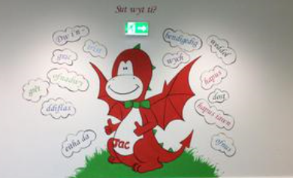
[Figure 1: ‘Jac y ddraig’ from School A’s website]
My observation took place in a Year 1 class of around 30 pupils. The event that I will be focussing on took place during the morning routine. The children had a clear steps to following order to settle into class and waited for the teacher to begin the teaching for the day. The classroom culture was mostly relaxed and organised with only two children who were unsettled and required more encouragement and guidance to participate in the daily routine, such as putting personal items in the draw, hanging coats up and sitting on the carpet to wait for the teacher.
Methodology
The method I adopted for my observation was a non-participant approach. This method ensured minimal intervention from myself and for the lesson to be as natural as possible. However, the Hawthorne effect suggests that any observation taking place will inevitably affect the performance of the teacher due to their awareness and natural response of having an onlooker, as well as disrupting the pupils with a new member in the classroom (Cosser, 1998). As supported by Kumar (2014), this could be a positive or a negative influence on children. For example, pupils may show more endeavour in order to impress; or hide away in an unfamiliar and new context. Additionally, the observer could be a distraction for children therefore they will pay less attention to the teacher and the task. An ideal situation would be for the observer to appear ‘invisible’ to avoid being of any influence of what happens in the class (Taber, 2007). Arguably, there could be ethical issues that could arise if the observer attempts to hide or be of absence in a classroom (Ibid, 2007).
Following BERA (2018) research guidelines, the school, teacher and all pupils observed will be anonymised as School A and Pupil X. I observed the class during throughout the day. While studying the layout, provision, culture, objectives, teaching methods and the pupils in the observation with guidance of a tables; as seen in appendices. To identify a particular situation to analyse can be very subjective. This can rely on the observers prior knowledge, attitudes and opinions (Kumar, 2014); therefore, it is particularly important to use an unbiased approach as suggested by Taber (2007:151) ‘as always, our decisions are influenced by our basic (paradigmatic) assumption about the research’. To avoid this, I focused my observation using a holistic approach as well as focusing on a single definition of a critical incident. DEFINE CRITICAL INCIDENT. I gathered primary data during my observation and later analysed to identify a incident. This does not mean that it is negative but that it raises questions and shows a possibility of improvement or research.
Critical incident linked with Donaldson’s Four Purposes
During their daily routine, the morning consisted of reinforcing the Welsh language with a variety of phrases repeated by every pupil. These included short, simple sentences of ‘everyday Welsh’ used to discuss the weather, attendance, feelings and lunch. It is true to use the term ‘everyday’ simply because it is reinforced every day in the classroom (REFERENCE IN GREEN BOOK). However, it could be questioned whether the language is used outside of the classroom in everyday conversation. As suggested by Welsh Government (2018) language taught should have a reasoning and learners should be able to use to communicate in the ‘real world’. Halliday claimed that to use language effectively to communicate, learners should be able to implement the language appropriately into the correct context (Bachman, 1990). Considering this, the language taught should be more age-appropriate that children will be able to put into practice outside of the classroom context such as yard games, topics of their interests or everyday conversations such as places, food, etc. to increase interest and motivation (Cameron, 2001). Supporting this, Y Cwricwlwm Cymreig (YCC) aims to provide opportunities to use Welsh inside and beyond the classtoom, in order to reach for a bilingual country.
During the register, every child present would say ‘dyma fi’. However, one girl appeared to be confident and ambitious enough to take this phrase one step further and responded to her name with ‘ga i dyma fi’. These are two common phrases (‘can I have’ and ‘here I am’) used in a classroom regularly, yet together, are unsuitable.
The teacher replied with verbal praise ‘bendigedig’. Assuming that an inaccurate answer was detected, I identified a clear approach that the teacher adopted in order to deal with this situation. Therefore, decided to use this as my critical incident due to the engaging starting point for innovative improvements to practice (Tripp, 2012).
Donaldson (2015) proposes four core purposes of the curriculum that will shape learners and prepare them for life-long experiences. One of the core purposes is shown in figure 2.
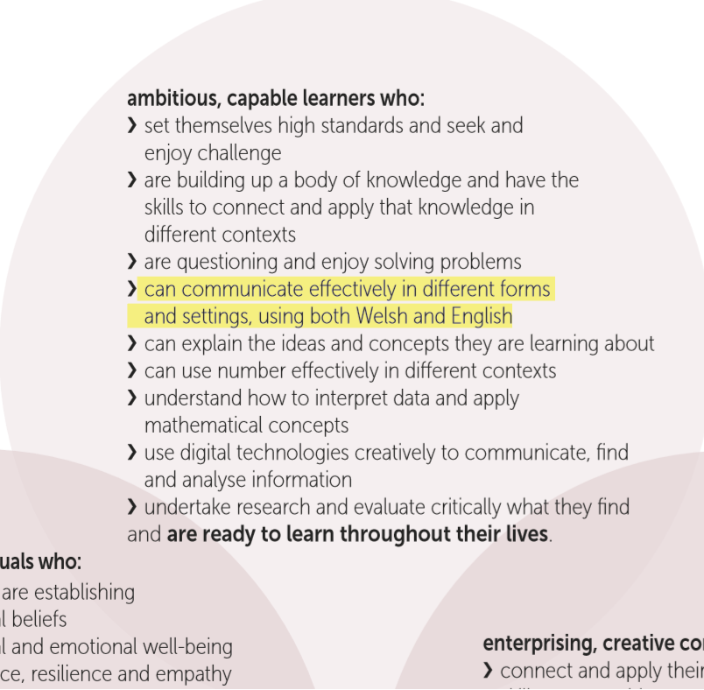[Figure 2: Donaldsons 4 Purposes]
As highlighted, there is a clear connection here as a possible incentive to why School A have implemented this routine. It is a focus that children are to have the ability to communicate in Welsh as well as English, which will be elaborated later in the assignment.
The school slogan is ‘Working together, Learning forever’. Firstly, this has a strong meaningful connection to the Donaldson report that wish children to become ‘ambitious, capable learners who are ready to learn throughout their lives’. This also implies a strong sense of collaboration which is supported by the Estyn report that evaluated the schools partnership working good.
Investigating the response of the teacher in this situation, it is possible that the teacher did not dismiss nor correct the response due to the possible effect it can have on the pupil’s confidence. As seen in figure 3, another core purpose of Successful Futures is to shape confident individuals that will improve participation and performance.
It is important to consider the reason for this is for the child to shape a positive attitude towards the Welsh language and to continue with self-efficiency. The sense of failure can have a drastic effect on one’s confidence and attitudes (Perrot, 1982) and therefore participation as well as behaviour. This can also affect on a child’s character and motivation; a child who has a decrease in their confidence due to being told they are wrong could develop an attitude that failure is inevitable.
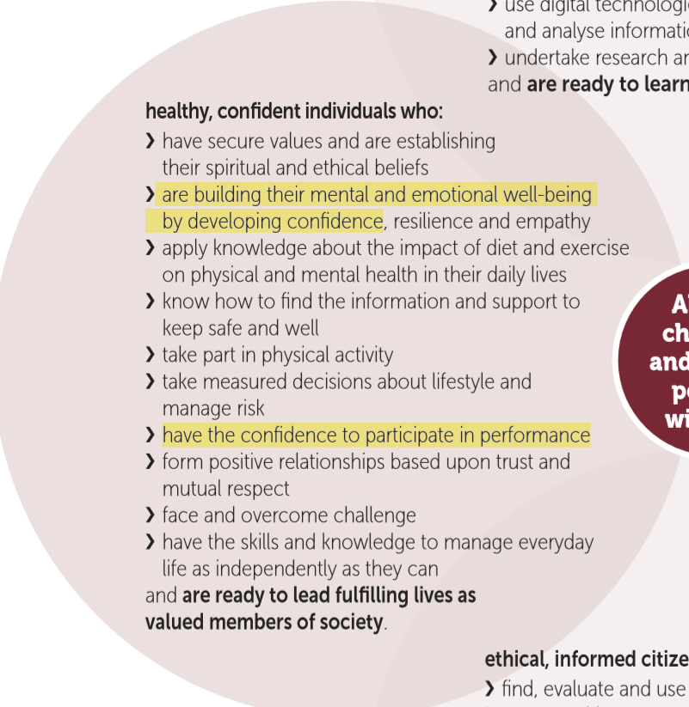[Figure 3: Donaldson 4 Purposes, 2008]
Literature Review
There is emphasis on the Welsh language in contemporary education in Wales, with schemes in schools such as Criw Cymraeg and the Welsh language Charter displaying evident effort into promoting the Welsh language. The most apparent reason for this is the national ambition set by the Welsh Government to increase the number of Welsh speakers to one million by 2050 (Education Wales, 2017a). On the other hand, some believe that teaching language should not be focused on a limited number of the population (Brumfit, 1979), which suggests that a greater focus should be made on a language used worldwide like English.
I believe that every individual is different due to both nature and nurture effects. Each person has strengths and weaknesses which can be skills such as retaining information and reading; which can impact and their ability to learn a new language at any age.
It also should be considered that the teacher was limited to the Welsh language and was teaching phrases in her second language. The lack of literature and research on teaching in a second language is surprising, especially when there is an expectation for teachers to be able to teach Welsh in order to meet the 2050 targets as well as the National Mission which states that all individuals will be able to communicate in Welsh when they leave school (The Education Directorate, 2017 & Donaldson, 2015).
However, there is provision available to support teachers. The Welsh Government have put in place a Sabbaticals Scheme for Welsh language training for teachers to improve their Welsh as well as becoming more confident using and teaching it (Welsh Assembly Government, no date). Though, this scheme is optional which suggests that not all teachers undertake the course and therefore do not reap the full benefits of the provision made available. This is a five-week course, free of charge and funding for supply cover, travel and accommodation (WJEC, 2019) This opens its accessibility and interests to offer great achievements and professional developments.
Education Wales (2017b) suggest that Y Cwricwlwm Cymreig (YCC) does not only focus on learning to communicate in Welsh but also provides opportunities to learn in every area of learning and experience (AoLE) in the 2022 curriculum as well at the current. This includes a variety of subjects and opportunities for cross-curricular lessons including literacy, numeracy, the history of Wales and local visits as examples. This builds a stronger sense of belonging for the children and allows learners to become informative citizens. In addition, learning about different topics on Wales keeps the children interested and avoid any negative attitudes as lessons and tasks will vary.
As seen in the incident, it is possible that autonomous behaviour has set where ‘ga i’ is simple Welsh that is reinforced at a young age, but pupils may not display a clear understanding. Independently, pupil X has merged two phrases that she knows which shows initiative and self-efficiency; which presents her aims to achieve (Gray & MacBlain, 2015). It is possible that pupil X has associated ‘ga i’ as a Welsh phrase that is used when speaking Welsh in the classroom, without putting into a suitable context. This could show that incidental language learning in the year 1 classroom does not teach children the explanation of words or phrases and therefore a lack in understanding. As Wragg & Brown (2003) suggest, it is crucial to have a clear explanation for a understanding, which could be one of the three main types: interpretive, descriptive and reason-giving.
‘If more or less the same routine happens for each child in the class, the written text becomes part of the event and will be learnt through participation in the event’ (Cameron, 2001:143).
Moving on to Skinners Operant Conditioning Theory. This theory appears to be strongly influenced by Thorndike’s work (Gray & MacBlain, 2012). The operant conditioning theory stresses on the affect a response can have on behaviour (ibid, 2012) and therefore learning. This can strengthen or weaken behaviour depending on whether the response provided is positive or negative. These can be presented using many different methods (Keenan, 2002). Following Skinner’s theory, the verbal praise given to pupil X after giving an incorrect response could have been perceived that the pupil’s response was correct. According to the Operant Conditioning Theory, if wrong answers are reinforced positively, it will increase the possibility of repeating the phrase again. As well as this, it could affect her fellow peer who will identify the praise she has been given, believe that it is correct and therefore follow her example in order to impress and have a desired reaction from the teacher (Aubrey & Riley, 2016).
According to this theory, when using positive and negative reinforcement correctly, behaviour will eventually become autonomous. Developing autonomy correctly can lead to successful learners (Benson, 2011). However, it is therefore important to erase any undesired behaviour that could become autonomous. This can be dealt this in different ways, such as dismissal, correction, modelling or negative reinforcement. While doing this is it also important to be aware of a child’s self-esteem and well-being therefore dealt with sensitively in specific situations. Muijs & Reynolds (2011:57) clearly instruct that teachers must ‘acknowledge that the answer is incorrect in a businesslike way’ whilst avoiding being personal that can become ‘harmful rather than helpful’.
However, Skinners experiment of Operant Conditioning had evidence supporting animal behaviour and not humans. It is believed that humans have a rational approach towards actions and behaviour (Nye, 1979).
Reflection / Evaluation and Next Steps
As suggested by Schon (1983), a professional that has been in the same job for a long period of time could miss or avoid opportunities to reflect and improve practice. This could be due to attitudes and routines that have developed; and therefore could result in errors being repeated (ibid, 1983). This argues the importance of refection to develop and enhance professionalism. As a student-teacher, every strategy and method of teaching is new, therefore will not affect any routines, habits or confidence. Reflection in teacher education should be a continuous process due to the constant changes in many variables such as learners, barriers to learning, expectations, policies and legislations (Hamilton, 2002) as well as the new curriculum coming into action. Reflective practice promotes and maintains awareness to guide our learning and professional development and therefore our strategies and actions towards maximising successes (Tripp, 2011).
Black & Wiliam (2001) develop research on formative assessment. They suggest that any feedback given to a learner should also contain an appropriate in-task targets to provide opportunity for learners to rectify any mistakes, negative behaviour and erase any misconceptions. In this situation, it would be useful to use strategies such as the exploration of incorrect answers, praise or modelling correct answers.
In order to ensure understanding of the Welsh language I would use a sandwich technique. This is when a teacher would use the learners first language (English) hand-in-hand with their taught language (Welsh) in order for children to have full understanding of words taught or used. This could also be useful to get children to confirm understanding by getting them to explain phrases or repeat them in English. When doing this it can also identify any misconceptions of words, phrases or questions asked and therefore will be able to correct and further explain the meaning of the words and language taught. Eventually, the mother language should be aimed to be eliminated when teaching Welsh to avoid reliability of the first language to understand.
Schmitt and Schmitt (1995) believe that tasks which require more elaborate thought, manipulation or processing of a new word will help with the learning and understanding of the word, or phrase. When analysing the response that translates to ‘can I have here I am’, as a class pair, it is possible to explore the response and reason why it is partially incorrect. By asking ‘what does ‘ga I’ mean?’, ‘what does ‘dyma fi’ mean?’. Putting these into the same context in their first language will help understanding, identifying where the correct and incorrect part of the answers are and the development of a child’s explanation and description in English.
Bandura and the more recent, Bronfenbrenner’s social learning theories both acknowledge Skinner’s Operant Conditioning theory with an addition on the importance of imitation and identification. This suggests that with a role model imitating an action or behaviour, learning is made. Additionally, Linden (2005) states that children do not only copy physical behaviour, but also verbal behaviour. With these in mind and put into practice, teacher confidence will increase due to evidence the experiments have presented (Quigley, 2016). Unlike Skinner, Banduras Bobo doll experiment was proven by using children rather than animals.
Due to the imitation of adults from the Bobo doll experiment, it is clear adults, including teachers are seen as role models for children. Therefore suggests that modelling will lead to repetition. The use of modelling will emphasise high expectations for learners to imitate (Griffith & Burns, 2014). This could be used using ‘my turn your turn’ for pupil X to identify the mistake in her response and can correct herself. This allows child to have a second opportunity to respond without negative reinforcement or dismissal, which can then be praised in order to build confidence and reinforce correct answer, as well as develop enthusiasm (Skinner, 2010).
This could then move on to praising half of the response was desired and correct to raise confidence of her eagerness to impress the teacher. Acknowledging that half of the response was used correctly, as a teacher it is vital to reinforce and be clear on which part was correct (Muijs & Reynolds, 2011). This can be easily done by saying phrases such as ‘nearly’, alongside modelling just ‘dyma fi’.
Routines and repetition is an ideal way for children to remember and learn phrases (REFERENCE). This is suggested by many writers such at SOMEONE that having a full understanding will develop once phrase is used in the correct context forty times. I assume as a daily routine this has been reached however, with praise being given to a response that was only half correct, could be misleading.
Other opportunities and exposure of the Welsh language could help develop and fast-track learning. This could be done with visits or visitors that are advanced Welsh speakers to put into practice and context (Smidt, 2011). This could influence the use of Welsh outside of the classroom and learn words that will be of more use when out in the community as suggested by Donaldson (2015).
As suggested previously, the response could be influsced by autonomous behaviour. To avoid this, it is important to consider using Welsh within a classroom in different contexts and lessons (as well as repetition during routines). In a foundation phase classtroom, this could be done in the role play area such as ‘the eisteddod’, as well as social opportunities like learning Welsh yard games to play on the yard and use of vocabulary such as feelings during check-in or circle time. However, Pratt (2006) suggests that children often see listening as more important than talking, even though it is through talk that a lot of understanding develops. Therefore, the balance of direct teaching should be considered.
Conclusion
This topic became more difficult due to the fact that I, the observer, am a fluent Welsh speaker. This means that the incident was clear and obvious to myself and became more effortful to put myself into the teachers position as a Welsh learner.
Not only has this assignment helped me explore new ideas and strategies to teach second language Welsh, but all aspects of teaching. Many strategies and proven theories can be put into any context within a classroom environment. This has helped me gain knowledge and therefore confidence to deal with behaviour, attitudes and learning. Most effectively, I have learnt new way to deal with questions that are misunderstood and/ or answered incorrectly or partially incorrect.
Moreover the little exposure I have had to teaching as part of my PGCE, it is clear more can be done on behalf of English medium schools to teach meaningful Welsh that will serve the children well for the rest of their lives in school and the workplace. This is supported by Donaldson (2015:28) for learners to ‘acquire a wider range of language skills in Welsh. This will enable them to use the language in their personal lives, socially and in the workplace’.
The emergence of the new Professional Standards for Teaching and Leadership has affected the way that I have observed as part of this assignment.

References
Aubrey, K. & Riley, A. (2016) Understanding & Using Educational Theories. London: SAGE Publications.
Bachman, L. (1990) Fundamental Considerations in Language Testing. New York: Oxford University Press.
Benson, P. (2011) Teaching and Researching Autonomy. 2nd edn. London: Routledge.
Black, P. & Wiliam, D. (2001) Inside the Black Box: Raising Standards through Classroom Assessment. Department of Education & Professional Studies.
Brumfit, C. J. (1979) “Communicative’ Language Teaching: An Educational Perspective’, in Brumfit, C. J. & Johnson, K. (eds.) The Communicative Approach to Language Teaching. London: Oxford University Press.
Cameron, L. (2001) Teaching Languages to Young Learners. Cambridge: Cambridge University Press.
Cosser, M (1998) ‘Towards the Design of a System of Peer-Review of Teaching for the Advancement of the Individual within the university’, Higher Education, 35(2), pp. 143-162.
Donaldson, G. (2015) Successful Futures. Crown Copyright. Cardiff. Available at: http://gov.wales/docs/dcells/publications/150317-successful-futures-en.pdf (Accessed on: 3rd October 2019).
Education Wales (2017a) Education in Wales: Our National Mission. Cardiff: Welsh Government. Available at: https://gov.wales/sites/default/files/publications/2018-03/education-in-wales-our-national-mission.pdf (Accessed: 10 October 2019)
Education Wales (2017b) Welsh in Education. Cardiff: Welsh Government. Available at: https://gov.wales/sites/default/files/publications/2018-02/welsh-in-education-action-plan-2017–21.pdf (Accessed: 5 October 2019)
Estyn (2017) https://primarysite-prod-sorted.s3.amazonaws.com/burlaisprimaryschoolswansea/UploadedDocument/408a575c957545eab629876fc2fd04c8/burlais-primary-school-estyn-report-june-2017.pdf
Ghaye, T. & Ghaye, K. (1998) Teaching and Learning through Critical Refelctive Practice. London: David Fulton Publishers.
Gray, C. & MacBlain, S. (2012) Learning Theories in Childhood. London: SAGE Publications.
Gray, C. & MacBlain, S. (2015) Learning Theories in Childhood 2nd ed. London: Sage Publications Ltd.
Griffith, A. & Burns, M. (2014) Teaching Backwards. Carmarthen: Crown house Publishing Limited.
Hamilton, M. (2002) ‘Change, Social Justice and Re-liability’, in Loughran, K. & Russell, T. (eds.) Improving Teacher Education Practices Through Self-Study. London: RoutledgeFalmer.
BERA (2018) Ethical Guidelines for Educational Research. Available at: https://www.bera.ac.uk/publication/ethical-guidelines-for-educational-research-2018-online#community (Accessed on: 5th October 2019).
Keenan, T. (2002) An Introduction to Child Development. London: SAGE Publications Ltd.
Kumar, R. (2014) Research Methodology: A Step-by-Step Guide for Beginners. 4th edition. London: SAGE Publications Ltd.
Linden, J. (2005) Understanding Child Development Child Development: Linking Theory to Practice. London: Hodder Education.
Muijs, D. & Reynolds, D. (2011) Effective Teaching: Evidence and Practice, 3rd edition. London: SAGE Publications Ltd.
Nye, R. D. (1979) What is B. F. Skinner Really Saying? New Jersey: Prentice Hall.
Perrott, E. (1982) Effective Teaching: A Practical Guide to Improving your Teaching. London: Longman.
Pratt, N. (2006) ‘Interactive teaching in Numeracy Lessons: What do Children Have to Say?’ Cambridge Journal of Education, 36(2), pp. 221- 235.
Quigley, A. (2016) The Confident Teacher: Developing Successful Habits of Mind, Body and Pedagogy. London: Routledge.
Schmitt, N., & Schmitt, D. (1995). Vocabulary notebooks: Theoretical underpinnings and practical suggestions. ELT Journal, 49(2), 133-143. http://dx.doi.org/10.1093/ elt/49.2.133.
Schon, D. (1983) The Reflective Practitioner: How professionals think in action. New York: Basic Books.
Skinner, D. (2010) Effective Teaching and Learning in Practice. London: Continuum International Publishing Group.
Smidt, S. (2011) Introducing Burner: A guide for practitioners and students in early years education. London: Routledge.
Taber, K. S. (2007) Classroom Research and Evidence-based Practice: A Guide for Teachers. London: SAGE Publications ltd.
The Education Directorate (2017) Education in Wales: Our National Mission. Cardiff: Welsh Government. Available at: https://gov.wales/sites/default/files/publications/2018-03/education-in-wales-our-national-mission.pdf (Accessed: 3rd October 2019)
Tripp, D. (2012) Critical incidents in teaching: developing professional judgement. London: Routledge.
Welsh Assembly Government (no date) Sabbaticals Scheme for Welsh-language training. Available at: https://wjec.co.uk/uploads/publications/16859.pdf (Accessed: 6th October 2019)
Welsh Government (2018) An overview of approaches to second language acquisition and instructional practices. Available at: https://gov.wales/sites/default/files/statistics-and-research/2019-06/180228-overview-approaches-second-language-acquisition-instructional-practices-en.pdf (Accessed on: 20th October 2019).
WJEC (2019) The Sabbatical Scheme. Available at: https://wjec.co.uk/teachers/support-team-for-the-welsh-language-in-education/the-sabbatical-scheme.html (Accessed: 6th October 2019)
Wragg, E. & Brown, G (2003) Explaining in the Secondary School. London: Routledge.

Appendices
OBSERVATION / FIELD NOTES
(Questions adapted from Fletcher Wood (2016)
Date: 26/09/2019

Lesson details: Literacy lesson. The children were split into three groups to complete different literacy activities.
Group 1 – Guided reading
Group 2 – Spelling and reading games using ICT
Group 3 – Spelling board game (observed)

Classroom culture
(Are the students focused on learning?)
The objectives were shared using a character from the story they were sharing as a class that week. Children were engaged and intrigued with the challenges they needed to complete to help ‘Beegu’. All children used good teamwork skills to encourage and help eachother wherever possible.

Objectives
(Is there a clear purpose to the lesson? How do the lesson activities promote that purpose?)
Each task was described clearly on the carpet before they were split into groups.
Group 3 were told to roll 3 phonetic dice and to create three-letter words with the chosen letters, using magnetic letters.

Direction
(Are the students clear about what they are doing and how to do it well?)
The pupils were clear with each task given without support or supervision from the class teacher. The task appeared to be well rehearsed as if used at different levels of their development.

Access and challenge
(Are all students able to engage in the lesson? Are all students challenged?)
All students were engaged and some were able to recognise CVC words whereas others would use a trial and error method by mixing the letters around until a familiar words was formed. The children that understood the concept quicker would use their own initiative to help others explaining in their own words how to complete the task. All children were able to work at their own pace where some found 3 words and others found up to 10.

Assessment
How does the teacher assess student understanding before, during and after the lesson? How is this used in their teaching?
The teacher allowed time on the carpet for any questions about the tasks. Teacher appeared to use SMART targets to evaluate the completion of the task.
S-Specific – Create three-letter words by rolling the dice
M-Measurable – Record at least 3 words using the magnetic letters
A-Agreed – Children were excited to help Beegu
R- Realistic – Due to the target stating ‘at least’ allowed flexibility for every child to reach the target with support from peers if needed
T- Timely – By the end of the lesson

Specifics / Critical Incidents
Are there particular telling moments and examples which it would be helpful to discuss?
When the children were split into their groups to proceed with their set activities, every child in group 3 decided to explore the equipment that they were provided before beginning the task. Every child began by searching for the magnetic letter to create their name. I believe that the teacher was aware of this and let them do so. When they all completed their names, without any prompting they began the task and completed it.

Repeating similar tasks to allow children to be more confident and independent to carry out tasks without support or encouragement.

Model Beirniad Wedi Adfyfyrio (BWA)

Assisted Reflective Conclusions (ARC) Model
Dyddiad/Date: 26/09/2019
Digwyddiad critigol (Ffocws)/Critical incident (focus): Spelling out names before task
Profiad/ Experience

Feelings  “What are your feelings regarding the experience?” | Intrigued to how the teacher would address the situation.  Interested in what the children would do next.  Did the children understand the task?  Is this autonomous behavior as children are told always to put their names on their work?  Is this a technique of leadership
Remember and Understand  “Can you list the aspects of the learning experience that went well?”  “What were the elements of the learning experience that were disappointing?” | After children spelt their names they were on task without prompt or encouragement from the teacher in the classroom – which eventually showed good classroom management.
Evaluate and analyse  “What will you keep the same to ensure effective teaching and learning in the future?”  “What was the cause of the most important disappointing element?” | Allow children to explore equipment given before starting the task.  Analyse how children work independently- what would they do first
Conclusions and actions  “What are your possible solutions to the disappointing issues identified?”  “What will you do next?” | Address that it was not required to do in this task  Understand that it is a part for children to explore task and allow them to do their name at the start like teacher did  Give them the opportunity to make words of their choice near the end of the lesson once met a target
Y profiad newydd / Transformed experience

OBSERVATION / FIELD NOTES
(Questions adapted from Fletcher Wood (2016)
Date: 26/09/2019

Lesson details: Follow up lesson after making step-by-step instructions to make cheese on toast. Class read and followed the instructions to make cheese on toast each.

Classroom culture
(Are the students focused on learning?)
The objectives were shared using a character from the story they were sharing as a class that week. Children were engaged and intrigued with the challenges they needed to complete to help ‘Beegu’. All children were encouraging eachother with a very friendly atmosphere.

Objectives
(Is there a clear purpose to the lesson? How do the lesson activities promote that purpose?)
Lesson was to follow instructions and complete each step before moving on as a group. This task showed team work and good understanding of what they needed to do.
Overall objective was created as a class from previous lesson – as a group children wrote the instructions on the board.

Direction
(Are the students clear about what they are doing and how to do it well?)
Instructions were broken down clearly, using appropriate language.
All children were aware of the outcome with an example picture as well as the staff member doing the steps alongside the children.

Access and challenge
(Are all students able to engage in the lesson? Are all students challenged?)
Children were supporting each other with shared reading and discussing each step to ensure understanding.

Assessment
How does the teacher assess student understanding before, during and after the lesson? How is this used in their teaching?
Continuous

Specifics / Critical Incidents
Are there particular telling moments and examples which it would be helpful to discuss?
Children were very encouraging of eachother.
‘waw well done, I didn’t think of doing that’ (when a child folded his toast in half
‘look what they’ve done’
‘that’s brilliant’

Model Beirniad Wedi Adfyfyrio (BWA)

Assisted Reflective Conclusions (ARC) Model
Dyddiad/Date: 26/09/2019
Digwyddiad critigol (Ffocws)/Critical incident (focus): Children praising eachother
Profiad/ Experience

Feelings  “What are your feelings regarding the experience?” | Happy  Heart-warming
Remember and Understand  “Can you list the aspects of the learning experience that went well?”  “What were the elements of the learning experience that were disappointing?” | The children showed a lovely idea of teamwork  Praising and encouraging eachother to complete task  Created a nice work environment for every individual  Children showed possible actions and phrases heard at home or in school by other adults  This incident was a positive without any aspects I could see to improve as the children did praise at correct times when peer were doing well on task
Evaluate and analyse  “What will you keep the same to ensure effective teaching and learning in the future?”  “What was the cause of the most important disappointing element?” | I love the idea where all children in the class are supportive and encouraging of their peers to succeed.  This incident was a positive without any aspects I could see to improve as the children did praise at correct times when peer were doing well on task
Conclusions and actions  “What are your possible solutions to the disappointing issues identified?”  “What will you do next?” | I would like to create an environment such as this in a classroom by allowing opportunities for peer-assessment, group work and role play.  I would like to focus on praise rather than punishment to reinforce good behavior and work.
Y profiad newydd / Transformed experience

OBSERVATION / FIELD NOTES
(Questions adapted from Fletcher Wood (2016)
Date: 02/10/2019

Lesson details: Morning routine – Register, practice welsh.

Classroom culture
(Are the students focused on learning?)
Children understood well the introduction to the day at school.
The children have a routine before they began the day while the teacher continued to welcome the children in.
Most children were on task and many helped others to get their morning routine completed while waiting for the teacher.

Objectives
(Is there a clear purpose to the lesson? How do the lesson activities promote that purpose?)
To reinforce Welsh phrases during daily routines
This was clearly used daily in classroom as every child would respond to register in Welsh without encouragement

Direction
(Are the students clear about what they are doing and how to do it well?)
Each child repeating same phrases showed peer modelling

Access and challenge
(Are all students able to engage in the lesson? Are all students challenged?)
All children learnt phrases prior to this routine

Assessment
How does the teacher assess student understanding before, during and after the lesson? How is this used in their teaching?
Routine was consistent and practiced daily
Specifics / Critical Incidents
Are there particular telling moments and examples which it would be helpful to discuss?
One child replied to her name on the register with ‘ga I dyma fi’ then the teacher replied with ‘bendigedig’

Model Beirniad Wedi Adfyfyrio (BWA)

Assisted Reflective Conclusions (ARC) Model
Dyddiad/Date: 02/10/2019
Digwyddiad critigol (Ffocws)/Critical incident (focus): ‘ga i dyma fi’ ‘bendigedig’
Profiad/ Experience

Feelings  “What are your feelings regarding the experience?” | It was enjoyable to see all the children putting the effort into learning the Welsh language in an English-meduim school
Remember and Understand  “Can you list the aspects of the learning experience that went well?”  “What were the elements of the learning experience that were disappointing?” | Repetition in the same phrase and consistency ensured children would remember Welsh phrases.  Praising to ensure children gain confidence when talking aloud in class.  The use of praise when answer was partially wrong could give a false sense that the response was correct.
Evaluate and analyse  “What will you keep the same to ensure effective teaching and learning in the future?”  “What was the cause of the most important disappointing element?” | I would use repetition to ensure children remember things as well as daily routines.  I would use praise for children to build confidence.  I would not use any punishment or negative reinforcement with a child shows effort to answering a question.  I would promote the Welsh language in English schools  I would use a different approach when dealing with an incorrect answer.
Conclusions and actions  “What are your possible solutions to the disappointing issues identified?”  “What will you do next?” | I would consider the use of explaining why an answer is wrong or give opportunities for child to correct themselves.  I would use modelling an example for child to repeat.  I would ask questions why child may think the answer was correct and give further information to why it was only partially correct.  I would use praise to acknowledge that some of the response was correct
Y profiad newydd / Transformed experience

OBSERVATION / FIELD NOTES
(Questions adapted from Fletcher Wood (2016)
Date: 02/10/2019

Lesson details: Free choice. Challenges set around the classrooms on different stations such as small words play, construction play, numicon snap, ICT paint, creative play using recycled materials, cutting & sticking and spelling using white boards.

Classroom culture
(Are the students focused on learning?)
Children were selecting stations with friendship groups. Teacher did not have to specify how many at each station as they were spread around the classrooms themselves.

Objectives
(Is there a clear purpose to the lesson? How do the lesson activities promote that purpose?)
This lesson was to allow children to have a choice of what they were engaging in and with who. Every activity had a challenge surrounding their theme ‘our local area’, except for the numicon game.

Direction
(Are the students clear about what they are doing and how to do it well?)
The pupils were very excited to take part in their chosen activities with their friends and most were on task throughout the lesson. They understood each task and were allowed to change stations as they wish.

Access and challenge
(Are all students able to engage in the lesson? Are all students challenged?)
The tasks were set for children to complete with their own initiative therefore challenge was limited. Every task was achievable without support.

Assessment
How does the teacher assess student understanding before, during and after the lesson? How is this used in their teaching?
Children would have to take a picture and upload to HWB when each task was completed
Specifics / Critical Incidents
Are there particular telling moments and examples which it would be helpful to discuss?
Even with verbal encouragement, no child chose to play the numicon snap.

Model Beirniad Wedi Adfyfyrio (BWA)

Assisted Reflective Conclusions (ARC) Model
Dyddiad/Date: 02/10/2019
Digwyddiad critigol (Ffocws)/Critical incident (focus):
Profiad/ Experience

Feelings
“What are your feelings regarding the experience?”
Remember and Understand
“Can you list the aspects of the learning experience that went well?”
“What were the elements of the learning experience that were disappointing?”

Evaluate and analyse
“What will you keep the same to ensure effective teaching and learning in the future?”
“What was the cause of the most important disappointing element?”

Conclusions and actions
“What are your possible solutions to the disappointing issues identified?”
“What will you do next?”
Y profiad newydd / Transformed experience

