Programme: BA (Hons) International Hotel Management
Module: Managing Food and Beverage Operations
Module Code: BMIH6002
Assignment Title: Student Learning Log
Student ID Number: 2120533
Hotel’s Food and Beverage Operation

Figure 1: Hotel’s Food and Beverage Operation
Source: (Realfoodheaven, 2023)
The hotel I observed a supervisory role in the Food and Beverage (F&B) division is a mid-scale luxury hotel with various F&B units ranging from the main dining restaurant, a coffee shop, a pool-side bar, and catering for event functions. As implementing the organization, the F&B department has the responsibility of increasing the level of satisfaction of the guests through ensuring that only the best quality food is offered together with excellent F&B services. In addition to these objectives, the department’s main goal will be to enable the achievement of the organization’s vision through efficient management of operations, control of food quality, consistency, and food excellence.
Model of Reflection Used
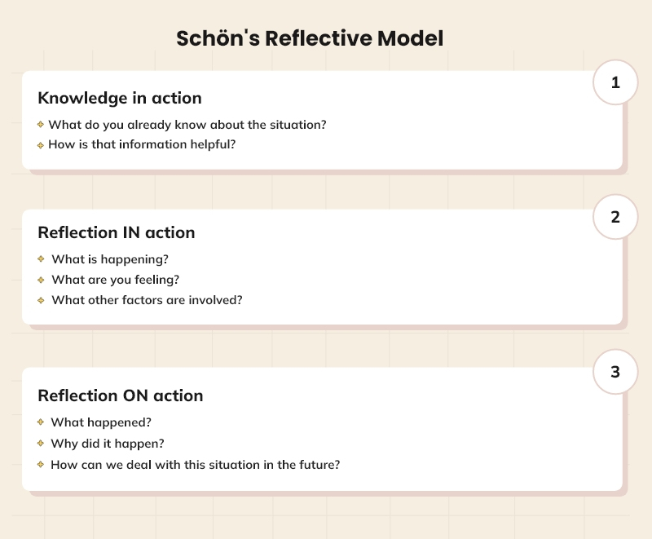
Figure 2: Donald Schön’s model of reflection
Source: (Robinson, 2022)
In this consideration, I applied Donald Schön’s model of reflection that divides it into two main types: reflection in-action and reflection on-action. Real-time thinking is reflection that happens during the learning activity, which can be effective in guiding changes during the activity or situation; free reflection is thinking that occurs after an event has taken place, which allows for a deeper understanding of the event or activity (Ramage, 2021).
Placement Learning Objectives
Develop Leadership Skills: An enhanced competency with regards to the aspect of personnel management with a focus on a diverse work force in a fluid context.
Enhance Operational Efficiency: It is equally important to comprehend and integrate approaches to organizing performance processes and enhancing productivity.
Master Conflict Resolution: Discover the practices that should be followed when there is conflict between employees and noble rules that one should follow when dealing with customers’ complaints.
Deepen Culinary Knowledge: Get acquainted with various food preparations, how dishes should be presented and how they can be offered to the potential guests.
Improve Guest Interaction: Skills may be learned in how to handle guests with friendliness with the aim of satisfying them throughout their dining.
Understand Financial Management: Understand the importance of costs in the F&B operation and how it relates to controlling costs, creating a budget and reporting the finances.
Enhance Marketing Skills: It is important to comprehend how marketing will play an instrumental role in delivering the F&B services to the guests and ensuring better footfalls.
Improve Inventory Management: Strive to develop skills for proper management of inventory to avoid product waste while ensuring that vital stocks are available in the market at all times.
Develop Health and Safety Knowledge: Overemphasizing HS in F&B setting and its relation to health and safety regulation.
Enhance Sustainability Practices: Find out strategies for the procurement of food, control of food waste, and efficiency in energy as a measure towards green working.
Reflection on Experience
Leadership
Consequently, in light of my shadowing experience, I was made to appreciate the foundational significant of leadership in F& organizations particularly in the F&B department. In this case, it was established that the supervisor plays a crucial role in the manner in which the employees in the team perform their duties as well as the level of morale exhibited among the members of the team. Leadership differs from management in that it not only defines, organizes, plans, and co-ordinates but also encourages and appreciates the workers (Takaza, 2021). They could as well appreciate my leadership style and how I manage to ensure that everyone at the workplace has a smile on their face as well as understand how important it is to be approachable at the workplace.
Operational Efficiency
As per the study by Lawrence-Chuku (2022), flexibility is another significant factor to consider since the F&B Industry is extremely competitive and fast-paced. I also noticed methods the supervisor employed in ensuring work was efficiently organized, adequate time was gotten for the staff, the integration of the staff with the kitchen and proper ordering of food. The integration of proper working strategies maintained a constant and smooth working cycle of the service without significant disruptions, even during the peak traffic time. It also made me realize the significance of planning, organization and attempting to embrace the concepts of continuous improvement in all the processes that take place in organizations.
Conflict Resolution
Another important aspect that can and should be expected in the function of an F&B team manager is conflict resolution. There are several cases which made me see the supervisor having to resolve staff conflicts as well as with guests. As a freely spoken communicator, it required time to remain composed, attentive to sides involved, and come to recognizable compromises that would help maintain businesses’ friendly atmosphere and satisfy guests(Matta, 2021). I was able to learn how to resolve conflicts in a diplomatic way and without being hasty and aggressive towards others.
Culinary Knowledge
Erasmus has highlighted that it is crucial to be acquainted with the gastronomical side to make the experiences of the guests more lip-smacking (Warren, 2021). I proved to be able to understand different cooking methods and ways of arranging food and the necessity of choosing good quality food products. It’s quite notable that he seemed to possess quite a good understanding of the menu and could recommend the right options based on the guest preferences (Patil, 2023). It has been quite enlightening and has helped in realizing the need to regularly update oneself on the current trends in culinary arts.
Guest Interaction
It is understandable that interacting with guests has a significant impact on their attitudes towards it. I analyzed how the supervisor properly responds to guests as individuals – from simple greetings to holding follow-up conversations about their experience at the restaurant. This is a clear indication that the guests were well taken care of and their concerns and issues were well considered (Mehran, 2021). This aspect of the experience provided a clear idea of how effective communication skills, the ability to listen effectively, and assertiveness can be particularly crucial when dealing with guests.
Financial Management
I looked at how the supervisor managed affordable funds, controlling and reporting expenditures. Knowledge of financial details of the F&B department is essential in appealing and maintaining profitability in the department (MARGARET, 2021). It also brought to the understanding of the need to have a good understanding of the amount of cash flow as well as the best strategies to adopt.
Marketing Skills
This section helped me understand how F&B services are marketed and sold; the methods used include social media marketing, offers and discounts, as well as collaborations with other outlets. Marketing plays an important role in ensuring that potential guests are attracted to the hotel and also in creating the reputation of the hotel (Ho et al., 2022). This experience was a learning effect that helped to understand that creativity and good knowledge as well as the perception of market trends are required.
Inventory Management
Stock control as it requires a proper understanding of the management to ensure the proper inventory of stock and avoid storage of unnecessary items. The assignment focused on analyzing the following aspects of work: The method of tracking specific inventory items in order to monitor their status, Requisition of orders, and the management of relations with particular suppliers. It helped me understand that time management, focus, and precision is key, as well as how to plan ahead accordingly.
Health and Safety
Knowledge of legal requirements and regulations concerning OH&S is paramount in the F&B business (Noroozi, 2023). I identified measures to be taken to prevent in consumption and the cleanliness, and health of the people working there. It also brought into the picture the need to observe set regulations and ensuring that workplace is safe for everybody.
Sustainability Practices
I also recognized that the hotel practices a sustainable marketing strategy, for instance, the use of locally sourcing the products, minimizing wastage of recycles, and the use of energy-efficient devices. Sustainability is one of the most crucial areas in the field of hospitality as its promotion is becoming essential (Molina-Collado, 2022). This had a significant role of enhancing the perception and importance of ecological practices in the environment, and the effect on the company brand.
Organizational Issue Encountered
In my working area I came across a problem which in some way is related to that of staffing. The department also sometimes struggle low number of staff in the department which affects their service delivery and morale of the employees. This was notably so during rush hour traffic as well as eventful days.
Possible Solutions:
Improved Recruitment Strategies: Enhancing the recruitment processes to enhance the company’s staffing with competent employees.
Enhanced Training Programs: Ongoing programs whose aim to increase the adequate training of new employees to achieve the required level of service (Čelić, 2021).
Flexible Scheduling: Introducing more flexibility in organizational staffing to enhance coverage with the organizational supply.
Employee Retention Initiatives: Cores that can be addressed to act upon include designing methods for enhancing organizational staff’s job satisfaction and decreasing turnover rates, including promotions or bonuses for employees.
The indicating factor of experience will be the foundation of an action plan in the future as indicated in the following lesson plan.
Continue Developing Leadership Skills: Attend leadership development courses and ask my supervisors how I can become a good leader.
Participate in Operational Efficiency Projects: You should take part in initiatives to enhance the effectiveness of the processes in the company and study examples of the work in the field.
Master Conflict Resolution Techniques: If any, attend workshops on ways of handling conflicts and be able to demonstrate what has been learned in actual settings.
Pursue Culinary Education: This is because there are many programs in culinary courses that I can take to enhance my understanding of the food and beverage preparation and presentation(Patil, 2023).
Implement Guest Interaction Strategies: Then adhere to the said strategies in future careers in order to ensure guests are pleased and create good relations with them.
Develop Financial Literacy: It is difficult to ignore F&B costs; therefore, one needs to take courses in financial management to learn more about budgeting and controlling costs in the F&B context.
Enhance Marketing Knowledge: Specialize in marketing techniques for the F&B services and attend workshops as a way of enhancing on new techniques.
Improve Inventory Management Skills: To be more precise, it is necessary to get practical experience in managing inventory with the help of software and various techniques.
Stay Updated on Health and Safety Regulations: Policies and regular training and refreshing of health and safety regulatory measures are important too.
Promote Sustainability: Apply elements of sustainability in future positions and campaign for environmental conservation.
Conclusion
From Schön’s analysis of reflection, I would like to remark that reverberation on my shadowing has indeed proved very informative to understand those crucial competencies and know-hows used in the Food and Beverage department. These aspects alongside my personal and vocational growth have enriched my understanding the significance of leadership, operations, teamwork, food service, communication, budgeting, promotion, organization, hygiene, nutrition, teamwork, product control, health and safety as well as sustainability. Finding a long-term solution and improving the ways in which the company can reduce staffing problems and issues will help improve the success and efficiency of the F&B operation.
References
Realfoodheaven. (2023, May 1). What is the role of the food and beverage department in a hotel? Medium. https://medium.com/@realfoodheaven01/what-is-the-role-of-the-food-and-beverage-department-in-a-hotel-fb1ff4f0855a
Robinson, J. (2022, December 2). Master the Art of Reflection with Schön’s Reflective Model. Crowjack. https://crowjack.com/blog/strategy/reflection-models/schon-reflective-model
Ramage, M. (2021). Schön, Donald: Learning and Change in His Work–Reflection on Theory and Theory on Reflection. In The Palgrave Handbook of Organizational Change Thinkers (pp. 1541-1555). Cham: Springer International Publishing.
Takaza, S. C., Kanyere, D., &Chitereka, C. (2022). Perspective Chapter: Fostering Effective Leadership in Social Work Organisations. Social Work-Perspectives on Leadership and Organisation, 211.
Lawrence-Chuku, J., & Onuoha, B. C. (2022). Organizational Flexibility and Corporate Performance of Food and Beverage Firms in Rivers State, Nigeria. Research Journal of Management Practice| ISSN, 2782, 7674.
Matta, R., & Fares, R. (2021). The impact of interpersonal workplace conflicts on the long-term success of organisations. EuroMed Journal of Management, 4(1), 55-71.
Warren, D. (2021). Strange to Say: Etymology as Serious Entertainment. Paul Dry Books.
Patil, D. R., & Rane, N. L. (2023). Customer experience and satisfaction: importance of customer reviews and customer value on buying preference. International Research Journal of Modernization in Engineering Technology and Science, 5(3), 3437-3447.
Mehran, J., Escallada, O., & Olya, H. (2021). Employee well-being in guest-oriented industries: Evidence from food and beverage sector. In Emerging Transformations in Tourism and Hospitality (pp. 154-169). Routledge.
MARGARET, N. O. (2021). INFLUENCE OF SALES CONTROL IN FOOD AND BEVERAGE SERVICE ON FINANCIAL PERFORMANCE OF CLASSIFIED RESTAURANTS IN NAIROBI CITY COUNTY, KENYA (Doctoral dissertation, KENYATTA UNIVERSITY).
Ho, J. L., Chen, K. Y., Wang, L. H., Yeh, S. S., & Huan, T. C. (2022). Exploring the impact of social media platform image on hotel customers’ visit intention. International Journal of Contemporary Hospitality Management, 34(11), 4206-4226.
Noroozi, E., & Taherian, A. R. (2023). Occupational Health and Safety in the Food and Beverage Industry. CRC Press.
Molina-Collado, A., Santos-Vijande, M. L., Gómez-Rico, M., & Madera, J. M. (2022). Sustainability in hospitality and tourism: a review of key research topics from 1994 to 2020. International Journal of Contemporary Hospitality Management, 34(8), 3029-3064.
Čelić, I., Milićević, S., & Đorđević, N. (2021). Staff training and development: A comparative analysis of national hotels in Serbia and international hotel chains. Megatrend revija.

