An Analysis of the Staff Training, Learning and Development within the Food and Beverage Department at the Hilton hotel and the Impact it has on a Business.

Module Code: BMIH6008, BMIH6006

Student Name: Marko Malajner

Student ID: 2112111

Lecturer: Dr. Ernest Wavei

Executive Summary
The research project is centred on staff training and learning processes in the Hilton Hotel Reading. The aim has been taken to evaluate the training procedure in the food and beverage sector of the hotel industry and its impacts on employee skill, staff motivation and knowledge of the technique of keeping up customer satisfaction and increasing operational efficiency. The rationale of the projects includes industry importance, guest satisfaction maintenance, operational efficiency enhancement and others. The literature review has included the ideas of different authors on the basic topic of the research, which is staff training. The importance of staff training has been identified from the literature research as well as the current issues in training food and beverage staff have also been found.
The methods used included a case study format, an explanatory design, the deductive approach, a secondary qualitative mono-method, thematic analysis, and interpretivism. The case study involved a SWOT and PEST analysis of Hilton Reading Hotel, a competitor evaluation regarding its prices and service quality, in addition to a netnographic research on its customer market.
The theme exploration has been completed with a proper execution of thematic analysis. An extensive analysis of various training techniques and their effectiveness in the hospitality industry has been included. Along with these, the case study of the Hilton Hotel has been elaborated. The hotel is found to be dedicated to staff development as digital intervention has been observed in training. Additionally, some issues in training have been documented in several secondary sources. With the help of industry-based practices, recommendations have been made.
After the recommendations were provided for the betterment of the hotel’s food and beverage department, a reflective account was brought forth. It helped to find that primary research would help the study be more developed.
Table of Contents
Introduction 5
Research Background 5
Project Aim 5
Project Objectives 5
Research Question 6
Rationale 6
Literature Review 7
Literature Research 7
Benefits 9
Methods 10
Case Study Discussion 13
SWOT Analysis 16
Strengths 16
Weaknesses 17
Opportunities 18
Threats 19
PEST Analysis 19
Political Factors 20
Economic Factors 20
Social Factors 21
Technological Factors 22
Competitor Analysis 23
Netnography 25
The focus of the Research 26
Selection of Communities through Identification 26
Collection of Data 26
Evaluation 27
Interpretation 27
Theme Exploration 27
Conclusion and Recommendations 37
Conclusion 37
Recommendations 39
Reflective Account 41
References 44
Appendices 52
Appendix 1 52

Introduction

Research Background
The project is focused on the procedures of developing the efficiencies of employees in the current food and beverage department of hotels. With the increase of tourist visits, the responsibility of the hospitality industry to serve customers with proper food and drink is increasing (Jansson and Uba, 2023). Hotel Reading is a famous accommodation place under the Hilton Hotel. The research will elaborate on the staff training procedures in the hotel along with pointing out the positive and negative parts of the training processes.

Project Aim
The goal is to assess the influence of training, learning, and development initiatives on hotel employees, aiming to boost their motivation and engagement. This will be achieved by analyzing case studies of Hilton Hotels to enhance operational efficiency and guest satisfaction.

Project Objectives
The aim has been broken down into three objectives, which will be met after completing the research project.
- Assess the effectiveness of current training programs in Hilton hotel's food and beverage department in boosting employee motivation, knowledge, and skills. This evaluation will be based on pre- and post-training assessments, and performance metrics.
- Determine key areas for enhancement in the training, learning, and development initiatives within Hilton hotel's food and beverage department by analyzing case studies, benchmarking against industry standards, and consulting with departmental stakeholders.
- Develop recommendations to improve training, learning, and development strategies in Hilton hotel's food and beverage department. These recommendations will align with organizational goals, employee needs, and industry best practices, focusing on enhancing operational efficiency and guest satisfaction.

Research Question
- What is the effectiveness of the training program in Hilton Hotel to boost employee motivation and enhance their skills?
- What are the areas of staff training and learning programs that need to be improved?
- What are the remedies to minimise the training gap?

Rationale
The specific project tasks are important in the hospitality industry. With well-trained employees, the food and beverage sector can improve performance (Fyall et al., 2022). Hilton Hotel reading can achieve guest satisfaction by increasing operational efficiency. The method of benchmarking is selected to develop knowledge of the specific techniques that can ensure effective training. The generated remedies can help Hilton Hotel to combat competitors. The project is also necessary to address the ways in which Hilton Hotels adheres to the evolving needs of its customers.

Literature Review

Literature Research
Staff training is the most important part of a hotel business. As documented by Atef and Eissa (2021), the hospitality industry of the UK is following a global trend of being converted into learning organisations. All the departments in the hotel, especially the department concerning the service of food and beverage have implemented advanced technology to train the new employees. Using ICT tools, the roles and responsibilities of staff are visually represented. The procedure creates a deep understanding of the ways of treating hotel guests among the new staff. Along with increasing the knowledge of staff roles, the training programmes in recent hotels aim to develop the employees' skills by engaging them in intense practice of professional development. The hotels have started arranging apprenticeship programs for young learners. Such a technique plays a key role in increasing the experience of the apprentices through work-based learning.
The strategy of implementing technology for training purposes has been criticised by several authors. As per the arguments of Sjarifudin and Rony (2023), the hospitality organisations have started increasing the investment for training purposes. The access of ICT tools to the trainees and new employees has increased the extra cost of the organisations. A financial pressure has been created on the UK hotels due to increase the focus on digital training method.
Arguments have been developed on the effectiveness of recent training sessions in the UK hospitality sector. As argued by Barreto and Mayya (2023), the hotels failed to arrange a proper time period for the training session. The increasing customer demands have forced the management to focus on serving the customers, which in turn has created a shortage of time to train the staff. The HR manager in many hotels fails to give enough time for the training programs. Hence, the employees fail to learn their roles properly. The other training gap observed by the author is the lack of HRD specialists in hospitality companies. The main responsibilities of HRD specialists are overseeing the procedures of training programmes and evaluating the progress of employees in terms of skill development. Insufficient HRD professionals is a reason for the failure of skill development among new workers. The other problem pointed out by the author is the lack of employee engagement.
The issue of absence of HRD professionals and employee engagement has been critically analysed in some literature sources. As stated by Filimonau et al. (2023), in some hospitality organisations, like, Marriott International, the presence of HRD professionals have lowered company profit despite increasing the quality of training. The higher authorities of hotel companies should influence the existing HR professionals to strengthen training by adding appropriate learning programmes rather than investing in hiring new professionals.
The training programs can be made effective through increasing the engagement of employees. As per the view of Reidhead (2020), a constructive organisational culture embraces the employees to help their organisation improve business performance. HR can create a positive culture in the workplace by maintaining an inclusive environment and facilitating the employees financially. The authenticity of organisational culture can encourage the workers to be involved in the training program with a mission to offer sustainable performance to the company.
Some authors have criticised the current policy of HR to modify organisational culture to increase employee motivation on training. As criticised by Kim et al. (2023), hospitality organisations are selecting an inaccurate approach to changing corporate culture. The HR is becoming overfriendly to motivate the employees for training, which is an inappropriate approach. The HR needs to strict the organisational policies rather than turning the organisational environment into clan culture. The policies should make it mandatory to join training classes to continue employment in the organisation. In this process, the training can be effective enough.

Benefits
The research can provide several benefits to the researcher. It is expected that the research can achieve an in-depth understanding of various areas of staff training. The measurable three benefits from the research are employee performance upgradation, boosting of guest satisfaction and lowering of staff turnover.
Upgradation of employee performance: Staff training is conducted for the purpose of improving the efficiencies of the employees. For the food and beverage sector, training is compulsory to make the employees knowledgeable on the procedures of maintaining drinks and food items and serving them the the guests (Arnholtz and Lillie, 2020). The research will increase the depth of knowledge on the role of staff training in enhancing the workability of the workers. Additionally, the hotel staff need to possess some specific set of skills besides the knowledge of executing business tasks (Fletcher, 2023). The ways in which staff training develops professional skills, such as communication, time management, teamwork and conflict resolution among the workers can be elaborated through the research.
Raising guest satisfaction: The research can highlight the weaknesses of the training program. As a consequence, the challenges of maintaining guest satisfaction can be figured out. With the mitigation of the training gap, it will become possible to enhance the satisfaction of hotel guests with the beverage sector (Fyall et al., 2022). The hotels can receive positive feedback from customers and experience a satisfactory guest retention rate. The anticipation of good customer experience, higher level of satisfaction and positive reviews can cause further expansion of the hotel business. Hence, it is very urgent to conduct research for the wellness of the business.
Reduction of employee turnover: Staff training fosters job satisfaction among employees. The enhancement of appropriate skill sets through extensive training supports the workers in performing their activities. As a consequence, the stress is reduced, and the employees gain satisfaction in their job roles. Along with this, the motivation given to the employees during training increases their enthusiasm for completing their job roles (Fletcher, 2023). The encouragement prevents employee turnover in a hotel business. The research will help to find suitable remedies to strengthen the training programs in hotels, which can be beneficial to stop further employee turnover. The hotel industry can be proliferated with a strong workforce.

Methods
A case study methodology has been used for this entire research study on Hilton Reading Hotel’s food and beverage department. Utilising case studies is immensely helpful when researchers aim to study only one group, organisation, specific phenomenon, or person in detail (Sjoberg et al., 2020). That is why this strategy, in accordance with Saunders’ Research Onion, has been used. The advantages of this certain method include the fact that an in-depth study can be performed on a topical subject whereas the limitation lies on the grounds that the scope for a wider reading on similar conceptual matters is reduced (Schoch, 2020). The techniques in regards with this approach involve the performance of the study of Hilton Reading’s background, reviewing the available literature on similar topics, providing a detailed case study analysis through the help of SWOT (Strengths, Weaknesses, Opportunities, and Threats), PEST (Political, Economic, Social, and Technological factors), price and quality-based competitor evaluation, and netnography. Netnographic research involves studying the online behaviour of human beings through the identification of specified communities, the gathering of information on them, and its resultant analysis and interpretation (Hancock et al., 2021). The methodological choice of mono-method was used in terms of a qualitative study since only the secondary technique has been applied through a tabular format of codified thematic analysis. Mono-methods imply that only one process of data collection is utilised (Thomas, 2021). In addition to this, interpretivist philosophy has been used to interpret the existing findings in the form of other authors’ works for the Literature Review and Thematic Analysis.
The approach used had been deductive in nature, since the objectives and questions were first developed, only after which research was performed to answer them. It is the kind of study wherein a general hypothesis is theorised and following that, information is gathered to observe it in a top-down manner (Casula et al., 2021). The explanatory design has been used in addition to that. That helps in explaining how circumstances and situations occur on the basis of reading regarding their causes and effects (Love and Corr, 2022). It has been used for the matter of the fact that it can aid in explaining concepts which have already been covered in-depth before, similar to this very topic itself. The sample size for the Literature Review is three journal articles while that for the Thematic Analysis was twelve articles from different journals, calculated on the basis of using four for each theme. Only the UK’s Hilton Reading and its food department was focused on through a qualitative and non-numerical study on behavioural patterns. Secondary studies refer to the data collected from secondhand sources, that is, findings developed from others’ writings (Proudfoot, 2023). That indicates the fact that other research scientists’ and scholars’ works were cited here accurately, and they were acknowledged through a show of gratitude, too. Reflective writing will be provided at the end of this study as well to write on how this was conducted and the ways in which it can be palliated in the long term. The timeline was developed at the end. [Refer to the Appendix]
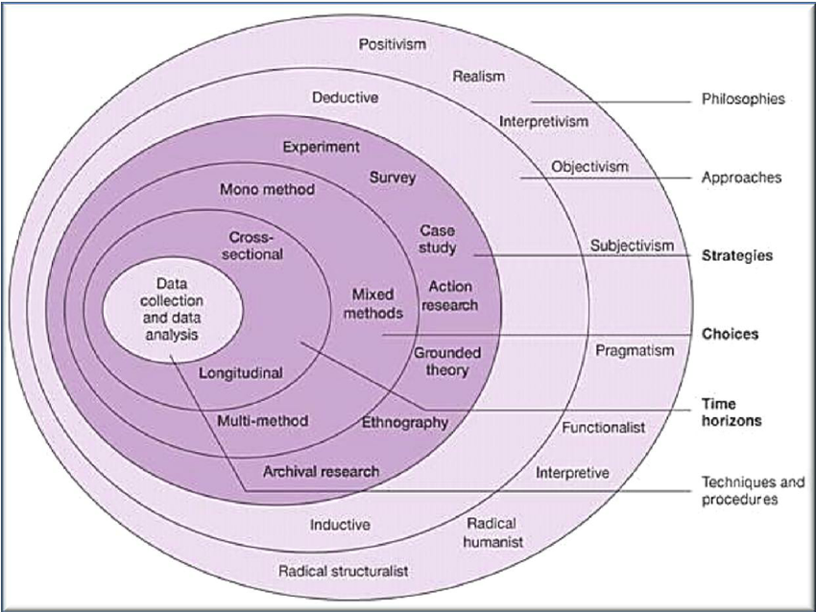
Figure 1: Saunders’ Research Onion
(Source: Saunders et al., 2007)

Case Study Discussion

Figure 2: The Logo of The Hilton Reading Hotel
(Source: Hilton, 2024)
Hotel Reading is one of the most popular branches of the Hilton, which is a chain of resorts based in the United Kingdom (UK). The placement hotel is situated in Drake Way, Reading, the UK. The hotel chain is made up of more than 7 thousand locations worldwide which are categorised under 22 different brands (Hilton, 2024). Due to the fact that it is one of the best-known hotel companies all over the world, it is composed of a high number of members of staff. Over 170 thousand people have been employed by it globally, of which around 200 have been hired by Hilton Reading (Statista, 2024). Culturally, it can be considered as having been diverse as it welcomes guests from the world over and has even recruited workers from a myriad of demographics to help them sell the services of the hotel to individuals belonging to their own cultures, since they can understand one another's mindsets better. Geographically, it has branched out into several countries, such as the UK, the United States of America (US), Australia, and a plenitude of others (Mun et al., 2022). On the basis of these factors, its characteristic attributes are going to be analysed in a critical manner below.
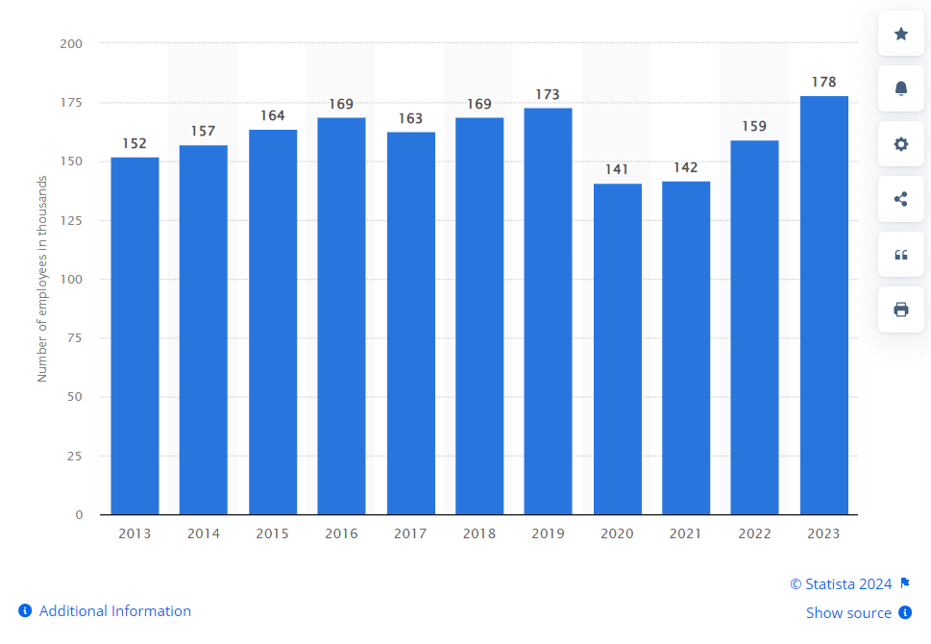
Figure 3: The Total Number of Staff Members of Hilton Hotels Worldwide
(Source: Statista, 2024)
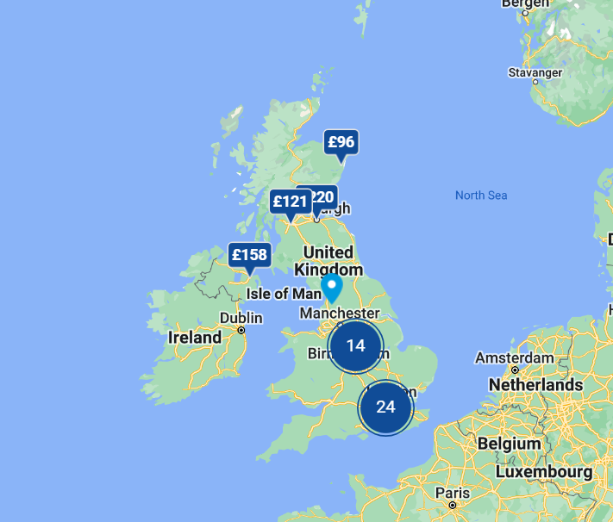
Figure 4: A Map of the Locations of Hilton Hotels
(Source: Hilton, 2024)

SWOT Analysis
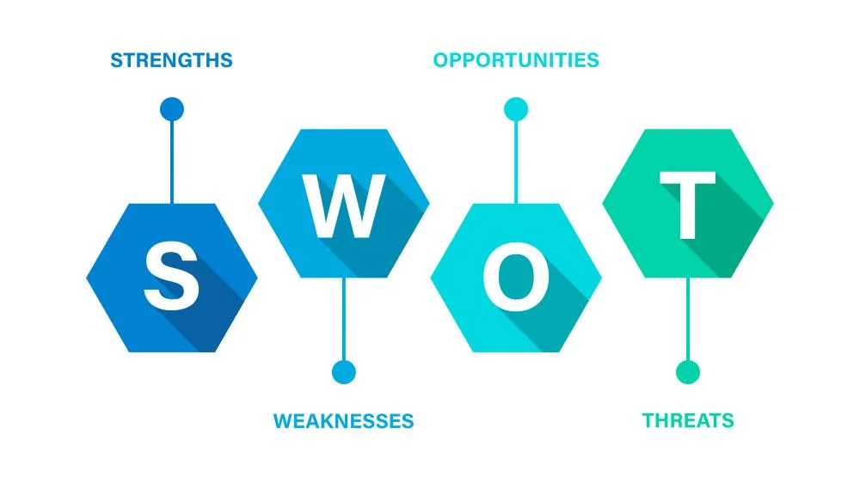
Figure 5: The Model of SWOT Analysis
(Source: Benzaghta et al., 2021)

Strengths
The strengths of a business organisation are those of its internal elements which allow it to thrive competitively against all of its rivals. The following factors are what provide Hilton Reading Hotel with its power:
- It has a large number of employees in its restaurant group, which strengthens it owing to the grounds that their actions generate sales, which in turn garners an immense level of profits for the business (Hilton, 2024).
- Overall, it has been made up of more than 100 thousand members of the staff force.
- The branch in particular has quite a famous and accessible geographical location as Reading averages 74 thousand guests (Hilton, 2024).
- That is one of the many reasons why more people prefer to make use of its services as opposed to those of a few of the other branches of the hotel.
- Being ethnically diverse has enabled it to become more inclusive, attracting socially conscious consumers (Jonker and Cavagnaro, 2023).
- It also consists of a wide range of services that help it to keep in mind the wishes of different kinds and groups of visitors, which is why it provides many different types of cuisines owing to the skills and talents of its food department.
- The quality of its commodities has been stated as being good in accordance with online reviews from tourists who have stayed there.

Weaknesses
It is important to find out what the weaknesses of a company are as well. The weaknesses of a business are those which refrain from allowing it to compete on par with its competitive rivals (Collis and Hussey, 2014). Hilton Reading's areas for improvement are listed below:
- Hilton Reading faces stiff competition from other established companies in and around the area, like Marriott International, Premier Inn, and a lot of other hotels.
- It is relatively more expensive than its contemporaries such as those that have been mentioned above, making it slightly less affordable than they are, hence turning away potential customers who are not very financially strong (Shaheen et al., 2021).
- Even in spite of the fact that it is extremely popular internationally, a majority of the UK's residents prefer Premier Inn as it is cheaper, an example of which is that Premier Inn costs 71.8 Great British Pounds sterling (GBP) per night whereas Hilton Reading charges over 300 GBP, both on weeknight as well as even on the weekends.

Opportunities
Knowing of the opportunities possessed by a company allows it to conduct research into how it can ameliorate its practices. The opportunities of a firm are the external traits of its surrounding business environment that enable it to alleviate its position in its industrial market of choice (Saunders et al., 2012). That is the reason why the chances of success for Hilton Reading have been provided below:
- After the rates of the cases of the global COVID-19 pandemic subsided, the tourism industry began succeeding once again, and that is why more inbound travellers have started to arrive in the UK in anticipation for their visits to the well-known destinations in the nation-state (Sharma et al., 2021).
- That is the reason why Hilton Reading can take complete advantage of this opportunity to display its high-quality services in order to be able to accomplish the purpose of appealing to clients appearing from overseas nations.
- It can perform more thorough market research on the dynamically evolving needs of domestic as well as international travellers for the reason of providing relevant facilities (Goh et al., 2022).
- The beverage and food department of the Reading branch can learn of the up-and-coming new dishes and diets, which can make its services and items appear even more unique than those of the rest.

Threats
The threats that are experienced by any corporate business organisation are inclusive of the exterior aspects which threaten its survival. In regard to the context of Hilton Reading Hotel, these have been provided as follows:
- The growing popularity of cheaper hotels such as Premier Inn may hurt the growth of Hilton Reading due to the reason that more people can afford them.
- Another factor which is threatening the survival of this specific organisation is the growing fame of AirBnB and even homestays as people now have the tendency to prefer the comfort of these to the traditional and luxurious services of expensive hotels (Qiu et al., 2022).
- They may be more interested in home-cooked meals than high-priced food items.
- The economy of the UK fluctuates due to inflation rates and currency exchanges, which is why it is difficult for it to completely appeal to international tourists.

PEST Analysis
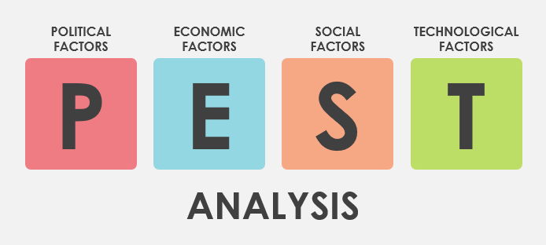
Figure 6: The Model of PEST Analysis
(Source: Cox, 2021)

Political Factors
Brexit, which refers to the exit of Britain from the rest of the continent of the European Union (EU), forced many of its employees in England, that is, those who had come from other countries, had been forced to return to their home nations. That reduced the labour market of all sectors in the UK, including the arena of hotel, hospitality, tourism, travel, and accommodation as nearly 460 thousand employees had to leave (Douch and Edwards, 2021). Since Hilton Reading is a part of that field, it was affected negatively by this as well, especially in terms of its food and beverage department.

Economic Factors
The economy of a nation affects the operations of its sectoral industries. Economic elements have to do with the involvement of the Consumer Price Index (CPI rate), also known as inflation, the GDP (Gross Domestic Product), and conversion rates, among many more (Cottrell, 2014). The rate of inflation is indicative of the rising prices of consumer goods. In the case of the UK, the rate for the month of March in the year 2024 was nearly 4%, which is higher than what the Government wanted it to be on the part of the national bank of the UK, that is, the Bank of England (BoE) (ONS, 2024). As a direct result of that, many people are unable to purchase enough basic products from the food and hotel sector. It has also led the hospitality industry to buy expensive raw materials as the costs of supplies have increased, too. Hence, Hotel Hilton Reading has had to spend and maximise its prices even further, causing it to be impacted in an unfavourable manner. Nevertheless, the positive element which has occurred here is that it has contributed almost 8 billion GBP to the rate of the GDP in the United Kingdom (Statista, 2024). That has increased its brand awareness up to 89 per cent.
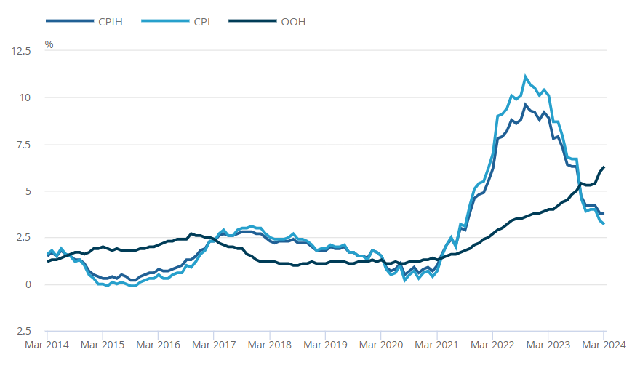
Figure 7: Rate of Inflation in the UK, March 2024
(Source: ONS, 2024)

Social Factors
The social factors of a country influence the functioning of its resident firms. These have to do with the inclusion of the literacy and education rate in the entirety of the nation-state (Veal, 2006). The number of well-educated people in the UK is massively high. The rate of literacy in the nation is at 99% (UNA-UK, 2024). Henceforth, from this piece of information, it can be construed that the accommodation industry is able to receive skilled labour. The food and beverage team of Hilton Reading has been affected favourably due to this data.

Technological Factors
The technologies of a nation can either positively or negatively affect the workings of its business, based on whether or not it is competitively advanced enough. The digital advances of any given country include the high level of usage of the Internet (Bryman, 2008). One of those aspects has to do with the penetration rate of the Internet. The Internet penetration rate in the UK has risen to almost 98% in 2024 (Statista, 2024). Therefore, the food and accommodation businesses of the nation-state have been able to perform digital operations multinationally. Thus, the multinational corporation (MNC) Hilton Hotels and its branch in Reading have been affected positively by this.
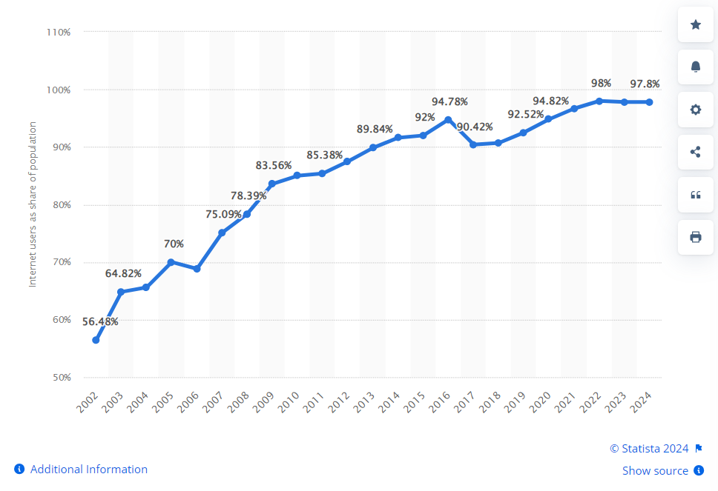
Figure 8: Rate of Internet Penetration in the UK in 2024
(Source: Statista, 2024)

Competitor Analysis
As there are a broad multitude of hotel companies which are based in the UK, it can easily be stated that the chosen organisation, that is, Hotel Hilton Reading, comprises a large number of rivals. Conducting a competitor analysis by evaluating the position of a company provides lots of information in regard to how it performs, in addition to the ways in which it can function even better (Cottrel, 2011). That helps research studies greatly. While Hilton has many competitive rivals, two of the most famous ones are Premier Inn and Travelodge. Marriott UK is yet one more famous rival, too, however, the other two are more popular amongst the dwellers of this country as they are based here (Şanlıöz-Özgen and Kozak, 2020). It can be considered that Hilton Reading charges a lot more for its food and beverage services and products since it is a luxury company. Nevertheless, its prices can arguably be justified since they are of an intensely high quality, even more than those of Premier Inn.
It differentiates itself from the other ones on the basis of the fact that it utilises good-quality ingredients from international supply chains that cost a lot. The customers of a luxury business do not care for its prices as they know that they can afford to pay high amounts of capital for good qualities, which they do not wish to compromise upon (Cottrel, 2014). On the other hand, Premier Inn focuses on prices as its differentiating factor though its quality is good as well. Nonetheless, as the quality of its food and drinks is not as high as that of Hilton Reading, it makes sense that it emphasises low costs (Reidhead, 2020). Meanwhile Travelodge, conversely, does not sell food that is of as high a quality as that of Hilton Hotels, which is why it has chosen to use the cost leadership strategy. In this type of strategic policy, firms make themselves appear unique by offering the lowest possible marketable prices compared to their contemporary rivals (Denscombe, 2010). The positioning map for these three hotels has been given down below:
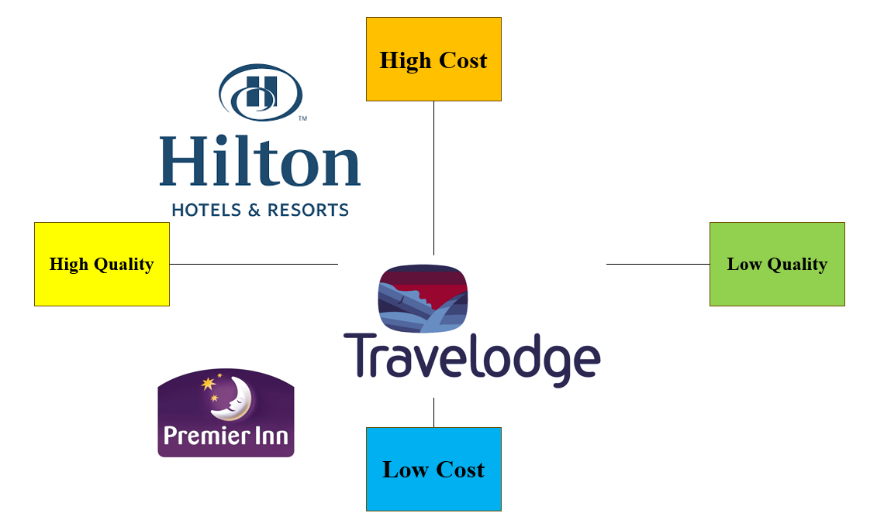
Figure 9: Positioning Matrix of Hilton Hotels and its Key Competitors
(Source: Self-Developed)

Netnography
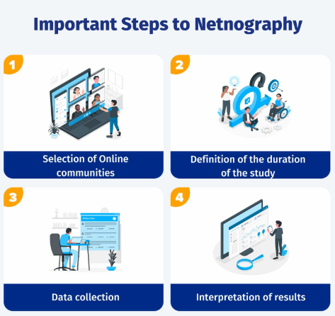
Figure 10: The Various Stages of Netnography
(Source: Atsız et al., 2022)
Netnography should be conducted in phases to develop every research study in a proper fashion. The eponymous word implies a five-step descriptive study of the overall Internet, which helps to determine human behaviour through the investigation and a methodical record of their cultures (Robson, 2016). In this case, a netnographic study will be performed for Hilton Reading below:

The focus of the Research
A primary point of a research study needs to be mentioned. That can assist readers to identify what is being spoken about (Greetham, 2014). Here, the focal topic is regarding the food and beverage department of the Hilton Reading Hotel. The total study took three weeks to perform.

Selection of Communities through Identification
The communities for a netnographic analysis can be chosen by realising who Hilton Reading’s customers are. Segmentation and targeting can help with this process (Silverman, 2011). Demographic, geographic, psychographic, and behavioural categories can help. Demographic implies ages, ethnicities, genders, and more (Pallant, 2010). Hilton would target those with high incomes. Geographic categories involve the subject matter of where consumers reside (Grbich, 2006). Hilton Reading targets metropolitan city-dwellers. Psychography indicates people’s interests (McGiven, 2006). Hilton Reading Hotel can attract travellers and those who enjoy exotic food. Regarding behaviour, individuals may be grouped according to their actions (Yin, 2003). Hilton generally targets wealthy businesspersons who have to travel regularly and often use social media.

Collection of Data
Social media has helped study Hilton Reading’s customers’ behaviour. Respectful anonymity, informed consent, and privacy should be retained while researching people’s behaviour online (Khan and Fatma, 2022). A study on Facebook, Instagram, and X (formerly Twitter) showed that its visitors are majorly between 25 and 55 years of age, earn a high living, are willing to try out new unique dishes, are active on networking sites, and enjoy polite service. Hilton also provides cultural context for those interested in history (Girija et al., 2023). Nonetheless, Hilton Reading is almost always completely booked during summer, which inconveniences some of its potential clients.

Evaluation
The aforementioned data has been analysed. Social media studies can help research on trends (Tavakoli and Mura, 2020). The netnography on Hilton Reading’s buyers showcased that they are busy individuals as they travel a lot for their work. They share information on their professions and speak of how good food and services quench their resulting exhaustion (Kozinets, 2020). They post matters on culture, displaying that they enjoy Hilton’s diversity.

Interpretation
It can be said that the Hilton Reading Hotel communicates quite actively with its customers. Analysed results should be interpreted to understand how phenomena can be improved (Gewinner, 2023). Hilton must interact with them more as this can let it work in correspondence with both their positive and negative opinions.

Theme Exploration
Sl. No. | Theme(s) | Article or journal | Author | Year
1 | “Evaluation of efficiencies of employee training and learning in Food and beverage sector of Hilton Hotel Reading for increasing skill, motivation and knowledge of staff” | “Tourism Management, 98, p.104765” | “Tandon, A., Dhir, A., Madan, P., Srivastava, S. and Nicolau, J.L.,” | 2023
1 |  | “Athens Journal of Tourism, 8(3), pp.147-162.” | Jones, P. and Comfort, D. | 2021
1 |  | “Worldwide Hospitality and Tourism Themes, 12(5), pp.509-523.” | Matteucci, V. | 2020
1 |  | “Academic Journal of Business & Management, 3(11), pp.20-27.” | Zeng, L., | 2021
2 | “Areas in which training, learning and strategies of employee development can be improved within Hilton Hotel Reading” | “Research in Hospitality Management, 13(3), pp.143-151.” | Enachi, F., Suleri, J. and Tarus, E., | 2024
2 |  | “The Market: International Journal of Business, 1, pp.91-107.” | Daskalaki, E. | 2020
2 |  | “Talent management innovations in the international hospitality industry (pp. 9-30).” | Garavan, T., Matthews-Smith, G., Gill, A.M. and O’Brien, F., | 2021
2 |  | “The Routledge Handbook of Diversity, Equity, and Inclusion Management in the Hospitality Industry.” | Rockett, G., | 2023
3. | “Recommendations to improve the strategies of training, learning and development in Hilton Hotel’s food and beverage department” | “FEMIB (pp. 101-106).” | Belias, D. and Trihas, N., | 2022
3. |  | “Administrative Sciences, 13(3), p.66.” | Al-Sabi, S.M., Al-Ababneh, M.M., Masadeh, M.A. and Elshaer, I.A. | 2023
3. |  | “Journal of Tourism Theory and Research, 7(2), pp.85-96.” | Bello, M.B. and Bello, Y.O. | 2021
3. |  | “Tourism and Hospitality Research, 24(2), pp.187-202.” | Salem, I.E., Aideed, H., Alkathiri, N.A. and Ghazi, K.M., | 2024
Table 2: Thematic analysis
(Source: Created by the Learner)

Evaluation of efficiencies of employee training and learning in the Food and beverage sector of Hilton Hotel Reading for increasing skill, motivation and knowledge of staff
The food and beverage department is the most essential department in the hostel service. According to the research of Tandon et al. (2023), the performance of a hotel service is influenced by the quality of the food and beverage facilities in the hotel alongside room service. Hence, the HR of the current hotel organisation has started to reinforce the training policies of the food and beverage department. The employees are trained to arrange the food items, cooperate properly with the guests and serve them their necessary items. Additionally, the training methods in current hotels have incorporated lessons on business ethics. Food safety is one of the most important parts of business ethics. Hotels have the responsibility to keep the health of the guests protected by serving fresh and healthy food and drinks. Consequently, the staff training has focused on increasing the knowledge of the staff to maintain cleanliness and food safety. The training in Premier Inn and other hotels has incorporated a vital learning session on the health codes in the UK. The employees are taught the ways of following the health codes. The other knowledge, such as ways of maintaining good behaviour with the guests is also a crucial part of employee training in the present food and beverage department. The training has enhanced the ability of the employees to protect the guests’ health and give them a proper experience of accommodation in the hotel.
The current research on training in the hospitality industry has included the information that training programmes are becoming digitised to cope with the trend of technological intervention. The trainees develop better knowledge when they are taught with the help of digital appliances (Jones and Comfort, 2021). The theory has been applied in famous hotels in the UK, for instance, Travelodge, Premier Inn, Imperial London Hotel and many others. The employees get a visual representation of their duties of serving and managing the beverage and food services in the hotel. The trainers, in order to increase the interest of the employees in training, have incorporated a flexible training environment. The workers, especially those associated with the management of the food and beverage are offered to attend the training virtually using a technological platform. As a consequence, the motivation of remote workers for training has increased to a great extent. The trainees are also given lessons on valuable professional skills through digital platforms. The employees get familiar with the demandable skills that can increase the performance standard of the hotel through training. Further, the trainers help the new employees in learning the skill by setting professional development plans using technological resources. The other important responsibility that is executed by the trainers in a training session is raising the motivation level of the employees to work in the organisation. The trainers represent the potential career opportunities to the trainees in training sessions and encourage them to skill development (Jones and Comfort, 2021). The technique has caused a high employee motivation in the present hotel sector.
Vast information on the training procedures of Hilton Hotel has been documented in different articles. As per the documentation of Matteucci (2020), Hilton Hotel has followed the current strategy of the hotel industry and has transferred itself into a learning organisation. Hilton Hotel has arranged apprenticeships for job seekers so that they can develop themselves professionally and enter the field of professionalism. The applicants of the apprenticeship program get the opportunity to learn important skills such as teamwork, maintaining coordination, leading a team, managing food safety and food distribution and many others. The skills gained through intense practice during training, help the trainers become experts in operating the food and beverage department. In addition, Hilton Hotel has included the learning opportunities of “Graduate-and-internship” for young learners, who completed their graduation in Hotel and business management (Matteucci, 2020). The employees go through intense training in professional skill enhancement during the internship period. The employment opportunities at the end of the internship have created motivation among the job-seekers to take part in the arranged training programmes.
The training session in the Hilton Hotel is dedicated to enhancing workers’ competency in performing complex business tasks. Compared to other hotel organisations, Hilton Hotel is more forced on cultural awareness (Zeng, 2021). At Hilton Reading Hotel, the employees learn the significance of cultural sensitivity in the context of hotel services. The employees are trained to maintain polite behaviour with the guests. Additionally, they are trained to develop emotional intelligence which can help them to understand the customers’ expectations of food and beverages. The hotel has digitalised the management system of food and beverage. Hence, training is given to the workers to raise their digital efficiencies. Using ICT tools and management software, the employees are taught to utilise the resources for the maintenance of food safety and security. The other feature of employee training in Hilton Hotel, that differentiates it from other organisations is the procedure of taking employee feedback. The HR makes the planning of the training program based on the thoughts of the trainers collected through the feedback process.
Areas in which training, learning and strategies of employee development can be improved within Hilton Hotel Reading
In contradiction with the statements of other authors regarding the success of the training program at Hilton, some other authors have found several weak points in the training procedures. In accordance with the arguments of Enachi et al. (2024), the training programs in the hotel are insufficient for the performance improvement required in the hospitality sector. The extent of employee engagement in the training programs is very low making the programs ineffective for organisational success. The trainers in several hotel organisations have shown incompetency in making the employees interested in attaining the training programs. The workers have started neglecting the training period pursuing a negative thinking on its significance. A trend of increasing absenteeism has been observed in the Imperial London Hotel and other organisations. The fact has weakened the training programs. The employees are failing to develop their skills as a result of not attaining the training programs. The consultation with trainees of different hotels has pointed out the main reason for the lack of interest in training is the absence of proper practical activities during training. The employees expect practical-based training, which is absent in some hotel organisations.
The documentation of the advantages of digital training has also been argued. According to the viewpoint of Daskalaki (2020), the digital method of training has decreased the standards of training sessions. Work-based learning is the most suitable for conducting a training program. Such learning can be successfully provided through face-to-face interaction. However, most UK hotel companies have incorporated strategies for remote worker, which has made the training ineffective for their professional development. The critical constraint in the training and development procedure is the high training cost. The digital method has increased the cost of training, which is a major barrier for small UK hotels, such as Queens Gate Hotel London. The arrangements for digital applications have restricted the companies from investing the budget for the other training activites. A poor budget plan for training has lowered the training quality, which needs to be improved.
The case studies on Hilton Hotel have helped to identify the challenging areas in the training procedures of the food and beverage sector. According to the research of Garavan et al. (2021), the Hilton Hotel has poor Human resource management. As training arrangement is directed by HR practitioners, incompetency in that functional area can raise challenges for employee training. The professionals, HRD carry out the role of taking strategies for employee development and training. In addition, the processes of training are also executed under the governance of the professional. Hilton Hotel lacks HRD professionals, who can organise training for the food and beverage department. Such weakness in organisational structure has lowered the quality of training planning. The process of benchmarking has shown the training process in Hilton Hotel is less effective than that of Premier Inn due to inappropriate business structure. The employees have started losing interest in the training programs of Hilton Hotel after finding its inapplicability in their career opportunities.
The inefficiency of HR and increasing business activities for geographical expansion have hampered the training period in a combined way. As per the findings of Rockett (2023), the training period at Hilton Hotel is insufficient for skill development. The trainees require a proper period in order to acquire proper skills and knowledge. The management gives less importance to training for managing the other business activities. Poor time arrangement of training sessions is a weakness of staff training in the hotel. Time management for employee training is a critical area for improvement. The other problem that has been identified is the improper allocation of financial resources. The HR emphasis on digital implementation in employee training influences a poor arrangement of other training activites. The company requires to improve the budgeting problem.
Recommendations to improve the strategies of training, learning and development in Hilton Hotel’s food and beverage department
Depending on industry-based practices, recommendations can be made for recovering the current gap in the training programmes of the Hilton Hotel. As opined by Belias and Trihas (2022), a strong career opportunity can be the driving force of staff motivation to attain training programmes. At Premier Inn, the employees are facilitated with promotions, salary increments and other rewards for showing reliable performance in managing the food and beverage sector (Al-Sabi et al., 2023). Such opportunities have increased the encouragement of workers for joining the training in order to boost personal performance as a professional. Hilton Hotel needs to make arrangements for such opportunities to increase the number of trainees. The increase in employee participation can in turn increase the operational efficiency of Hilton Hotel. Along with offering employment facilities, the presentation of such career growth opportunities can make the graduates interested in the training. Additionally, some hotels, like Travelodge have made training a compulsory part of the requirement. The application of such a technique can also be helpful for Hilton Hotels.
Organisational culture is considered as a valuable factor of making the training session effective in performance enhancement. As per the viewpoint of Bello and Bello (2021), the culture within a company can increase the dedication level of the employees. The HR manager at Marriott International values the employees and provides them compensation and all the other kinds of privileges. Further, the absence of favouritism and ethical behaviour has influenced the workers to participate in training to sustain the financial performance of the company by increasing operational efficiency. Hilton Hotel can follow the approach of improving business ethics to leverage more employee participation. Some other suggestions are also included in the secondary resources. It is important to focus the training activities in a program. The virtual training need to cover all the areas that are taught in face-to-face training processes. Important topics, such as menu creation, safety management, cost management and others are important to make the learning effective enough for the achievement of customer satisfaction.
The learning and development strategy can be strengthened with the support of the HR department. HRD in popular hotels, like, Marriott International develops a well-planned training strategy to make ensure proper guest satisfaction (Salem et al., 2024). The case example indicates the remedy of incorporating HRD professionals to handle the training and development of food and beverage staff in Hilton Hotel Reading. The professional can take the responsibility of arranging proper time and budget for the training facilities. The hotel needs to apply an accurate schedule for the trainers by consulting with HRD. It is also important to utilise the budget in a proper way to give all the facilities for professional development. In Premier Inn, a strong coordination between finances and HR has offered an accurate allocation of financial resources. The strategy is urgent to be applied in Hilton Hotels as well to mitigate the problems with budget management. Necessary financial resources can be arranged for the training session by borrowing money from banks and taking grants from the government.

Conclusion and Recommendations

Conclusion
Overall, it is understood that proper involvement of appropriate staff in the work will enhance the productivity of the business. The above study is a hotel placement report in the Hilton Hotel in the food and beverage department. The main aim of this research project is to understand the impact of the learning and development of employees within the hotel business. It is seen that managing staff and resources will help to boost the overall performance of the organisation. The Hilton Hotel has approximately 178 thousand employees in the year 2023 worldwide. The main weakness of this brand is extreme competition and the business has been affected by the UK economy negatively due to frequent fluctuations. The main area the above report has discussed is the food and beverage department of the Hotel which reflects various aspects effectively. However, appropriate methods and research approaches have been incorporated into the above report. The researcher has selected the method to be completed following the secondary qualitative method. The methodology of case study analysis has been conducted to meet the aim and objectives. A detailed case study on Hilton Hotel has been analysed keeping the main focus on Hilton Hotel Reading.
The case study on Hilton has shown the effects of important external business environments such as Brexit, inflation and internet penetration on the company's staff performance. The high literacy has helped the company to recruit competent employees and through training their competency is strengthened. A high employee number and geographical access are the strengths of Hilton whereas its high cost is a weakness. The weakness has put it in a disadvantageous position compared with Travelodge and Premier Inn. The thematic analysis has been completed exploring the themes based on the objectives. The digital training, apprenticeship and employment opportunities have made the training session effective. On the contrary, the absence of HRD, poor budget and time allocation and failure to engage employees are the areas where further improvement is needed. With examples of best training practices in the hotel industry, important recommendations have been determined for Hilton Hotel Reading.

Recommendations
- Development of comprehensive training programs- The Hilton hotel needs to incorporate some appropriate training within the food and beverage department to improve employee efficiency. The organisation can cover all aspects of food and beverage operations, including menu creation, cost management, service standards and product knowledge in their training module (Waqanimaravu. and Arasanmi, 2020). However, these programs should be tailored to the specific needs of the hotel and its target markets.
- The utilisation of resources and expertise in the supply chain- The Hiltons corporate food and beverage team, will incorporate the SVP of F&B VP of Culinary and other senior professionals who will help to guide and support the development and implementation of the effective training program (Michael and Fotiadis, 2022). All of these will also train to use available resources to manage costs at the time of inflation in the UK. However, these appropriate programs will allow the business to manage the supply chain as well as help to boost the efficiency of the business very positively.
- Encourage a culture of continuous learning and development- In the food and beverage department, the involvement of regular feedback sessions and performance reviews will assist the employees to improve their weak areas very positively (Putra and Law, 2023). The senior management of the hotel will help to build the internal environment of continuous learning and development which will help to boost the overall business productivity as well as help to boost the brand image in the market.
- Implementation of a dedicated team- A separate team will be responsible for concept delivery with a bespoke training programme. Additionally, the particular team will regularly monitor the performance of the staff in the food and beverage department in the Hilton Hotel and ensure that they are well-engaged and prepared to execute effectively in the area (Ushakov et al., 2020). They will also train the employees in some critical areas where the root of the problem begins and will make sure that the new concepts will be properly communicated among staff (Phuong and Tran, 2020). However, they will provide proper mentorship and help maintain high standards of service in the Reading branch of the Hilton hotel.

Reflective Account
The following study is a reflective practice based on this entire above-given research. Reflections let students figure how they can heighten their skills (Caeiro et al., 2020). The benefits, drawbacks, and long-term action plans will be developed on the foundation of the placement at Hilton Reading and the case study.
Reflective studies must be ideally conducted for all research studies. That is due to the fact that it can help to figure out where a dissertation or project proposal has been performed well, the areas of it that have to be developed even further, and the methods by which it can be enhanced for the long run (Diamantopoulos and Schlegelmilch, 2002). During my placement at Hilton Reading Hotel, I noticed that the tall building was packed with guests who appeared to be enjoying themselves. I had gone there to study the training, learning, and development of the staff in its food and beverage department. While I noticed that most of the employees, such as the chefs and cooks, were talented and well-behaved, I also realised that a few of them were not as skilled as the rest and required more training regarding table manners and other etiquette. It is crucial for hotel workers to be provided with training by their managers to help them learn in a continuous manner, thereby developing their future careers (El-Said et al., 2020). I noted these details down and decided to perform my research proposal on these issues for the purpose of understanding how this could be improved upon.
When I began to conduct research into how the servers and waitstaff of Reading Hilton Hotel can ameliorate their skills, I was intimated at first since I had never performed a dissertation project before. For all amateur researchers, it is vital to reflect upon their favourable and unfavourable feelings regarding the experience of an event related to their studies (Chernikova et al., 2020). Despite that, fortunately, I was also looking forward to completing a research project as an undergraduate learner of higher education (HE), which can be categorised as a positive emotion. I also felt well when I had finished performing research on the background of the study, as well as on the hotel branch itself. My tutors and study group sessions had helped me conduct this, which is a favourable factor that had happened.
Unfortunately, it also has to be said that the study took a lot of time to complete, which I consider to be a negative element here. Therefore, I should try to develop my time-management skills with the assistance of the formulation of a daily schedule in which I set short deadlines for myself and attempt to complete them. Time management is one of the essential skills that is imperative for all trainees to learn (Trentepohl et al., 2022). While studying the hotel branch, I learned that it is quite well-known and what kind of customers usually visit it. That helped me develop objectives for the study. Knowing how SMART (Specific, Measurable, Achievable, Relevant, and Time-Bound) goals are formed is an important practice for all higher-learning pupils (Wilson et al., 2021). I then collected three journal articles with which the Literature Review could be conducted and decided that since this is a well-studied topic, secondary qualitative data may be collected. That was when I jotted down the methods I utilised here. My research on the hotel was consolidated into the Case Study. After this, the three objective-based themes were studied. Those helped me decide what recommendations could be suggested to the hotel for a better performance. The entire study introduced me to the concept of Netnography, which I would need to keep practising for better results. To strengthen the study, I can gather primary qualitative and quantitative data in the forms of interviews and survey questionnaires respectively for the managers, employees, and clients of the business. Using governmental and industrial information would help.
To infer, the reflective report showed the happenings during the placement. The positive aspects and the gaps in the study were upheld. Governmental and sectoral records would have strengthened the research even further. In addition, primary information can be used here later.

References
Al-Sabi, S.M., Al-Ababneh, M.M., Masadeh, M.A. and Elshaer, I.A., 2023. Enhancing innovation performance in the hotel industry: the role of employee empowerment and quality management practices. Administrative Sciences, 13(3), p.66.
Arnholtz, J. and Lillie, N. eds. (2020) Posted work in the European Union. London: Routledge.
Atef, A.M. and Eissa, M.M. (2021) 'Role and contribution of knowledge management to development of competitiveness in the hotel industry', International Journal of Heritage, Tourism and Hospitality, 15(1), pp.191-200.
Atsız, O., Cifci, I. and Rasoolimanesh, S.M. (2022) 'Exploring the components of meal-sharing experiences with local foods: A netnography approach', Current Issues in Tourism, 25(6), pp.919-936.
Barreto, N. and Mayya, S. (2023) 'A systematic review on training and development in the hotel industry', International Journal of Management, Technology and Social Sciences (IJMTS), 8(2), pp.22-52.
Belias, D. and Trihas, N. (2022, April) 'Human resource training of front office employees and change management in hospitality sector during crisis', In FEMIB (pp. 101-106).
Bello, M.B. and Bello, Y.O. (2021) 'Personality traits and employees’ job performance in hotel industry', Journal of Tourism Theory and Research, 7(2), pp.85-96.
Benzaghta, M.A., Elwalda, A., Mousa, M.M., Erkan, I. and Rahman, M. (2021) 'SWOT analysis applications: An integrative literature review', Journal of Global Business Insights, 6(1), pp.54-72.
Bryman, A. (2008) Social Research Methods. 2nd ed. Oxford: Oxford University Press.
Caeiro, S., Sandoval Hamón, L.A., Martins, R. and Bayas Aldaz, C.E. (2020) 'Sustainability assessment and benchmarking in higher education institutions—A critical reflection', Sustainability, 12(2), p.543.
Casula, M., Rangarajan, N. and Shields, P. (2021) 'The potential of working hypotheses for deductive exploratory research', Quality & Quantity, 55(5), pp.1703-1725.
Chernikova, O., Heitzmann, N., Stadler, M., Holzberger, D., Seidel, T. and Fischer, F. (2020) 'Simulation-based learning in higher education: A meta-analysis', Review of Educational Research, 90(4), pp.499-541.
Collis, J. and Hussey, R. (2014) Business Research: A Practical Guide for Undergraduate and Postgraduate Students. London: Palgrave.
Cottrell, S. (2011) Critical Thinking Skills: Developing Effective Analysis and Argument. Palgrave Study Guides. Basingstoke: Palgrave Macmillan.
Cottrell, S. (2014) Dissertation and Project Reports - A Step by Step Guide. Basingstoke: Palgrave Macmillan.
Cottrell, S. (2014) Dissertations and Project Reports: A Step by Step Guide. New York: Palgrave Macmillan.
Cox, J. (2021) 'The higher education environment driving academic library strategy: A political, economic, social and technological (PEST) analysis', The Journal of Academic Librarianship, 47(1), p.102219.
Daskalaki, E. (2020) 'Cultural diversity and indicated intercultural implications in the hotel working environment in the United Kingdom: Underpinning the employee’s perspective', The Market: International Journal of Business, 1, pp.91-107.
Denscombe, M. (2010) Ground Rules for Social Research: Guidelines for Good Practice. 2nd ed. Maidenhead: Open University Press.
Diamantopoulos, A. and Schlegelmilch, B.B. (2002) Taking the Fear Out of Data Analysis. London: Dryden.
Douch, M. and Edwards, T.H. (2021) 'The Brexit policy shock: Were UK services exports affected, and when?', Journal of Economic Behavior & Organization, 182, pp.248-263.
El-Said, O.A., Al Hajri, B. and Smith, M. (2020) 'An empirical examination of the antecedents of training transfer in hotels: the moderating role of supervisor support', International Journal of Contemporary Hospitality Management, 32(11), pp.3391-3417.
Enachi, F., Suleri, J. and Tarus, E. (2024) 'Retention of graduate trainee programmes: a case study of Hilton’s Elevator fast-track to general manager graduate programme', Research in Hospitality Management, 13(3), pp.143-151.
Filimonau, V., Chiang, C.C., Wang, L.E., Muhialdin, B.J. and Ermolaev, V.A. (2023) 'Resourcefulness of chefs and food waste prevention in fine dining restaurants', International Journal of Hospitality Management, 108, p.103368.
Fletcher, G. (2023) Management and Visualisation: Seeing Beyond the Strategic. London: Taylor & Francis.
Fyall, A., Garrod, B., Leask, A. and Wanhill, S. eds. (2022) Managing Visitor Attractions. London: Routledge.
Garavan, T., Matthews-Smith, G., Gill, A.M. and O’Brien, F. (2021) 'Strategic talent management in the hospitality industry', in Talent Management Innovations in the International Hospitality Industry. Emerald Publishing Limited, pp. 9-30.
Gewinner, I.V. (2023) 'Netnography and its potential for studies in tourism and hospitality', in Cutting Edge Research Methods in Hospitality and Tourism. Emerald Publishing Limited, pp. 173-196.
Girija, S., Sharma, D.R. and Kaushal, V. (2023) 'Exploring dimensions of the customer experience at budget hotels during the COVID-19 pandemic: a netnography approach', Qualitative Market Research: An International Journal, 26(4), pp.320-344.
Goh, E., Okumus, B., Jie, F., Djajadikerta, H.G. and Lemy, D.M. (2022) 'Managing food wastage in hotels: discrepancies between injunctive and descriptive norms amongst hotel food and beverage managers', British Food Journal, 124(12), pp.4666-4685.
Grbich, C. (2006) Qualitative Data Analysis. London: Sage Publications Ltd.
Greetham, B. (2014) How to Write Your Undergraduate Dissertation. Basingstoke: Palgrave Macmillan.
Hancock, D.R., Algozzine, B. and Lim, J.H. (2021) Doing Case Study Research: A Practical Guide for Beginning Researchers.
Hilton (2024) Hilton Hotels in United Kingdom - Find Hotels - Hilton. Available at: https://www.hilton.com/en/locations/united-kingdom/hilton-hotels/ (Accessed: 10 May 2024).
Hilton (2024) Hilton Reading. Available at: https://www.hilton.com/en/hotels/lhrhrhi-hilton-reading/(Accessed: 10 May 2024).
Jansson, J. and Uba, K. (2023) 'Cycles of labour protests: public and private sector unions' contentious actions', Employee Relations: The International Journal, 45(4), pp.840-856.
Jones, P. and Comfort, D. (2021) 'Modern slavery statements and leading UK hotel companies', Athens Journal of Tourism, 8(3), pp.147-162.
Jonker, E. and Cavagnaro, E. (2023) 'Food and beverage sustainability criteria: Leading question: What are the food and beverage criteria necessary to operate sustainably?', in Critical Questions in Sustainability and Hospitality. Routledge, pp. 77-86.
Khan, I. and Fatma, M. (2022) 'Using netnography to understand customer experience towards hotel brands', Sustainability, 15(1), p.279.
Kim, M.S., Ma, E. and Wang, L. (2023) 'Work-family supportive benefits, programs, and policies and employee well-being: Implications for the hospitality industry', International Journal of Hospitality Management, 108, p.103356.
Kozinets, R.V. (2020) 'E-Tourism research, cultural understanding, and netnography', in Handbook of e-Tourism. pp.1-16.
Love, H.R. and Corr, C. (2022) 'Integrating without quantitizing: two examples of deductive analysis strategies within qualitatively driven mixed methods research', Journal of Mixed Methods Research, 16(1), pp.64-87.
Matteucci, V. (2020) 'How can the hospitality industry increase corporate value aligned with sustainable development goals? Case examples from Hilton, Meliá and Sun', Worldwide Hospitality and Tourism Themes, 12(5), pp.509-523.
McGiven, Y. (2006) The Practice of Market and Social Research: An Introduction. Harlow: Prentice Hall.
Michael, N. and Fotiadis, A.K. (2022) 'Employee turnover: The hotel industry perspective', Journal of Tourism, Heritage & Services Marketing (JTHSM), 8(1), pp.38-47.
Mun, S.G., Park, E.O. and Woo, L. (2022) 'Strategic target customers of food and beverage offerings in full-service hotels: Outside-hotel customers', International Journal of Hospitality Management, 102, p.103159.
ONS (2024) Inflation and Price Indices - Office for National Statistics. Available at: https://www.ons.gov.uk/economy/inflationandpriceindices (Accessed 10 May 2024).
Pallant, J. (2010) SPSS Survival Manual. Buckingham: Oxford University Press.
Phuong, T.T.K. and Tran, T.V. (2020) 'Job satisfaction, employee loyalty and job performance in the hospitality industry: A moderated model', Asian Economic and Financial Review, 10(6), p.698.
Proudfoot, K. (2023) 'Inductive/deductive hybrid thematic analysis in mixed methods research', Journal of Mixed Methods Research, 17(3), pp.308-326.
Putra, F.K.K. and Law, R. (2023) 'Critical success factors for virtual hotel operator partnership with small-and medium-sized hotels: perspectives of owners and operators', Journal of Hospitality and Tourism Insights.
Qiu, H., Chen, D., Bi, J.W., Lyu, J. and Li, Q. (2022) 'The construction of the affinity-seeking strategies of Airbnb homestay hosts', International Journal of Contemporary Hospitality Management, 34(3), pp.861-884.
Reidhead, C. (2020) 'Impact of organizational culture on employee satisfaction: A case of Hilton hotel, United Kingdom', Journal of Economics and Business, 3(1).
Robson, C. (2016) Real World Research. 2nd ed. Oxford: Blackwell.
Rockett, G. (2023) 'History/overview of Hilton', in The Routledge Handbook of Diversity, Equity, and Inclusion Management in the Hospitality Industry.
Salem, I.E., Aideed, H., Alkathiri, N.A. and Ghazi, K.M. (2024) 'Retaining talented employees during COVID-19 pandemic: The leverage of hotel pandemic response strategies', Tourism and Hospitality Research, 24(2), pp.187-202.
Şanlıöz-Özgen, H.K. and Kozak, M. (2020) 'Managing brand experience and reputation in the hotel business', in The Routledge Handbook of Tourism Experience Management and Marketing. Routledge, pp. 337-351.
Saunders, M., Lewis, P. and Thornhill, A. (2012) Research Methods for Business Students. Harlow: FT/Prentice Hall.
Saunders, M., Lewis, P.H.I.L.I.P. and Thornhill, A.D.R.I.A.N. (2007) Research Methods for Business Students. 4th ed. Pearson Education Limited, England, 6(3), pp.1-268.
Schoch, K. (2020) 'Case study research', in Research Design and Methods: An Applied Guide for the Scholar-Practitioner. pp.245-258.
Shaheen, O.H.A.G., Morsy, M.A., Qoura, O. and Zaki, K.M.G. (2021) 'The impact of yield management on the profitability of food and beverage department in five-star hotels', International Journal of Heritage, Tourism and Hospitality, 15(1), pp.116-126.
Sharma, A., Shin, H., Santa-María, M.J. and Nicolau, J.L. (2021) 'Hotels' COVID-19 innovation and performance', Annals of Tourism Research, 88, p.103180.
Silverman, D. (2011) Qualitative Research Methods. 2nd ed. London: Sage.
Sjarifudin, D. and Rony, Z.T. (2023) 'Mentoring and coaching programs to improve performance management', International Journal of Scientific Multidisciplinary Research, 1(5), pp.485-496.
Sjoberg, G., Orum, A.M. and Feagin, J.R. (2020) A Case for the Case Study. The University of North Carolina Press.
Statista (2024) Hilton Worldwide Holdings Inc.: Revenue 2019. Available at: https://www.statista.com/statistics/297760/revenue-of-hilton-worldwide-holdings-inc/ (Accessed: 25 May 2024).
Statista (2024) Hilton: employee numbers 2013-2018, Statista. Available at: https://www.statista.com/statistics/297758/number-of-hilton-worldwide-employees/ (Accessed 10 May 2024).
Statista (2024) UK: Internet User Penetration 2015-2022, Statista. Available at: https://www.statista.com/statistics/553589/predicted-internet-user-penetration-rate-in-the-united-kingdom-uk/(Accessed 10 May 2024).
Tandon, A., Dhir, A., Madan, P., Srivastava, S. and Nicolau, J.L. (2023) 'Green and non-green outcomes of green human resource management (GHRM) in the tourism context', Tourism Management, 98, p.104765.
Tavakoli, R. and Mura, P. (2020) 'Netnography in tourism beyond Web 2.0: A critical assessment', in Netnography Unlimited. Routledge, pp. 131-146.
Thomas, G. (2021) How to do your case study. London: Sage, pp.1-320.
Trentepohl, S., Waldeyer, J., Fleischer, J., Roelle, J., Leutner, D. and Wirth, J. (2022) 'How did it get so late so soon? The effects of time management knowledge and practice on students’ time management skills and academic performance', Sustainability, 14(9), p.5097.
UNA-UK (2024) International Literacy Day - Factsheet. Available at: https://una.org.uk/international-literacy-day-factsheet (Accessed 10 May 2024).
Ushakov, R.N., Kryukova, E.M., Khetagurova, V.S., Mukhomorova, I.V. and Zelenov, V.V. (2020) 'Efficiency of hotel management: Training of specialists in hotel industry field', Journal of Environmental Management and Tourism, 11(2), pp.388-395.
Veal, A.J. (2006) Research Methods for Leisure and Tourism. 3rd ed. Harlow: Financial Times Prentice Hall.
Waqanimaravu, M. and Arasanmi, C.N. (2020) 'Employee training and service quality in the hospitality industry', Journal of Foodservice Business Research, 23(3), pp.216-227.
Wilson, R., Joiner, K. and Abbasi, A. (2021) 'Improving students’ performance with time management skills', Journal of University Teaching & Learning Practice, 18(4), p.16.
Yin, R.K. (2003) Case Study Research. 4th ed. London: Sage.
Zeng, L. (2021) 'Analysis of Hilton Worldwide Hotel Group’s Transnational Operation Strategy', Academic Journal of Business & Management, 3(11), pp.20-27.

Appendices

Appendix 1
Activities | Week 1 | Week 2 | Week 3 | Week 4 | Week 5 | Week 6 | Week 7 | Week 8 | Week 9
Research background | ☑️
Research aims and objectives | ☑️ | ☑️
Research rationale and literature review |  | ☑️ | ☑️ | ☑️
Methodology |  |  | ☑️ | ☑️
Data collection and interpretation |  |  |  |  | ☑️ | ☑️ | ☑️
Results and conclusion |  |  |  |  |  |  |  | ☑️ | ☑️
Table 3: Research timeline

