Abstract
With the development of information technology in recent years, the influence of information technology in various sectors has been increasing, which has brought great convenience to people's production and life, but also brought different challenges. In this paper, for the problem of clothing classification, the machine learning methods of KNN and decision tree are used to train and learn the data of Fashion-MNIST data set, and the verification results of different indicators are compared, so as to understand the characteristics, advantages and disadvantages of the two algorithms, and further understand the application of machine learning in practical problems.

Introduction
In this paper, a KNN classifier and a decision tree classifier are used to build the corresponding classifier for identifying and classifying clothing data in Fashion-MNIST dataset. The Fashion-MNIST dataset is intended as a direct replacement for the MNIST dataset. MNIST dataset is a dataset of handwritten digits. Handwritten digit recognition is a classical problem in the machine learning community, but it has a single feature that seems too old-fashioned for machine learning at this stage. This time, machine learning trained classifiers are used to recognize and distinguish specific types of clothing. In, the performance of the trained model is evaluated using different metrics, such as the control variable method, the K-value in the KNN algorithm, the distance computation method, and other metrics. In the decision tree approach, the effect of controlling the depth is analyzed and conclusions are drawn.

Related works
This study used KNN and decision tree methods to classify the data in the Fashion-MNIST dataset, which studied the Python language, the sklearn class in Python, the method of image normalization, a variety of evaluation indicators, the adjustment of hyperparameters in the algorithm, and the application of multiple training weights, the method of image normalization, and the method of image normalization. Finally, the optimal solution of each algorithm is obtained, and the two optimal solutions are compared and finally the conclusions are drawn.

Methodology
In this study, the handwritten digit dataset from the Fashion-MNIST dataset is applied and the sklearn library in Python, which has a large library of basic training models and validation methods related to machine learning, is used. In this study, the KNN model and the decision tree model from the sklearn library are used and the evaluation metrics are: accuracy, precision, recall, F1.
Fashion-MNIST dataset
The Fashion-MNIST dataset is a dataset of clothing images provided by the German company Zalando, which contains a training set of 60, 000 samples and a test set of 10, 000 samples. Each sample is a 28x28 grayscale image associated with a label from one of the ten categories. The Fashion-MNIST dataset is intended as a direct alternative to the original MNIST dataset for benchmarking machine learning algorithms.
Label | Description
0 | T-shirt
1 | Trouser
2 | Pullover
3 | Dress
4 | Coat
5 | Sandal
6 | Shirt
7 | Sneaker
8 | Bag
9 | Ankle boot
Table 1. Fashion-MNIST dataset Label and Description
Sklearn
Scikit-learn, also known as sklearn, is an open source Python-based machine learning toolkit. It uses python libraries such as NumPy, SciPy, and Matplotlib for efficient algorithmic use and covers virtually all major machine learning algorithms.
In engineering applications, it is highly unlikely that an algorithm can be implemented from scratch with python hand-written code. Not only is it time-consuming and labor-intensive, but it may not be possible to write a model with a clear structure and strong stability. In most cases, this is done by analyzing the collected data, selecting the appropriate algorithm based on the characteristics of the data, calling the algorithm in the toolkit, adjusting the parameters of the algorithm, and obtaining the required information to achieve a balance between the efficiency and the effect of the algorithm. Sklearn is just one such toolkit that can help us efficiently implement the algorithm.
KNN
KNN (K-NearestNeighbor) is a theoretically mature and one of the simplest machine learning algorithms. A sample is most similar to k samples in the dataset, and if the majority of these k samples belong to a certain class, the sample also belongs to that class. In other words, the classification decision of this method depends only on the class of the nearest sample or several samples to determine the class of the sample to be segmented. The KNN method is only associated with an extremely limited number of neighboring samples when deciding the class.
Hyperparameter Settings
KNeighborsClassifier (
n_neighbors=5,
weights="uniform",
algorithm="auto",
leaf_size=30,
p=2,
metric="minkowski",
metric_params=None,
n_jobs=None,
):
Only the hyperparameters used in this paper are presented.
n_neighbors: The value of k in KNN; defaults to 5.
leaf_size: This value controls the threshold number of leaf nodes at which to stop building a subtree when using KD-tree or ball-tree The default is 30.
metric, p: Distance metric, default minkowski distance (p=1 for Manhattan, p=2 for Euclidean).
Decision Tree
Decision Tree is a machine learning method. The decision tree generation algorithms include ID3, C4.5 and C5.0. A decision tree is a tree structure where each internal node represents a judgment on an attribute, each branch represents the output of a judgment result, and finally, each leaf node represents a classification result.
Decision Tree is a nonparametric supervised learning method that can summarize decision rules from a series of data with features and labels, and present these rules in a dendrogram structure to solve classification and regression problems. Decision Tree algorithms are easy to understand, suitable for a wide variety of data, and have decent performance in solving a wide variety of problems. In particular, tree models have been widely used in various industries and domains as the core of various ensemble algorithms.
Hyperparameter Settings
DecisionTreeClassifier(
class_weight=None,
criterion='entropy',
max_depth=None,
max_features=None,
max_leaf_nodes=None,
min_impurity_decrease=0.0,
min_impurity_split=None,
min_samples_leaf=1,
min_samples_split=2,
min_weight_fraction_leaf=0.0,
presort=False,
random_state=None,
splitter='best'
):
Only the hyperparameters used in this paper are presented.
ccp_alpha: This is the alpha value for pruning.The default is no pruning.
min_samples_leaf: The minimum number of samples in a leaf node
max_depth: This is the maximum depth of the tree branch.
Verification method
Confusion Matrix
TP (True Positives) : samples are positive, and the prediction is positive
FP (False Positives) : if the sample is negative, the prediction is positive
TN (True Negatives) : If the sample is negative, the prediction is negative
FN (False Negatives) : If the sample is positive, the prediction is negative
Specifically:
Correct, relevant (wanted) incorrect, not relevant
Detected TP (True Positives) FP (False Positives)
Undetected TN (True Negatives) FN (False Negatives)
accuracy
Let denote the ratio of sample books correctly classified by the classifier to the total number of samples for a given test data set, that is, the probability of correct prediction.
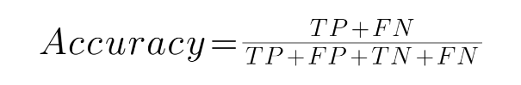 (1)
Accuracy rate
Represents the number of actual positive samples among the predicted positive samples.
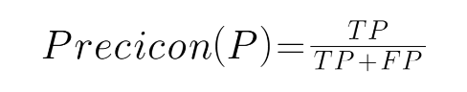 (2)
Recall rate
Let denote the proportion of samples that are actually positive that are judged to be positive
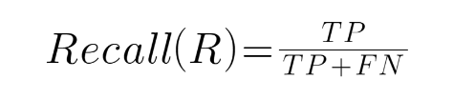 (3)
F1 score
Precision and Recall are contradictory metrics. In general, when Precision is high, Recall tends to be low. However, when the Precision value is low, the Recall value is often high. When the classification confidence is high, the Precision is high. When the classification confidence is low, the Recall is high. To be able to take these two metrics together, the F-measure (weighted harmonic mean of Precision and Recall) was proposed.
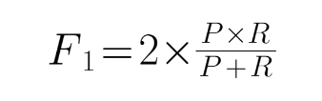 (4)
The core idea of F1 is to improve Precision and Recall as much as possible, while also hoping that the difference between them is as small as possible. F1-score is suitable for binary classification problems, and for multi-classification problems, the F1-score of binary classification is extended, and there are two measures: Micro-F1 and Macro-F1. Macro-F1 is used in this experiment.

Results
Knn
When leaf_size=30, the calculated distance is p=2, that is, Manhattan distance. The k value (1-15) is changed, and the accuracy rate, precision rate, recall rate and F1 score are selected for comparison:
Accuracy
K Value | 1 | 2 | 3 | 4 | 5 | 6 | 7 | 8 | 9 | 10 | 11 | 12 | 13 | 14 | 15
Accuracy(%) | 84.13 | 84.40 | 84.96 | 85.43 | 85.33 | 85.43 | 85.24 | 85.15 | 84.94 | 84.87 | 84.90 | 84.66 | 84.71 | 84.57 | 84.38
Table 2. Accuracy in the case of controlling k values
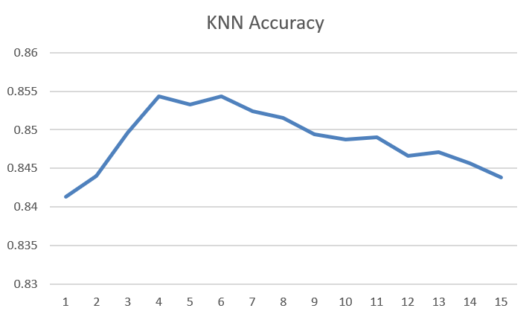
Figure 1. Accuracy in the case of controlling k values
Precision
K Value | 1 | 2 | 3 | 4 | 5 | 6 | 7 | 8 | 9 | 10 | 11 | 12 | 13 | 14 | 15
Precision(%) | 84.13 | 84.40 | 84.96 | 85.43 | 85.33 | 85.43 | 85.24 | 85.15 | 84.94 | 84.87 | 84.90 | 84.66 | 84.71 | 84.57 | 84.38
Table 3. Precision in the case of controlling k values

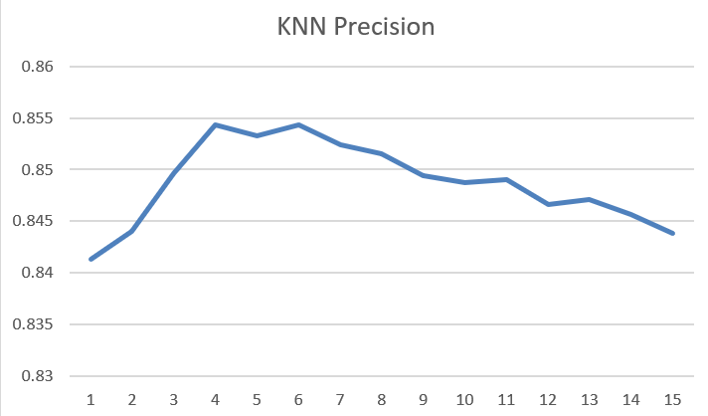
Figure 2. Precision in the case of controlling k values
Recall
K Value | 1 | 2 | 3 | 4 | 5 | 6 | 7 | 8 | 9 | 10 | 11 | 12 | 13 | 14 | 15
Recall(%) | 84.59 | 84.96 | 85.28 | 85.65 | 85.65 | 85.72 | 85.57 | 85.44 | 85.31 | 85.17 | 85.27 | 85.00 | 85.11 | 84.91 | 84.78
Table 4. Recall in the case of controlling k values
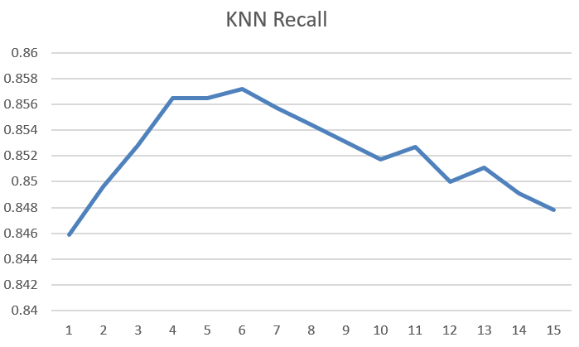
Figure 3. Recall in the case of controlling k values
F1
K Value | 1 | 2 | 3 | 4 | 5 | 6 | 7 | 8 | 9 | 10 | 11 | 12 | 13 | 14 | 15
F1(%) | 84.27 | 84.16 | 84.97 | 85.35 | 85.34 | 85.38 | 85.24 | 85.11 | 84.96 | 84.84 | 84.90 | 84.65 | 84.73 | 84.55 | 84.40
Table 5. F1 in the case of controlling k values
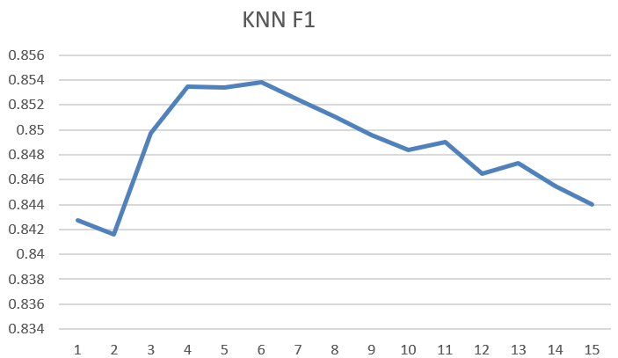
Figure 4. F1 in the case of controlling k values
When the value of k is 6, the calculated distance is p=2, that is, Manhattan distance. leaf_size is modified and the accuracy is used for comparison. The results are as follows:
leaf_size Value | 15 | 20 | 25 | 30 | 35 | 40
Accuracy(%) | 85.43 | 85.43 | 85.43 | 85.43 | 85.43 | 85.43
Table 6. Accuracy in the case of controlling leaf_size values
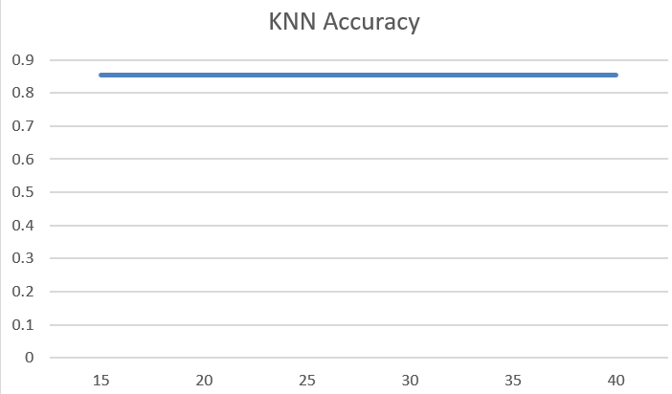
Figure 5. Accuracy in the case of controlling leaf_size values
When k value is 6 and leaf_size is 30, the modified calculated distance is p= 1,2 where p=1: that is, Euclidean distance; p=2: Manhattan distance, using accuracy for comparison.
P Value | 1 | 2
Accuracy(%) | 0.8595 | 0.8543
Table 7. Accuracy in the case of controlling P values
Best results
When the value of k is 6, leaf_size=30, p=1 is the Euclidean distance, which is the optimal result and the correct rate is: 85.95%.
The predicted data results of the test set for each data are shown below.
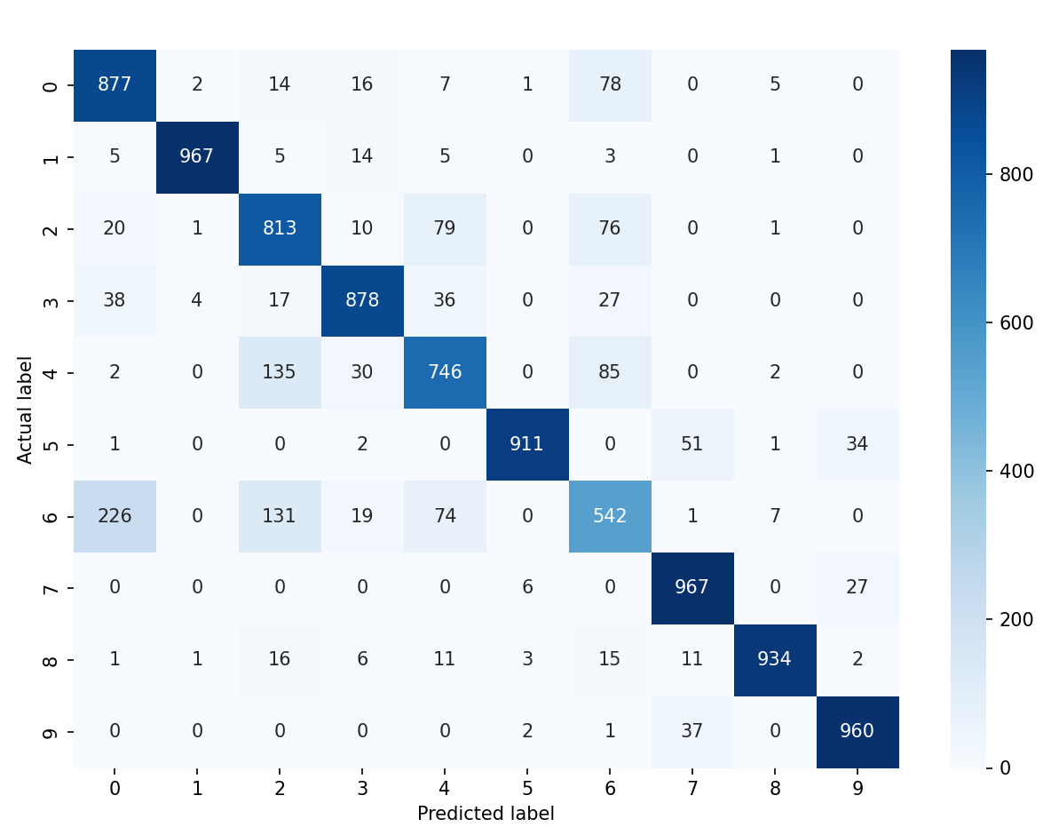
Figure 6. The predicted data results of the test set for each data
Decision tree
We only control the depth of the decision tree and change the depth value.
Depth Value | 8 | 9 | 10 | 11 | 12
Accuracy(%) | 78.13 | 80.18 | 81.06 | 81.56 | 81.29
Table 7. Accuracy in the case of controlling Depth values
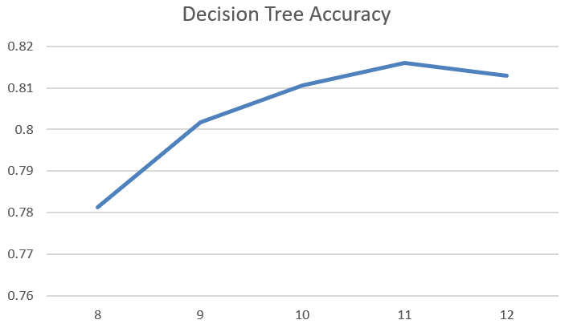
Figure 7. Accuracy in the case of controlling Depth values
The modified decision tree of depth 11 using the pre-pruning and post-pruning methods looks like this:
Pre-purning by using min_sample_size value is 5, and the accuracy is 81.51%.
post-pruning by using cca_alpha value is 0.0013, and the accuracy is 79.8%.
Best results
When the depth is 11, the optimal result is obtained without any processing, and the accuracy is 81.56%.
The predicted data results of the test set for each data are shown below.
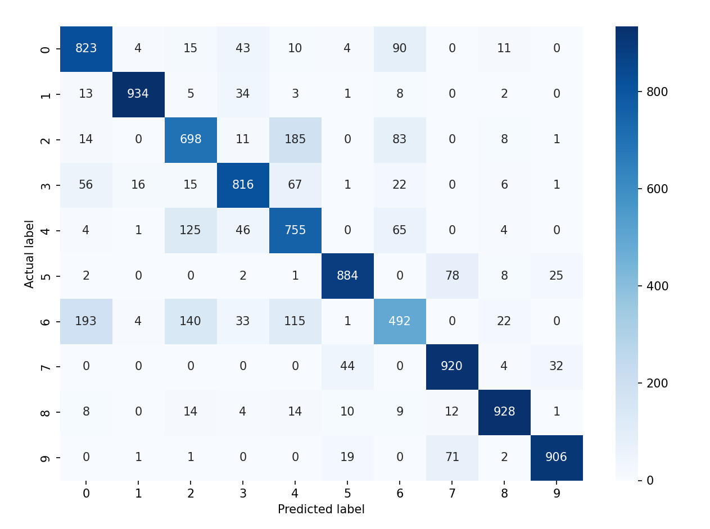
Figure 8. The predicted data results of the test set for each data

Discussion
​The effect of each parameter on the accuracy is more intuitive by adjusting the hyperparameters in the algorithm. In the process, the following conclusions were reached:
In the KNN algorithm, we adjust the value of k for the same number of different parameters and find that the accuracy is not highly desirable when the value of k is one to three. The accuracy is relatively strong for values of k between four and six, with the highest accuracy for a value of k of six. Subsequently, as the value of k increases, the accuracy starts to gradually decrease. And, in terms of accuracy, recall that the three categories F1 also appear in the same case. The only difference is that the F1 value appears to have the lowest value for two values of k, which requires additional study.
In the KNN algorithm, we adjust leaf_size with the same different parameters, with a default value of 30. We tested six values of 15, 20, 25, 30, 35, 40 and found that the shift of the value did not affect the accuracy, and the default value was used directly in subsequent use.
In the KNN algorithm, we adapt the measurement method with the same additional parameters, and the results are better when p = 1, that is, when Euclidean distance is used, than when p = 2, that is, when Manhattan distance is used.
Therefore, the parameters that obtained the best results were set as k value of six, p value of 1, leaf_size used the default value (considering that it would not affect the results), and the accuracy was 85.95%.
In the decision tree algorithm, by adjusting the maximum depth of the decision tree, it was found that for the case of multi-class classification, a tree of larger depth is needed to solve such problems. When the maximum depth is 8-11, the precision rises, indicating that it has not yet been reached. However, when the maximum depth reaches 12, the depth of the tree stops at 11 and we find that the optimal solution for this classification is at depth 11. We then tried pre-pruning and post-pruning, but found that this did not improve the accuracy of the decision tree, but rather reduced it. Finally, the optimal decision tree model has an accuracy of 81.56%.
Due to the depth problem of the decision tree, it could not be fully displayed in the paper, so the output tree model was included in the appendix; See the attachments for details.

Conclusion
Based on the above discussion, the following conclusions are drawn: We find that the value of k in the KNN algorithm is typically chosen between four and six, and that the accuracy shows a tendency to oscillate downward with the subsequent increase of the value of k. The two measures are the Euclidean distance and the Manhattan distance, the accuracy of the Euclidean distance is due to the Manhattan distance in decision tree algorithms. We found that in the case of ten classes, the depth of the tree is essentially kept at the depth of 11 levels by default, so we tried pruning operation, but found that it did not have a positive effect, possibly because of ten classes, so there are too many cases to consider, and it is impossible to distinguish each class by fewer feature values.
Through this research, it was discovered that
KNN Advantages:
Simple, easy to understand, high accuracy, mature theory that can be used for classification and regression;
It can be used for both numerical data and discrete data;
the training time complexity is O(n). No data input is assumed;
It is insensitive to the outlier.
KNN Cons:
Extreme computational complexity; high space complexity;
imbalanced samples (i.e., some classes have a large number of samples and others have a limited number of samples)
Typically, this is not needed when you have extremely large numbers because it is too computationally expensive. However, a single sample should not be overly narrow, otherwise it will be easy to classify.
The biggest drawback is the inability to give intrinsic meaning to the data.
Decision tree Advantages:
One that is easy to understand and interpret. Visualization of the tree structure
Training requires less data and alternative machine learning models often require data normalization, such as building dummy variables and removing missing values.
3. The cost of using the decision tree is exponentially distributed due to the number of data points used to train the decision tree (the time complexity of training the tree model is the log value of the training data points).
4. Being able to handle both numerical and categorical data. Additional techniques are normally only used to analyze datasets that specialize in one variable type.
5. capable of handling multi-output problems;
6. Use white-box models. If a given situation is observable in the model, then it is easy to interpret the situation using Boolean logic, in contrast to black-box models, which are difficult to interpret;
7. the model can be validated by numerical statistical tests. This makes it possible to interpret and validate the reliability of this model.
8. The model performs well even when its assumptions are more realistic and the data provided by the model is considerably violated.
Decision tree Cons:
1. Decision tree models tend to produce overly complex models that do not generalize well to data. This is known as overfitting, and strategies such as pruning, setting a minimum number of samples to leaf nodes, or setting a maximum number of depths are the most effective ways to avoid this problem. (Pruning: The importance of the decision tree algorithm in the classic machine learning algorithm must be known to everyone. The problem with ID3, C4.5, etc., is that the complete decision tree generated by the direct generation is "overfitting" to the training samples, that is, overly accurate. The complete decision tree is not the best decision tree for analyzing fresh data because it is "too precise" to describe the features of the training examples. The solution to this problem is to prune the decision tree, pruning the branches that affect the prediction accuracy. There are two common pruning strategies: pre-pruning and post-pruning. Pre-pruning is to establish some rules to limit the full growth of the decision tree, and post-pruning is to prune the decision tree after it has wholly grown.)
2. Decision trees can be unstable, as small changes in the data can result in absolutely different tree generation. This problem can be mitigated by an ensemble of decision trees;
3. Learning an optimal decision tree is in general an NP-hard problem under various performance optimisation and simplification concepts.
Therefore, practical decision tree learning algorithms are based on heuristics, such as greedy algorithms that make local optimal decisions at each node, which are not guaranteed to return the global best decision tree. This problem can be alleviated by ensemble learning to train multiple decision trees, which are mostly generated by randomly sampling features and samples and replacing them.
4. Some concepts are difficult to learn by decision trees because they are hard to represent explicitly, such as XOR, parity, or multiplexing problems;
5. It is recommended to balance the dataset before fitting, as the dominance of some classes in the problem can bias the original decision tree.

