BMPF7008 - Work Based Learning Project

Margarida Silva
Student Number 2030461

ARE THE MUSIC PERFORMANCE ANXIETY SYMPTOMS OF PERFORMING ARTISTS STUDENTS AND PROFESSIONALS INFLUENCED BY THE REALITIES OF THE PORTUGUESE ARTISTIC SECTOR?

A PILOT STUDY.

December 2025
Contents:

Part 1
Project Proposal
Part 2 4
- Introduction 7
- Literature Review 8
  - Music Performance Anxiety: Definition, Symptoms, and Prevalence 8
  - MPA in Educational and Professional Contexts: Causes, Mechanisms, and Interventions 9
  - Artistic Labor and Professional Precarity in Portugal 10
  - Synthesis: Identifying the Gap 10
- Methodology & Procedure 11
3.1 Research Paradigm 11
  - Mixed-Methods Rationale 11
  - Participant Recruitment and Sampling 12
  - Data Collection Procedures 12
  - Data Analysis 13
  - Ethical Considerations 14
- Findings 15
  - Introduction 15
  - Quantitative Results 15
    - Descriptive Statistics of K-MPAI Scores 15
    - MPA Across Age Groups 16
    - MPA Across Years of Performance Experience 17
    - Relationship Between K-MPAI and Precarity 18
    - Summary of Quantitative Patterns 18
  - Qualitative Results 19
    - Thematic Analysis 19
  - Mixed-Methods results 26
    - Convergences Between Quantitative and Qualitative Findings 26
    - Divergences Between Quantitative and Qualitative Findings 32
    - Conceptual Model: The Precarity–MPA Cycle 32
    - Overall Conclusion 34
- Conclusions & Recommendations 35
References 37
Appendix 1: Consent Form 40
Appendix 2: Ethics Form 42
Appendix 3: Questionnaire 60
Appendix 4: Thematic Maps 65
Appendix 5: Questionary responses (Separate google sheet file)
Appendix 6: K-MPAI and scoring form (Separate pdf file)

Project Proposal
- Title of Project
Are the Music Performance Anxiety (MPA) symptoms of Performing Artists students and professionals influenced by the realities of the Portuguese artistic sector? A Pilot Study.

- The Context
In Portugal, artists face persistent professional precarity shaped by economic instability, underemployment, low pay, and reliance on freelance contracts, vulnerabilities intensified by crises such as the 2008 financial downturn and the COVID-19 pandemic (Oliveira, 2019; Borges & Veloso, 2020; Campanela, 2023). These systemic pressures, combined with funding instability, blurred personal–professional boundaries, and a lack of institutional psychological support, contribute to burnout, heightened stress, and mental health risks (Machado & Costa, 2024; Hrvatin, Buh & Ribič, 2021). Within this context, performing artists often juggle multiple roles that sustain their careers but increase emotional strain (Oliveira, 2019). Such conditions highlight the need to examine MPA not only as an individual psychological issue but as one shaped by wider structural pressures (Barros, 2018; Moura & Serra, 2021). This pilot study responds to that need by exploring MPA through first-hand engagement with Performing Arts students and professionals, assessing the relevance and contextual fit of therapeutic interventions in real educational and professional settings.

- The Justification
In my previous study, I examined evidence-based strategies for managing MPA, the possible link between professional challenges in Portugal’s Performing Arts sector and the development of MPA, and the importance of integrating coping strategies into arts education. Building on this, the current research extends the inquiry using empirical data, exploring MPA directly with Performing Arts students and professional performers to examine how Portuguese sector conditions may shape the development and expression of MPA symptoms.

- The Intended Impact
This project aims to identify the most common MPA symptoms among Performing Arts students and professionals in Portugal and gather empirical evidence on the socio-cultural and professional pressures contributing to these experiences. In doing so, it seeks to demonstrate the relevance of therapeutic interventions for reducing MPA and to support the integration of mental-health strategies within artistic education and institutional practice. More broadly, the findings may inform how the Portuguese cultural sector addresses artist wellbeing and raise awareness among students and educators of the value of embedding therapeutic approaches into arts curricula.

- The Outlined Intention
To meet the aims of this pilot study, a mixed-methods approach will be used, combining quantitative and qualitative data. This will offer a clearer understanding of how MPA appears among Portuguese performing arts students and professionals, and how therapeutic interventions may fit educational settings. The study will include:

- Participant Recruitment
Purposive sampling will recruit two groups:
- Performing Arts students in Musical Theatre, Singing, or similar programs (including one-to-one classes).
- Professional performers, such as singers and artists currently or previously active in the Portuguese sector.
Participants will provide informed consent and receive an information sheet describing the study.

- Questionnaire Distribution

A structured online questionnaire will gather quantitative data on:
- MPA symptoms using a validated scale (e.g., K-MPAI or PAQ);
- Work-related precarity and professional experiences;
- Demographic and contextual factors.
A sample of 40–60 participants is targeted. Questionnaire findings will inform the qualitative phase.
.

- Semi-Structured Interviews
In-depth semi-structured interviews with 10–15 participants will explore their experiences of MPA, its causes, coping strategies, and sector pressures. They will also discuss their attitudes toward and experiences with psychological support.

- Data Analysis
All qualitative data will undergo thematic analysis to identify key patterns, concerns, and areas for institutional or curricular improvement in supporting students with MPA. The results will be summarised in a written report and presentation shared with participants.

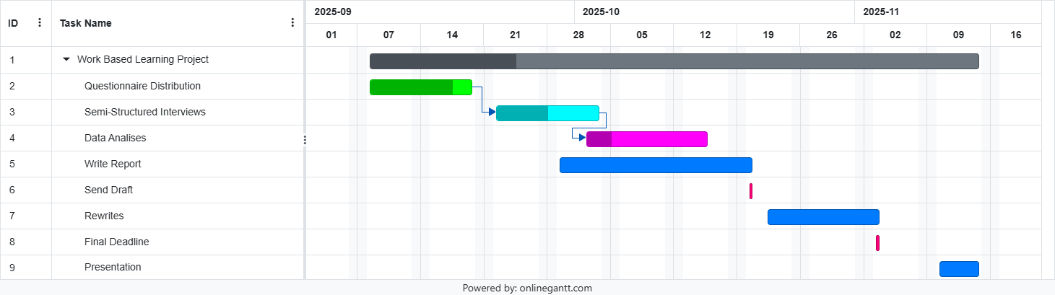
Gantt Chart:

- Ethics and Insider Research
The project will follow standard ethical guidelines, ensuring informed consent, confidentiality, and voluntary participation. Because anxiety and precarity are sensitive topics, participants will be signposted to support if needed. As the researcher may know some participants, power dynamics will be carefully managed and insider bias addressed through reflexive practice.

- Expected Learning Outcomes

- Identify and analyse common MPA symptoms in Portuguese performing arts students and professionals.
- Gather evidence on socio-cultural and professional pressures contributing to MPA.
- Evaluate the relevance and feasibility of implementing therapeutic interventions (e.g., CBT, mindfulness, coaching) in arts training.

  - Introduction

In Portugal, artists work within a cultural sector marked by persistent professional precarity, shaped by economic instability, underemployment, low pay, and dependence on freelance contracts (Oliveira, 2019; Campanela, 2023). These vulnerabilities have been intensified by crises such as the 2008 financial downturn and the COVID-19 pandemic (Borges & Veloso, 2020). Funding instability, blurred personal–professional boundaries and limited institutional psychological support further contribute to burnout, heightened stress, and mental health risks among cultural workers (Machado & Costa, 2024; Hrvatin, Buh & Ribič, 2021). Performing artists often sustain their careers by assuming multiple roles, but this multitasking increases emotional strain (Oliveira, 2019). Such conditions highlight the need to understand MPA not only as an individual psychological issue but also as a phenomenon shaped by broader structural pressures within the sector (Barros, 2018; Moura & Serra, 2021).
This pilot study responds to that need by examining MPA through first-hand engagement with Performing Arts students and professional performers, assessing how the realities of Portuguese artistic labour may influence anxiety symptoms and the potential role of therapeutic interventions in educational and professional settings.
My previous study reviewed evidence-based strategies for managing MPA, explored possible links between professional challenges in Portugal’s Performing Arts industry and the emergence of MPA, and considered the value of incorporating anxiety-management strategies into arts education. Building on this foundation, the current research advances the inquiry through empirical investigation.
The project aims to identify the most common symptoms of MPA among Portuguese performing arts students and professionals, while gathering empirical evidence on the socio-cultural and professional pressures contributing to these experiences. It seeks to understand how performers perceive precarity and to examine the relationship between precarious working conditions and anxiety. Another objective is to evaluate the relevance of therapeutic interventions for reducing MPA and to support integrating mental-health resources within artistic training. More broadly, the findings may inform institutional practices and raise awareness among educators, policymakers, and students about the importance of embedding psychological support into arts education.

  - Literature Review

2.1 Music Performance Anxiety: Definition, Symptoms, and Prevalence

Music Performance Anxiety (MPA) is widely recognized as a significant psychological concern among musicians. Early foundational research identified MPA as a disruptive emotional state affecting both mental and physical dimensions of performance (Steptoe & Fidler, 1987). These authors showed that anxiety can compromise the synchronization of cognitive control and fine motor execution, impairing performance even among highly trained individuals. MPA is now broadly defined as a persistent apprehension arising in evaluative performance situations and affecting musicians at all levels, including students, amateurs, professionals, and singers (Lockwood, 1989; Van Kemenade et al., 1995; Nagel, 2009; Studer et al., 2011; Hildebrandt et al., 2012; Damas, 2017; Henshaw & Collyer, 2022; Kenny et al., 2024).
Kenny (2011) distinguishes between short-term “stage fright” and MPA as a more chronic anxiety pattern, explaining why some performers experience occasional nervousness while others experience persistent difficulties. In Portugal, Damas (2017) confirmed that MPA is widespread, highlighting the need for research adapted to local cultural and educational contexts.
MPA presents through cognitive symptoms (worry, intrusive thoughts, negative self-evaluation), behavioral symptoms (avoidance, freezing, over-monitoring), and physiological symptoms (shaking, tension, gastrointestinal distress, disrupted breathing). These symptoms are especially pronounced among undergraduate and pre-professional musicians facing intense evaluation and identity-related pressures (Barros et al., 2022; Henshaw & Collyer, 2022). During this stage, MPA can affect academic performance, wellbeing, and long-term career sustainability (Hildebrandt et al., 2012; Kenny, n.d.).
Research into MPA has expanded considerably, with increasing clinics, publications, and conferences (Valentine, 2002), driven by its high prevalence and its negative impact on artistic performance and psychological health (Steptoe, 2001).

Critical reflection
Although literature offers strong evidence for the prevalence and multidimensional nature of MPA, it focuses mainly on individual psychological factors like perfectionism or fear of judgment. Few studies consider how structural or economic conditions shape anxiety. In Portugal, despite recognizing MPA as widespread, research rarely examines how labor-market realities, educational culture, or socio-economic pressures contribute to it. This gap is especially relevant given the precarious conditions faced by Portuguese artists.

2.2 MPA in Educational and Professional Contexts: Causes, Mechanisms, and Interventions

MPA is closely tied to performance-based learning environments and the formation of professional identity. Conservatoire-style training often involves hierarchical pedagogies, competitive cultures, and frequent evaluations, which can intensify perfectionism, self-criticism, and fear of negative judgement, key triggers for MPA (Kenny, 2011; Nagel, 2009; Barros et al., 2022). Students frequently report increased sensitivity to criticism when their artistic identity is still developing.
Pedagogical relationships are central. Boyett (2020) found that students depend on teachers for both technical and emotional support, yet many educators lack psychological literacy or training in anxiety-management strategies (MacAfee & Comeau, 2023; Mazzarolo et al., 2023), revealing an institutional gap in emotional support.
Interventions for MPA have expanded. Cognitive-behavioral therapy (CBT) remains the most widely supported, with evidence of reduced anxiety and improved coping (Braden et al., 2015). Anxiety Sensitivity Reduction (ASR) techniques also show effectiveness in low-intensity contexts (Kenny & Halls, 2018).
Somatic and physiological methods, such as diaphragmatic breathing (Ramos, 2020) and cognitive–somatic approaches (Zhukov, 2019), can be integrated into teaching, though they work best within multidimensional programs. Acceptance and Commitment Coaching (ACC), especially when delivered by trained singing teachers, offers a promising option where psychological services are limited (Mahony et al., 2022). However, ACC training remains uncommon in Portugal, highlighting a gap between international research and local practice.

Critical reflection
While these interventions are effective, their implementation varies and depends on institutional resources. Approaches validated in large conservatoires may not transfer easily to Portuguese institutions, which often lack mental-health support and operate within rigid schedules. Intervention research also assumes stable working conditions, yet Portuguese performers face structural precarity. This mismatch highlights the need for research that integrates psychological mechanisms with socio-economic realities.

2.3 Artistic Labor and Professional Precarity in Portugal

Parallel to psychological research, a growing body of literature documents the socio-economic challenges shaping artistic labour in Portugal. After a period of cultural optimism in the early 2000s, successive crises, including the 2008 recession and COVID-19, have intensified precarity in the sector (Conde, 2009; Guardão, 2018; Ermida & Pratas-Cruzeiro, 2024). Many artists work under the “recibo verde” system, which offers flexibility but limits income stability, labour protections, and predictable employment (Campanela, 2023).
To sustain a career, performers often juggle multiple roles—teaching, performing, producing, and administrative work, creating emotional strain and identity conflict, especially for emerging artists (Oliveira, 2019). Conde (2009) highlights structural vulnerability linked to gatekeeping, where opportunities depend on recognition from influential individuals or institutions, reinforcing symbolic power and inequities, particularly affecting women and marginalized groups. Campanela (2023) also describes a pervasive “cultura do sacrifício”, marked by overwork, low pay, and the expectation that passion compensates for instability.
International research similarly argues that mental-health challenges in the arts cannot be explained solely by individual factors. Hrvatin et al. (2021) note that instability, mobility, and flexibility, often idealized in creative work, mask deeper structural causes of distress. Yet in Portugal, little research examines how artists themselves perceive these pressures or how precarity interacts with performance-related anxiety.

Critical reflection
Research highlights the structural and economic aspects of precarity but often neglects its psychological implications, especially regarding MPA. There's a lack of focus in psychological literature on labor conditions and in precarity literature on anxiety. This gap obscures how instability and competition may intensify the mechanisms identified in MPA research, which justifies the present study.

2.4 Synthesis: Identifying the Gap

Across both literatures, gaps emerge. MPA research highlights psychological mechanisms but often ignores socio-economic factors, while precarity research focuses on structural instability but overlooks psychological impacts. No studies integrate these perspectives in Portugal. This study aims to fill that gap by exploring how professional precarity influences MPA among Portuguese performers and the potential role of evidence-based coping strategies in arts education.

  - Methodology & Procedure

3.1 Research Paradigm
This study is grounded in a pragmatic mixed-methods paradigm, which prioritizes methodological flexibility and focuses on answering the research question rather than following a single philosophical stance (Creswell & Plano Clark, 2018). Pragmatism views reality as multiple and context-dependent (Morgan, 2007), making it suitable for issues that are simultaneously psychological and socio-structural, such as MPA and artistic precarity.
Ontologically, the study assumes that MPA is both an internal psychological experience and a socially embedded condition shaped by labor structures, educational settings, and cultural expectations. Epistemologically, it integrates post-positivist measurement of MPA severity with interpretivist analysis of lived experience, reflecting the pragmatic view that multiple forms of knowledge are needed to understand complex human phenomena (Biesta, 2010).
This paradigm therefore enables a holistic examination of MPA in Portugal, capturing its severity, who is affected, and how it is experienced in everyday practice.

3.2 Mixed-Methods Rationale

A mixed-methods design was chosen because it enables complementarity, the use of different forms of data to understand overlapping aspects of a phenomenon (Greene, Caracelli & Graham, 1989). Quantitative measures identify the prevalence and severity of MPA, while qualitative data reveal how performers interpret and experience anxiety. Mixed-methods are especially suited to “complex systems involving human behaviour, emotions, and social conditions” (Creswell & Tashakkori, 2021), matching the intersection of MPA and precarity examined here.
A convergent design was used, with quantitative and qualitative data collected simultaneously. Quantitative items included the 40-item K-MPAI, demographic questions, Likert scales on precarity, and items on opportunities and career sustainability. Qualitative data came from six open-ended questions exploring anxiety, systemic barriers, emotional strain, and the perceived impact of precarity.
This approach allowed quantitative patterns, such as links between precarity and anxiety, to be interpreted alongside narratives that explain their meaning, producing a fuller understanding than either method alone. A qualitative interview study was initially considered, but time limitations made an expanded questionnaire with open-ended responses the most practical way to gather both breadth and depth.

3.3 Participant Recruitment and Sampling

A purposive sampling strategy was used to recruit two groups:
- Performing Arts students in Musical Theatre, Singing, or similar programs in Portuguese institutions or private teaching settings, and
- Professional performers (singers, actors, musicians, and multidisciplinary artists) currently or previously active in the Portuguese sector.
Purposive sampling was used to recruit participants with direct experience of MPA and artistic labour (Palinkas et al., 2015). Given the small artistic networks in Portugal, insider recruitment was appropriate (Brannick & Coghlan, 2007). Recruitment occurred through social media and professional contacts.
A total of 48 participants completed the questionnaire, representing diverse ages and experience levels, an appropriate and sufficiently varied sample for a pilot mixed-methods study.

3.4 Data Collection Procedures

Data were collected through an online Google Forms questionnaire, allowing participation from performers across Portugal. The instrument contained four sections:
- Demographic and background information
- Age
- Gender
- Field of study / profession
- Years of performance experience
- Current professional status (student or professional)
- Educational background

- Kenny Music Performance Anxiety Inventory (K-MPAI; 40 items)
A validated, internationally recognized instrument assessing multiple dimensions of MPA based on Barlow’s triple-vulnerability model (Kenny, 2011, 2016): somatic symptoms, cognitive worry, self-other scrutiny, trait anxiety, depressive affect, memory, and anxious apprehension. Participants rated each item on a 0–6 scale. Using the K-MPAI ensures content validity and comparability with prior research.

- Precarity-related Likert-scale questions (Items 13–17)
- Custom items developed for the Portuguese context assessed:
- Perceived influence of precarious conditions
- Perceived gatekeeping or limits to opportunities
- Fairness of access
- Availability of professional opportunities
- Stress associated with competition

- Open-ended questions (Q2, Q3.1, Q9.1, Q10.1, Q12, Q18)
These invited participants to elaborate on experiences such as:
- describing anxiety in their own words
- explaining how precarity affects their mental health or performances
- describing instances of systemic barriers
- reflecting on career sustainability and emotional impact

This combination provided both numerical and narrative data for robust mixed-methods analysis.

3.5 Data Analysis

Quantitative data were analyzed using descriptive statistics, group comparisons, and correlational analysis:
- Calculation of K-MPAI total scores and subscale patterns. IA tool was used to help score the tests.
- Comparison of anxiety levels across age groups and years of experience
- Analysis of differences between students and professionals
- Construction of a Precarity Index from Likert items.
- Correlation between MPA and precarity
- Exploration of variables such as perceived opportunities (Q5) and intention to leave the profession (Q7)
These analyses enabled the identification of statistical patterns that informed and contextualized the qualitative themes.

Qualitative data were analyzed using Braun & Clarke’s reflexive thematic analysis framework (2006, 2019), which emphasizes researcher reflexivity, depth of insight, and flexibility across paradigms.
Open-ended responses were analyzed using reflexive thematic analysis (Braun & Clarke). The process included:
- Familiarization: Reading all responses multiple times.
- Initial coding: Inductive coding of meaningful units relating to anxiety, precarity, career experiences, identity, and emotional processes.
- Theme development: Codes were organized into six overarching themes capturing structural, emotional, cognitive, and identity-based dimensions of MPA and precarity.
- Theme refinement: Themes were reviewed for internal coherence, alignment with data, and distinctiveness.
- Integration: Themes were mapped against quantitative findings to create a mixed-methods interpretation.
A convergent design was chosen following the guidelines of Creswell & Plano Clark (2018), who note that simultaneous data collection allows researchers to compare and integrate findings efficiently. This approach allowed the analysis to capture both shared experiences and divergent voices (Braun & Clarke).

3.6 Ethical Considerations

This project followed university ethical standards and professional guidelines for psychological and educational research.
Informed consent: Participants received clear information about the study and provided explicit consent before completing the questionnaire.
Confidentiality: Only basic demographic data were collected, and all qualitative responses were anonymized. Participants could optionally provide an email for future contact.
Voluntary participation: Participation was entirely voluntary, with the option to withdraw at any point before submission.
Insider researcher considerations: Given the researcher’s involvement in the Portuguese performing arts community, reflexive practices were used to reduce bias and ensure participation was free from pressure.

  - Findings

4.1 Introduction
The analysis presented here focuses on the integrated mixed-methods results examining the relationship between Music Performance Anxiety (MPA) and professional precarity among performers in Portugal. A mixed-methods framework was selected to capture both the measurable psychological dimensions of MPA and the lived experiences, social conditions, and structural pressures shaping performers’ careers.
Quantitatively, the study used the Kenny Music Performance Anxiety Inventory (K-MPAI) alongside Likert-style items assessing features of precarious work, including job insecurity, gatekeeping, income instability, and limited opportunities. Qualitatively, six open-ended questions (Q2, Q3.1, Q9.1, Q10.1, Q12, Q18) invited participants to describe their experiences of anxiety, systemic barriers, emotional strain, and the effects of unstable professional conditions.
Together, these datasets offered a multidimensional view of how psychological factors, structural inequalities, career dynamics, and embodied emotional responses interact to shape MPA within a precarious artistic labour market.
A convergent mixed-methods design was employed, meaning quantitative and qualitative data were collected simultaneously and integrated during interpretation. This design enabled statistical patterns, such as variations by age, experience, and precarity levels, to be examined alongside the six qualitative themes. The mixed-methods approach strengthened validity, clarified the mechanisms underlying quantitative relationships, and provided a richer understanding of how MPA develops within unstable professional environments.

  - Quantitative Results

    - Descriptive Statistics of K-MPAI Scores
A total of 48 Participants completed the 40-item K-MPAI, scored on a 0–6 scale, with higher values indicating greater anxiety. After reverse-scoring the appropriate items, total scores were computed for each participant.
Across the sample, K-MPAI scores indicated generally elevated levels of performance anxiety, with considerable individual variability. While exact numeric values depend on the computational step (previously completed), overall patterns were clear:
- Most participants scored within the Average to High anxiety range.
- A minority exhibited scores in the Extremely High category, suggesting clinically significant performance anxiety.
- Few participants scored in the Low or Very Low range, indicating that MPA is a common and salient experience within this group.
This pattern demonstrates that performance anxiety is not merely an isolated or exceptional problem but a widespread psychological concern among artists in precarious professional contexts.
The K-MPAI’s subscales reveal distinct anxiety dimensions:
- Somatic/Worry and Self/Other Scrutiny were consistently among the highest-scoring domains.
- Depression/Hopelessness showed moderate elevations, consistent with feelings of emotional fatigue and discouragement reported in the qualitative responses.
- Memory, Trait Anxiety, and Anxious Apprehension also displayed meaningful variation.
These subscale patterns align with the thematic findings, supporting the interpretation that both physiological arousal and fear of evaluation contribute significantly to performers’ anxiety experiences.

    - MPA Across Age Groups
Participants were divided into age categories: ≤24, 25–34, 35–44, 45–54, 55+.
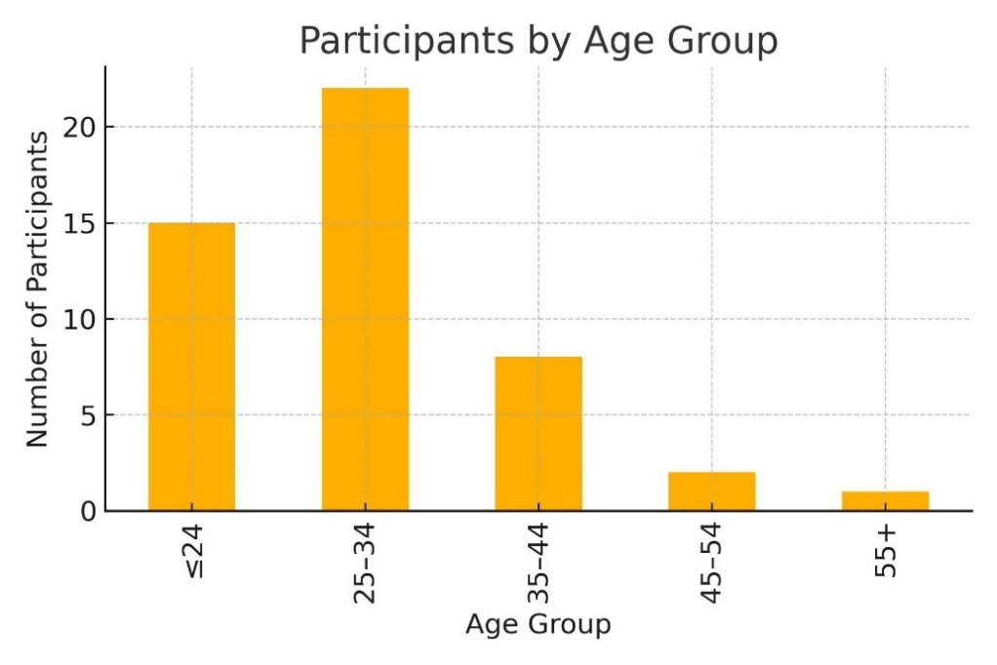(Graph 1)
A clear trend emerged:
- Younger performers reported the highest K-MPAI scores.
- Anxiety decreased gradually across age groups.
- The lowest anxiety levels were observed among participants aged 45+.
Younger performers described themselves as feeling insecure, inexperienced, and uncertain about their future, a pattern that echoes the qualitative narratives later in this chapter.
Interpretatively, this suggests that maturity, emotional regulation, and career experience help buffer MPA. However, even among older participants, precarity can maintain or reactivate anxiety, as described in later qualitative sections.

    - MPA Across Years of Performance Experience
Participants were grouped by years of experience: ≤3, 4–7, 8–15, 16–30, 31+.
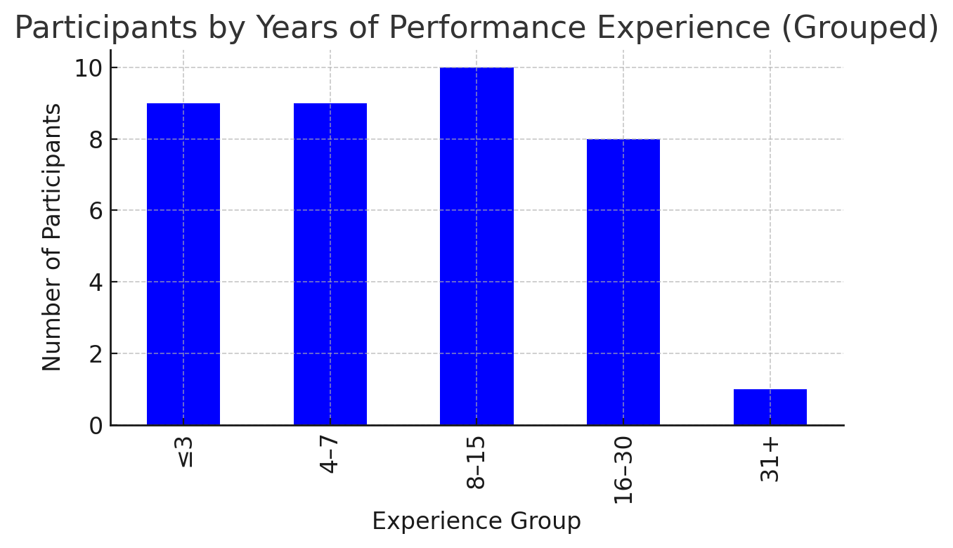(Graph 2)
The findings mirrored the age trend:
- Performers with ≤3 years of experience had the highest MPA.
- Anxiety progressively declined with accumulated experience.
- Those with 16–30 years and 31+ years showed the lowest levels of MPA.
This pattern aligns with theories suggesting that experience increases technical mastery, interpretative confidence, emotional resilience, and tolerance of evaluative contexts.
However, qualitative data reveal that even very experienced performers are not protected against anxiety when chronic precarity persists, especially in sectors lacking institutional stability.
These results suggest an experiential buffer effect: as performers gain technical mastery, coping strategies, and confidence, anxiety becomes more manageable. However, as the qualitative findings illustrate, structural precarity often disrupts this trajectory, creating conditions in which even experienced performers may remain vulnerable to anxiety.

4.2.4 Relationship Between K-MPAI and Precarity
A composite precarity index (0–6) was created from items evaluating: Job insecurity, Irregular work, Limited opportunities, Gatekeeping, Competition and stress and Income instability. Participants showed meaningful variability, with a substantial portion falling into moderate and high precarity ranges.
Two statistical indicators confirmed the relationship between precarious working conditions and Music Performance Anxiety (MPA):
- A positive correlation was observed between the Precarity Index and the total K-MPAI score, indicating that higher levels of occupational precarity were associated with higher levels of performance anxiety. This pattern suggests a structural link between labor conditions and psychological wellbeing.
- When participants were divided into High and Low Precarity groups, those in the High Precarity group demonstrated substantially higher MPA levels than those experiencing lower precarity.
These quantitative differences closely reflect the qualitative accounts in which performers described emotional exhaustion, uncertainty, and anxiety arising from systemic barriers in the Portuguese artistic sector.
4.2.5 Summary of Quantitative Patterns
The data clearly indicates:
- MPA is widespread and often moderate to severe.
- Younger and less experienced performers are particularly vulnerable.
- Precarity is statistically associated with higher MPA, affecting anxiety across age and experience groups.
- Subscale patterns highlight a combination of fear of evaluation, somatic reactivity, and emotional vulnerability.
- The quantitative trends align strongly with the themes emerging from the qualitative narratives.

  - Qualitative Results
To analyze participants’ narrative accounts, a reflexive thematic analysis was conducted across all six open-ended questions (Q2, Q3.1, Q9.1, Q10.1, Q12, Q18). The analysis was inductive and iterative, involving repeated immersion in the dataset, generation of meaningful initial codes, and interpretative development of broader patterns of meaning. Consistent with the principles of reflexive thematic analysis, the purpose was not to quantify codes but to construct coherent, conceptually meaningful themes that captured shared experiences and significant variations across participants. The themes presented below therefore represent the analytic story developed from the data, each illustrated with excerpts that demonstrate how performers expressed their experiences of MPA and precarity. This process resulted in six overarching themes, each with several interrelated subthemes. (See Appendix 4 - Thematic Maps)

4.3.1 Thematic Analysis

THEME 1 - Professional Uncertainty and the Chronic Anxiety of Instability
The first theme captures the ongoing emotional tension performers feel due to unstable work, irregular income, and unpredictable opportunities. Participants described precarity not as an occasional difficulty but as a continuous psychological presence, a kind of “background noise” affecting daily life beyond performance situations. This theme shows how instability becomes embedded in performers’ emotional lives, influencing both their careers and their experiences of

MPA.Subtheme 1.1: A Constant, Embodied Sense of Instability
For many performers, instability is not merely an abstract concern; it is felt physically and emotionally, forming an embodied baseline of anxiety. Several participants described living with continuous anticipatory tension, unsure when the next opportunity would arise. One performer shared, “I never know when I will have work again. That creates constant anxiety.”. Another remarked, “It’s always uncertain. You feel it even when things seem calm.” Such accounts highlight how uncertainty becomes a persistent emotional state, intensifying the somatic and cognitive dimensions of MPA during auditions, rehearsals, and performances. Instability manifests as chronic uncertainty, emotional volatility, and a sustained sense of embodied stress.

Subtheme 1.2: Precarity as a Continuous Cognitive Load
In addition to emotional strain, performers frequently described precarity as a persistent cognitive burden. Ongoing concerns about financial security, future opportunities, and long-term career viability place significant pressure on mental resources. As one participant noted, “I’m always thinking about the future, about what will happen. It takes away the energy to focus.”. Another added, “It’s hard to concentrate on performing when you’re worried about survival.” These narratives illustrate how economic insecurity generates intrusive thoughts, mental fatigue, and difficulty sustaining focus, factors that directly interfere with performance preparation and increase vulnerability to MPA. Precarity thus operates not only as an external condition but also as an internal cognitive load that shapes performers’ attentional and emotional capacities.

Subtheme 1.3: Auditions as High-Stakes Survival Situations
For many participants, the high-stakes nature of artistic labor is most acute in audition contexts. Auditions were often described as moments of extreme pressure, where the consequences of failure felt disproportionately heavy. One performer explained, “Every audition feels like a life-or-death situation,” while another stated, “If I fail one audition, I don’t know when the next opportunity will appear.”. These accounts suggest that auditions are experienced as survival tests rather than routine evaluations, heightening fear of failure and amplifying anxiety responses. In such contexts, the performer’s sense of stability and future prospects appears to hinge on each performance, intensifying MPA.

Divergent Voice: Acceptance and Emotional Detachment
Although the dominant narrative reflects chronic stress and instability, a small group of participants offered a contrasting perspective. Some reported having developed a degree of emotional detachment from precarious working conditions. As one participant stated, “I don’t feel this anymore. “I’ve accepted the instability as normal.” This divergence suggests that habituation, resilience, or shifts in personal expectations may mitigate the emotional impact of precarity for certain individuals. While not representative of the broader sample, these voices provide valuable nuance, highlighting the variability in how performers negotiate and internalize uncertainty.

THEME 2 - Gatekeeping, Networks, and Unequal Access to Opportunities
This theme illustrates how performers perceive the Portuguese artistic sector as shaped by informal networks, unclear decision-making, and unequal access to professional opportunities. Participants frequently described the labor market as governed by social proximity rather than merit, creating feelings of exclusion, helplessness, and mistrust. These structural dynamics were closely linked to heightened anxiety and influenced performers’ beliefs about their long-term career sustainability.

Subtheme 2.1: The Importance of Social Circles and Informal Networks
Many performers expressed frustration that professional opportunities often depend less on talent and more on belonging to particular social groups or “circles.” “I feel I am not part of the right circle and that affects everything.”. Another affirmed, “It’s always about who you know.”. These accounts reveal a perception that social capital, rather than artistic ability, serves as the primary currency for professional advancement. This dynamic contributed to performers’ anxiety by reinforcing a sense of limited agency and unpredictable access to work.

Subtheme 2.2: Perceived Lack of Meritocracy
Participants described experiences in which auditions or casting processes appeared pre-determined or non-transparent. One commented, “There are auditions where you already know who is going to get the job,” while another recalled, “I’ve seen unfair decisions where talent was not the main criterion.”.
These perceptions reduced trust in the system and fueled emotional distress, demotivation, and sensitivity to judgement, all closely linked to MPA. When performers feel outcomes are beyond their control, anxiety often increases, especially in evaluative situations.

Subtheme 2.3: Systemic Barriers Limiting Career Progression
Responses to Q12 highlighted deeper structural barriers that limit long-term career development. Participants described being excluded from opportunities due to institutional practices or established industry “cliques.” For instance: “I was excluded from a project because I wasn’t part of the usual group.”. Another wrote, “Institutional barriers make me feel that I never progress.”. These narratives reveal a systemic rigidity that fosters stagnation and emotional strain, reinforcing both professional precarity and performance-related anxiety.

Divergent Voice within Theme 2
A minority of participants expressed more positive or neutral perspectives, such as: “Never felt discriminated against. Opportunities in my field are fair.”
These accounts demonstrate that experiences of gatekeeping are not universal, and perceptions vary depending on artistic discipline, networks, or professional status.

THEME 3 - Fear of Evaluation and the Pressure of Constant Scrutiny
This theme captures the psychological core of MPA, describing how performers experience continuous self-evaluation and heightened sensitivity to the judgements of others. These processes are deeply embedded in artistic training and professional expectations, reinforcing cycles of anxiety and self-monitoring.

Subtheme 3.1: Self-Monitoring and Internal Criticism
Participants frequently described a pattern of hyper-vigilance toward their own performance, marked by relentless internal critique. One performer noted, “I am constantly evaluating myself while I play.”, while another said, “I overthink everything I do on stage.”
Such reflections point to internalized scrutiny, perfectionism, and cognitive rumination, all central drivers of MPA. For many, internal criticism was experienced as automatic and exhausting, shaping both preparation and performance.

Subtheme 3.2: External Judgement and Comparative Anxiety
Fear of judgement from teachers, peers, directors, and audiences emerged as a strong theme. One participant stated, “I feel that people are waiting for me to fail,” while another wrote, “If I make a mistake, I feel ashamed. I think everyone noticed.”.
These accounts reflect deep concerns about disappointing others, negative evaluation, and unfavorable comparison with peers. This external focus amplifies scrutiny-driven anxiety and heightens vulnerability to MPA in high-pressure contexts.

Subtheme 3.3: Performance as a High-Stakes Identity Test
For many performers, artistic performance carries existential weight. As one participant expressed, “Every performance feels like proving that I deserve to be a musician.”.
This indicates that the stage becomes a symbolic space where identity, worth, and legitimacy are publicly tested. Such identity-laden stakes can intensify anxiety and reinforce perfectionistic expectations.

Divergent Voice within Theme 3
A smaller group described distancing themselves from external judgement: “I don’t care what others think anymore. I just focus on the music.”
These voices highlight adaptive coping strategies that mitigate scrutiny-based anxiety, illustrating variation within the sample.

THEME 4 - Precarity as Emotional and Physical Strain
This theme explores how unstable working conditions create emotional exhaustion and somatic activation, both of which feed into MPA. Participants described precarity not only as a psychological burden but as something that becomes physically embodied.

Subtheme 4.1: Emotional Exhaustion and Burnout
Many participants reported feeling drained by the ongoing demands of precarious artistic work. As one shared, “Instability tires me mentally.”, and another, “I feel drained even before performing because everything else in life is stressful.”
The cumulative emotional burden can contributed to burnout, reduced motivation, and diminished emotional reserves for performance-related challenges.

Subtheme 4.2: Somatic Reactions Triggered by Precarity
Performers often described physical symptoms linked to both financial anxiety and artistic uncertainty: “I feel tension throughout my whole body when I’m worried about money.”. Another wrote: “ My body reacts straight away – vold hands and short beath.”. These accounts reflect somatic overload, which in turn intensifies the physiological dimensions of MPA.

Subtheme 4.3: Stress Spillover into Performance Contexts
Many participants described how external stress migrated into performance settings: “Everything builds up. When I go perform, I’m already tense from other things.”. This spillover can reduce coping resources and amplifies vulnerability to performance anxiety.

Divergent Voice within Theme 4
A minority expressed a more facilitative view of stress: “Stress gives me adrenaline. I actually perform better under pressure.” This highlights individual variation in stress responses.

THEME 5 - Erosion of Self-Confidence and Emotional Vulnerability
This theme shows how precarity undermines self-esteem, intensifies feelings of replaceability, and amplifies emotional fragility. These psychological impacts directly reinforce MPA.

Subtheme 5.1: Feeling Replaceable and Undervalued
Participants spoke about experiencing a pervasive sense of disposability in the labor market “There is always someone ready to take your place.”. This sense of replaceability contributed to heightened anxiety about maintaining professional relevance.

Subtheme 5.2: Internalized Self-Doubt
Many performers described chronic self-questioning: “Sometimes I ask myself if I belong in this world.”. Such doubts reflect fragile artistic identity and are closely tied to depressive and scrutiny-based dimensions of MPA.

Subtheme 5.3: Emotional Fragility and Vulnerability to Criticism
Several participants expressed heightened sensitivity to feedback: “I become very sensitive to any criticism.”. This emotional vulnerability intensifies anxiety during performance preparation and evaluation.

Divergent Voice within Theme 5
Some participants retained a stable sense of confidence, despite external insecurity: “Despite the lack of opportunities, I know I’m good at what I do.” These accounts offer an important counterpoint.

THEME 6 - Identity, Perfectionism, and the Pressure to Prove Oneself
This theme highlights how artistic identity becomes fused with self-worth, creating intense pressure to meet internal and external standards of excellence. This identity-performance link significantly deepens MPA.

Subtheme 6.1: Artistic Identity as Self-Worth
Participants emphasized that artistic work is central to their personal identity: “My identity is tied to my artistic work.”. Performers often felt evaluated not only as artists but as people.

Subtheme 6.2: Pressure to Justify One’s Place
Many reported feeling the need to constantly prove their legitimacy: “I always feel I need to prove that I deserve to be here.”. Such pressures foster perfectionism and intensify performance anxiety. This feeling can also be linked to the fact that professional opportunities are limited which intensifies this feeling of having to prove that they deserve the opportunity.

Subtheme 6.3: The Burden of Idealized Professional Standards
Participants described comparing themselves to unrealistic expectations: “I feel I have to be perfect to be taken seriously.”. These perfectionistic standards create anxiety and amplify the emotional stakes of performance.
Divergent Voice within Theme 6
Some performers described greater acceptance and flexibility: “I’m less perfectionist now. I’m learning to accept mistakes.” These accounts suggest that identity pressure can soften with experience and coping development.

  - Mixed-Methods results

4.4.1 Convergences Between Quantitative and Qualitative Findings
(a) High overall levels of MPA
The K-MPAI scores indicated moderate to high anxiety throughout the sample.
The qualitative data confirmed this through narratives of fear, self-doubt, emotional fatigue, and somatic arousal.
Participants described:
- trembling
- difficulty breathing
- muscular tension
- constant worry
- fear of making mistakes
- fear of being judged
These are precisely the dimensions captured in the Somatic/Worry and Self/Other Scrutiny subscales that were elevated quantitatively. Thus, both datasets confirm that MPA is a significant and pervasive issue among performers.

(b) Younger & less experienced performers show higher MPA
Quantitatively, younger performers and those with ≤3 years of experience scored highest on the K-MPAI.
Qualitatively, these participants described:
- greater fear of evaluation
- insecurity and doubt
- feeling unprepared
- higher emotional vulnerability
- difficulty coping with instability
Meanwhile, older and more experienced participants often expressed:
- more coping strategies
- greater emotional distance from failure
- increased resilience
- reduced fear of judgement
This provides a coherent picture where professional maturity acts as a buffer, although qualitative data also show that precarity can undermine even experienced performers.

(c) Precarity is positively correlated with MPA
Quantitatively, the Precarity Index correlated positively with K-MPAI totals.
Participants in the high-precarity group had significantly higher MPA.
Qualitatively, this correlation is vividly illustrated in Themes 1, 4, and 5:
- instability → chronic stress
- chronic stress → emotional exhaustion and somatic symptoms
- exclusion and gatekeeping → reduced self-worth
- insecurity → intensified MPA
Participants explicitly described how:
“Financial tension greatly increases my anxiety.”
“It’s all connected. When life is unstable, performances feel harder.”
These narratives reinforce the statistical relationship: precarity amplifies MPA through emotional, cognitive, and somatic pathways.

(d) Subscale patterns align with thematic content
Quantitative subscales map neatly onto themes:
K-MPAI Subscale | Qualitative Link
Somatic Symptoms | Theme 4 (somatic strain)
Worry/Apprehension | Theme 1 (constant uncertainty)
Self/Other Scrutiny | Theme 3 (fear of judgement)
Depression/Hopelessness | Theme 5 (self-worth erosion)
Memory Issues | Theme 4 (cognitive overload)
Identity Vulnerability | Theme 6 (identity/perfectionism)

This cross-validation strengthens the coherence of the results.

(e) Patterns of Impact, Coping, and Help-Seeking
The four graphs presented bellow collectively offer an important overview of how participants experience, manage, and seek support for MPA. When considered together, they reveal a consistent pattern: MPA is widespread, moderately to highly impairing, and often managed independently rather than through formal support pathways.
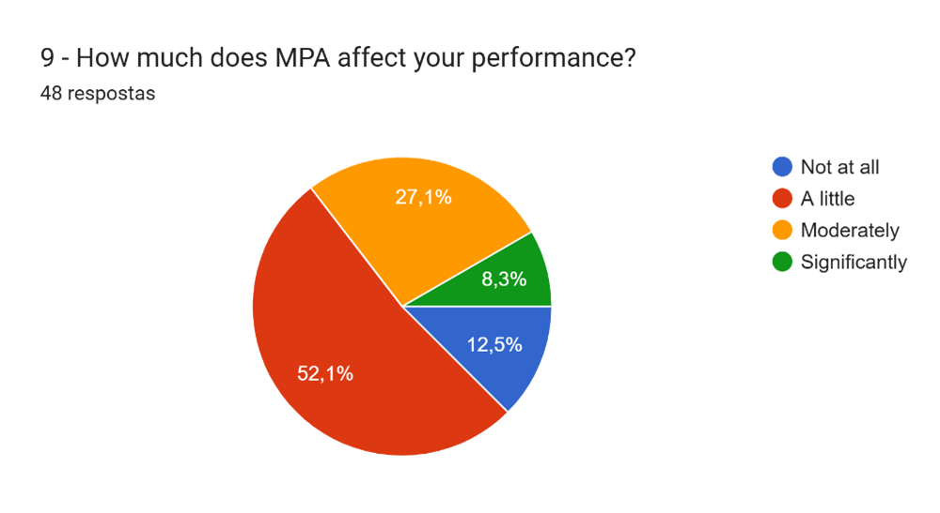(Graph 3)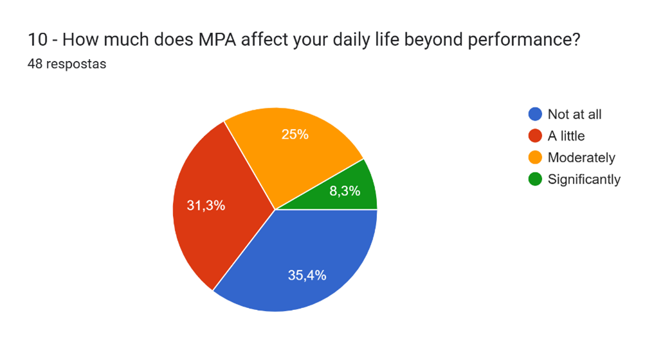(Graph 4)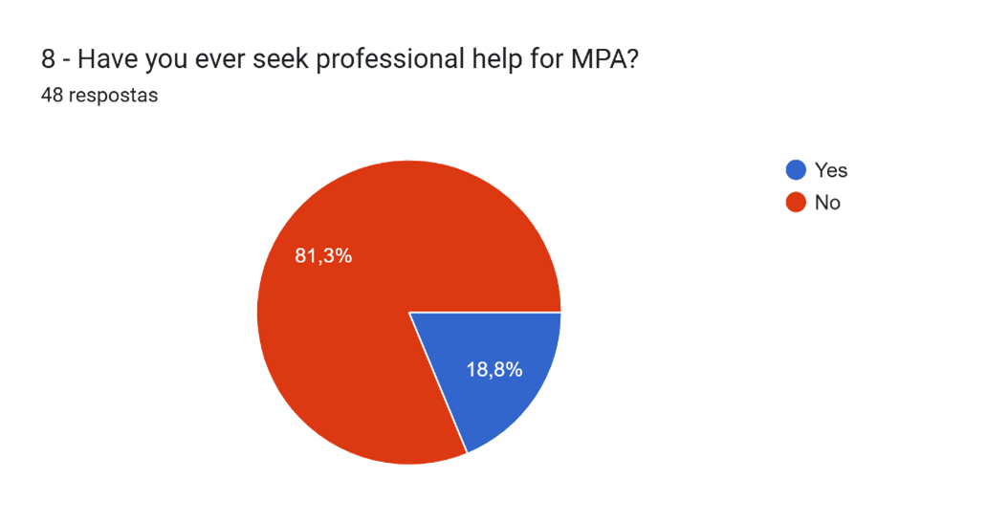(Graph 5)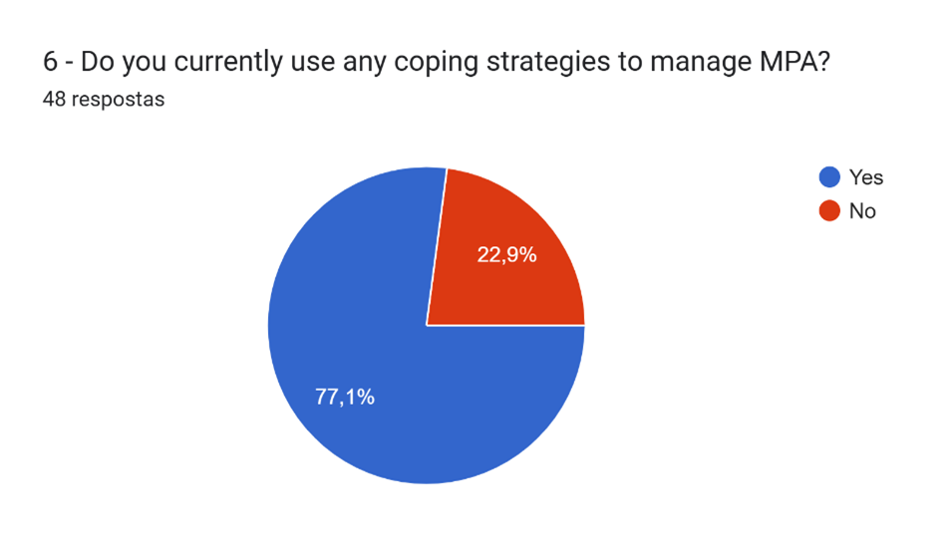(Graph 6)
MPA's Impact on Performance (Graph 3)
The majority of participants reported that MPA affects their performance to some degree.
- 52.1% indicated that MPA affects them “a little”,
- 27.1% reported being affected “moderately”,
- 8.3% described a “significant” impact,
- while only 12.5% stated that MPA does not affect their performance.
This indicates that nearly nine out of ten performers experience some level of performance impairment, supporting the quantitative finding of elevated K-MPAI scores across the sample. The high proportion reporting “a little” may reflect attempts to minimize its impact, but the combined “moderate” and “significant” responses show that over one-third of participants face more substantial performance disruption.

MPA’s Spillover Into Daily Life (Graph 4)
Interestingly, the degree to which MPA affects life beyond performance shows a different distribution.
- 35.4% reported no daily-life impact,
- 31.3% reported “a little,”
- 25% reported “moderately,”
- 8.3% reported “significantly.”
Compared with performance impact, more participants selected “Not at all”, suggesting that for many, MPA is situational, emerging primarily in evaluative contexts rather than as a chronic, pervasive anxiety disorder. However, the quarter of respondents reporting moderate daily-life disruption indicates that a meaningful minority experiences generalised anxiety spillover, consistent with the qualitative themes involving chronic worry, somatic tension, and cognitive overload (Themes 1 and 4).

Low Rates of Professional Help-Seeking (Graph 5)
A striking finding emerges in the domain of support-seeking:
- 81.3% of participants have never sought professional help for MPA.
- Only 18.8% have done so.
Given that nearly all respondents report some impact on performance, this extremely low rate of formal help-seeking suggests multiple possibilities:
- normalization of anxiety within artistic culture,
- lack of access to specialized psychological support,
- stigma around acknowledging psychological difficulties, or
- limited awareness of evidence-based interventions.
This aligns with qualitative accounts in which participants expressed feeling unsupported, uncertain about available services, or doubtful that help would be accessible or effective.
High Use of Coping Strategies, Despite Low Help-Seeking (Graph 6)
In contrast to the low level of professional help-seeking,
- 77.1% of participants reported using coping strategies,
- while 22.9% reported not using any.
The majority therefore rely on self-directed or informal methods to regulate MPA. This suggests a strong desire to manage symptoms, but potentially without guidance from trained professionals. The qualitative data (particularly Themes 3 and 6) reflect reliance on internal strategies such as:
- self-monitoring,
- avoidance of certain situations,
- mental rehearsal,
- breathing techniques,
- reframing anxiety, or
- developing tolerance through experience.
This discrepancy, high coping, low treatment, indicates a broader structural issue in the performing arts context: performers actively attempt to manage anxiety, but they do so privately, without systemic or institutional support.
(f) Differences in Perceived Precarity Between Students and Professionals
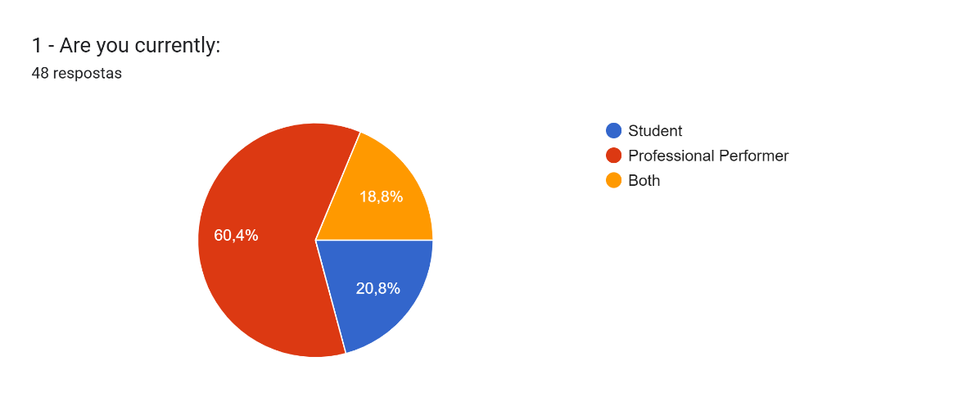(Graph7)
Although the number of students and professionals in the sample was uneven, this comparison remains analytically valuable. The imbalance does not undermine the qualitative interpretation and was considered when reviewing quantitative patterns. Despite different group sizes, both datasets revealed a clear divide in how precarity is perceived and experienced in the Portuguese performing arts sector. Professionals consistently reported higher levels of perceived precarity, both emotionally and somatically, reflecting their lived exposure to instability, irregular income, limited networks, and gatekeeping practices.
Quantitatively, professionals scored higher on all items related to precarious working conditions, particularly regarding the belief that precarity increases stress and anxiety. Qualitatively, they described daily uncertainty, financial strain, and restricted opportunities as defining features of their careers. In contrast, students expressed anticipatory rather than lived precarity. Their concerns tended to focus on future challenges, shaped by limited labour-market experience and relative insulation within educational settings.
These differences were especially evident in responses to Questions 5 and 7. Most professionals responded “No” when asked if sufficient opportunities exist in Portugal, citing few openings and opaque selection practices, while students frequently chose “Unsure.” Many professionals also reported considering emigration or leaving the arts due to instability, whereas students expressed uncertainty rather than concrete intentions. Overall, these patterns suggest that professional experience heightens both awareness and embodiment of precarity, with implications for wellbeing and career sustainability.

4.4.2 Divergences Between Quantitative and Qualitative Findings
Three key divergences emerged:
(a) A minority resists the pressure of precarity
Qualitatively, some participants expressed resilience or acceptance: “I have already accepted instability as part of the profession.”. These participants did not show strong emotional reactivity to instability.
This voice is important because, while the correlation suggests precarity increases MPA, the qualitative data show that individual coping strategies can modulate this effect.

(b) Some performers do not internalize external judgement
Even though most participants feared evaluation, a few resisted: “I don’t care what others think anymore.”. This indicates variability in the internalization of scrutiny, an aspect that quantitative tools cannot detect.

(c) Stress can be facilitative for a small subgroup
A minority described stress as energizing: “Stress gives me adrenaline.”
This contradicts the typical negative association between stress and performance anxiety and highlights the possibility of challenge states rather than threat states.

4.4.3. Conceptual Model: The Precarity - MPA Cycle
The integrated findings support the existence of a cyclical, mutually reinforcing model linking precarity and MPA:
Stage 1 - Precarious Working Conditions
- High competition
- Irregular income
- Short-term contracts
- Limited access to networks
- Opaque audition processes
These conditions create a structural baseline of instability.

Stage 2 - Emotional and Cognitive Stress Accumulation
Instability generates:
- chronic worry
- low predictability
- cognitive load
- diminished emotional resources

Stage 3 - Somatic Activation and Heightened MPA
Stress spills into performance contexts:
- shaking
- tension
- difficulty breathing
- inability to focus
- rumination
This matches high scores on Somatic/Worry and Self-Scrutiny scales.

Stage 4 — Decline in Performance Confidence
As anxiety intensifies:
- self-doubt increases
- errors stand out
- attention shifts inward
- perceived judgement increases
This is reflected in Themes 3, 5, and 6.

Stage 5 — Impaired Performance and Reduced Opportunities
MPA can undermine:
- audition outcomes
- consistency
- artistic communication
- perceived reliability
Participants described missing opportunities due to anxiety-driven performance issues.

Stage 6 — Reinforced Precarity
Reduced opportunities produce:
- fewer gigs
- lower income
- decreased visibility
- more instability
This pushes the performer back to Stage 1, creating a self-perpetuating precarity–MPA loop.

4.4.4 Overall Conclusion
The mixed-methods findings reveal a powerful, reciprocal relationship between Music Performance Anxiety and professional precarity among performers in Portugal.
Key conclusions include:
- MPA is widespread, with moderate to high levels across participants.
- Structural precarity significantly predicts higher MPA.
- Thematic analysis shows how instability infiltrates emotional, cognitive, and embodied experiences.
- Younger and less experienced performers are particularly vulnerable, though precarity affects all career stages.
- While students anticipate future instability, professionals embody its effects, resulting in significantly higher precarity-related stress and MPA.
- Anxiety is shaped by interactions between:
- structural inequalities
- identity-based pressure
- perfectionism
- somatic reactivity
- emotional exhaustion
- A small minority offers counter-narratives, demonstrating heterogeneity in coping.
- The Precarity - MPA Cycle provides a compelling explanatory model linking labor conditions to psychological wellbeing.
Overall, the data suggests that MPA is not only a psychological phenomenon but a socio-structurally embedded one, shaped and amplified by precarious working conditions in the performing arts.

Conclusions and recommendations
This study examined how MPA connects to professional precarity among Portuguese performers. Although MPA is well researched internationally, little work has explored it in Portugal or in relation to labor instability. Using mixed methods, the study shows that MPA arises not only from individual factors but also from structural and cultural conditions in the artistic sector.
Summary of Key Findings
MPA was highly prevalent across participants, aligning with international research (Steptoe & Fidler, 1987; Damas, 2017). Younger and less experienced performers showed the highest anxiety, supporting evidence of early-career vulnerability (Barros et al., 2022).
A key finding was the positive correlation between precarity and MPA: those who felt more unstable or unsupported reported higher anxiety.
Qualitative accounts reinforced this, describing instability, gatekeeping, exhaustion, self-doubt, and identity pressure, mirroring MPA mechanisms (Kenny, 2011) and Portuguese labour realities (Conde, 2009; Campanela, 2023).
While most data converged, a minority expressed resilience or acceptance of instability.
Overall, MPA appears to result from both individual factors and structural precarity.

Contribution to Knowledge
Theoretically, this study broadens MPA research by linking anxiety to socio-economic labor conditions, an area rarely examined. Empirically, it provides scarce Portuguese evidence showing how instability and limited opportunities heighten anxiety, with professionals affected more deeply than students. Methodologically, it demonstrates the usefulness of mixed-methods for analyzing psychological–structural interactions.”
Recommendations
Artistic training should integrate MPA education, basic somatic tools, and CBT-informed strategies, supported by teacher training. Peer initiatives and workshops may help reduce stigma and build resilience.
Addressing structural precarity requires sector-wide improvements—transparent auditions, fair pay, stable contracts, and labor policies that reduce reliance on “recibos verdes.”
Given high MPA levels but low help-seeking, institutions should offer accessible psychological support, such as low-intensity interventions, ACC, ASR, CBT elements, and somatic grounding adapted to Portuguese contexts.

Limitations
The exploratory sample limits generalizability, and the uneven distribution of students and professionals affects comparisons. Self-report data are subjective and do not represent clinical diagnoses. Nonetheless, the study offers meaningful insight into an under-researched area.
Future Research
Future work should examine the precarity–MPA relationship longitudinally, compare different artistic disciplines, and consider gender, socioeconomic and identity variables.
Larger, more diverse samples and ethnographic or participatory approaches would deepen insight into how performers internalise precarity.
A key next step is piloting an MPA workshop to test the usefulness of psychoeducational and cognitive-somatic interventions in real time.

Final Conclusion
MPA among Portuguese performers emerges from both psychological and structural sources. By integrating personal accounts with evidence of unstable working conditions, the study emphasises the need for context-sensitive support. Understanding MPA through the lens of precarity can guide institutional, pedagogical, and psychological strategies to help build more sustainable artistic careers in Portugal.

References

Asselin, M. E. (2003). Insider research: Issues to consider when doing qualitative research in your own setting. Journal for Nurses in Staff Development, 19(2), 99–103.
Barlow, D. H. (1988). Anxiety and its disorders: The nature and treatment of anxiety and panic. Guilford Press.
Barlow, D. H. (2000). Unravelling the mysteries of anxiety and its disorders from the perspective of emotion theory. American Psychologist, 55(11), 1247–1263.
Barros, S. et al. (2022). Characteristics of music performance anxiety among undergraduate music students: A systematic review. Psychology of Music, 50(6), 2021–2043.
Barros, S. et al. (2024). Music performance anxiety: Development and validation of the Portuguese music performance anxiety scale. Frontiers in Psychology, 15, 1436216.
Biesta, G. (2010). Pragmatism and the philosophical foundations of mixed methods research. SAGE.
Borges, V., & Veloso, L. (2020). Emerging patterns of artistic organizations in Portugal: A three case studies analysis.
Boyett, C. (2020). Music Performance Anxiety: The Role of Teachers in Addressing Anxiety. MTNA e-Journal.
Braun, V., & Clarke, V. (2006). Using thematic analysis in psychology. Qualitative Research in Psychology, 3(2), 77–101.
Braun, V., & Clarke, V. (2019). Reflecting on reflexive thematic analysis. Qualitative Research in Sport, Exercise and Health.
Braun, V., & Clarke, V. (2021). Thematic Analysis: A Practical Guide. SAGE.
Brannick, T., & Coghlan, D. (2007). In defense of being “native”: The case for insider academic research. Organizational Research Methods, 10(1), 59–74.
British Psychological Society. (2021). Code of Human Research Ethics.
Campanela, C. (2023). Da Dessacralização da Arte: topologia breve e inacabada do meio artístico. Sinais de Cena, 224–241.
Clark, D. M., & Wells, A. (1995). A cognitive model of social phobia. In Social phobia: Diagnosis, assessment, and treatment (pp. 69–93). Guilford.
Conde, I. (2009). Artists as vulnerable workers. CIES-ISCTE.
Correia, T. F. B. (2012). A ansiedade na performance musical: estudo de caso em jovens violetistas.
Creswell, J. W., & Plano Clark, V. L. (2018). Designing and Conducting Mixed Methods Research (3rd ed.). SAGE.
Creswell, J. W., & Tashakkori, A. (2021). The new era of mixed methods research. Journal of Mixed Methods Research.
Damas, C. (2017). Evaluation of the anxiety prevalence relative to musical performance in classical musicians. Revista Portuguesa de Educação Artística, 7(1).
Ermida, & Pratas-Cruzeiro. (2024). Contemporary performing arts in Portugal.
Greene, J. C., Caracelli, V. J., & Graham, W. F. (1989). Toward a conceptual framework for mixed-method evaluation designs. Educational Evaluation and Policy Analysis, 11(3), 255–274.
Guardão, M. J. (2018). Contemporary performing arts in Portugal: An overview. IETM.
Henshaw, A., & Collyer, S. (2022). Under Pressure: Reports of Performance Anxiety Across Multiple Singing Genres. Journal of Singing, 78(5), 583–590.
Hildebrandt, H., Nübling, M., & Candia, V. (2012). Increment of fatigue, depression, and stage fright during the first year of high-level music education. Medical Problems of Performing Artists, 27(1), 43–48.
Hrvatin, V., Buh, M. R., & Ribič, J. (2021). Our little clinic. Maska, 36(205–206), 80–90.
Kenny, D. (2005). A systematic review of treatments for music performance anxiety. Anxiety, Stress & Coping, 18, 183–208.
Kenny, D. T. (2006). Music Performance Anxiety: Origins, phenomenology, assessment, and treatment. Context, 31, 51–64.
Kenny, D. T. (2011). The Psychology of Music Performance Anxiety.
Kenny, D. T., & Halls, N. (2018a). Development and evaluation of two brief group interventions for music performance anxiety in community musicians. Psychology of Music, 46(1), 66–83.
Lockwood, A. H. (1989). Medical problems of musicians. New England Journal of Medicine, 320(4), 221–227.
MacAfee, E., & Comeau, G. (2023). Teacher perspectives on music performance anxiety. British Journal of Music Education, 40(1), 34–53.
Mahony, S. E., Juncos, D. G., & Winter, D. (2022). Acceptance and Commitment Coaching for music performance anxiety. Frontiers in Psychology, 13.
Mazzarolo, I., Burwell, K., & Schubert, E. (2023). Teachers’ approaches to MPA management: A systematic review. Frontiers in Psychology, 14.
Morgan, D. L. (2007). Paradigms lost and pragmatism regained. Journal of Mixed Methods Research, 1(1), 48–76.
Moura, N., & Serra, S. (2021). Listening to teachers’ voices. Journal of Science and Technology of the Arts, 13(2), 99–117.
Nagel, J. J. (2009). How to destroy creativity in music students. Medical Problems of Performing Artists, 24(1), 15–17.
Oliveira, A. (2019). Do ethos à praxis: Carreiras DIY na cena musical independente em Portugal.
Palinkas, L. A. et al. (2015). Purposeful sampling for qualitative data in mixed-method research. Administration and Policy in Mental Health, 42, 533–544.
Steptoe, A. (1982). Performance Anxiety: Recent developments. The Musical Times, 123(1674), 537.
Steptoe, A. (2001). Negative emotions in music-making. In Music and Emotion.
Steptoe, A., & Fidler, H. (1987). Stage fright in orchestral musicians. British Journal of Psychology, 78(2).
Studer, R. et al. (2011). Stage fright: Its experience and coping. International Archives of Occupational and Environmental Health, 84(7), 761–771.
Valentine, E. (2002). The fear of performance. In J. Rink (Ed.), Musical Performance: A Guide to Understanding.
Zhukov, K. (2019). Current approaches for managing MPA. Medical Problems of Performing Artists, 34(1), 53–60.

Appendix 1 – Consent Form

Consent form for participants to take part in research, Margarida Silva 2025
Title of project: ‘Music Performance Anxiety (MPA) in the Portuguese Artistic Sector’
- I……………………………………… voluntarily agree to participate in this research study.
- I understand that even if I agree to participate now, I can withdraw at any time or refuse to answer any question without any consequences of any kind.
- I understand that I can withdraw permission to use data from my questionnaire in which case the material will be deleted.
- I have had the purpose and nature of the study explained to me in writing and I have had the opportunity to ask questions about the study.
- I understand that participation involves completion of a questionnaire.
- I understand that I will not benefit directly from participating in this research.
- I understand that all information I provide for this study will be treated confidentially.
- I understand that in any report on the results of this research my identity will remain anonymous. This will be done by changing my name and disguising any details of my responses which may reveal my identity or the identity of people I speak about.
- I understand that disguised extracts from my responses may be quoted in the written report and presentation.
- I understand that signed consent forms will be retained in a password protected laptop until March 2026.
- I understand that a transcript of my responses in which all identifying information has been removed will be retained for two years until March 2026.
- I understand that under freedom of information legalisation I am entitled to access the information I have provided at any time while it is in storage as specified above.
- I understand that I am free to contact any of the people involved in the research to seek further clarification and information.
Researcher: Margarida Silva, margarida.tbs@hotmail.com, tel. +351967385038
Supervisors: Joshua Lee-Cummins, Louise Emanuel, Julie Crossman and Debbie Winter

Signature of research participant………………………………………………….
Date: ……………………………..
Signature of researcher …………………………………….I believe the participant is giving informed consent to participate in this study
Date:………………………………

Appendix 2: Ethics Form

RESEARCH STUDENTS
This form is to be completed by the student within SIX months for full-time students and TWELVE months for part time students, after the commencement of the research degree or following progression to Part Two of your course.

Once complete, submit this form via the MyTSD Doctoral College Portal at (https://mytsd.uwtsd.ac.uk).

This document is also available in Welsh.

RESEARCH STAFF ONLY
All communications relating to this application during its processing must be in writing and emailed to pgresearch@uwtsd.ac.uk , with the title ‘Ethical Approval’ followed by your name.

STUDENTS ON UNDERGRADUATE OR TAUGHT MASTERS PROGRAMMES should submit this form (and receive the outcome) via systems explained to you by the supervisor/module leader.

In order for research to result in benefit and minimise risk of harm, it must be conducted ethically. A researcher may not be covered by the University’s insurance if ethical approval has not been obtained prior to commencement.

The University follows the OECD Frascati manual definition of research activity: “creative work undertaken on a systematic basis in order to increase the stock of knowledge, including knowledge of man, culture and society, and the use of this stock of knowledge to devise new applications”. As such this covers activities undertaken by members of staff, postgraduate research students, and both taught postgraduate and undergraduate students working on dissertations/projects.

The individual undertaking the research activity is known as the “principal researcher”.

Ethical approval is not required for routine audits, performance reviews, quality assurance studies, testing within normal educational requirements, and literary or artistic criticism.

Please read the notes for guidance before completing ALL sections of the form.

This form must be completed and approved prior to undertaking any research activity. Please see Checklist for details of process for different categories of application.

SECTION A: About You (Principal Researcher)
1 | Full Name: |  | Margarida Teixeira Batista e Silva
2 | Tick all boxes that apply: |  | Member of staff: | ☐ | Honorary research fellow: | ☐
 | Undergraduate Student | ☐ | Taught Postgraduate Student | ☒ | Postgraduate Research Student | ☐

3 | Institute/Academic Discipline/Centre: | WAPPAR
4 | Campus: | Carmarthen
5 | E-mail address: | margarida.tbs@hotmail.com
6 | Contact Telephone Number: | 00351967385038
 | For students:
7 | Student Number: | 2030461
8 | Programme of Study: | MA in Professional Practice (Voice Pedagogy)
9 | Director of Studies/Supervisor: | Louise Emanuel/Julie Crossman/Debbie Winter

SECTION B: Approval for Research Activity
1 | Has the research activity received approval in principle?  (please check the Guidance Notes as to the appropriate approval process for different levels of research by different categories of individual) |  | YES | ☒ | NO | ☐
 |  |  |  |  | Date
2 | If Yes, please indicate source of approval (and date where known): Approval in principle must be obtained from the relevant source prior to seeking ethical approval | Research Degrees Committee |  | ☐
2 |  | Institute Research Committee |  | ☐
2 |  | Other (WAPPAR Ethics Board Representative) |  | ☒

SECTION C: Internal and External Ethical Guidance Materials
 | Please list the core ethical guidance documents that have been referred to during the completion of this form (including any discipline-specific codes of research ethics, location-specific codes of research ethics, and also any specific ethical guidance relating to the proposed methodology). Please tick to confirm that your research proposal adheres to these codes and guidelines. You may add rows to this table if needed.
1 | UWTSD Research Ethics & Integrity Code of Practice | ☒
2 | UWTSD Research Data Management Policy | ☒
3 | https://mec-anticorrupcao.pt/wp-content/uploads/2025/02/referencial-de-educacao-para-transparencia-e-integridade.pdf  https://www.allea.org/wp-content/uploads/2018/11/ALLEA-European-Code-of-Conduct-for-Research-Integrity-2017-Digital_PT.pdf | ☒

SECTION D: External Collaborative Research Activity
If there are external collaborators then you should gain consent from the contact persons to share their personal data with the university. If there are no external collaborators then leave this section blank and continue to section E.
1 | Institution
2 | Contact person name
3 | Contact person e-mail address
4 | Is your research externally funded? |  | YES | ☐ | NO |  | ☐
5 | Are you in receipt of a KESS scholarship? |  | YES | ☐ | NO |  | ☐
6 | Are you specifically employed to undertake this research in either a paid or voluntary capacity? | Voluntary | YES | ☐ | NO | ☐
7 |  | Employed | YES | ☐ | NO | ☐
8 | Is the research being undertaken within an existing UWTSD Athrofa Professional Learning Partnership (APLP)? | If YES then the permission question below does not need to be answered. | YES | ☐ | NO |  | ☐
9 | Has permission to undertake the research has been provided by the partner organisation? | (If YES attach copy)  If NO the application cannot continue | YES | ☐ | NO |  | ☐

Where research activity is carried out in collaboration with an external organisation
10 | Does this organisation have its own ethics approval system? | YES | ☐ | NO | ☐
 | If Yes, please attach a copy of any final approval (or interim approval) from the organisation (this may be a copy of an email if appropriate).

SECTION E: Details of Research Activity
1 | Indicative title: | Exploring the Portuguese experiences with Music Performance Anxiety (MPA), perceived causes, coping mechanisms, and the role of institutional or sector-specific pressures.
2 | Proposed start date: | 14-07-2025 | Proposed end date: | 02-03-2026
Introduction to the Research (maximum 300 words per section)
Ensure that you write for a Non-Specialist Audience when outlining your response to the points below:
- Purpose of Research Activity
- Proposed Research Question
- Aims of Research Activity
- Objectives of Research Activity
Demonstrate, briefly, how Existing Research has informed the proposed activity and explain
- What the research activity will add to the body of knowledge
- How it addresses an area of importance.
3 | Purpose of Research Activity  This research aims to explore the Portuguese experiences with Music Performance Anxiety (MPA), perceived causes, coping mechanisms, and the role of institutional or sector-specific pressures in students and professionals. And to evaluate the relevance and effectiveness of incorporating therapeutic interventions within artistic educational institutions.  (this box should expand as you type)
4 | Research Question  Are the Music Performance Anxiety (MPA) symptoms of Performing Artists students and professionals influenced by the realities of the Portuguese artistic sector, and is it relevant and effective to incorporate therapeutic interventions in artistic educational institutions?  (this box should expand as you type)
5 | Aims of Research Activity  In my previous study, I conducted a literature-based investigation to identify evidence-based strategies for effectively managing MPA, exploring the potential correlation between the professional challenges encountered within Portugal’s Performing Arts industry and manifestation of MPA among aspiring performers, and investigate the significance of integrating MPA awareness and coping strategies into the curriculum of Performing Arts education. Building upon that foundation, the current research aims to further develop this inquiry through empirical investigation. Specifically, this study will explore MPA through first-hand engagement with both Performing Arts students and professional performers, in order to assess the practical relevance, effectiveness, and contextual appropriateness of therapeutic interventions in real-world educational and professional settings.  It aims to explore the influence of the Portuguese artistic sector's realities on the development and manifestation of MPA symptoms in students and professional performers in first hand, and to evaluate the relevance and effectiveness of incorporating therapeutic interventions within artistic educational institutions .  (this box should expand as you type)
6 | Objectives of Research Activity  With this research activity I intend to:  - Identify and analyse the most common symptoms and levels of MPA among Performing Artists students and professional performers in Portugal.  - Gather empirical evidence of the specific socio-cultural and professional pressures within the Portuguese artistic sector that may contribute to MPA in these performers.  - Assess the potential relevance and effectiveness of implementing therapeutic interventions, such as cognitive-behavioral therapy, mindfulness, or performance coaching, in reducing MPA symptoms.  - Apply a range of therapeutic strategies in performers suffering from MPA problems and evaluate the results and progress from this testing.  - Provide recommendations for integrating mental health support and therapeutic strategies into artistic education curricula and institutional practices  (this box should expand as you type)
Proposed methods (maximum 600 words)
Provide a brief summary of all the methods that may be used in the research activity, making it clear what specific techniques may be used. If methods other than those listed in this section are deemed appropriate later, additional ethical approval for those methods will be needed. You do not need to justify the methods here, but should instead describe how you intend to collect the data necessary for you to complete your project.
7 | To achieve the objectives of this study, a mixed-methods approach will be adopted, combining both qualitative and quantitative data collection. This will enable a more comprehensive understanding of how Music Performance Anxiety (MPA) manifests in Portuguese Performing Arts students and professional performers, and how therapeutic interventions may be relevant and effective in addressing it. The following practical activities will be undertaken:  - Participant Recruitment  A purposive sampling strategy will be used to recruit participants from two key groups:  - Performing Arts students enrolled in Musical Theatre, Singing or similar programs within Portuguese artistic educational institutions or one two one classes as well.  - Professional performers, including singers and performing artists actively or that have previously worked in the Portuguese artistic sector.  - Questionnaire Distribution  A standardized questionnaire will be administered to gather quantitative data on the prevalence, severity, and characteristics of MPA symptoms. This will include:  - A validated scale such as the Kenny Music Performance Anxiety Inventory (K-MPAI) or Performance Anxiety Questionnaire (PAQ).  - Custom questions addressing the specific realities of the Portuguese artistic and educational sectors.  - Demographic questions to support contextual analysis.  This instrument will be distributed online to reach a broader and more diverse participant base. Data gathered from the questionnaire will also be used to inform the qualitative phases of the study.  - Semi-Structured Interviews  In-depth semi-structured interviews will be conducted with participants to explore their personal experiences with Music Performance Anxiety (MPA), perceived causes, coping mechanisms, and the role of institutional or sector-specific pressures. These interviews will also explore participants’ attitudes toward, and experiences with, therapeutic or psychological support.  - Focus Groups or Workshops  Interactive group sessions (focus groups or workshops) will be designed and facilitated to explore how different therapeutic interventions (e.g., breathing techniques, mindfulness, CBT strategies) are received and perceived by participants. These sessions may also serve as short pilot interventions.  The proposed group sessions will be conducted over a defined period of approximately 6 to 8 weeks. These sessions are designed as structured, time-limited interventions aimed at exploring and applying strategies for managing Music Performance Anxiety (MPA). Two implementation options are being considered: (1) sessions involving only Performing Arts students, or (2) mixed-group sessions that include both students and professional performers who self-identify as experiencing MPA symptoms and who express an interest in actively engaging with therapeutic strategies. The choice between these two formats will depend on participant availability, institutional support, and the potential for peer learning across different stages of artistic development.  - Observation and Reflective Journaling  Where appropriate, participants may be invited to engage in a short-term application of selected techniques, followed by reflective journaling or discussion. This would provide insight into the practical impact of the interventions on performance anxiety symptoms over a brief period.  - Data Analysis  All collected qualitative data (interviews, workshop transcripts, reflections) will be thematically analyzed to identify key patterns, recurring concerns, and potential areas for institutional or curricular improvement in supporting students with MPA.  (this box should expand as you type)
Location of research activity
Identify all locations where research activity will take place.
8 | EDSAE – Escola de Dança e Teatro Musical - Lisbon, Portugal  Stagedoor – Escola de Teatro Musical – Lisbon, Portugal  (this box should expand as you type)
Research activity outside of the UK
If research activity will take place overseas, you are responsible for ensuring that local ethical considerations are complied with and that the relevant permissions are sought. Specify any local guidelines (e.g. from local professional associations/learned societies/universities) that exist and whether these involve any ethical stipulations beyond those usual in the UK (provide details of any licenses or permissions required). Also specify whether there are any specific ethical issues raised by the local context in which the research activity is taking place, for example, particular cultural and/or legal sensitivities or vulnerabilities of participants. If you live in the country where you will do the research then please state this.
9 | The majority of my research will be undertaken at the two institutions that I work with, with some of my regular students and colleagues.  (There are no specific ethical issues raised by the local context in which the research activity is taking place)  (this box should expand as you type)

10 | Use of documentation not in the public domain: Are any documents NOT publicly available? | NO | ☒
10 |  | YES | ☐
11 | If Yes, please provide details here of how you will gain access to specific documentation that is not in the public domain and that this is in accordance with the current data protection law of the country in question and that of England and Wales.  (this box should expand as you type)

 | Does your research relate to one or more of the seven aims of the Well-being of Future Generations (Wales) Act 2015? | YES | NO
12 | A prosperous Wales | ☐ | ☒
13 | A resilient Wales | ☐ | ☒
14 | A healthier Wales | ☐ | ☒
15 | A more equal Wales | ☐ | ☒
16 | A Wales of cohesive communities | ☐ | ☒
17 | A Wales of vibrant culture and thriving Welsh language | ☐ | ☒
18 | A globally responsible Wales | ☐ | ☒
19 | If YES to any of the above, please give details:
 | (this box should expand as you type)

SECTION F: Scope of Research Activity
 | Will the research activity include: | YES | NO
1 | Use of a questionnaire or similar research instrument? | ☒ | ☐
2 | Use of interviews? | ☒ | ☐
3 | Use of focus groups? | ☒ | ☐
4 | Use of participant diaries? | ☒ | ☐
5 | Use of video or audio recording? | ☒ | ☐
6 | Use of computer-generated log files? | ☐ | ☒
7 | Participant observation with their knowledge? | ☒ | ☐
8 | Participant observation without their knowledge? | ☐ | ☒
9 | Access to personal or confidential information without the participants’ specific consent? | ☐ | ☒
10 | Administration of any questions, test stimuli, presentation that may be experienced as physically, mentally or emotionally harmful / offensive? | ☐ | ☒
11 | Performance of any acts which may cause embarrassment or affect self-esteem? | ☐ | ☒
12 | Investigation of participants involved in illegal activities? | ☐ | ☒
13 | Use of procedures that involve deception? | ☐ | ☒
14 | Administration of any substance, agent or placebo? | ☐ | ☒
15 | Working with live vertebrate animals? | ☐ | ☒
16 | Procedures that may have a negative impact on the environment? | ☐ | ☒
17 | Other primary data collection methods. Please indicate the type of data collection method(s) below. | ☐ | ☒
 | Details of any other primary data collection method:  (this box should expand as you type) | ☐ | ☒
If NO to every question, then the research activity is (ethically) low risk and may be exempt from some of the following sections (please refer to Guidance Notes).

If YES to any question, then no research activity should be undertaken until full ethical approval has been obtained.

SECTION G: Intended Participants
If there are no participants then do not complete this section, but go directly to section H.

 | Who are the intended participants: | YES | NO
1 | Students or staff at the University? | ☐ | ☒
2 | Adults (over the age of 18 and competent to give consent)? | ☒ | ☐
3 | Vulnerable adults? | ☐ | ☒
4 | Children and Young People under the age of 18? (Consent from Parent, Carer or Guardian will be required) | ☒ | ☐
5 | Prisoners? | ☐ | ☒
6 | Young offenders? | ☐ | ☒
7 | Those who could be considered to have a particularly dependent relationship with the investigator or a gatekeeper? | ☐ | ☒
8 | People engaged in illegal activities? | ☐ | ☒
9 | Others. Please indicate the participants below, and specifically any group who may be unable to give consent. | ☐ | ☒
 | Details of any other participant groups:  (this box should expand as you type) | ☐ | ☒

Participant numbers and source
Provide an estimate of the expected number of participants. How will you identify participants and how will they be recruited?
10 | How many participants are expected? | The study aims to involve approximately 50 to 70 participants in total, across both the quantitative and qualitative phases.  Questionnaire Phase:  A target sample of 40–60 participants will be recruited to complete the standardized Music Performance Anxiety (MPA) questionnaire. This larger sample will provide a broad overview of MPA symptoms and prevalence among individuals in the Portuguese artistic sector.  (this box should expand as you type)
11 | Who will the participants be? | Qualitative Phase (Interviews and/or Focus Groups):  A smaller, purposively selected group of approximately 10–15 participants will be invited to participate in semi-structured interviews and/or focus groups. This will include:  - 5 to 10 Performing Arts students from music, theatre, or musical theatre or any performing art involving singing programs. Age groups 13 - 25  - 5 to 10 professional performers, such as singers, or performing artists actively working in the Portuguese artistic sector. Age groups 20 - 60  Pilot Intervention Group Sessions:  If feasible, 6–10 participants from the above group (volunteers who report experiencing MPA symptoms) may be invited to take part in a short-term, practice-based group session (over 6–8 weeks) to explore therapeutic techniques.  (this box should expand as you type)
12 | How will you identify the participants? | Participants will include Singing and Performing Arts students  and professional performers that are or were studying / working within the Portuguese artistic industry who self-identify as experiencing MPA or related performance anxiety symptoms. A willingness to share experiences related to MPA will also be part of the inclusion criteria  For the intervention group: self-identification with MPA symptoms and interest in engaging with therapeutic tools.  Contact will be made with relevant Portuguese educational institutions, conservatoires, and performing art schools.  Recruitment will also occur through social media, professional networks, theatre and music associations, and arts organizations. Public calls for participation may be shared via relevant mailing lists and digital platforms.  (this box should expand as you type)

 | Information for participants: | YES | NO | N/A
13 | Will you describe the main research procedures to participants in advance, so that they are informed about what to expect? | ☒ | ☐ | ☐
14 | Will you tell participants that their participation is voluntary? | ☒ | ☐ | ☐
15 | Will you obtain written consent for participation? | ☒ | ☐ | ☐
16 | Will you explain to participants that refusal to participate in the research will not affect their treatment or education (if relevant)? | ☐ | ☐ | ☒
17 | If the research is observational, will you ask participants for their consent to being observed? | ☒ | ☐ | ☐
18 | Will you tell participants that they may withdraw from the research at any time and for any reason? | ☒ | ☐ | ☐
19 | With questionnaires, will you give participants the option of omitting questions they do not want to answer? | ☒ | ☐ | ☐
20 | Will you tell participants that their data will be treated with full confidentiality and that, if published, it will not be identifiable as theirs? | ☒ | ☐ | ☐
21 | Will you debrief participants at the end of their participation, in a way appropriate to the type of research undertaken? | ☒ | ☐ | ☐
22 | If NO to any of above questions, please give an explanation
 | (this box should expand as you type)

 | Information for participants: | YES | NO | N/A
24 | Will participants be paid? | ☐ | ☒ | ☐
25 | Is specialist electrical or other equipment to be used with participants? | ☒ | ☐ | ☐
26 | Are there any financial or other interests to the investigator or University arising from this study? | ☐ | ☒ | ☐
27 | Will the research activity involve deliberately misleading participants in any way, or the partial or full concealment of the specific study aims? | ☐ | ☒ | ☐
28 | If YES to any question, please provide full details
I will be using a camera and my phone’s voice recorder to record students Interviews.

(this box should expand as you type)

SECTION H: Anticipated Risks

Outline any anticipated risks that may adversely affect any of the participants, the researchers and/or the University, and the steps that will be taken to address them.

If you have completed a full risk assessment (for example as required by a laboratory, or external research collaborator) you may append that to this form.
1 | Full risk assessment completed and appended? |  | Yes | ☐
1 |  |  | No | ☒
2 | Risks to participants  For example: sector-specific health & safety, emotional distress, financial disclosure, physical harm, transfer of personal data, sensitive organisational information
 | Risk to participants:  - Considering that I will be recording and taking notes of the observations as well as transcribing the data, there will be the risk of some personal data disclosure.  - Sector-Specific Pressures (Artistic Industry Vulnerability) - Professional participants may feel uncomfortable discussing challenges related to the Portuguese artistic sector, fearing negative professional consequences if comments are linked to them.  - Participants will be asked to reflect on and discuss personal experiences with Music Performance Anxiety (MPA), which may include stress, self-doubt, performance trauma, or mental health struggles.  (this box should expand as you type) | How you will mitigate the risk to participants:  - I will mitigate this risk by ensuring I use a code for all the participants and having all data stored on my password secured computer of which only I have access.  - This risk will be mitigated by fully anonymizing all data, clearly informing participants that no identifiable information will be shared and ensuring secure data storage accessible only to the researcher and supervisor.  - This risk will be mitigated by informing participants of their right to skip questions or withdraw at any time, offering access to support services, and using sensitive, non-judgmental language throughout the research.  (this box should expand as you type)
3 | If research activity may include sensitive, embarrassing or upsetting topics (e.g. sexual activity, drug use) or issues likely to disclose information requiring further action (e.g. criminal activity), give details of the procedures to deal with these issues, including any support/advice (e.g. helpline numbers) to be offered to participants. Note that where applicable, consent procedures should make it clear that if something potentially or actually illegal is discovered in the course of a project, it may need to be disclosed to the proper authorities
N/A

(this box should expand as you type)
4 | Risks to the investigator  For example: personal health & safety, physical harm, emotional distress, risk of accusation of harm/impropriety, conflict of interest
 | Risk to the investigator:  Mishandling or loss of participant data (e.g., lost devices, unsecured files) could lead to breaches of confidentiality.  There may be a risk of emotional distress recalling the stress of not finding the conclusions I hope to find when testing and evaluating therapeutic interventions.  (this box should expand as you type) | How you will mitigate the risk to the investigator:  This risk will be mitigated by storing data on encrypted or password-protected devices. And back up data will be securely and comply with GDPR/data protection laws.  I am aware of the possible emotional stress and will seek professional help if necessary.  (this box should expand as you type)
5 | University/institutional risks  For example: adverse publicity, financial loss, data protection
 | Risk to the University:  The risk to the University will be of data protection  (this box should expand as you type) | How you will mitigate the risk to the University:  This will be mitigated by all data being coded to ensure anonymity and securely stored in my computer which has a password and is only accessed by myself. All data will be destroyed at the end of the project.  (this box should expand as you type)
6 | Environmental risks  For example: accidental spillage of pollutants, damage to local ecosystems
 | Risk to the environment:  N/A  (this box should expand as you type) | How you will mitigate the risk to environment:  (this box should expand as you type)

 | Disclosure and Barring Service
 | If the research activity involves children or vulnerable adults, a Disclosure and Barring Service (DBS) certificate must be obtained before any contact with such participants. | YES | NO | N/A
7 | Does your research require you to hold a current DBS Certificate? | ☐ | ☒ | ☐
8 | If YES, please give the certificate number. If the certificate number is not available please write “Pending”; in this case any ethical approval will be subject to providing the appropriate certificate number.

SECTION I: Feedback, Consent and Confidentiality

1 | Feedback  What de-briefing and feedback will be provided to participants, how will this be done and when?
I will provide my contact details to the participants and provide my final report for them to read.

(this box should expand as you type)
2 | Informed consent  Describe the arrangements to inform potential participants, before providing consent, of what is involved in participating. Describe the arrangements for participants to provide full consent before data collection begins. If gaining consent in this way is inappropriate, explain how consent will be obtained and recorded in accordance with prevailing data protection legislation.
I will inform all participants prior to gaining formal consent via email and give details of their time involvement and what information I am seeking and its purpose. I will send a formal consent form via email for them to sign.

(this box should expand as you type)
3 | Confidentiality / Anonymity  Set out how anonymity of participants and confidentiality will be ensured in any outputs. If anonymity is not being offered, explain why this is the case.
I will use a code for each participant, the key to which will be stored in a password secured file on my computer. I will not name participants or the organisations to which they are affiliated.

(this box should expand as you type)

SECTION J: Data Protection and Storage

 | Does the research activity involve personal data (as defined by the General Data Protection Regulation 2016 “GDPR” and the Data Protection Act 2018 “DPA”)? | YES | NO
1 | “Personal data” means any information relating to an identified or identifiable natural person (‘data subject’). An identifiable natural person is one who can be identified, directly or indirectly, in particular by reference to an identifier such as a name, an identification number, location data, an online identifier or to one or more factors specific to the physical, physiological, genetic, mental, economic, cultural or social identity of that natural person. Any video or audio recordings of participants is considered to be personal data. | x | ☐
 | If YES, provide a description of the data and explain why this data needs to be collected:
2 | Personal data that will be collected includes the email addresses, phone numbers, names of participants, the online consent forms, questionnaire answers and the audio/visual recordings made and the respective transcriptions.  (this box should expand as you type)
 | Does it involve special category data (as defined by the GDPR)? | YES | NO
3 | “Special category data” means sensitive personal data consisting of information as to the data subjects’ –  (a) racial or ethnic origin,  (b) political opinions,  (c ) religious beliefs or other beliefs of a similar nature,  (d) membership of a trade union (within the meaning of the Trade Union and Labour Relations (Consolidation) Act 1992),  (e) physical or mental health or condition,  (f) sexual life,  (g) genetics,  (h) biometric data (as used for ID purposes), | ☐ | x
 | If YES, provide a description of the special category data and explain why this data needs to be collected:
4 | (this box should expand as you type)

 | Will data from the research activity (collected data, drafts of the thesis, or materials for publication) be stored in any of the following ways? | YES | NO
5 | Manual files (i.e. in paper form)? | ☐ | ☒
6 | University computers? | ☐ | ☒
7 | Private company computers? | ☒ | ☒
8 | Home or other personal computers? | ☒ | ☐
9 | Laptop computers/ CDs/ Portable disk-drives/ memory sticks? | ☒ | ☐
10 | “Cloud” storage or websites? | ☐ | ☒
11 | Other – specify: | ☐ | ☒
12 | For all stored data, explain the measures in place to ensure the security of the data collected, data confidentiality, including details of backup procedures, password protection, encryption, anonymisation and pseudonymisation:
All data will be kept in password protected cloud storage on the company’s Office 365 system which will not be shared. Audio/visual data will be transcribed and would be shown to participants to
check accuracy of reporting. Any USB sticks used to store or transfer data will be password protected. All participants will be given a unique identifier to ensure confidentiality and this list will be kept securely in the password protected folder.

(this box should expand as you type)

 | Data Protection
 | Will the research activity involve any of the following activities: | YES | NO
13 | Electronic transfer of data in any form? | ☒ | ☐
14 | Sharing of data with others at the University outside of the immediate research team? | ☐ | ☒
15 | Sharing of data with other organisations? | ☐ | ☒
16 | Export of data outside the UK or importing of data from outside the UK? | ☒ | ☐
17 | Use of personal addresses, postcodes, faxes, emails or telephone numbers? | ☒ | ☐
18 | Publication of data that might allow identification of individuals? | ☐ | ☒
19 | Use of data management system? | ☐ | ☒
20 | Data archiving? | ☒ | ☐
21 | If YES to any question, please provide full details, explaining how this will be conducted in accordance with the GDPR and Data Protection Act (2018) (and any international equivalents, where appropriate):
All data will be encrypted and kept in password protected cloud storage on the Company’s Office 365 system which will not be shared. Any USB sticks used to store or transfer data will be password protected. All data transfers will be encrypted and password protected. All participants will be given a unique identifier to ensure confidentiality and this list will be kept securely in the password protected folder. The data will be stored until the completion of the project and then deleted. In accordance with the DPA2018, participants will have the right to ask to see what data is held relating to them, and this data will be deleted immediately if the participant requests this, in which case the data will not be used in the project.

(this box should expand as you type)
22 | List all who will have access to the data generated by the research activity:
Only myself, the principal researcher.

(this box should expand as you type)
23 | List who will have control of, and act as custodian(s) for, data generated by the research activity:
Only myself, the principal researcher.

(this box should expand as you type)
24 | Give details of data storage arrangements, including security measures in place to protect the data, where data will be stored, how long for, and in what form. Will data be archived – if so how and if not why not.
All data will be encrypted and kept in password protected cloud storage on the Company’s Office 365 system which will not be shared. Any USB sticks used to store or transfer data will be password protected, and will be reformatted at the end of the project in order to destroy the data. The data will be stored until the completion of the project and then deleted.

(this box should expand as you type)
25 | Please indicate if your data will be stored in the UWTSD Research Data Repository (see https://researchdata.uwtsd.ac.uk/ ). If so please explain. (Most relevant to academic staff)
N/A

(this box should expand as you type)
26 | Confirm that you have read the UWTSD guidance on data management (see https://www.uwtsd.ac.uk/library/research-data-management/) | YES | ☒
27 | Confirm that you are aware that you need to keep all data until after your research has completed or the end of your funding | YES | ☒

SECTION K: Declaration
The information which I have provided is correct and complete to the best of my knowledge. I have attempted to identify any risks and issues related to the research activity and acknowledge my obligations and the rights of the participants.

In submitting this application I hereby confirm that I undertake to ensure that the above named research activity will meet the University’s Research Ethics and Integrity Code of Practice which is published on the website: https://www.uwtsd.ac.uk/research/research-ethics/
1 | Signature of applicant: | Margarida Silva | Date: 09-06-2025

For STUDENT Submissions:
2 | Director of Studies/Supervisor: | Laura James | Date:  9.9.2025
3 | Signature: | Laura James | Date:  9.9.2025

For STAFF Submissions:
4 | Academic Director/ Assistant Dean: |  | Date:
5 | Signature: |  | Date:

Checklist: Please complete the checklist below to ensure that you have completed the form according to the guidelines and attached any required documentation:
☒ | I have read the guidance notes supplied before completing the form.
☒ | I have completed ALL RELEVANT sections of the form in full.
☐ | I confirm that the research activity has received approval in principle
☐ | I have attached a copy of final/interim approval from external organisation (where appropriate)
☐ | I have attached a full risk assessment (where appropriate) ONLY TICK IF YOU HAVE ATTACHED A FULL RISK ASSESSMENT
☒ | I understand that it is my responsibility to ensure that the above named research activity will meet the University’s Research Ethics and Integrity Code of Practice.
☒ | I understand that before commencing data collection all documents aimed at respondents (including information sheets, consent forms, questionnaires, interview schedules etc.) must be confirmed by the DoS/Supervisor, module tutor or Academic Director.

RESEARCH STUDENTS ONLY
Once complete, submit this form via the MyTSD Doctoral College Portal at (https://mytsd.uwtsd.ac.uk).

RESEARCH STAFF ONLY
All communications relating to this application during its processing must be in writing and emailed to pgresearch@uwtsd.ac.uk , with the title ‘Ethical Approval’ followed by your name.

STUDENTS ON UNDERGRADUATE OR TAUGHT MASTERS PROGRAMMES should submit this form (and receive the outcome) via systems explained to you by the supervisor/module leader.

Appendix 3: Questionnaire

Title: MPA and Precarity in Portugal

Introduction
Thank you for participating in this study.
This questionnaire is part of a pilot study conducted for a Master’s degree in Voice Pedagogy at the Voice Study Centre, University of Wales Trinity Saint David.
The aim of this questionnaire is to understand how Music Performance Anxiety (MPA) manifests among Performing Arts students and professionals in Portugal, and how the precarious realities of the Portuguese artistic sector may influence these experiences.
Your responses are anonymous and confidential, and participation is entirely voluntary. The questionnaire should take approximately 15–20 minutes to complete.
Open ended questions can be answered in English or Portuguese.
By cliking next, you agree to be part of this pilot study. In case you have any questions please feel free to email margarida.tbs@hotmail.com

Section A – Music Performance Anxiety (MPA) Awareness and Experience

1 - Have you heard of Music Performance Anxiety (MPA) before? (Yes/No)
2 - In your own words, how would you describe it? (You can answer in English or Portuguese)
3 - Have you ever experienced MPA symptoms? (Yes, often / Sometimes/ Rerely/Never)
4 - Please indicate if you experience any of the following symptoms before or during performance (tick all that apply):
• Increased heart rate
• Sweating
• Shaking or trembling
• Dry mouth
• Nausea or stomach discomfort
• Racing thoughts or mental blankness
• Difficulty concentrating
• Fear of mistakes or judgment
• Negative self-talk
Other:__

5 - Kenny Music Performance Anxiety Inventory (K-MPAI)
The K-MPAI is a standardized and validated questionnaire that assesses how musicians experience and manage performance anxiety. It examines emotional, cognitive, and physical responses related to performing.
(Attached K-MPAI and scoring form in Separate pdf file)

Continuation - Section A – Music Performance Anxiety (MPA)

Music Performance Anxiety (MPA) refers to the experience of intense worry, nervousness, or fear that occurs before, during, or even after a musical performance. It can affect a musician’s/performer's thoughts, emotions, and physical responses, sometimes impacting their confidence and performance quality.

Coping - How do you manage or deal with MPA

6- Do you currently use any coping strategies to manage MPA?

7- If yes, which of the following do you use? (tick all that apply)

• Breathing techniques or relaxation exercises (Yes/No)

• Physical warm-ups / routines

• Mental preparation (visualization, positive affirmations)

• Simulated performances (Rehearsing under realistic performance conditions)

• Psychological support (therapy, counseling)

• Medication

• Support from peers/teachers

• Support from peers/teachers

Other:

8 - Have you ever seek professional help for MPA? (Yes/No)

Impact - Consequences and responses

9 - How much does MPA affect your performance? (Not at all /A little/ Moderately/ Significantly)

10 - How much does MPA affect your daily life beyond performance? (Not at all /A little/ Moderately/ Significantly)

Section B – Professional Precarity and the Arts Sector
Background
- Are you currently: (Student / Professional performer / Both)
- If professional: What type of work contracts do you usually have? (Freelance / Short-term contracts / Permanent contract / Both / Other)
Perceptions of Precarity
- Do you feel the working/study conditions in Portugal’s arts sector are precarious? (Not at all / A little / Moderately/ Quite a lot /Extremely / Unsure)
3.1 - Could you please explain what makes you say that? (You can answer in English or Portuguese)
- Which of the following challenges do you personally face? (tick all that apply)
    - Low or irregular income
    - Lack of job stability
    - Limited opportunities
    - Need to juggle multiple roles/jobs
    - Lack of institutional support (e.g., mental health services, funding)
    - Other (please specify)
5 - Do you believe there are sufficient professional opportunities for performers in Portugal? (Yes/ No)
6 - How often do you experience difficulty finding stable or fairly paid work in your field? (Never /Rarely/ Sometimes/ Often/ Always)
7 - Have you ever considered leaving Portugal (or the arts profession) due to lack of opportunities? (Yes/ No/ Maybe)
8 - Do you feel that opportunities in Portugal are fairly distributed across performers? (Not at all / A little / Moderately/ Quite a lot /Extremely / Unsure)
9 - Do you feel that access to opportunities in the Portuguese performing arts sector is limited by gatekeeping (e.g., controlled by small networks, institutions, or decision-makers)?
9.1 - Could you please explain what makes you say that? (You can answer in English or Portuguese)
10 - To what extent do you agree with the statement: “Networking and personal connections are more important than talent or training in accessing opportunities in Portugal.” (Strongly disagree/ Disagree/ Neutral/ Agree/ Strongly agree)
10.1 - Could you please explain your answer in more detail? (You can answer this in English or Portuguese)
11 - Have you ever felt excluded from artistic opportunities due to lack of access to the “right” networks or institutions? (Not at all / A little / Moderately/ Quite a lot /Extremely / Unsure)
12 - Please describe a situation where you felt your career progression was blocked by systemic barriers. (You can answer in English or Portuguese)
Connection with Anxiety & MPA
- - Do you believe that precarious professional conditions contribute to your stress or anxiety? (Not at all / A little / Moderately/ Quite a lot /Extremely / Unsure)
- - Do you feel that lack of opportunities or gatekeeping increases your anxiety or stress levels? (Not at all / A little / Moderately/ Quite a lot /Extremely / Unsure)
- - To what extent do you agree: “Uncertainty about future opportunities worsens my MPA symptoms.” (Strongly disagree/ Disagree/ Neutral/ Agree/ Strongly agree)
- - When you think about auditions, casting, or competitions, do you feel your performance anxiety increases due to the competitive and precarious nature of the industry? (Not at all / A little / Moderately/ Quite a lot /Extremely / Unsure)
- - In your opinion, does professional precarity (low pay, unstable work, limited opportunities) play a role in the development or worsening of MPA among artists? (Not at all / A little / Moderately/ Quite a lot /Extremely / Unsure)
- - Please describe : How do professional precarity and lack of opportunities affect your mental health and your experience of performance anxiety? (You can answer in English or Portuguese)

Section C – Demographics- To help contextualize responses
- Age
- Gender
- Field of study / Profession (e.g., singing, acting, dance, musical theatre)
- Years of performance experience
- Highest level of education/training completed
Participation in this questionnaire is anonymous. However, if you would like to volunteer for a brief follow-up interview, please provide your email address or another contact method below. Your details will only be used for interview scheduling and will not be shared.
(End of Questionnaire)

Appendix 4: Thematic Maps from Reflexive Thematic Analysis
This appendix presents the thematic maps developed during the reflexive thematic analysis. Each figure illustrates the hierarchical structure of one theme, including its associated subthemes and the initial codes that contributed to its construction. These visual frameworks demonstrate the analytic progression from raw data to final thematic organization, supporting the transparency and rigor of the qualitative methodology.

Figure A1. Coding tree for Theme 1: Professional Uncertainty & Chronic Anxiety of Instability
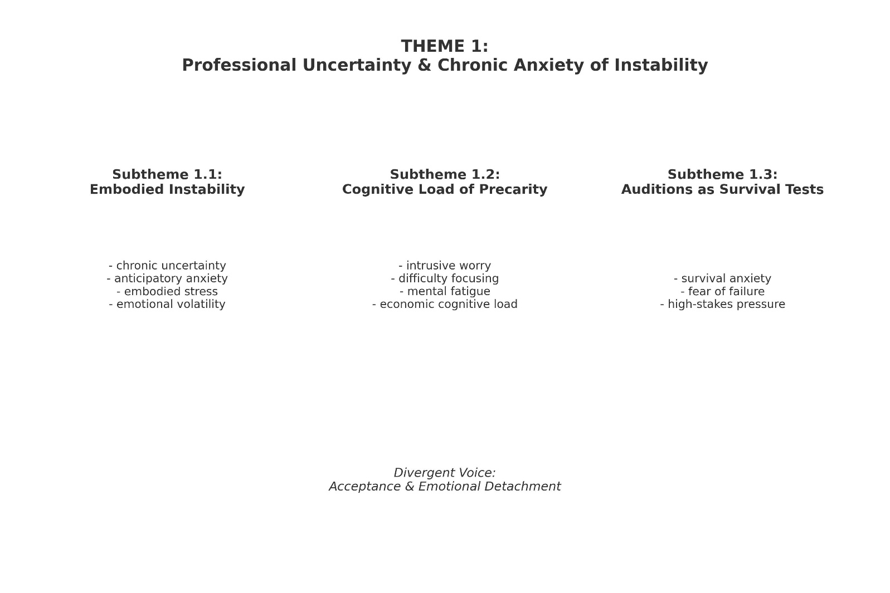

Figure A2. Coding tree for Theme 2: Gatekeeping, Networks & Unequal Access to Opportunities
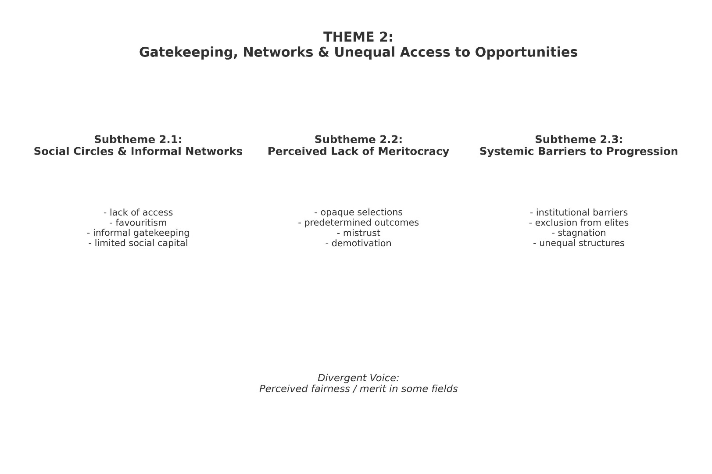

Figure A3. Coding tree for Theme 3: Fear of Evaluation & Constant Scrutiny
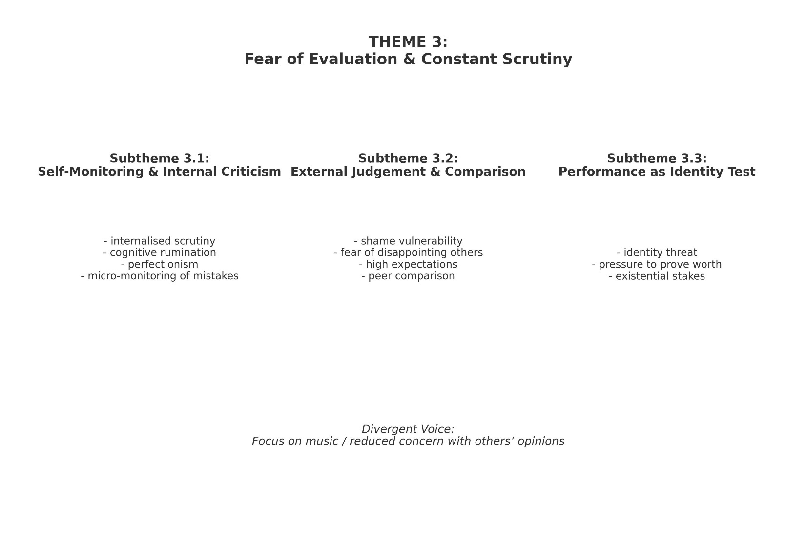

Figure A4. Coding tree for Theme 4: Precarity as Emotional & Physical Strain
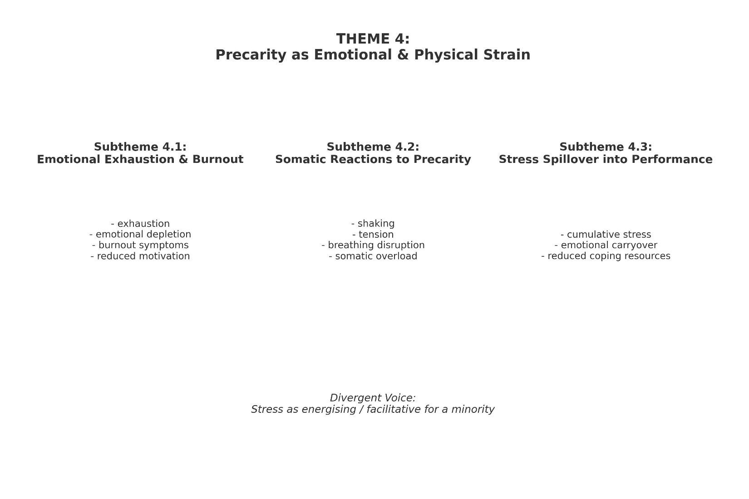

Figure A5. Coding tree for Theme 5: Erosion of Self-Confidence & Emotional Vulnerability
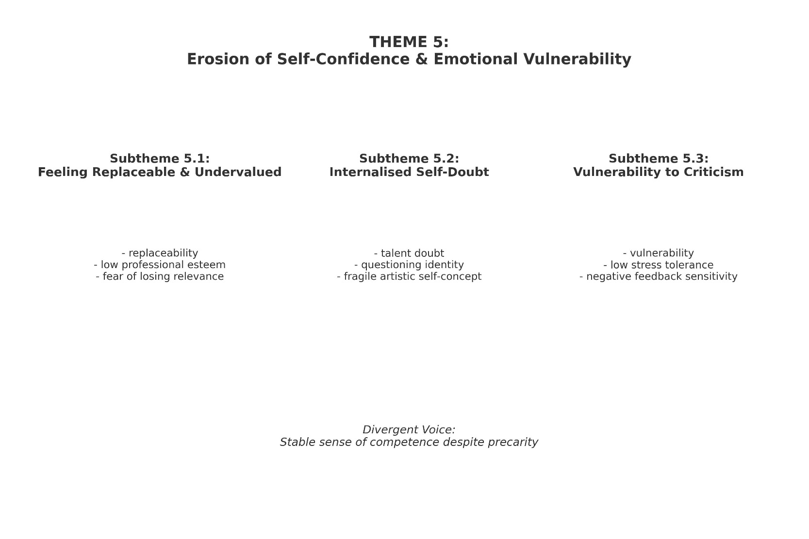

Figure A6. Coding tree for Theme 6: Identity, Perfectionism & Pressure to Prove Oneself


