The Medieval Warm Period and the Rise of London: Climate, Innovation, and Urban Transformation (950–1250 CE)

The Medieval Warm Period (MWP), spanning approximately 950 to 1250 CE, represents a climatically anomalous era of relatively warmer temperatures across much of the Northern Hemisphere, particularly Europe, first identified by Hubert Lamb in 1965 (as the “Medieval Warm Epoch”). While the specific regional impacts of this warming trend have been the subject of scholarly debate, its influence on societal, economic, and urban developments is widely acknowledged. London, emerging as a significant urban centre during this period, offers a compelling case study in understanding how climatic and environmental shifts can intersect with human agency and socio-economic structures to drive urban growth. This essay critically examines the role of the MWP in shaping London’s trajectory during the High Middle Ages, situating this analysis within broader historiographical and cultural contexts.

The Medieval Warm Period is characterised by an approximate 1–2°C increase in average temperatures in parts of Europe, a shift that profoundly influenced agricultural and economic patterns. Compared to the preceding Early Middle Ages, the MWP’s climate was more stable and conducive to agricultural expansion. For England, the milder winters and longer growing seasons allowed the cultivation of previously marginal lands and an increase in overall agricultural yields. This climatic stability underpinned broader societal transformations, creating the conditions necessary for urban expansion and demographic growth.

Scholars have long debated the extent to which climatic factors alone can account for such changes, emphasising the interplay between environmental conditions and human innovation. In England, innovations such as the heavy plow and the three-field system complemented the climatic advantages, allowing medieval farmers to maximise productivity. These developments provided the material foundation for population growth and the emergence of trade networks that increasingly centred on urban hubs like London. As historian Lynn White Jr. notes, “The wide application of the heavy plough in northern Europe was only the first major element in the agricultural revolution of the early Middle Ages.”

The agricultural boom catalysed by the MWP was instrumental in fostering London’s growth. Surplus production, enabled by favourable weather and technological advancements, freed portions of the rural population from subsistence farming, facilitating their migration to urban centres. Georges Duby notes “Medieval towns like London emerged as reflections of the agricultural revolution, their prosperity rooted in surplus production and trade fostered by climatic stability.” London, strategically situated on the River Thames, became a focal point for the exchange of goods and labour, functioning as both a transportation corridor and a commercial artery, connecting London to regional and international trade networks. Agricultural surplus from the surrounding countryside was transported to London, where it was marketed and distributed. The city’s role as a commercial hub was further solidified as merchants, artisans, and laborers converged to take advantage of these economic opportunities, and this rural-to-urban migration not only fuelled London’s demographic expansion but also diversified its social composition, setting the stage for its transformation into a vibrant, multi-faceted urban centre.
The significance of agricultural surplus in this period extends beyond its material contributions. Scholars have argued that the availability of surplus facilitated the specialisation of labour and the development of markets, creating a self-reinforcing cycle of economic growth. London’s rise during the MWP can thus be understood as part of a broader pattern of urbanisation seen across Europe, reflecting the interplay of climatic, economic, and social dynamics.

One of the most pronounced effects of the MWP on London was its integration into expanding trade networks, both domestic and international. England’s economy during this period began to diversify, with increasing emphasis on the production and export of goods such as wool, textiles, and metalwork. London’s location on the Thames facilitated its emergence as a key node in these networks, serving as both a centre of production and a gateway for international trade.

The production of wool exemplifies the intersection of climatic and economic factors. Warmer temperatures during the MWP supported the growth of sheep pastures, enabling England to produce high-quality wool that became a cornerstone of its export economy. London’s ports facilitated the export of wool to Flanders and other European markets, while simultaneously importing luxury goods such as wine, spices, and fine textiles. The domestic wine industry also flourished because of this climactic change as Gavin Schmidt, a climate modeller for NASA explored in his RealClimate blog post:

The earliest documentation that is better than anecdotal is from the Domesday Book (1087) – an early census that the new Norman king commissioned to assess his new English dominions, including the size of farms, population etc. Being relatively ‘frenchified’, the Normans (who had originally come from Viking stock) were quite keen on wine drinking (rather than mead or ale) and so made special note of existing vineyards and where the many new vines were being planted. Sources differ a little on how many vineyards are included in the book: Selley quotes Unwin who records 46 vineyards across Southern England (42 unambiguous sites, 4 less direct).

This dynamic exchange fostered the rise of a merchant class and the establishment of guilds, institutions that played a critical role in regulating trade and maintaining economic stability.
The Normans further accelerated London’s economic and infrastructural development, recognising the city’s strategic importance by investing in fortifications, administrative buildings, and commercial infrastructure. The construction of the Tower of London, for example, not only symbolised Norman authority but also underscored the city’s growing political and economic significance. These developments, driven by climatic, economic and political factors, highlight the multifaceted nature of London’s growth during the MWP.

The Medieval Warm Period not only shaped London’s economic fortunes but also had profound implications for its social and political structures. As the city’s population expanded, so too did its social complexity. The influx of migrants from rural areas and foreign lands created a cosmopolitan urban environment, characterised by cultural diversity and economic dynamism. Distinct neighbourhoods emerged, each reflecting the occupations, origins, and social status of their inhabitants.
This period also witnessed significant developments in governance and urban organisation - by the late 12th century, London had established a degree of self-governance, with the election of city officials and the formation of a mayoralty. These administrative innovations were necessitated by the city’s expanding population and economic activity, marking an important step in its evolution as a centre of political power. Scholars have noted that London’s governance during this period reflected broader trends in medieval urbanisation, where economic prosperity often went hand-in-hand with political autonomy.

The medieval city also saw the establishment of key religious and commercial landmarks, including St. Paul’s Cathedral and various markets, which became focal points for civic life. London’s foundational growth at this time was not just a case of economic expansion but also saw cultural and political consolidation, laying the groundwork for its enduring significance in English history.

Nothing highlights this consolidation more than the Common Seal of London, used by the newly incorporated City of London, which today still stands as the oldest continuous municipal democracy in the world.

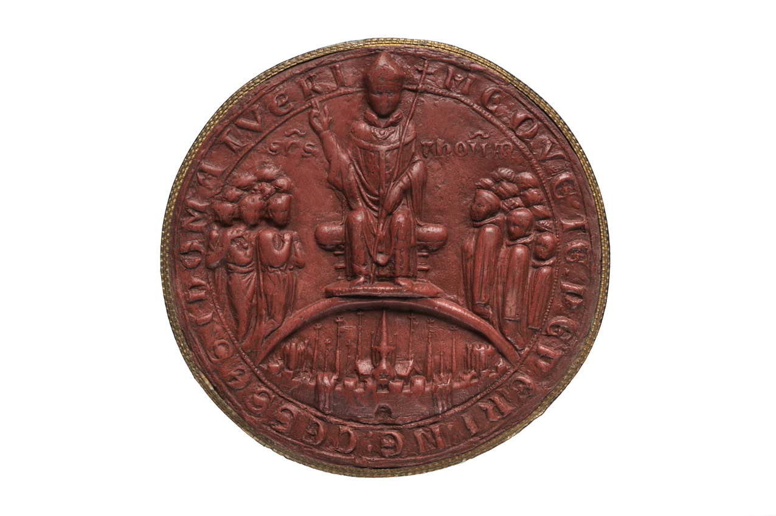
Figure 1. City of London Common Seal. Becket is shown surrounded by both clergy and merchants, with the City of London below. Museum of London Origin/Date: England || c. 1219 (?)
The Common Seal of London is often recognised as one of the most significant corporate seals, is notable in referencing Thomas Becket, with the seal shown in Figure 1 dated to c1219, at the very beginning of the corporation of London.

The seal features Thomas Becket, identified as St Thomas Archbishop, shown enthroned, blessing, and separated from a highly detailed cityscape by an arched bar. Beside Becket are figures believed to represent groups of Londoners in postures of supplication and merchants, though their exact identity remains speculative. The seal’s design is similar to other European town seals that were becoming prevalent throughout the 13th century, characterised by key motifs such as buildings, walls, bridges, churches, patron saints, and maritime elements for ports. Although not entirely unprecedented in London, the unique combination of a cityscape with figures representing the merchant class on a civic seal is particularly striking. This design likely reflects the medieval understanding of a city as comprising both its physical structures and its people. The seal places both the human community and the city’s material structure under the protection of Thomas Becket, and unlike the straightforward devotional inscriptions typically found on seals featuring spiritual patrons, the text here delivers a remarkable message. Speaking as the city itself, London appeals to Thomas Becket, reminding him of his obligations:

“Me Que Te Peperi Ne Cesses Thoma Tveri”
("Do not cease, Thomas, to protect me who gave thee birth.")

This enjoinder underscores the city's corporate identity and its enduring reverence for Becket as a spiritual protector.

While the Medieval Warm Period provided the conditions for London’s growth, it also posed significant challenges. The rapid increase in population strained the city’s infrastructure, leading to problems such as overcrowding, inadequate sanitation, and periodic outbreaks of disease. These issues, though not unique to London, underscore the difficulties faced by medieval cities in managing growth.
The reliance on trade and agricultural surplus also made London vulnerable to economic disruptions. Conflicts, shifts in trade routes, or climatic fluctuations—even within the relatively stable MWP—could threaten the city’s prosperity. The city’s leaders responded to these challenges with measures aimed at improving urban living conditions and ensuring economic stability. Investments in public works, such as marketplaces and water supply systems, reflect the city’s resilience and adaptability.
It is also worth noting that the MWP was not uniformly beneficial. Regional variations in climate meant that while some areas thrived, others faced challenges such as drought or resource depletion. The Annals of St Bertin, a Medieval chronicle highlighting climatic conditions and societal impacts shows the variations faced by people of the time:

The Emperor's army suffered much distress from the prolonged hot weather that autumn and the fierceness of the sun. Most men went down with fever, some died and some got home after a dreadful journey. The seriousness of this situation imposed itself on the Emperor: hampered by the harshness of the winter that was now coming on, he released the rest of his army and withdrew to winter quarters at Poitiers.

London’s success during this period must therefore be understood within the broader context of regional disparities and the city’s ability to capitalise on its specific advantages.

Conclusion: Climate and Human Agency in Historical Perspective

The Medieval Warm Period serves as a compelling example of how climatic factors can shape human societies, but it also highlights the importance of human agency in responding to environmental opportunities and challenges. London’s growth during the MWP was not merely a product of favourable weather but also of technological innovation, economic adaptability, and political foresight.
By broadening our perspective away from traditional historical and archaeological studies, we can gain insights from paleoclimatology that deepen our understanding of the forces that drive urbanisation and economic development. The case of London underscores the need for a wider approach to historical analysis, one that recognises the complexity of environmental, social, and cultural factors. As society grapples with contemporary challenges of climate change, we are becoming more aware of the lessons of the Medieval Warm Period, highlighting the resilience, adaptability, and capacity for innovation in the face of environmental change.

References

Abu-Lughod, J. L. 1989. Before European Hegemony: The World System A.D. 1250-1350 (Oxford University Press)

Brázdil, R. 2005. “Historical Climatology in Europe - The State of the Art,” Climatic Change, 70: 363–430

Campbell, B. M. S. 2016. The Great Transition: Climate, Disease, and Society in the Late-Medieval World (Cambridge University Press)

Davies, R. R. 2000. The Age of Conquest: Wales 1063-1415 (London, England: Oxford University Press)

Davies, R. R. 2002. The First English Empire: Power and Identities in the British Isles 1093-1343 (London, England: Oxford University Press)

Diamond, Jared. 2018. Colapso: Por Que Unas Sociedades Perduran y Otras Desaparecen / Collapse: How Societies Choose to Fail or Succeed (Debate)

Duby, Georges. 1978. The Early Growth of the European Economy: Warriors and Peasants from the Seventh to the Twelfth Century, trans. by Howard B. Clarke (Ithaca, NY: Cornell University Press)

Fagan, Brian. 2000. The Little Ice Age: How Climate Made History 1300-1850 (Basic Books)

Harvey, P. D. A., Andrew MacGuinness, and Andrew McGuinness. 1995. A Guide to British Medieval Seals (London, England: British Library Publishing Division)

Hoffmann, Richard. 2014. Cambridge Medieval Textbooks: An Environmental History of Medieval Europe (Cambridge, England: Cambridge University Press)

Hope, W. H. [n.d.]. 1894-5 ‘Municipal Seals of England and Wales (Proc Soc Antiq), xv

Keene, D. 2008. “‘Text, Visualisation and Politics: London, 1150-1250’ Trans,” Royal Hist Soc (Series), 5: 69–99

Lamb, H. H. 1965. “The Early Medieval Warm Epoch and Its Sequel,” Palaeogeography, Palaeoclimatology, Palaeoecology, 1: 13–37 <https://doi.org/10.1016/0031-0182(65)90004-0>

Lamb, Hubert H. 1995. Climate, History and the Modern World, 2nd edn (London, England: Routledge)

Maitland, F. W. 1988. Domesday Book and beyond: Three Essays in the Early History of England, 2nd edn (Cambridge, England: Cambridge University Press)

New, E. 2008. “Seals and Status in Medieval English Towns: A Case-Study of London, Newcastle and Durham,” in Good Impressions: Image and Authority in Medieval Seals, ed. by N. Adams and J. Cherry (London), pp. 31–37

———. 2015. “The Common Seal and Communal Identity in Medieval London,” in Medieval Coins and Seals: Constructing Identity, Signifying Power, Tournhout, pp. 297–318

Pedrick, Gale. 2018. Borough Seals of the Gothic Period: A Series of Examples, Illustrating the Nature of Their Design and Artistic Valve (Trieste Publishing)

Pirenne, Henri. 2014. Medieval Cities: Their Origins and the Revival of Trade (Princeton, NJ: Princeton University Press)

“The City’s Government.” [n.d.]. City of London <https://www.cityoflondon.gov.uk/about-us/law-historic-governance/the-citys-government> [accessed 6 January 2025]

“The Common Seal.” 1219. (Museum of London) <https://www.thebecketstory.org.uk/london/themes/patron-saint#:~:text=The%20seal%20of%20the%20City,me%20who%20brought%20you%20forth'.>

Unwin, Tim. 1990. “Saxon and Early Norman Viticulture in England,” Journal of Wine Research, 1.1: 61–75 <https://doi.org/10.1080/09571269008717857>

Verlinden, C. 1979. “The Cambridge Economic History Of,” in Trade and Industry in the Middle Ages, ed. by M. M. Postan (Cambridge University Press), ii

Waitz, Georg, and France Saint-Bertin. 2022. Annales Bertiniani (Legare Street Press)

White, Lynn. 1966. Medieval Technology and Social Change (New York, NY: Oxford University Press)

Zarnecki, G., and J. Holt. 1984. English Romanesque Art 1066-1200 (London)

H.H. Lamb, “The Early Medieval Warm Epoch and Its Sequel,” Palaeogeography, Palaeoclimatology, Palaeoecology, (1965) vol 1: p.13–37 https://doi.org/10.1016/0031-0182(65)90004-0
Richard Hoffmann, Cambridge Medieval Textbooks: An Environmental History of Medieval Europe (Cambridge, England: Cambridge University Press 2014)
Lynn White, Medieval Technology and Social Change (New York, NY: Oxford University Press 1966) p.57
Georges Duby, The Early Growth of the European Economy: Warriors and Peasants from the Seventh to the Twelfth Century, trans. by Howard B. Clarke (Ithaca, NY: Cornell University Press 1978) p.114
Henri Pirenne, Medieval Cities: Their Origins and the Revival of Trade (Princeton, NJ: Princeton University Press 2014) p.87
J.L. Abu-Lughod, Before European Hegemony: The World System A.D. 1250-1350 (Oxford University Press 1989) p.54-62
Robert Rees Davies. The First English Empire: Power and Identities in the British Isles 1093-1343 (London, England: Oxford University Press 2002) p.151 and p.153-5
T. Unwin, Saxon and early Norman viticulture in England. Journal of Wine Research, 1(1), 1990. p.61–75. https://doi.org/10.1080/09571269008717857
Gavin Schmidt, “Medieval Warmth and English Wine,” RealClimate | Climate Science from Climate Scientists (RealClimate 2006) <https://www.realclimate.org/index.php/archives/2006/07/medieval-warmth-and-english-wine/> [accessed 6 January 2025]
C. Verlinden, “The Cambridge Economic History Of,” in Trade and Industry in the Middle Ages, ed. by M. M. Postan (Cambridge University Press 1979) Vol ii
“The City’s Government.” [n.d.]. City of London https://www.cityoflondon.gov.uk/about-us/law-historic-governance/the-citys-government [accessed 2 January 2025]
E. New. “The Common Seal and Communal Identity in Medieval London,” in Medieval Coins and Seals: Constructing Identity, Signifying Power, Tournhout, 2015. p. 297–318
Figure 1, “The Common Seal.” 1219. (Museum of London) https://www.thebecketstory.org.uk/london/themes/patron-saint#:~:text=The%20seal%20of%20the%20City,me%20who%20brought%20you%20forth [accessed 4 January 2025]
New, The Common Seal, p.302
Gale Pedrick, Borough Seals of the Gothic Period: A Series of Examples, Illustrating the Nature of Their Design and Artistic Value (Trieste Publishing 2018)
Jared Diamond, Collapse: How Societies Choose to Fail or Succeed (Debate, 2018)
B. M. S. Campbell, The Great Transition: Climate, Disease, and Society in the Late-Medieval World (Cambridge University Press 2016)
R. Brázdil, “Historical Climatology in Europe - The State of the Art,” Climatic Change, 2005, 70: p.363–430
F.W. Maitland, Domesday Book and beyond: Three Essays in the Early History of England, 2nd edn (Cambridge, England: Cambridge University Press 1988) p.48

