STUDENT NAME : MIRELA ELENA IONESCU
STUDENT NUMBER : 1815193
MODULE TITLE : HOTEL ADMINISTRATION AND FRONT OFFICE OPERATIONS - M4X01920
ASSIGNMENT TITLE : PREPARE A REPORT BY ANALYSING HOW COMMUNICATIONS BETWEEN THE FRONT OFFICE AND THE OTHER DEPARTMENTS OF HOTEL TO EXECUTE OPERATIONS SUCCESSFULLY.
LECTURERE NAME : DR. JAHANZEEB QURASHI

TABLE OF CONTENT

PMS – PROPERTY MANAGEMENT SYSTEM
COMMUNICATION TOOLS
OPERATIONAL REPORTS
- Front Office
- Food and Beverage
- Housekeeping
- Reservation
- Forecasting/Budgeting
GUEST LIFE CYCLE
CONCLUSION
REFERENCES

PMS AND OTHER COMMUNICATION
Property Management Systems are software that automates the operations of a hotel / resort, restaurant, casino, or cruise line. This automation includes the integration of front-office applications and back-office applications to allow for complete management of the entire property. When running at its full potential, the system should be able to integrate all value-chain areas within the hospitality corporate network into a single functional repository for data management, planning, visibility, and reporting. ( Chris Cunnane , 2010)

Given that technology has advanced in recent years, hotel communications have evolved throughout this, so from text messages, chat systems between employees, mobile phones and other systems that have not been very efficient, there are now many options of communication tools, created especially for the hospitality industry such as: two-way radio - has been used in the hospitality industry for some time and is still a communication tool used by hotel professionals, being praised for the reliability of the network connection; hotel services optimization system - is an application that offers a complete communication package for the hotel. It: connects the guests with the hotel (improves the guests' experience in the hotel), works as a communication tool between the hotel staff (they can use the application on smartphones or tablets), the front desk can assign tasks to the staff, so that the communication is simplified and efficient; DECT phones - digital wireless technology that works on the telephone line and can be used as an intercom. ; complete communication solutions in the hotel - contains a communications server that can handle large call volumes, office phones that has a multifunctional terminal with IP functions, fixed / wireless / wireless phones, network infrastructure that allows voice and data communications.
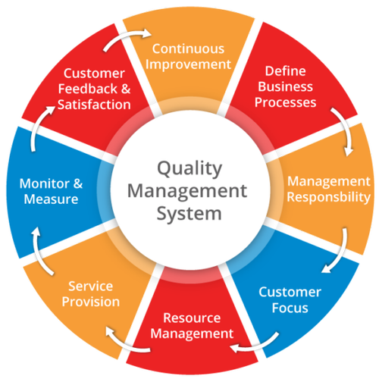
Even if the technology has evolved, the hotel manager must still communicate verbally with employees, customers and colleagues. in the hospitality industry both communications (verbal and non-verbal) should be emphasized and well executed. The convincing communication skills of the employees with the clients are very important in a hotel and these skills are a learned art and any hotel should consider training the staff to improve this communication skills.
All the communications that take place in a hotel are efficient because, in this way, the hotel improves the service offered to the clients, a better understanding between the manager and the employees, the understanding of the technology used in the hotel, the confidence of the employees to win as many customers, the employees would have an attitude positive at work and the understanding between the superiors will be at a high and efficient level.

OPERATIONAL REPORTS
In a hotel the reports have an important role in the daily operations, the reports provide the management with an in-depth analysis of the hotel's performance on that day. Each department uses one or more reports in their daily operations.
The reports are issued naturally from the property management systems, eg: Opera, Fidelio, Protel, Hetras.
- FRONT OFFICE REPORTS
There are two types of operations that front desck performs: front operations when the client interacts and sees these operations and back operations where guest involvement is not required.
The front operations consist of: welcoming the guests, checking the availability of rooms, collecting customer data, creating an accounting account for clients, taking over the keys from clients, clients settle the money at the time of departure.
The back operations consist of: the type of client (for example, if he is new to the hotel or if he was already in the hotel), maintaining the clients account with the accounting system, preparing the invoices for the clients, collecting the invoices, generating reports.
Wake-up call: it must contain the guest's name, the date and time of the wake, the room number, special requests (example: the client wants to be awakened at 7 am, the management insists if the quest does not answer and to bring breakfast to the room at 7 30 am)
The report for picking up and leaving customers at the airport contains: the name of the flight company, the time of arrival of the flight, the number of the landing and departure flight, the customer's telephone number, special requests (example: the car with which it wants to be taken to the customer, if they want to serve something in the car (drinks, food) This report is used by the travel / concierge office.
Internal report of guests containing: number of clients (children, adults), name of company / agency through which clients arrive at the hotel, group names, date of arrival, date of departure, details of invoices. This report is used to verify the details of everyone in the hotel.
Reports for incidents within the hotel contain: the date of the report, the time of the report, the place of the report, the name of the reporter, the details of the client, details of the incident, the actions taken to resolve the incident, the signatures of the client / staff / general manager.

- FOOD AND BEVERAGE REPORTS.
Banquet report: after the client and the hotel management have agreed on the terms and planning of the banquet, a contract will be prepared which the client will receive for approval. this report contains: the date when the banquet will be held, the number of guests, the selected room, the type of configuration, the cancellation policy, special equipment, and special requests.
Room service order: tea and coffee service is available 24/7 and the time it reaches the customer is 5-10 minutes, taking over the guest's name and room, the customer is asked where he wants to serve the meal, the food should be served hot and fresh, presenting the food beautifully, the guests are informed about the time of delivery, the one who serves the food must have a correct attitude, uniformed, the speed of the services adapted to the needs of the customers.

- HOUSE KEEPING REPORTS.
The housekeeping report contains the duties of the employees, who are responsible for the maintenance of the rooms. these attributions are: removing the bed linen, lifting the mattresses, checking the existence of stains, arches from the mattress, cleaning the bed, cleaning the pillows or replacing them, removing the dust, cleaning the smoke detectors, wi-fi routers, ventilation holes, curtains, windows , cleaning the bathroom with special solutions.
After the cleaning is finished, the housekeeping employees must make available to the customers towels, hygiene products, bathrobes, slippers.
Must address to the manager the irregularities found in the room, found objects, picture with the found object, if the customers have consumed something from the minibar.
After the manager has received the report from the house keeping, the manager compiles the report for the maintenance in which to write, the problems found in the room, the number of the room and how many people are needed to solve the problem.

- RESERVATION REPORTS.
This report presents the bookings chosen for the chosen dates, the waiting list, the canceled reservations and the arrivals.The report is used to make the search more efficient for the clients, it can follow the reservations made at a certain date.
This report contains: guest name, proof of id, date of arrival, departure date, number of guests (adults, children) room number, room type, room price, rate name, group / corporate name.

- FORECASTING/BUDGETING
In the hospitality industry, budgeting is an important part. budgeting is used to set the target that the hotel has but also to increase performance. This department of the hotel increases the interest of the shareholders and the owners regarding the distribution of standard services so that the business is credible.
Forecasting is a department that helps hotel management anticipate future hotel performance, thus preparing the hotel to cope with future uncertainties. The hotel manager can make reports on the key values of the hotel, such as: occupancy of the rooms, total income or average daily rate, only by using previous performance data but also by industry trends

GUEST LIFE CYCLE
Pre-arrival: this is the stage where guests want to stay at the hotel. The client requests information on availability, on the type of room and hotel facilities, on prices.
At the other end, the hotel collects details from the client, such as: name, age, contact number, length of stay to reserve the room and communicates to the client everything he wants.
Arrival: the employee at the reception greets the client. for guests with confirmed reservation, the employee at the reception desk gives the client a form that they must complete. Following is the registration of the client in the database and handing over the key to the client.
Occupation: through the accounting system, the customer is tracked purchases from the restaurant, bar, room service or any other. at the clients' request, the front office arranges for transportation, local tourism or even babysitting.
Departure: the accounting system ensures payment for the goods and services provided. at the time of departure, the reception staff thank the clients for being given the opportunity to serve them and if the client requests additional services, such as, taking to the airport or another service, the front desk fills out it.

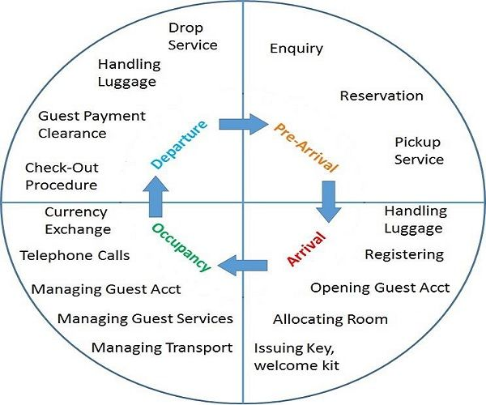
.

CONCLUSION
In conclusion, all the operations in the hotel are important and all the departments also because without them, a hotel would not work properly and correctly.
In a hotel, the reports are also very important for both the hotel and the customers because these reports create a close connection between the hotel employees and the hotel and the customer.

REFERENCES
- Chris Cunnane (2010) Property Management Integration , p.1 accessed at 27.11.2019
- Tutorial points. Front Office Management. Available: https://www.tutorialspoint.com/front_office_management/front_office_management_tutorial.pdf . Accessed at 27/11/2019
- Google Image available : https://www.google.com/search?q=quality+management&rlz=1C1CHBD_en-GBGB850GB850&source=lnms&tbm=isch&sa=X&ved=2ahUKEwj6k8yC24rmAhXCuHEKHZlFD10Q_AUoAXoECBAQAw&biw=1024&bih=648#imgrc=C2VyLqOAE03IhM Accessed at 27/11/2019
- Google image available : https://www.google.com/search?q=guest+life+cycle+in+a+hotel&rlz=1C1CHBD_en-GBGB850GB850&source=lnms&tbm=isch&sa=X&ved=2ahUKEwjUj4jK24rmAhVZURUIHSAAD0IQ_AUoAXoECA4QAw&biw=1024&bih=648#imgrc=tfbyu1gCo9i9lM accessed at 27/11/2019

