Information Engineering – Assessment 1 Task 2
Module Code: ACCC4004
Student Name: VERZHINIA ILIEVA
Student ID: 1912496

Table of Contents
Introduction. 3
Entity relationship diagram 4
Tables. 9
Forms. 17
Reports. 20
Relationships. 23
Using SQL to Add Records to Tables. 29
Reproducing Reports from Queries 30
Functionality of the Main Menu and Form Navigation 33
Performing Calculations in a Report. 34
Master and Embedded Forms. 34
The Menu displayed immediately the database is opened 36
User Guidelines 36
Conclusion. 37
References. 39

Introduction.
In ancient times, data was managed in an analog way for instance it was curved on stone tablets, sketches and writings on objects. After the invention of ink and paper, data was now stored on scrolls/paper in the form of writings and paintings. But this mode of data storage and management was not reliable and efficient. It was only accessible by only those who had the privilege and means to own some of these materials. These systems of data management had several limitations such as almost impossible to perform simple operations like editing - to correct any errors without destroying a part of it if not all, limited storage space and duration and was prone to distortions as a result of breaking or wearing out of parts of writing materials like papers. This system of data storage also, did not allow the stored data to be accessed in different formats or outputs. Data storage techniques then evolved to a more advanced form of data management system where Database Management Systems (DBMS) were invented. It was now easy and efficient to manage data, document and access it in any desired outputs/formats. DBMS made handling of data very effective and efficient as data could be stored, managed and accessed in various formats with the use of tools such as MS Access, SQL and MySQL that facilitates the manipulation and storage of data more effectively and over a long period of time. This report will be discussing the development and implementation of DBMS for Universal Sports Club which is planning to upgrade from the analog methods of data management to a more advanced data management systems that will ensure their data is managed properly according to their requirements.

Entity relationship diagram.
According to (Davis and Yen, 2019), an ERD is a modelling tool used for planning and designing of DBMS. They are comprised of both entities and normalizations which can be used interchangeably to validate the other. The ERD model is comprised of entities which have their very specific characteristics and shows how these entities relate to each other making the analysis of data stored more meaningful and sensible. According to (Davis and Yen, 2019), ERD models can be used simultaneously with flow diagrams to give a clear logical view of how the systems should look like. This lays down a good understanding and strong foundation for planning, designing and modelling of DBMS.
With respect to the Universal Sports, the analysis shows various tables with each table portraying its various characteristics. These characteristics are related to one other in various ways that reveals the relationships among the tables. For instance, the below ERD is designed using the crow foot annotations to show the relationships between the tables.
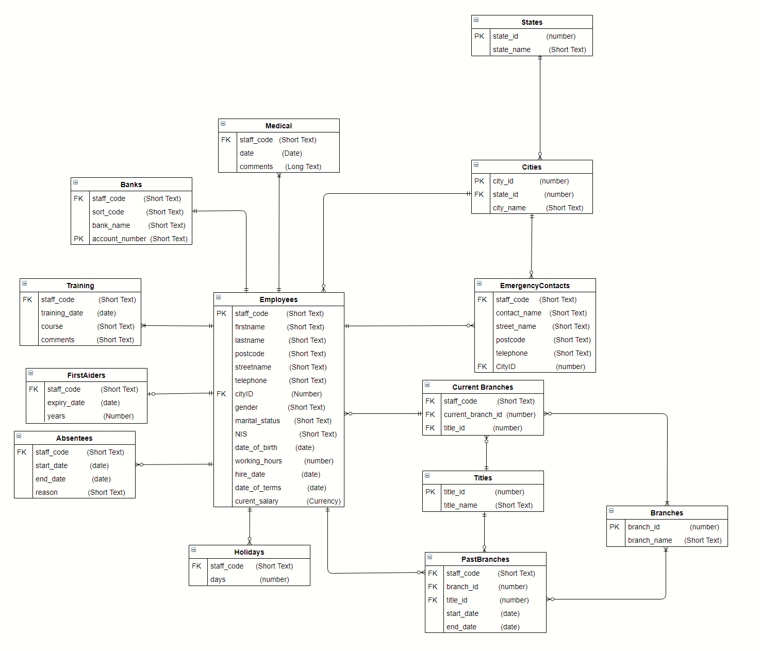
ERD with members classes

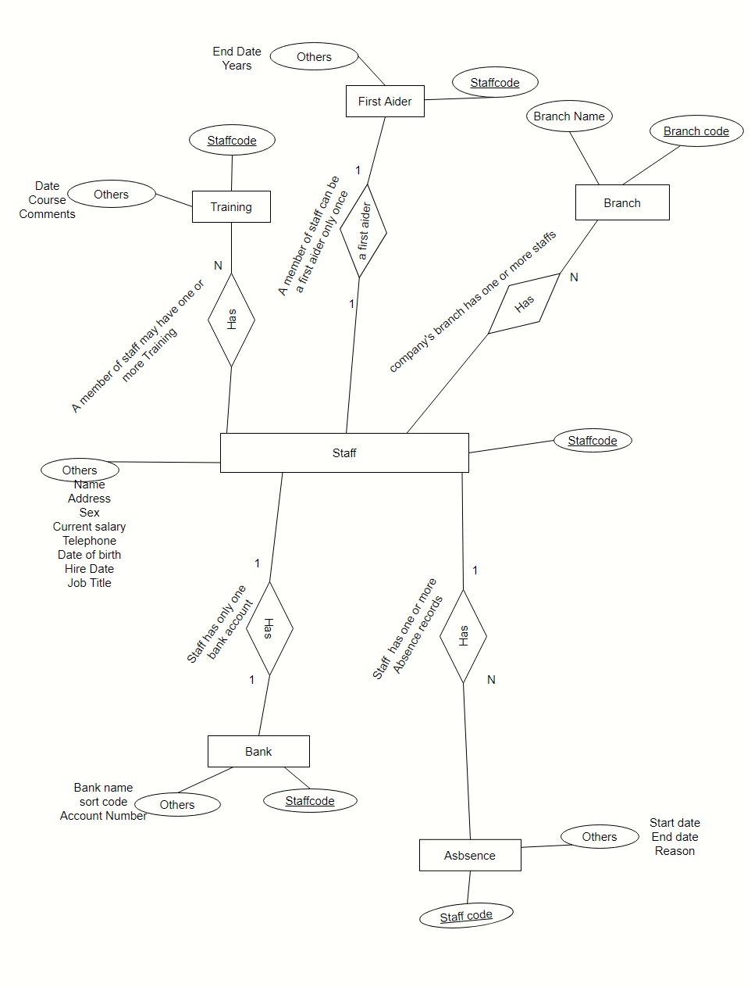
Fig. Degree of relation with annotations

Documentation.
UNF | 1NF | 2NF | 3NF | ENTITY
Employee Information | Staff number (PK) | Staff number (PK) | Staff number (PK)
 | First name | First name | First name
 | Last name | Last name | Last name
 | postcode | Phone number | Phone number
 | Street name | postcode | postcode | EMPLOYEES
 | city | Street name | Street name
 | state | City id (FK) | City id (FK)
 | salary | Current salary | Current salary
 | sex | sex | sex
 | status | status | status
 | National Insurance Number | National Insurance Number | National Insurance Number
 | Birth date
 | Hire date
 | Hours of work
 | Terms and conditions date
Emergency contact Information | Staff number (FK) | Staff number (FK) | Staff number (FK)
 | Contact name | Contact name | Contact name | Emergency contacts
 | Street name | Street name | Street name
 | Postcode | Postcode | Postcode
 | City | City ID | City ID
 | State | Telephone | Telephone
 | Telephone
First aider Information |  | Staff number (FK) | Staff number (FK) | First aiders
 |  | Expiry date | Expiry date
 |  | Number of Years | Number of Years
Past Branch Information |  | Staff number (FK) | Staff number (FK) | Past Branches
 |  | Branch id (FK) | Branch id (FK)
 |  | title id (FK) | title id (FK)
 |  | Start date | Start date
 |  | End date | End date
Current branch |  | Staff number (FK) | Staff number (FK) | Current branches
 |  | Branch id (FK) | Branch id (FK)
 |  | title id (FK) | title id (FK)
 |  | Staff number (FK) | Staff number (FK)
Absence |  | Start date | Start date | Absentees
 |  | End date | End date
 |  | Reason for absence | Reason for absence
 |  | Number of Days | Number of Days
Training |  | Staff number (FK) | Staff number (FK)
 |  | Training date | Training date | Training
 |  | Course | course
 |  | comments | comments
City |  | City id (PK) | City id (PK)
 |  | State id (FK) | State id (FK) | Cities
 |  | City name | City Name
Bank |  | Staff number (FK) | Staff number (FK)
 |  | Sort code | Sort code | Banks
 |  | Bank name | Bank name
 |  | Account no (PK) | Account no (PK)
Title |  | Title id (PK) | Title id (PK) | Titles
 |  | Title Name | Title Name
State |  | State id (PK) | State id (PK) | States
 |  | State Name | State Name
Branch |  | Branch id (PK) | Branch id (PK) | Branches
 |  | Branch name | Branch name
Medical |  | Staff number (FK) | Staff number (FK)
 |  | Examination date | Examination date | Medical
 |  | Comments | Comments
Holiday |  | Staff number (FK) | Staff number (FK) | Holidays
 |  | Number of Days | Number of Days

3NF
According to (Alexander and Kusleika, 2019), 3NF is the practice of leaving out all the fields whose data can be derived from other fields in the tables or from other tables in the database as illustrated below.
Assumption made in designing an ERD.
- Every worker owns only one bank account showing all the data and credentials of the worker in one record in the BankDetails table that corresponds to the staff code in the Workers table.
- Each worker can own more than one Medical and Training records at any given time.
- Each worker can either be a first aider or not at any given period.

Tables.
When it comes to DBMS (Zygiaris, 2018), the main purpose of tables is to store data which can be inserted inside these tables in different ways by use of SQL statements. For instance, the SQL statement used to create a table in the DB is the CREATE TABLE SQL statement. When data is being inserted in a table, it must be done using procedures designed specifically for that exact purpose. This ensures consistency, credibility and accountability of database tables with error-free but accurate data. This ensures that the output information is complete and accurate and not garbage.
In the ERD below, we have used the CREATE TABLE SQL statement to create various tables as illustrated by the diagrams.
All tables created.
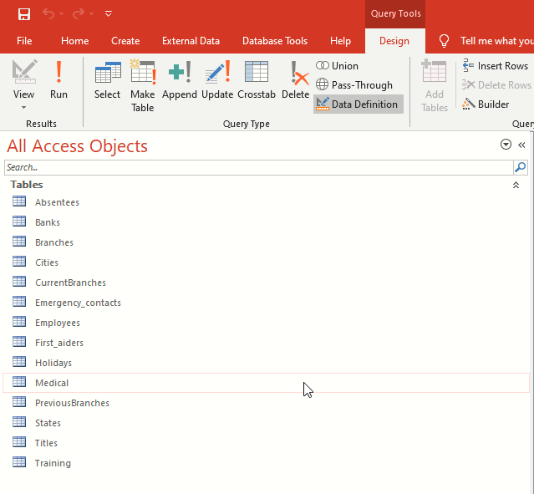

Employees Table
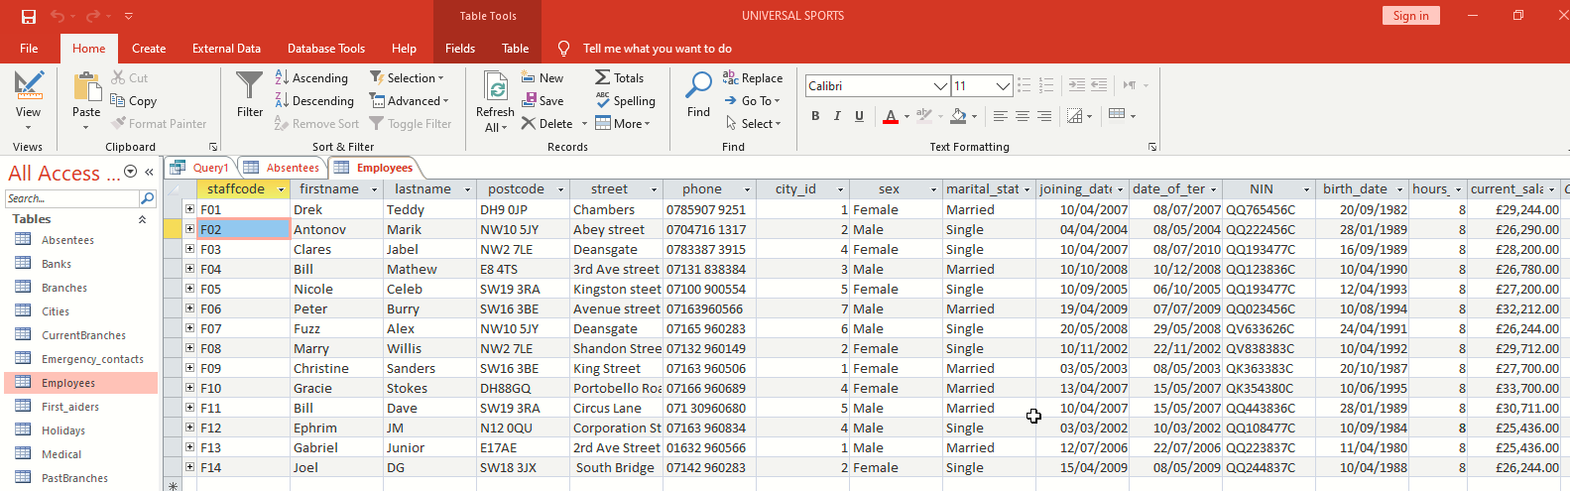
Query for creating Employees table.
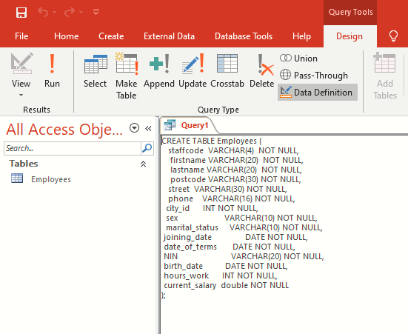

Absenteeism table.
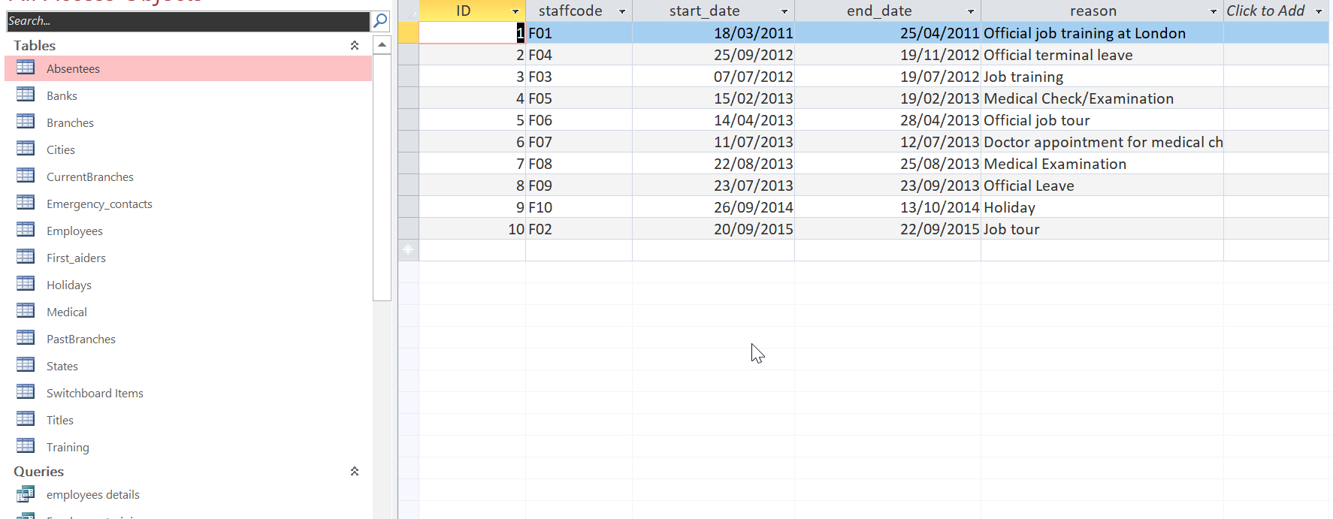
Query for creating Absenteeism table.
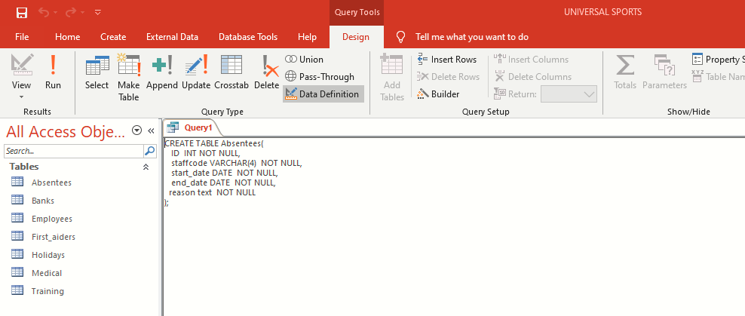

Medical table.
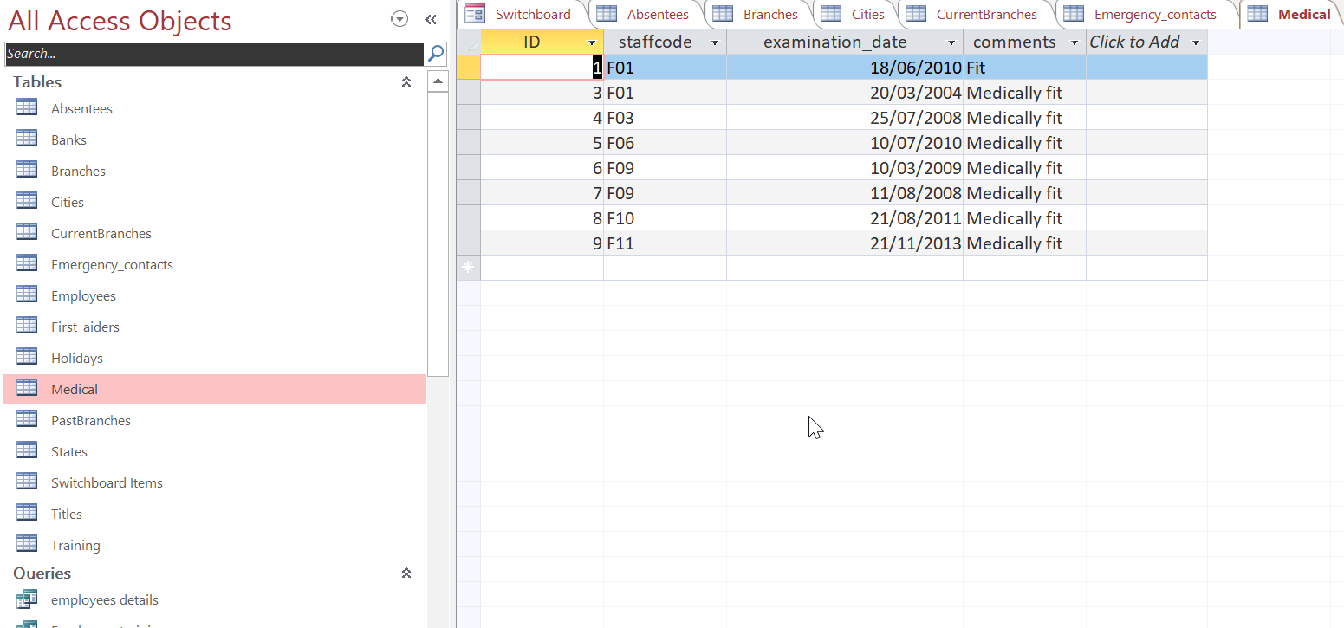Query for creating Medical table.
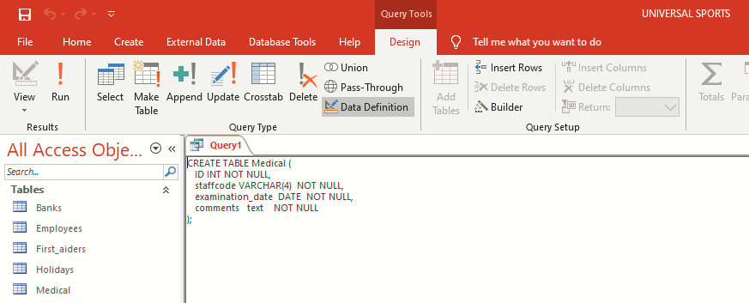

Training table.
Query for creating Training table.
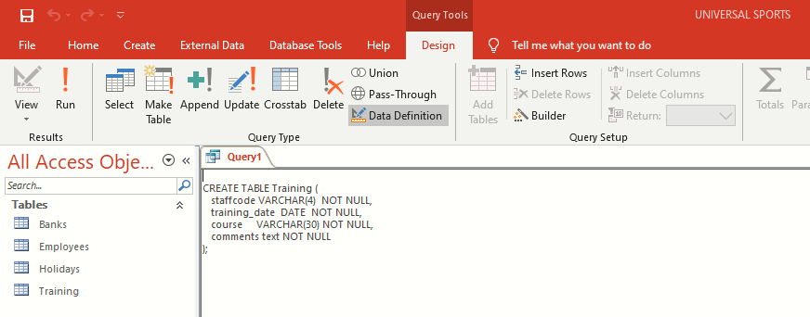

Bank Details
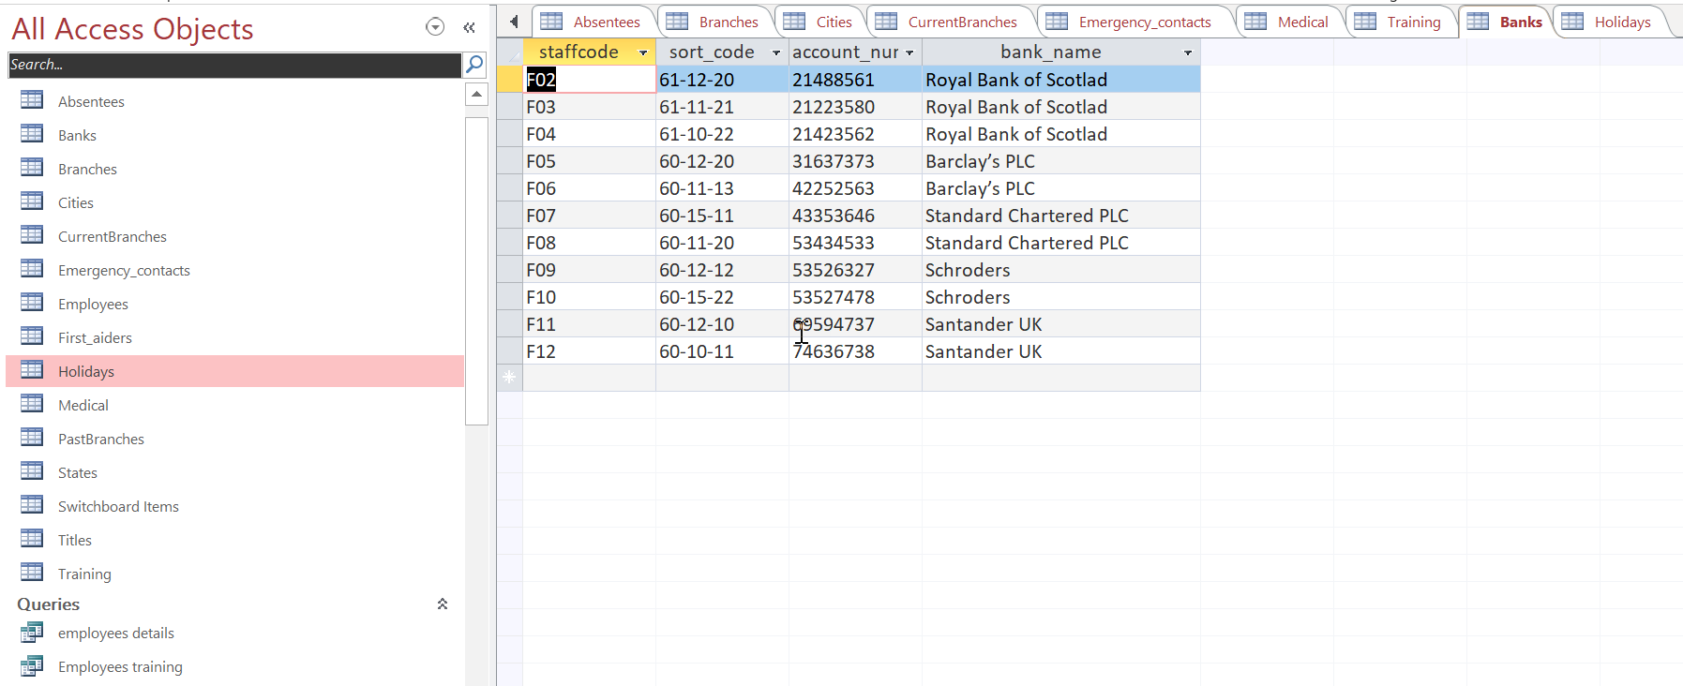
Query for creating bank details table
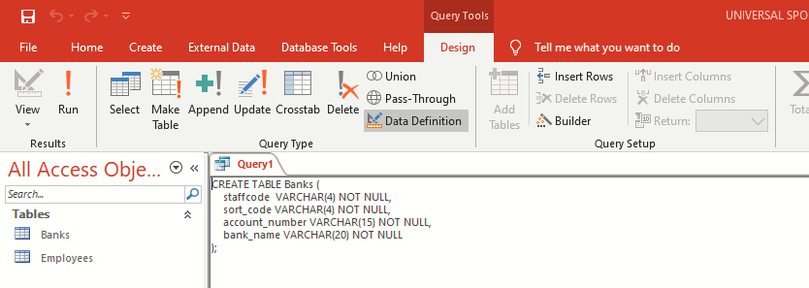
HolidayEntitlement table.
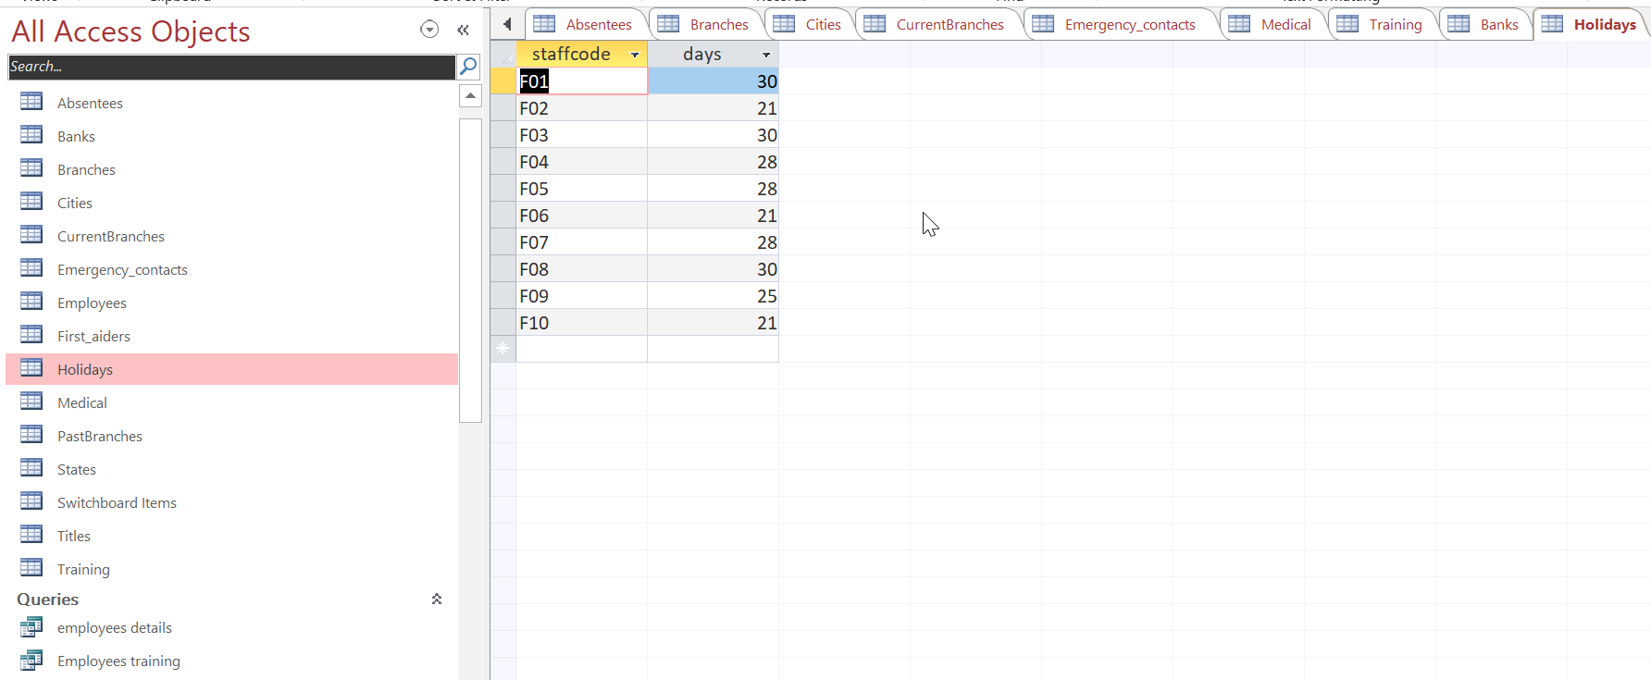
Query for creating HolidayEntitlement table.
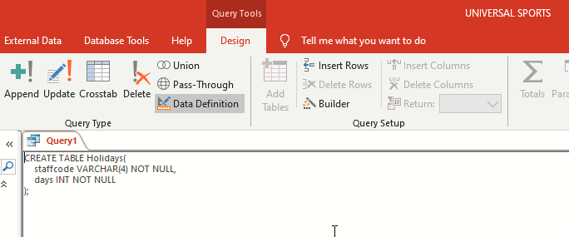

First Aiders table
query 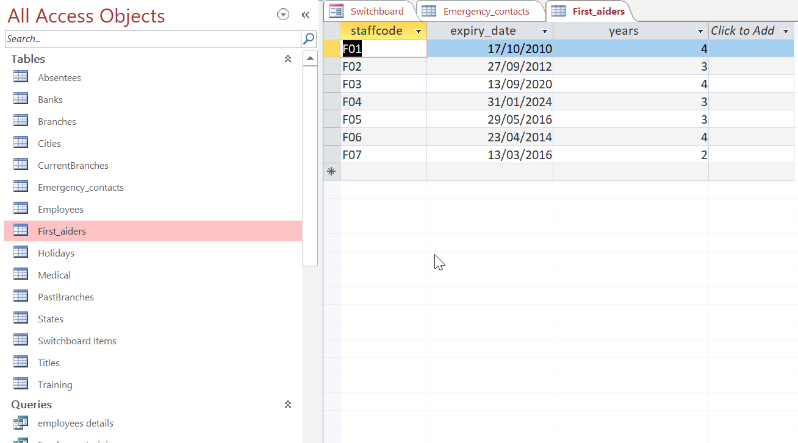
query for creating first aiders table
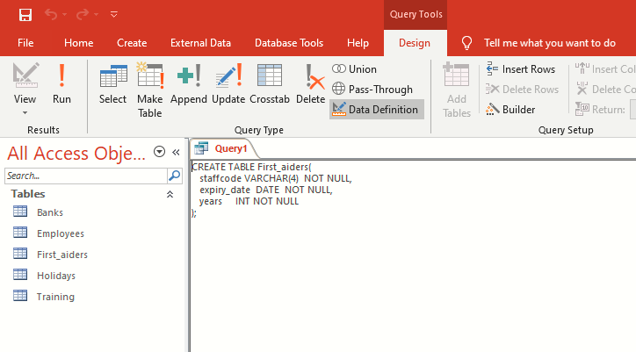

Forms.
In MS Access (Bhattacharya, 2014), forms are majorly used to input new entries in to the database, view and output information. It is by use of forms that the end user can be able to get around and interact with the DBMS and access other forms or execute SQL queries with ease and comfortability. Back to our Universal Sports database, forms have been used to achieve the process of inputting and outputting of details and credentials of various staff members as illustrated below.
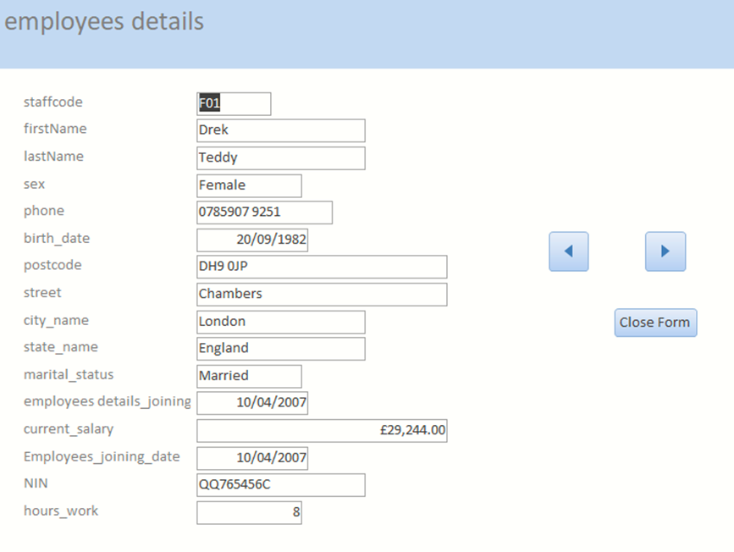
Forms for the employee provides for the manipulation of their personal details within the in the club.
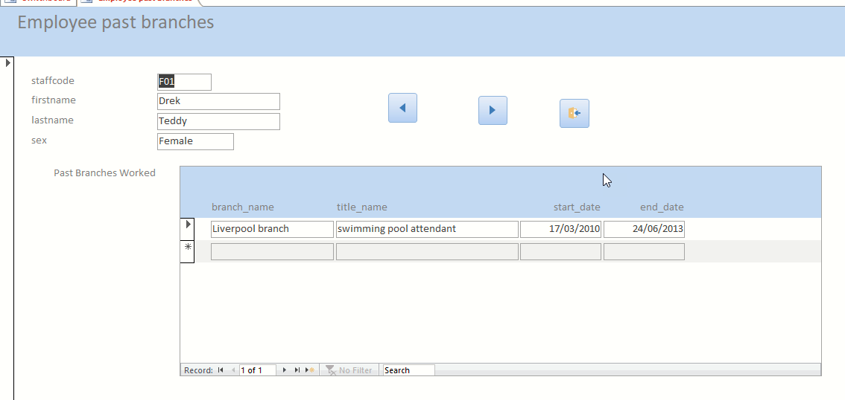
Employee past branches form gives information on all the Universal Sports Branches each worker has ever worked before.

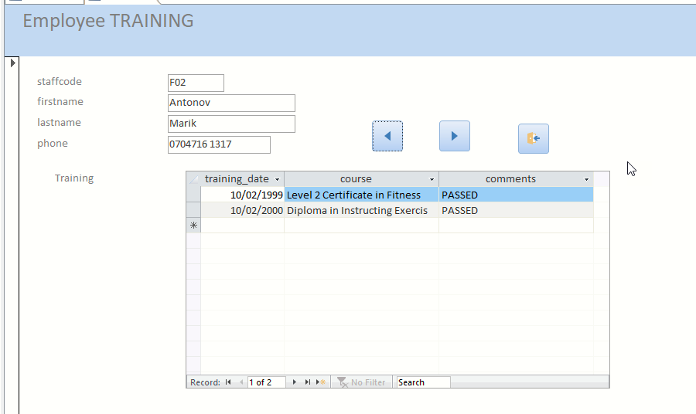
The employee Training form is for inputting and manipulation of the training sessions each staff member has attended so far.
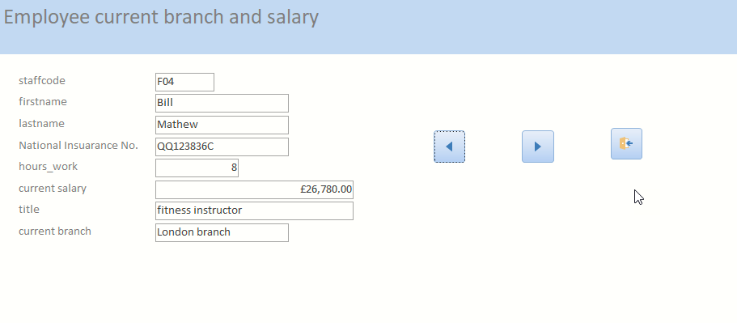
Current employee branch and salary form

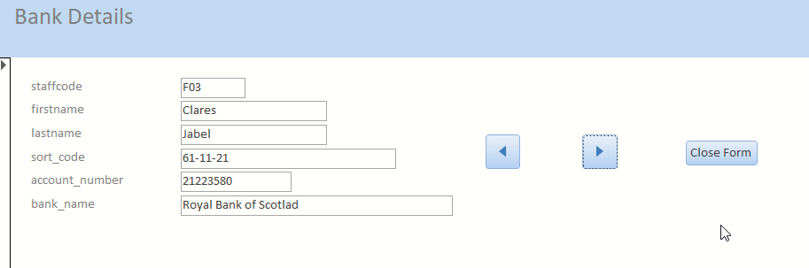
Bank details form

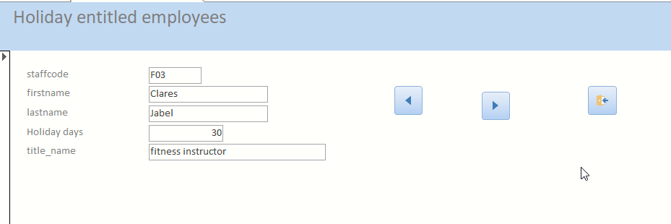
Holidays entitled form.

Reports.
According to (Fredrichsen, 2016), reports can simply be defined as primary objects that are used in the printing of the database contents facilitated by their ability to provide formatting layouts and options for a summery or simplified version of the database. They provide the user with mechanisms through which they can access the meaningful information from the database with respect to their preference as shown below;
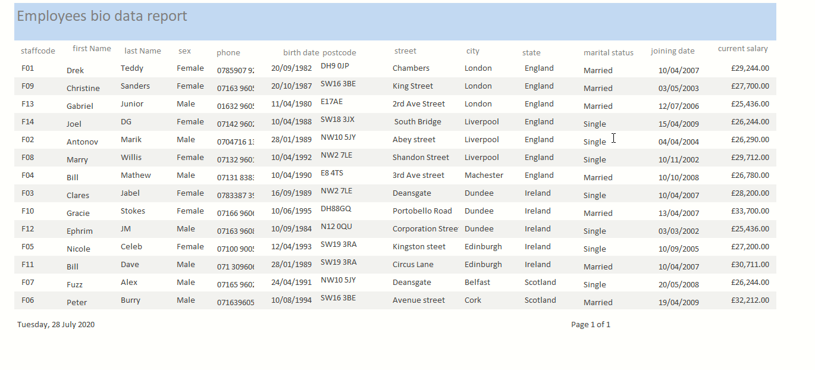
Employee personal information report
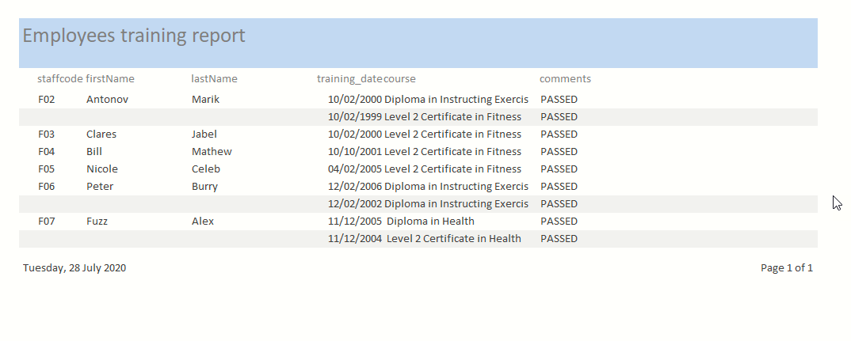
Employee training information report
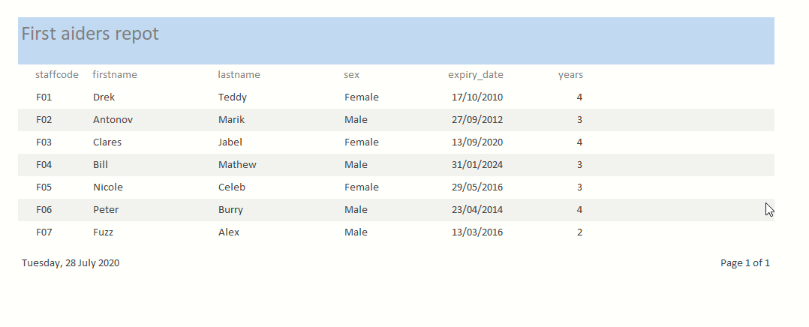
First aiders report
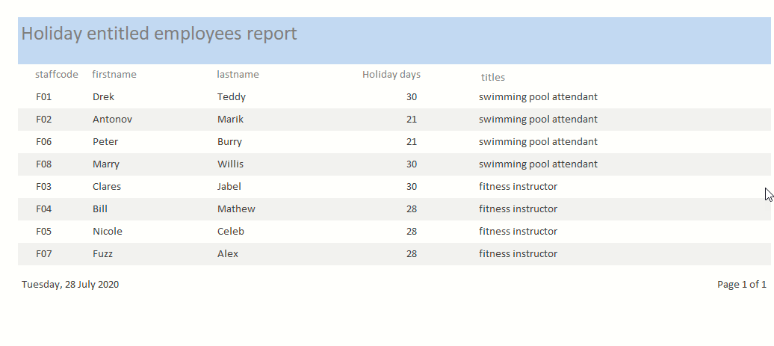
Holiday entitled report
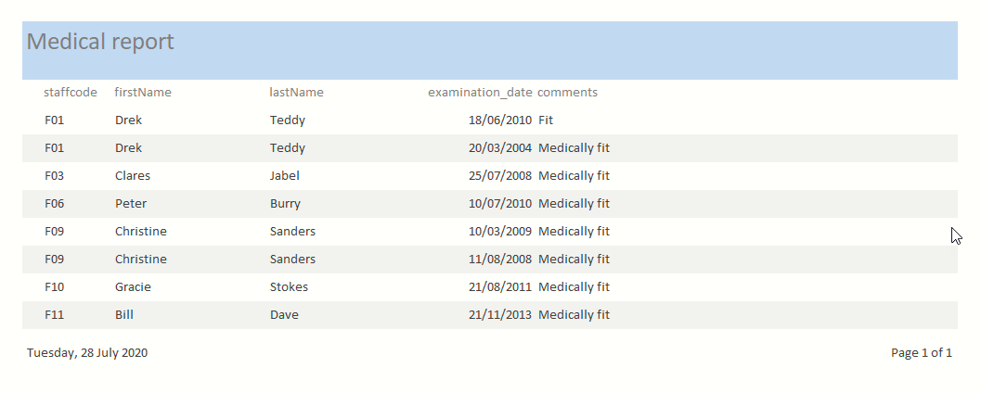
Medical report
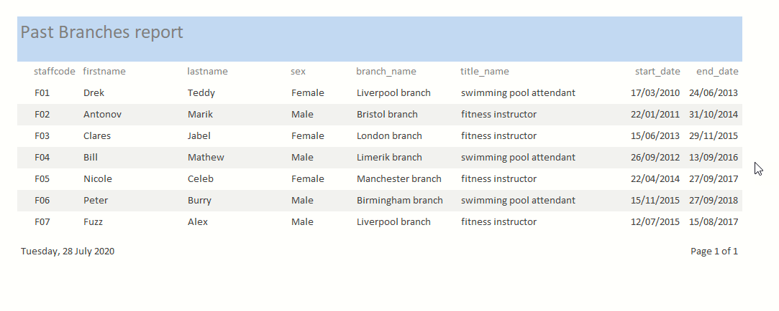
Repot on employees’ past branches

Relationships.
According to (Eckstein and Schultz, 2018), MS Access allows for creation and visualization of different tables and their relationships and the querying of stored data in different tables as illustrated below. In order to perform this, primary and foreign keys are used in defining the relationship between different tables.
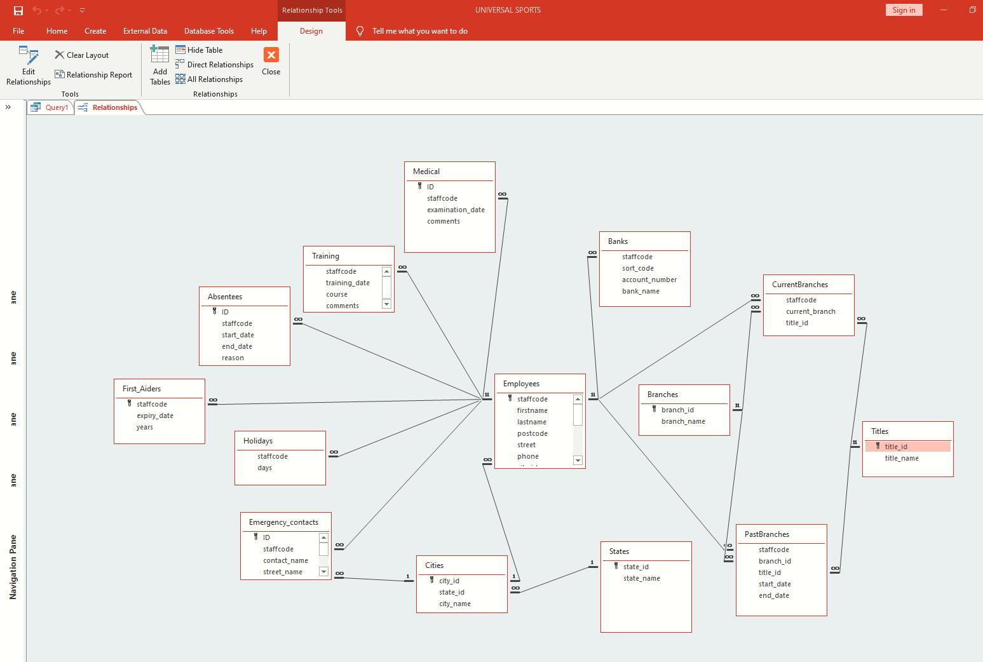
Using SQL in creation of relationships in tables through primary key.
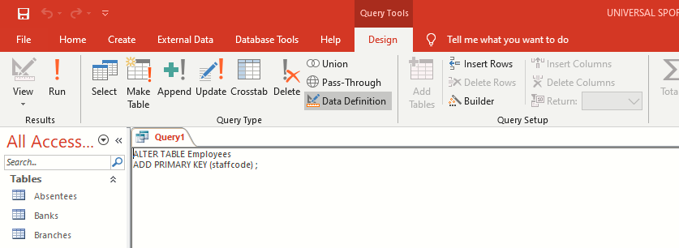
Adding relationships to Employees’ Tables.

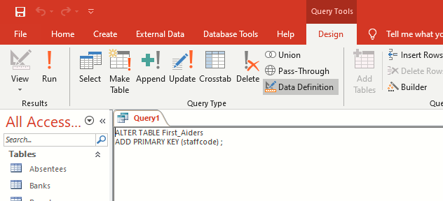
Adding relationships to first aiders
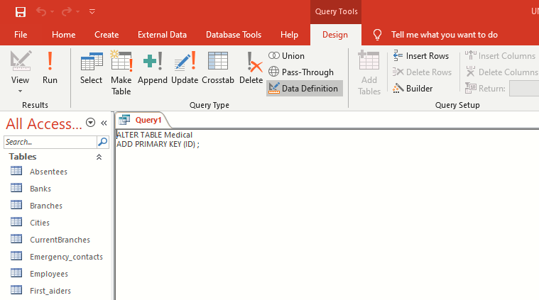adding relationship on medical table.
Using SQL to Create Relationships through foreign key (FK).
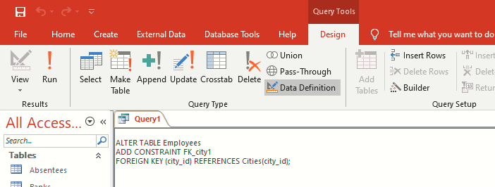
adding Foreign Keys to Employees table
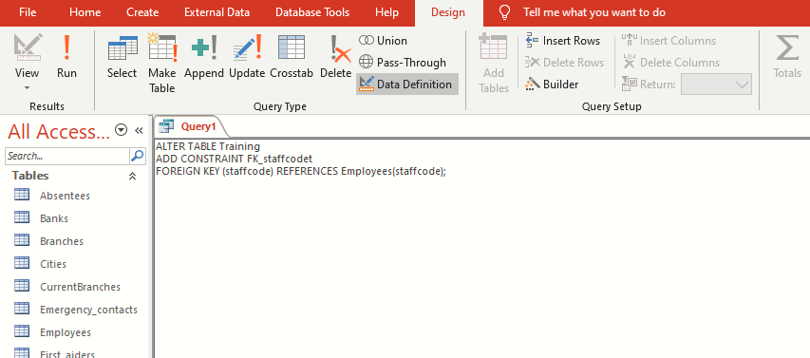
adding foreign key to Training table
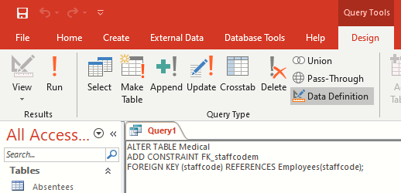
Adding foreign key to Medical Table
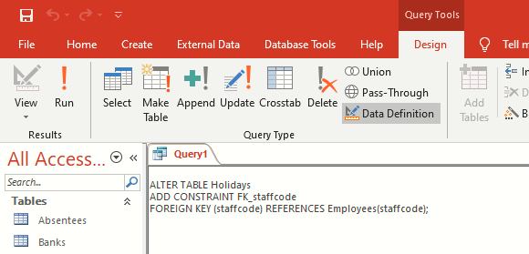
Adding foreign key to Holidays table
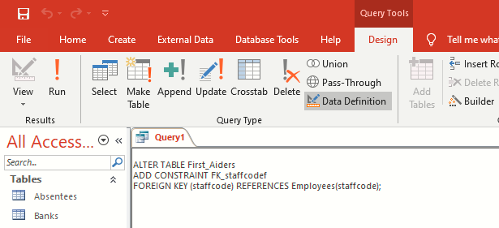
Adding foreign key to First Aiders table
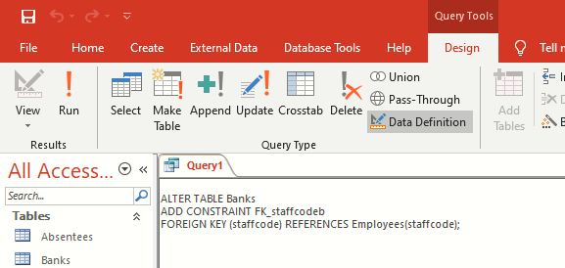
adding FK to the Banks table

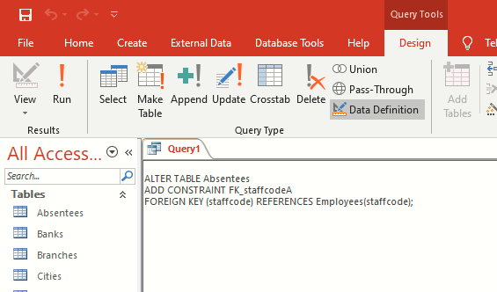
Adding FK to the Absentees table

Using SQL to Add Records to Tables.
When adding records into tables, SQL uses the keyword INSERT as indicated below
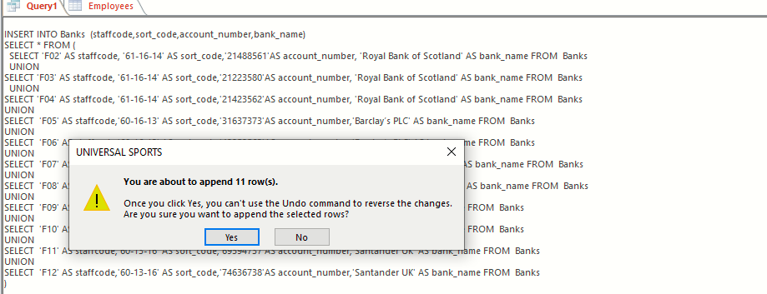
Adding records into the Banks table
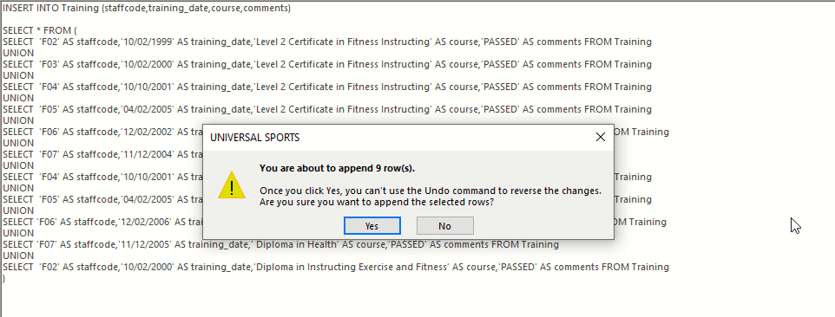
Adding records into Training table
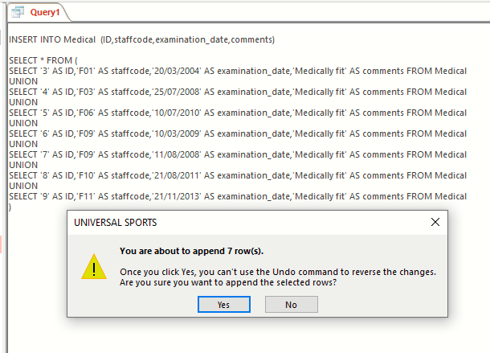
Adding records into Medical table
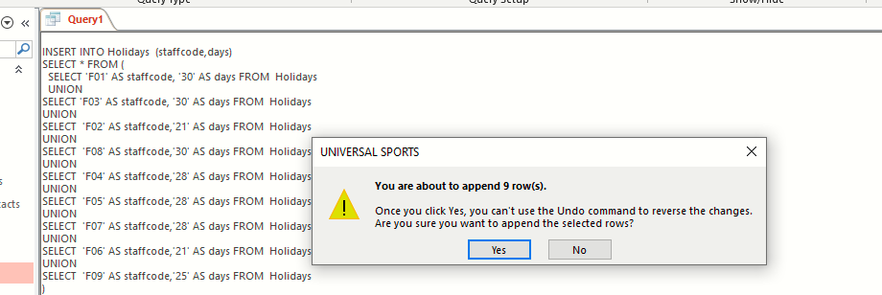
Adding records into Holidays table.
Reproducing Reports from Queries.
First Aiders report
Employees Training Report
Employees training Report
Holiday entitled report
Medical report
Past Branches report

Functionality of the Main Menu and Form Navigation.
Main Navigation Menu.
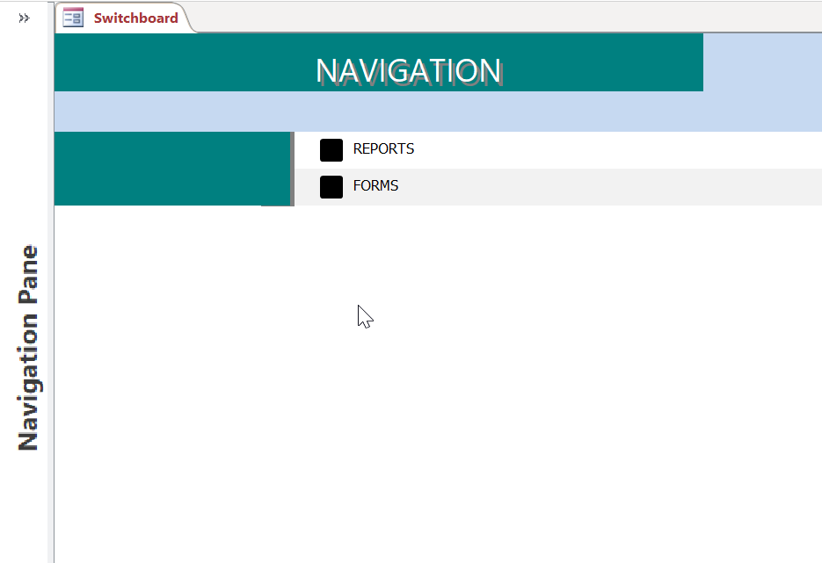
Form Navigation Menu.
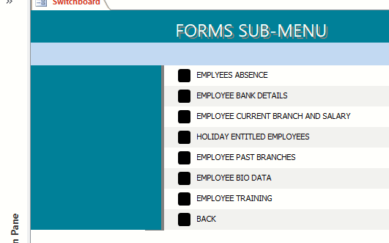

Performing Calculations in a Report.
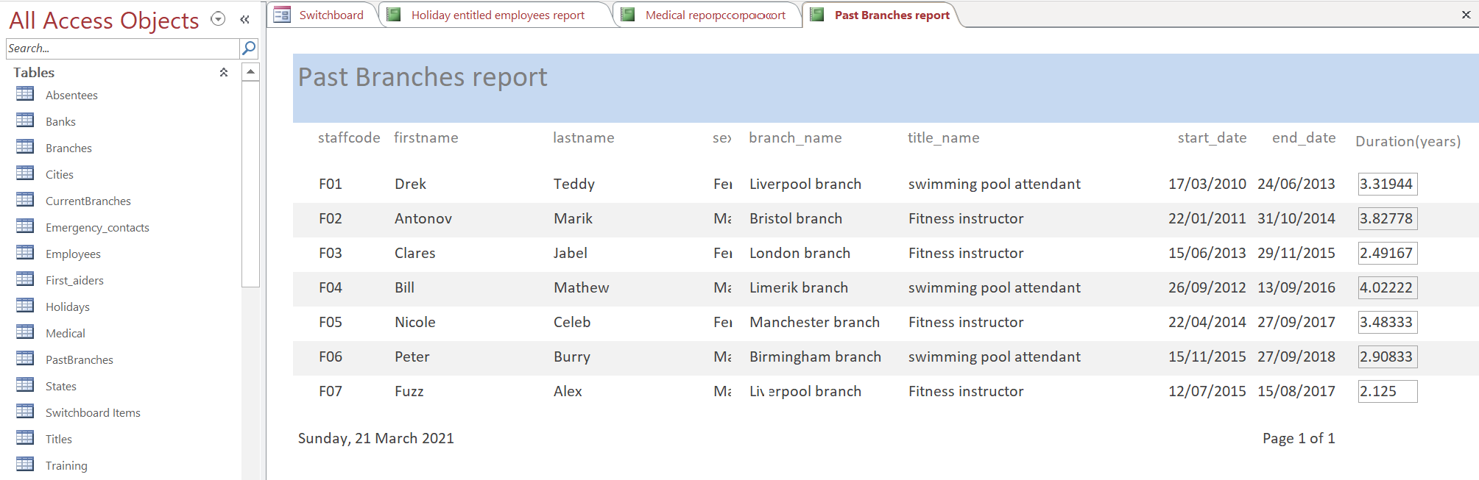
Calculation of Employee duration in past branches

Master and Embedded Forms.
According to (Groh et al, 2011), forms can be designed to be either a master form or embedded form. MS Access uses the LinkMasterFields and LinkChildFields queries to choose the records in either the embedded or sub-forms that are related to the master forms. This ensures consistency and should there be any changes made in the main forms’ link, an automatic re-query of the sub-form is prompted.
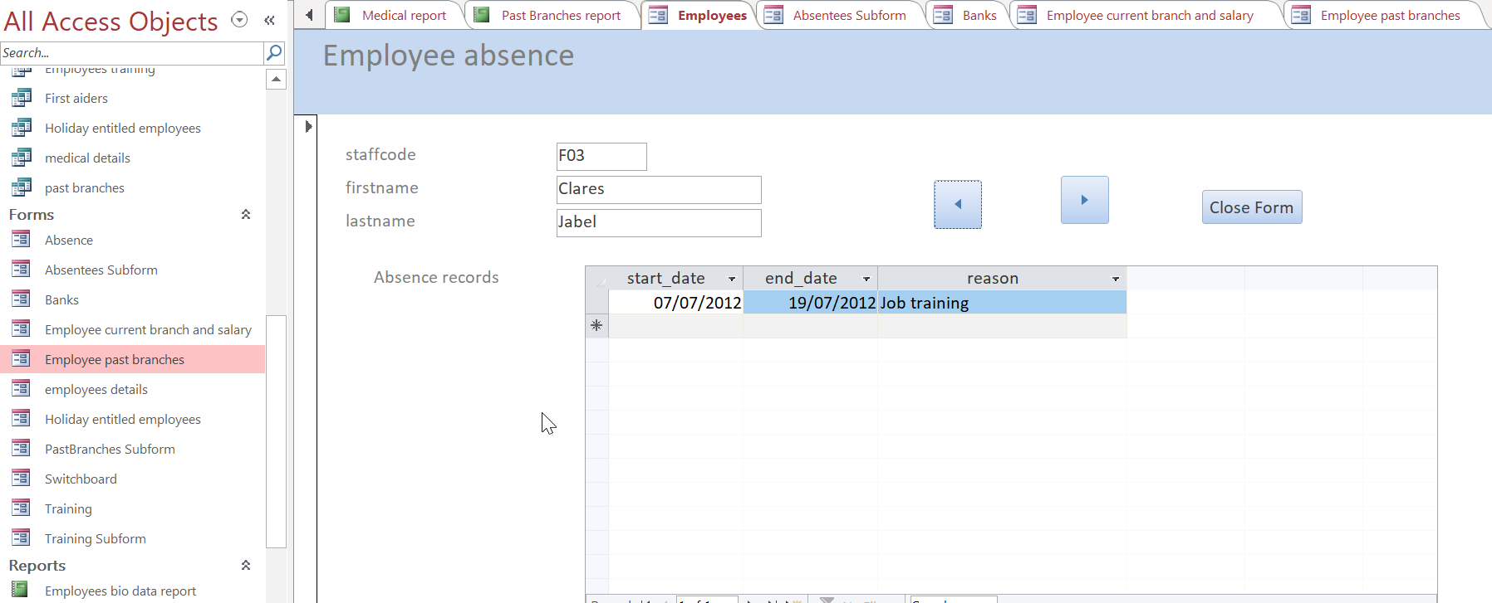

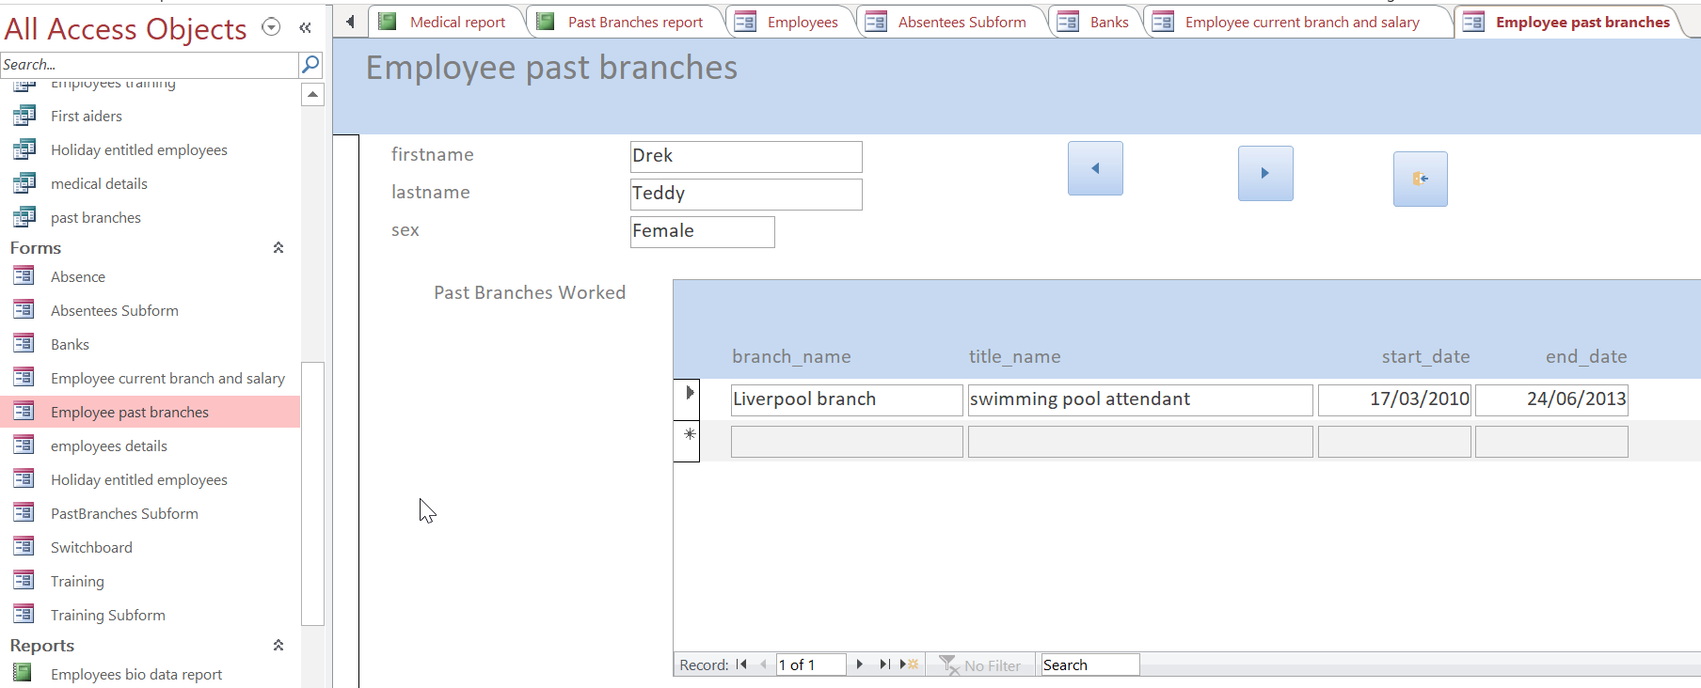

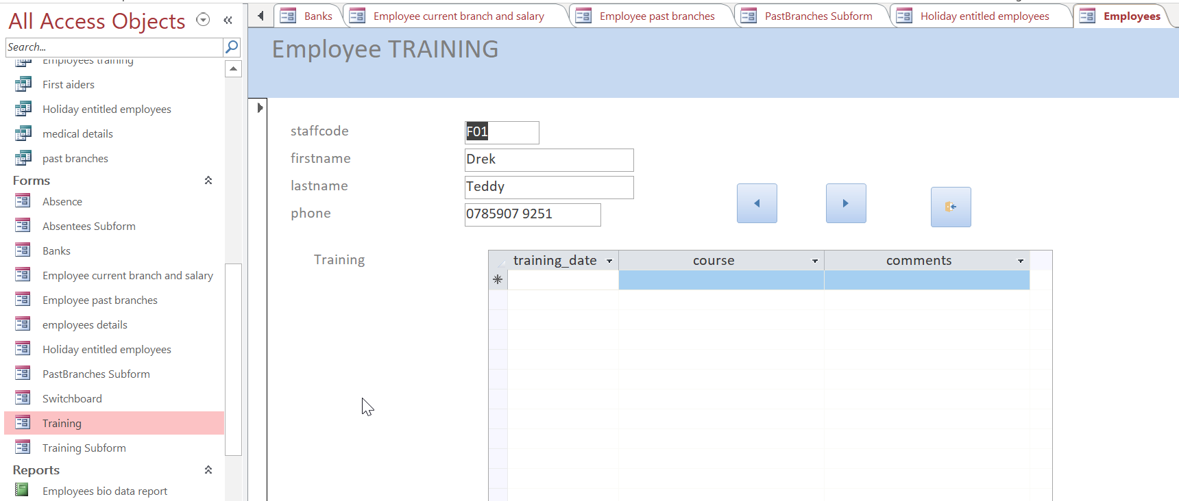

The Menu displayed immediately the database is opened.
The image below illustrates how the main UI of the database looks like upon the opening of the database.

User Guidelines
On the main menu, forms are used as the main interface for inputs to the database while the reports acts as the main interface for outputting information from the database. The main interface also enables the user to choose what operations they want to perform on the database and depending on the option they click on; they will be redirected to the desired forms and be able to navigate around the database with ease. That means, if the user wants to input some data into that database, they must select the relevant form as shown in the diagram below.
On the contrary, if the user desires to generate some information from the database, they must select the report option as shown below.
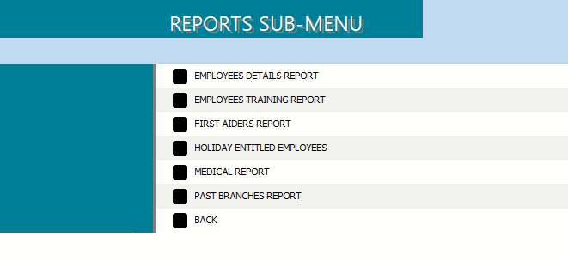

Conclusion.
DBMS offers great advantages in terms of data management as we have observed in our earlier discussion in the report. These great capabilities can only be realized through accurate designing and development of the DBMS following very specific procedures and protocols. As observed in this report, MS Access database, requires prior planning and analysis of the user requirements like any other DBMS. This is achieved by the help of ERD techniques that enables us to have a clear picture of how the database system should be structured and designed.

References.
Alexander, M. and Kusleika, D. (2019). Access 2019 Bible. Indianapolis, IN: John Wiley & Sons, Inc.
Bhattacharya, J. (2014). Rudiments of Computer Science. Kolkata: Academic Publishers.
Davis, W. and Yen, D. C. (2019). The Information System Consultant's Handbook: Systems Analysis and Design. Boca Raton, FL: CRC Press.
Eckstein, J. and Schultz, B. R. (2018). Introductory Relational Database Design for Business, with Microsoft Access. Hoboken, NJ: John Wiley & Sons Ltd.
Friedrichsen, L. (2016). Enhanced Microsoft Access 2013. Boston, MA: Cengage Learning.
Groh, M. R., Stockman, J. C., Powell, G., Prague, C. N., Irwin, M. R. and Reardon, J. (2011). Access 2007 Bible. Indianapolis, IN: Wiley Publishing, Inc.
Zygiaris, S. (2018). Database Management Systems: A Business-Oriented Approach Using Oracle, MySQL, and MS Access. Bingley: Emerald Publishing Ltd.

Appendix.

