

Kinetic Energy Recovery
Alternative Propulsion Systems ACHA5010

Ethan Davies
2305338

Word Count: 2491

University of Wales Trinity Saint David
School of engineering
Motorsport Engineering BEng

30/11/2025

Contents
1 Introduction 3
2 Vehicle characteristics 4
2.1 Test Mass 4
2.2 Aerodynamic Properties 5
2.3 Rolling Resistance 6
2.4 ‌Summary of Key Parameters 6
3 Worldwide harmonised Light vehicle Test Procedure (WLTP) 6
3.1 Method for calculating Forces, Power & Energies in Excel 7
3.1.1 Acceleration 7
3.1.2 Rolling Resistance Force 7
3.1.3 Aerodynamic Drag Force 7
3.1.4 Acceleration Force (Inertial Force) 7
3.1.5 Total Tractive Force 7
3.1.6 Tractive Power 8
3.2 Energy Integration method 8
3.2.1 Cumulative Tractive Energy 8
3.2.2 Cumulative Braking Energy 8
4 WLTP Results & Analysis 9
4.1 Tractive Forces 9
4.2 Tractive Power Profile 10
4.3 Cumulative Energy Analysis 11
4.4 Maximum Braking Event Energy 11
4.5 Recovered Energy Returned to Wheels 12
5 KERS Selection & Specification 13
5.1 MGU 13
5.2 Power Inverter 13
5.3 Energy Storage 13
5.4 Placement & Packaging 13
5.5 Mass Increases 14
5.6 System Efficiency 14
6 System Operation 15
7 Bibliography 16
8 Appendix 17

Figure 1: Frontal view of the Corolla 3
Figure 2: Side view of the Corolla 3
Figure 3: Completed preparation for the Corolla measurements. 4
Figure 4: Final reading on the Intercomp scales. 4
Figure 5: Final Intercomp scales test mass value. 5
Figure 6: All tractive forces vs time 9
Figure 7: Tractive power v time 10
Figure 8: Cumulative Energies v Time 11
Figure 9: Recovered energy to the wheels for the KERS 12
Figure 10: P2 on axis hybrid module (BorgWarner, 2024) 13
Figure 11: P2 on axis hybrid configuration module (Borgwarner, 2024) 14

Introduction
Recovery and reuse of kinetic energy have become a big focus in modern automotive engineering (Itagaki et al, 2002) as manufacturers are forced to meet increasingly stricter emissions legislation and strive to improve fuel efficiency. Internal combustion engine (ICE) vehicles dissipate a significant amount of their energy through braking. Kinetic Energy Recovery Systems (KERS) offer a means to capturing the heat energy lost to the environment. The KERS will use the otherwise wasted energy and stores it temporarily for later use through acceleration, thereby reducing the engine’s load and overall fuel consumption. While regenerative braking is widely deployed in hybrid and electric vehicles, the potential integration into standard ICE vehicles has become an active area of interest, where cost, packaging and drivability constraints must be carefully balanced.
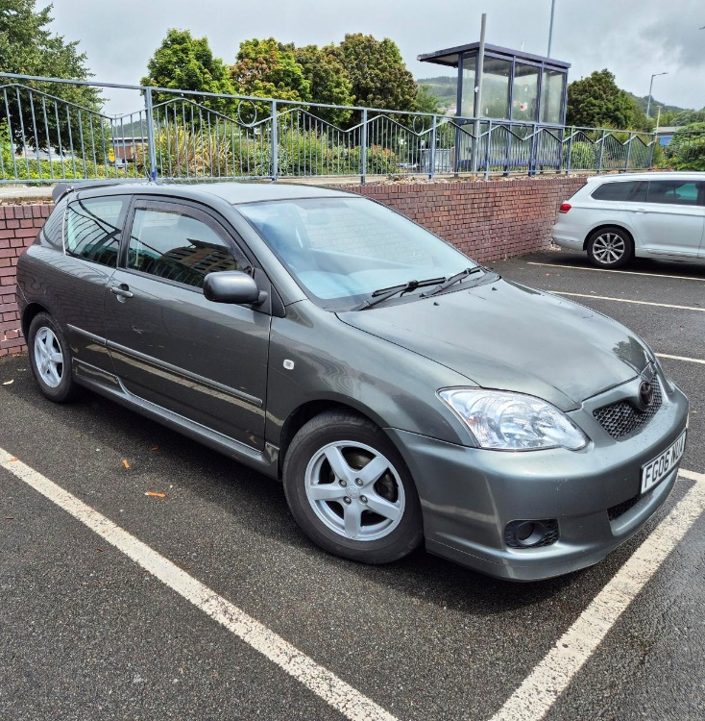
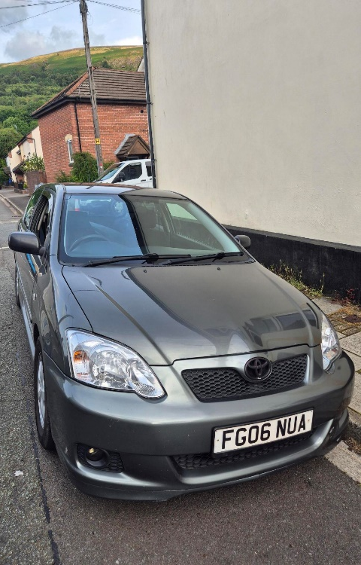
This report investigates the feasibility and potential benefits of implementing KERS in a standard passenger vehicle: the Toyota Corolla 1.4 VVT-I T2 (2006) by using the WLTP Class 3 cycle. The method of analysing forces, power, energy then KERS sizing will be put in place to investigate a P2 on-axis layout for a battery & MGU system.
Figure 2: Frontal view of the Corolla
Figure 1: Side view of the Corolla

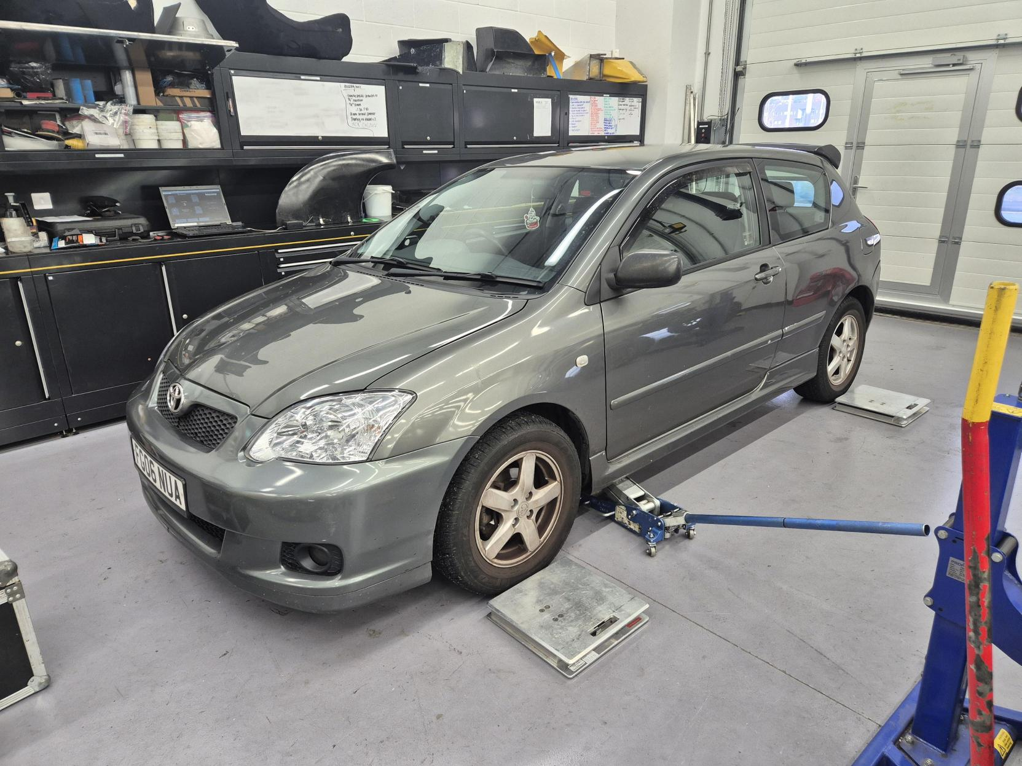
Vehicle characteristics
Figure 3: Completed preparation for the Corolla measurements.

Test Mass
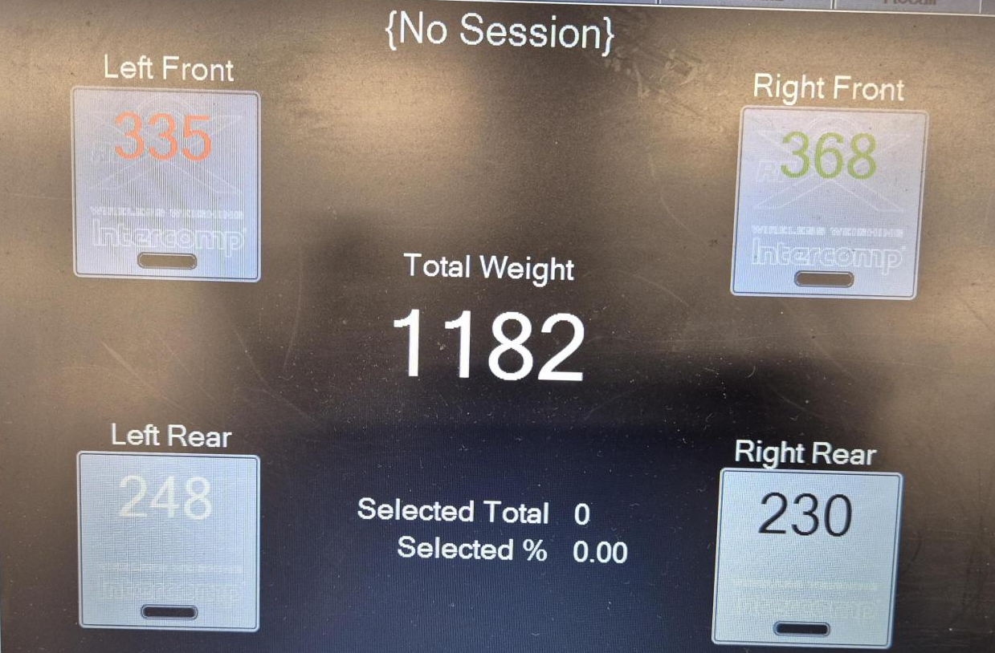
To ensure the WLTP force and energy modelling used realistic input data, I weighed the car on Intercomp corner weight scales as seen in Figure 3 supplied by UWTSD’s motorsport workshop. I weighed the car multiple times to ensure consistency. The resulting values showed no variation between readings, the third and final measurement can be seen in Figure 4.
Figure 4: Final reading on the Intercomp scales.

This came out to be a kerb mass of 1182kg.
To be able to obtain the WLTP test mass I had to include the weight of the driver, necessary equipment & a standardised payload. This initial test mass was to compare with manufacturer specifications as validation for use of the Intercomp scales.
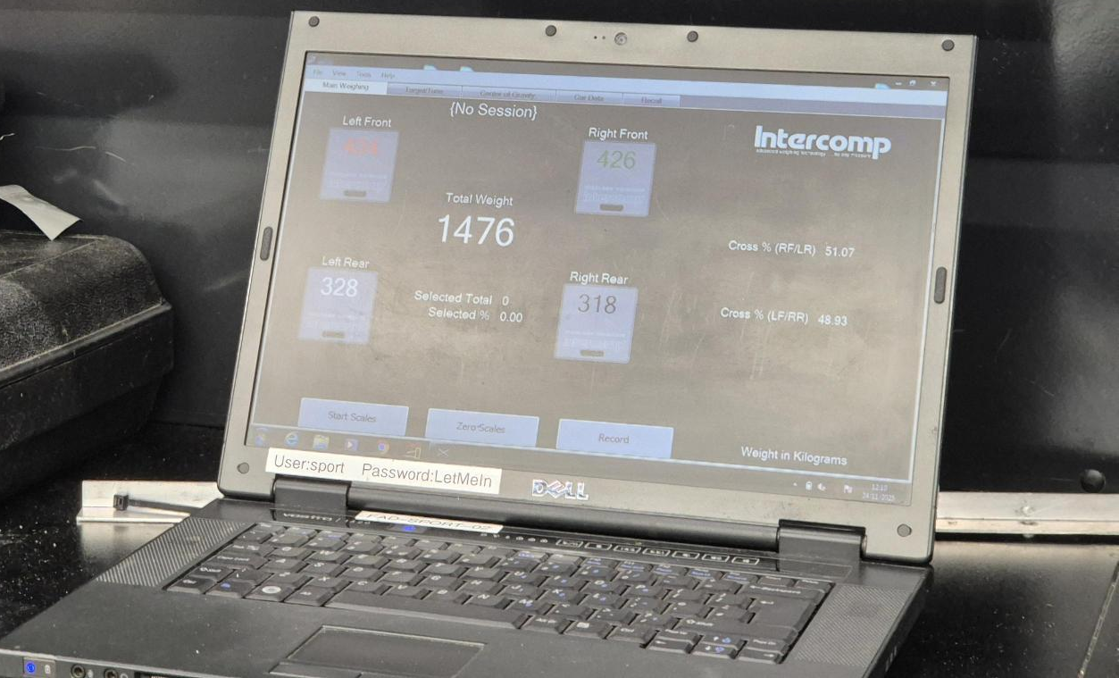
Figure 5: Final Intercomp scales test mass value.
As seen in Figure 5 this value came out to be a final test mass of 1476kg. To account for luggage & car damages I will be rounding it up to 1500kg.

Aerodynamic Properties
My corolla is not T2 standard and has the upgraded T-sport bodywork parts which include bumpers, spoiler & skirts where some will have to be factored in when calculating the frontal area. The frontal area of the car is derived from the width * height and applying a correction factor of approximately 0.8 account for the car’s nonrectangular shape. (TUV, 2012)
Height (H) = 1.475m
Width (W) = 1.71m
Frontal shape correction coefficient (C_{f}) = 0.8
$$A_{f}=C_{f}*W*H$$
$0.8*1.71*1.475=2.0178m$²
I have reviewed this value by using published data of the T-sport to ensure the value matches my calculation. I now have confidence that this is value is correct. (Parkers, 2020)
The aerodynamic property of drag has been assessed via published manufacturer data. The coefficient of drag for my corolla with added T-Sport bodywork comes out to be 0.31. (Ecomodder, 2018)

Rolling Resistance
The rolling resistance was modelled using a coefficient obtained from tyre manufacturer data. This value is the constant resistive force that persists at all speeds, it will be particularly relevant in the low speed urban sections of the WLTP Class 3 where aerodynamic drag is exceedingly small. My Corolla currently has a full set of Goodyear Eagle GT-HR tyres on which for the size P225/60R16 the coefficient for rolling resistance is 0.01217. (Goodyear, 2005)
$$C_{rr}=0.01217$$

‌Summary of Key Parameters
Table 2-1: Summary of key parameters
Parameter | Value | Unit | Source
Test Mass | 1500 | kg | Measured
Cd | 0.31 | n/a | EcoModder
$$A_{f}$$ | 2.0178 | M² | Calculated
$$C_{rr}$$ | 0.01217 | n/a | Tyre data

Worldwide harmonised Light vehicle Test Procedure (WLTP)
To analyse the vehicle’s potential for kinetic energy recovery, the WLTP was used as the driving cycle for this study. WLTP is the current international standard for evaluating emissions and fuel consumption, the older being the NEDC cycle. It has been redesigned to reflect modern driving behaviour including realistic accelerations, stop-starts and sustained high speeds. These characteristics of the WLTP very suitable for analysing potential KERS performance since any regenerative opportunities depend directly on braking magnitude and frequency.
I will be using the WLTP Class 3 cycle as it is representative of higher powered passenger vehicles and includes a combination of urban, suburban and motorway phases. Its transitions between accelerations make it highly suitable for analysing regenerative braking opportunities. (TUV, 2012)

Method for calculating Forces, Power & Energies in Excel
An Excel spreadsheet was created to calculate the forces acting on the vehicle and the resulting power & energy requirements throughout the WLTP cycle. The WLTP data will provide a vehicle speed value at each second of the cycle.
The following steps and equations were used to calculate each value:

Acceleration
Acceleration was calculated from the change in speed between consecutive time steps
$$a=\frac{v-(v-1)}{∆t}$$
$$∆t=1$$

Rolling Resistance Force
The rolling resistance force was calculated to be constant throughout the cycle
$$F_{rr}=C_{rr}*m*g$$

Aerodynamic Drag Force
Aerodynamic drag was calculated for each time step where $ρ$ is air density. Drag becomes more dominant at higher speeds, particularly in the WLTP extra high phase
$$F_{d}=\frac{1}{2}{ρC}_{d}A_{f}v^{2}$$

Acceleration Force (Inertial Force)
The inertial force is calculated using Newton’s second law
$$F_{acc}=m*a$$

Total Tractive Force
The total force required at the wheels
$$F_{trac}=F_{acc}+F_{rr}+F_{d}$$
The total tractive force will see spikes during acceleration and can become negative during long braking zones.

Tractive Power
$$P_{trac}=F_{trac}*v$$
For tractive power, positive power values are propulsion, negative power is braking. The negative power magnitude determines the regeneration potential and is what I am interested in looking at.

Energy Integration method
Tractive power was integrated numerically using a cumulative formula to determine both propulsion and braking energy across the WLTP cycle. Positive power values were accumulated to obtain the tractive energy demand, while negative power values were also accumulated to their absolute magnitude to gather how much braking energy is available for recovery.

Cumulative Tractive Energy
=IF(‘Tractive power’>0, ‘tractive power’, 0)

Cumulative Braking Energy
=IF(‘Tractive power’<0, ABS(‘Tractive power’), 0)

WLTP Results & Analysis

Tractive Forces

Figure 6: All tractive forces vs time
Figure 6 illustrates the main resistive and inertial forces calculated from the WLTP Class 3 cycle. Rolling resistance remains small and constant throughout as expected, whereas aerodynamic drag increases significantly at higher speeds over 60 km/h. In contrast, inertial force fluctuates rapidly due to frequent acceleration and deceleration events. The combined tractive force reflects all interactions and highlights the zones of the highest drivetrain load.

Tractive Power Profile

Figure 7: Tractive power v time
The tractive power profile in Figure 7 clearly differentiates between propulsion and braking periods. The negative power spikes indicate the magnitude of kinetic energy dissipated during deceleration; this forms the basis for regenerative braking potential. The peak negative power is 29kW which will define the MGU power requirement. The power oscillates the most in urban sections/low speed sections.

Cumulative Energy Analysis

Figure 8: Cumulative Energies v Time
Figure 8 shows cumulative tractive energy rises steadily throughout the cycle where in the higher phases it rises at a much higher rate. Cumulative braking energy increases sharply during heavy decelerations. The difference between the two highlights the inefficiency of standard ICE vehicles where so much energy is wasted that could contribute to more tractive energy. The total braking energy quantifies the maximum possible KERS recovery which provides the map for the KERS design. Figure 8 also displays that braking energy is spread over many small events rather than few large events. This favours a battery KERS system as it can be charged more consistently at a lower but more constant rate than a supercapacitor that would want big, short braking moments.

Maximum Braking Event Energy
The excel has given the data that the peak braking power is 29kW and the maximum braking energy event corresponds to approximately 80Wh. This value governs the minimum useable capacity required for the KERS energy storage to avoid oversaturation during regeneration.

Recovered Energy Returned to Wheels

Figure 9: Recovered energy to the wheels for the KERS
Figure 9 shows a reduced version of the cumulative braking energy where the trends will be the exact same, but the gradient of the graph will be smaller due to considering KERS efficiency at each component. The round-trip regeneration efficiency is approximately 77% where the total energy returned to the wheels is 2202kj.

KERS Selection & Specification
For the Toyota corolla the most suitable KERS to implement would be P2 on-axis hybrid layout. The P2 on-axis is compatible with every type of vehicle no matter the transmission whether manual or automatic. (BorgWarner, 2024)

MGU
Firstly, a 35kW MGU is chosen to accommodate for the 29kW WLTP peak regenerative braking power calculated and obtained from the WLTP analysis. The approximate 20% buffer zone is to allow for inefficiencies to ensure the MGU is not operated above its limit. This power level matches with typical hybrids capable of delivering 60-80Nm of torque at the crankshaft depending on gear ratios and RPM. The MGU must also sustain high rotational speeds as a P2 unit commonly operates across 3-12 thousand RPM to match the engine speed range. This will have an efficiency of 93%

Power Inverter
The power inverter chosen must run continuous for 35kW. It must also peak to at least 40kW to match the chosen MGU rating and provide a safety margin. Modern automotive inverters typically operate using high frequency IGBT or Sic MOSFET switching devices offering an efficiency of 97%. The high efficiency is essential to minimise thermal heat rejection during repeated WLTP braking events as inverter overheating causes direct limitations to regeneration capability. (Felictyess, 2024)

Energy Storage
For the KERS energy storage unit, it must have a minimum capacity of 80Wh to accommodate for the peak braking period however, a 0.2kWh lithium-ion battery pack is chosen to account for repeating braking without saturation. A nominal 320V is chosen to allow the 35kW MGU to operate efficiently as for a higher voltage there is a lower current meaning smaller cables leading to overall better efficiency. (Pesaran, 2019) This will have an efficiency of 94%. A 320V battery also is more compatible with automotive inverters. (Faraday Inst, 2020)

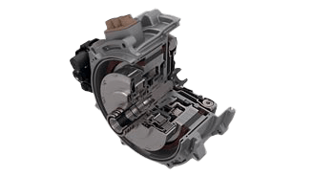
Placement & Packaging
Figure 10: P2 on axis hybrid module (BorgWarner, 2024)

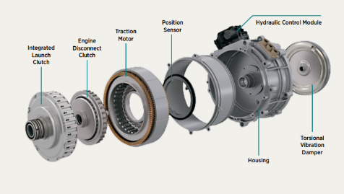
A P2 on-axis configuration is to be placed between the engine and gearbox. This allows for efficient regenerative braking and propulsion assist while making little change to the current drivetrain layout. This is due to the system being compatible with all transmission architectures that has a compact design and high performance. (BorgWarner, 2024)
Figure 11: P2 on axis hybrid configuration module (BorgWarner, 2024)
Choosing a P2 over a different ‘P system’ was an easy choice as P2 has a torque blending ability where it can contribute torque directly to the crankshaft. The ECU can also add small amounts of electric assists to compensate for engine lag. The P2 is more ‘package friendly’ than the P1 as the P2 can fit directly onto any transmission system whereas the P1 requires quite a big redesign and movement of components to make it fit. Compared to the P3 the P2 does not interrupt combustion where for EV only driving the P3 would be a great choice but not for the Corolla which is more focussed on ICE driving where just the electronic assist is wanted.

Mass Increases
The overall estimated masses of the components are:
- MGU – 20kg
- 0.2kWh battery – 15kg
- Inverter & wiring – 5kg
This adds an approximate 50kg overall to the corollas test mass. Which is a small penalty as the overall increased fuel efficiency of the car will be increased to combat this.

System Efficiency
The overall system efficiency will be calculated by the equation
$η_{regen}=$ 0.93 (MGU) * 0.97 (inverter) * 0.94 (battery) * 0.97 (inverter) * 0.93 (MGU)
$$η_{regen}=0.765$$
However, to have more accurate calculations for overall KERS system efficiency I calculated each energy value individually for the efficiency going in and out of each component. This will negate any deviation in my results as the efficiency value will be in its full form and not rounded.

System Limitations
Some limitations of the system implementation would start with the thermal saturation of the MGU. This is the repeated high powered regeneration events that will heat the MGU quickly the 35kW unit may derate if the cooling system cannot handle WLTP surge loads which means once it has reached its thermal limit torque is restricted by the inverter reducing performance and efficiency.
Regenerative braking can only provide as much power by the driving cycle. Hard braking events require good condition friction brakes to supply the vast majority of the stopping power, limiting regeneration contribution and leading to higher and more frequent costs of replacement brakes.
There will be increased engine drag when clutch is engaged which reduces regeneration efficiency particularly at lower speeds. This means the ECU must choose between increased engine drag or more clutch activity.
The P2 layout support torque assist but not sustained EV-only driving, meaning the battery cannot be used for silent launch or low-speed cruises. Efficiency gains are therefore smaller than full hybrids
The dependence on WLTP conditions is also important to highlight as WLTP Class 3 has relatively mild braking compared to real world driving where steep hills, heavy traffic, emergency stops at high speeds may exceed the system’s regeneration capacity. Conversely, constant motorway driving provides next to no regeneration opportunity at all.

System Operation
With the Corolla being fitted with a P2 ‘on-axis’ KERS lithium-ion battery system it operates in two main modes: regenerative braking and motor assist. During deceleration, the P2 mounted MGU is driven by the drivetrain allowing the vehicles kinetic energy to be captured and converted into electrical power. The inverter supplies the 320 V battery pack while maintain safe voltage and current limits. The control unit prioritises battery protection by limiting regeneration when the battery approaches its maximum charge. This ensures the system follows the WLTP braking profile without exceeding the battery’s constraints.
On the other hand, in acceleration the MGU operates as a motor delivering torque into the crankshaft. This reduces the engines load at low speeds which will improve fuel efficiency. Torque blending between the engine and MGU is controlled to avoid drivability issues, where the clutch will decouple when the engine is off or when electric only launches are not wanted. The limitations to this however is that during repeated high power periods the MGU will get very hot and that there is only a small window where energy is useable. Nevertheless, this system enables effective recovery of kinetic energy that overall helps in performance. (Itagaki et al, 2002)

Conclusion
Overall, this study modelled the Toyota Corolla 1.4 VVT-I T2 (2006) on WLTP Class 3 and identified where braking energy was available for regeneration. The results found were used to design a KERS to reduce overall fuel consumption. Some key findings where the peak regenerative braking power was 29kW and the maximum single braking event is 80Wh. WLTP shows most regeneration potential in low/medium speed phases. Selected P2 on-axis hybrid layout for best balance of packaging and efficiency, the MGU rated at 35kW, 0.2 kWh lithium-ion battery and a 320 V electrical system chosen for a lower current but higher efficiency. In this study the goal of increasing overall fuel efficiency has been achieved by reducing engine load in acceleration and enhancing drivability via a smoother launch and better transient response.

Bibliography
- BorgWarner (2024) Explore our Technologies P2 Module for Hybrid Vehicles.

- BorgWarner (2024) P2 hybrid architecture https://www.borgwarner.com/technologies/p2-hybrid-architecture

- Ecomodder.com. (2018). Vehicle Coefficient of Drag List - EcoModder Forum Wiki. [online] Available at: https://ecomodder.com/wiki/Vehicle_Coefficient_of_Drag_List.

- Faraday Inst (2020) High-energy battery technologies.

- Felictyess (2024) what is inverter efficiency and why it matters. www.felictyess.com/what-is-inverter-efficiency-and-why-it-matters/

- GoodYear (2005) Passenger Tire Rolling Resistance Measurements Made Available by Three Tire Companies, September 2005 (referred to as RMA data in report).

- Itagaki, K., Teratani, T., Kuramochi, K., Nakamura, S. et al., "Development of the Toyota Mild-Hybrid System (THS-M)," SAE Technical Paper 2002-01-0990, 2002, https://doi.org/10.4271/2002-01-0990.

- Pesaran, A., Santhanagopalan, S. & Kim, G-H. (2019) Li-ion Battery Thermal Performance and Cycling Study. Golden, CO: National Renewable Energy Laboratory (NREL).

- Parkers.co.uk. (2020). Toyota Corolla Hatchback 1.8 VVTL-i T Sport 3d (04) specs & dimensions. [online] Available at: https://www.parkers.co.uk/toyota/corolla/hatchback-2002/18-vvtl-i-t-sport-3d-(04)/specs/

- TUV (2012) ANNEX 1 DRIVE CYCLES AND SHIFTING PROCEDURES.

Appendix

