Task 1. e-Commerce Website builders/software solutions
Some of today’s modern SaaS solutions provide feature-filled and intuitive tools for creating and maintaining online stores efficiently for businesses. Here’s a look at some of the most popular e-commerce website builders today:

1. Shopify
Shopify is popular due to its ease of use and the plethora of features it can be used for businesses of any size. Store creation is easy using its drag and drop editor and templates, even for users with no coding experience. [1] The Shopify platform has several built-in applications, however there is virtually an app for everything in the app store, ranging from inventory and marketing to analytics. It also helps to SEO; businesses are also able to access a wider market through the search engines. Shopify is a highly scalable platform coupled with Shopify plus for enterprise businesses making it ideal for both startups and large-scale businesses. [2]

2. WooCommerce
WooCommerce is a versatile plugin for e-commerce built for WordPress, the most popular content management system. This plugin converts your WordPress website into a commercial platform and provides a lot of flexibility because of its open-source base. Due to the availability of numerous plugins and themes, WooCommerce is preferred by those users who need a great deal of control over the store appearance and options. [3]This is particularly suitable for WordPress users since they can manage their content at the same time as running an online shop. [4]

3. BigCommerce
BigCommerce is a highly scalable ecommerce solution and is more appropriate for fast growing businesses. [5]In contrast to other platforms, BigCommerce offers a large list of in-built features for selling across multiple channels, SEO optimization, and analytics, which reduces the use of applications. What’s even better, its payment gateway integrations are free, which would be a big plus for stores with a lot of sales. Using sophisticated SEO tools and multiple selling opportunities, BigCommerce assists companies in finding their clients. [6]

4. Squarespace
Squarespace is preferred by artists and entrepreneurs who value aesthetic. Featuring stunning designs, Squarespace is a site builder that lets users create great looking, professional websites without any hassle. Squarespace’s e-commerce facilities are not as comprehensive as Shopify or BigCommerce, but it provides basic functions such as inventory control, payments acceptance, and tracking. It will suit small stores which appreciate elegance and do not require complex configurations.

5. Wix eCommerce
Wix has a simple solution for building an e-commerce website with a drag-and-drop editor and a set of templates. It is suitable for learners or small businesses since it is easy to use and cheap. Wix has built-in solutions for products management, payments, and shipping, in addition to such functionalities as abandoned cart, and marketing automation. [7] While it isn’t quite as expansive as some of the competition, it’s ideal for small businesses looking for a low-cost yet easy-to-navigate tool. [8]

6. Magento (Adobe Commerce)
Magento or Magento Open Source now called Adobe Commerce is an open-source solution that is fully customizable and great for large businesses with complex needs. On one hand, it is perfect for creating custom solutions, but on the other hand, it is not always easy to handle if you do not have a special background. [9]Magento has powerful features such as multi- store management, customer division and customer specific customization, which makes Magento a premium choice for large scale enterprises willing to spend on hiring a dedicated development team. Adobe Commerce Cloud is a hosted edition that is tightly linked with other Adobe solutions, which is a plus for big enterprises. [9]

Task 2. Mind-map of contemporary software applications

Part a)

Mind Mapping: An Overview
It is a technique of listing information in a hierarchical structure of subtopics around a central concept on a spider web like structure. Having a main idea in mind, a mind map spreads out in many directions, connecting different ideas; thus, making it easier to understand large amounts of information. Mind maps have recently been introduced by Tony Buzan to work both the right and left sides of the brain and are useful in business, education and project management. [11]

Advantages of Mind Mapping in Business Processes
Mind mapping is not only an effective tool in business for creating ideas but also in project managing and teamwork. Here’s how it can benefit business operations:

1. Academic improvement in areas such as problem solving and decision making
Mind maps enable a systematic thinking process with regards to issues. Tools based on the visualization of ideas allow for multiple solutions to be viewed and the connections between them to be examined. This assists teams in risk assessment and in making evaluation of results that in return enhances informed decision making.

2. Pert Project Planning and Management
In project management, mind maps have their use especially in the outlining of tasks, time of completion, resources needed and others. Through such visualization, project managers and teams get to know the relationship of each task to the project. This structure brings order in work delivery, completeness, compliance to agreed time schedules, and clarity of roles. [12]

3. Increased Creativity and Idea Flow
Mind mapping is helpful in arriving at creative solutions since it allows ideas to be followed in a free form. This approach assists in capturing innovative solutions which may not be evident when people are brainstorming. Mind maps are best used during the product development or marketing concept generation processes where new ideas are crucial.

4. Better Co-ordination
The mind maps find their useful application in the corporate environment when it is necessary to convey the information to the team. During meetings, they assist in the organization of the flow of the meeting and make sure that all points have been taken on the board. This enhances cohesiveness because employees can understand how best every member is working towards the same plan and direction.

5. Greater knowledge management and organization
It is used to organize information for ease of retrieval through training, strategic planning and meeting sessions. Saying that, mind maps help to enhance comprehension and retention of information using visuals, which makes it easier to recall essential information and use it appropriately.

Part b)

Mind map of contemporary software applications
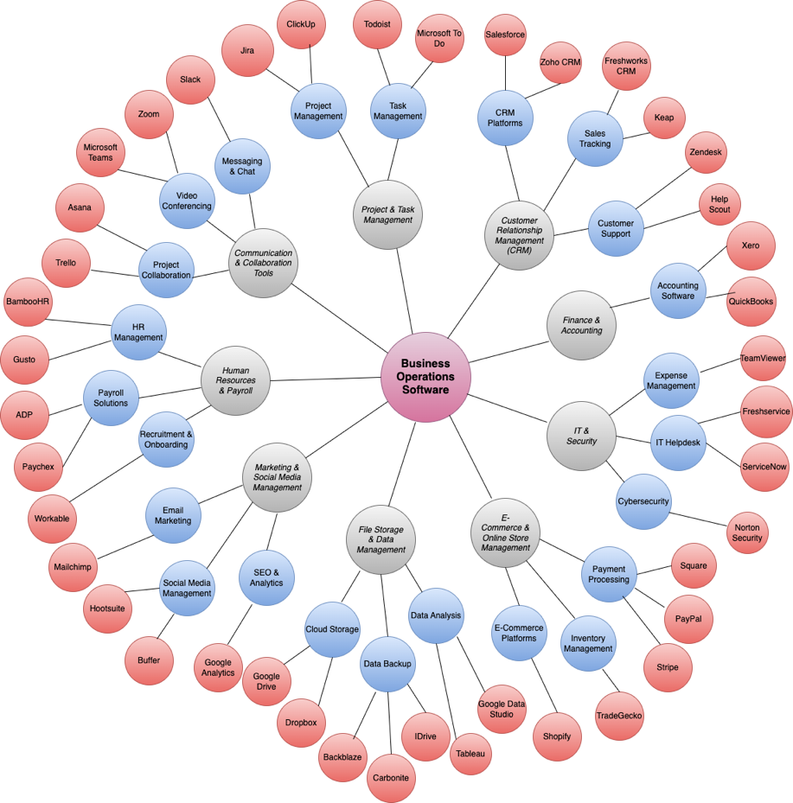
Figure 1 Mind map of contemporary software applications

Task 3. Office Applications for creating, storing, presenting, and analyzing information/data

Part a)
Here's a description of each software solution, followed by a concise table summarizing their major features, benefits, and limitations:

1. MS Word
Microsoft Word is an efficient word processing software which is applied in different companies to develop, modify and style documents. It allows the co-authoring of documents, has different templates, and offers integration with cloud solutions for sharing or accessing the documents. [13]

Figure 2 MS Word

2. MS PowerPoint
Microsoft PowerPoint is an application for creating business-oriented presentations. It has features for media embedding, use of animations and simultaneous sharing of information and is suitable for use in business workshops, management training and report writing.
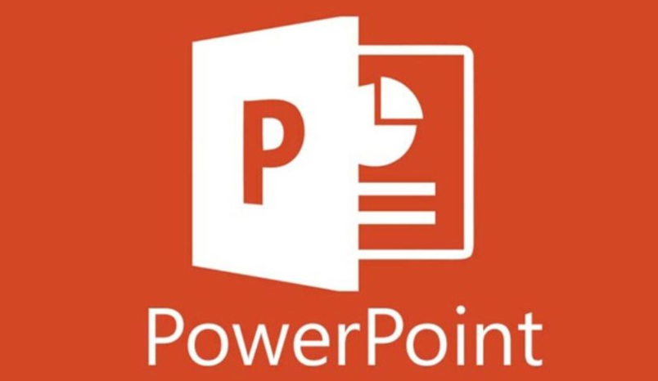
Figure 3 MS PowerPoint

3. MS Excel
Microsoft Excel is one of the most important applications used to organize, analyze and present data in form of a spreadsheet. It is used in budgeting and financial forecasting, project management and tracking, formulations, charts, pivot tables and data visualization. [14]
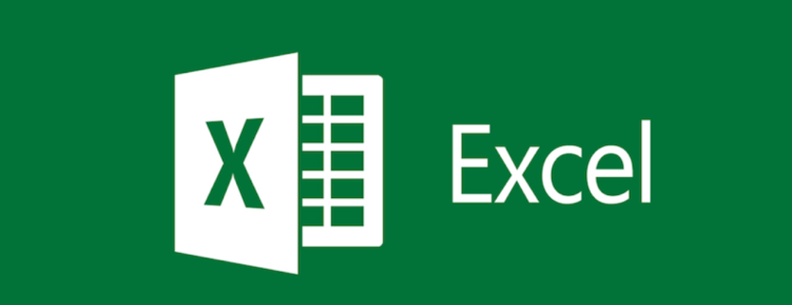
Figure 4 MS Excel

4. MS Access
Microsoft Access is a tool of database management that helps company and businesses in collection, storage and analysis of large amount of data. Rich in such features as query-building tools, reporting features, and capabilities of Relational Database Management Systems, Access is ideal for use in customer information management, inventory, and other data-centered operations. [15]

Figure 5 MS Access
Software Solution | Major Features | Benefits | Limitations
MS Word | Document creation, formatting, templates, and collaboration tools | Versatile for business documents; easy collaboration | Limited data analysis features
MS PowerPoint | Slide creation with multimedia support, animations, and cloud collaboration | Ideal for presentations and training | Large files may cause performance issues
MS Excel | Data organization, formulas, charts, pivot tables | Excellent for data analysis and reporting | Not suited for large database management
MS Access | Database management, query-building, reporting, and data relationships | Efficient for managing large data sets | Steeper learning curve; not ideal for beginners

Part b)

1. Mail Merge (Creating Personalized Messages in Excel Using Concatenation)
Purpose: To show how to write customized messages inside Excel as an imitation of the typical Mail Merge without having to incorporate other programs. In Excel, there is Concatenate and Text Join which can be used to combine data fields into personalized messages that are useful in developing messages to match each record in a dataset.
Steps:

Create a Data Source in Excel
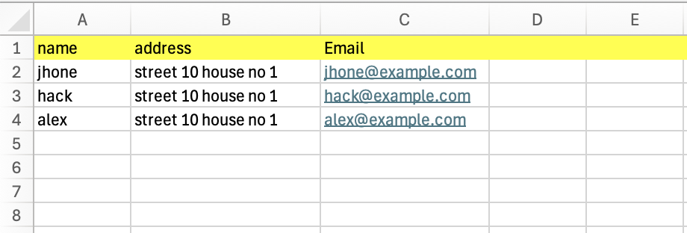
Figure 6 Data Source in Excel

Concatenation
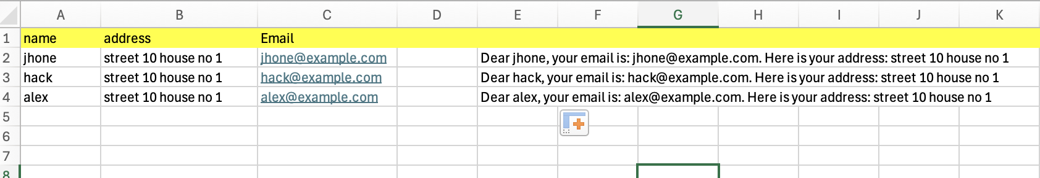
Figure 7 Concatenation

2. IF Function
The IF function evaluates a condition and returns one value if the condition is true and another if it’s false. This is useful for conditional calculations.
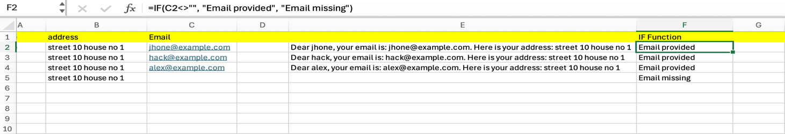
Figure 8 IF Function

3. Using VLOOKUP
purpose: Use VLOOKUP to pull additional information related to a specific Name (for instance, retrieving the address).
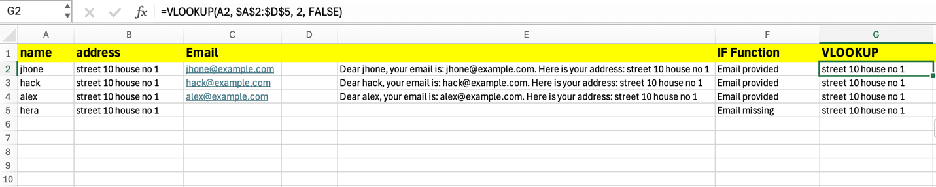
Figure 9 Using VLOOKUP

4. Creating a Pivot Table
Purpose: Use a Pivot Table to summarize data, such as the count of records by address.
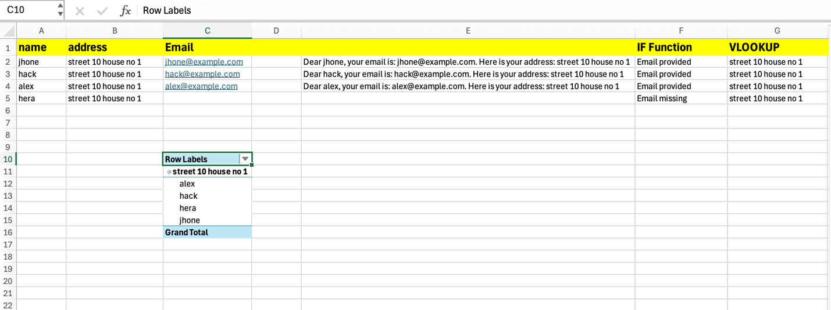
Figure 10 Pivot Table

5. Using Goal Seek
purpose: Use Goal Seek to find a required value, such as how many emails need to be added to reach a target number.
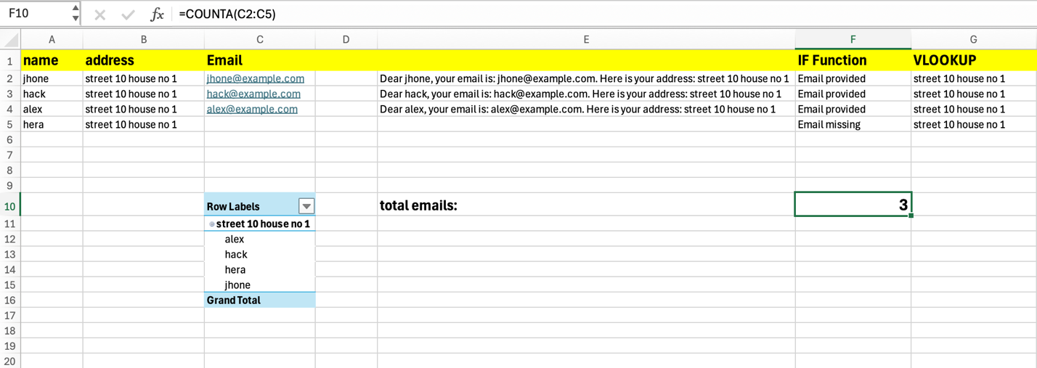
Figure 11 Goal Seek

Task 4. Communication and Collaboration applications

Part a)

Email (Gmail and Outlook)

Overview
In as much as new communication technologies have evolved, email still ranks among the most popular communication means in the business world. Most of the emails such as Gmail and outlook offer advanced amenities for business use. [16]

Key Features
- User Interface: Both Gmail and Outlook have very good and friendly interfaces, with organized boxes and options for customization. Users can sort emails into folders like Gmail uses labels while Outlook uses folders.
- Integration: These applications are also compatible with other productivity applications. For instance, Gmail is fully connected with Google Drive and Calendar, and Outlook is linked to MS Office applications.
- Search Functionality: Some of the great features include: A highly efficient search capability to find emails using keywords, dates and attachments.
- Collaboration Tools: Users are allowed to share documents from the email interface and even set up meetings through calendars.
- Mobile Accessibility: Both platforms have mobile applications so that the users can be able to communicate while on the move.
- Security Features: The two applications have spam filtering, encryption, and multi-factor authentication features to boost security.

2. Microsoft Teams

Overview
Microsoft Teams is a collaboration tool that is aligned with the Microsoft 365 solution set, which is a communication and work environment. [17]

Key Features
- Chat Functionality: Teams enables the use of one-on-one and group messaging systems for the purpose of sharing messages, files and links in real-time.
- Video Conferencing: The platform also allows for high-definition video calls with up to 10,000 participants perfect for large meetings and webinars.
- File Sharing and Collaboration: Teams works with SharePoint and OneDrive so that users can work on the documents in real-time.
- Integration with Other Apps: Users can create tabs for their most used apps such as Planner, Trello and other tools to avoid having to switch between tabs.
- Meeting Scheduling: It is also possible to schedule meetings either from the Teams calendar or by using Outlook calendar integration.
- Security and Compliance: Microsoft Teams is also secure and comes with features such as data encryption and compliance certifications.

3. SharePoint

Overview
SharePoint is an online collaboration tool connected to Microsoft 365 that is used for creating company SharePoint sites for sharing and managing business content.

Key Features
- Document Management: Microsoft SharePoint is a reliable system for storage, document control, and access enabling document versioning and tracking.
- Team Sites: The audiences can create the team site specifically for the certain projects that will help to structure the collaboration effectively.
- Integration with Microsoft 365: One of the best things about SharePoint is its compatibility with other Microsoft products such as Teams, Outlook, and OneDrive.
- Customization: SharePoint sites can be further personalized with web parts, templates as well as customization of branding by the organizations.
- Security and Compliance: It also has power security capabilities such as permission of SharePoint and compliance that help in protecting of sensitive data.

4. Slack

Overview
Slack is an app meant for communication and project management that has an extensive usage as a team messaging tool. [18]
Key Features
- Channels: Users can create channels for different teams, projects or topics through which they can have a systematic discussion and not have to go through the emails overload.
- Integrations: Slack allows many third-party apps (Google Drive, Trello, and Zoom etc.) to be connected to make a single workspace.
- Searchable History: Slack has a feature of saving the previous messages and documents with the ability to conduct a search of the corresponding materials.
- Voice and Video Calls: The platform includes voice and video calls, which enables the occurrence of real-time associations.
- Custom Notifications: The application allows users to select what kind of notifications they would like to receive in order not to be overloaded with messages.

part b)

Communication Application: Gmail (or Outlook)

Feature 1: Organize Emails with Labels (Gmail)

Creating a label
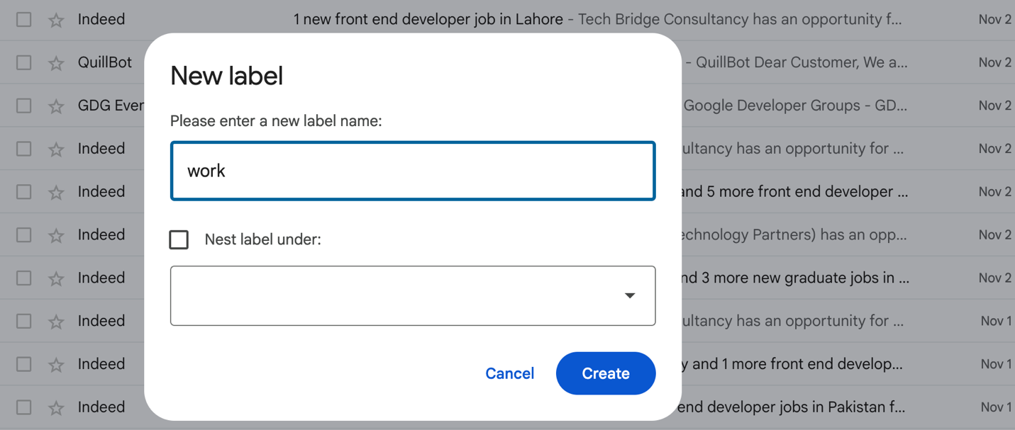
Figure 12 Creating a label

Applying label
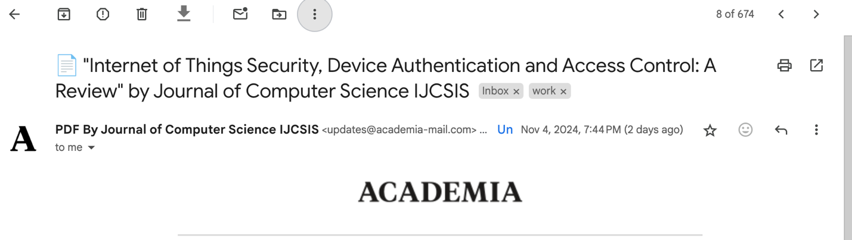
Figure 13 Applying label

Feature 2: Setting Up Filters and Forwarding Rules

Creating the filter
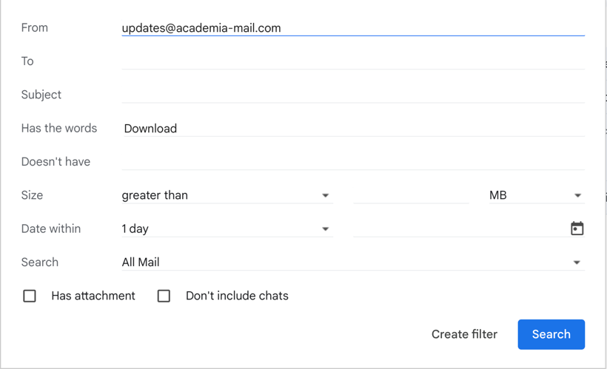
Figure 14 Creating the filter

Adding massage criteria
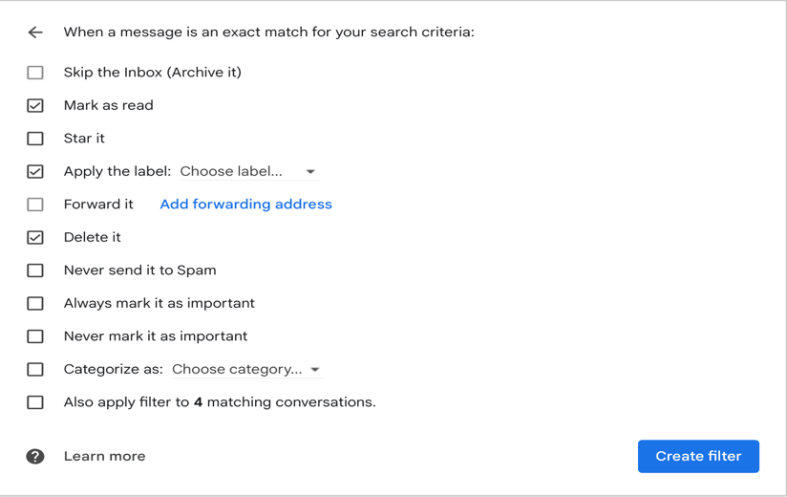
Figure 15 Adding massage criteria

Collaboration Application: Google Drive

Feature 1: Creating Shared Folders and Managing Permissions

Creating folder:
Figure 16 Creating folde

Managing permission:

Figure 17 Managing permission:

Feature 2: Real-Time Collaboration on Google Docs

Create sub folder in main folder
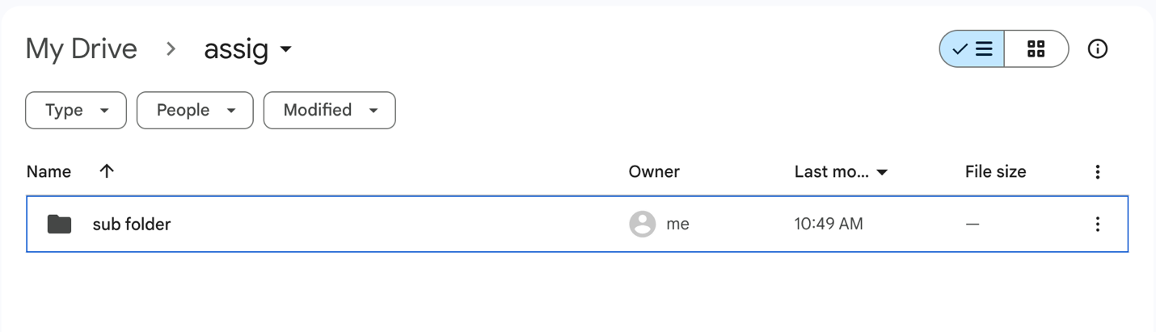
Figure 18 Create sub folder in main folder
Manage permission:
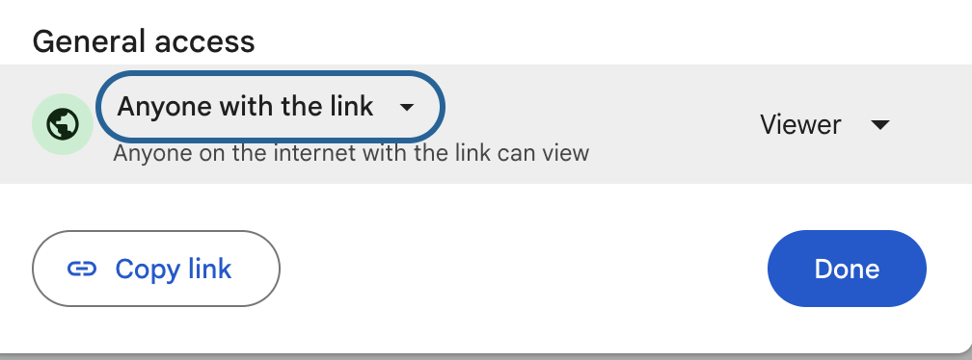
Figure 19 Manage permission

Bibliography

[1] | "What does Shopify do?," , . [Online]. Available: https://www.shopify.com/faq/what-does-shopify-do. [Accessed 6 11 2024].
[2] | C. . Brown, "25 Best Shopify Themes and Templates," , 2014. [Online]. Available: http://templendo.com/shopify-themes-and-templates. [Accessed 6 11 2024].
[3] | "WooCommerce," , . [Online]. Available: https://wordpress.org/plugins/woocommerce/. [Accessed 6 11 2024].
[4] | "WooCommerce keeps gaining Market Share," , . [Online]. Available: http://prowoos.com/woocommerce-keeps-gaining-market-share/. [Accessed 6 11 2024].
[5] | "BigCommerce Investors," , . [Online]. Available: https://www.crunchbase.com/organization/bigcommerce#section-investors. [Accessed 6 11 2024].
[6] | T. . Geller, Create Your First Online Store with Drupal Commerce, ed., vol. , , : lynda.com, , p. .
[7] | J. . Barrett, "Wix introduces game-changing App Market for web developers," , . [Online]. Available: http://communities.washingtontimes.com/neighborhood/status-update/2012/oct/16/wix-introduces-game-changing-app-market-web-develo/. [Accessed 6 11 2024].
[8] | "Compiler," , . [Online]. Available: http://wixtoolset.org/documentation/manual/v3/overview/candle.html. [Accessed 6 11 2024].
[9] | B. . Delvaux and N. . Ferdous, "Magento 1.8 Development Cookbook," , 2010. [Online]. Available: https://amazon.com/magento-development-cookbook-bart-delvaux/dp/1782163328. [Accessed 6 11 2024].
[10] | "MAGENTO CERTIFICATION," , . [Online]. Available: https://www.magentocommerce.com/certification/. [Accessed 6 11 2024].
[11] | "Five Best Mind Mapping Tools," , . [Online]. Available: http://lifehacker.com/five-best-mind-mapping-tools-476534555. [Accessed 6 11 2024].
[12] | B. . Esselink, A Practical Guide to Localization, ed., vol. , , : John Benjamins Publishing Company, 2000, p. 428.
[13] | "Word Viewer," , . [Online]. Available: http://www.microsoft.com/en-us/download/details.aspx?id=4. [Accessed 6 11 2024].
[14] | "Download Excel Viewer from Official Microsoft Download Center," , . [Online]. Available: http://www.microsoft.com/en-us/download/details.aspx?id=10. [Accessed 6 11 2024].
[15] | "New in Access for developers," , . [Online]. Available: http://msdn.microsoft.com/en-us/library/office/jj250134.aspx. [Accessed 6 11 2024].
[16] | "Email History," , . [Online]. Available: http://www.livinginternet.com/e/ei.htm. [Accessed 6 11 2024].
[17] | "Microsoft Launches Free, Unrestricted Version Of Visual Studio For Small Teams," , . [Online]. Available: https://techcrunch.com/2014/11/12/microsoft-makes-visual-studio-free-for-small-teams/. [Accessed 6 11 2024].
[18] | "Slack API," , . [Online]. Available: https://api.slack.com/. [Accessed 6 11 2024].

