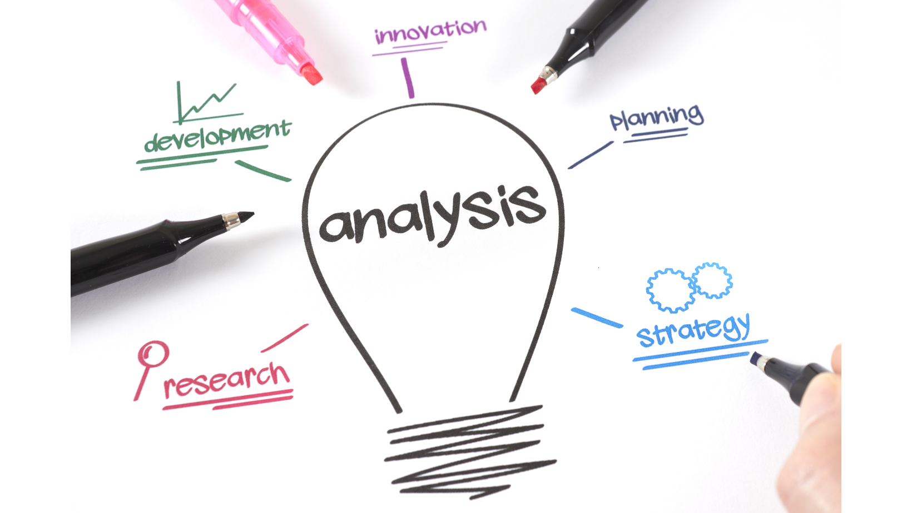  the impact of external environment on employee recruitment and retension at hyatt hotels and resorts  Assignment 2 Research Project Proposal | Abstract  The external environment like Automated intelligence, generation changes and retirement tide are constantly shaping the way organisation are adapting to the changing circumstances are these changes good or bad for the organisation? What about the external factors such as political influences environmental effects and legal obligation? How can organisation adapt to these impacts and still prosper?  Melania Kolozsi 2206485  Personnel resources and Development BMIH5005 Tutor: Helen Lee

Word count: 2116

Executive summary

Hyatt Hotels and Resorts, a leading international hospitality brand, is confronted with dynamic external challenges that have an impact on employee recruitment and retention. This analysis examines how global economic conditions, sociopolitical issues, and changing societal values influence Hyatt's staffing strategy. The hospitality industry, including Hyatt, is subject to a surplus of external influences. Due to uncertainty in immigration and foreign worker rights, political changes, most notably Brexit, have hampered recruitment. While Hyatt demonstrates resilience in the face of challenges such as inflation by ensuring commendable recovery, it has had to adapt to employee retention demands with higher bonuses and pay in order to retain they employees. As statistics shows some employee would leave for a higher pay job. In a world that values cultural diversity and changing travel trends, Hyatt focuses on inclusivity, catering to emerging needs such as wellness and eco-tourism. As a result, the brand is appealing to a diverse clientele and workforce. The incorporation of technologies such as AI and data analytics has transformed Hyatt's HR practises. These tools not only help with recruitment, but they also help with employee retention by providing insights into turnover trends and encouraging real-time communication. The COVID-19 pandemic necessitated novel responses, such as "Work from Hyatt." Concurrently, legal mandates in regions such as the United Kingdom have emphasised the importance of non-discriminatory hiring practises and data protection, ensuring that Hyatt's operations remain compliant and employee friendly. Notably, Hyatt leads the hospitality industry in employee retention, with a sizable majority of its workforce expressing happiness. Such high retention rates demonstrate the brand's dedication to employee well-being. While Hyatt's strengths are its global expansion and employee commitment, the company faces challenges in maintaining consistent operations. Opportunities abound due to the brand's global presence, but department-specific issues and job security concerns pose threats. Hyatt emphasises tech-adaptability, civic values, and engagement with younger generations to stay relevant and appealing as an employer. Despite external challenges, Hyatt's adaptive and proactive strategies show its resilience and commitment to employee welfare. Despite these challenges, Hyatt's innovative and employee-centric approach positions it for long-term success in the volatile hospitality industry.

Table of Contents

Executive summary 1
Introduction 3
External impact on internal factors 4
PESTEL 4
Political 4
Economical 4
Social 4
Technological, 5
Environmental 5
Legal, 5
Retirement tide 6
Automatic Intelligence 7
Hyatt employee retention score 7
SWOT 8
Conclusion 10
Recommendations 11
References 12

The impact of external environment, on employee recruitment and retension in Hyat Hotel and Resorts

Introduction
Hyatt Hotels and Resorts is a well-known international hospitality brand that operates in several global markets and offers opulent accommodations as well as unrivalled service. The purpose of this proposal is to look into the impact of the external environment on Hyatt's recruitment and retention practises, shedding light on the issue of staff retention in the midst of recruitment and retirement waves. The hospitality industry is constantly influenced by external factors ranging from global economic conditions to regional sociopolitical climates. These external factors can have a significant impact on luxury hotel chains' ability to recruit and retain top talent, such as Hyatt. Hyatt has faced a variety of challenges in retaining employees in recent years, so they have adapted their processes to match trends in order to stand out from the among other industry competitors. Among the most pressing issues are Staff Economic dynamics, combined with shifting workforce preferences, have resulted in an apparent shortage of skilled labour in the hospitality industry (EHL, 2023). This has made it difficult for businesses like Hyatt to recruit and retain employees. To maintain the high service standards for which Hyatt is known, training is required. However, due to budget constraints or operational challenges, training programmes can fall through the cracks, resulting in a decline in employee competence and confidence. As a result, employee retention may suffer (Yang, Wan, & Fu, 2012). Employee satisfaction is negatively impacted by poor management (Sánchez-Gardey, Martín-Alcázar and García-Carbonell, 2021). Inconsistency in leadership and unclear communication can deter prospective recruits and discourage current employees, affecting retention rates. Woods, Choi, and Murrmann (2000) The recruitment process, particularly in the hospitality industry, is about finding the ideal candidate for the brand's ethos as well as filling a vacant position. This is critical to Hyatt, and the processes involved - job posting, screening, interviews, and onboarding - are meticulously designed to ensure that the recruited individuals share Hyatt's vision and values. This procedure must be followed not only for immediate operational needs, but also for long-term employee retention. A well-planned recruitment process ensures that new hires feel a sense of belonging and purpose, which contributes significantly to their brand loyalty (Maxwell & Knox, 2009). The analysis covers generational shift in the workforce and the adaptations that Hyatt hotels must make in order to recruit and retain the next generation.

External impact on internal factors

PESTEL
Political, Due to immigration and foreign worker rights uncertainties, Brexit has made staff recruitment harder. EU workers are crucial to the vulnerable hospitality industry, (Cameron, Jenkins, & Marson, 2018). With fewer EU workers arriving in the UK and many considering leaving post-Brexit, a staffing deficit may result. Visas and immigration policies affect worker influx, and restrictive measures could worsen hospitality industry problems. Businesses can reduce risk by proactively addressing these issues by working with local employees to avoid Visa issues, or by offering seasonal work to employees overseas to fill vacancies during peak times. However, this can cost time and money because new employees will need to be trained on a regular basis.
Economical, the economic consequences of the inflation have a significant impact on Hyatt Hotel's internal operations, particularly recruitment and employee retention as higher bonuses and pay been implemented in order to retain employees (Hyatt, 2023). While the hotel industry faced enormous challenges as a result of restrictions, financial data shows Hyatt's commendable recovery when compared to peers such as Intercontinental Hotels Group and MGM. Hyatt's impressive net income and higher employee retention, combined with a low long-term debt ratio, demonstrate a resilient operational position according to Qi (2023). These positive economic indicators almost certainly increased confidence in employee retention and strategic recruitment. Nonetheless, despite the recovery, the future remains uncertain, necessitating vigilance in internal workforce management.
Social, the global emphasis on cultural diversity necessitates the hiring of culturally competent personnel in order to provide an inclusive environment for diverse guests (Hyatt Hotel, 2023). Travel trends, such as wellness and eco-tourism (Sebayang, Sutama, & Wendri, 2023), necessitate hiring employees who are sensitive to such shifting demands. Hyatt Hotel is focusing on external social impact to assist the organisation in overcoming social issues such as diversity and inclusion, which increases brand value and gains respect from the younger generation. Furthermore, as environmental consciousness grows, Hyatt can prioritise individuals with sustainability expertise. Hyatt's competitiveness and workforce satisfaction are ensured by incorporating these influences.
Technological, HR practises have been profoundly transformed by technology, particularly recruitment and employee retention. For recruitment, technologies such as applicant tracking systems (ATS) streamline candidate sourcing and evaluation, whereas platforms such as LinkedIn facilitate targeted headhunting and broader network access (Mohdzaini, 2021). In addition, virtual reality and AI-driven assessments provide more precise measures of aptitude and suitability (Caspari-Sadeghi, 2022). Data analytics helps HR predict turnover trends and understand employee needs to improve employee retention (Robson, 2021). Tools such as pulse surveys and platforms such as Slack facilitate real-time communication and feedback, thereby increasing engagement and commitment. As these technologies advance, the HR department's ability to attract and retain talent will become increasingly dependent on its skilful integration of them.
Environmental, The COVID-19 pandemic and societal changes have had a significant impact on Hyatt's approach to employee recruitment and retention. As remote work became the new normal, Hyatt identified emerging consumer needs, resulting in initiatives like "Work from Hyatt," which provided guests with holistic living and working solutions. Such creative responses not only demanded a diverse workforce, but also emphasised the significance of employees' agility and adaptability. Furthermore, Hyatt's shift to technology-driven services such as virtual events and digital well-being resources highlighted the value of technologically savvy employees (Hyatt Hotels, 2023). Furthermore, Hyatt's commitment to understanding consumer behaviour in these changing times highlights the significance of hiring professionals skilled in non-traditional data sourcing and analysis (Beaudry, 2021).
Legal, the recruitment and retention practises of Hyatt Hotels in the United Kingdom are influenced by external legal factors. The Equality Act of 2010 and other UK employment laws require Hyatt to implement non-discriminatory hiring practises (PWC, 2023). Immigration laws have an impact on Hyatt's ability to recruit international talent, The 2018 Data Protection Act of the United Kingdom, in accordance with the GDPR, governs how Hyatt handles applicant and employee information (Gov UK, 2018). In addition, regional regulations regarding employee benefits, such as statutory leave entitlements and the National Living Wage, influence Hyatt's retention strategies. For Hyatt to operate successfully in the United Kingdom, it is crucial that its HR practises align with these legal mandates, thereby protecting its brand and ensuring employee satisfaction.

Retirement tide
As the next generation outnumbers the current workforce, since the baby boomer’s generation soon reaches the retirement tide, the need for organisations to adapt to their needs and values is essential for following and involving them in employee retention to avoid shortages. Hyatt (2023) Following trends and involving the next generation in the employee retention cycle to avoid employee shortages as they outnumber the current workforce requires adapting to their needs and values. These generations are adept at branding due to their digital upbringing, constant trend adoption, use of AI and automation, and engagement with a growing audience (Crownholm, 2023). These groups value self-care, wellbeing, balanced work, and strong civic or environmental values, which Hyatt (2023) has tried to accommodate (Bates 2019).
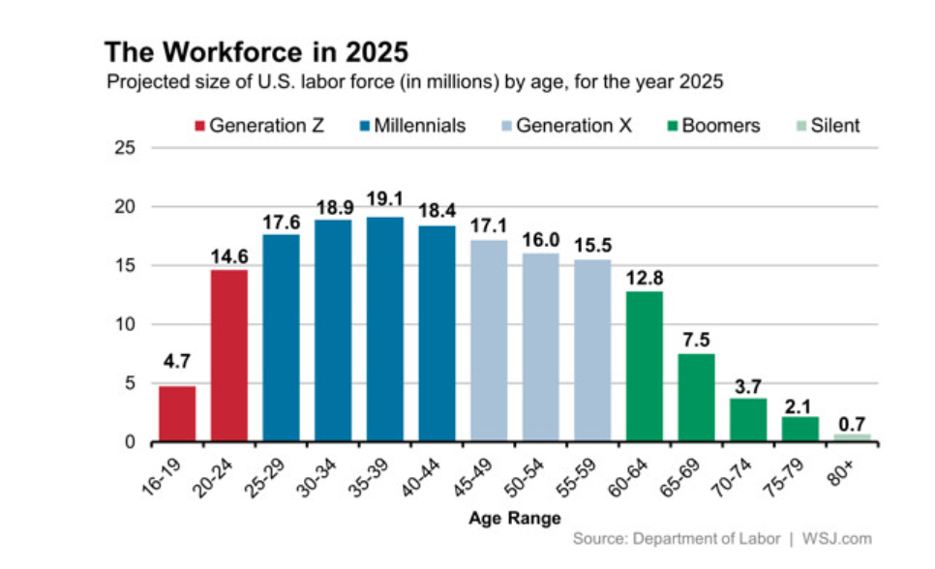

Automatic Intelligence
Hyatt is reimagining the talent experience to incorporate AI into recruitment and retention (Crownholm, 2023). By working with PWC to identify HR process pain points and create a strategy for implementing technology to improve HR processes in the the company. These can help to overcome unconscious bias in the recruitment process (Tsipursky 2020). PWC rewrite the application process and implied new onboarding strategies to create resources to help avoid unfair recruitment. Evolving hire orientation programme streamline the candidate experience in Hyatt hotels. The goal is to reduce the time in hiring the right candidate into the company to maximise employee retension. They are also focusing on eliminating colleague pain points and simplifying HR programmes and processes. They want career advancement, performance measurement, and reward transparency. They are also reaching out to diverse communities to recruit talent, which may increase candidate diversity (PWC, 2023).

Hyatt employee retention score
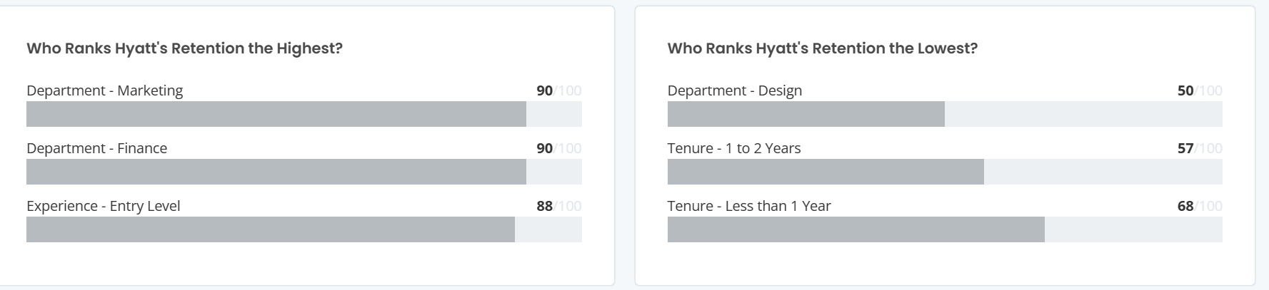
Hyatt ranks in the top 10% of similar-sized companies on Comparably (2023), demonstrating its exceptional staff retention.
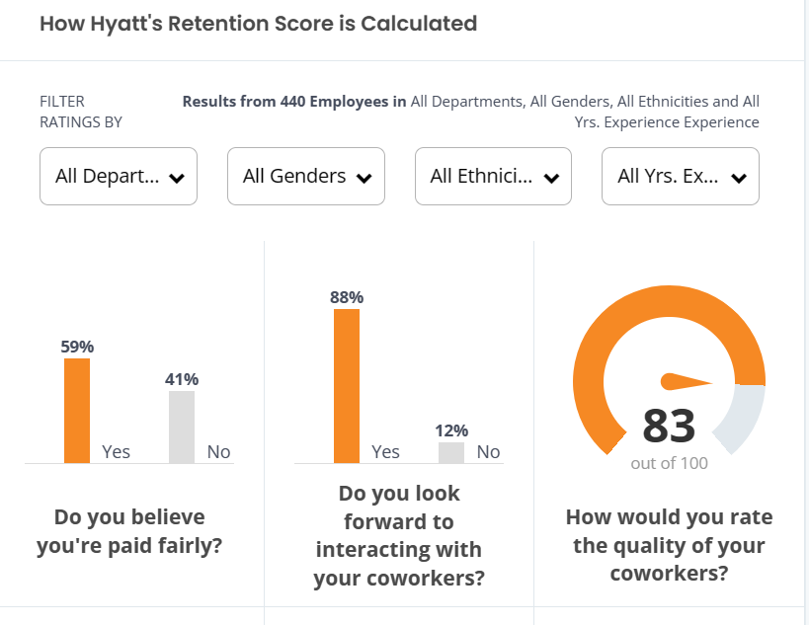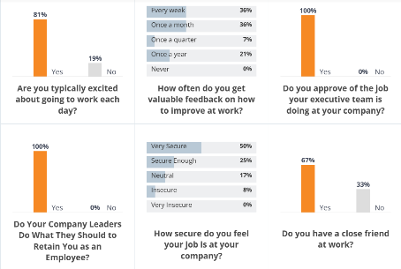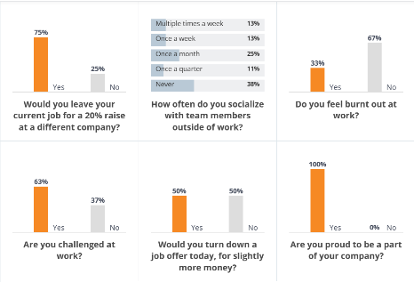
Eighty-one percent enjoy their work, and fifty percent would stay even if offered a similar salary, however the statistic shows 75% of employee would leave they job, if offered 20% more in wage, These retention rates demonstrate Hyatt's commitment to employee welfare, making it a top employer in a competitive market.
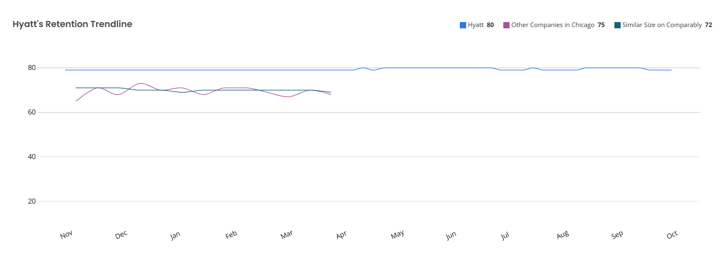
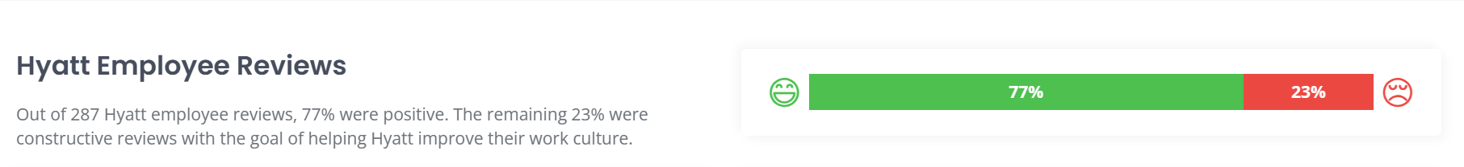
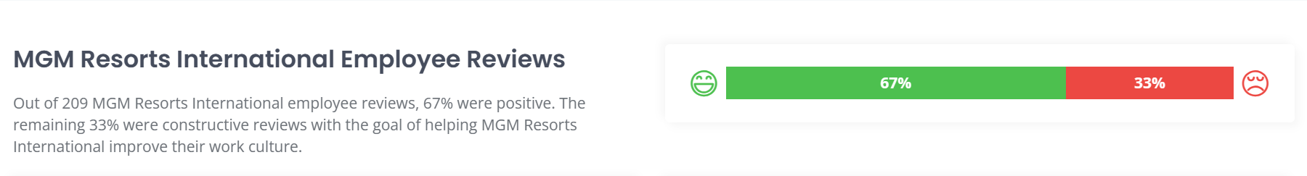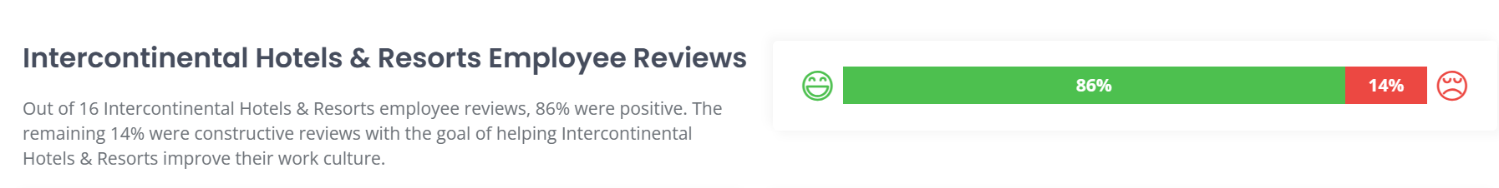
Brand | Employee retention score | Company culture grade
Hyatt hotels and resorts | 83% | A
MGM resorts | 76% | B
IHG | 67% | C-
According to the analysis Hyatt hotel employee retention is higher than competitors and holds a great cultural diversity and inclusivity score.

SWOT
Strength As one of the top employers in the hospitality industry, Hyatt Hotels demonstrates an unmatched dedication to its employees. Their high retention rates demonstrate the brand's commitment to fostering a nurturing and inclusive workplace. Hyatt's global expansions, from major cities such as Houston to Tokyo, bolster their reputation and growth trajectory. Consistent global expansion and positive employee experiences distinguish Hyatt, reinforcing its status as an industry-preferred employer. (Harmer, 2014).
Weaknesses lie in its inability to maintain consistent on-site operations, which ensures a consistent guest experience. Though luxury and exclusive, the brand sometimes has inefficient operational costs that can be reduced. Its prices are also higher than many competitors, making the Hyatt experience inaccessible to moderate-income travellers. Tourist dependence makes the brand vulnerable to market changes. Due to employee turnover, Hyatt must spend more on training and development (Shastri, 2023).
Opportunity Hyatt Hotels, a top hospitality employer, is unmatched in its dedication to its employees. High retention rates show the brand's commitment to a supportive and inclusive workplace. Hyatt's expansions in Houston and Tokyo show its global reputation and growth. The luxurious Thompson Hotels in the Americas and the prestigious The Unbound Collection in Europe and Asia cater to a variety of customer preferences and offer employee advancement opportunities. Consistent global expansion and positive employee experiences distinguish Hyatt, reinforcing its position as an employer of choice in the industry.
Threat Hyatt's Design department stands out with its notably lower retention score on research on Comparability, signalling possible department-specific issues. These disparities highlight the importance of addressing such obstacles to ensure consistent employee satisfaction. In addition, some employees' concerns about job security can erode motivation and engagement, highlighting the significance of reassurance and transparency in sustaining a committed workforce (Comparably 2023).
Hyatt hotel competitor’s whit lower net margins are:
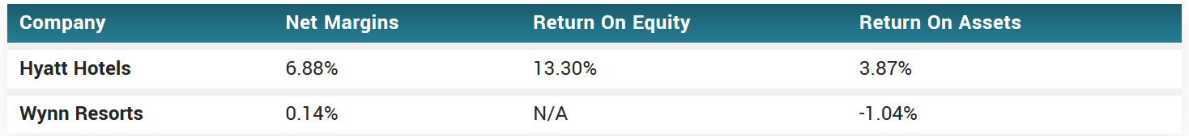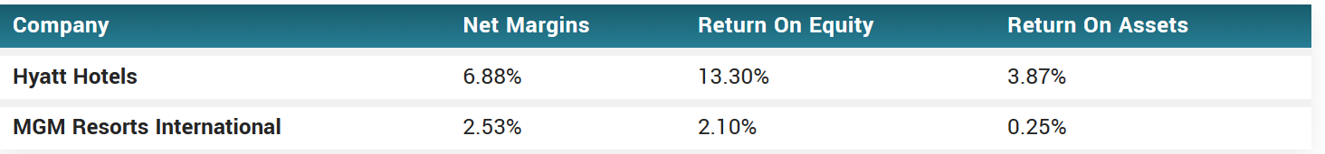
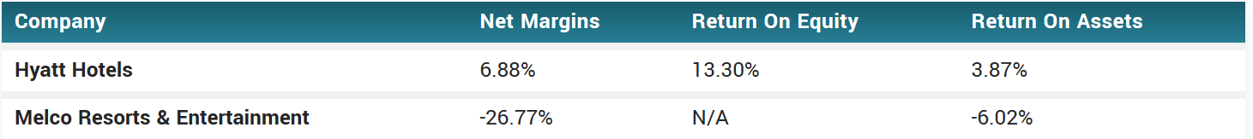
Competitors with higher in Net margins (Market beat, 2023)
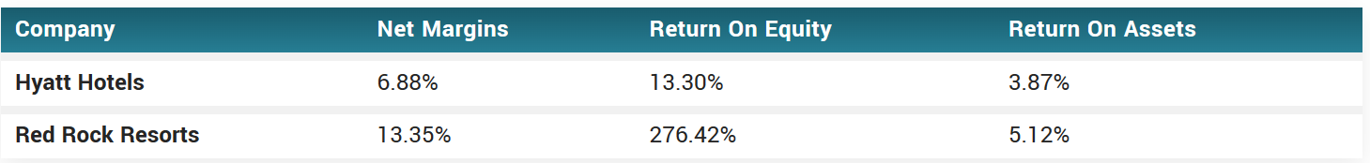
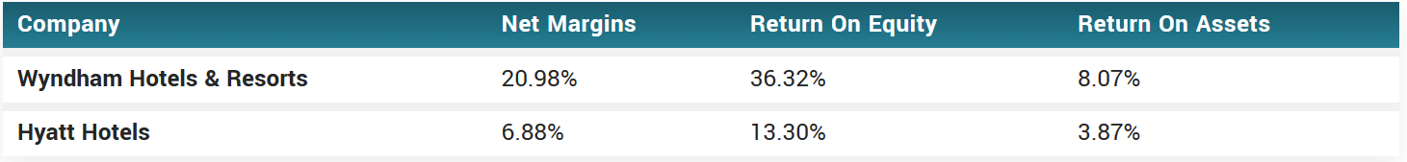

Conclusion
After analysing Hyatt Hotels and Resort's recruitment and retention practises in light of external challenges, it is clear that external factors—both positive and negative—influence the brand's workforce management strategy. Luxury hotel chains like Hyatt face challenges from the hospitality industry's global and regional changes. Brexit and its impact on immigrant worker rights have made recruitment difficult, while inflation has affected internal operations. Hyatt's strength is shown in its recovery and financial stability. In response to the sociocultural emphasis on diversity, Hyatt showed its forward-thinking. The brand capitalises on wellness, sustainability, and cultural competency travel trends to stay relevant and competitive. Technology has improved Hyatt's recruitment and retention strategies. Hyatt's use of AI-driven assessments and data analytics shows its modernity and efficiency. Environmental factors, especially COVID-19, have changed the hospitality industry. Hyatt's creative responses to new generations' needs and values demonstrate the brand's adaptability and understanding of employee needs. UK law emphasises HR alignment to create a compliant and satisfying workplace. Hyatt's SWOT analysis highlights its global expansion and employee welfare. Inconsistent on-site operations and market vulnerability suggest improvements. The brand's global reach and commitment to employee growth are opportunities, but department-specific threats require immediate attention. Retirements are changing the workforce, requiring adaptability. Hyatt's proactive approach emphasises younger generations, tech-savvy environments, and civic values. In recruitment, the brand uses AI to show its forward-thinking. Finally, while external challenges will always affect businesses, Hyatt Hotels and Resorts demonstrate adaptability, resilience, and innovation. High retention rates show their commitment to employee welfare in the hospitality industry. Despite challenges, Hyatt's proactive and adaptive strategies help it adapt to changing environments and stay competitive.

Recommendations
Suggesting to conducting a market analysis to ensure that salaries are competitive with industry standards, addressing burn out issue to protect employee’s well-being, can help employee retention.

Address employee burnout | Address employee living for higher pay issue
- Vacation Encouragement | - Benefits Packages
- Workload Management | - Wage raises
- Flexible Work Arrangements
- Wellness Programs

References

Beaudry, J. (2021) How to Navigate Cultural Differences As a Global HR Professional. [online] lattice.com. Available at: https://lattice.com/library/how-to-navigate-cultural-differences-as-a-global-hr-professional (Accessed 1 Nov. 2023).
Cameron, D., Jenkins, A., & Marson, J. (2018) The consequences of the Brexit vote on management attitudes to recruitment in the hospitality industry. Business Law Review, 39(4). Available at: https://doi.org/10.54648/bula2018020 (Accessed 1st Now 2023).
Caspari-Sadeghi, S. (2022) ‘Artificial Intelligence in Technology-Enhanced Assessment: A Survey of Machine Learning’, Journal of Educational Technology Systems, 51(3), pp. 372–386. Available at: https://doi.org/10.1177/00472395221138791. (Accessed on 2nd Nov. 2023).
Choi, J., Woods, R.H. and Murrmann, S.K. (2000) "International labour markets and the migration of labour forces as an alternative solution for labour shortages in the hospitality industry", International Journal of Contemporary Hospitality Management, Vol. 12 No. 1, pp. 61-67. https://doi.org/10.1108/09596110010305154. (Accessed 2nd Nov. 2023).
Comparably (2023) Hyatt Retention Score. [online] Comparably. Available at: https://www.comparably.com/companies/hyatt/retention [Accessed 1 Nov. 2023].
Crownholm, R. (2023) Council Post: What We Get Wrong About Gen-Z And Millennials (And What We Can Learn From Them). [online] Forbes. Available at: https://www.forbes.com/sites/forbesbusinesscouncil/2023/09/28/what-we-get-wrong-about-gen-z-and-millennials-and-what-we-can-learn-from-them/ (Accessed 1st Nov. 2023).
EHL (2023) Facing skilled worker shortage in the hospitality industry. [online] hospitalityinsights.ehl.edu. Available at: https://hospitalityinsights.ehl.edu/skilled-worker-shortage-in-the-hospitality-industry (Accessed 1st Nov. 2023).
Escobar. M., C. (2020) 2020 Enterprise Innovator: Hyatt. [online] Hospitality Technology. Available at: https://hospitalitytech.com/2020-enterprise-innovator-hyatt (Accessed 1st Nov. 2023).
Gov UK (2021) Hospitality strategy: Reopening, recovery, resilience. [online] GOV.UK. Available at: https://www.gov.uk/government/publications/hospitality-strategy-reopening-recovery-resilience/hospitality-strategy-reopening-recovery-resilience (Accessed 1st Nov. 2023).
Harmer, J. (2014) Hyatt Hotels named as one of the best UK... [online] The Caterer. Available at: https://www.thecaterer.com/news/hotel/hyatt-hotels-named-as-one-of-the-best-uk-workplaces (Accessed 1st Nov. 2023).
Harver (2019) How to Manage Generational Diversity in The Workplace - Harver. [online] Harver. Available at: https://harver.com/blog/generational-diversity-in-the-workplace/ (Accessed 1st Nov. 2023).
Hyatt Hotels (2023) Hyatt Strengthens Position as Leader in Luxury, Lifestyle and Leisure in 2023 and Beyond with Record Global Pipeline. [online] investors.hyatt.com. Available at: https://investors.hyatt.com/investor-relations/news-and-events/financial-news/financial-news-details/2023/Hyatt-Strengthens-Position-as-Leader-in-Luxury-Lifestyle-and-Leisure-in-2023-and-Beyond-with-Record-Global-Pipeline/default.aspx (Accessed 1st Nov. 2023).
Hyatt Hotels and Resorts (2023) Hyatt Careers, Hyatt Hotels and Resorts. Available at: https://careers.hyatt.com/en-US/careers/ (Accessed 2nd November 2023).
Market Beat (2023) Hyatt Hotels Competitors and Alternatives 2023 (NYSE:H), www.marketbeat.com. Available at: https://www.marketbeat.com/stocks/NYSE/H/competitors-and-alternatives/ (Accessed 2nd November 2023).
McAllister, J. ed., (2022) Hospitality job vacancies dip slightly but remain at record high. [online] restaurantonline.co.uk. Available at: https://www.restaurantonline.co.uk/Article/2022/08/16/hospitality-job-vacancies-dip-slightly-but-remain-at-record-high-ons-figures-show (Accessed 1st Nov. 2023).
Mody, P. (2021) Turning the tide on the retirement crisis. [online] www.linkedin.com. Available at: https://www.linkedin.com/pulse/turning-tide-retirement-crisis-raj-mody (Accessed 1st Nov. 2023).
Mohdzaini, H. (2021) CIPD | Using technology to improve hiring and onboarding, CIPD. Available at: https://www.cipd.org/uk/views-and-insights/thought-leadership/insight/using-technology-to-improve-hiring-and-onboarding/. (Accessed on 2nd Nov. 2023).
PWC (2023) Hyatt’s talent strategy transformation. [online] PWC. Available at: https://www.pwc.com/us/en/library/case-studies/hyatt-talent-strategy-transformation.html (Accessed 1st Nov. 2023).
Qi, Y. (2023) Financial Analysis of Hyatt Hotels Corporation. Highlights in Business, Economics and Management, 15, 111-116. Available at: Financial Analysis of Hyatt Hotels Corporation | Highlights in Business, Economics and Management (drpress.org) (Accessed 1st Nov 2023).
Robson, R. (2021) How to predict and improve employee retention with data, CIPHR. Available at: https://www.ciphr.com/advice/how-to-predict-and-improve-employee-retention-with-data/ (Accessed: 2 November 2023).
Sánchez-Gardey G, Martín-Alcázar F and García-Carbonell N (eds) (2021) Beyond Human Resources - Research Paths Towards a New Understanding of Workforce Management Within Organizations. IntechOpen. Available at: http://dx.doi.org/10.5772/intechopen.92925. (Accessed on 2nd Nov 2023).
Sebayang, G. A., Sutama, I. K., & Wendri, I. (2023) The Implementation of Green Training to Improve Employees’ Pro Environmental Behavior at Hyatt Regency Bali (Doctoral dissertation, Politeknik Negeri Bali) Available at: Improvement of Corporative Sustainability Development Strategy (on the basis of Internship Report at Hyatt Regency Kyiv) (uacu.edu.ua) (Accessed on 1st Nov 2023).
Shastri S. (2023) In-Depth SWOT Analysis of Hyatt - 2022 Case Study | IIDE. [online] Indian institute of digital education. Available at: https://iide.co/case-studies/swot-analysis-of-hyatt/. (Accessed 2nd Nov. 2023).
Shastri S. (2023). In-Depth SWOT Analysis of Hyatt - 2022 Case Study | IIDE. [online] Indian institute of digital education. Available at: https://iide.co/case-studies/swot-analysis-of-hyatt/. (Accessed 1st Nov. 2023).
Tsipursky, G. (2020). What Is Unconscious Bias (And How You Can Defeat It). [online] Psychology Today. Available at: https://www.psychologytoday.com/us/blog/intentional-insights/202007/what-is-unconscious-bias-and-how-you-can-defeat-it.

