

Salma Begum
Student ID: 2323795
Component 1: Portfolio
Lecturer: Parese Ahmed
Module Code: BMHP5015

Task 1 – Personal Brand
Write about your own person brand and how you could develop this to enable you to reach your employment goals (200 words- 2 referenced sources)

Introduction
My professional identity, abilities, and beliefs are presented to others through my personal branding. Because it shows my integrity, ethical behaviour, and capacity for trust-building, it is essential for a profession in social work (BASW, 2021).

Body
Compassion, empathy, and dependability, qualities essential to social work are exhibited by my present personal brand. In line with the BASW Code of Ethics (BASW, 2021). I'm dedicated to upholding diversity, empowering people, and advancing social justice. It might be difficult to balance obligations as a parent of children under 16 and a baby on the way soon. I do, however, see this as a strength because it has moulded my perseverance, time management, and will succeed. To provide a better future for my family, these attributes drive me to advance in my Level 5 and 6 Health and Social Care courses. Although Shepherd (2005) and Peters (1997) contend that personal branding necessitates ongoing development, Banks (2012) emphasises that introspection and values shape professional identity. I'll increase my practical experience, develop my understanding of safeguarding, and employ supervision skilfully to strengthen my brand.

Conclusion
Strengthening my identity will come from building my personal brand via perseverance, introspection, and career advancement. By doing this, I will be able to fulfil my ambition of being a respected, capable, and moral social worker who can truly help families and young vulnerable children.

Task 2 - Network Map and Rationale
Create a map of your own network considering career, support, social and community dimensions. Additionally you should provide a supporting rationale explaining and critically assessing this (200 words- 2 referenced sources).
My personal and professional Network Map

ME(Salma)

sa
Support Network
Social
University tutor
Professionals
Family

Carers

Friends
Key Codes
Bonding
Bridging
Linking

Rationale
My personal and professional network diagram illustrates the essential connections that contribute to my growth and wellbeing as I advance in the field of health and social care. At the core is myself (Salma), encircled by various individuals and groups who significantly influence both my personal life and career development. My family serves as my primary source of emotional and practical support, providing encouragement and motivation to manage my studies alongside my responsibilities. Friends and my social network create avenues for exchanging experiences, alleviating stress, and enhancing my overall wellbeing. My support network enables me to navigate challenges and cultivate resilience through guidance and mutual understanding (Drageset, 2021).
University tutors and other professionals play a crucial role in establishing essential linking relationships. They provide academic guidance, constructive feedback, and assist me in developing a more profound understanding of the professional standards and expectations within health and social care practice. Career advisors significantly contribute by providing guidance on job opportunities and assisting me in aligning my skills and experiences with my professional objectives. Their assistance boosts my career preparedness and self-assurance in seeking future positions. These relationships foster reflection and skill enhancement, which ultimately improve my employability. In summary, this network map illustrates the significance of bonding, bridging, and linking connections in facilitating my goal achievement. Each type of relationship bolsters my confidence, communication skills, and professional identity, allowing me to grow personally and thrive in my selected career path (Eriksson, 2011; Drageset, 2021).

Task 3- Blog
Write a blog exploring a current topic or issue of your choice within the health and social care sector in the UK. The purpose of this is to inform a specific target audience of your choosing (300 words)

Improving Mental Health Support for Young Adults

Introduction
The number of young individuals experiencing mental health problems is alarmingly increasing. A mental health disorder affects one in four individuals between the ages of 17 and 24 annually, according to NHS Digital (2023). Many still encounter obstacles while trying to get help, even with increased awareness. This blog examines why these issues are important and how we might help youth deal with these difficulties more effectively.
The Current Challenge
Adolescence to maturity is a challenging time in life, but for people who are dealing with stress, anxiety, or depression, the process might be too much to handle. Regrettably, the mental health system frequently adds to the stress. With lengthy wait times and stringent eligibility requirements, many young individuals are caught between child and adult services (Mind, 2024).
Social media and digital support platforms have emerged as popular venues for conversations on mental health, but not all online guidance is reliable or supported by research. Digital inclusion has contributed to the normalisation of discussions about mental health, but it cannot take the place of regular, in-person professional care (YoungMinds, 2024).
Services must be created with young people, not for them, if they are to bring about significant change. This entails:
• Growing early intervention initiatives in educational institutions.
• Educating experts about the particular stresses that young adults face.
• Increasing financing for community-based programs and counselling tailored to young people.
Conclusion
Supporting the mental health of young adults is a social priority as well as a medical one. We can assist a generation in going from surviving to thriving by paying attention to the opinions of the youth and making sure that services are easily accessible and customised.

Task 4- NHS Equality, Diversity and Inclusion Quiz (250 words equivalent)

- What is the primary goal of the NHS Equality, Diversity, and Inclusion Improvement Plan?
(Answer in one or two sentences.)

To promote an inclusive culture and lessen prejudice, the NHS Equity, Diversity, and Inclusion (EDI) Improvement Plan seeks to make sure all workers feel appreciated (NHS England, 2023).

- How does the NHS EDI Improvement Plan propose to tackle the gender pay gap?
(Answer in one to two sentences.)

Through pay data analysis and improvement initiatives, the plan addresses the gender pay gap (NHS Employers, 2023). The Mend the Gap recommendations are also extended to non-medical staff.

- What is meant by the term ‘intersectionality’ as used in the NHS EDI Improvement Plan?
(Answer in one to two sentences.)
Understanding that people's intersecting identities, such as race, gender, and disability, can result in cumulative impacts of disadvantage or discrimination is known as intersectionality (NHS England, 2023).

- Why is it important for the NHS to create a psychologically safe work ;(Answer in one to two sentences.)
Employees can voice concerns and ideas without fear in a psychologically secure workplace (NHS England, 2023). This enhances patient care, teamwork, and morale.

- How does the NHS EDI Improvement Plan suggest improving the experience of internationally recruited staff?
(Answer in one to two sentences.
The plan provides pastoral care, equitable access to training, and inclusive induction for newly hired employees from overseas (NHS England, 2023). Additionally, it fosters team cultures that foster a sense of community.

- What role does leadership play in advancing EDI objectives according to the NHS Improvement Plan?
(Answer in one to two sentences.)

Leadership sets quantifiable goals and exemplifies inclusive behaviour to propel EDI forward (NHS Employers, 2023). It is the responsibility of senior leaders to establish fair workplaces.

- Identify one way the NHS EDI Improvement Plan aims to reduce health inequalities within the workforce.
(Answer in one to two sentences.)

By addressing disparities through wellbeing talks and data, the approach lowers health inequities (NHS Employers, 2023). This guarantees equitable treatment and assistance for every employee.

- Why does the NHS EDI Improvement Plan emphasise the importance of collecting and analysing data on protected characteristics?
(Answer in one to two sentences.)
Finding patterns of inequality is aided by gathering and evaluating data on protected characteristics (NHS Employers, 2023). It directs focused efforts to increase inclusiveness and fairness.

- Explain how flexible working policies can contribute to equality and inclusion in the NHS workforce.
(Answer in one to two sentences.
By assisting employees in juggling professional and family obligations, flexible working promotes equality (NHS Employers, 2023). For diverse workers, it promotes professional advancement and retention.

- What is one strategy mentioned in the NHS EDI Improvement Plan to combat bullying and harassment in the workplace?
(Answer in one to two sentences.)

By establishing reduction goals and enhancing complaint procedures, the plan tackles bullying and harassment (NHS England, 2023). It encourages staff psychological support and early intervention.

Task 5- A Letter to Yourself
Think of a time in the past when you may have been experiencing issues or difficulties, and after considering what you have learned in this module about emotional intelligence and resilience write a letter to your younger self explaining how these attributes were important at that time and perhaps how developing these areas could have been useful (250 words)

Dear Me,

I remember the time when my daughter was involved in a car accident. As a single parent with no support, I felt completely overwhelmed, anxious, and unsure how I could cope. My wellbeing was at its lowest, and I struggled to manage my emotions and responsibilities.

Reflecting on my past, I regret not recognizing the importance of emotional intelligence (Mayer, Salovey, & Caruso, 2008). Had I been aware of my feelings of fear, stress, and helplessness, I might have been able to handle them more adeptly rather than suppressing them. Articulating my emotions and reaching out for support, even in minor instances, would not have signified weakness it would have facilitated better coping and reduced my sense of isolation.

Resilience held equal significance. During that period, I perceived the circumstances as hopeless; however, resilience (Luthar, Cicchetti & Becker, 2000) might have enabled me to regard challenges as fleeting and manageable. Acquiring the ability to adapt, maintain optimism, and engage in self-compassion would have empowered me to concentrate on actionable measures to assist both me and my daughter, instead of being in fear.

My advice would be to take each day as it comes, prioritize your wellbeing, and have faith in your ability to cope. Developing emotional intelligence and resilience will not only assist you in navigating this crisis but will also strengthen your character and compassion, making you a more effective social worker in the future.

With love,
Me

Task 6- GANTT Chart (200 words equivalent)
Compile a Gantt chart which illustrates the tasks you have to complete to achieve your future employment goals
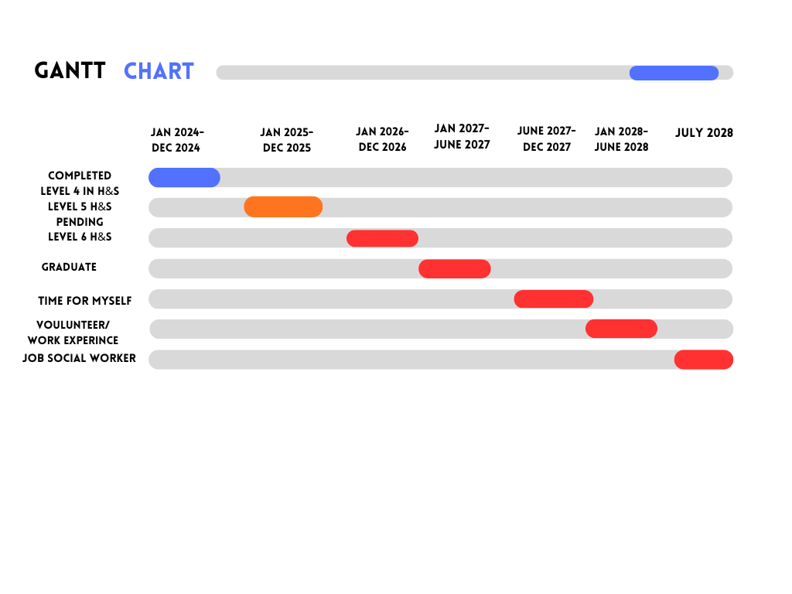

Key Codes
Done
Pending
Not Done

Task 7- Making Changes- Report
You are the manager of a care home and want to make changes your workplace. Identify one specific change that you want to implement and write a brief report on how this is going to be achieved considering the necessary skills needed and addressing possible barriers to success. Relevant change models can be highlighted (250 words- 2 referenced sources).

Implementing Digital Care Planning in a Care Home
Introduction
As the manager of the care home, I intend to implement digital care planning to improve the accuracy of records, facilitate communication, and elevate the quality of care. This transition will engage both care and administrative personnel.
Planning the Change
The adjustment involves a shift from paper-based care plans to digital formats. This is necessary to minimize errors, save time, and enhance information sharing (UK Government,2023). I will implement this change by applying Kotter’s 8-Step Model: Creating Urgency – Stress the risks linked to paper records, such as mistakes and delays, to inspire staff motivation. Forming a Guiding Coalition – Create a team comprising senior nurses, administrative staff, and IT support to lead the change. Developing a Vision – Aim for digital care plans that are precise, accessible, and efficient to enhance patient outcomes. Communicating the Vision – Implement meetings, newsletters, and briefings to ensure that staff grasp the benefits. Empowering Action – Deliver training to fill digital skill gaps and involve staff in choosing software and giving feedback (Kotter, 1996).
Skills Required
As the manager of the care home, essential skills I require encompass leadership to direct the team, effective communication to articulate benefits, technical proficiency to comprehend the system, time management to supervise implementation, and conflict resolution to address staff resistance (Bayot & Varacallo,2023).
Barriers and Solutions
Potential challenges consist of employee resistance, inadequate digital abilities, and restricted time availability. Resistance can be diminished by involving employees in the planning stages and illustrating the benefits. Digital skill deficiencies can be resolved through specialized training sessions. Time constraints can be handled by implementing changes in phases and scheduling training during slower periods (Bradshaw et al., 2024).
Conclusion
The management of digital care planning will result in increased efficiency, accuracy, and communication within the care home. Addressing existing barriers and equipping staff with crucial skills will improve the quality of care and bolster staff confidence.

Task 8- Self-Reflection
Using one of the highlighted models of reflection, reflect on what you have learned about yourself during this module, as well as the knowledge you have gained, and explain how this has developed your skills and informed your future practice (250 words- you must reference the model you use)

Description
I will be employing Gibbs’ Reflective Cycle (The University of Edinburgh, 2024) to evaluate my personal and professional development as I develop a career plan to pursue a career in social work. This process has encouraged me to reflect on my experiences, strengths, and weaknesses, particularly in how I juggle my studies with my obligations as a mother while being pregnant.
Feelings
As I began my journey, I was initially overwhelmed by the challenge of juggling my studies, family commitments, and pregnancy. However, as I moved forward in the module, I found myself becoming increasingly positive and motivated to organize my time effectively, drawing on my experiences to bolster my resilience and empathy—crucial skills in the field of social work.
Evaluation
In my reflection, I have pinpointed essential strengths like empathy, communication, and resilience—attributes that are fundamental to social work. Conversely, I have also noted weaknesses in time management and focus, which are impacted by family and pregnancy-related challenges.
Analysis
By applying Gibbs’ Reflective Cycle (The University of Edinburgh, 2024), I have come to realize that recognizing weaknesses serves as a valuable opportunity for personal growth. I initiated the use of planners and the formulation of realistic goals to better my time management, resulting in decreased stress levels and heightened productivity.

Conclusion
I have learned that structured reflection aids in both personal and professional growth, allowing me to build resilience and enhance my self-awareness.

Action Plan
I intend to keep utilizing reflective practice to assess my progress, seek guidance from tutors and peers, and uphold a balanced approach to my studies, motherhood, and future career in social work.

Reference List

Banks, S. (2012) Ethics and values in social work. 4th edn. Basingstoke: Palgrave Macmillan.
BASW (2021) The code of ethics for social work: Statement of principles. Birmingham: British Association of Social Workers.
Bayot, M.L. & Varacallo, M.A. (2023) Management Skills. StatPearls [Internet]. Treasure Island (FL): StatPearls Publishing. Available at: https://www.ncbi.nlm.nih.gov/books/NBK544227/ (Accessed: 7 November 2025).
Bradshaw, A., et al. (2024) 'Factors Influencing the Implementation of Digital Advance Care Planning Systems in UK Care Settings', Journal of Health Informatics, 32(4), pp. 123–135.
Drageset, J. (2021) 'Social support', in Haugan, G. (ed.) Health Promotion in Health Care – Vital Theories and Research. Oslo: Cappelen Damm Akademisk, pp. 143–160. Available at: https://www.ncbi.nlm.nih.gov/books/NBK585650/ (Accessed: 26 October 2025).
Eriksson, M. (2011) 'Social capital and health: Implications for health promotion', Global Health Action, 4, pp. 5611. Available at: https://doi.org/10.3402/gha.v4i0.5611 (Accessed: 26 October 2025).
Kotter, J.P. (1996) Leading Change. Boston: Harvard Business School Press.
Luthar, S.S., Cicchetti, D. & Becker, B., 2000. The construct of resilience: A critical evaluation and guidelines for future work. Child Development, 71(3), pp.543–562. Available at: https://doi.org/10.1111/1467-8624.00164.
Mayer, J. D., Salovey, P., & Caruso, D. R. (2008). Emotional intelligence: New ability or eclectic traits? American Psychologist, 63(6), 503–517. https://doi.org/10.1037/0003-066X.63.6.503.
Mind (2024) Supporting young people’s mental health. [Online] Available at: https://www.mind.org.uk/ (Accessed: 4 October 2025).
NHS Digital (2023) Mental health of children and young people in England, 2023. [Online] Available at: https://digital.nhs.uk/data-and-information/publications/statistical/mental-health-of-children-and-young-people-in-england (Accessed: 4 October 2025).
NHS Employers (2023) NHS Equality, Diversity and Inclusion (EDI) Improvement Plan. [Online] Available at: https://www.nhsemployers.org/articles/nhs-equality-diversity-and-inclusion-edi-improvement-plan (Accessed: 4 October 2025).
NHS England (2023) NHS Equality, Diversity and Inclusion Improvement Plan. [Online] Available at: https://www.england.nhs.uk/long-read/nhs-equality-diversity-and-inclusion-improvement-plan/ (Accessed: 4 October 2025).
Peters, T. (1997) ‘The brand called you’, Fast Company, 10, pp. 83–90.
Shepherd, I.D.H. (2005) ‘From cattle and coke to Charlie: Meeting the challenge of self-marketing and personal branding’, Journal of Marketing Management, 21(5–6), pp. 589–606.
The University of Edinburgh (2024) Gibbs’ Reflective Cycle. [online] The University of Edinburgh. Available at: https://reflection.ed.ac.uk/reflectors-toolkit/reflecting-on-experience/gibbs-reflective-cycle [Accessed 31 Oct. 2025].
UK Government (2023) A plan for digital health and social care. London: GOV.UK. Available at: https://www.gov.uk/government/publications/a-plan-for-digital-health-and-social-care/a-plan-for-digital-health-and-social-care (Accessed: 7 November 2025).
YoungMinds (2024) Young people’s mental health support. [Online] Available at: https://www.youngminds.org.uk/ (Accessed: 4 October 2025).

