Title of the proposal
Transformational Leadership in long term care services of Hong Kong
INTRODUCTION
The following proposal is intended to study the relationship between the effective leadership style and the quality of care of the local long-term care services, since the Hong Kong population is becoming aging and the admission rate into long-term care service, like nursing homes services is comparatively high in global. Researcher, also as a practitioner belief that the positive and optimistic style of leadership affect very much on the quality of care and services. In addition, using the qualitative research approach, it is expected that how effective can be identified and includes the exploration of the practice knowledge & skills throughout the research process.
RESEARCH PROBLEMS AND OBJECTIVES
Industry Background – Long term care is a global issue
Long Term Care (LTC) implied well-planned care for elderly persons, incredibly frail and demented. Service types of LTC can stay at their own home with community services support, but mostly it means the nursing home care for the elderly.
Nursing Homes (NH) are usually operated by Nursing, Social Work, and Therapeutic professionals with the support of a large scale of frontline care workers. As the ultimate goal of LTC is to provide proper care for the old folks, the industry strongly relies on the manual work and good heart of the staff members. Therefore, quality of care is in line with the staff members’ stability and an optimistic attitude.
It is very common that the optimistic attitude towards routine caring is really fragile. Lacking cohesiveness and job satisfaction leads to a high turnover rate and directly affects the quality of care. The turnover of caring teams in LTC is typical, and it is a global issue.
The staff turnover rate in long-term care (LTC) facilities is becoming severe and complicated in the US. In 2011, a survey revealed the overall turnover rate of 49% for nurses and 71% for certified nursing assistants. We can find any one day in a year, there are approx. 100,000 nursing staff posts can be found LTC services. It seems to be very costly in recruitment, orientation, and training because of the huge vacancy.
It is discovered that because of the job complexity, and it may take around six months for a new employee to become fully adjusted and functional, which may negatively impact the provision of quality of care.
To compound these staffing needs, the demand for LTC services is also expected to increase for several decades as the baby boomer generation ages. The age group most likely to need LTC -those over 85 years of age is projected to increase threefold by 2040 (Utley et al. 2011).
Industry Background – Local significance
In Hong Kong, the population is rapidly aging. Retaining care staff is also a workforce concern for the long-term care industry, especially with the growing demand for nursing home services. However, we found little research to address the staff's leadership behaviors and their influence on organizational commitment. Therefore, the researcher’s idea is to study the leadership behaviors of direct importance for professional and frontline care workers and provide insight among workers and the impact of quality of eldercare.
Industry Background – Population Issue
The Hong Kong's population is predicted to escalate from 7.34 million in 2016 to 8.22 million in 2043, which will be at a procedural and average growth of 0.4% per year. The population aged 65 or above is estimated to be 1.37m (19%) and will be double in 2051.
As our population is getting aging, and aging is speedy. The number of elderly aged 65 and over is predicted to be more than two times in the coming thirty years. The ratio of elderly persons in the total population increases while that of younger people is decreasing. Therefore, Hong Kong is experiencing an up-side-down population pyramid. We'll have more and more elderly to care for, but fewer and fewer youngsters to rear or care for them.
Industry Background – LTC Services in Hong Kong
In Hong Kong, at present, around 6%, i.e., approx. Seventy thousands of the elderly population are living in long-term care facilities –nursing homes. The Homes run by NGOs and private sectors that the quality of management of care directly affects the well-being of the elderly, families, and Government policies.
At present, locally, there are 29,155 subvented beds which are operated by 251 Homes. We also have 49,030 privately run nursing home beds by 587 Homes. We have 838 Homes with 78,185 beds for the elderly.
All potential residents of subvented beds should have waited on the central waiting list for 3 to 6 years. According to Social Welfare Department (SWD) data, there are 35,714 persons on the list on 5/2021. For the subvented beds, the residents need to pay $2,060 per month, a standard fee decided by the Government but involves an additional at least 5.4 billion of government subvention per year.
The industry not only involves a significant amount of public money, but it also employs more than ten thousands front-line caring staff, according to the minimum staffing requirement of Licensing Office.
As the effectiveness of management and the quality of care of the industry have a significant impact on society, this study will aim to collect information from the management and staff of these facilities to explore the implications of the leadership approach.
(Source: www.swd.gov.hk)
Definition of Problems
In 2013, a survey conducted by the Hong Kong Council of Social Services highlighted the vacancies of frontline care assistants in local nursing homes were also increased by 12.4% because of the very high turnover rate. More than half of the workforce is aged 50-59, implied a large amount of coming retirement of the industry. According to the Government report in 2018, the turnover rate is becoming 18%.
(https://www.info.gov.hk/gia/general/201711/29/P2017112900367.htm?fontSize =1).
The turnover is becoming severe, mainly because of the fast growing number of older adults with widened and complex needs, which urge for quality of care and therefore pressing a need for innovation in nursing homes.
"Leadership: a key to successful innovations." The innovation attempts to change the underlying values of organizational culture. The review shows that being participative, more involving, and innovative Leadership are the critical elements to success in innovation processes. (Kari et al. 2019)
In recent years, we've found many types of research to discuss the job satisfaction of the trained nursing staff or the frontline care workers in the long-term care industry for the elderly. We're also trying to locate the dominants to sustain the workforce and minimize the workforce turnover. These studies are critical since the business is not just for profit but involved a significant proportion of government subvention and promoting the well-being of the older population.
Under such circumstances, other than collecting the workers' groups' data, the researcher believes that the management's leadership behavior is a critical area for evidence-based study.
Specifically, leadership styles have great impact to influence turnover (Donoghue & Castle, 2009). Nursing home managers have been found to be improved in the leadership skills which directly affect to have better organizational performance (Scott, Vojir, Jones, & Moore, 2005).
Research Questions
Assuming people-centered management is the dominant quality of care in long-term care services for older adults, what is the leadership style's impact in promoting influential people management?
Research Objectives
To study the transformational leadership approach in promoting the quality of management, especially the person-centered approach of long-term care services for older adults.
Review of Relevant Theories and Literature – Quality of Care in LTC
The services and quality care in nursing home (NH) facilities are full of challenges. The challenges happened every day, and the literature reviews that the quality of care (QOC) is always sub-optimal.
There is a long history for the NH facilities to adopt the person-centered culture (PCC) to run the Homes with quality care. However, the result is not manifest, especially on the staff performance, and seldom has studies on the outcome of the approach.
PCC training and intervention representing the core concept of the working place which its resources initiate a positive effect on stress released and job satisfaction of NH staff.
Clinical relevance supporting the nursing home workers through person-centred culture training is essential for fostering job satisfaction and reducing job‐related personal pressure. Thus, the turnover contributes to improve the quality of care delivered to the residents living in NH. (Santhiny et al. 2019)
Review of Relevant Theories and Literature – Significance of Transformational Leadership
It has been common to identify the NGO leaders to adopt the leadership style based on the concepts of Two-factor Theory and Situational Leadership (or Person-centred Situational Leadership). These two conventional approaches further developed the application of Transformational Leadership in the social welfare and health industry. Besides, Transactional Leadership and Servant Leadership are also found in popularity in the field because of the different training backgrounds of particular professions and the character of individuals.



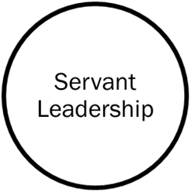
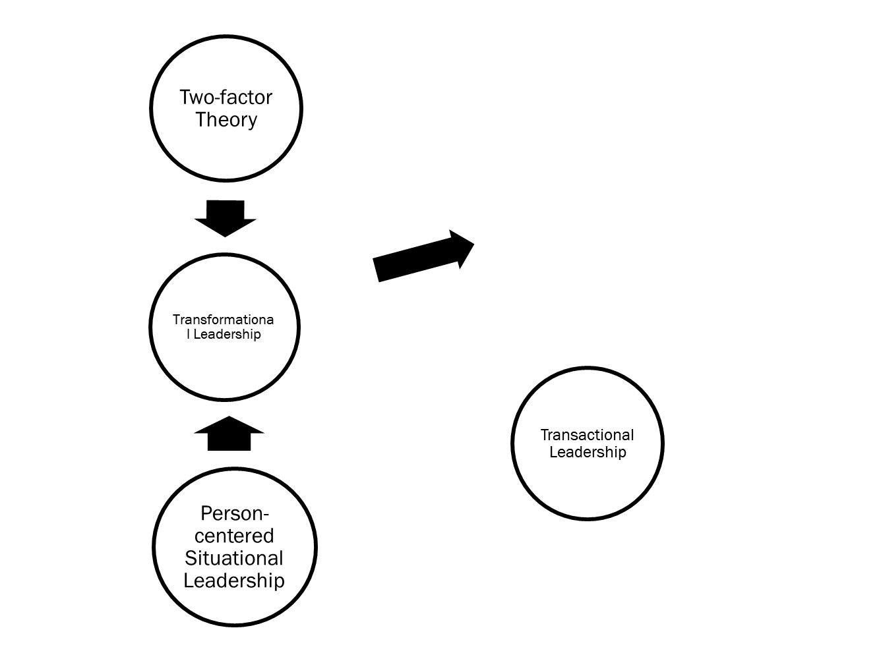
Review of Relevant Theories and Literature -Two-factor Theory
In the discussion of Herzberg's Two-factor Theory, other than Hygiene Factors, Motivators (e.g., showing appreciation to one’s work, promoting ownership, offer chances to overcome the job dilemma, opportunity to do something meaningful, participation in decision making, sense of belonging to organization) that give positive satisfaction, and arise from intrinsic conditions of the job itself, such as acknowledgement, accomplishment, or personal development (Hackman & Oldham 1976), which persuades managers who are obliged to put significant effort not only on the service delivery and the operation mechanism, but also to promote organization commitment, team spirit, and sense of belonging of the employees.
Therefore, the researcher would like to base on the belief of the Theory, which is reflected in the development of transformation leadership, to collect data and explore the implications on the job satisfaction of the employees and also the people management strategies of the organizations, in the hope of presenting a practical model for the nursing homes management to promote the employees' job satisfaction. A positive image of the discipline attracts the younger generation to join the sector.
Review of Relevant Theories and Literature -Person-Centered Situational Leadership
In recent years, many approaches concerning nursing leadership have been internationally developed but cannot demonstrate the manifest complex philosophy of nursing home care. The Person‐Centered Situational Leadership Framework, contended by Brighide in 2018 that supports the philosophy. It forms the theoretical basis after conducting an action research study.
The Person‐Centered Situational Leadership Framework captures seven core attributes of the leader that facilitate person‐centredness in others: relating to the essence of being; harmonizing actions with vision; maintain balance for the compliance with concern on person-centredness; connecting with the others in an instant; intentionally mobilizing the other person to act; listening to others with the heart; and unifying through collaboration, appreciation, and trust.
The Person-Centered Practice Framework makes a significant essential understanding around the world to fill up the gap in knowledge between leadership and residential care facilities for older people (Brighide et al., 2018).
Review of Relevant Theories and Literature – Servant Leadership
Servant Leadership is a paradox. Traditionally leaders influence, and servants follow. However, Servant leaders take a great account on the wellness of followers over their interests and stress followers' development (Hale & Fields, 2007). They present solid moral behavior to the followers (Graham, 1991; Walumbwa et al., 2010), the organizations, and the stakeholders (Ehrhart, 2004).
Review of Relevant Theories and Literature - Transformational and Transactional leadership
Burns (1978) distinguished between Transactional Leadership and Transformational Leadership.
Transactional Leadership refers to most leadership models, which focus on the exchanges between leaders and their team members, e.g., politicians and teachers. The exchange dimension of transactional Leadership is pervasive and can be found at different levels within all organizations.
In contrast, Transformational Leadership is the process that a person engages with others and forms a connection that enhances motivation and team spirit in both the leader and the team members. This kind of leader is very attending to the needs and idea of team members and attempts to assist team members to achieve their maximum potential.
(Burns 1978)
Assumptions or Hypothesis
As person-centered services, we've found that promoting the staff's ownership of the daily care for the frail elderly is essential and is in line with the quality of care.
Transformational Leadership is assumed to be one of the practical approaches to lead the team and reach the goals of the service aims.
Transformational Leadership Processes and Outcomes
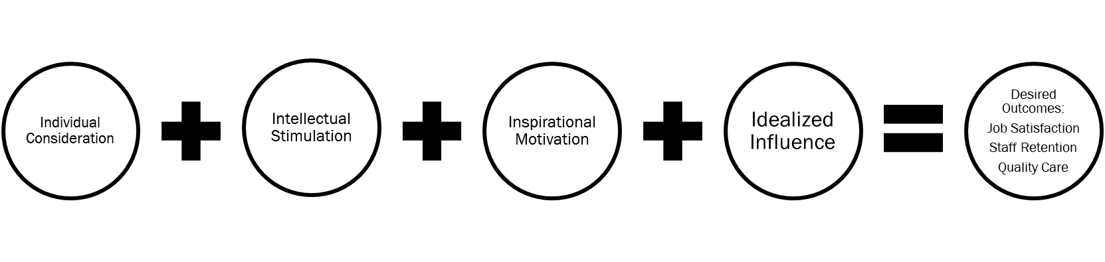
RESEARCH DESIGN
Operational Definition of Variables - Significance of Leadership
The relationship between leadership implementation and commitment in the organization among frontline workers in long-term care services has not been studied.
However, leadership is identified with the same importance with work experiences and job characteristics which are found as influences, or antecedents, on organizational commitment; these experiences and features include job challenges, work relationships, quality of user feedback, attitudes of a group, trust, job satisfaction, empowerment, and stress from role (Liou, 2008).
Operational Definition of Variables -What Is Long-Term Care?
National Institute on Aging – Long-term care involves carious of services designed to meet personal health and personal care needs in a period. The users can no longer care for themselves or perform every everyday activity by themselves. The services help them live as safely and independently as possible at their own Home.
In some countries, long-term care is provided by different caregivers in different places, up to the personal needs, and most of them are unpaid and be responsible by their family members and friends. It can also be in terms of a facility, like a nursing home that provides 24 hours care or day-care service in the daytime. (https://www.nia.nih.gov/health/what-long-term-care)
In Hong Kong, LTC mostly refers these residents' abilities include to (a) shower, dress, and groom; (b) transfer and mobility; (c) toileting; (d) eat and feed; and (e) use speech, hearing, or other functional communication systems (Allen 2016). The ultimate goal of LTC is to provide quality care to residents.
Operational Definition of Variables - Quality of care in LTC and Leadership
Reference from the health care industry, the ‘heroic’ language of “Leadership” began with Making a Difference: We need visionary leadership to help build new, inter-reliable services and to inspire and sustain the commitment of nurses, midwives, and health visitors during a period of significant change. Strong nursing, midwifery, and health visiting leadership are needed at every level. It is required to drive forward interagency and multidisciplinary team working, improve quality and practice through clinical governance, lead public health initiatives, plan and commission services locally through Primary Care Groups and Trusts, and effectively manage clinical services corporate functions. We need to develop the leadership skills of more nurses, midwives, and health visitors to meet this challenge. Our plans to improve health and healthcare call for a particular style of leadership. We need nurses, midwives, and health visitor leaders who can establish approaches and purpose, inspire, motivate and promote teams around common goals and produce tangible gains in clinical operation, quality, and services. We need motivated leaders, thus, self-aware, socially skilled, and able to work trans-disciplinary with others across professional and organizational boundaries (DH, 1999).
Leaders who introduce an atmosphere where employees are valued, acknowledged, challenged, and engaged in unit decision-making, which ultimately foster job satisfaction, staff retention, and quality of care (Utley et al., 2011). The nurse staffing levels alone are necessary but not sufficient for positively affecting care in nursing homes. Therefore, training, supervision, environmental conditions, Leadership and management, and organizational culture (or capacity) are essential elements in offering quality care to residents (Wunderlich & Kohler 2010).
Transformational Leadership provides the strength to change environment conditions and the culture of organization which can meet the needs of staff training and supervision.
Operational Definition of Variables -Transformational Leadership
Transformational Leadership is an approach that a leader motivates and inspires his team members to initiate or achieve a positive change in the enterprise and organizations. The leadership style can arouse group morale, leading to rapid innovation, improving conflict resolution, decreasing staff turnover, and fostering ownership within the team.
It is a process where leaders and followers mutually escalate each other to higher levels of motivation and morality, initiating change and transforming people. It is also essentially tackled with emotions, values, ethics, standards, and long-term goals. It includes assessing followers' motives, finding ways to meet their needs, and treating them as total people.
Transformational Leadership has an extraordinary influence that motivates followers to achieve more than what is habitually expected. (Northouse 2016)
DATA COLLECTION AND ANALYSIS AND REPORT
Research method and case analysis
This research is planned to apply qualitative research methods and develop a deeper understanding on the relationship of transformational leadership and quality of long-term care. Adopting the qualitative methods is not assuming the method will be easier than the quantitative one, however, firstly the researcher is a social worker and have strength in communication with people and secondly, the research can further explore and figure out systematically the knowledge and skills holding by those successful managers of the services.
Suggested Measures/Instruments
This Research can adopt the Qualitative Research method to collect data and analysis as Qualitative Research attempts precise measurement of something. It is based on research involvement in the phenomenon to be explored, grouping data that provide a thorough description of events, situations, and interaction between people and things, providing detail and depth. Such interpretative Research seeks to develop understanding through detailed description – often builds Theory but rarely tests it. (Cooper & Schindler 2014)
Research Method and Process
- Cases study – Leadership style of LTC Managers
- Action research – Transformational Leadership Coaching Program for LTCM
- Triangulation – Focus Groups and In-depth Interviews
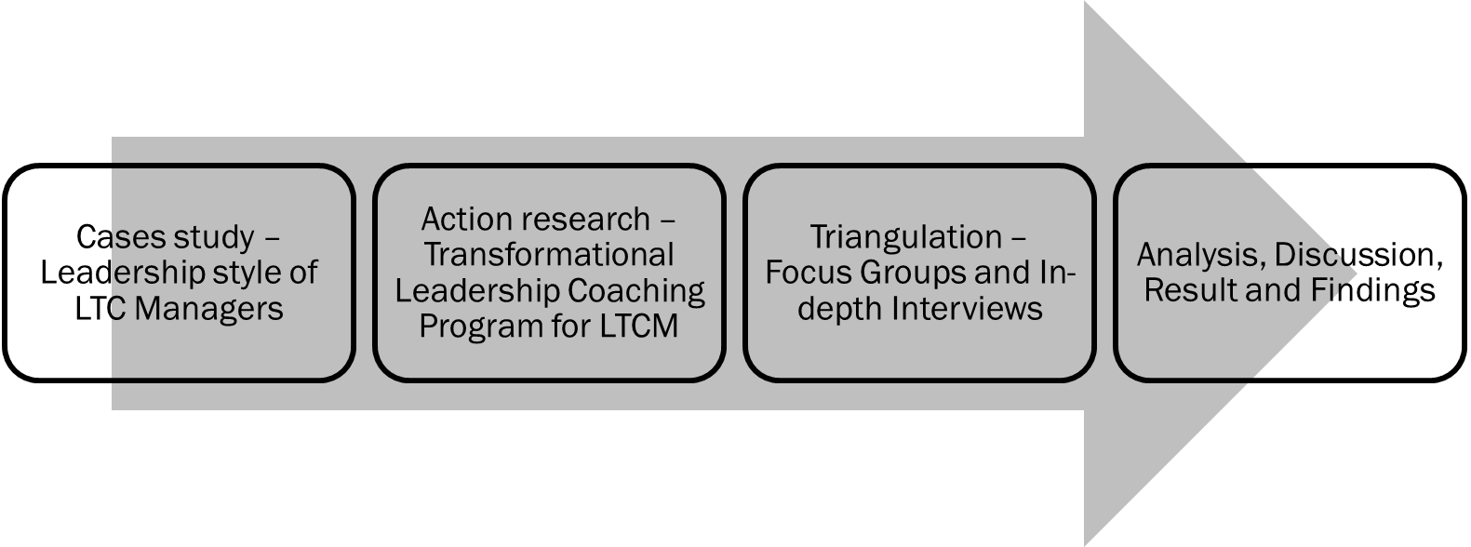
- Analysis, Discussion, Result, and Findings

Research Method -Case Study
The case study explores a single phenomenon in a natural setting using various methods to obtain in-depth knowledge. The importance of the context is fundamental, and the focus is on understanding the dynamics present within a single environment (Eisenhardt, 1984). It must be constructed to be sensitive to the context in which management behavior takes place (Bonoma1985).
Researcher is planned to approach several nursing home managers and have in-depth interviews with them about their concept and belief on the people management in the nursing homes as well as their assessment about the effectiveness about their own leadership and services. Interview guide will be prepared because these interviews. Moreover, researcher also conduct interviews with the subordinates of these managers to explore their views on the performance of their supervisors, their relationship, so as to solicit evidence about the critical elements of the leadership style of these managers.
Researcher will also adopt participant observation method to attend the staff meetings, and act as observer in the Home to observe the interaction of the mangers and the staff members.
In order to ensure the possibility and feasibility of the data collection methods, researcher will ask the consent from the research sample, as well as to seek for the approval of the mother Agencies of these nursing homes.
Research Method -Action Research
Other than the case studies method with certain individual nursing home managers, researcher will conduct Action Research and attempt to solicit useful data on the strength and weakness of transformational leadership towards the long term care services.
Research belief that Action research has been found to have great utility at improving work-based learning (Williamson 2005).
Action Research is also a methodology used in applied Research to find an operative way of bringing about conscious awareness in a partly controlled environment. The main objective of action research is to go into a situation, attempt to bring about change, and monitor the results. The inquiry process is believed to form a cycle of planning, acting, observing, and reflecting (Lewin 1946) and focused on the outcome that might result from the research being done (Baker 1999).
Under such circumstances, research will formulate a coaching package and recruit some of the nursing home managers to participate and observe what constitute their change of the leadership style.
Research Method - Plan of Action Research
For the principles, the planning stage identifies the objective it intends to achieve and how it may be done. Observed effects of action and reflected on before modifying the overall plan. The Researcher and the target sample must be agreed on the aims of the study. (Collis & Hussey 2014)
The Action plan includes recruiting target LTC managers, adopting the framework of TL for LTC (Utley et al. 2011), periodically, individual interviews, group sharing sessions, participant observation into meetings and operation, and reflective journal by Researcher. The duration will last for 6 to 9 months.
Researcher will be alert to evaluate the observation and effectiveness by phases, which are T0-before the implementation of the coaching package; T1- after one-third of the package; T2-another one third of the process; and T3-completion of the training package.
Research Method –Coaching Framework of Transformational Leadership Behaviors
The coaching program will be designed which reference the following framework, includes:
Principle | Strategy | Practice
Individualized Consideration | Knowing the team members | Initiate the members are being cared as a person
Individualized Consideration | Knowing the team members | Negotiate flexibility of schedule.
Individualized Consideration | Offer chances to achieve the objectives | Stressed on the strength of the members
Individualized Consideration | Offer chances to achieve the objectives | Matching between the member’s strength and the assignment.
Intellectual Stimulation | Put staff development always the first | Facilitate the members for challenges and expand abilities
Intellectual Stimulation | Put staff development always the first | Promote educational elements through periodical staff meetings
Intellectual Stimulation | Show appreciation on the knowledge and skills of the members | Involve the members to have problem-solving in the care issues of residents
Intellectual Stimulation | Show appreciation on the knowledge and skills of the members | Promote an atmosphere that the members fee safe to seek for multiple solutions
Intellectual Stimulation | Show appreciation on the knowledge and skills of the members | Stressing on the encouragement in innovation and creativity
Inspirational Motivation | Demonstrate enthusiasm and optimism to team members
Inspirational Motivation | Provide frequent response and appreciation | Verbally appreciate members who perform well
Inspirational Motivation | Provide frequent response and appreciation | Have good plan for formal recognition programs and incentives for members
Inspirational Motivation | Reinforce good communication and teamwork | Establish a reward system for mutual help
Inspirational Motivation | Reinforce good communication and teamwork | Establish friendly team competitions to meet resident care goals
Inspirational Motivation | Encourage members’ independence and empowerment | Invite ideas from members that may make their jobs easier and improve the quality of care
Inspirational Motivation | Encourage members’ independence and empowerment | Motivate the members to be more advocate to identify residents at risk of pressure sore, falls, or other accidents.
Idealized Influence | Should be visible and practical
Idealized Influence | Presenting competency and integrity
Idealized Influence | Well-structured of your expectations | Fully inform the expectations to members
Idealized Influence | Well-structured of your expectations | To be consistent in actions, vision and mission
Idealized Influence | Well-structured of your expectations | Treat everyone accountable to the same standards
Idealized Influence | Well-structured of your expectations | Hold regular meetings to review current care issues
Source: Some data are from Bass et al. (2003) and Stewart (2006)
Sample and Sampling method
It is suggested Convenience Sampling will be more feasible, and the Case Studies can be 5 to 8 cases. The Action Research will recruit 12 to 15 LTC managers, and the inclusion criteria should be the manager or In-Charge of NH. As researcher is working in a local NGO which is solely providing services for the elderly people, it is anticipated that researcher will invite the colleagues of his working Agency who are holding the post of the management in the nursing homes.
Moreover, researcher will make use of the service network, and try to reach out to the nursing homes of the other agencies, and invite their managers to join the Focus Groups of the study. The purpose of Focus Groups is to share the research topic with the leaders in the industry, and collect their views according to their experience of the successful leadership style in the nursing home management. Focus Groups are believed definitely to increase the research's validity, and 2 to 3 groups can be run during the research process.
Data Collection and Analysis
Research can use structured, semi-structured, and unstructured interviews, participant observation, records review, transcription of focus groups minutes, and reflective journal, which serve as the research data, and conduct contents analysis in detail for the data analysis.
Content analysis will be used as a technique for making replicable and valid references from data to their contexts (Payne & Payne 2004). The researcher seeks for structures and the regularities of pattern in the text and makes inferences on the basis of the regularities (Myers 2020).
Besides, throughout the Action Research process, researchers and participants will continuously reflect on recent observations and narratives, so as to inform change (Winter & Munn-Giddings, 2001).
Furthermore, it is preferable to process the triangulation research, which is used to describe the combining of several qualitative methods or combine qualitative with quantitative methods (Cooper & Schindler 2014), which can also enhance the reliability of the study.
Suggested Research can combine various qualitative methods for the triangulation, including focus groups and in-depth interviews with other LTC managers will be worth the comparison. The Researcher will solicit valid quantitative research instruments to run the triangulation as well. Researcher will continuously explore if any quantitative research method can be included in this study which serves the methodology as a mixed mode one.
Expected Findings
This suggested research is expected to find the ways of various Home's management in processing the people management and its effectiveness to promote people-centered caring for the users. The researcher assumes that the transformational leadership approach will be the most effective in mobilizing the teams' spirit, cohesiveness, motivation, job satisfaction, ongoing staff development, and sustaining staff members.
Managerial / Practical Implications
The study results are expected to induce discussions within the service sectors, especially young managers with a long-term commitment to the industry. Certainly we belief that more and more managers to aware their leadership style and approach to a transformational one, will surely benefit to the people management as well as the quality of care. Moreover, the research is also likely to foster the attention of the academic institutes and the Government, continuously provide expertise and resources for the advanced training of the social service managers, not only to strengthen their leadership to be more focused on people development but also promote the quality of management of the whole sector. After the Research, it is also assumed that active policies should reflect the organization's values and follow from a compelling, collective vision and mission.
Limitations
According to the above-said research focus and research methods, it is predicted there will have difficulties in recruiting the target of coaching and focus group, as most of the LTC Managers are competent enough to run their operation with their style. Secondly, the sample size is still tiny, which cannot generalize the conditions of the observation. Thus, triangulation is limited to various qualitative methods that may not be adequately convincing; determining a quantitative approach afterward will enhance the validity.
Ethical Issues
The Researcher's ethical responsibilities include the overarching principles of academic integrity and honesty and respect for other people throughout the research process, whether in this paper or the suggested further study.
Therefore, the ethical considerations will be addressed in the process (Punch 2014), which include informed consent is essential to the people in the study, it is vital to offer the purpose and information of the Research to them; keeping the data collection in confidentiality and anonymity; beware of not misusing the research results; always be aware of the reciprocity relationship with the participants of the Research, not just of the Researcher's interest in all aspects; beware of any harm or risk involved, and handle with care about conflicts of interest.
REFERENCES
Allen J. E. (2016). Nursing Home Administration. NY: Springer Publishing.
Baker T.L. (1999). Doing Social Research. McGraw-Hill College.
Bass B, Avolio B, Jung D, et al. (2003). Predicting unit performances by assessing transformational and transactional leadership.J Appl Psychol 2003;88:207-18
BobomaT.V. (1985). Case research in marketing Opportunities, problems, and a process. Journal of Marketing Research, XXII, May, pp. 199-208.
Brighide L. M ; McCance, Tanya ; McCormack, Brendan ; Brown, Donna, (2018). The development of the Person‐Centred Situational Leadership Framework: Revealing the being of person‐centredness in nursing homes.England: Wiley Subscription Services, Inc.Journal of clinical nursing, 2018-01, Vol.27 (1-2), p.427-440
Burns, J. M. (1978). Leadership, New York: Harper & Row.
Centers for Medicare and Medicaid Services. (2004). National nursing home quality measures: user manual. Cambridge, MA: Abt Associates; 2004.
Collis J. & Hussey R. (2014). Business Research. Palgrave.
Cooper D.R. & Schindler P.S. (2014). Business research methods. McGraw-Hill Irwin
Department of Health (DH) (1999), Making a Difference - Strengthening the Nursing, Midwifery, and Health Visiting Contribution to Health and Health Care. London: Department of Health.
Donoghue, C., & Castle, N. G. (2009). Leadership styles of nursing home administrators and their association with staff turnover. The Gerontologist, 49(2), 166-174. doi:10.1093/geront/gnp021
Eisenhardt K.M. (1989). Building theories from case research. Academy of Management Review, 14(4), pp 532-50.
Graham, J.W. (1991). Servant leadership in organizations: Inspirational and moral. Leadership Quarterly, 2, 105-119.
Hackman, J. Richard ; Oldham, Greg R Elsevier B.V (1976). Motivation through the design of work: test of a theory. Organizationalbehavior and human performance, 1976, Vol.16 (2), p.250-279
Hale, J. R., & Fields, D.L.. (2007). Exploring servant leadership across cultures: A study of followers in Ghana and the USA. Leadership, 3, 397-417.
Kari Brodtkorb ; Skaar, Ragnhild ; Slettebø, Åshild, (2019). The importance of leadership in innovation processes in nursing homes: An integrative review. London, England: SAGE Publications. Nordic journal of nursing research, 2019-09, Vol.39 (3), p.127-136
Kuhnert, K.W. (1994). Transforming Leadership: Developming people through delegation. In B.M. Bass & B. J. Avolio (Eds.), Improving organizational effectiveness through transfomrational leadership (pp. 10-25). Thousand Oaks, CA: SAGE
Lewin K. (1946). Action Research and minority problems, Journal of Social Issues, 2, pp. 34-6
Lewin K, Lippit R, White RK. (1939). Patterns of aggressive behavior in experimentally created social climates. J SocPsychol 1939;10:271-301.
Liou, Shwu-Ru (2008). An Analysis of the Concept of Organizational Commitment. Malden, USA: Blackwell Publishing Inc. Nursing forum (Hillsdale), 2008-07, Vol.43 (3), p.116-125
Myers M.D. (2020). Qualitative Research in Business & Management. London: SAGE
Northouse P. G. (2016). Leadership, Theory and Practice. SAGE edge
Payne G. & Payne J. (2004). Key Concepts in Social Research. London: SAGE
Punch F.K. (2014). Developing Effective Research Proposals. London: SAGE Publications.
Santhiny Rajamohan, ; Porock, Davina ; Chang, Yu‐Ping. (2019). Understanding the Relationship Between Staff and Job Satisfaction, Stress, Turnover, and Staff Outcomes in the Person‐Centered Care Nursing Home Arena.United States: Wiley Subscription Services, Inc.Journal of nursing scholarship, 2019-09, Vol.51 (5), p.560-568
Scott, J., Vojir, C., Jones, K., & Moore, L. (2005). Assessing nursing homes’ capacity to create and sustain improvement. Journal of Nursing Care Quality, 20(1), 36-42. http://dx.doi.org/10.1097/00001786-200501000-00007
Stewart J. (2006). Transformational leadership: an evolving concept examined through the works of Burns, Bass, Avolio, and Leithwood. Can J Ed Adm Pol 2006;54:1-29.
Utley R., Anderson R., Atwell J. (2011). Implementing Transformational Leadership in Long-Term Care. Geriatric nursing (New York), 2011, Vol.32 (3), p.212-219. Mosby, Inc
Walumbwa, F.O., Hartnell, C.A., & Oke, A. (2010). Servant leadership, procedural justice climate, servive climate, employee attitues, and organizational citizenship behaviour: A cross-level investigation. Journal of Applied Psychology. 95, 517-529.
Williamson T. (2005). Work-based learning: a leadership development example from an action research study of shared governance implementation. Journal of Nursing Management, 2005, 13, 490–499.
Wunderlich G,, Kohler P, eds. (2010). Institute of Medicine, Committee on Improving Quality in Long-Term Care, Division of HealthCare Services. Washington, DC: National Academy Press; 2001.
https://www.hkpopulation.gov.hk/chi/facts.html
https://www.lwb.gov.hk/tc/blog/post_04102020.html
https://www.swd.gov.hk
Handouts of Professor E. Yu

