Programming I
Assignment
Programming I
Lecturer: Mike Dacey
Student Number: Abdurahman Ibrahim
Student P Number: P150461
Module Title: Programming 1

PART A (UNDERSTANDING):

- What is a variable?
A variable memory location that is named and assigned a value by the person executing the program.
The value of a variable once it’s been assigned can also be changed inside the program however many times the person executing the program wants to, this means that value is not fixed and changeable.
[1]

- Why are they important in writing programs?
Variables are very Important parts of computer programming, they all the programmer to write programs that are flexible.

Pretty much anything you need to do in programming, you are going to need to store something in the memory, and this is what variables allow you to do.

The data type of a variable indicates the sort of value the variable is representing, things like whether the value of the variable is an integer, a floating-point number, or a character. The opposite of a variable is a constant.

Identifiers
Identifiers can only be a sequence of one or more letters, digits, or underscore characters (_). There cannot be any Spaces, punctuation marks and other symbols in an identifier.
They should always start with a letter.
They can also begin with an underline character (_), but they cannot by anyway begin with a digit. [2]
C++ is a "case sensitive" language. This means if an identifier is written with a capital letter it’s not the same as the same word or identifier that is written with small case letters.
Fundamental data types:
The most important fundamental types in c++ are the integer, the float which also includes the double type which is a bigger version and more accurate than the float for larger float numbers, the character variable and also the Bool Data Type.
The variables are stored in the computers memory, but the computer has to know what kind of data the user wants to store in the variables, storing a simple number does not take the same amount of memory as storing a single letter or large numbers, so they are not interpreted the same way.
Computer memory is organised in bytes, 1 byte is the smallest amount of memory that we can use in C++.
1 byte is only able to hold one single character or a small integer (generally an integer between 0 and 255).
The computer can hold more complex data types that come from putting together several bytes, like long numbers and non-integer numbers.
Data types:
Char:
Character or small integer can hold only 1 byte, it ranges for the signed between -128 – 127 and 0 - 255.
Short Int:
The short integer holds only 2 bytes, it ranges from -32768 to 32767 signed and 0 to 65535 unsigned.
Int:
The Integer holds 4bytes and it ranges from 2147483648 to 2147483647 signed and 0 to 4294967295 Unsigned.
Long int:
The Long integer is double the size of the int, it holds 4 bytes, and it ranges from 2147483648 to 2147483647 signed and 0 to 4294967295 unsigned.
Bool:
The Boolean value can only take one of two values, true or false, each value only holds 1 byte.
Float:
The Floating point number holds 4bytes, it ranges from
3.4E-38 to 3.4E38 positive or negative, and the floating point number can represent seven significant decimal digits of precision.
Double:
The double Range is double the float and holds 8 bytes, and it ranges from 1.7E-308 to 1.7E308 positive or negative, and it also has a higher precision rate as it can represent approximately 15 significant digits.
Long double:
Long double precision floating point number. 8bytes +/- 1.7e +/- 308 (~15 digits)
wchar_t:
Wchar_t is 2 or 4 bytes, and it is used when the programmer needs to hold characters with a larger value than 255, this makes it greater than char as the char can only hold a value as big as 256, this wchar_t holds 65536 values.

Declaration of variables:
Int C;
Float mynum;
These are two variables declared, the first one has the data type integer which holds 2 bytes and the identifier is a capital c, the second variable is a float, it holds 4 bytes and the identifier that is declared to it is mynum.

You can also declare more than one variable in one sentence this can be done only if all the variables are of the same type, so for example:
Int h, l, g;
Is the same as:
Int h;
Int l;
Int g;
The integer types char, short, long and int can either be signed or unsigned, this depends on the range of numbers represented in the value stored.
Signed types can hold positive and negative values, and unsigned types can only be positive values including 0.
You can declare this in the variable by typing signed or unsigned before the value type, for example:
Unsigned short int my_kids;
Signed int Cash_deposit;
If you don’t type in signed or unsigned the value will automatically be signed.
Short and long int are also assigned in the same way, but they can also be used alone without adding the int, the same can be done for signed and unsigned they can both be stand alone.

This program below is me operating with variables:

#include <iostream>

Using namespace std;

Int main ()
{
Int a, b, Sum; // declaring variables in the same line

cout <<"Enter The first number: \n"; // doing the program process giving the variable a value by the users entry
cin >>a;
cout <<"Enter The second number: \n";// same as above
cin >>b;

Sum = a + b ;// giving the value of the final variable

cout<<" The sum of "<<a<<" and "<<b<<" is = "<<sum; // printing out the complete program.
return 0; // terminate the program
}

Initialization of variables:
You can initialize variables by using the same method used by me in the above program by letting the user enter the value, you can also do the it the way that I initialized the sum valu by using = to assign the value in the middle of the program, you can also do it the same way but at the beginning of the program.
Example 1:
cout <<"Enter The first number: \n";
cin >>a;

Example 2:
Sum = a + b;
Int a = 5;

Example 3:
Int a = 5

a = a +5;
Strings:
Variables that store values that are not numbers and also longer than 1 character are called strings.
To use this string type we need to use an additional header file, this header file is typed like this: <string>.
In the declaration and assignment part it is the same as all the other fundamental data types can.
This is the first way to declare, assign, initialize and print out the string:

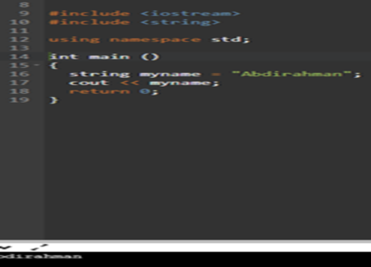
This is the second way to to declare, assign, initialize, and print out the string, but this time as I done before on the integer variables you can reassign the identifier value in the middle of the program:

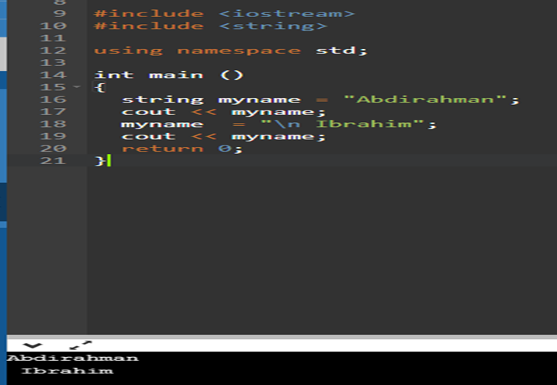

Explain why the for-loop can also be referred to as a counting-loop and give an example of why you would use it:
You can use any loop for any case. You can achieve the same effects with all of them.

Loops are used whenever you feel like you need to repeat something (for example counting things).
The for loop is called counting loop because you have the 'count' part in the declaration with the condition. It's mostly used for the cases like this:

For (int I = 0; I < 10; I++)
Cout << I << endl; [2]

Syntax:

The for loop syntax starts with the first step which declares and initializes the variable in the loop, the statement is then followed by a semi colon: For (int I = 0;

The second step evaluates a certain condition, if the condition put in is true then the following statement is executed in the loops body, if the statement is false the program skips this loop and goes to the next step: I < 10;

In the third and final step the condition is evaluated again, If the condition is true the loop will execute and repeat itself until the condition becomes false: I++)

Execution:
This is how I executed my basic program using the for-loop
#include <iostream>
using namespace std;
int main () {
// for loop execution
for( int c = 52 ; c < 62; c++ ) {
cout << "value of a: " << c << endl;
}
return 0;
}
The above program first declares and initializes the variable in the loop, the statement which assigns the value of 52 to the variable c, this is then followed by a semi colon to close the first part.
Then the condition is checked to see if the variable c is less than 62, if this condition is true which it then the loop moves on to the last step after another semi colon.
The last part is to increment the value of c and add 1 to it till the value becomes false and is no longer less than 62, then the for-loop becomes false and skips the body of the loop as the job of the for-loop is completed.
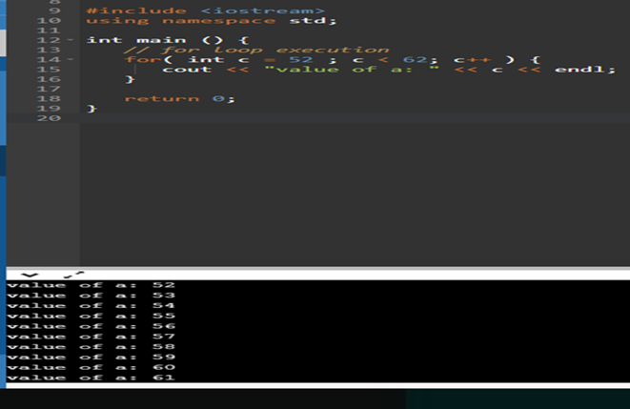
Explain how arguments in functions can be used:
The way arguments can be used in functions is when you want to work on a variable from another place in your program you need to send it through function arguments.

// example of a function being used with arguments
#include <iostream>
using namespace std;

int multiplication (int a, int b)
{
int G;
G = a * b;
return r;
}

int main ()
{
int W;
W = multiplication (15,8);
cout << "The result is " << W;

In the above program the function is performing a multiplication of 2 different integer values, in the main function there is a value which I identify as W, this = the name of the multiplication function which stores the arguments inside it with two number being passed to the arguments in multiplication function which then executes the command of multiplying the two integer values by a newly stored variable that was named G, The program is then told to return the value of the program.

Describe the purpose of a class in Object Oriented Programming:

The purpose of class in object-oriented programming is to describe one or more objects.
It serves as a template for creating, or representing specific objects within a program.
While each object is created from a single class, one class can be used to instantiate plenty of separate objects. [1]
The way I understood classes was like cooking a meal, the class is basically the recipe of the meal, the meal can be eaten but the recipe itself cannot be eaten, so only if you follow everything the recipe tells you to add will you be able to make the full meal.

If you correctly do what the recipe tells you to do then you have a ready to be eaten meal.
That readymade meal is an instance of the meal class.
You can make as many meals as you want using the same meal recipe. [5]

PART B (INTERPRETATION):

Reading and providing an explanation of how the code for the application in the appendix has been implemented:

This is the main Header File, all the function names, variables and variable names are all stored here before executing the program on the main console page.
The main integers are also given constant names and values.

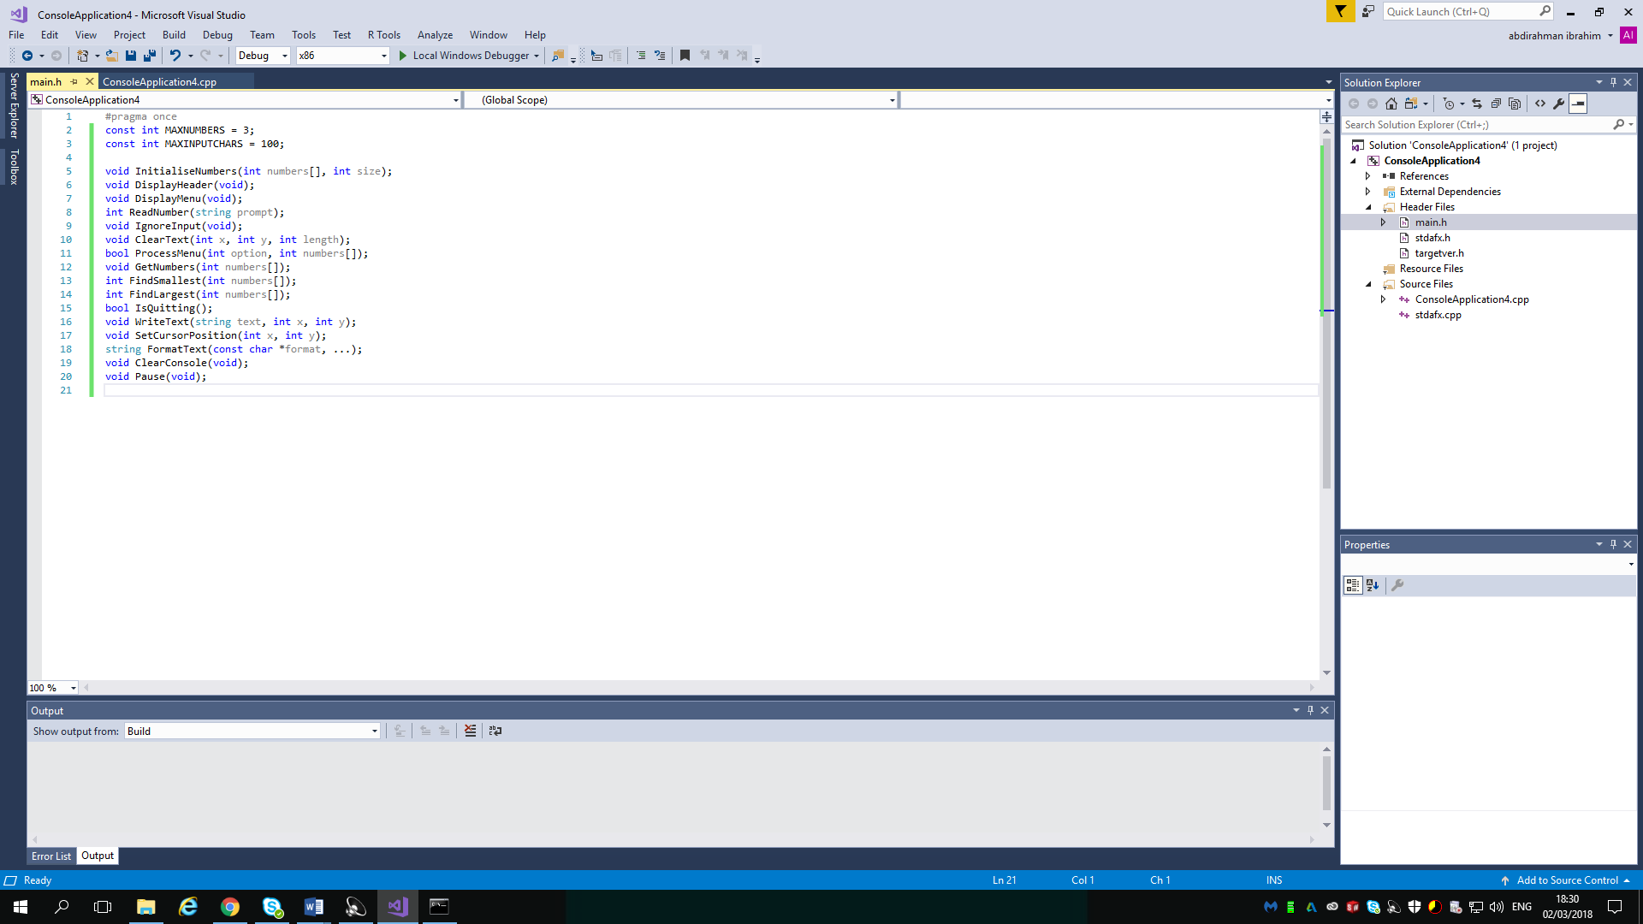

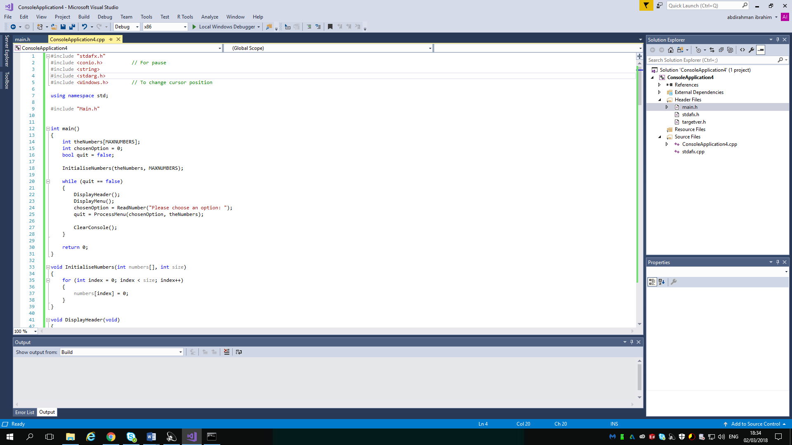

The <iostream> provides basic input and output for C++ programs
It is needed for this program because cout and cin the input and output objects for c++ are stored in the standard library as part of the iostream header.

All these separate headers are needed in some part of this program, string is for the use of strings in the program and the Main.h is calling the main header page that has all the values needed for the program stored.

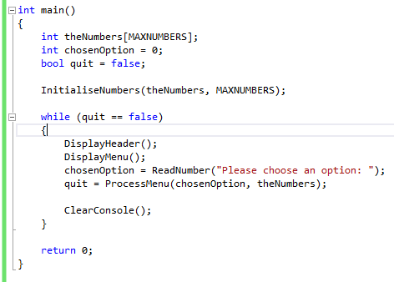

Int main () Initiates the calling of a function.
This function has multiple different things going on, first of all the integers are called upon and given values, the bool element is also called upon, the main objective of this function is giving the calling the user to choose an option of given numbered statements, the while loop if the test is passed executes this, it also gives the user the option to quit the program by choosing the correct number given.

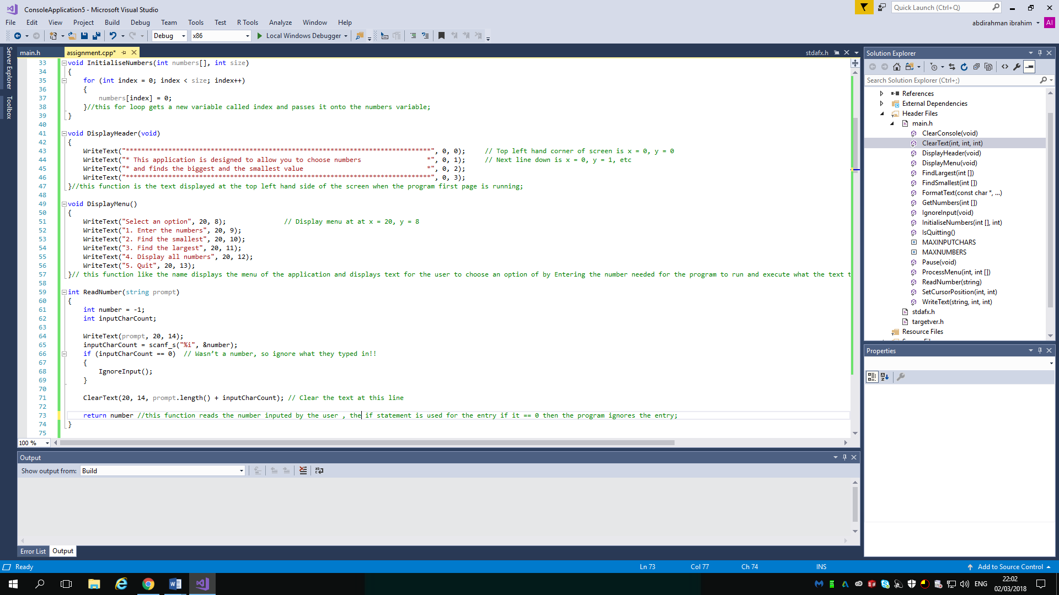

This function below like the name displays the menu of the application and displays text for the user to choose an option of by Entering the number needed for the program to run and execute what the text tells you it will execute.

This function Below reads the number inputed by the user , the if statement is used for the entry if it == 0 then the program ignores the entry.

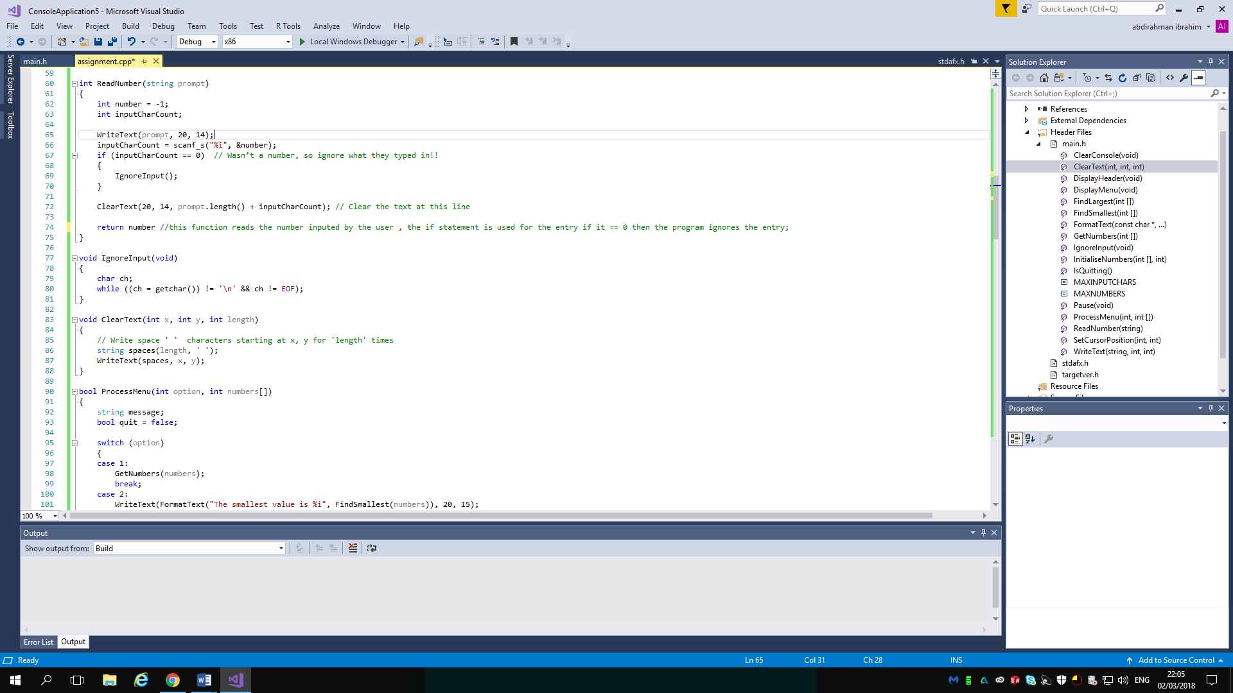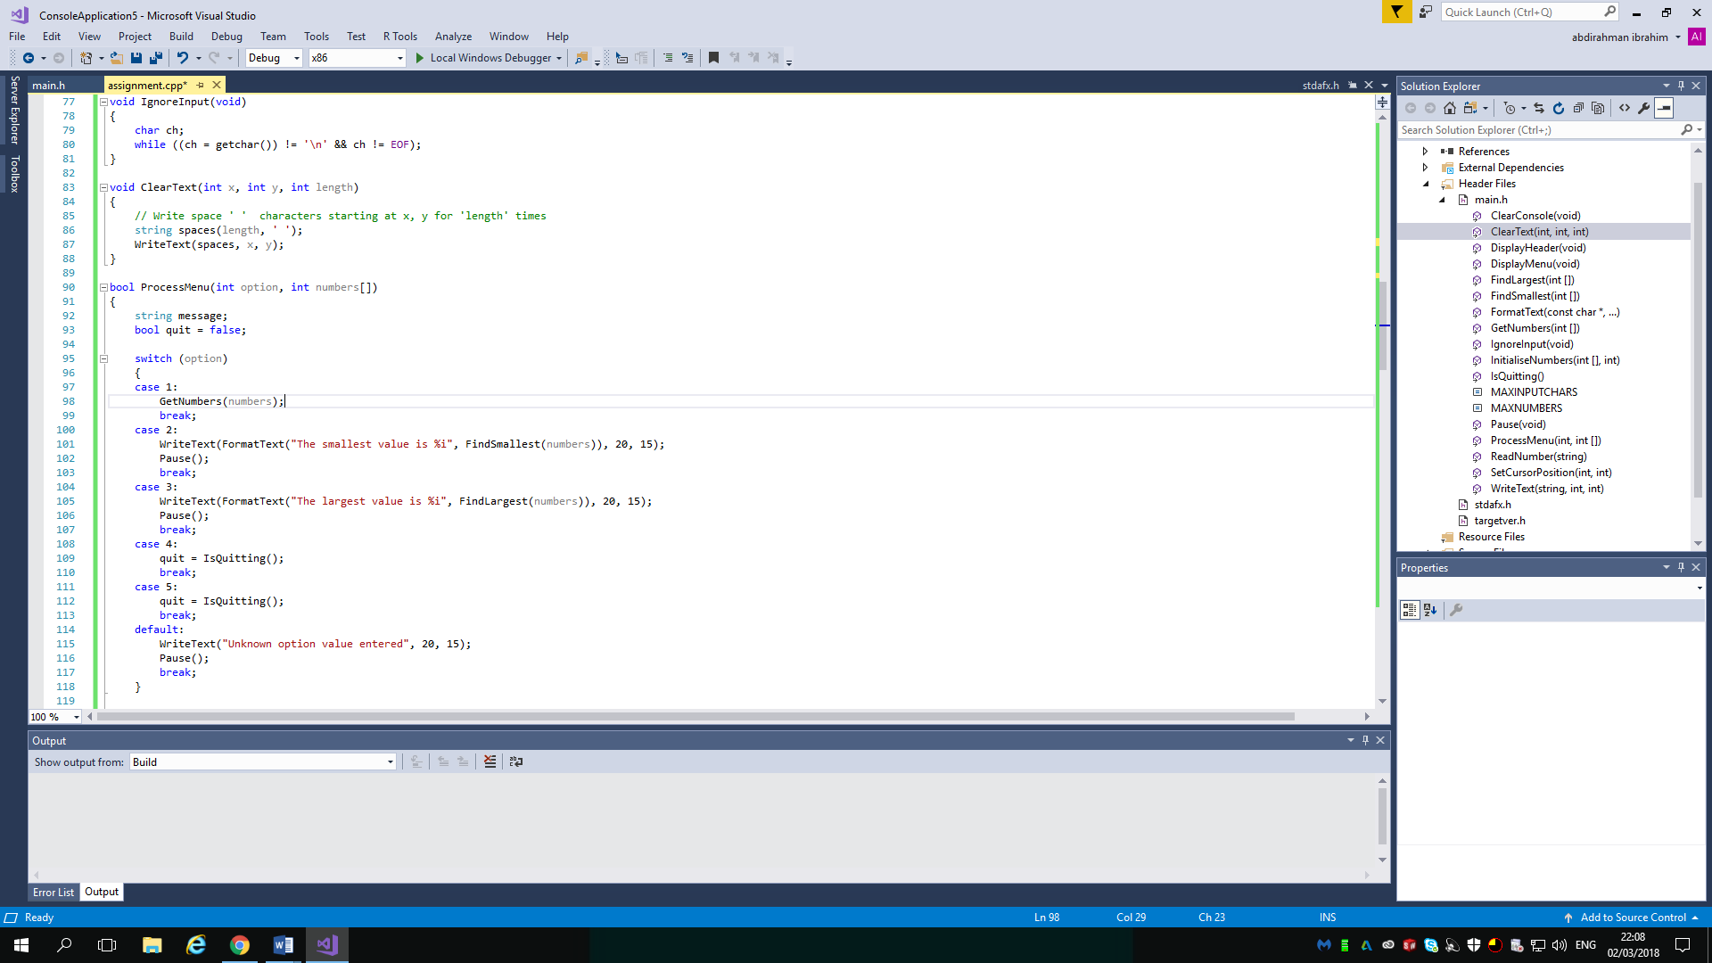
The first function above is the one executed by the program if the user inputs 0 at the number entry part, this calls the function ignore input, which then does the obvious, the second function is executed once the first function is and it clears all the text.
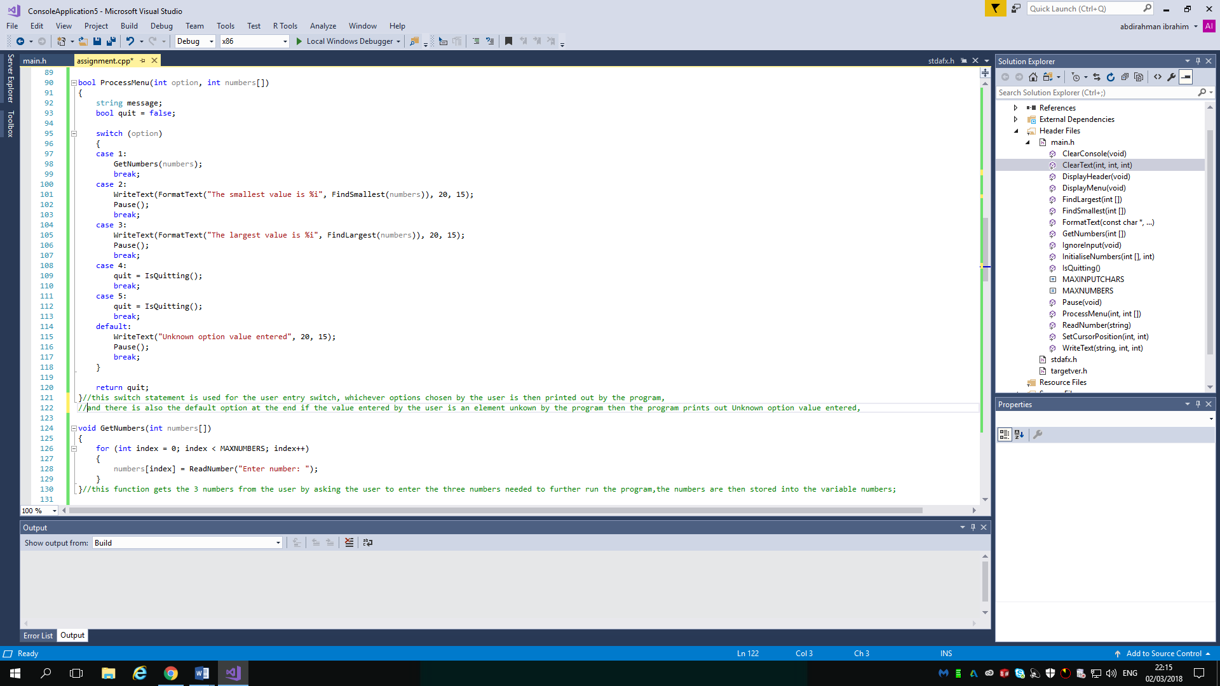
This switch statement is used for the user entry switch, whichever options chosen by the program then prints out the user,
In addition, there is the default option at the end if the value entered by the user is an element unknown by the program then the program prints out Unknown option value entered.

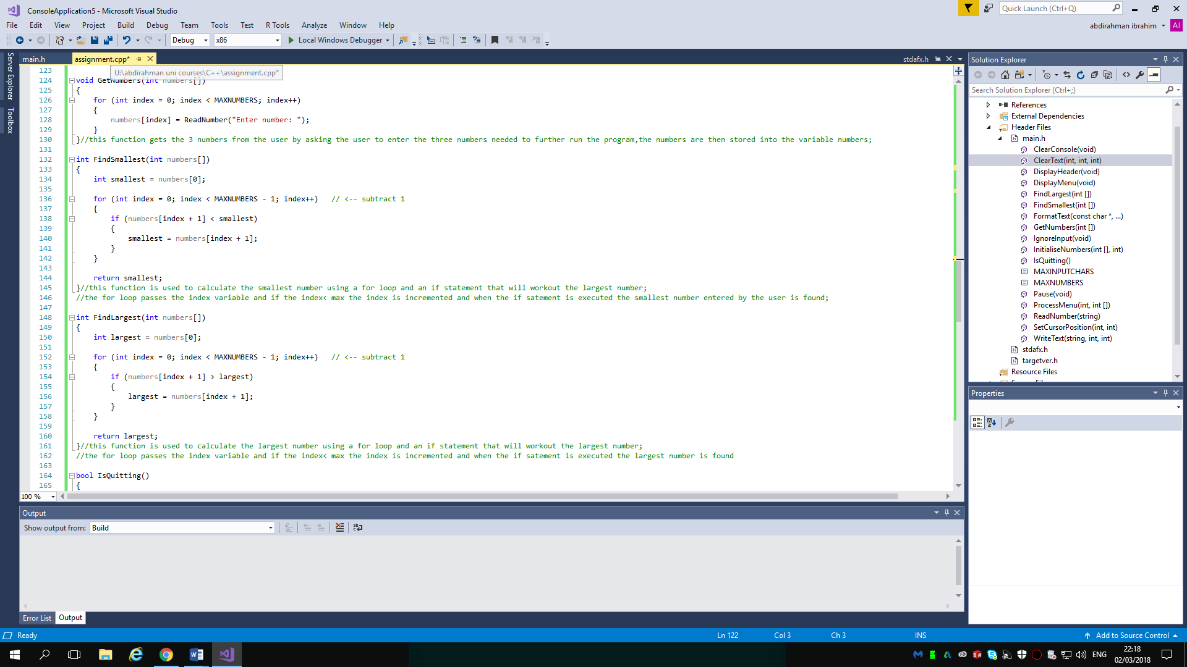
This function gets the 3 numbers from the user by asking the user to enter the three numbers needed to further run the program, the numbers are then stored into the variable numbers.

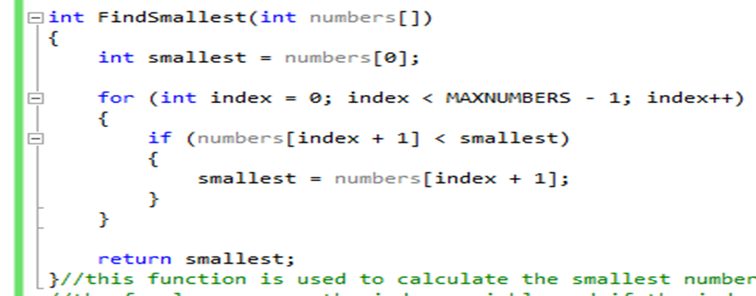
This function is used to calculate the smallest number using a for loop and an if statement that will work out the largest number.
The for loop passes the index variable and if the index< max the index is incremented and when the if statement is executed the smallest number entered by the user is found.

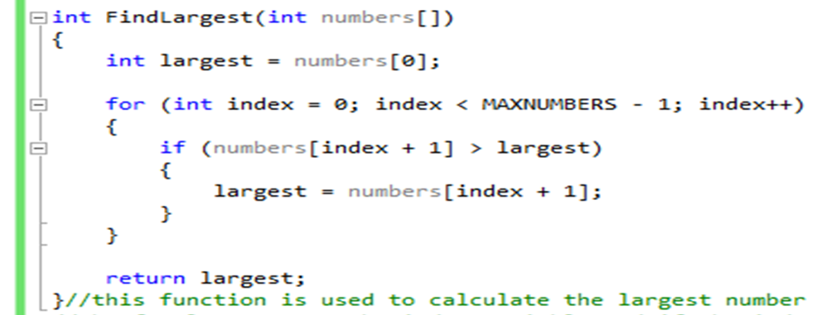
This function is used to calculate the largest number using a for loop and an if statement that will work out the largest number;
//the for loop passes the index variable and if the index< max the index is incremented and when the if statement is executed the largest number is found.

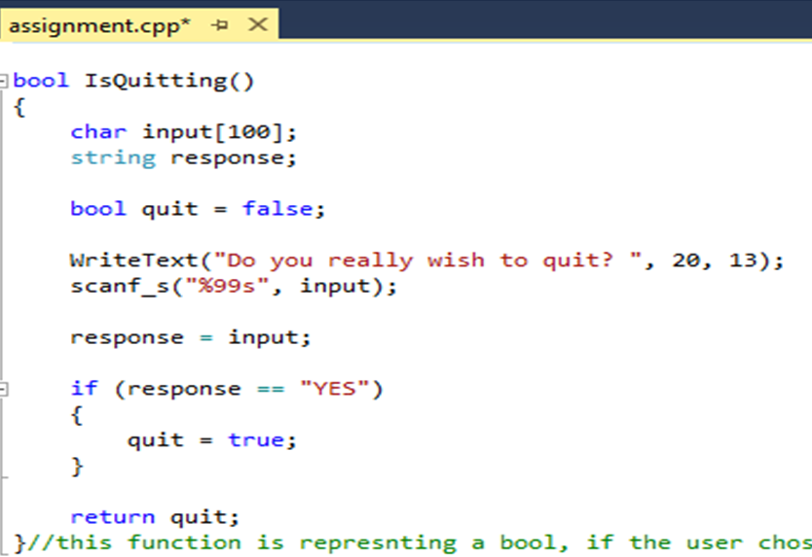
This function is representing a bool, if the user choses the option for quitting the program produces this text above, the Boolean value is for quit is false, once the user actually types in the string in place of the stored string response the quote "yes" then it changes to true and the program is closed as a result of the if statement.

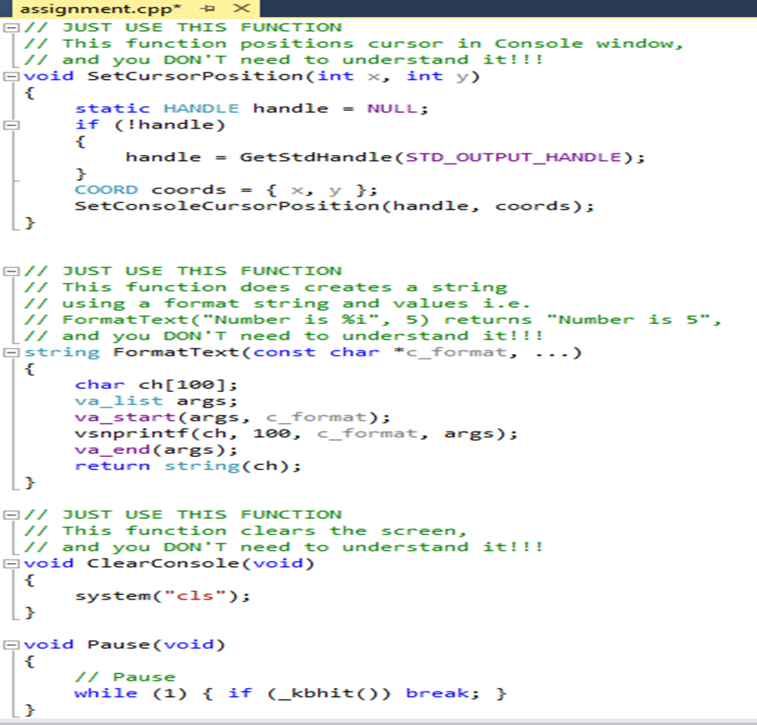
These function are explained!!!

Test this code and identify any bugs:
After attempting to run the code on the appendix there was 2 minor errors, it could as just be warnings but as a result of the compiler I’m using, the compiler keeps telling me to use scanf_s for the output instead of the original scanf.
After changing this everything else works fine.

Bibliography

[1] | http://www.cplusplus.com/doc/tutorial/variables/. [Online].
[2] | [Online]. Available: Identifiers.
[3] | https://www.tutorialspoint.com/cplusplus/cpp_for_loop.htm. [Online].
[4] | https://www.tutorialspoint.com/cplusplus/cpp_functions.htm. [Online].
[5] | https://www.adobe.com/devnet/actionscript/learning/oop-concepts/objects-and-classes.html. [Online].
[6] | https://www.adobe.com/devnet/actionscript/learning/oop-concepts/objects-and-classes.html. [Online].

