Change Management
Managing People and Change
Gareth Thomas

Contents
Introduction 2
What is Change? 2
Change Management 2
Planning for Change 2
Lewin’s Force Field Analysis 3
Chosen Organisation 4
Changes and Developments 4
Change Management 4
Internal and external Change Drivers 4
Internal Factors 4
External Factors 4
Lewin’s Force-Field Analysis 6
Change Management theories and Strategies 6
Lewin’s Change Management Model 6
The ADKAR Model 7
Recommended Management Style 7
Conclusion 8

Introduction

What is Change?
The world is continually changing rapidly; with new technology, business strategies and consumer demand. Organisations must continue to change and adapt to new markets otherwise they will fall behind and start the suffer as an organisation which may result in loss of jobs, profits and lack of business. Ineffective leaders and management styles will begin to struggle without change [1]. The leadership skills of management can greatly affect the outcome and the transition of any change in an organisation. Leaders need to be effectively trained and educated with the methods to effective help and plan in the transition of change.

Change Management
Change management refers to the process, tools and techniques used to help facilitate the process of change within a company and used to help achieve its end goals. There is no single methodology that will fit perfectly with every organisation. There are only set practises and techniques which can be used to achieve goals [2]. Change itself can be an intimidating concept for employees as changes will affect how they work, salaries may be affected, and some employees may fear they will lose their job. The initial transition of change is most crucial part of any implementation of change. If the employees don’t adapt or accept the changes then an organisation may be left in a worse state [3].

Planning for Change
Before starting any implementation of change, it must be thoroughly planned and thought through to ensure that works efficiently and provides enough benefits to adopt the change. A clear vision must be created so all employees understand what is to come and knows how it will be implemented. A clear vision can help simply the hundreds of decisions that must be made. It can help motivate people into making the first painful steps as they will know what the end goal of the change is [4].
At first employees may react badly to the idea of change. They may feel intimidated or scared of any unknown outcome that could occur after the change. To ensure employees do not start to resist change; establishing a communication plan for the employees is essential. Communicating clearly with employees during this time is essential as it could start to ease their worries about certain aspects. Offering transitional support and delivering an annual newsletter to employees to highlight latest news and information about the future of the organisation. Letting employees have a say or voice their opinions can start to make to them feel they contributing to the change and will be open to it. Establishing the facts and the need for the change will help employee embrace the idea and gradually accept the need for it. [5]
It is important to continually adapt and change the implementation plan to ensue the success of the plan. Provide consistent reports and analyse and monitor the progress made to ensure that everything is going smoothly. Management should have a clear picture of the coming change so they may assist in spreading the word to employees to prepare and inform them. Team leaders must maintain an honest approach. Rewards and incentives could also be used to promote the change. Offer chances for promotions, recognition or bonuses; these offers will help reinforce the acceptance change. [6]

Lewin’s Force Field Analysis
The Lewin Force Field analysis model is considered to be an important contribution to the theory of change management. This framework is used to identify the factors that can either help or hinder an organisation in making progress to a goal [7]. Factors will be spilt into different force which are for the change or against it. Lewin’s analysis can be used to quickly identify the balance of power involved in an issue or proposed idea, identify the people who may for or against change and provide some insight on how to influence people to accept change.

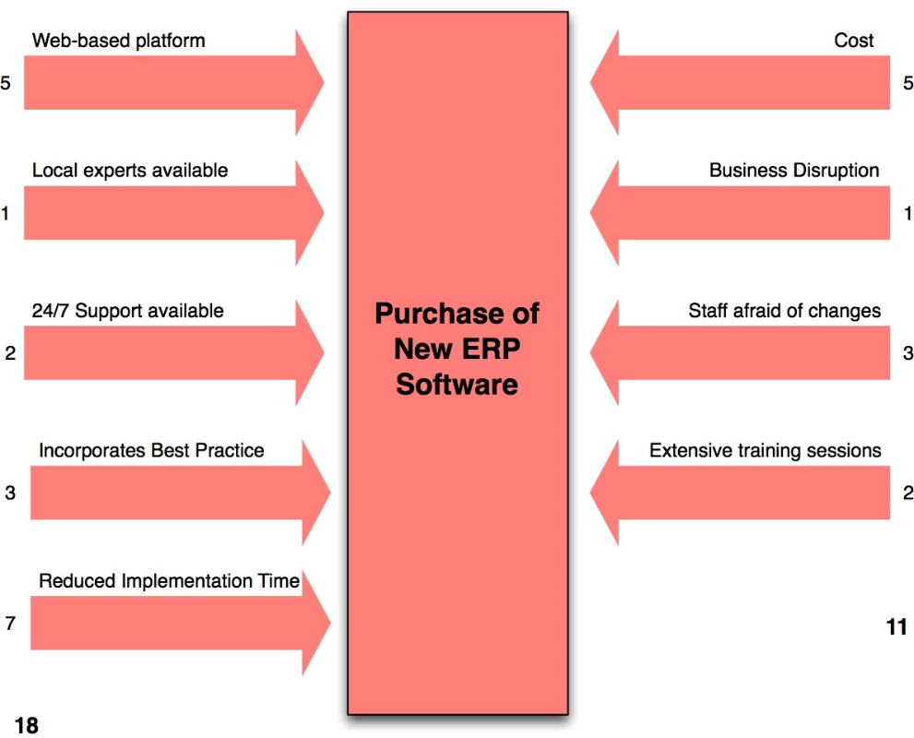
Figure 1 - Example of Lewin Force Field Analysis
Here is an example of the analysis. Each factor is rated with a score will be tallied up to provide an overview to see if the proposed idea or change is worth the risk. Using this information, decision can be made to determine methods to reduce the resisting forces.

Chosen Organisation
Amazon has been chosen of the subject of this report. Amazon is the world’s largest online retailer and offers a prominent cloud service. The retailer offers a wide selection of products ranging from books, music, furniture and apparel. Originally Amazon was a book seller but eventually expanded its range of products. Now, it offers a wide range of their own electronic devices such as the Kindle and online services such as Amazon Video. Amazon allows independent sellers to make use of their website. Sellers can use Amazon to advertise and sell their products. By allowing the third-party sellers use its site; it allowed amazon to grow in recognition and allowed it grow as a business.
Amazon endeavours to the give their customers the lowest price possible to remain the leading competitor in the market. Amazon Prime is a service that people may sign up for, for a yearly fee, which grants them One-Day deliveries and access to a range of services such as Amazon Music and Videos. The One-Day delivery policy helps them keep an edge of any competition and helps them gather a loyal customer base especially the people who want speedy delivery.

Changes and Developments
Amazon CEO, Jeff Bezos, predicted his company will start to deliver packages via drones. This was considered a bold move and would revolutionise the delivery system for the company. The main idea is to deliver packages via drones. Amazons idea is to guarantee that a package will be delivered within 30 minutes of ordering. The drone is planned to be fully autonomous. There are some issues already arsing; currently there are not many regulations on low altitude air traffic control. This is causing the implementation of the drones to slow down.

Change Management

Internal and external Change Drivers

Internal Factors
Staff play a big part as an internal factor for Amazon. They play a major part on the success of organisation. If staff are treated well and have high morale, then they will begin to perform better in the workplace. Proper training will ensure employees will perform effectively at their jobs. Managers should be adequately trained to ensure they lead their teams and employees appropriately.
Earning profit is main goal of most organisations. Profit and money are an internal factor for Amazon. Jeff Bezos are always maintained that investing in future growth is far more important than getting those quarterly earnings targets. Amazon focuses more on expansion and investments than earning profit. Amazon first reported their first quarterly profit in 2001 of $5 million.
Maintaining efficiency in the workplace may be good reason to implement changes. As Amazon tries to offer one day deliveries; they must continuously maintain efficiently in the workplace and online. If they begin to fail to meet the promises, then customers will begin to lose faith in their service which will begin hurt profits and the independent sellers.

External Factors
The online marketplace for retailers is a very competitive market. Staying one step ahead of the competitive allows Amazon to keep maintaining their dominance as the top world-wide retailer. This may be why Amazon wishes to adopt Air Prime quickly to maintain the edge of the competitors. However, as this will be first example of drone delivery, there is little guarantee it will succeed as a concept.
As a retailer, customers are one of the biggest external factors for Amazon. Amazon tries to keep their prices lower than the competition to keep their customers loyal and to encourage people who want a cheap deal. Amazon offers the one-day delivery via their prime service; this can be a very enticing for some customers. Customer confidence and trust is an important factor for Amazon.
Currently, Amazon relies on external companies to delivery their packages such as DPD, UPS and the postal service. Amazon does not have much control over postage service and will still over one day delivery. If Amazon decided to start the drone deliveries, then they would not rely too much on external services and will begin to have a foothold on their delivery service. This may begin to reduce costs in general as they wouldn’t be paying DPD or UPS as much.

Lewin’s Force-Field Analysis
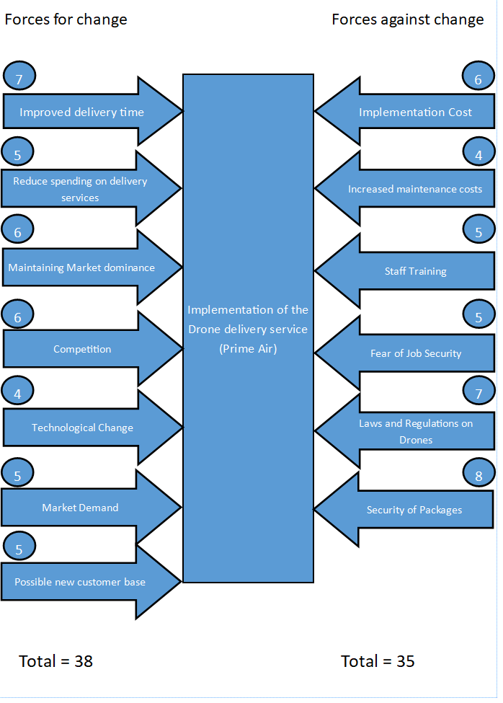
Figure 2-Lewin Analysis on Prime Air

Change Management theories and Strategies

Lewin’s Change Management Model
Kurt Lewin first introduced the change management model in 1951. It involves a three-step process which identifies the process of change. It stages are Unfreeze, Change, Freeze. Unfreeze is the first stage of the process. It involves preparing the organisation for the change. It used to help employees accept that change is necessary and will help in the long run. Developing a message for the employees identifying that current methods at work aren’t working and must change to allow the organisation to start succeeding. Unfreezing the status quo of the organisation to allow for the implementation of change. The second step is the change; this step involved people adapting to the change. To encourage this, employees must know how the change is benefiting them. Getting leaders to persuade employees and support the change will be beneficial. The third is called Re-Freezing. This takes place after the change has been implemented. This step allows the organisation to internalize or institutionalize the changes. It encourages people to keep adapt the changes and accept them. Without this step, employee may revert to their original state before the change. [8]

The ADKAR Model
The ADKAR model is a bottom-up method which focuses more on the individuals that are involved in the change. This model was created by Jeffery Hiatt. It follows the idea that company itself doesn’t but the people within it does. It is a goal-oriented model; its name is an abbreviation of the goals that need to be achieve for the success of a change. [9]
A – Awareness of the need to change
D – Desire to support the change
K – Knowledge of how to change
A – Ability to implement the change
R – Reinforcement to sustain the change
Individuals within the organisation must understand these five elements to truly be prepared for the change. With no understanding they will be resistant to the change.

Recommended Management Style
Leaders set direction, building an inspiring vision to help guide employees into succeeding in their tasks and in the work place. They need to make use of certain management skills to help guide employees into making the correct decisions and keep them motivated. Employment motivation is an important factor as it keeps them committed and engaged in their job and tasks. Ensuring that there is trust and communication between management and the employees is a perfect way to get the most out of the employees.

Democratic Leadership Style
Democratic leadership, also called participative leadership, is a type of leadership which gets the employees involved in the decision-making process. It allows the free exchange of ideas, opinions and discussion is encouraged. This type of leadership can be employed in most organisations. Even though this leadership style involves group discussion; there is still a designated leader who should try to control the discussion and offer guidance to employees [8]. This type of leadership generally allows for higher morale and participation from employees.

Autocratic Leadership Style
Autocratic leadership is often known as the authoritarian leadership. Its characteristics show that the team is dictated by one person who make all the decisions based on their own ideas and judgement. They generally do not seek guidance or ideas from their employees. Employee input can be discouraged which may begin to decrease the morale of the employees. They may begin feel resentment to management or the organisation which will begin to affect their work. Autocratic leadership may sound negative, but it can offer some benefits. For example, decisions can be made quicker which will help in workplaces that are fast paced and stressful. Strong and directive leaders may benefit from using this style, but it solely depends on their own leadership skills. [9]

Strategic Leadership
Strategic leadership tries to create the best possible outcome for the organisation. A manager must employ a strategic vision for the organisation while trying to keep employees motivated and persuading them to see this strategic vision. Managers must keep expressing this vision and try to passionately work towards achieving it. These leaders must build and maintain their teams and guide to them complete a common task while simultaneously keeping them motivated to develop their own skills. An effective leader must be able to foresee and comprehend the work place to able delegate the tasks to the right employee. [10]

Recommended Style
Amazon may benefit from adopting the strategic leadership style. As Amazon currently hires hundreds of people per warehouse. This strategy may be able to convey a new vision to the employees. An inspiring leader may be able to help employees see and understand the new vision or change of the company. If the employees understand and follow the vision, then they shall be more open to the upcoming change.
Expand

Conclusion

Summarise and recommend a management strat – be short and concise

