Legionaries Armour

Roman Legionaries were
the basic foot troops of
the Roman Army
occupying Wales after
invasion in 75AD.

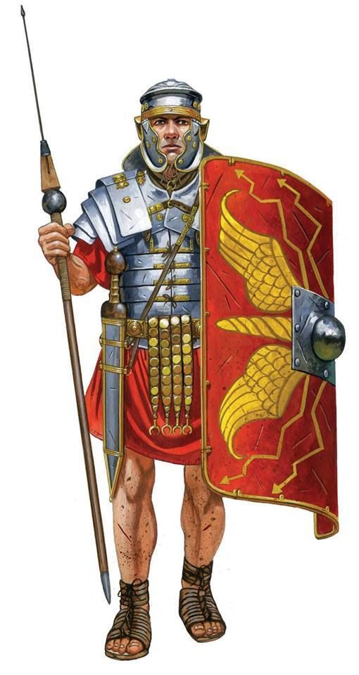
The Roman Legionaries
that would have been
based in Caerleon would
have worn armour very
similar to this.

The armour was designed to
be lightweight but also
effective and protective.

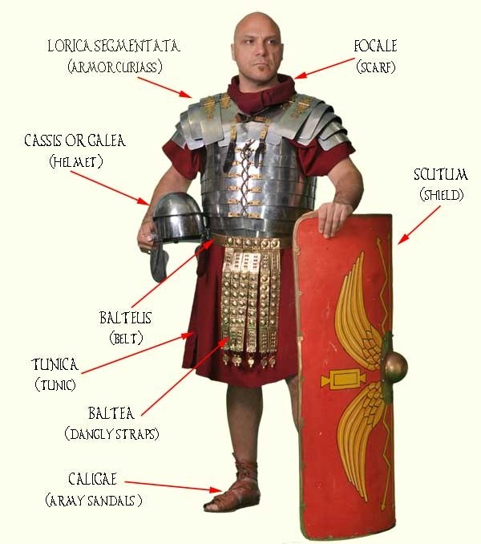
In Detail

As is seen, the armour would have been as minimal as possible to increase both movement and manufacturability. The cuirass is reinforced by overlapping sheets of metal (usually iron on the inside and occasionally steel outside) while the body is protected mainly by the large Scutum shield.

At Caerleon

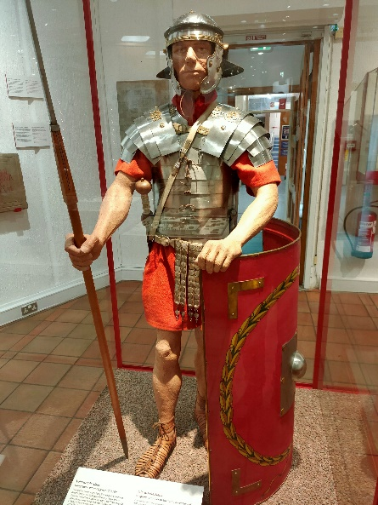
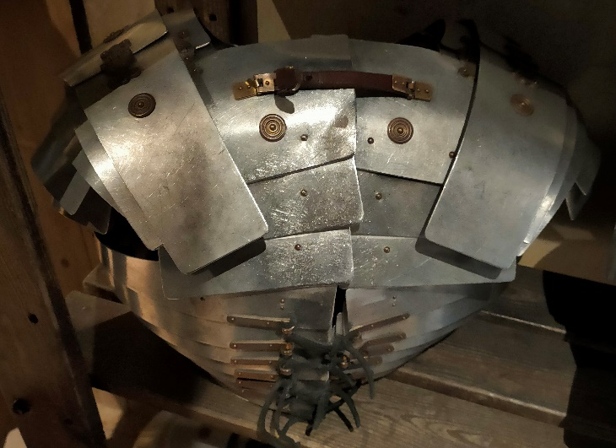
The Lorica Segmentata is known to have four differing variants, being the Kalkriese (c. 20 BC to 50), Corbridge (c. 40 to 120), and Newstead (c. 120 to possibly the early 4th century) with the fourth only being known to few and known only as it was found on a statue in Rome. Both Corbridge and Newstead variants of the armour can be found in Caerleon.
Using mainly common
materials such as iron,
brass and leather, the
armour was easily mass produced but did not
lack in quality.

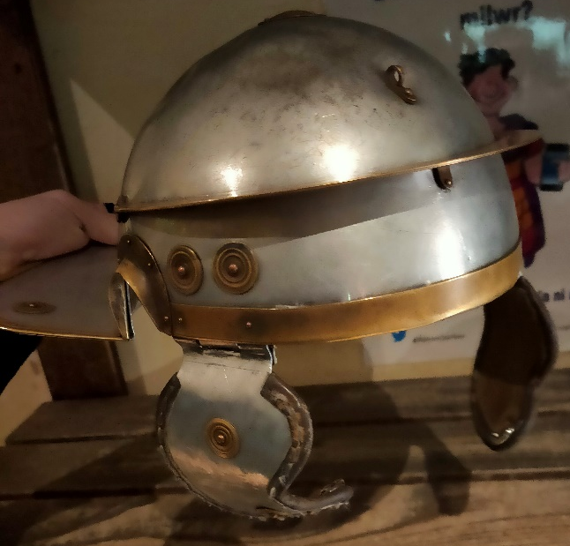
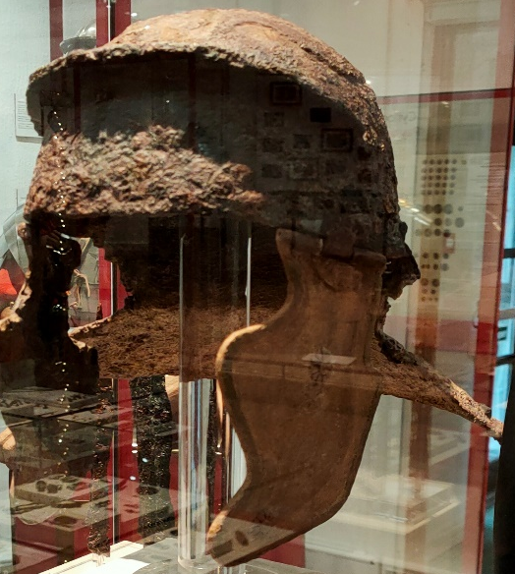
The helmets to be used in Caerleon would have most probably been Imperial Gallic helmets, distinguishable by their sloping neck guards and cross eyebrow guards.
Left: Early 1st century Iron Imperial Gallic Helmet, similar to what would have been worn at Caerleon
Right: Modern recreation of the same helmet

