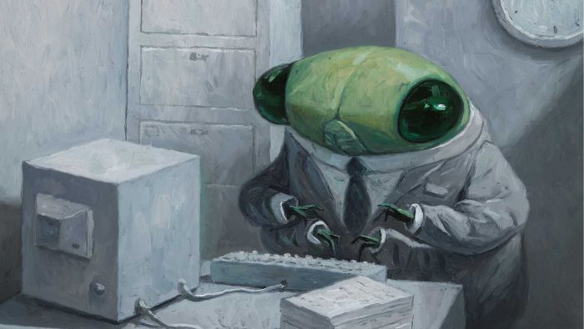
Shaun Tan

Oil Painting Workshop (limited palette)
Over the last few sessions you have used different media (acrylic and watercolour etc) and last week with watercolour you started to understand colour superimposing washes over a white ground using the white of the paper as your white.
In relation to how professional their work is, a prime issue for any artist and illustrator is how they master colour. This is very important. You all need to learn how to use colour and learn the value of the colour you are using (i.e. how light or dark it is) and the colour saturation [ie how intense the colour is as opposed to how ‘grey’ it is.
Today, to start facilitating your awareness of this, you are going to use a limited palette and the effect of different coloured grounds which you can continue to experiment with. You are then going to practice mixing your colours. This is a morning’s exercise. You will develop as large a range of colour as you can with your limited palette.
White
Yellow – Yellow ochre
Red - Burnt sienna (Indian red is better)
Blue -Ultramarine or cobalt blue
Dark Brown-Raw umber

There are many different combinations of limited palette. Look them up!

A Limited Palette
Many people new to painting use a palette full of different colours. This can cause problems for mixing and the results will often be a muddy brown. It also places the emphasis on colour use, when contrast and tone are far more important for a successful painting. I would suggest starting with a palette of just three paints, a blue a yellow and an earth colour. The actual paints used can be varied for each painting. Taking things to the extreme, you can achieve a remarkably effective painting using just one colour, such as Sepia or Burnt Sienna.
When using a 3 colour palette, mix the colours as much possible to introduce graduated tones into your painting. Try to avoid mixing all the colours together, but use combinations of two colours. Remember that areas of light and dark are the most important.
The paints you use should reflect the subject of the painting. The earth colour, in particular, will vary greatly from painting to painting. Crimson Alizarin for a sunset, Burnt Sienna for beaches. I suggest choosing a blue from French Ultramarine, Cobalt Blue or Cerulean Hue. Cadmium yellow is probably the most useful yellow, especially if there are to be a lot of
greens in your painting. Burnt Sienna Is good for beaches and autumn colours.
Unfortunately, the only way to learn is to practice and to try different combinations.
Rembrandt, and Velasquez, did some of their greatest masterpieces with amazingly few colours
Examples;
1. White, Ultramarine Blue, Burnt Sienna, and Winsor Red.
2. Cadmium Yellow, Winsor Red, Burnt Sienna, Ultramarine Blue, Permanent Green and Titanium White.
3. French Ultramarine, Burnt Sienna and White
4. Alizarin Crimson, Hooker's Green and White
5. Winsor Violet, Yellow ochre and White

Oil Painting Assignment Suggestions
Coloured Grounds
White Gesso primer acrylic gives a brightness that reflects through the paint. Can use emulsion – mixed with plaster –loads of textured materials in art shops that can be used as grounds. Acrylic bases for oil painting. White can be inhibiting
for the beginner as they tend to paint in pale tones. Also white
can be dazzling when working outdoors, mid tone is useful –ties the painting together. Paint and white spirit, a wash –good for the beginner.

Alta Prima
Italian meaning “at first”, a painting completed in one session –painted wet into wet – Constable and Impressionists used this method once tube paint became available. Requires confidence, otherwise it will become muddy.

Blending
Where one colour merges into another. Tones merge

Broken Colour
Using your brush marks to make colours. Small brush stroke of
juxtaposed colours can produce vibrant colour. Good to use on
coloured ground for this as it will unify the picture.

Building Up
Work fat over lean – this is so that the thick paint will not be
disturbed by later brush strokes. Thick paint takes longer to
dry. Fat, high oil content; lean thinners – turps or white spirit –
lean will dry quicker than fat so will crack on the surface and
may flake off.

Collage
Picasso one of the first people to use this method – stick
objects onto canvas or press cloth and pebbles etc into paint
will act as glue. Can use collage as a methods of working out
composition ie where figures should go and their size.

Correcting
Wet paint can be scrapped off or wiped off with white spirit.

Dabbing
Put on with cloth or sponge

Defining edges
Careful to keep edges soft unless you want to really define the
edges then be careful to be accurate and sensitive.

Dry Brush
Literally a dry brush – minimum of paint worked quickly.
Use your finger
Leonardo – Titian – Turner and Goya.
Toxic, so always clean hands after – could use a rag around
fingers.

Glazing
Bit like water colour – one colour lies over another –
translucent. Old days used linseed oil, but will colour – use
modern synthetic. Can use acrylics as an under painting.

Impasto
Thick paint showing brush marks – can get mediums to bulk out
paint – can speed drying time

Size
Need to put size on so that surface is protected from the
effects of the oil paint ie it will rot in time. Get size from art
shops not builders merchants as the latter will contain
fungicide. Acrylic primer no size necessary. Prime on both
sides to prevent warping. Use emulsion – can texture it.

Imprinting
Press in objects

Knife painting
Palette Knife

Mono Printing
Oil on glass and print off image. Can put acrylic on paper
before you print it off – rub with hand or roller.

Palette
Group into warm or cool colours – I tend to have a spectrum of
colours, going from yellow to blue – then earth colours and
white.

Paint on Board
Unprimed - oil absorbed bit like pastels, Degas used this
Method

Pointillism
Tiny dabs of colour – when viewed from a distance they all
merge.

Scraffito
Scratching into paint

Texture
Sand – plaster – woodchips – sawdust – mixed in (experiment)

Tonking
Unworkable painting, paint too thick – blot off the top surface
with newsprint – can then work into it.

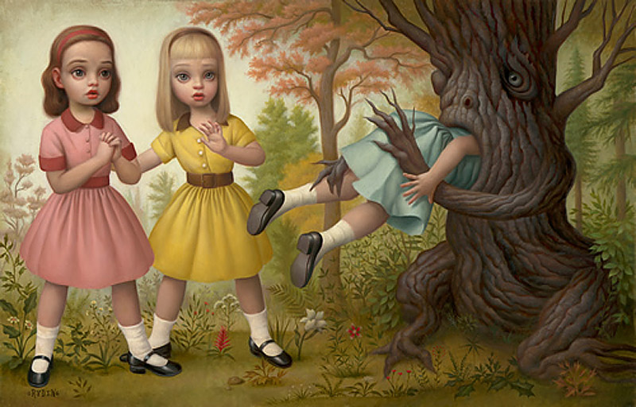
Mark Ryden

