Strategic Management and Sustainability

Executive Summary

The following report has highlighted the relationship between the external context and internal context of an organisation named Volkswagen which is a well-renowned automobile company. The business plan has shed light on the strategies of the company to evaluate its competitiveness and development in the context of its contemporary strategic management issues. Furthermore, the organisation's strategy includes a description of the SWOT Analysis and industry Five Forces models to determine the organisation's possible dangers and possibilities.

Table of Contents
Introduction 4
Business strategies of Volkswagen over the past five years 5
Identifying the resources and capabilities and analysing the integration of such resources and capabilities of Volkswagen 8
Enhancing competitiveness in applying sustainability and environmental responsibility in the organisation 10
Recommendation 12
Conclusion 15
References 16

Introduction
Strategic management and sustainable development have become interwoven ideas that serve an important role in steering enterprises to achieve profitable growth while taking into account the societal, social, and financial implications of their actions. The following report will focus on the primary business strategies of a well-known company named Volkswagen. It is a multinational automobile production company having its headquarters in Germany, it ranks as one of the world's major automakers. The corporation was established on May 28, 1937, under the Third Reich in German. Volkswagen is famous for manufacturing a diverse range of automobiles, including automobiles, transport vehicles, and lorries. Relating to its business objectives, SWOT Analysis and Five Forces Theory describes the strength, weaknesses, opportunities and risks relating to the business. Numerous pieces of evidence are explained to show the desire for Volkswagen to become more competitive with considering the Sustainable and environmental variables in their objective. Further, identification and alignment of resources and capabilities of Volkswagen to its business activities. Additionally, various recommendations will be made on sustainability practices that can help the mentioned organisation to develop its competitive advantages in the coming future.

Business strategies of Volkswagen over the past five years
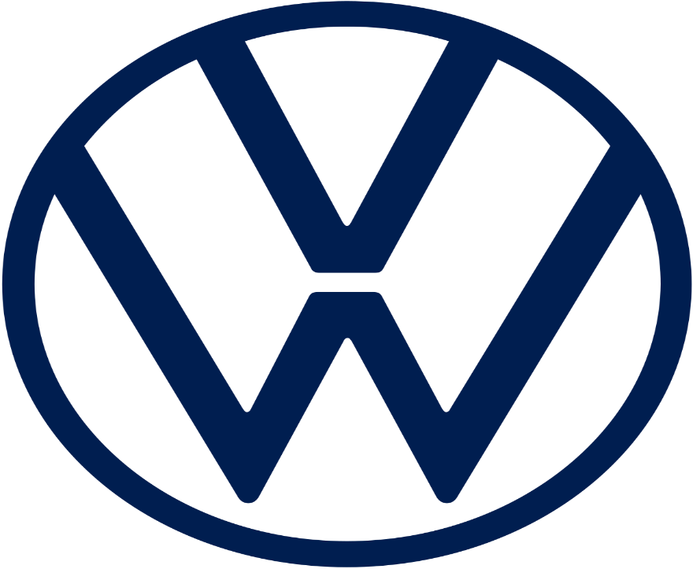
Source: (Broccardo, et al., 2023)
Figure: Volkswagen
Volkswagen is a German international automobile manufacturer located in Wolfsburg, Germany. Volkswagen constitutes one of the worldwide leading manufacturers and a major player in the worldwide auto sector. The German Workers Front, Nazi a trading organisation, established the corporation in the year 1937 to produce inexpensive automobiles to obtain the German populace. Subsequently, VW has evolved into a multi-brand automobile conglomerate. It is crucial to remember that corporate plans might change over time as a result of evolving market conditions, market developments, and internal issues. To receive accurate and recent details about Volkswagen's present efforts after consulting the company's official statements, financial statements, and other trustworthy resources (Broccardo, et al., 2023). VW has been expanding its attention to electric automobiles to become the dominant player in the field of electric cars. The firm has spent extensively in creating electric automobiles and has ambitions for a wide variety of automobiles powered by electricity in future years. Various things influenced this strategy:

Identifying the resources and capabilities and analysing the integration of such resources and capabilities of Volkswagen
Volkswagen's resources and capabilities throughout the last 5 years:
1. Manufacture and Operation abilities: VW has a huge worldwide manufacturing as well as production infrastructure that comprises multiple production sites located in various countries. This large network enables the corporation to effectively create an extensive variety of automobiles while meeting changing customer needs (Dominguez, et al., 2023).
2. Research and Development: It has a robust scientific and technological division that spends much on technological advancement and manufacturing. This competence has allowed the corporation to create and manufacture novel models while remaining relevant in the automobile sector.
3. Brand Image: It has a long-standing brand image. Facing difficulties such as the Dieselgate incident, the business's image continues to be strong, providing it with an edge over its rivals and trust from customers.
4. Financially Durability: The business's sound finances and financial capabilities have enabled it to make investments in emerging innovations, extend product lines, and carry out strategic projects (Fan, 2023).

Resource and capability integration along with company approaches:
1. Concentration on Electric cars: VW has focused its efforts and talents on electric cars. The corporation spent a lot of money on studies and experiments to create electric car systems and technologies. In addition, to assist the manufacture of electric automobiles, it has increased its electrolyte manufacturing facility and formed agreements with battery providers.
2. Technological Advancement: Volkswagen identified the significance of technological change in the automobile sector and allocated assets and expertise appropriately. To improve the customer satisfaction and profitability of its cars, the firm invests in technology like automatic driving, interaction, and online resources (Febrianto, et al., 2023).
3. Sustainable advancement: Volks prioritised sustainability in addressing ecological issues and shifting consumer demands. The firm used its production ability to create electric automobiles with a low environmental effect. It also incorporated sustainable techniques throughout its supplier chain and manufacturing operations.
4. Brand Image: With the Dieselgate incident hurting the business's credibility, VW focused on strengthening its image and reallocated its finances to rebuild confidence. This includes improved openness, stronger oversight of business operations, and a dedication to ecological responsibility (Fitri, and Belgiawan, 2023).

Enhancing competitiveness in applying sustainability and environmental responsibility in the organisation
1. Electric Automobile Strategy: Volkswagen claimed in 2020 the company has invested around €33 billion in electric vehicle development and planned to introduce more than 70 electric cars throughout the company's lines from 2029, including a goal of generating a million Automobiles yearly in 2023. Being a component of its environmental drive, Volkswagen is making substantial efforts to transition to electric cars. The corporation has substantially spent studying and developing ways to establish electric underpinnings and introduce electric products. Among its biggest-selling electric products include the ID 3 along with the ID 4, which is a component of the ID Technologies series of hybrid vehicles. It intends to lower its environmental impact and make a contribution to the worldwide effort to battle global warming by investing in Vehicles (Hill, 2023).
2. Recovering and the Sustainable Cycle: The corporation has begun battery reuse studies and wants to build a battery reusing factory to recover expensive parts from spent corpses. Volkswagen continues to be looking into methods to boost the economy's circularity by using recycled materials used to construct its cars. This strategy tries to decrease waste creation and dependency on limited resources.
3. Engagement to Carbon Independence: VW pledged in 2020 to make its global manufacturing plants carbon-free before 2050. In addition, the corporation plans to reduce greenhouse gases by 30% per automobile by 2025, as opposed to 2015 standards. The said company is establishing lofty targets to achieve zero emissions across all of its value chains. This entails not just decreasing emissions generated by its automobiles, but also tackling the environmental impact of its vendors, manufacturing procedures and transportation (Cegarra-Navarro, et al., 2023).
4. Responsible Logistics: It has launched efforts to enhance sustainable mineral extraction and procurement, which happens to be an essential part of battery cells for electric vehicles. The corporation is also participating in projects such as the International Battery Association to improve ethical battery distribution networks. VW is cooperating with those who supply it to guarantee that they meet social as well as environmental criteria (Wilderom, et al., 2023). To prevent adverse effects on environments and neighbourhoods, the firm is dedicated to ethical substance procurement, particularly the ones employed by batteries for electric vehicles.
5. Multipurpose Electric Vehicle: The MEB system underlies various electric automobiles and forthcoming products the Volkswagen Group has been able to realise efficiencies in size and speed the manufacturing of batteries thanks to this technology. Volkswagen created the MEB system, which is an adaptable and versatile electric motor technology (Russell, and Padfield, 2023). The system enables the corporation to build diverse electric automobiles with greater efficiency and with a reduced cost, rendering electric automobiles more readily available to customers.
Discussing the time emission of Volkswagen
When it was discovered that Volkswagen had inserted computer in the diesel cars it sold to tamper with emissions tests, the corporation was hit with a serious scandal involving emissions in 2015. This resulted in testing emissions values that were unnaturally low while actual driving emissions from the vehicles were greater. The "Dieselgate" controversy, which resulted from this discovery, had far-reaching repercussions, including hefty penalties, legal lawsuits, falling prices for shares, and reputational harm. In order to rebuild its reputation and address environmental issues, Volkswagen turned its attention to electric vehicles and implemented stronger compliance controls.

VRIO Analysis
Value: Due to its well-known brand name, extensive global presence, and wide range of product offerings, Volkswagen (VW) has significant value. (Broccardo, et al., 2023). A wide client base is drawn to the brand because it is linked with quality, dependability, and innovation. In order to meet a wide range of consumer preferences, the company's inventory includes automobiles in several classes, from affordable to luxurious. Volkswagen’s value offer is strengthened by its capacity to address a variety of market demands.
Rarity: Volkswagen’s uniqueness in the automotive sector is a result of its patented technology and engineering prowess. Its Modular Transverse Toolkit (MQB) platform, for instance, provides flexible production across a range of vehicle types, lowering costs and speeding up time to market. Given that hardly other manufacturers have such cutting-edge modular platforms, this distinction sets VW apart from rivals (Broccardo, et al., 2023). The business's efforts in autonomous and electric technology also contribute to its uniqueness in a sector that is developing quickly.
Imitability: Volkswagen's production volume and technological know-how put obstacles in the way of replication. Cost benefits that are challenging for rivals to match are made possible by the tremendous economies of scale it delivers (Sancak, 2023). Additionally, the significant R&D expenditures and intellectual property associated with electric cars and autonomous driving put Volkswagen in a technologically superior position, making it difficult for rivals to quickly catch up.
Organisation: In order to maintain its competitive edge, Volkswagen’s organisation is crucial. Strong research and development activities of the firm encourage ongoing innovation. The company's innovation culture encourages cross-functional cooperation and creativity, which results in ground-breaking developments. In order to maximise efficiency and save costs, the entire supply chain as well as the distribution network have been optimised. (Sancak, 2023). Strong organisational structure at Volkswagen ensures that resources are used effectively by coordinating them with strategic goals.

Recommendation
Volkswagen may further incorporate environmentally friendly procedures throughout its fundamental company approach and increase its market share to establish itself as a premier ecological automobile producer. Sustainable projects may not only promote corporate success but also benefit the natural world and humanity in general. Therefore, various implementations are considered for the following recommendation below:
1. Promote Electrification: Keep going making investments in electrical vehicle technologies and extend the capabilities of battery-powered cars. Focus on battery development to enhance range, charged velocity, and overall efficiency (Sancak, 2023). VW can position its company as an innovator in the developing electric car industry through its position at the centre of the advancement of electric vehicles.
2. Concentration on green power: Promote the usage of renewable resources in industrial facilities and business activities. It might include setting up rooftop panels and windmills, as well as developing collaborations with energy sources that are renewable. Performing to entirely use renewable energies can help Volkswagen's credibility as an environmentally responsible firm. Volkswagen's efforts to become more lucrative while prioritising safety and environmental responsibility are obvious in major investments in electric car technology, ecologically friendly manufacturing methods and accountable supplier network activities (Schaltegger, et al., 2023).
3. Recycling Economic Initiatives: Establish more thorough efforts to recycle and promote the sustainable economy paradigm. Designing vehicles has an emphasis on simple deconstruction and the capacity for recycling goods, to guarantee old automobiles are effectively scrapped and repurposed. This technique not only reduces waste additionally reduces reliance on scarce resources. Its efforts to become more financially viable while setting goals for security and sustainability are obvious in major investments in electric cars and environmentally conscious supplier network activities (Wheelen, et al., 2023).
4. Ecological Supply Chain: Enhancing Sustainability To achieve a more environmentally friendly supply network, enhance environmental requirements in supplier agreements. Coordinate with manufacturers to implement green procedures that involve lowering emissions, utilising environmentally friendly resources, and upholding labour and equality. A profitable supply network may help Volkswagen's credibility while also attracting environmentally aware customers.
5. Investment in Renewable Resources: Continuing to invest in renewable energy sources other than electric cars, which include fuel cells made from hydrogen and environmentally friendly biofuels. Researching alternate fuel choices may give a firm an edge over competitors by expanding its product line and appealing to varied customer preferences (Russell, and Padfield, 2023). Volkswagen's attempts to evolve into more profitable while emphasising safety and ecological responsibility are visible in large expenditures on electric vehicle technology, environmentally friendly production processes, emission-free promises, and responsible supplier chain activities.
6. Electronic Efficiency Techniques: Use digital technology to streamline operations, enhance logistics, and cut energy use. Modern production, machine learning, and statistical information analysis may improve productivity and environmental sustainability throughout the worth chain. Establishing an enthusiastic dedication to an environmentally friendly future helps attract ecologically conscientious entrepreneurs and consumers (Wilderom, et al., 2023).
Overall, Volkswagen's attempts to evolve into more profitable while emphasising safety and ecological responsibility are visible in large expenditures on electric vehicle technology, environmentally friendly production processes, emission-free promises, and responsible supplier chain activities. These actions not only help the business maintain its future productivity, but they also fit with worldwide efforts to develop a more environmentally conscious and sustainable automotive sector. Volkswagen continues to make investments in digital technology and modernise its processes to increase productivity and client satisfaction. This covered efforts such as self-driving automobiles, linked autos, and online amenities.

Conclusion
The abovementioned report focuses on the sustainability and effective strategic management of Volkswagen company which is a well-renowned multinational automobile company in Germany. Incorporating durability into business planning entails recognising and resolving possible dangers and possibilities associated with social and ecological challenges, resulting in a more durable and accountable firm. It examines the relationship between the external and internal context of the said organisation with the help of SWOT analysis and Five Forces theory to find out its strength and weaknesses to improve the productivity of the business in the competitive market globally. To build the organisation sustainably in a competitive economy, pestle analyses the social, environmental, technical, and political implications on the productivity and effectiveness of the firm. Numerous pieces of evidence are given to demonstrate Volkswagen's ambition to grow more competitive while keeping friendly and ecological aspects in mind. Furthermore, assessment and alignment of the company's resources and competencies to its company operations. Furthermore, numerous pieces of advice on sustainable practices that might assist the indicated organisation in developing its selling points in the years to come have been provided.

References
Broccardo, Truant, and Dana, L.P., (2023). The interlink between digitalisation, sustainability, and performance: An Italian context.
Brorström, (2023). The sustainability shift: The role of calculative practices in strategy implementation.
Challinor, (2023), January. Global Oncology Nursing Recruitment and Retention: A SWOT Analysis.
Clarke, S.J., Ngo, and Au, (2023). China Strategic Analysis. In Contemporary Strategic Chinese American Business Negotiations and Market Entry.
Clement, Esposito, and Crutzen, (2023). Municipal pathways in response to COVID-19: a strategic management perspective on local public administration resilience. Administration & Society, 55(1), pp.3-29.
Dominguez, J.A., Pacheco, L.A., Moratalla, Carugno, J.A., Carrera, Perez‐Milan, Caballero, and Alcázar, J.L., (2023). Diagnosis and management of isthmocele: a SWOT analysis.
Fan, (2023). Research on the Marketing Strategy of Banking and Finance Business Given Big Data Technology. In SHS Web of Conferences (Vol. 154, p. 02018).
Febrianto, Andriani, R.D. and Sawitri, M.E., (2023). A SWOT Analysis on the Implementation of the Yoghurt Marketing Strategy: A Case Study in the Malang, Indonesia.
Fitri, and Belgiawan, (2023). Proposed Marketing Strategy for Schouten. id to Increase Brand Awareness and Purchase Intention.
Hill, (2023). Business development. Early Years Educator, 23(19), pp.34-36.
Martínez-Martínez, Cegarra-Navarro, J.G. and Garcia-Perez, (2023). Sustainability knowledge management and organisational learning in tourism: Current approaches and areas for future development.
Puyt, R.W., Lie, F.B. and Wilderom, C.P., (2023). The origins of SWOT analysis. Long Range Planning, p.102304.
Russell, S.V. and Padfield, R.W. eds., (2023). A Research Agenda for Sustainability and Business.
Sancak, I.E., (2023). Change management in sustainability transformation: A model for business organisations. Journal of Environmental Management, 330, p.117165.
Schaltegger, Loorbach, and Hörisch, (2023). Managing entrepreneurial and corporate contributions to sustainability transitions. Business Strategy and the Environment, 32(2), pp.891-902.
Wheelen, T.L., Hunger, J.D., Hoffman, A.N. and Bamford, C.E., (2023). Strategic Management and Business Policy: Globalisation, Innovation, and Sustainability. Pearson.

Appendices
Swot Analysis
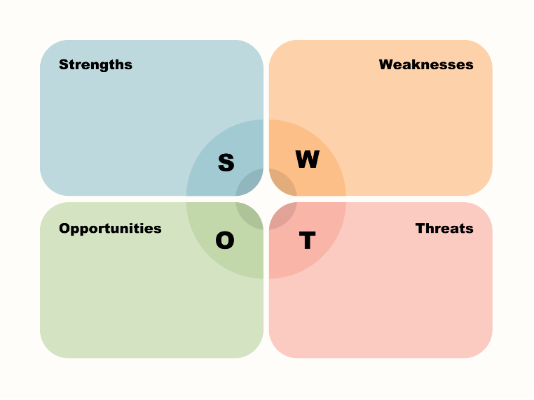
Source: (Challinor, 2023)
Figure: SWOT analysis
1. Strengths: The worldwide position and existing brand recognition offered a good basis for a successful entry into the field of electric vehicles. The brand's finances and scale enabled the corporation to successfully engage in its digital growth efforts.
2. Weaknesses: The most highlighted controversy (Dieselgate) harmed the business's reputation, necessitating a transition toward cleaner technology to recover confidence. Conventional automobile manufacturers struggled to adjust to quickly emerging digital technology (Brorström, 2023).
3. Opportunities: An increasing need for electric automobiles provided a chance for VW to establish a competitive edge in the field of electric vehicles (Challinor, 2023). As technologies became more integrated into automobiles, there was more potential to improve consumer interaction and create new income sources.
4. Threats: It included strong competition through other manufacturers joining the EV industry as well as the possibility of disruption from unanticipated technical breakthroughs. The company's modernisation initiatives have been threatened by rivalries from technological enterprises approaching the automotive sector (Challinor, 2023).
Porters Five Forces Theory
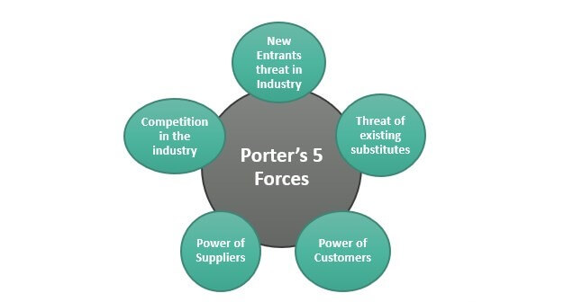
Source: (Clement, et al., 2023).
Figure: Porters Five Forces
1. New Entrants: the company's solid reputation and broad supply chain functioned as obstacles in getting started for new companies that entered the EV industry.
2. Buyers' Bargaining Power: An increasing need for sustainable automobiles enhanced the ability to negotiate on behalf of environmentally aware customers, pushing Vw to comply with comparable EV products.
3. Supplier Bargaining Power: Because EVs demanded particular parts that include batteries It needed to engage with manufacturers and address possible vendor concerns (Clement, et al., 2023).
4. Substitutes: The advent of other environmentally friendly transportation choices posed an opportunity for danger to Wagen's selling of electric cars.
5. Competitors: Dealing with other manufacturers' EV options, like Tesla Motors, Nissan, as well as General Motors, is needed to distinguish its goods and sell successfully.
Pestle analysis
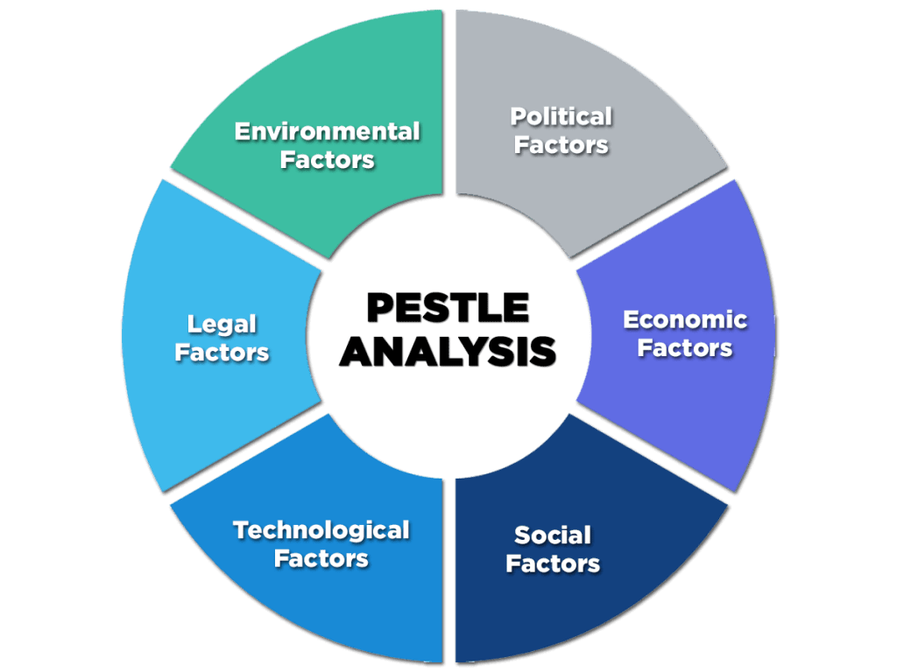
Source: (Clement, et al., 2023)
Figure: PESTLE analysis
Political factors: Production and sales at Volkswagen are impacted by government laws and emission standards. For instance, in 2015's "Dieselgate" crisis, the company's brand and revenues were negatively impacted by heightened scrutiny and fines (Schaltegger, et al., 2023).
Economic factors: Volkswagen's revenue and market share are influenced by the economy, currency rates, and customer spending trends. A downturn in the economy may result in a decline in consumer demand for automobiles, which would affect sales for the corporation.
Social factors: Volkswagen has invested in electric and hybrid car types in response to shifting consumer demands for more sustainable and technologically advanced automobiles (Schaltegger, et al., 2023). The company's strategic choices are also influenced by social worries about emissions and sustainability.
Technological factors: Volkswagen must spend money on R&D to create automatic driving, electrically powered transportation systems, and connection capabilities in order to stay compete in the market (Clement, et al., 2023).
Environmental factors: Volkswagen has been compelled to switch to electric cars and implement more environmentally friendly manufacturing techniques in order to lessen its carbon footprint by strict pollution regulations and rising environmental consciousness.
Legal factors: Volkswagen's activities are strongly impacted by legal aspects such adherence to safety requirements, product liability legislation, and intellectual property rights (Clement, et al., 2023). Legal disputes originating from scandals like "Dieselgate" have an impact on reputation and finances.

