CSPB4001 PERSUASIVE LANGUAGE
Week 4: Copywriting and Language Use
SLOGAN | ADVERTISER | AD AGENCY | YEAR | MEDIA STILL
Access. Your flexible friend. | Access |  | 1978 | 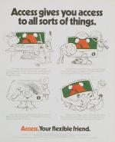
Impossible is nothing | Adidas | TBWA / 180 Amsterdam | 2004 | 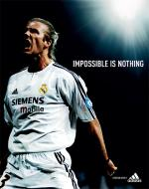
Ah! Bisto | Bisto |  | circa 1919 | 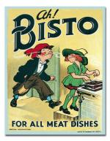
The ultimate driving machine. | BMW | Ammirati & Puris | 1975 | 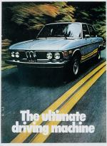
It's good to talk. | British Telecom/BT | Abbott Mead Vickers/BBDO | 1994 | 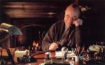
A little dab'll do ya. | Brylcreem | Kenyon & Eckhardt | 1949 | 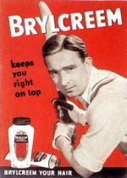
Are you a Cadbury's Fruit & Nut case? | Cadbury's Fruit & Nut | Young & Rubicam | 1978 | 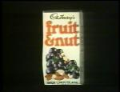
And all because the lady loves Milk Tray. | Cadbury's Milk Tray | Leo Burnett | 1968 | 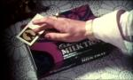
I bet he drinks Carling Black Label. | Carling Black Label | WCRS | 1986 | 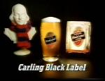
Probably the best lager in the world. | Carlsberg | Saatchi & Saatchi | 1973 | 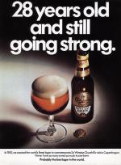
Australians wouldn't give a XXXX for anything else. | Castlemaine XXXX | Saatchi & Saatchi | 1984 | 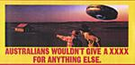
The Citi never sleeps. | Citibank | Wells, Rich, Greene | 1976 | 
It's the real thing | Coca Cola | McCann-Erickson | 1969 | 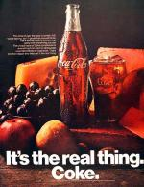
Simples | Comparethemarket.com | VCCP | 2009 | 
Hand-built by robots. | Fiat Strada | Collett Dickenson Pearce & Partners | 1979 | 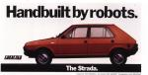
A diamond is forever. | De Beers Consolidated | N W Ayer | 1948 | 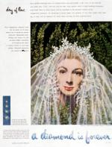
The last place you want to go | Dixons | M&C Saatchi, London | 2009 | 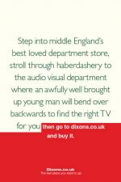
Go to work on an egg. | Egg Marketing Board | Mather & Crowther | 1957 | 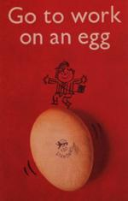
No FT, no comment. | Financial Times |  | 1982 | 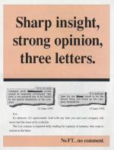
Say it with flowers. | FTD (Interflora) | The Company | 1917 | 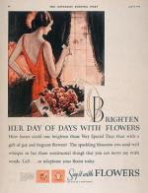
My goodness, my Guinness! | Guinness | S H Benson | 1936 | 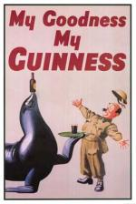
http://www.adslogans.co.uk/site/pages/home/hall-of-fame.php

