Academic Skills

Personal Development Plan

Table of contents

1.Introduction 3
1.1 PowerPoint presentation 3
Section 2: Skills Evaluation 6
Section 3: Action Plans 9
Section 4: Application 9
Time management and organization 10
Section 5: Conclusion & Evaluation 12
Section 6: Appendices 12
Skills test 13

Section 1.
Hello, my name is Iulian Palada and I am a student of the University of Wales Trinity Saint David. From an early age I was attracted to computers and everything started in an internet cafe, I was first attracted to games after I was curious about how a computer works (both physically and software).


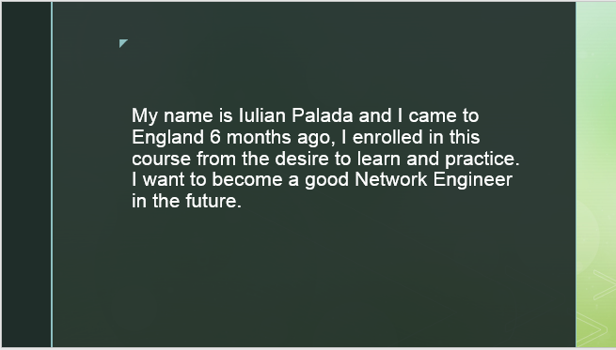
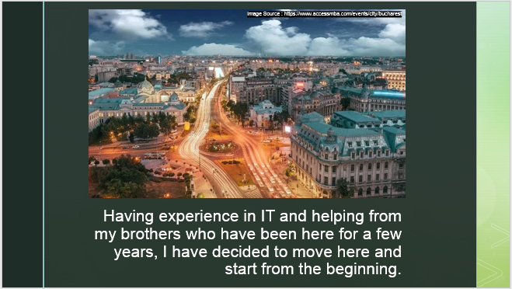
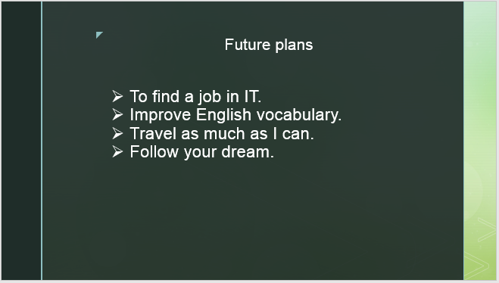

During the course of Academic and Employability Skills, I learned how to make a presentation (PowerPoint) and what are the rules for an excellent presentation.
List key points for successful PowerPoint presentation :
- Show up early and verify that your equipment works properly.
Make sure that all equipment is connected and running.
*https://support.office.com/en-us/article/tips-for-creating-and-delivering-an-effective-presentation-f43156b0-20d2-4c51-8345-0c337cefb88b
- Speak Slowly
It’s tempting to think that you need to divulge as much information as possible but talking too fast is really hard for audiences to digest. Watch a TV newscaster and see how the speak slowly with lots of pauses. It’s definitely a case of “less is more” and you’ll be amazed how much better the audience absorb stuff. The breathing space will also give you more brain ‘CPU time’ to gauge audience reactions and respond accordingly. Speaking too fast is a common trait of nervous speakers but ironically, slowing down will give you more time to relax and give your presentation more gravitas.
**https://www.participoll.com/powerpoint-presentation-tips/
- Start With A Summary
Summarising your presentation in a single slide at the beginning gives your audience a clear idea of what they’re going to learn and stimulates anticipation of the whole story. It’s also a good discipline for you as a presenter to help keep you keep the topic succinct. If you can’t summarise your presentation topic in 10-15 words, then it’s probably too long or too vague.
*https://www.participoll.com/powerpoint-presentation-tips/
- Make Eye Contact
It’s very easy to end up staring at the one person on the front row who seem to be smiling at you but focussing on just one person or just staring into space makes the main audience feel like you’re not interested in them. With a small audience, be sure to move eye contact from person to person without fixating on any particular individual. If you have a larger audience, try scanning your attention from left-to-centre-to-right and back again focussing on random individuals each time. Don’t forget the people right at the back too!
*https://www.participoll.com/powerpoint-presentation-tips/
- Use Images
A picture tells a thousand words and good images are far better than tons of text. Don’t use cheesy stock imagery though – that’s a real turn off. Choose pictures that directly illustrate or support what you’re saying or set the tone of the slide. In the right setting, a bit of humour can cheer the audience up and keep them engaged too (there are loads of great Internet meme graphics you can use or adapt.)
*https://www.participoll.com/powerpoint-presentation-tips/
- Do not read the presentation.
Practice the presentation so that you can speak from bullet points. The text should be a cue for the presenter rather than the full message for the audience.
*https://support.office.com/en-us/article/tips-for-creating-and-delivering-an-effective-presentation-f43156b0-20d2-4c51-8345-0c337cefb88b
- Use Your Hands And Body
Body language is big part of communication but you don’t have to be a trained orator to get it right. It’s a classic case of “be yourself” – do use your hands, gestures and facial expressions to accentuate what you’re saying but don’t do anything that feels unnatural.
*https://www.participoll.com/powerpoint-presentation-tips/
- Stay on time.
If you plan a certain amount of time for your presentation, do not go over. If there is no time limit, take less time rather than more to ensure that people stay engaged.
*https://support.office.com/en-us/article/tips-for-creating-and-delivering-an-effective-presentation-f43156b0-20d2-4c51-8345-0c337cefb88b
- Interact With The Audience
Ask your audience to hold questions until the end.Questions are an excellent indicator that people are engaged by your subject matter and presentation skills. But if you save questions until the end of the presentation, you will get through your material uninterrupted. Also, early questions are often answered by ensuing slides and commentary.
*https://support.office.com/en-us/article/tips-for-creating-and-delivering-an-effective-presentation-f43156b0-20d2-4c51-8345-0c337cefb88b

Section 2: Skills Evaluation

- 1. Adaptive Thinking
In the digital age, things are changing at exponential rates. By the time employees learn the newest software or program, a better version is coming about. Future employers will need to continuously adapt to changing conditions as well as be able to learn new things quickly and efficiently.
- 2. Critical Thinking and Problem Solving Skills
There is a decreased emphasis on employers following directions and an increased emphasis on employers thinking critically and solving problems. In a rapidly changing world, employers need employees who can solve problems, provide ideas and help improve the organization.

- 3.Personal Management
This includes the ability for employers to independently plan, organize, create and execute, rather than wait for someone to do this for them.
- 4.Inquiry Skills
The large majority of academic assessments ask students for answers. Rarely do we assess students on how well they can ask questions. The ability to ask great questions, however, is a critical skill that is desperately needed in a culture which requires constant innovations.
- 5.Creativity and Innovation
This skill is mentioned often. I believe that it correlates with the ability to ask good questions and the ability to problem solve. Employers will be looking to employees more and more for creative and innovative solutions to issues that exist.
- 6. Empathy and Perspective
Although this skill has always been important, it seems to be another one that is slowly disappearing. The ability for our students to put themselves in someone else’s shoes, to understand their feelings, and to help solve their problems.
*https://learning.linkedin.com/blog/education/10-skills-all-students-need-to-be-successful
Self-Evaluation - Discover your strengths and weaknesses.
I used this test (https://www.mindtools.com/pages/article/get-started.htm) to be able to find out my strengths , weaknesses and personality type. (Accessed 05/06/2019).
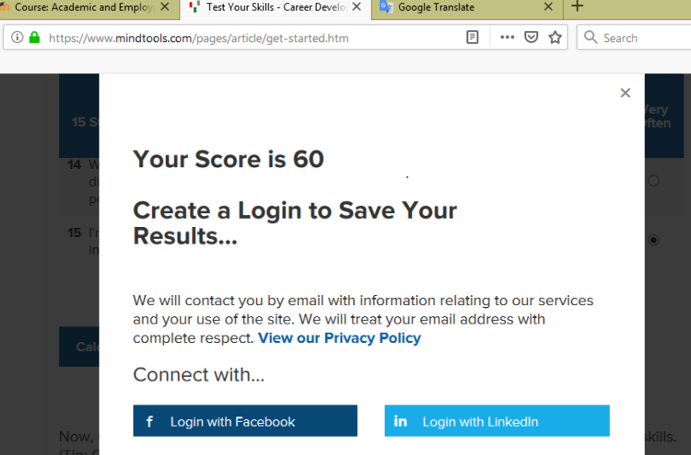
Leadership and Management
(Questions 5, 7, 12)
Your score is 14 out of 15
Whether you're in a formal leadership position or not, you need good leadership and management skills if you're going to make best use of the opportunities open to you. (After all, you can get much, much more done when you have the help of other people.) The good news is that you can learn how to lead and manage effectively!

Problem Solving and Decision Making
(Questions 2, 10, 14)
Your score is 8 out of 15
Problem solving and decision making are two areas where you'll need to excel to be a success in your career. (Together with people skills, they're what make up "good judgment" and "wisdom.") Like leadership and management, these two areas are closely related.

Communication Skills
(Questions 9, 11, 13)
Your score is 12 out of 15
The ability to communicate clearly is key to your success, whatever role you're in.

Time Management
(Questions 1, 4, 6, 15)
Your score is 20 out of 20
Time management is one of the most important career skills areas. Not only does it help you to be more productive; you'll also be much less stressed!

Personal Mastery
(Questions 3, 8)
Your score is 6 out of 10
When you know how to "lead yourself" and make good choices for your future, you'll be that much further ahead when it comes to the other skills areas that we've already looked at.
Section 3: Action Plans

1.Short term goals.
- Improve personal skills.
- Get the certificate CCNA.
- Find a job in IT.
2. Long-term goals
- Finish Cloud Computing Course.
- Career in IT domain.
- To make a family.

In order to achieve short term and long-term goals I defined before, I have to improve my personal and professional skills before.
Action steps :
- Do not sleep more than 6 hours a day.
- Finding a job closer to home do not waste too much time on the roads.
- Communicate as much as possible with people who have experience not to have to make the same mistake and to waste time.
- Do not miss school and interact more with classes.
- Set targets for each month.
- To find time to enjoy life.
- To have little luck.

Section 4: Application

Backup strategy to protect my data :
- Back-up data
Save all the material related to the University on USB stick , Personal Computer and Cloud (Personal account UNI).
- Up to date - Antivirus.
Ensure that you have a robust and up-to-date internet security package running – With online threats becoming increasingly more sophisticated and cybercriminals willing to jump on any social trend to spread malware, the online threat landscape is changing drastically by the minute. Security software from a recognised name like Norton is the best and safest option when it comes to stopping malicious software from installing on your PC as it can prevent it from taking over or slowing down your system.
*https://uk.norton.com/internetsecurity-how-to-8-ways-to-protect-your-private-information-online.html
Complicated password
Use a password from letters and numbers and special characters.
ALL the possible disaster scenarios :
- Injure laptop
- Steal laptop
- Computer viruses.
- Hacking.
I can recover my data instantly because there are two more options (USB stick and Cloud).

Time management and organisation:
- Use a Time Planner
The first time management technique that you can use is a time planning system that contains everything you need to plan your life and improve your organizational skills. A good time planner will contain a master list where you can capture every task, goal, and required action as it comes up. This master list then becomes the core of your time-planning system to increase productivity throughout your life. From this master list, you allocate individual tasks to various months, weeks, and days.
The second part of the time-planning system is a calendar that enables you to improve your organizational skills by planning several months ahead. With the right system, you will be able to transfer individual items from your master list to the exact day when you intend to complete them.
The next part of your system is a daily list. This daily list is perhaps the single most important planning tool you can have. Some people call it a ‘‘to-do list.’’
*https://www.briantracy.com/blog/time-management/mastering-time-management-and-organizational-skills-to-increase-productivity/
- Increase Productivity by Working from a List
Every effective executive works from a daily list. It is the most powerful time management technique ever discovered to increase productivity and improve your organizational skills. Ineffective executives, those who are overwhelmed with too many things to do and too little time, either do not use a list or do not refer to a list if they have one in the first place. They often resist the idea of writing everything down. As a result, they find themselves continually distracted by ringing phones, interruptions, unexpected emergencies, and e-mail requests.
When you create your daily list, you begin by writing down every single task that you intend to complete over the course of the day. The rule is that you will increase productivity by 25 percent the very first day that you start using a list. This means that you will get two extra hours of productive time in an eight hour day from the simple act of making a list of everything you have to do before you start work. You can bring order out of chaos faster with a list than with any other time management tool.
Once you have written up your daily lists and begun work, new tasks and responsibilities will come up. Telephone calls will have to be returned. Correspondence will have to be dealt with.
In every case, write it down on the list before you do it.
Sometimes a task or demand on your time will seem urgent when it comes up. But something that might distract you from your other work regains its true importance when you write it down. An item that is written down on the list next to all your other tasks and responsibilities often doesn’t seem so important after all.
*https://www.briantracy.com/blog/time-management/mastering-time-management-and-organizational-skills-to-increase-productivity/
- Organize Your List by Priority
Once you have a list for your day’s activities, the next step is for you to organize this list in order of priority. Once your list is organized, it becomes a map to guide you from morning to evening in the most effective way to help you increase productivity. This time management guide tells you what you have to do and what is more or less important. You will soon develop the habit of using your list as a blueprint for the day and improve your organizational skills along the way. Refuse to do anything until you have written it down on the list and organized it relative to its value in comparison to the other things you have to do.
*https://www.briantracy.com/blog/time-management/mastering-time-management-and-organizational-skills-to-increase-productivity/
- Start Early
To increase productivity, start your day early. The more time you take to sit, think, and plan, the better organized you will be in every area of your life.In the biographies and autobiographies of successful men and women, almost all of them have one thing in common. They developed great organizational skills and the habit of going to bed at a reasonable hour and rising early.Many successful people arise at 5:00 A.M. or 5:30 A.M. so that they can have enough time to think and plan for the coming day. As a result, they are always more effective than those who sleep in until the last possible moment.A few minutes of quiet reflection before you begin any undertaking can save you many hours executing the task. When you get up early and plan your day in advance, you tend to be more calm, clear-headed, and creative throughout the day.
*https://www.briantracy.com/blog/time-management/6-time-management-tips-to-increase-productivity-organizational-skills/

Section 5: Conclusion & Evaluation.

I understand that the results do not come overnight and that you can become a successful man you have to work a little every day, through this essay I understand what my strengths are and what are my weak points , What do I have to do in the future to become better than I was yesterday and the most important thing to spend time to accomplish what I have proposed.

Section 6: Appendices:
References :

https://support.office.com/en-us/article/tips-for-creating-and-delivering-an-effective-presentation-f43156b0-20d2-4c51-8345-0c337cefb88b
https://www.participoll.com/powerpoint-presentation-tips/
https://www.participoll.com/powerpoint-presentation-tips/
https://learning.linkedin.com/blog/education/10-skills-all-students-need-to-be-successful
https://www.mindtools.com/pages/article/get-started.htm
https://uk.norton.com/internetsecurity-how-to-8-ways-to-protect-your-private-information-online.html
https://www.briantracy.com/blog/time-management/mastering-time-management-and-organizational-skills-to-increase-productivity/

Skills test


