

Name of Report - Hotel Arts Barcelona In Spain A Strategic Consultancy Report for Enhanced Operational Efficiency and Guest Experience
Student name: Alina Boestean
Student number: 2207646
Company name: Global Insight Strategies (GIS)
Date: 12.11.2024
Lecturer: Jaliya de Silva

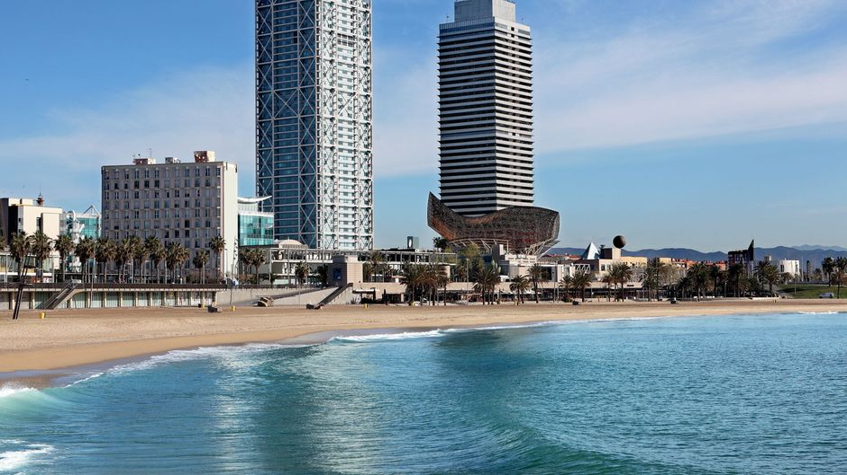



I have used Grammarly (https://www.grammarly.com/) on 1st November 2024 to remove spelling errors from my report. I hereby declare that I have not used any AI tools in the research and development of this report. I hereby declare that I have not included any AI-generated materials as part of my work. I hereby declare that I possess my drafts, notes, and other materials that I may be asked to produce as evidence.

Table of Contents
Table of Contents 2
1 Executive Summary 4
1.1 Key Findings 4
1.2 Analysis 5
1.3 Recommendations 5
1.4 Conclusion 6
2 Introduction 7
3 Analysis 9
3.1 Identified Issues Impacting Hotel Arts Barcelona 9
3.1.1 Seasonal Demand and Occupancy Rates 9
3.1.2 Increased Competition 10
3.1.3 Guest Experience and Feedback Management 10
3.1.4 Sustainability and Environmental Pressures 11
3.1.5 Labor Shortages and Staff Retention 11
3.2 PESTEL Analysis 12
3.3 SWOT Analysis 13
3.4 TOWS Analysis 14
4 Recommendations and Change Management 15
4.1 Implementing a Flexible Staffing Model 15
4.2 Enhancing Guest Experience through Technological Upgrades 15
4.3 Strengthening Sustainability Initiatives 15
4.4 Creating a Competitive Pricing Strategy 15
4.5 Implementing Employee Retention and Wellbeing Programs 16
4.6 Measuring Success and Monitoring Impact 16
4.7 Benefits of Implementing the Recommendations 17
4.8 Cost Analysis and Financial Feasibility 17
5 Action Plan 20
6 Conclusion 22
7 References 23

Executive Summary
This consultancy report, prepared by Global Insight Strategies (GIS), considers the operational and strategic challenges facing Hotel Arts Barcelona, a luxury hotel located on the beachfront of the city. Under the management of Ritz Carlton, the hotel has made a name for modern architecture, premium amenities and world class service, and has become a known brand in the luxury hospitality market. However, it is now starting to lose its grip on this position, with problems such as seasonal demand fluctuations, increasing competition, changing guest expectations, sustainability pressures and labour shortages beginning to erode its ability to hold on. The challenges to Hotel Arts are analysed using PESTEL, SWOT and TOWS frameworks, and strategic recommendations are offered to the hotel to maintain its competitive position and improve its operational efficiency.

Key Findings
Since Barcelona’s seasonal tourism patterns peak from May to September, hotel arts experiences significant variations in occupancy. This season has occupancy peaks around 82% and drops to 54% in the off. The variations complicate revenue management, staffing, and resource allocation, especially when occupancy drops below the average for other luxury hotels in the area during off-peak months. Revenue service consistency and guest satisfaction can take a hit from such fluctuations when the resources are not adequately available during peak times.
With the entrance of international brands such as Four Seasons and Ritz-Carlton, the local Barcelonan luxury hospitality sector is becoming more competitive, forcing Hotel Arts to distinguish itself. A prestigious location and brand affiliation are no longer unique in an oversaturated market of premium choices, so the hotel benefits. Competition is driving price wars, and in particular, if the hotel places too much emphasis on rate adjustments, it can erode profit margins.
Today’s modern luxury travellers expect a seamless and personalised experience while travelling with digital services like contactless cheque-ins and real-time service requests. The feedback shows that people want faster service at travel times when they tend to experience most delays, especially as it relates to changes that are using digital enhancements to provide more convenience. For now, the hotel does not have the digital footing to fulfil this expectation as fully as we’d like, resulting in gaps in the guest experience. If it cannot meet these standards, failure leaves it open to damaging its reputation since negative experiences and delays could mean bad reviews.
Rising environmental pressures are also highlighted in the report. Sustainable practices are now on the radar of 76 per cent of global travellers who prefer eco-friendly accommodations. Hotel Arts has started incorporating some sustainable initiatives, but its current practices don’t meet the industry standard. This gap may alienate environmentally conscious travellers, a growing segment of the luxury market, and it’s a missed opportunity to save on energy and water usage. To tackle this, Hotel Arts requires a full sustainability strategy that is consistent with guest expectations and serves to improve operational efficiency.

Analysis
This report analyses the external factors affecting Hotel Arts’ operations through a PESTEL analysis. The hotel is highly sensitive to economic instability in Europe, the drive toward digital transformation in the hospitality industry, and changing social preferences for eco-conscious tourism. Hotel Arts has a strong reputation, architectural appeal, and strategic location as its key strengths, but it is vulnerable to high operational costs and its current sustainability practices.
This report translates the insights of the SWOT analysis into strategic actions using a TOWS analysis. However, many of the opportunities described above come down to Hotel Arts’ ability to capitalise on what it stands for — exclusive eco-luxury packages and upgrading its digital guest service options into something more personalised and technology-driven. These initiatives enable the hotel to exploit these potential threats as opportunities and tackle the identified weaknesses – employee turnover and inconsistency in service quality.

Recommendations
Global Insight Strategies (GIS), therefore, proposes five targeted recommendations to optimise the operations and market positioning of Hotel Arts. The flexible staffing model for implementing a model in which the real demand for the season is met without degrading service quality is essential. The hotel will have a combination of full-time core staff supplemented by part-time and call-in employees during peak periods. They can adjust staffing levels in response to demand, reducing labour costs by 10-15%. This model also helps to alleviate burnout in the staff, which in turn helps support higher standards for consistent levels of service delivery year-round and contributes to improving morale.
The second critical recommendation is to invest in digital upgrades. With tech-savvy luxury travellers in mind, a dedicated mobile app would change the game with digital cheque-ins, room access, and real-time service requests. These innovations cut wait times and streamline interactions; Hotel Arts is a tech-enabled, forward-thinking luxury brand. These upgrades are expected to increase guest satisfaction by 5-10% and loyalty and revenue. Meeting evolving guest expectations and leveraging cost savings requires enhanced sustainability practices. Installing LED lighting, solar panels, and water-saving fixtures and obtaining eco certifications will make Hotel Arts more appealing to eco-conscious travellers and save the hotel about €15,000 a year in utility costs.
The hotel will take a dynamic pricing approach, where the room rates will change on real time demand, seasonality, and local events around it. Hotel Arts, if it takes this approach, will make the most of occupancy and revenue without falling into unprofitable price wars. Dynamic pricing increases revenue by 5-10%, especially helpful for dealing with seasonal demand and to provide a competitive advantage.

Conclusion
It is discussed in this Global Insight Strategies (GIS) report a detailed strategic roadmap for Hotel Arts Barcelona, where we propose how the challenges can be tackled by flexible staffing, technological innovation, sustainability initiatives, dynamic pricing and employee retention. It will be closer to what the desired modern luxury traveller expectations are and will optimise its operation and financial performance. Hotel Arts is in a position to become a leading destination in Barcelona’s fiercely competitive luxury hospitality market and address existing and future issues by providing these tailored recommendations.

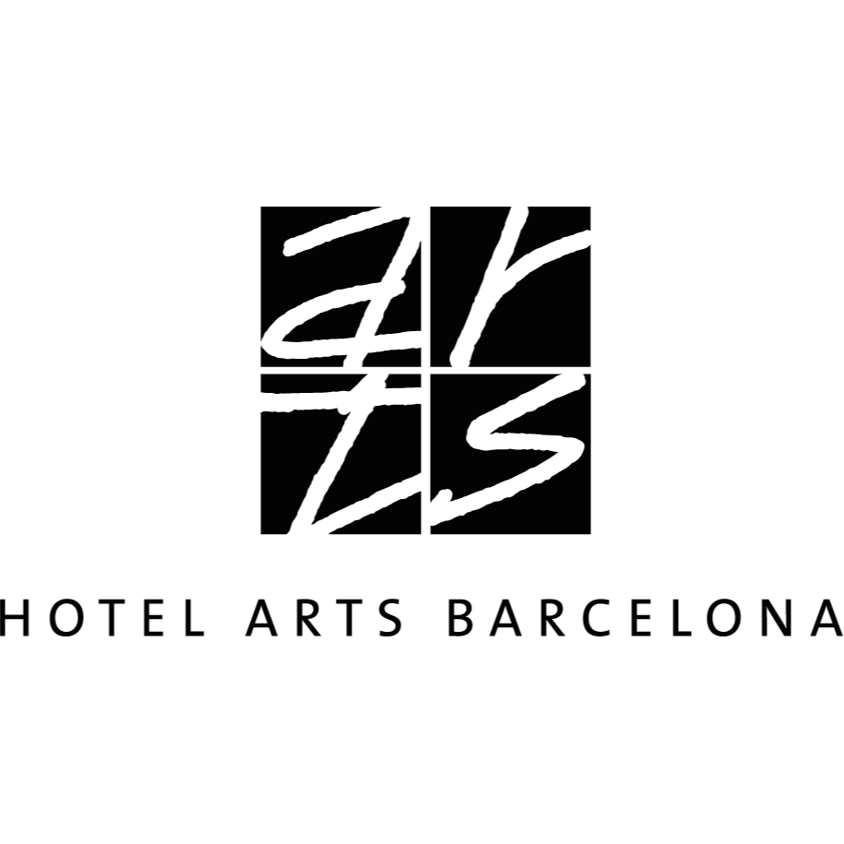

Introduction
Global Insight Strategies (GIS) prepared this consultancy report to address the operational and strategic challenges facing Hotel Arts Barcelona. It has been recommended in the study of Williams et al. (2023) that Hotel Arts is a large luxurious hotel situated in the middle of Barcelona’s beach destination, with its modern architecture, stunning sea views and high-quality service. The hotel opened in 1994 and has 483 guest rooms, including 28 exclusive duplex penthouses, each offering the finest stay experience with a view of the Mediterranean and the city skyline (Mooser et al., 2022). Hotel Arts is managed by The Ritz-Carlton Hotel Company and is known for its vibrant mix of Catalan culture and luxury, catering to high-end travellers who want comfort and the real local experience.
Vinogradov et al. (2022) have identified in their research that seasonal demand fluctuations, rising competition in Barcelona’s luxury hospitality market, managing guest expectations, sustainability pressures and labour shortages are the main issues facing Hotel Arts Barcelona. Because Barcelona is seasonal and tourism is at its highest from May to September, occupancy rates rise to 80 per cent during this period and fall to 50–60 per cent during the rest of the year. Such fluctuation complicates revenue management staffing and resource allocation and may result in inefficiencies and variability in guest satisfaction (Mishra, 2023). Competition has been ratcheted up by the influx of luxury competitors like Four Seasons and Ritz-Carlton, as well as the city’s status as a European destination.
Feedback management is still one of the most important areas of the hotel, and it is essential to its success. Guest experience is another important factor. Today’s modern luxury traveller is looking for more and more personalised experiences, technological convenience, and environmental responsibility (Miao, 2024). High guest satisfaction with the hotel’s ambience and location is observed in platforms such as TripAdvisor, while platform feedback indicates that particular concerns emerge relating to the delay in services, especially during peak seasons. Without proper management, such feedback can ruin a brand reputation, a crucial asset for the luxury hospitality industry. Furthermore, according to Upadhyay et al. (2023), 76% of travellers prefer eco-friendly accommodation (Booking.com, 2023), and environmental concerns are starting to play a key role in consumer choice.
Testa et al. (2022) have discussed in their study that Global Insight Strategies (GIS) has been selected to tackle these challenges as a renowned consultancy firm specialising in strategic management and operational optimisation. Global Insight Strategies (GIS) has a track record of advising global luxury brands on competitiveness improvement in hospitality management, change management and sustainable practices. The firm states that its approach consists of providing actionable insights that support the objectives of the hotel to maintain high service standards, to use resources optimally, and to achieve long term growth (Manresa et al., 2024). Global Insight Strategies (GIS)’s strategic frameworks have been applied by Hotel Arts Barcelona to navigate the complexities of the luxury hospitality market and become a leading service quality and sustainable tourism service.
To analyse the issues facing Hotel Arts Barcelona, this report will use a number of strategic frameworks such as PESTEL, SWOT and TOWS analysis. Political, economic, social, technological, environmental, and legal (PESTEL) framework will help identify external forces that affect the operation and strategic decision of the hotel. This will present a whole picture of the environment of the hotel; whether it is a risk or opportunity. According to another researcher in his research, Staley and Endicott (2023) said that in SWOT analysis, the external opportunities and threats of hotel and internal strengths and weaknesses of hotel will be analysed and a comprehensive snapshot of the hotel’s current competitive position will be taken. Following from the SWOT analysis, the TOWS framework will be used to create strategic actions from using strengths and opportunities to remove weaknesses and threats, and transform them into strategic actions.

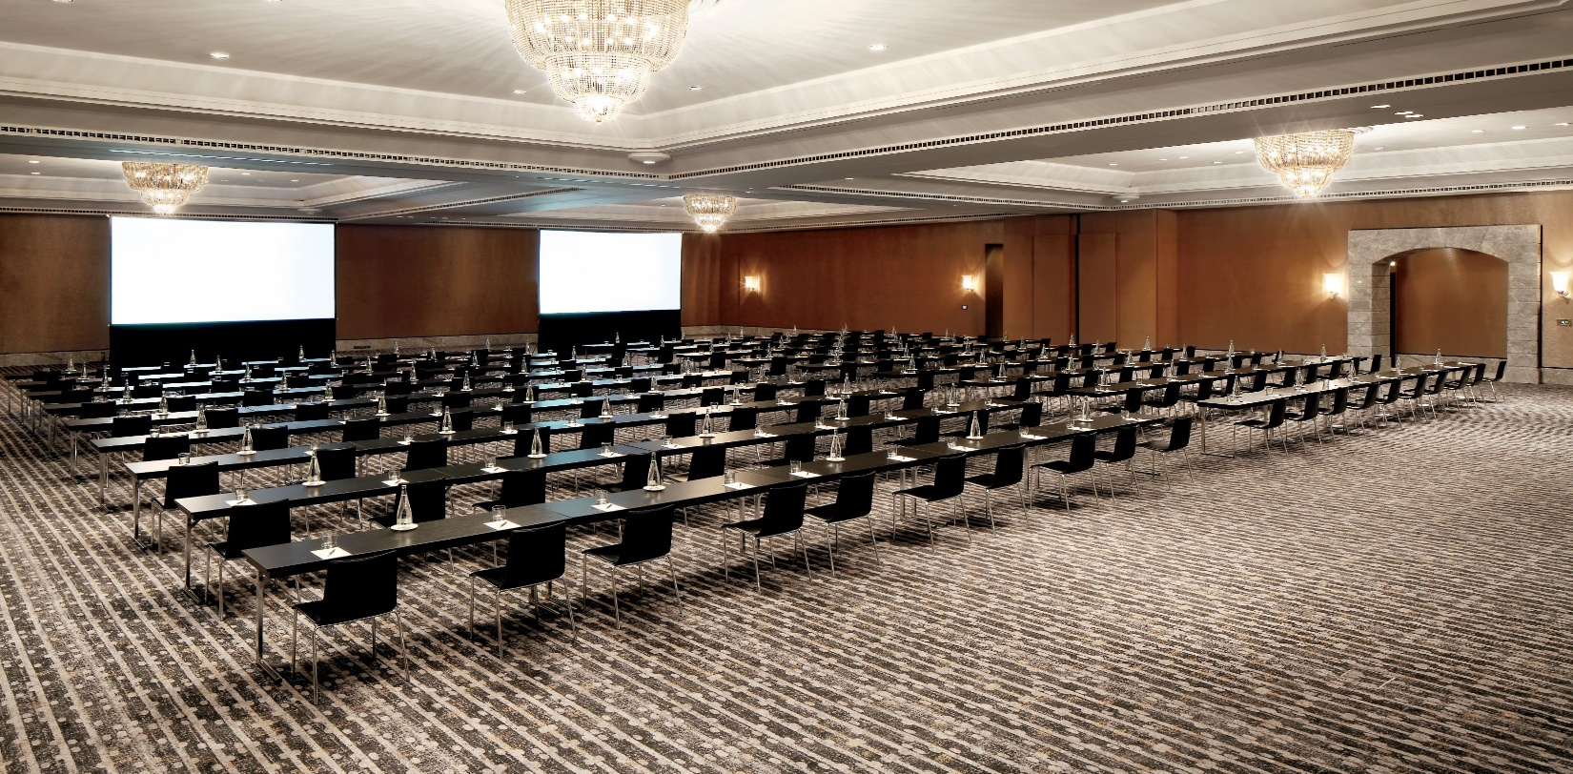

Analysis
Hotel Arts Barcelona, located in the middle of Barcelona’s beachfront and one of the most luxurious hotels in Spain, should be your cheque if you live in Spain. The centre is known for its prime location, service and iconic architecture (Mandić and Walia, 2023). High-profile guests love it; it plays a major role in the city's tourism economy. Furthermore, this statement has been supported by Spina (2024), who states that, like many hotels in competitive tourist destinations, Hotel Arts Barcelona has challenges that can jeopardise its performance and reputation. This section discusses these issues critically using a PESTEL and SWOT analysis to identify internal and external factors and a TOWS analysis to suggest strategic directions.

Identified Issues Impacting Hotel Arts Barcelona
Hotel Arts Barcelona is a luxury hotel on Barcelona's beautiful beachfront, with a reputation for its outstanding location, architecture, and high service standards. Yet, it has several hurdles to overcome to retain its competitive advantage and guest satisfaction. Contrary to this, Sidani (2024) has argued in his study that seasonal demand fluctuations, intense competition, managing guest feedback, rising environmental pressures, and labour shortages are some of these challenges. Below, these issues are analysed regarding the challenges they present to the hotel and the implications for its operations and strategic positioning.
Table 1 Occupancy Rates Comparison (2023)
Period | Hotel Arts Barcelona | Barcelona Luxury Hotel Average | Impact
Peak Season | 82% | 80% | Above average, indicating strong demand and reputation
Off-Peak Season | 54% | 60% | Below average, showing vulnerability to seasonal demand variations

Seasonal Demand and Occupancy Rates
Barcelona’s tourism patterns are seasonal, with peak tourism activity from May through September. The occupancy rates of luxury hotels like Hotel Arts Barcelona are very similar based on this seasonality. According to a 2023 industry report, occupancy in luxury hotels in Barcelona remains around 80% in peak season and drops to 50 to 60 per cent in off-peak months (Statista, 2023). This fluctuation challenges hotel revenue management, which has to book months of high profitability followed by low revenue periods. Moreover, it has been anticipated in the study of Shuldyk (2023) that managing operational and staffing requirements, particularly during low occupancy months, is complicated by the need to maintain consistent and high service and staff morale when the organisation operates below a normal activity level.

Increased Competition
Barcelona's luxury hotel market is competitive as one of Europe’s most popular destinations. It has been determined in the research of Rana et al. (2022) that the competition for high-end clientele, as more than 70 luxury hotels, including global brands like Ritz-Carlton and Four Seasons, have set up shops in the city. For Hotel Arts Barcelona to compete in such a competitive environment, they must distinguish themselves by unique value propositions with differentiated service quality, unique amenities, or personal guest experiences. Nevertheless, intense competition often forces pricing strategies to be a rate war among luxury hotels. In a market where the average daily rates (ADR) are a cross between local and foreign competition, and where in such a sector, the margin between the cost of service and price is reducing, it is possible that maintaining high service standards could severely reduce profit margins (Langer, 2024).

Guest Experience and Feedback Management
Barcelona's luxury hotel market is competitive as one of Europe’s most popular destinations. The competition for high-end clientele, as more than 70 luxury hotels, including global brands like Ritz-Carlton and Four Seasons, have set up shops in the city (Kage and Salakki, 2024). Hotel Arts Barcelona has to find ways to differentiate itself in this competitive market through unique value propositions consisting of greater service quality, a greater set of amenities, and more personalised guest experiences. Nevertheless, Pauceanu (2022) found that intense competition often forces pricing strategies to be a rate war among luxury hotels. However, in a Competitive market where average daily rates (ADR) are determined by both domestic and international competitors, maintaining high service standards whilst adjusting prices to ensure a competitive position can risk eating into profit margins.
Table 2 Guest Satisfaction Ratings (2023)
Criterion | Hotel Arts Barcelona | Industry Benchmark (Luxury Hotels in Barcelona) | Comment
Room Quality | 4.6/5 | 4.5/5 | Excellent rating, competitive advantage
Check-In Process | 4.1/5 | 4.3/5 | Slightly below benchmark, improvement area
Customer Service | 4.4/5 | 4.5/5 | Meets industry standards
Eco-Friendly Initiatives | 3.9/5 | 4.2/5 | Below industry standard, improvement area
Overall Guest Satisfaction | 4.3/5 | 4.4/5 | Competitive but needs enhancements

Sustainability and Environmental Pressures
A 2023 survey by Booking.com showed that 76% of travellers prefer accommodations with eco-friendly initiatives, and sustainability is becoming a central consideration for modern travellers (Joubert, 2022). Hotel Arts Barcelona is extensive in amenities and high energy demands and faces the challenge of fulfilling these expectations. While the hotel has already started some sustainable practices, there is room to improve and align more with the green technology other industry leaders have adopted, including solar panels, energy-efficient systems, and advanced waste reduction practices. Moreover, it has been suggested in the study of Palau-Pinyana et al. (2024) that sustainability is not a compliance issue but a reputational one, and failing to adopt eco-friendly practices can alienate eco-conscious guests and negatively affect the hotel's appeal.

Labor Shortages and Staff Retention
Spain’s hospitality sector struggles with labour shortages, a problem only exacerbated by the post-pandemic period. According to the World Travel & Tourism Council (2023), the industry is short of 15% skilled labour, which has put a lot of pressure on many hotels, including Hotel Arts Barcelona. Staff shortages during peak tourist seasons cause overworking the available staff, which can result in burnout, a decrease in service quality, and a decrease in guest satisfaction. In particular, a shortage of skilled labour makes it difficult to accomplish service standards, particularly in luxury, where individual attention and efficiency matter (Gowreesunkar et al., 2023). Further, having very high turnover rates in the industry can also cause employee retention to be a problem because it is difficult to keep members of your team cohesive to uphold the standards of the hotel.

PESTEL Analysis
A PESTEL analysis is conducted to identify external factors impacting Hotel Arts Barcelona.
Factor | Description | Impact on Hotel Arts Barcelona
Political | Barcelona is subject to local regulations to control tourist activity, particularly in response to complaints about overtourism. Regulations like limits on short-term rentals affect accommodation demand in the hotel sector (Gill, 2022). | These regulations could indirectly benefit Hotel Arts by reducing competition from alternative accommodations (De León Nazareno, 2023). However, increasing restrictions may limit the hotel’s operational flexibility.
Economic | Spain’s economy is heavily reliant on tourism. Economic downturns in Europe or global markets can reduce travel budgets, impacting occupancy rates and room pricing flexibility. | An economic downturn could reduce occupancy, especially from non-essential business travel, which makes up a significant portion of the hotel’s clientele. As Murgatroyd (2024) posted, maintaining stable revenue may become challenging.
Social | Changing consumer preferences, particularly an increased demand for eco-conscious practices and unique experiences, influence the global hospitality industry (Cortelezzi and Ferrari, 2022). | Hotel Arts Barcelona must remain competitive by catering to eco-conscious tourists and adopting sustainable practices. As per Morrow (2023), the hotel must also innovate to provide memorable experiences to meet these evolving expectations.
Technological | Digital innovation in guest services, such as app-based check-in and room controls, is rising in the hospitality sector. | Adopting these technologies can enhance guest satisfaction but also requires significant IT infrastructure and training investment.
Environmental | Environmental sustainability is becoming crucial in hospitality. In this research, Morrison and Buhalis (2024) asserted that guests increasingly expect hotels to implement green practices, from reducing plastic use to conserving energy. | Hotel Arts must adopt eco-friendly practices to attract environmentally-conscious travellers (Caciulan et al., 2023). Failure to act on sustainability could negatively affect its brand image and guest satisfaction.
Legal | Spain’s labour laws mandate fair working conditions and limit maximum working hours. Williams et al. (2023) have also emphasised in their study that the country is implementing stricter regulations on tourism-related businesses to control environmental impacts. | Compliance with labour regulations impacts the hotel’s staffing flexibility. Legal limitations on working hours require efficient workforce planning, which can be challenging amidst the existing labour shortages in the hospitality industry (Boys and Ford, 2023).

SWOT Analysis
The SWOT analysis identifies the strengths, weaknesses, opportunities, and threats for Hotel Arts Barcelona.
Strengths | Weaknesses
- Iconic architecture and beachfront location make it highly attractive to tourists and business clients. | - High operational costs due to luxury standards, seasonal staffing needs, and property maintenance.
- Strong brand reputation and affiliations with Ritz-Carlton’s luxury standards. | - Limited sustainability initiatives may deter eco-conscious guests (Banerjee, 2024).
- Excellent amenities, including Michelin-starred restaurants and premium spa services, enhance the guest experience (Gowreesunkar et al., 2023). | - Inconsistent guest service experiences during peak seasons, potentially damaging reputation.

Opportunities | Threats
- Growing demand for eco-friendly accommodations, allowing the hotel to attract eco-conscious clientele with sustainable upgrades. | - Increased competition from other luxury hotels and short-term rental platforms like Airbnb, which offer competitive pricing and alternative accommodation options (Gill, 2022).
- Digital transformation and service automation to improve efficiency and guest experience, enhancing brand loyalty (Mooser et al., 2022). | - Economic instability in Europe could reduce tourism spending and occupancy rates, affecting profitability.
- Expanding international tourism to Barcelona, increasing demand for luxury accommodations. | Labour shortages in Spain's hospitality industry could impact hotels' ability to maintain service quality, especially during peak periods (Mishra, 2023).

TOWS Analysis
The TOWS analysis translates the insights from the SWOT analysis into actionable strategies for Hotel Arts Barcelona.
Strategies to Leverage Strengths and Opportunities (SO) | Strategies to Address Weaknesses by Leveraging Opportunities (WO)
- Capitalize on the hotel's reputation by introducing eco-luxury packages, emphasising sustainable practices to attract eco-conscious travellers (Miao, 2024). | - Invest in renewable energy sources and eco-friendly amenities to align with eco-conscious trends and offset operational costs.
Expand digital guest service offerings, such as personalised apps for check-in and service requests, to enhance guest experiences. | - Improve staff efficiency during high-demand periods through specialised training and process automation (Manresa et al., 2024).

Strategies to Leverage Strengths to Mitigate Threats (ST) | Strategies to Address Weaknesses and Mitigate Threats (WT)
- Strategic Pricing: Implement flexible pricing strategies to adjust rates in response to economic changes, maximising revenue during peak seasons. | - Improve workforce planning through AI-driven forecasting tools to manage fluctuating demand and reduce dependency on seasonal hires.
- Brand Partnership with Eco-Friendly Initiatives: Partner with sustainable brands to enhance eco-conscious marketing and maintain competitiveness (Mandić and Walia, 2023). | - Develop a competitive benefits package and wellness programs to attract and retain quality staff amidst labour shortages.

Hotel Arts Barcelona has a strong brand reputation, iconic architecture and a prime location. But in this research, Vinogradov et al. (2022) suggest that the hotel must endure fluctuating occupancy rates, rising competition, service consistency and sustainability. It is found in the analyses that the key strategies of the hotel should be to learn how it can improve eco-friendly practices, encourage staff development and employ digital tools to improve guest satisfaction. Hotel Arts Barcelona can rely on Global Insight Strategies (GIS)’s hospitality consulting expertise to face the industry trend towards sustainable and high-quality digital services with the support of Global Insight Strategies (GIS)’s hospitality consulting expertise (Langer, 2024).

Recommendations and Change Management
This study then analyses how the core challenges of Hotel Arts Barcelona can be addressed, and a series of targeted recommendations are proposed to make the operations more efficient, sustain competitive advantage, and increase guests’ satisfaction (Kage and Salakki, 2024). The recommendations focus on seasonal demand, competition, guest expectations, sustainability pressures, and labour shortages along a strategic path forward for the hotel.

Implementing a Flexible Staffing Model
The only way to deal with seasonal irregularities or labour shortages is with a flexible staffing model. The structure of Hotel Arts Barcelona could be as a core team of full-time employees and part-time and on-call staff during peak seasons (Joubert, 2022). Using this approach, the hotel can respond to demand surges without overworking regular employees and underutilising staff during off-peak times. It has been evaluated by Upadhyay et al. (2023) that hospitality has seen flexible staffing models work well in reducing labour costs by as much as 15 per cent while maintaining service quality. This approach also reduces employee burnout by keeping staff engaged and able to provide year-round high service standards.

Enhancing Guest Experience through Technological Upgrades
The guest experience at Hotel Arts Barcelona can be significantly improved through investment in technological advancements like mobile apps, contactless check-in, digital room keys, and real-time service requests. On the other hand, it has been argued in the study of Testa et al. (2022) that today’s travellers want digital solutions for easier and more personalised experiences, and studies indicate that 68% of luxury travellers prefer hotels that offer digital amenities. Such technology satisfies guest expectations and provides real-time feedback, thus enabling quick replies to any issues and enhancing overall satisfaction. Also, a streamlined digital experience makes it easier on staff, especially at cheque-ins, and helps the hotel repeatedly provide the same quality of service (De León Nazareno, 2023).

Strengthening Sustainability Initiatives
As sustainability has become an important factor in consumer behaviour, Hotel Arts Barcelona must become more eco-conscious. Reducing operational costs with such things as LED lighting, solar panels, and water-saving technology, as well as offering eco-friendly systems, will appeal to green travellers (Cortelezzi and Ferrari, 2022). According to a survey by Booking.com (2023), 76 per cent of travellers want hotels with sustainable practices, and these improvements can help improve brand perception and a hotel’s competitiveness. Additionally, it has been highlighted in the research of Staley and Endicott (2023) that the hotel is taking the long-term sustainable initiative by reducing single-use plastic and sourcing from local eco-friendly suppliers to be a responsible luxury leader.

Creating a Competitive Pricing Strategy
Hotel Arts Barcelona has been caught in a pincer movement of fierce competition in Barcelona’s luxury hotel market, and we believe that dynamic pricing can help optimise its revenues. For example, studies such as Spina (2024) show that the hotel can increase occupancy and profitability in various periods by changing room rates according to demand, seasonality and local events. Dynamic pricing strategies (Deloitte, 2023) allow us to maintain or improve service quality while improving revenue by 5–10%. It allows Hotel Arts Barcelona to maintain its competitiveness (Caciulan et al., 2023) and stay competitive (Caciulan et al., 2023) in an ever-changing market by continuously good revenue (Caciulan et al., 2023) driven to consistently good revenue (Caciulan et al., 2023).

Implementing Employee Retention and Wellbeing Programs
Handling the labour deficits and high turnover rates of Hotel Arts Barcelona requires this situation. Therefore, the hotel can bring in employee retention programs concerning flexible working hours, wellness benefits and professional development (Boys and Ford, 2023), thereby enhancing staff satisfaction and minimising staff turnover. Our European Hospitality Industry Report (2024) gives data that demonstrates that staff retention programmes can decrease staff turnover by 20%, thereby creating a secure and renewed workforce. Furthermore, Sidani (2024) suggested that a structured retention programme makes the service consistent and provides an enabling environment for long-term organisational health and brand reputation. We need feedback channels where employees feel heard and valued to manage change in this area effectively.

Measuring Success and Monitoring Impact
The only way to evaluate the success of these recommendations at Hotel Arts Barcelona is to use a system of key performance indicators (KPIs) and feedback systems. KPIs that are implemented based on each strategy are quantitative benchmarks to assess improvements and keep the hotel’s objectives in focus (Kitsos, 2022). In the case of the flexible staffing model, the KPIs will be things like employee satisfaction scores, seasonal labour cost savings, and retention rates. It has been determined in the research of Tomas et al. (2024) that the hotel can monitor the satisfaction level of employees by regularly surveying them to see if flexible staffing arrangements may bring about better work-life balance and reduce burnout in this aspect, which is crucial for morale and the quality of service. Guest satisfaction ratings, digital engagement and cheque-in/cheque-out efficiency will be assessed against technological upgrades (Hernández-Barahona et al., 2023).
However, Terol Niksic (2023) has argued that KPIs for sustainability initiatives will include monthly reductions in energy and water usage, eco-certification of the hotel, and guest feedback on the hotel’s green practices. Energy-efficient upgrades immediately show reduced utility costs. Green Key or LEED-certified hotels are a good way to indicate the hotel’s responsible approach toward the environment, and its image as a luxury hotel ensures the economy as a green hotel brand. Further feedback from eco-conscious guests will help showcase how well these initiatives will resonate with visitors and help build brand loyalty (Guardiola Agustí, 2022). Feedback mechanisms are equally important. Primary sources of insights will come from guest feedback from surveys and reviews, including preferences for technological amenities and sustainable practices.

Benefits of Implementing the Recommendations
The implementation of these recommendations will have a major positive impact on Hotel Arts Barcelona, increasing guest satisfaction, operational efficiency, and positioning in the market. Tarique (2022) has identified in his research that the hotel is a leader in modern luxury, focusing on flexible staffing, technology, and sustainability to meet today’s traveller’s demands. However, a primary benefit is to enhance guest satisfaction and loyalty. Mobile cheque-ins and real-time service requests provide convenience for guests, shortening wait times and allowing guests more control over their stay. The efforts meet the expectations of today’s tech-savvy travellers, who often prefer ease and personalisation. Sustainability improvements, such as reducing plastic use and energy-efficient amenities, attract eco-conscious guests and improve the hotel’s appeal above competitors (de la Calle-Vaquero and García-Hernández, 2023).
Key outcomes are also operational efficiency and cost savings. Hotels can realign labour needs with demand through flexible staffing arrangements, cutting costs in low occupancy periods, and providing service quality (Choudhury, 2024). The hotel can also minimise burnout, keeping staff on longer and reducing turnover's financial and logistical costs. However, these long-term cost savings on utility expenses in a large facility can be achieved through sustainability initiatives like LED lighting and water-saving measures. Finally, these initiatives strengthen Hotel Arts Barcelona's competitive positioning, delivering it as a forward-looking brand offering green and tech-savvy guests. According to Stolowy and Stolowy (2022), as modern luxury travellers seek experiences that combine luxury and sustainability, the hotel stands out in Barcelona’s crowded luxury market by providing unique amenities and sustainability initiatives that speak to guests.

Cost Analysis and Financial Feasibility
To make the recommendations financially feasible, the initial costs and expected returns for each recommendation must be assessed. These are not only manageable but strategically wise for long-term growth in view of Hotel Arts Barcelona’s revenue streams and luxury positioning.
Recommendation | Initial Cost (€) | Annual Maintenance Cost (€) | Estimated Savings/Revenue Impact | Return on Investment (ROI)
Flexible Staffing Model | €30,000 | - | 10-15% reduction in annual labor costs | ROI within 1–2 years
Staff Training for Flexibility | €10,000 | - | Reduced turnover and improved service consistency (Chisholm, 2023). | Immediate benefit in employee retention
Technological Upgrades | €70,000 | €10,000 | 5-10% increase in bookings due to improved guest experience (Brooke-Smith, 2022). | ROI within 1–2 years
Digital Engagement Platform | €20,000 | €5,000 | Enhanced guest satisfaction, higher digital engagement | ROI within 1–2 years
Sustainability Enhancements | €100,000 | - | €15,000 annual savings on utility costs | ROI within 3–4 years
Eco-Certifications & Marketing | €10,000 | - | Strengthened brand reputation among eco-conscious guests | Schneider (2023) discussed long-term brand loyalty and differentiation in his study.

To implement a flexible staffing model, payscale systems must be adjusted to accommodate various shifts of part-time and call-off personnel. This structural shift will cost about €30,000 a year in payroll changes and another €10,000 in staff training. However, Rius-Ulldemolins and Klein (2022) have identified in their research that this investment will lead to a 10-15% reduction in labour costs in the first year and a full return on investment in two years, reducing off-peak labour costs and minimising turnover-related expenses. In accelerated labour stability, Hotel Arts will have fewer service quality disruptions than in previous periods, a key element in maintaining its high standards (Boukabou, 2024).
A big but impactful investment is in technological upgrades such as a mobile cheque-in system, digital keys and an app for guest service requests. Postigo (2023) found out that these digital systems can cost about €70,000 for initial development or licencing, with annual maintenance costs of about €10,000. An additional €20,000 will be spent on a digital engagement platform to collect real-time feedback. These tools offer dual benefits: They simplify service interactions for guests and automate manual tasks for the staff, increasing their overall efficiency and guest satisfaction (Blázquez-Resino et al., 2024). These enhancements are expected to raise occupancy rates and guest loyalty levels by 5-10%, enabling Hotel Arts to return on its investment in two years.
While initially coming with a cost, sustainability initiatives ultimately contribute huge long-term returns. It has been determined in the research of Mercadé-Melé et al. (2023) that installing LED lights, water-saving systems, and possibly solar panels would cost about €100,000, with an extra €10,000 to get eco-certifications and to promote the hotel’s sustainable image. The aim is to save approximately €15,000 in utility costs per year and to appeal to the increasing market of eco-conscious travellers (Bastianes, 2024). These changes will not only help improve brand image but the investment could be recouped in 3–4 years through accumulated cost savings and increased guest loyalty.

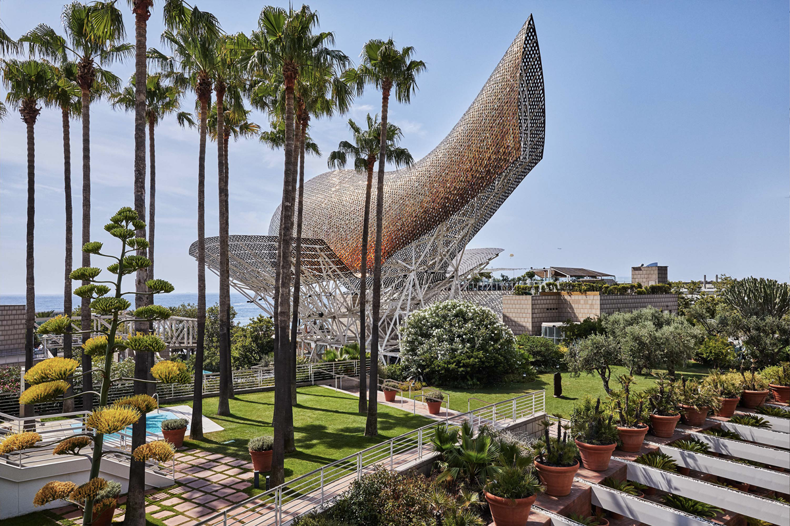

Action Plan
The action plan table below will provide Hotel Arts Barcelona with a clear road map to solving the main challenges, defining achievable goals, and allocating budgets in order to successfully implement strategies that improve operational efficiency and customer satisfaction.
Number | Problem | Solution | Desired Outcome | Time Scale | Completion Date | Planned Budget
1 | Seasonal demand fluctuations affecting occupancy | Implement a flexible staffing model with a mix of full-time and part-time/on-call employees to adapt to peak and off-peak seasons (Bastianes, 2024). | Improved efficiency in staffing, reduced burnout, and cost savings, ensuring consistent service quality year-round. | 6 months | 01/04/2024 | €40,000
2 | Guest demand for enhanced digital experiences | Develop and implement a mobile app for digital check-in/check-out, room access, and real-time service requests. | Increased guest satisfaction, reduced wait times, and streamlined check-in/check-out processes (Addis et al., 2024). | 4 months | 01/03/2024 | €70,000
3 | Rising need for eco-friendly initiatives | Install LED lighting, solar panels, and water-saving fixtures throughout the hotel and obtain eco-certifications like Green Key or LEED. | It has been anticipated in the study of Marce Garcia (2022) that enhanced brand reputation among eco-conscious travellers, reduced utility costs, and improved sustainability profile. | 8 months | 01/08/2024 | €100,000
4 | High competition in Barcelona's luxury hotel market | Mansilla and Milano (2022) have discussed in their study that to maintain competitiveness and revenue stability, they should adopt a dynamic pricing strategy to adjust room rates based on demand, seasonality, and local events. | Optimised revenue generation and competitive positioning in the luxury hotel market. | 3 months | 01/02/2024 | €15,000
5 | Labour shortages and high turnover rates | Implement employee retention programs with wellness benefits, professional development opportunities, and feedback channels to improve staff satisfaction and retention. | Reduced turnover, improved morale, and consistent service quality, reducing hiring and training costs over time (Kitsos, 2022). | 5 months | 01/05/2024 | €30,000

Conclusion
This Global Insight Strategies (GIS) report concludes by analysing the hotel’s core challenges and providing actionable recommendations to improve the hotel’s operational efficiency, customer satisfaction and market competitiveness. Using strategic frameworks such as PESTEL, SWOT and TOWS, the report has identified some major issues that are affecting Hotel Arts Barcelona’s performance, including seasonal demand fluctuations, stiff competition in Barcelona’s luxury hospitality market, rising guest expectations for personalised and digital experiences, mounting pressures to adopt sustainable practices and labour shortages. We find that seasonal demand, which exhibits high occupancy during peak tourist months and low occupancy during off-peak periods, creates severe revenue instability, staffing, and resource allocation challenges. To handle this, we suggested managing a flexible staffing model that enables the hotel to work effectively with changing numbers of people with minimum service quality and employee loading.
Also highlighted was the need for richer digital experiences, as luxury travellers worldwide are seeking more convenience, personalisation and efficiency in their accommodation. With this demand, we have proposed using a mobile app for digital check-in, room access and real-time service requests. Through this upgrade, wait times are expected to be drastically cut, guest satisfaction will improve, and Hotel Arts Barcelona will be positioned as a leading luxury tech-enabled destination. Hotel Arts Barcelona’s guests are no exception, and environmental responsibility has become a vital consideration for modern travellers. Installing LED lighting, solar panels, and water-saving fixtures and getting eco certifications are recommended. These measures are expected to make the hotel more appealing to eco-conscious travellers, help save on long-term utility expenses, and help build the hotel’s brand reputation as a responsible luxury establishment.
In addition, the analysis revealed that there is a lot of competition in the Barcelona luxury hotel market and Hotel Arts was not very dynamic with prices. Implementing its seasonal demand and local event based dynamic pricing strategy, the hotel can optimise its revenue while maintaining its competitive positioning. In addition, employee retention programs dedicated to addressing the labour shortfall, health and wellness benefits, and professional development will further motivate the workforce and help ease turnover costs resulting in stable service quality and overall operation stability. Global Insight Strategies (GIS) is grateful to Hotel Arts Barcelona for its incredibly support to this project. It’s a privilege for us to be responsible for digging deeper, analysing and figuring out the strategic solution for this high premium hotel.

References
Addis, G., Masino, S., Massi, M. and Camilleri, M.A., 2024. The artification of hospitality: Art hotels as the new frontier of sustainable cultural tourism. In Tourism Planning and Destination Marketing, 2nd Edition (pp. 175-196). Emerald Publishing Limited.
Banerjee, R., 2024. Who Blunders and How: The Dumb Side of the Corporate World. Penguin Random House India Private Limited.
Bastianes, M., 2024. Multilingualism, diversity, and performing arts. A home for Spanish language theatre in post-Brexit gentrified London. International Journal of Cultural Policy, 30(2), pp.238-252.
Blázquez-Resino, J.J., Martínez-Ruiz, M.P. and Muro Rodríguez, A.I., 2024. Spain is different! An analysis of the promotion strategies in the tourism industry in Spain. Journal of Historical Research in Marketing, 16(1), pp.25-47.
Boukabou, R., 2024. The Art Lover's Guide to Barcelona.
Boys, J. and Ford, P. eds., 2023. The e-revolution and post-compulsory education: using e-business models to deliver quality education. Taylor & Francis.
Brooke-Smith, J., 2022. Accelerate!: A History of the 1990s. The History Press.
CACIULAN, L.R., Mihart, L.A., Vagner, D.F., Vodislav, M.G., IVASCU, L. and TAMASILA, M., 2023. Evaluating the Impact of Promotional Activity on Marketing. Scientific Bulletin of the Politehnica University of Timişoara Transactions on Engineering and Management, 3(1), pp.7-13.
Chisholm, A., 2023. Dreaming of al-Andalus: The Manifestation of Spanish Orientalism and Anachronistic Space in a 5-Granadino Hotel.
Choudhury, D., 2024. Technology and its Impact on Gender Disparity: an Analysis with Special Reference to Artificial Intelligence.
Cortelezzi, F. and Ferrari, A. eds., 2022. Contemporary Issues in Islamic Law, Economics and Finance: A Multidisciplinary Approach. Taylor & Francis.
de la Calle-Vaquero, M. and García-Hernández, M., 2023. Turistification and Urban Heritage in Spanish Historic Centres: Permanence and Changes in a Long Process. In Spanish Tourism Geographies: Territorial Diversity and Different Approaches (pp. 125-144). Cham: Springer International Publishing.
De León Nazareno, D.O., 2023. " DIGITAL TRANSFORMATION AS A FACTOR OF CHANGE IN ECUADOR'S PRODUCTIVE MATRIX". Journal of Social Sciences & Humanities Researches, 9(8).
Gill, G.P., 2022. Urban Sustainability Amid Neoliberalism: the Tensions Between Capital and Economic Wellbeing in the Contemporary City (Doctoral dissertation, University of York).
Gowreesunkar, V.G., Maingi, S.W. and Cooper, C., 2023. Tourism policies for the next normal. Routledge Handbook of Trends and Issues in Global Tourism Supply and Demand.
Guardiola Agustí, G., 2022. Fintech, the new challenge for banking.
Hernández-Barahona, J., Mateo, T., Gil-López, Á. and San Román, E., 2023. Collective Entrepreneurship in the Spanish Hotel Industry: The Internationalization of a Domestic Cluster. In Collective Entrepreneurship in the Contemporary European Services Industries: A Long Term Approach (pp. 11-28). Emerald Publishing Limited.
Joubert, L. ed., 2022. Craft Shaping Society: Educating in the Crafts—The Global Experience. Book One (Vol. 35). Springer Nature.
KAGE, V.R. and SALAKKI, S.S., 2024, July. CYBER SECURITY AND SECURITY IMPACTS IN DIGITAL TRANSACTION FOR RURAL INDIA. In SEMINAR PROCEEDINGS.
Kitsos, V., 2022. Urban policies for a contemporary periphery: Insights from eastern Russia (Doctoral dissertation, Södertörns högskola).
Langer, C., 2024. Social entrepreneurship as enactment of social innovation in tourism and hospitality: an analysis of its implementation and functioning.
Mandić, A. and Walia, S.K. eds., 2023. The Routledge handbook of nature based tourism development. Routledge.
Manresa, A., Sammour, A., Mas-Machuca, M., Chen, W. and Botchie, D., 2024. Humanizing GenAI at work: bridging the gap between technological innovation and employee engagement. Journal of Managerial Psychology.
Mansilla, J.A. and Milano, C., 2022. Becoming centre: Tourism placemaking and space production in two neighborhoods in Barcelona. Tourism geographies.
Marce Garcia, A., 2022. Prostituting the Global City: The Case of Twenty-First Century Barcelona (Doctoral dissertation, UC Davis).
Mercadé-Melé, P., Almeida-García, F., Martinez-Garcia, A. and Coll-Ramis, M.A., 2023. Hotel rooftops as a space for consumption in historic centres: the case study of Palma (Spain). Land, 12(3), p.657.
Miao, J.T., 2024. 6 The infrastructures of innovation districts. Routledge Companion to Creativity and the Built Environment, p.73.
Mishra, S., 2023. Industry acceptance of alternative delivery methods for last mile distribution (Master's thesis, Universitat Politècnica de Catalunya).
Mooser, A., Anfuso, G., Herbert, V., Williams, A.T. and Aucelli, P.P., 2022. Coastal scenic assessment in northern France: a useful tool for characterization and conservation of most attractive sites following the Conservatoire du littoral management approach.
Morrison, A.M. and Buhalis, D. eds., 2024. Routledge handbook of trends and issues in tourism sustainability, planning and development, management, and technology. New York, NY: Routledge.
Morrow, S., 2023. Reporting and Communicating the Performance and Value of Football. In The People's Game? Football, Finance and Society (pp. 53-122). Cham: Springer International Publishing.
Murgatroyd, S., 2024. The Future of Higher Education in an Age of Artificial Intelligence. Ethics International Press.
Palau-Pinyana, E., Llach, J. and Bagur-Femenías, L., 2024. Mapping enablers for SDG implementation in the private sector: a systematic literature review and research agenda. Management Review Quarterly, 74(3), pp.1559-1588.
Pauceanu, A.M., 2022. Innovation, Innovators and Business: Arab World Edition. Springer Nature.
Postigo, A., 2023. 2023/58 “Governing the Digital Economy in Thailand: Domestic Regulations and International Agreements” by Antonio Postigo.
Rana, S., Shrivastava, A.K. and Raut, S.K. eds., 2022. Promotional Practices and Perspectives from Emerging Markets. Taylor & Francis Group.
Rius-Ulldemolins, J. and Klein, R., 2022. From top-down urban planning to culturally sensitive planning? Urban renewal and artistic activism in a neo-bohemian district in Barcelona. Journal of Urban Affairs, 44(4-5), pp.524-544.
Schneider, J., 2023. Labor migration schemes, pilot partnerships, and skills mobility initiatives in Germany. Background paper to the World Development Report, p.17.
Shuldyk, V., 2023. Relations between Ukraine and Poland. Prospects for the development of the event industry (based on the National Palace of Arts" Ukraine" case) (Doctoral dissertation, Private Higher Educational Establishment-Institute “Ukrainian-American Concordia University").
Sidani, Y. ed., 2024. Routledge Handbook on Business and Management in the Middle East. Routledge.
Spina, S., 2024. Tools based on immersive technologies for supporting decision making to achieve sustainability and resilience in Small and Medium Enterprises (Bachelor's thesis, Universitat Politècnica de Catalunya).
Staley, D.J. and Endicott, D.D., 2023. Knowledge towns: Colleges and universities as talent magnets. JHU Press.
Stolowy, N. and Stolowy, H., 2022. Name and Shame: A Comparative and International Analysis of Whistleblowing Laws. HEC Paris Research Paper No. LAW-2023-1491.
Tarique, I. ed., 2022. The Routledge companion to talent management. 605 Third Avenue, New York, NY 10158: Routledge.
Terol Niksic, D., 2023. The contribution of Sports to Tourism and Economy throughout the history of Spain.
Testa, G., Compañó, R., Correia, A. and Rückert, E., 2022. In Search of EU Unicorns: What Do We Know about Them?. Bruxells, Belgium: Publications Office of the European Union.
Tomas, C.M.M., Amsler, A., Pinto-López, I.N. and Montaudon-Tomás, I.M., 2024. Evolution of Business Intelligence. In Strengthening Industrial Cybersecurity to Protect Business Intelligence (pp. 57-80). IGI Global.
Upadhyay, N., Upadhyay, S., Al-Debei, M.M., Baabdullah, A.M. and Dwivedi, Y.K., 2023. The influence of digital entrepreneurship and entrepreneurial orientation on intention of family businesses to adopt artificial intelligence: examining the mediating role of business innovativeness. International Journal of Entrepreneurial Behavior & Research, 29(1), pp.80-115.
Vinogradov, E., Leick, B. and Assadi, D. eds., 2022. Digital Entrepreneurship and the Sharing Economy. Routledge.
Williams, A.T., Mooser, A., Anfuso, G., Herbert, V. and Aucelli, P.P., 2023. Coastal scenic assessment in northern France: An attempt to quantify scenic beauty and analyse the role played by the Conservatoire du littoral. Ocean & Coastal Management, 236, p.106446.
Zan, L. ed., 2022. The Venice Arsenal: Between History, Heritage, and Re-use. Taylor & Francis.

