Report: current trends of business intelligence

mODULE CODE: LCBB5000
module name: Data handling and business intelligence
Lecturer: Gasso Wilson Mwaluseke, anupam mazumdar, amitave banik
Student Number: 2028273
Student name: Stanislava boneva
CONTENTS PAGE
- INTRODUCTION…..……………………………………………………………………2
- Business intelligence trends…………………….……………………………………2

  - trend 1 – expansion of bi market leading to better economic performance…………………………….2
  - trend 2 – BI will enhance predictive analysis in the strive for maximization of environmental performance…………………………………………………………….3
  - trend 3 – BI as a way to minimize the challenge of handling big data ………………………………………………4
  - trend 4 – business intelligence will enhance social performance ………………………………………………5
  - trend 5 – business intelligence is a tool for establishing resilience and sustainability …………5
- Conclusion…… …………………………………………………………………………………..6

- Reference List……..…………………………………………………………………….……….7

- INTRODUCTION
Business intelligence (BI) is a concept which refers to extracting useful information for the business entity through a combination of management techniques and information technologies (Richards et al, 2019). This is pivotal for the decision-making processes within an organization and the integration of support practices (Arnott et al, 2004).
In times of constant economic changes, globalization trends and technological advances, BI is viewed as the only alternative to assess tendencies of the market and capabilities of the corporations and to foster activities toward integration of big data into informative analysis and practices (Eidizadeh et al, 2017).
business intelligence trends
The global pandemic situation as well as the constant rapid movement toward growth and technological changes has pushed the organizations to innovate through knowledge diffusion promotion and altering of decision-making practices through the prism of BI (Heang &Mohang, 2017).
trend 1 – expansion of bi market leading to better economic performance
In this fast–growing and constantly developing world, applying more complex than the traditional technological perspective to intensify data exploration and visualization and to provide effective support for businesses is a key to success (Anadiotis, 2013). The trend portrays a tendency of an increased new generation BI tools usage, which will positively reflect upon enlarging the BI market share overall, observable by Diagram 1 (Gilbert, 2022). The integration of cloud-computing BI systems will rise exponentially with the emergence of new technological concepts and the market will continue to grow (Chaudhuri et al, 2011).
Diagram 1
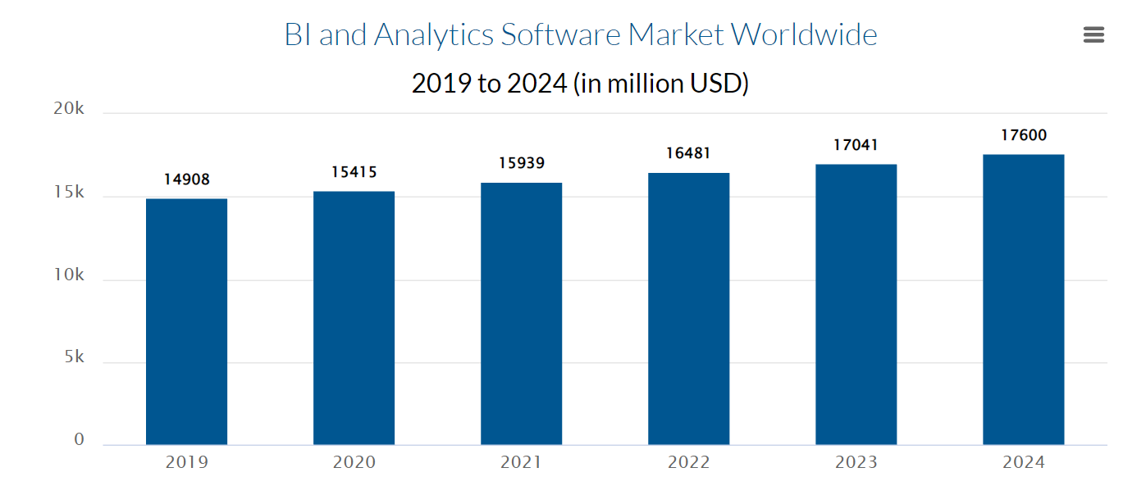
Source: Gilbert, 2022
This utilization of BI will further shape another emerging trend – enhancement of the economic performance of organization (Lim&Teoh, 2020). Through applying effective BI tools, management practices will become more transparent and optimal and will guarantee innovativeness. This refinement of strategic management ensures cost efficiency, rising sales and revenue values, financial stability, and refinement of overall productivity of the entity (Puklavec et al, 2018).
  - trend 2 – BI will enhance predictive analysis in the strive for maximization of environmental performance
The need of engaging more descriptive and diagnostic analysis in the operation of businesses is urgent due to the increased competition on organizational levels. One of the challenges on current markets is to establish a solid ground balancing between realization of profit maximization goals and minimization of negative environmental impacts (Lim&Teoh, 2020). Therefore, businesses are focusing on adopting predictive analysis with reliable real-time information to assess their performance and provide alternatives for minimization of the environmental repercussions.
Establishing a stable path of business intelligence operations is a way to predict easily market situations and to invest efforts and resources into sustainable practices (Gilbert, 2022). By gathering sufficient data, corporations enable themselves with the opportunity to evaluate their performance, to observe their development and to fix their goals in such a way as not only to maximize profits and minimize expenses, but also to touch upon the importance of diminishing adverse impact on natural environment. Turning to “green thinking” through security practices positively correlates with strengthening environmental performance and providing overall sustainability for the organization (Lim&Teoh, 2020).
  - trend 3 – BI as a way to minimize the challenge of handling big data
BI tools provide a ground for identification opportunities, application of machine learning algorithms and AI features, modification of warehousing and production processes as well as easy interaction between various stakeholders (Gilbert, 2022). Separating the organization operational tasks between machine learning forecasting and simulating, human analysis, and artificial intelligence algorithms for management leads to establishment of an efficient and transparent performance process. This whole approach will equip the corporations with the power to effectively manage the exhausting tasks, to work optimally with the big data and to be able to differentiate between techniques and to combine them in such a way that the processes to be efficiently optimized (Gilbert, 2022).

  - trend 4 – business intelligence will enhance social performance
Business intelligence tools can function as a driver of knowledge sharing practices, innovation, and corporate social activities (Lim&Teoh, 2020).
What this means is that application of BI techniques makes it easier for companies to access technologies for providing transparent flow of knowledge and information across the business network and for smoothly establishing social programs within the organization (Lim&Teoh, 2020). This is a chance to bring the employees closer together, to empower them with morale and cognition and to shape their mind toward self-actualization. By creating a robust human workforce, organizations guarantee that they will acquire responsible personnel who will build a good brand reputation (Lim&Teoh, 2020). This entire process portrays a new trend – BI has turned into a tool not only for contributing to human development but also for reinforcement of social performance of companies.
  - trend 5 – business intelligence is a tool for establishing resilience and sustainability
Finally, another current trend observed on the fast-changing global market is that business intelligence turns out to be a way of increasing efficiency and pointing toward organizational resilience and sustainability (Bataweel, 2015). The human potential should be combined with technological advancements and alternative approaches in the face of BI to be effective. Therefore, business intelligence tools have been integrated and have provided a newly emerging trend – to save business processes by expansion and growth and thus to ensure sustainability of operations (Sauter, 2011).
Sustainability of decision-making attained through BI tools further impacts the resilience of the corporation. By becoming increasingly equipped and prepared for upcoming supply chain and performance disturbances, businesses establish resilient operational activities (Bataweel, 2015). This is a way for them to be able to meet and face new challenges on the constantly evolving market and to ensure their survival and growth. They gain more robustness and resilience which creates a competitive advantage in their industry.
- conclusion
The current pandemic situation and the rapid growth of globalization practices has shaped a new tendency in the thinking of businesses – to embody digital competency, human capital development and BI tools to strengthen and realize optimally their goals of following the vision of how to empower sustainable development, resilient performance, and efficiency in a dynamic setting.
Here comes business intelligence development and integration and its current trends – to foster economic, environmental, and social performance, to establish resilience and sustainability and to boost market growth thus guiding businesses to go up on the ladder of success.

rEFERENCE lIST
Anadiotis, G. (2003). Agile Business Intelligence: reshaping the landscape (http://www.tableausoftware.com/sites/default/files/media/gigaom-research-agile-business-intelligence.pdf?signin=89ae0 7dd32727354922f756f98e40144)
Arnott, D., Gibson, M., & Jagielska I. (2004). Evaluating the intangible benefits of business intelligence: review & research agenda. The IFIP TC8/WG8.3 International Conference, 1-11. doi:10.1.1.94.8550
Bataweel, Dalal Suliman. (2015). "Business Intelligence: Evolution and Future Trends". Theses. 283.
https://digital.library.ncat.edu/theses/283
Chaudhuri, Surajit & Dayal, Umeshwar & Narasayya, Vivek. (2011). An Overview of Business Intelligence Technology. Commun. ACM. 54. 88-98. 10.1145/1978542.1978562.
Eidizadeh, R., Salehzadeh, R. and Chitsaz Esfahani, A. (2017), “Analysing the role of business intelligence, knowledge sharing and organizational innovation on gaining competitive advantage”, Journal of Workplace Learning, Vol. 29 No. 4, pp. 250-267, doi: 10.1108/JWL-07-2016-0070.
Gilbert. (2022). Finances. 8 Business Intelligence Software Trends for 2022/2023: Predictions You Should Be Thinking About - Financesonline.com. (2022). Financesonline.com. [online] 3 Jan. Available at: https://financesonline.com/business-intelligence-software-trends/.
Heang, R. and Mohan, R. (2017). Literature Review of Business Intelligence. [online] Available at: https://www.diva-portal.org/smash/get/diva2:1080911/FULLTEXT01.pdf.
Lim, Y.Y. and Teoh, A.P. (2020), "Realizing the strategic impact of business intelligence utilization", Strategic Direction, Vol. 36 No. 4, pp. 7-9. https://doi.org/10.1108/SD-09-2019-0184
Puklavec, B., Oliveira, T. and Popovic, A. (2018), “Understanding the determinants of business intelligence system adoption stages an empirical study of SMEs”, Industrial Management and Data Systems, Vol. 118 No. 1, pp. 236-261, doi: 10.1108/IMDS-05-2017-0170.
Richards, G., Yeoh, W., Chong, A.Y.L. and Popovic, A. (2019), “Business intelligence effectiveness and corporate performance management: an empirical analysis”, Journal of Computer Information Systems, Vol. 59 No. 2, pp. 188-196, doi: 10.1080/08874417.2017.1334244
Sauter, V. L. (2011). Decision Support Systems for Business Intelligence. Hoboken: John Wiley & Sons.

